**Login Page**

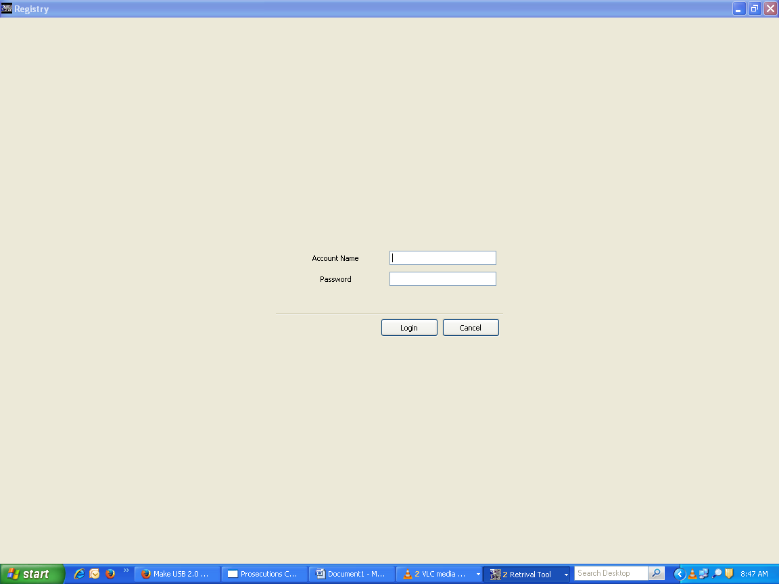

**Main Window**

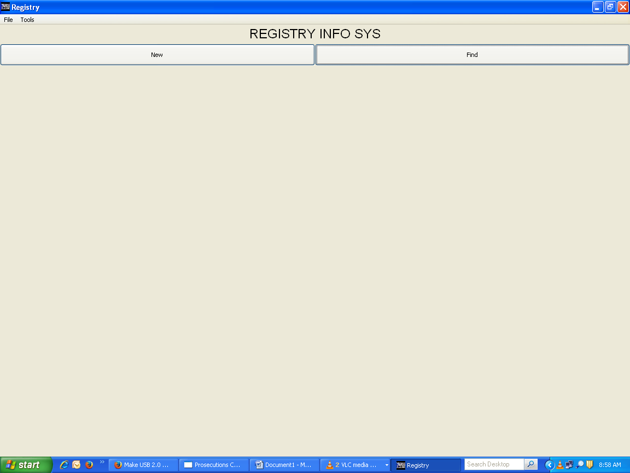

On Successful login, you will be presented with above window

Reference, Registry and Actions:

Ass all the files are fast tracked using their references, All the available reference are captured using this page.

From the Menu bar, goto Tools-Reference-reference tab or as appropriate

Enter the File reference and subject then click the add Button.

The list in the lower window shows all the available Items under the section. And to get to any (Search), just type the prefix of the reference.

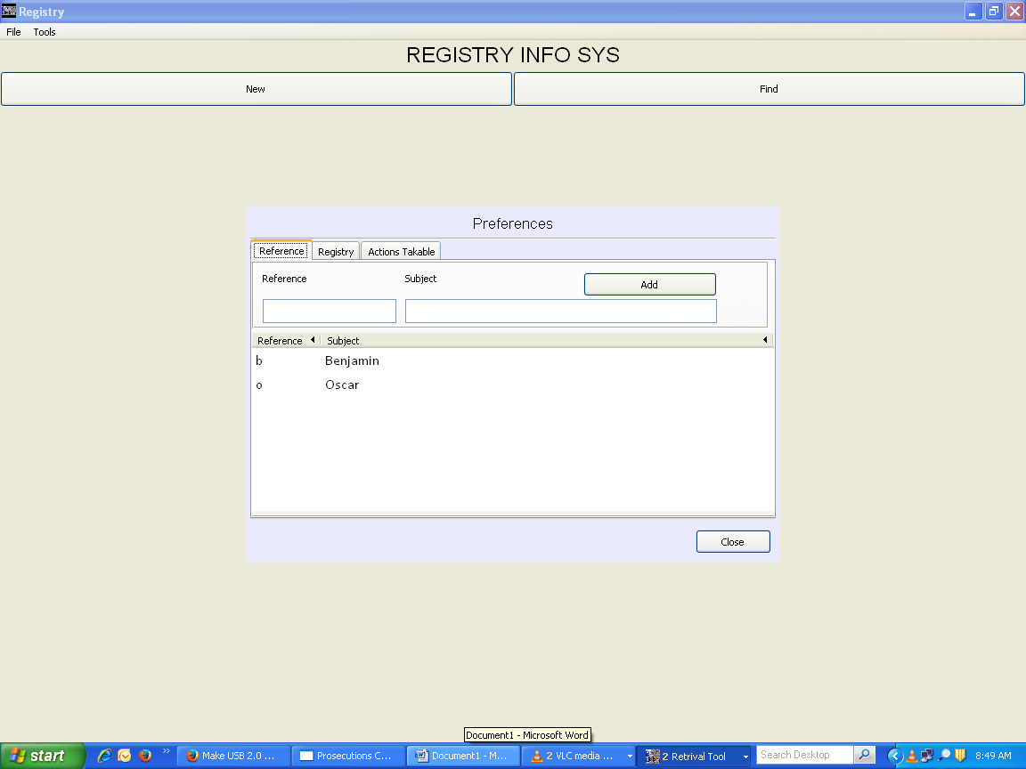

**New Entry;**

When entering a new entry, either click on the New button presented on the Main window or goto Menu item File-New files for Retention

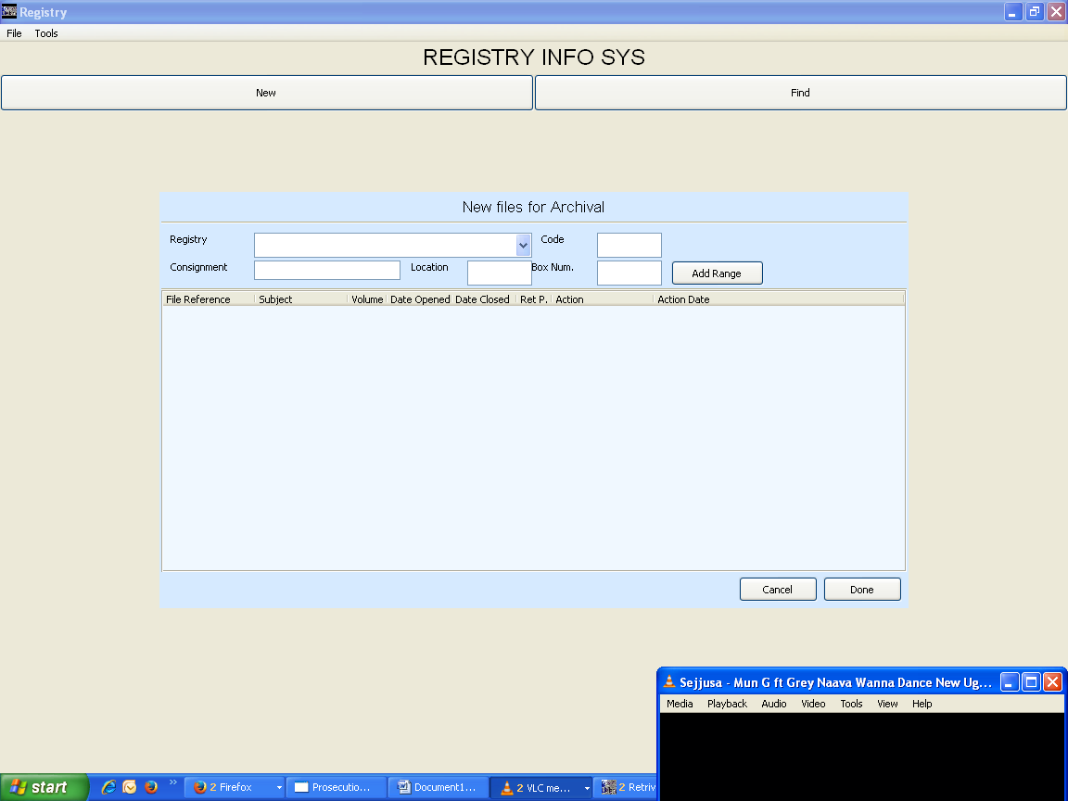

1. **PROCAM**: when capturing for Legal records (PROCAM Folders), use the Add Range button.

This will present you the window as shown below. 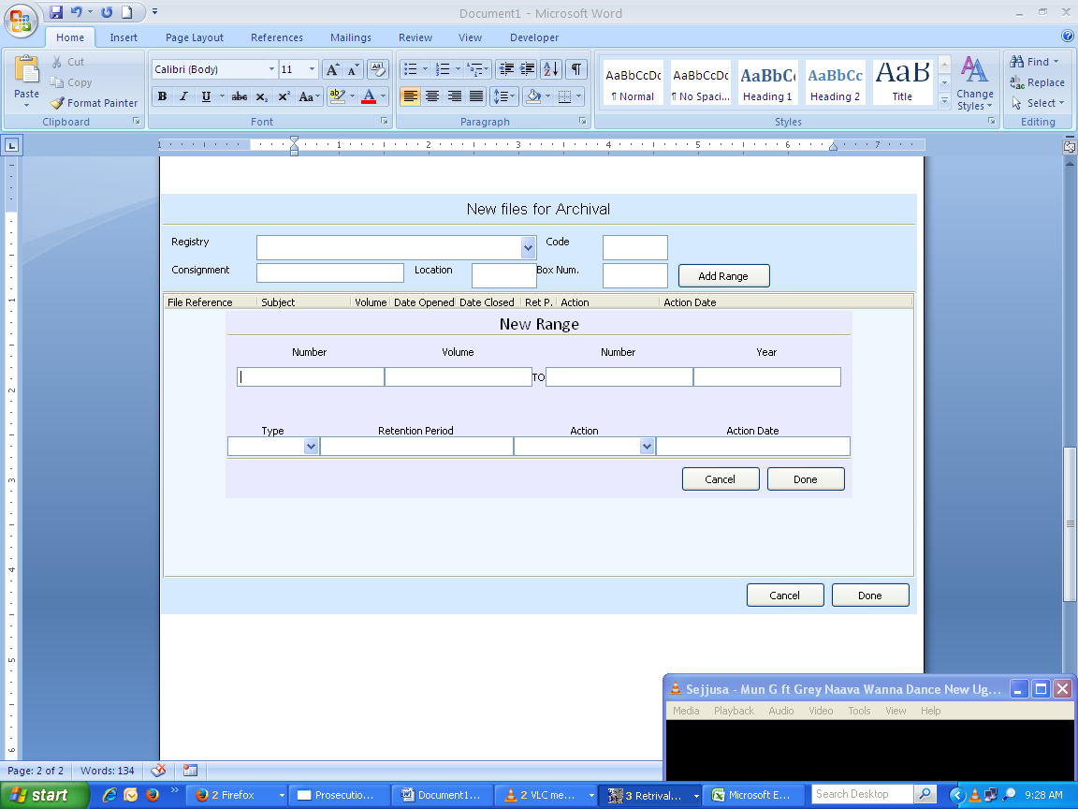

In the window, you are presented with various input fields.

* + The first and second fields for number are for entry for the starting and ending point range.
  + The volume fields is for entry of the files volume number
  + The year field is for the input of the file range year
  + The type input: here choose from the drop down list for the files type(category)
  + The retention period is for the duration in terms of months
  + The action field enables you to choose action taken on the files
  + And last action date

After which click the done button and the files will be entered into the New files for Archival Window.

1. **Subject files**: these file are captured directly into the New files for Archival window.

You can either click within the box and enter the file reference or press the insert key on the keyboard to activate a new line for entry.

The fields are pretty much the same as those found in the add range window

**Search for files**:

To find files, from the Main window click the find button then you will be presented with search window where you can fill in from Zero to all the parameters. 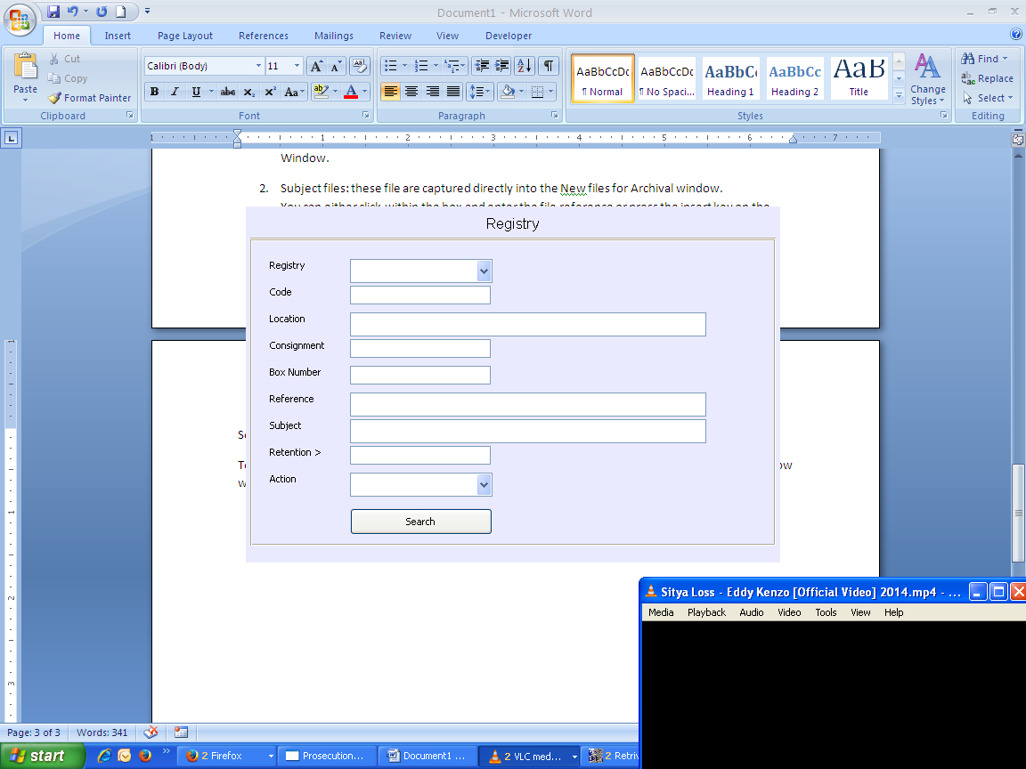

On search, a list will be presented like below 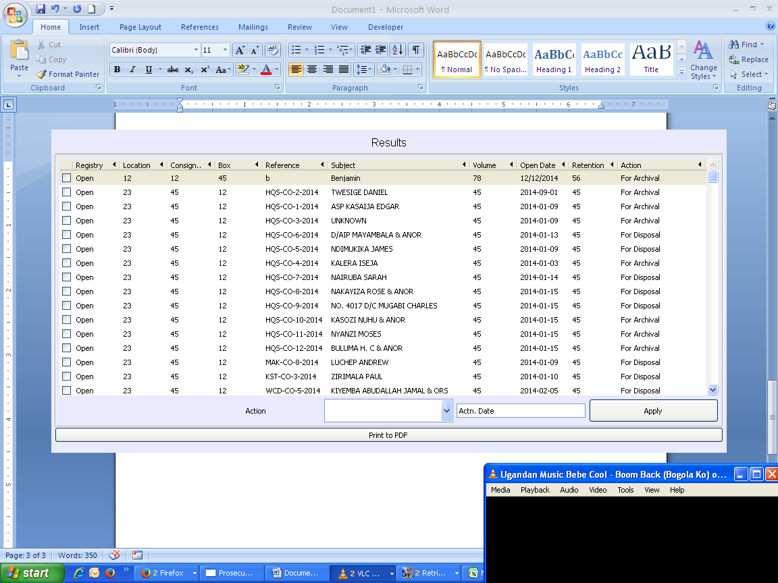

From this window, only one field can be changed, that’s the action. Which is achieved after highlighting the items and the action applied to it, depending on the case, these items will be removed from the list.