An Analysis of the Distribution of ELA Test Refusal Rates in Public Schools (2023-2024)​​

Introduction
In this report, we aim to find out the distribution of percent students that refused to take Grade 3-8 ELA tests in public schools during school year 2023-2024 in New York. In particular, we want to determine if the data listed is normally distributed or not by multiple methods such as shape of histogram and Q-Q plot. We hypothesize that schools’ refusal data of ELA is evenly distributed.

Methodology

Study Variables
Refusal percent is a continuous numerical variable included. It represents the percentage of students who refused to take the Grade 3-8 ELA test in a given public school during the 2023-2024 school year.

Statistical Symbols
Population mean $(μ)$
Population standard deviation $(σ)$
Population size $(N)$
Population median $(η)$

Statistical concepts
Mean, Median, Standard Deviation
Boxplot and IQR (Interquartile Range)
Histogram
Q-Q Plot

Technology and Tools
We used Microsoft Excel and R to analyze data and generate graphs.

Data Summary and Analysis
Table 1 Important Numerical Statistical Values of % Refused Students taking ELA Test by School
 | Population size $(N)$ | Population mean $(μ)$ | Population median $(η)$ | Population standard deviation $(σ)$
ELA Test refusal rates | 1011 | 9.6503 | 5.5 | 11.6

The data in Table 1 suggests a deviation from normality. If data is perfectly normally distributed, mean should equal to median. However, the refusal rates of students have a mean of 9.6503 and a median of 5.5, indicating extreme values are pulling the data away from the median towards the positive direction, which is later shown in Table 2 by skewed tails to the right.

Table 2 Histogram of Frequency of % Refused Students taking ELA Test by School

Figure 1 A perfect normal distribution.
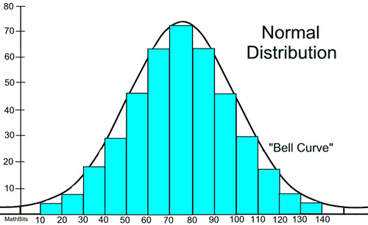

Analysis of the histogram
We have plotted the refusal rates for ELA tests by school is graphed in Table 2, with the interval being 4%. A strongly right-skewed distribution can be observed in Table 2, which indicates most schools have very low refusal rates (near 0%), while a few shows high rates. The vast majority of schools have refusal rates clustered within 0% and 20%. Conversely, Figure 1 displays a perfect normal distribution of data. The shape pattern of Graph 2 is different from Figure 1. As a result, distribution of refusal rates clearly deviates from normality where data should display a bell-shaped, symmetric curve in a histogram.
Table 3 Boxplot of % Refused Students taking ELA Test by School

Analysis of the boxplot
Table 3 is refusal rate for ELA test plotted in a boxplot. Multiple large outliers can be observed, indicating there are extreme values that are higher than the majority of data. According to the definition of interquartile range, as quartiles are displayed in the graph, data is not evenly concentrated around the median. We can observe that the interval between quarter 1 and median is much shorter than the interval between quarter 2 and median. Because all quartiles contain same number of data, quarter 1 and quarter 2’s data are more concentrated than quarter 3 and quarter 4, which concurs with the conclusion above that the distribution of refusal rates is strongly right skewed. At the same time, multiple outliers show the spread of extreme values. Therefore, the data is not normal distributed.
Table 4 Q-Q Plot of % Refused Students taking ELA Test by School
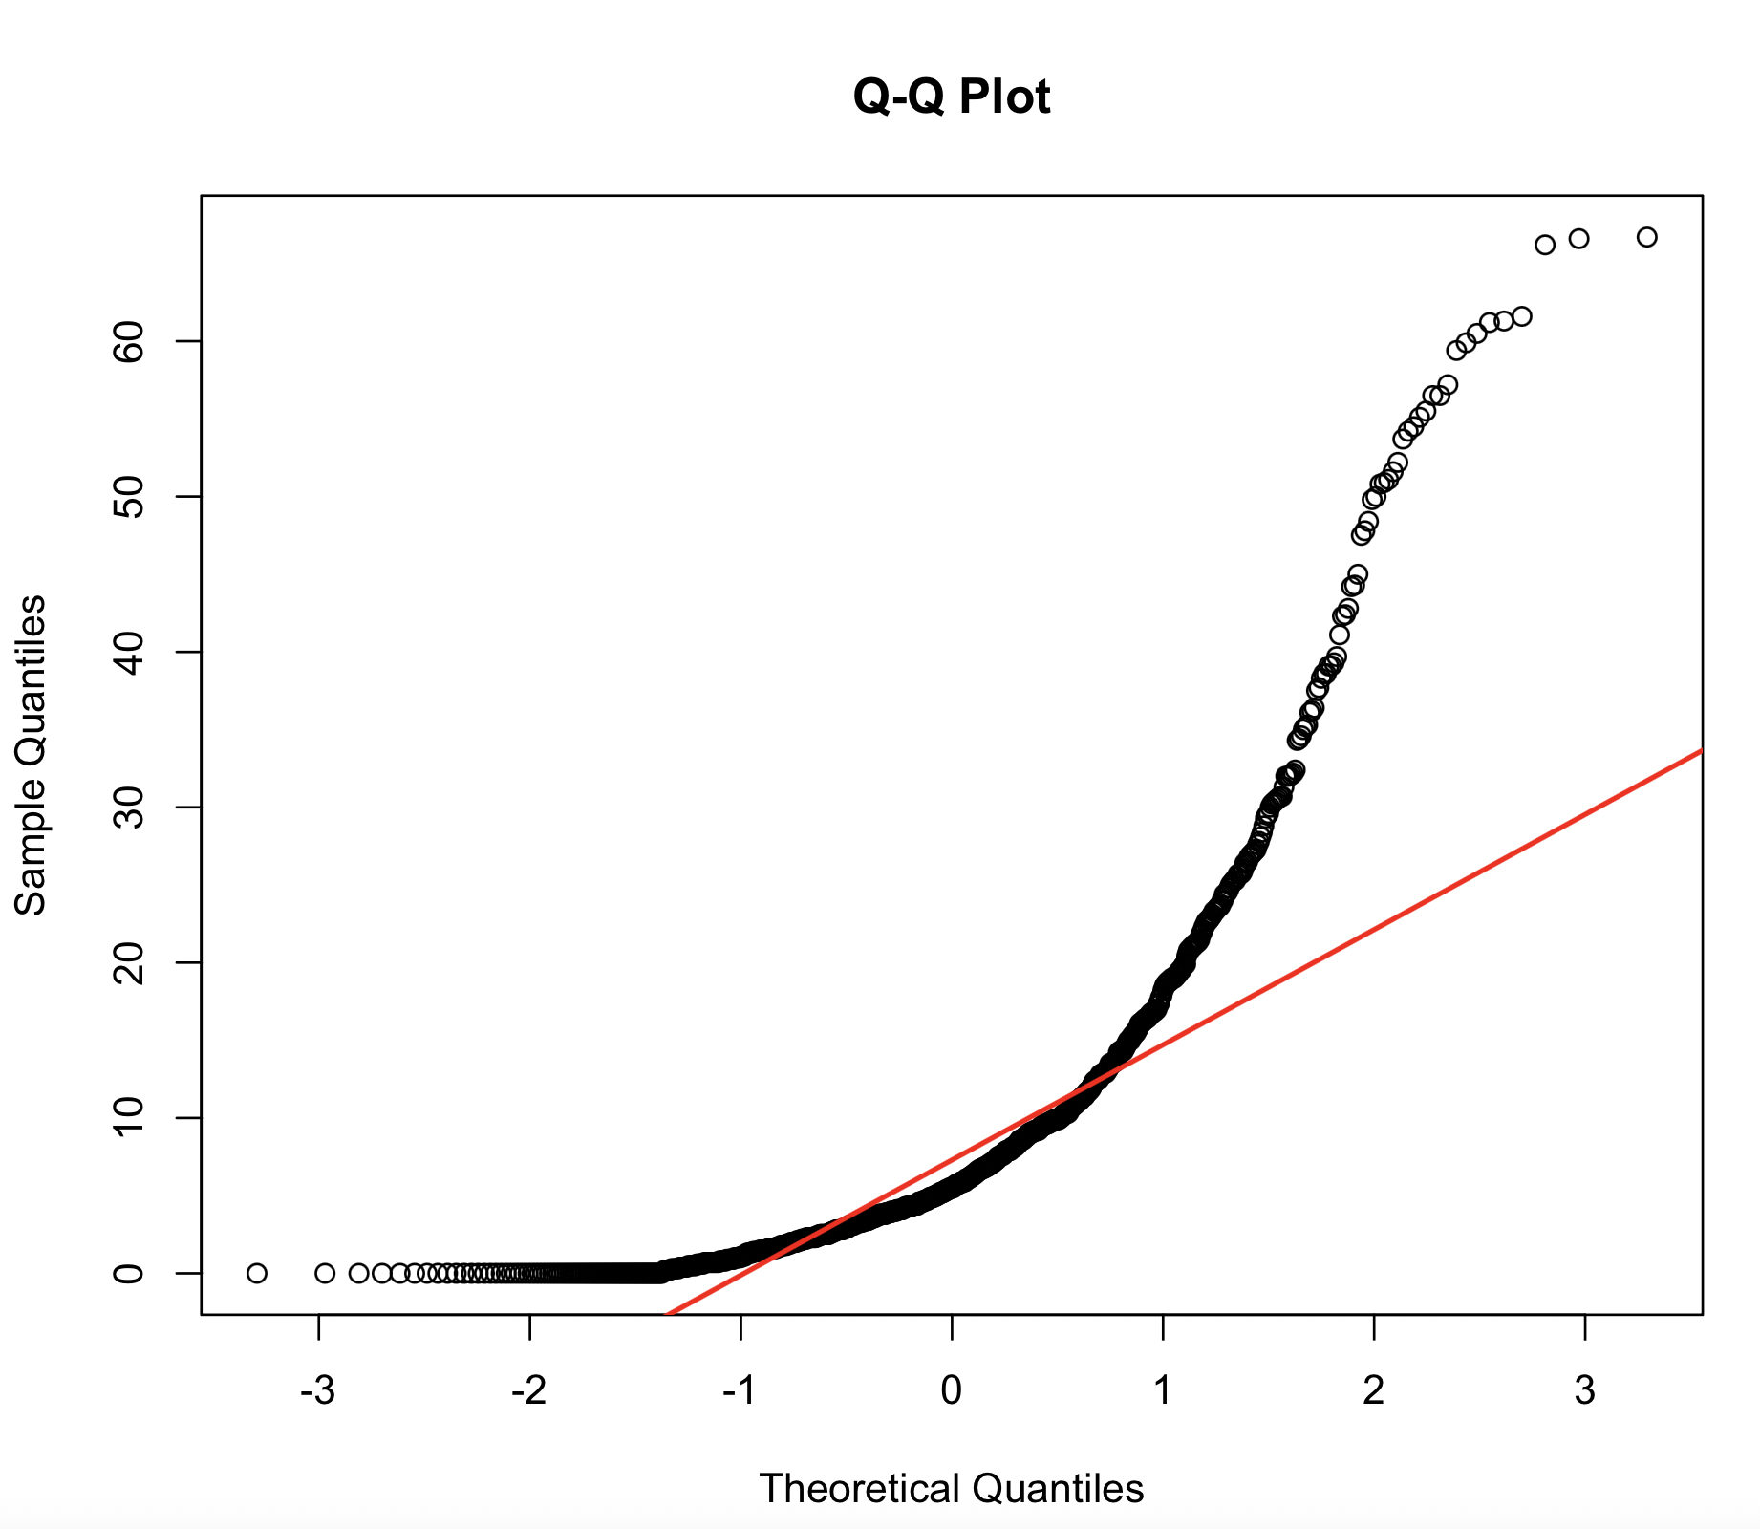

Analysis of the Q-Q plot
A Q-Q (Quantile-Quantile) plot is a graph used to assess if a dataset follows a particular theoretical distribution, in this case the normal distribution. It compares the empirical data against the quantiles of a theoretical distribution. If the data follows the theoretical distribution, the points will approximately lie along a straight reference line (y = μ + σx). Deviations from this line indicates skewed distribution such as skewed to left or skewed to right. In Table 4, the x-axis is theoretical normal distribution, and y-axis is empirical distribution of refusal rates. If the graph is normal distribution this graph should be aligned with the red line indicated in the graph. But the data points curve upwards away from the red reference line in the upper right section of the graph, which is a indicator of a ​right-skewed distribution​. It means that the largest refusal rates are more extreme than would be expected if the data were normally distributed, and these outliers drive a deviation from normality and pull the mean value to the right of the median.

Table 5 Q-Q Plot examples of right and left skewed data
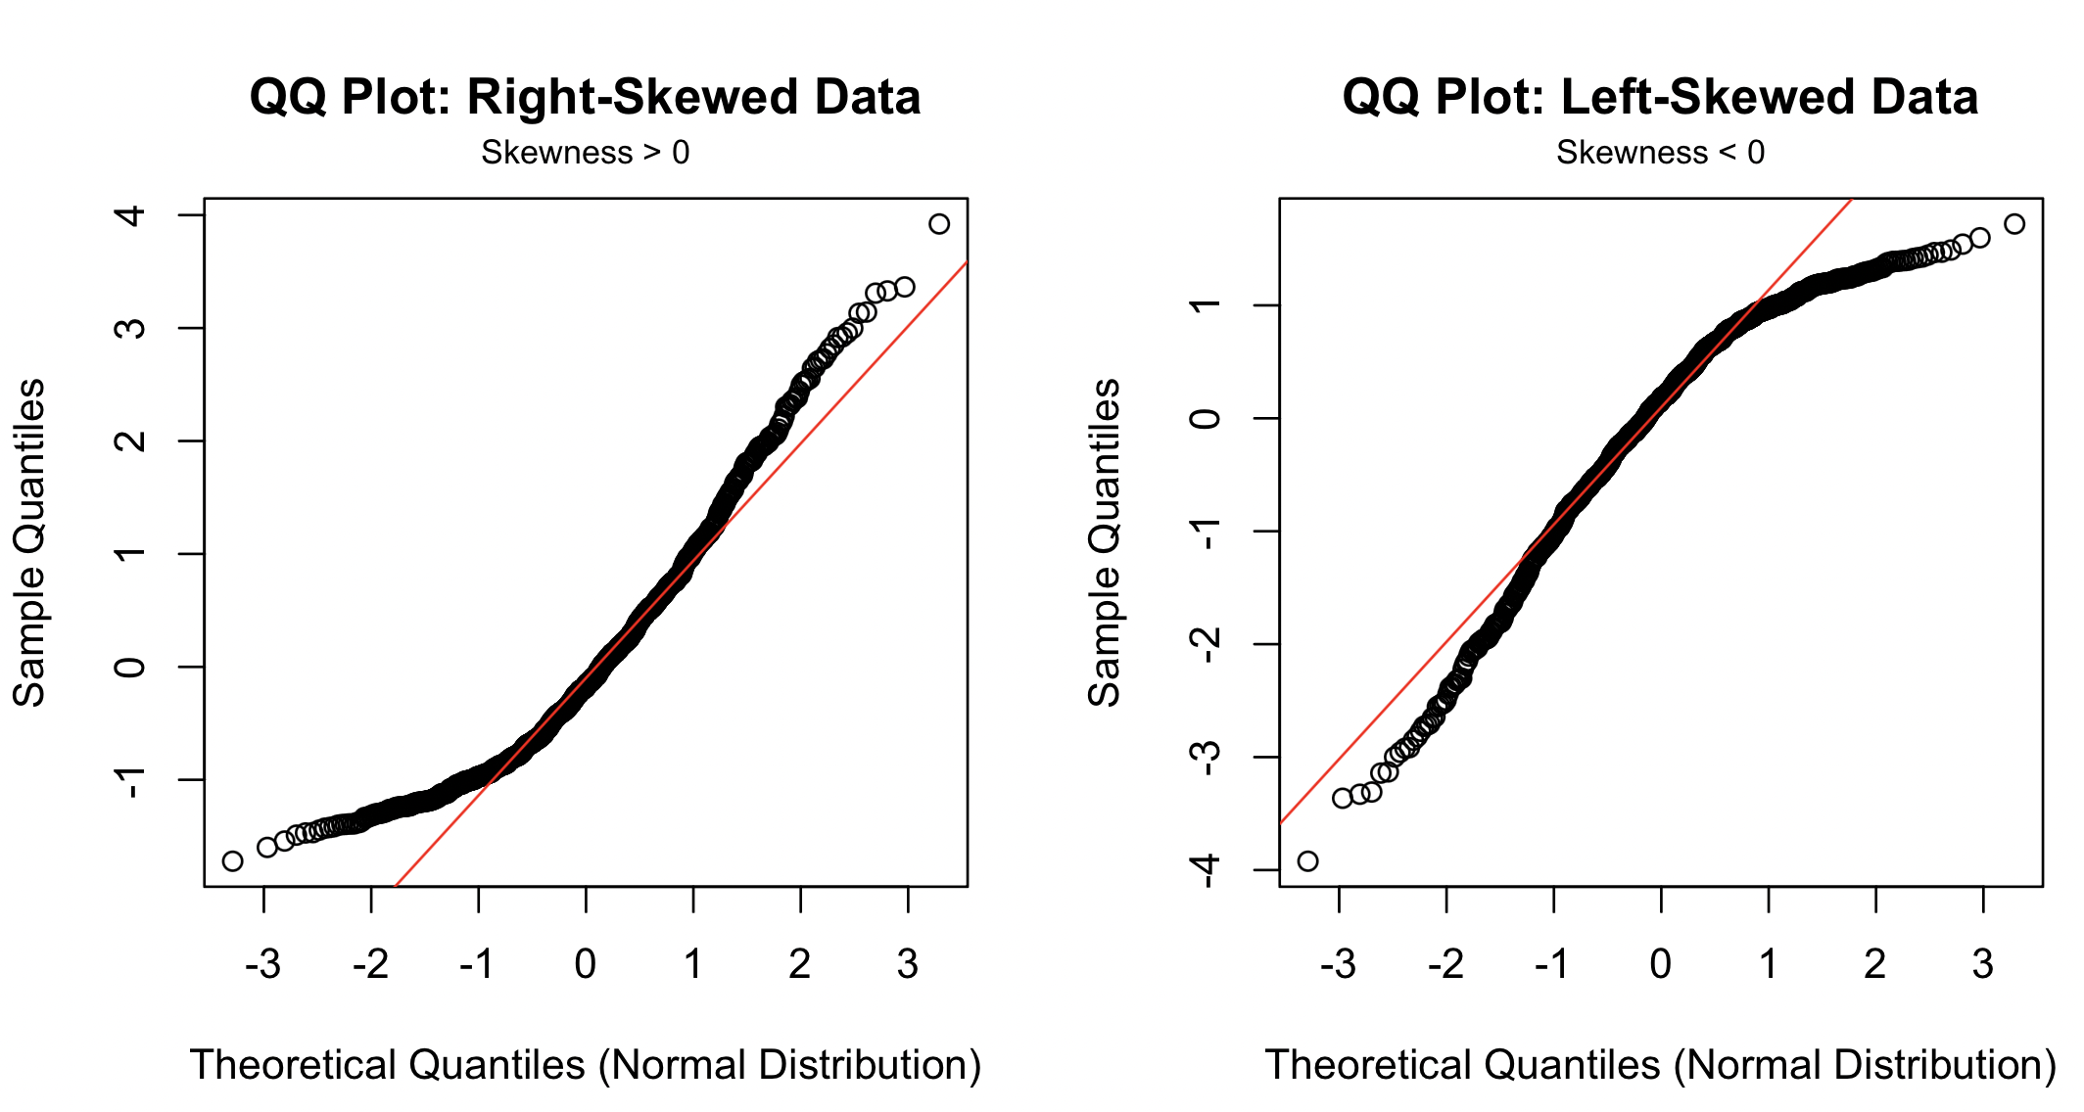

Conclusion
Our results reject our hypothesis that ELA test refusal rates are normally distributed. The histogram distribution is strongly right skewed, indicating that most schools have very low refusal rates (close to 0%), this skewness contradicts the assumption of a normal distribution.
The results suggests that the vast majority of public schools in New York take the ELA test in 2023-2024, and ELA test refusal is a rare phenomenon. However, there are still schools experiencing high refusal rates of taking ELA tests, which fundamental reasons for these abnormalities could be further investigated.

Reflection
Our report did well in analyzing how the refusal rates are distributed, and we made a clear conclusion that rejects our hypothesis. We found a clear right-skew distribution of the refusal rates, and we used multiple statistical methods to determine and describe it; for example, histogram, boxplot and Q-Q plot. We infer from our conclusion that while most schools in New York agreed to take ELA tests in 2023-2024, there are still a minority that refused to do so. However, further improvement and renovations could be made on analyzing the reasons behind the distribution: Why the majority of schools agreed to take the test but still some refused? Is there deeper societal, economic or policy related reasons behind the data? Moreover, since we only focused on the test taking refusal rates of the single subject of ELA, more comprehensive investigations could be conducted regarding other subjects involved in the initial data collection process (Science and Math).
Regarding methodology, although our graphical approach demonstrates a clear pattern of right-skew, simply judging by shape is not always reliable. More analytical methods other than Q-Q plot, like the Kolmogorov–Smirnov test, could be utilized to further validate our results.

Citation
Roberts, D. R. a. F. (n.d.). Normal Distribution - MathBitsNotebook(A2). MathBits.com (MathBitsNotebook.com) - Fred and Donna Roberts. https://mathbitsnotebook.com/Algebra2/Statistics/STnormalDistribution.html
Mishra, P., Pandey, C. M., Singh, U., Gupta, A., Sahu, C., & Keshri, A. (2019). Descriptive statistics and normality tests for statistical data. Annals of Cardiac Anaesthesia, 22(1), 67. https://doi.org/10.4103/aca.aca_157_18

