A Conceptual Wheelchair with Mecanum Wheels and Cushion-Based Shock Absorption System

Yuhong Luo, Bella Zhao
Beijing Haidian Kaiwen Academy
AP Physics 1
Fahad Raza
2025.6.23

Introduction
Wheelchairs play an important role in enhancing mobility and the quality of life for the disabled. Unfortunately, traditional wheelchairs often face challenges such as difficulty making turns in tight spaces. Also, some lack shock absorption systems — features that are typically only available in expensive, high-end models.
Our idea of designing a cost-efficient and agile wheelchair comes from real-life experience and observation. When pushing a friend with her leg injured in a wheelchair, we found it difficult to turn in narrow spaces. Turning the wheelchair around requires pushing it back and forth multiple times because the rear two wheels are too rigid. For example, in classroom settings, pushing a wheelchair into the seat between two desks is difficult. Due to the narrow space between the front and back desks, the two fixed rear wheels cannot move laterally, thus wasting a lot of time on entering and exiting. The fixed wheels and seat of an ordinary wheelchair are sturdy. While this prevents the wheelchair from collapsing, when passing over rough roads or door sills, patients can be jolted up from the wheelchair, causing secondary injuries to their original wounds. Moreover, our friend mentioned many times that sitting in the wheelchair is uncomfortable due to frequent shocks and small vibrations. That moment made us realize how much conventional wheelchair designs can overlook real user pain points, both physical and practical. After this experience, we began to pay attention to the societal scale of the problems wheelchair users are facing, and this led us to our design.
To address these issues, we are planning a project to design a wheelchair that improves operability and comfort while remaining low-cost. By incorporating better turning mechanisms and affordable shock absorbers, this innovation seeks to make wheelchairs more accessible and practical for patients worldwide.
Mecanum wheels became an inspiration for us from Dajiang Robomaster, a human-controlled cart for robot competitions. They’ve demonstrated fascinating mobility, with an ideal turning radius of zero, and compatibility with different devices, which is an ideal solution for wheelchairs to tackle indoors and city terrains where activity space is limited. Honeycomb-shaped gel is also an inspiration from daily use. One of us uses a honeycomb-shaped gel seat pad, and it largely relieved my numbness from long-term seating in front of the desk. We thought this might be helpful for wheelchair users who are also seated for a long time.
In all, we hope that our conceptual design can offer inspiration to future scholars who are also concerned about disabled people and rehabilitation services.

Literature Review

Assistive Technology Overview
Assistive technology (AT) plays a crucial role in improving disabled people living quality. According to the World Health Organization, “Assistive technology is an umbrella term for assistive products and their related systems and services”, in which wheelchairs play a crucial role, especially for people with difficulty in mobility. However, around 2.4 billion people are in need of rehabilitation services, with 80 million requiring wheelchairs—but only 5% to 35% actually have access to one, depending on their country. As the European Parliament reports mention, effective popularization of ATs is facing challenges, especially in universal and user-centered design (Nierling, 2018). A notable barrier innovative wheelchair design is facing is cost. An innovative design with Mecanum wheels and suspension system, similar to ours, is costly to manufacture. The suspension design by Zhang et al. (2024) has a complicated mechanical structure and is expensive for massive production. Similar designs by Velikis et al. (2019) and Thai et al. (2020) have similar problems - cost and intricacy of structure.

Wheelchairs in History and in Modern Days
Wheelchairs were invented more than 500 years ago, and have evolved from crude wooden chairs to AI-based electronic wheelchairs. Early designs were bulky and only focused on mobility; it was not until 1950 that the first electronic wheelchair, designed by George Klein, was put into mass production (Nias, 2019). Initially, electronic wheelchairs were to aid the rehabilitation of World War II veterans. Nowadays, wheelchairs are widely used in the rehabilitation of people with disability. Its integration with technology includes advanced manual wheelchairs, electric and motorized wheelchairs, and integration with IoT and AI (Technological Innovations in Wheelchairs | Loh Medical, 2024).

Suspension Systems of Wheelchairs
Traditional wheelchairs often lack shock-absorption design or damping systems, making them uncomfortable or even harmful for users, especially on uneven terrain. Recently, some products and demos incorporated shock-absorption or suspension systems. For example, Zhang et al. (2024) designed a suspension system to absorb that ensures the comfort of the user when the wheelchair passes through uneven terrains like door seals. For products, Frog Leg and SoftWheel are good examples of modularized shock-absorption tactics applied to wheelchairs. Frog Leg focuses on the small front wheel and smaller shocks; SoftWheel, being the expensive one, focuses on larger bumps of the back wheel (Frog Legs Manual Wheelchair Suspension Study, 2024; Technology - Softwheel, 2020).

Methodology

Potential User Gap in Wheelchair Design
As mentioned, rehabilitation services, with assistive products being a major part of it, are urgently needed. However, although companies and researchers have proposed many designs, they share a certain flaw – cost. According to research, regular power wheelchairs normally cost between $1300 - $2500; high-end assistive technology wheelchairs even reach $30,000 (Braunability, 2025). Being more specific to our case, shock-absorption shares this common flaw: high cost of production and difficulty in the application of electric wheelchairs in relatively underdeveloped areas. Even in developed countries, affording the cost to buy a wheelchair could be a burden for people, where wheelchairs with high-end assistive technology are usually not covered in medical insurance (Fatalo, 2015).

Shock-absorption Material Cushion
Regarding these barriers, our design aims to innovate from another perspective – materials. Research demonstrated two suitable shock and vibration absorption materials: polyurethane and a honeycomb-shaped gel cushion.
Shock absorption materials work by dissipating or dispersing impact energy, often converting it into other forms of energy like heat, and reducing the force of impact on an object or system. For our case, shock absorption is achieved by deformation of elastic materials, where energy from the shock is dispersed through them (Yu & Xue, 2022).
Polyurethane, known for its shock absorption ability, is a compound material with various functions: insulators, foams, elastomers, synthetic skins, coatings, adhesives, and so forth (de Souza et al., 2021). For our case, polyurethane is a suitable choice for seat cushion material for its economy, easy access, and simplicity in mechanism. The average price for polyurethane pads is $20 per square foot, and various types are accessible online (“Amazon.com : Polyurethane Pad,” 2025). As for honeycomb-shaped gel, research demonstrated it has a good vibration absorption character (Park et al., 2018); specifically regarding wheelchairs, this type of material demonstrated an ability to prevent bedsores by distributing pressure, and significantly increased the comfort of the wheelchair user (Bui et al., 2019). The average price for honeycomb-shaped gel pads is around $30 per pad (“Amazon.com : Honey Comb Gel Seat,” 2025). In all, polyurethane and honeycomb-shaped gel are two ideal materials for shock-absorption cushion design of wheelchairs.

Mecanum Wheel Integration
The Mecanum wheel is an omnidirectional wheel invented by Bengt Erland Ilon (1972), and it has been widely applied in multiple areas, including military, industry, medical, education, and so on (F. Adascalitei & I. Doroftei, 2011). Mecanum wheels are known for their exceptional mobility and agility due to their unique design. Because its wheels are structured 45˚ from the vehicle, the composition of the four wheels’ force vectors of opposite directions enables it to move laterally. Former designs have already integrated mecanum wheels on wheelchairs, and we consider it an effective innovation, so we chose to follow the design.
Typically, the space needed for a smooth U-turn (180˚ turn) in a wheelchair is 197 cm by 153 cm minimum, while ideally, a Mecanum wheel-based cart has a turning radius of 0. Mecanum wheels typically cost around $300 (4 pieces), and already a variety of choices are available, compatible with different circumstances and user needs (Dev, 2025). Overall, Mecanum wheels have an exceptional performance on maneuverability compared to traditional fixed wheels.

Action Plan

Overall Description
Our wheelchair design Mecanum wheels, a dual-layer cushion, and a sophisticated control system, aiming for omnidirectional movement, vibration reduction, and ergonomic support. Below is a draft and dimension data for reference of our wheelchair.
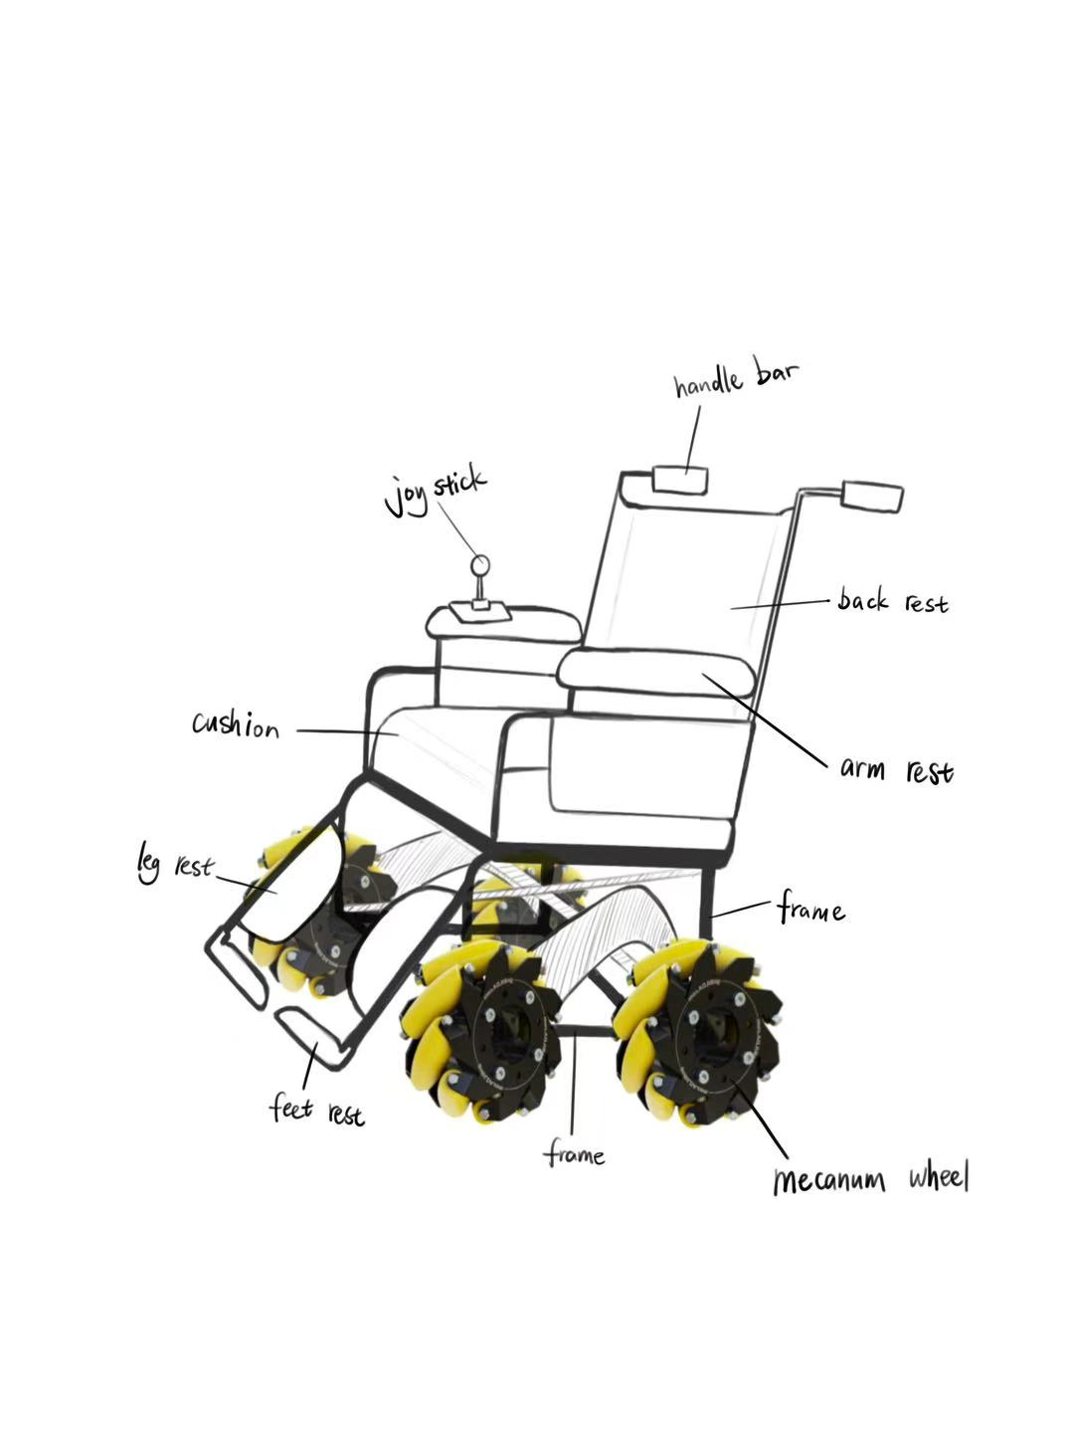
Figure 1 Overall structure of our conceptual wheelchair.
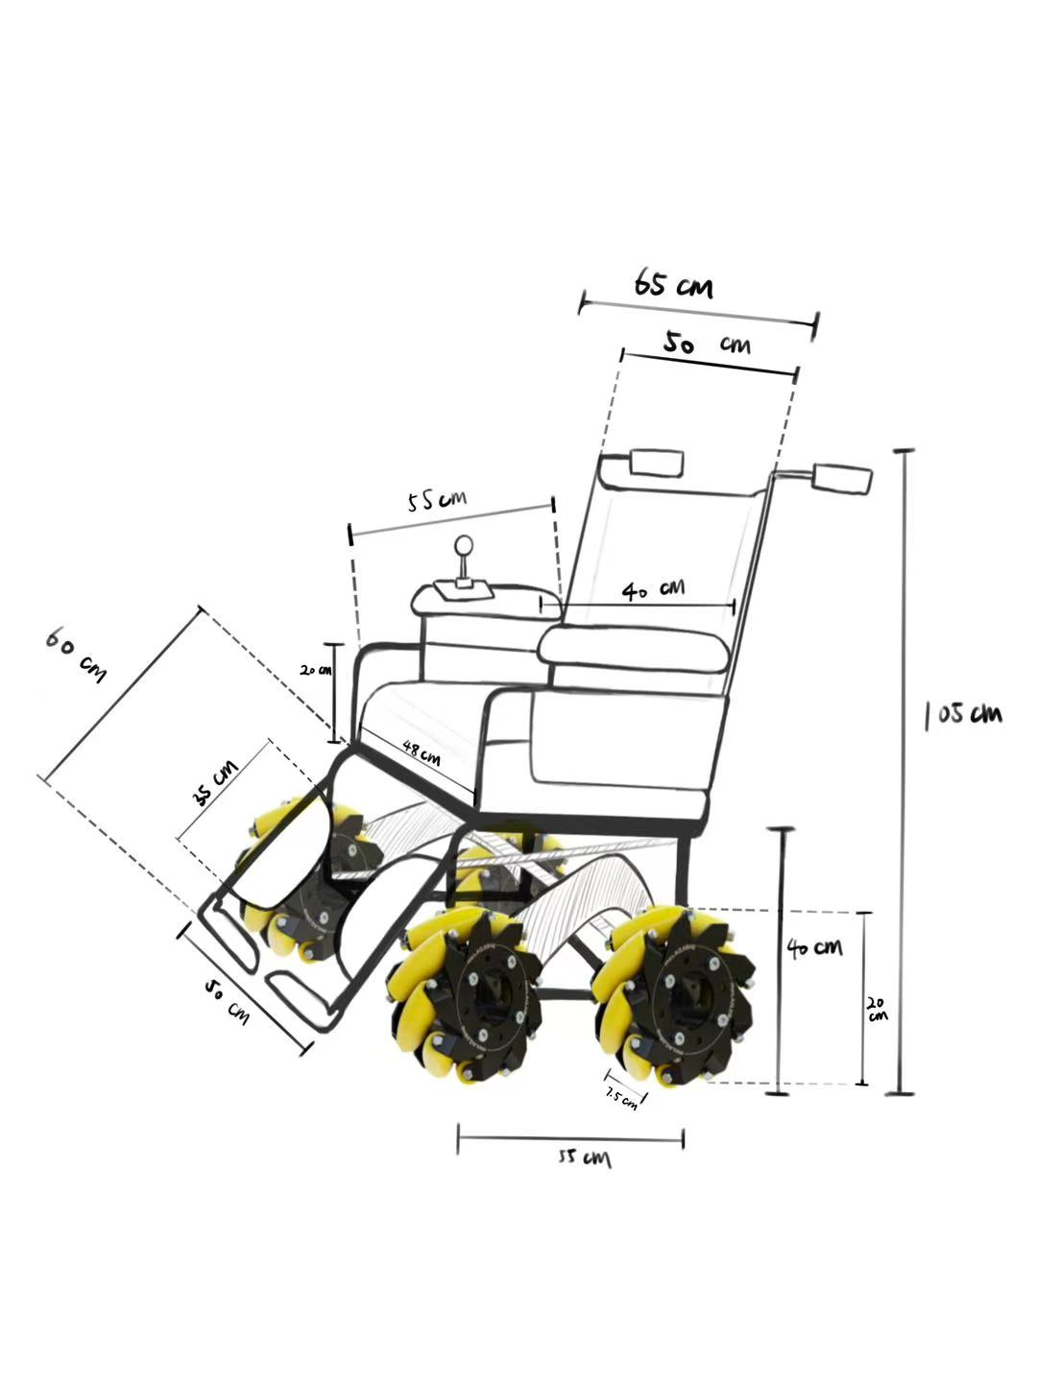
Figure 2 Conceptual dimension data of our wheelchair.

Mecanum wheel-based mobility system
The four wheels of the wheelchair were replaced with four identical mecanum wheels, each with a diameter of 200mm and a thickness of 75mm. On each wheel, there are 12 small rollers arranged at a 45-degree angle, with a diameter of 32mm and an interval of 1.5mm. The outer layer of the small rollers is covered with a layer of polyurethane to reduce vibration. This design enables all-around movement while maintaining a seat height of 480mm from the ground, meeting the standard of passing through a 3cm threshold and having an appropriate center of gravity height. Compared to ordinary wheelchairs, the mecanum wheels wrapped with polyurethane are 7.5cm thick, which increases the contact area with the ground, reduces vibration acceleration, and absorbs vibrations, making patients feel less shaking and jolting. The hub is made of 6061 aluminum alloy. The power system uses a 12V/30RPM DC gear motor.
The Mecanum wheels can be driven by manual force or by electric motors. The hub of each Mecanum wheel is connected to an electric motor to drive the wheel to rotate. Four wires that supply power to the motors are connected in parallel and then to the battery installed under the seat frame. The parallel connection ensures that each motor receives the same voltage while allowing independent control of speed and direction (controlled by a joystick). When the motors are not working, the wheels can freely rotate (with a non-locking design for the motor shaft), so the device can be moved by external force, and the motor drive and manual drive do not interfere with each other. When the motor or manual drive rotates the hub, the rollers come into contact with the ground at a 45° angle, generating friction. This friction can be decomposed into an axial force along the roller axis, which is counteracted by angular contact bearings, and a thrust force in the direction perpendicular to the axis.
In the logic of omnidirectional movement control, for different target movements, the wheel group has different rotation strategies (as shown in the diagram below). The forward and backward movements are the same as those of ordinary wheels; for example, when moving to the left, the left front and right rear Mecanum wheels rotate counterclockwise, and the right front and left rear Mecanum wheels rotate clockwise. The horizontal component of the advancing force of each wheel is synthesized to the left, and the vertical components cancel each other out, generating a pure leftward thrust. When moving to the right, the phase is reversed. When rotating on the spot, the advancing forces of each wheel form an opposing torque, and the resultant moment causes the device to rotate around the center, with the horizontal component of the resultant force being zero.
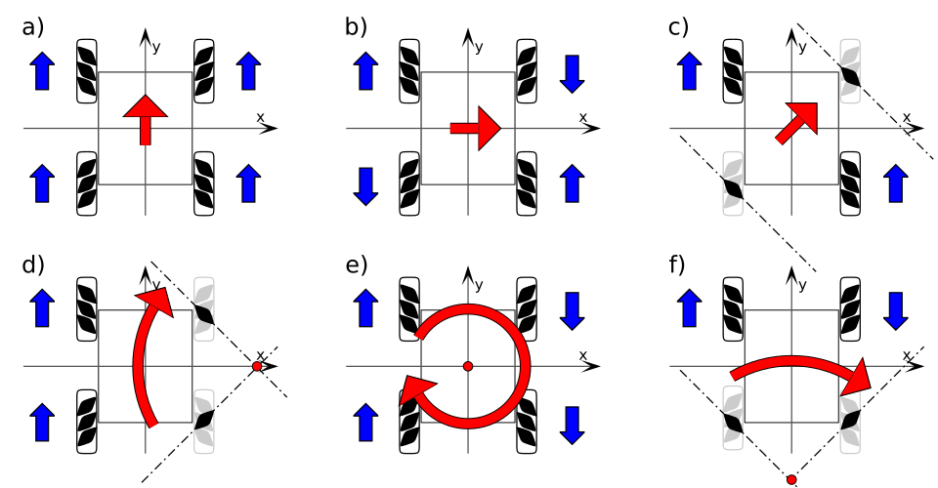
Figure 3 Force analysis of Mecanum wheels mobility system.

Polyurethane and Honeycomb-shaped Gel Cushion Design
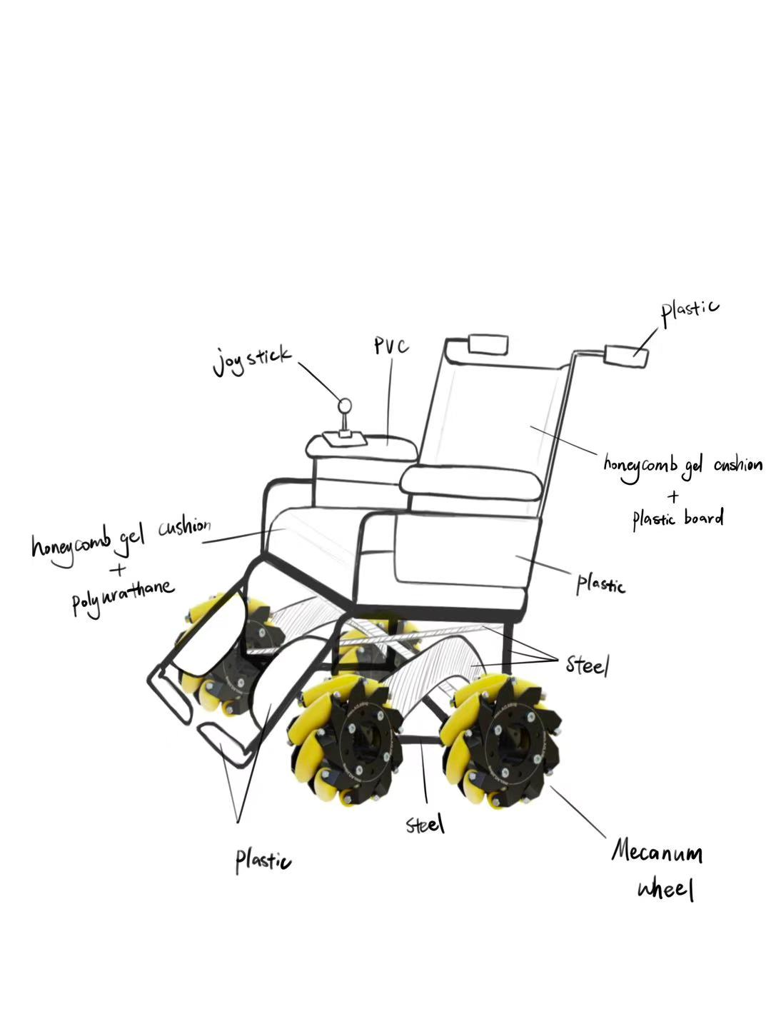
Figure 4 Conceptual material usage of our wheelchair.
The wheelchair cushion contains two layers: a honeycomb-shaped gel on top and 60A polyurethane on the bottom.
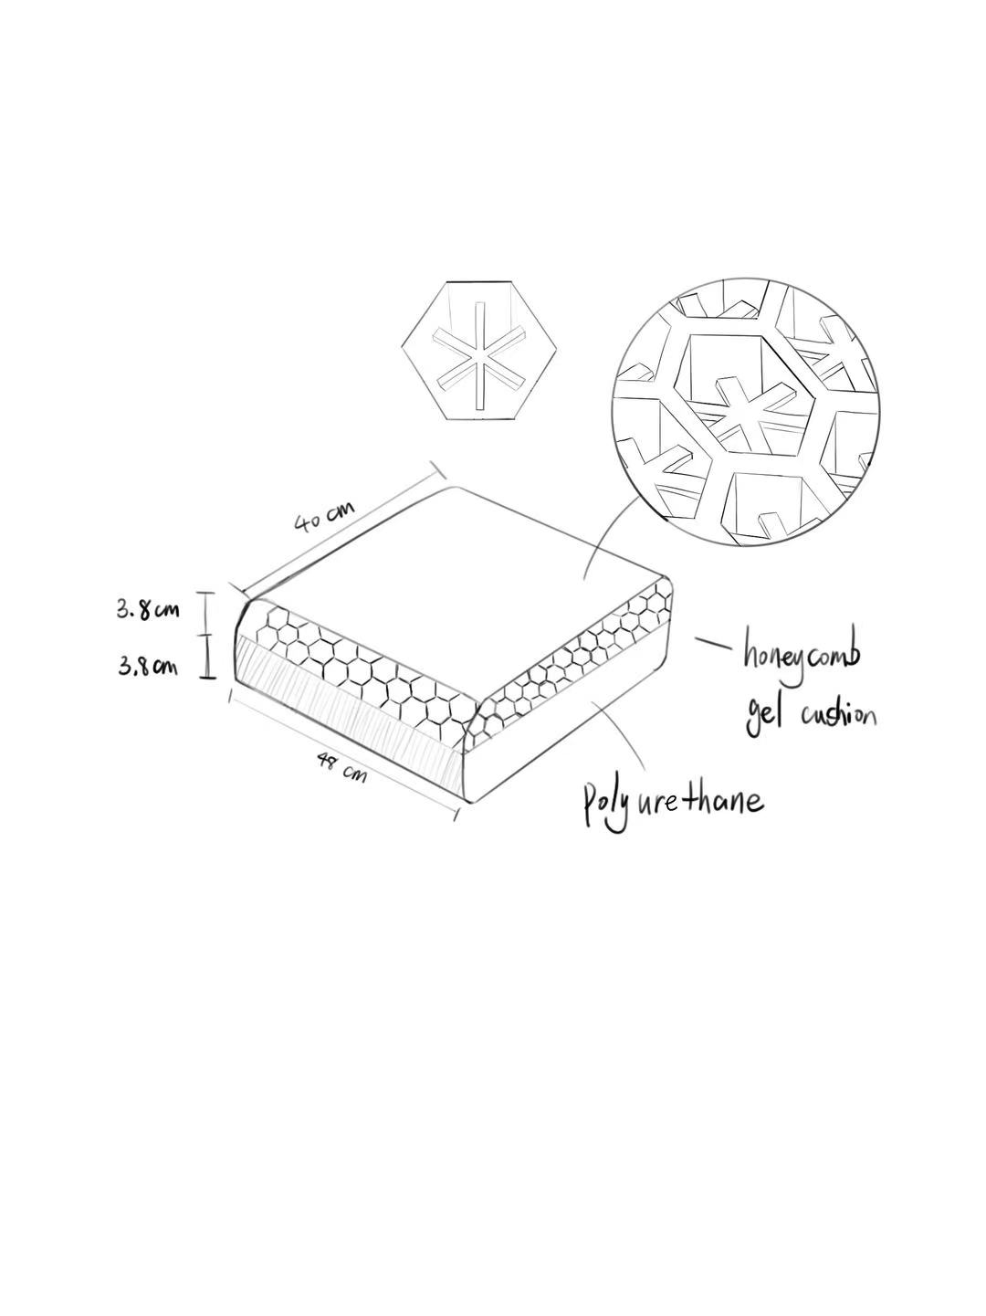
Figure 5 Double-layer cushion design.

Polyurethane Layer
Our cushion uses a 40A and 35 mm-thick polyurethane pad for the bottom layer. The Shore A hardness of 40A refers to the material’s resistance to indentation, measured on a scale from 0 to 100, where lower values indicate softer materials.
Compared to other materials like EPDM rubber and RLR (rubber-like resin), polyurethane is characterized by “both shock absorption and elasticity” (“Characteristics of Polyurethane (Elongation, Strength, Shock Absorption) and Comparison with Other Materials｜Nagase Chemtex Co., Ltd.,” 2025), by performing well in elongation tests and tensile strength tests. Polyurethane is suitable for shock absorption by outperforming other materials. Elasticity ensures the comfort of the user.
Also, polyurethanes are “characterized by excellent properties such as good resistance to abrasion”, which means polyurethanes have a high compatibility with different temperatures (-18˚C – 93˚C) (Amado, 2019). So, a polyurethane-made wheelchair cushion fits into different environments. Moreover, as mentioned, polyurethanes are cheap to synthesize, ensuring our goal to reduce cost; polyurethanes have a durability of 5-10 years (de Souza et al., 2021), extending their service life.
At 40A, polyurethane reaches a balance between softness and firmness. It provides both shock absorption and comfort. 40A guarantees the material's supporting ability, making the cushion suitable for people of different weights. This is critical for wheelchairs, where prolonged seating requires both comfort and support. Although larger hardness enhances its durability, its shock-absorption performance is weakened. On the contrary, although smaller hardness enhances shock-absorption, durability, resistance to shape change, and support are harmed.
The size of the wheelchair cushion is 40cm(depth) * 48cm(width) * 7cm(thickness). This is based on market investigation and real-life experience. This size fits most patients’ requirements and body data.
The polyurethane layer has a thickness of 38mm. First, the comfort of the user is ensured at this thickness. Combining with the honeycomb-shaped gel layer, the cushion has a total thickness of around 7cm, ideal for a wheelchair cushion. Even though studies demonstrate that thicker materials possess better energy-absorption ability, we want to achieve a balance between Shock absorption performance, user comfort, and cost-effectiveness. If the cushion is thinner, the user might feel uncomfortable because the seat is too hard; injuries like a sore back might be induced. If the cushion is thicker, the cost would rise, deviating from our objective.

Honeycomb-shaped Gel Layer
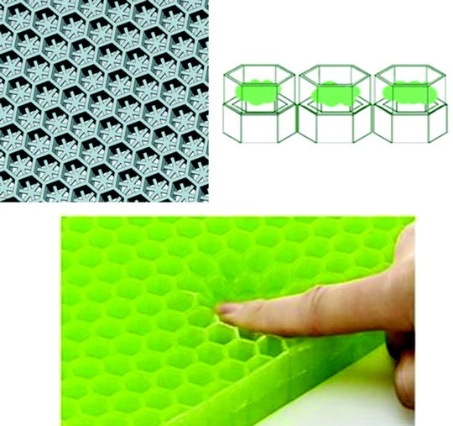
Figure 6 Structure of double-layered honeycombs made of Vetagel polymer, and commercial Bullsone Balance seat using honeycomb-structured cushion.
Honeycomb-shaped gel cushion design is a popular choice of seat pads. It is utilized in many sitting-required scenarios: wheelchair users, offices, schools, etc. Honeycomb-shaped gel is a cushioning material made of gel, designed with a honeycomb-like structure. This structure allows air circulation, keeping the cushion cool, while providing soft, supportive comfort for extended sitting.
In our wheelchair design, we want to refer to Kim, Seo, and Yoon’s (2019) patent. According to Kim, Seo, and Yoon (2019), “air is smoothly moved in the cushion by a ventilation structure having a superior breathability so that moisture and perspiration are effectively emitted and thus a thermal stability can be achieved, and the body pressure is equally distributed to mitigate a strain applied to a particular body portion so that the seat feeling can be improved.” Moreover, complementing Kim et al.’s design, “[honeycomb-shaped gel cushion] has significant vibration attenuation effect which increases ride quality of drivers and passengers”, according to Park et al. (2018). In all, the honeycomb-shaped gel performs well in shock absorption, breathability, comfort and affordability, making it a good match with the polyurethane layer.
The thickness of the honeycomb-shaped gel layer is around 38mm, the same as the polyurethane layer. This is because most products available are of this thickness, and it fits the design by Kim et al. (2018) well.

Control System and Auxiliary System

Auxiliary System
Many auxiliary devices are installed on the wheelchair to make the patients more comfortable and relaxed, including leg rest, footrest, and armrest. These structures can provide an applied force to assist and support the patient. For instance, the existence of a leg rest can cover the entire lower leg of the patient, which can help those with weak legs and reduce swelling in those legs. The frame of the leg rest and footrest can be adjusted in length because it is an embedded structure. By controlling the contraction or extension of the frame's length to adapt to the patient's leg length, that can ensure patient’s feet can be placed on the footrest to rest.
Leg rest and footrest can keep the patients in a naturally bent posture, with the knees bent about 90 degrees and both feet placed flat. That can prevent the feet from dragging on the ground and affecting movement. The footrest is a flip type, which is convenient for the patient to get on and off the wheelchair, and has anti-slip patterns on the plastic surface.
The last one is the armrest, which can support the patient's arms, maintaining the correct sitting posture and reducing shoulder and neck pressure. Moreover, the armrest is a supporting device that can help the patient stand up. The joystick is installed at the edge of the armrest, which is used for the patient to control the movement of the wheelchair independently.

Control System
We drive each of the mecanum wheels by connecting the motor via a joystick via Bluetooth. The patient can control the movement of the wheelchair by pushing the joystick. When the patient stops pushing, the wheelchair also stops moving. The joystick with an analog output can provide signals in two directions: X-axis and Y-axis. By connecting the Bluetooth to the main board of the joystick and the main board of the Mecanum wheel movement platform, respectively, a hidden communication link can be established.
After processing, the control instructions are sent through the Bluetooth module, and at the same time, the instructions are received to control the motor. The signals from the patient pushing the joystick can be parsed, and the motor can be commanded to rotate accordingly. After the hardware is ready, we need to write code to make the device understand the patient's operational intentions.
On the Arduino side, the code covers reading the joystick data and sending Bluetooth instructions. This code first reads the values of the joystick X-axis and Y-axis using the analog Read function. These values are analog signals ranging from 0 to 1023. Then, using the map function, these values are mapped to the range of -100 to 100, which is more convenient for subsequent processing and transmission. Finally, the processed data is sent to the main board of the Mecanum wheel movement platform through the Bluetooth module. For example, when we push the joystick to the left, the value of the X-axis will change. After the code processing, the corresponding signal will be sent out.
The main control board of the Mecanum-wheeled mobile platform also requires corresponding code to receive Bluetooth instructions and control the wheels. This code first receives the data transmitted via Bluetooth, then parses the data and extracts the values for the X-axis and Y-axis. Next, based on kinematics principles of the Mecanum wheels, it calculates the speeds of the four motors. Finally, based on the calculation results, it controls the rotation direction and speed of the motors to achieve full-directional movement of the wheels.
When the hardware connection is completed and the code has been written and uploaded, the first step is to connect the hardware. Connect the joystick module to the Arduino mainboard according to the pin definitions, and connect the Bluetooth modules to the two mainboards respectively. Configure the communication parameters to ensure they can operate normally and send data. At the same time, connect the motors of the Mecanum wheel moving platform to the corresponding pins of the mainboards, and assemble all the parts into a complete machine.
Next, upload the two compiled codes to the corresponding Arduino mainboards respectively. Then, perform Bluetooth pairing, pair the two Bluetooth modules, and establish a communication connection. After successful pairing, they can freely transmit data within a certain range, eliminating the need for troublesome and occupying cables.
Finally, when the patient gently pushes the joystick, the movement of the X and Y axis of the joystick will be converted into analog signals. These signals are read and processed by the Arduino mainboard and then sent to the Mecanum wheel moving platform via Bluetooth. After receiving the instructions, the mainboard of the platform controls the wheels to achieve the corresponding omnidirectional movement.

Advocacy and Reflection
Our wheelchair aims to improve the current electric wheelchair designs by innovating on its mobility, shock-absorption ability, comfort, agility to cope with city terrains and affordability. Our design utilized Mecanum wheels, a dual-layer cushion (polyurethane and honeycomb-shaped gel), and a sophisticated control system.
Challenges arise in balancing the cost-effectiveness of materials and ideal performance for the cushion design. Integrating the complex kinematics of Mecanum wheels with reliable Bluetooth control required precise coding and testing to ensure smooth operation. Overall, we have ignored many technical difficulties and practical issues like material procurement, programming and modeling in creating a real demo of our conceptual product. Future iterations could explore lighter materials or simplified controls to further enhance usability and reduce costs.

References
Amado, J. C. Q. (2019). Thermal Resistance Properties of Polyurethanes and Its Composites. In www.intechopen.com. IntechOpen. Retrieved from https://www.intechopen.com/chapters/67840
Amazon.com : honey comb gel seat. (2025). Retrieved June 28, 2025, from Amazon.com website: https://www.amazon.com/s?k=honey+comb+gel+seat&crid=1PH30AT78EE09&sprefix=honey+comb+gel+seat%2Caps%2C361&ref=nb_sb_noss_2
Amazon.com : polyurethane pad. (2025). Retrieved June 28, 2025, from Amazon.com website: https://www.amazon.com/s?k=polyurethane+pad&crid=XU5W4VC34VLK&sprefix=polyurethane%2Caps%2C422&ref=nb_sb_ss_saint-en-refocus-candidate_3_12
Andrew Fatalo. (2015, December 14). Does Insurance Cover Electric Wheelchairs? Retrieved from Mobility Scooters Blog - Mobility Scooters Direct website: https://www.mobilityscootersdirect.com/blog/electric-wheelchairs/insurance-cover-power-wheelchairs/
Braunability. (2025, February). How Much Does A Wheelchair Cost? Your Buying Guide. Retrieved June 12, 2025, from BraunAbility website: http://www.braunability.com/us/en/blog/accessible-living/how-much-does-a-wheelchair-cost.html
Bui, H-T., Nguyen, L-V., Debray, K., Tao, Q-B., & Lestriez, P. (2019). Modeling and Experimental of the Mechanical Behavior of Seat Cushion for Wheelchair Users. IOP Conference Series: Materials Science and Engineering, 540(1), 012015. https://doi.org/10.1088/1757-899x/540/1/012015
Characteristics of polyurethane (elongation, strength, shock absorption) and comparison with other materials｜Nagase Chemtex Co., Ltd. (2025). Retrieved June 18, 2025, from Nagase Chemtex Co., Ltd. website: https://group.nagase.com/nagasechemtex/e1/en/advanced-concept-materials/rubber-like-resin/polyurethane-properties-comparison/#link-01
Chwalik-Pilszyk, G., Dziechciowski, Z., Kromka-Szydek, M., & Kozień, M. (2023). Experimental study of the influence of using polyurethane cushion to reduce vibration received by a wheelchair user. Acta of Bioengineering and Biomechanics, 25(1). https://doi.org/10.37190/abb-02223-2023-03
de Souza, F. M., Kahol, P. K., & Gupta, R. K. (2021). Introduction to Polyurethane Chemistry. ACS Symposium Series, 1380, 1–24. https://doi.org/10.1021/bk-2021-1380.ch001
Dev, R. (2025, March 14). Wheelchair Turning Radius: Everything You Need to Know! Retrieved June 12, 2025, from Scootaround Store website: https://www.scootaroundstore.com/blogs/posts/wheelchair-turning-radius-everything-you-need-to-know?srsltid=AfmBOoo5-yrd4JP4k-4rqyyt8qwipCbcE2dHP6Jwru9RFrABtXTYx18h&
F. Adascalitei, & I. Doroftei. (2011). Practical applications for mobile robots based on Mecanum wheels - a systematic survey. Practical Applications for Mobile Robots Based on Mecanum Wheels - a Systematic Survey the Romanian Review Precision Mechanics, Optics & Mechatronics, (40), 21–29. Retrieved from https://www.researchgate.net/publication/233867057_Practical_applications_for_mobile_robots_based_on_Mecanum_wheels_-_a_systematic_survey
Frog Legs Inc. (2024). Frog Legs Manual Wheelchair Suspension Study. Retrieved June 12, 2025, from Frog Legs Inc. website: https://froglegsinc.com/pages/frog-legs-manual-wheelchair-suspension-study
Ilon, B. (1972). Wheels for a course stable selfpropelling vehicle movable in any desired direction on the ground or some other base . Retrieved from https://patents.google.com/patent/US3876255A/en?oq=US3876255
Kim, Y.-J., Seo, B.-J., & Yoon, H.-G. (2019). Honeycomb-structured sitting cushion . Retrieved from https://patentimages.storage.googleapis.com/96/04/5f/0d601d0e1b899c/US10206512.pdf
Mecanum Wheels. (2025). Retrieved June 17, 2025, from Walmart.com website: https://www.walmart.com/c/kp/mecanum-wheels
Mrmw. (2020). Mecanum wheel control principle. In Wikipedia. Retrieved from https://commons.wikimedia.org/wiki/File:Mecanum_wheel_control_principle.svg
Nias, K. (2019, March 1). History of the Wheelchair. Retrieved from Science Museum Blog website: https://blog.sciencemuseum.org.uk/history-of-the-wheelchair/
Nierling, L. (2018). Assistive Technologies for People with Disabilities.
Park, S. J., Hong, S., Kim, D., Seo, Y., Jin, K. Y., Jun, S. B., & Hussain, I. (2018). Effectiveness of Balance Seat on Vibration Comfort. Advances in Intelligent Systems and Computing, 62–69. https://doi.org/10.1007/978-3-319-94706-8_8
Shadel, B. (2014). Use of Mobility Devices in Developing Countries; A comparative Use of Mobility Devices in Developing Countries; A comparative literature review introducing the contextual factors surrounding literature review introducing the contextual factors surrounding accessibility and use of mobility devices in Ghana, Bangladesh, accessibility and use of mobility devices in Ghana, Bangladesh, and Guatemala. and Guatemala. Retrieved from https://scholarworks.wmich.edu/cgi/viewcontent.cgi?article=3500&context=honors_theses
Technological Innovations in Wheelchairs | Loh Medical. (2024a, June 12). Retrieved from Lohmedical.com website: https://www.lohmedical.com/en/blog/technological-innovations-wheelchairs
Technological Innovations in Wheelchairs | Loh Medical. (2024b, June 12). Retrieved from Lohmedical.com website: https://www.lohmedical.com/en/blog/technological-innovations-wheelchairs
Technology - Softwheel. (2020, November 2). Retrieved June 12, 2025, from Softwheel website: https://www.softwheel.technology/technology/
Thai, P. Q., Tai, V. C., & Tien, L. M. (2020). Design and Implementation of an Electric Wheelchair Operating in Different Terrains. International Journal of Mechanical Engineering and Robotics Research, 9(6), 797–802. https://doi.org/10.18178/ijmerr.9.6.797-802
Timeline | Advancing Accessibility: A Timeline | Exhibits | MSU Libraries. (2020). Retrieved June 4, 2025, from Msu.edu website: https://lib.msu.edu/exhibits/advancing-accessibility/timeline#1950
Velikis, K., Efkolidis, N., Kyratsis, P., & Tzetzis, D. (2019). DESIGN PROCESS AND DEVELOPMENT OF A PROTOTYPE ELECTRIC WHEELCHAIR. ACADEMIC JOURNAL of MANUFACTURING ENGINEERING, 17(2). Retrieved from https://www.ajme.ro/PDF_AJME_2019_2/L7.pdf
wheelchair foundation. (n.d.). Worldwide Need. Retrieved from Wheelchair Foundation website: https://www.wheelchairfoundation.org/fth/analysis-of-wheelchair-need/
World Health Organization. (2023). Wheelchair provision guidelines. World Health Organization.
World Health Organization. (2024). Rehabilitation. Retrieved from World Health Organisation website: https://www.who.int/news-room/fact-sheets/detail/rehabilitation
Yu, T., & Xue, P. (2022). Utilizing plastic deformation for energy absorption. Elsevier EBooks, 293–326. https://doi.org/10.1016/b978-0-323-98981-7.00011-7
Zhang Zhewen, Hongliu, Y., Wu Chengjia, Pu, H., & Wu Jiangui. (2024). A comprehensive study on Mecanum wheel-based mobility and suspension solutions for intelligent nursing wheelchairs. Scientific Reports, 14(1). https://doi.org/10.1038/s41598-024-71459-3

