**Training Support System**

– Hanoi, Jul 2022 –

**Table of Contents**

**I. Deliverable Package** **2**

**II. Installation Guides** **3**

**III. User Manual** **7**

1. Overview 7

2. Admin 7

3. Manager 11

4. Supporter 16

5. Trainer 21

# **I. Deliverable Package**

|  |  |  |
| --- | --- | --- |
| **No.** | **File** | **Notes** |
| 1 | g1finaldb.sql | Database, including both table structures and table data |
| 2 | SRS.docx | Final SRS (Requirement) Document |
| 3 | SDS.docx | Final SDS (Design) Document |
| 4 | ProjectTracking.xlsx | Final status for the application functions, which include:  - Function name, feature, roles, function description (changes compared to the original requirements are highlighted)  - In Charge, Planned iteration & Actual iteration  - Final status & note on the update you made  - The links to the SRS & SDS are tracked |
| 5 | Issues Report.xlsx | Final issues tracking list of the whole project |

Other related deliverables:

· Demonstration video: https://drive.google.com/drive/folders/1vqHQ0K1HYmW_Wh5XnhH3RIaiQ6wOZRwd?usp=sharing

# **II. Installation Guides**

Step 1:Get link tag and paste to search in Google and download with zip file

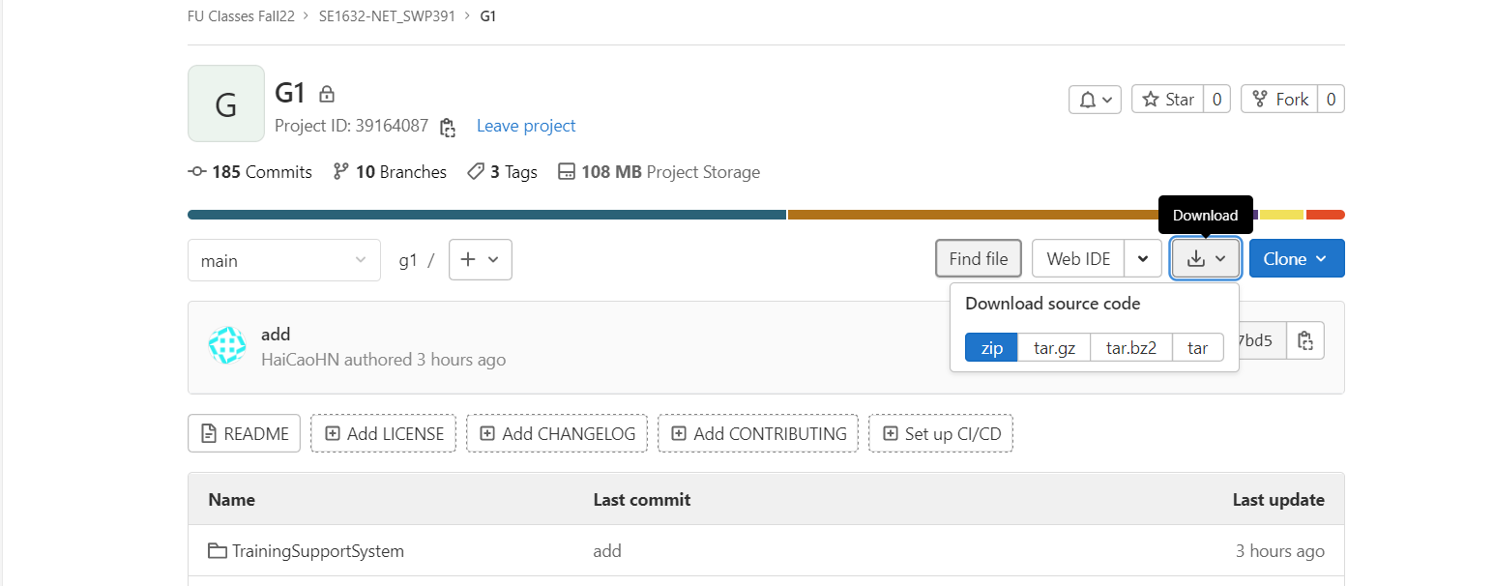

Step 2:get sql data in submit file and open mysql to import data

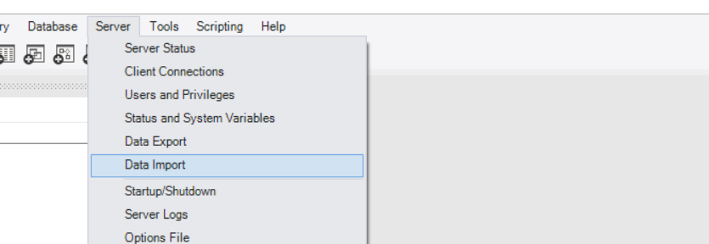

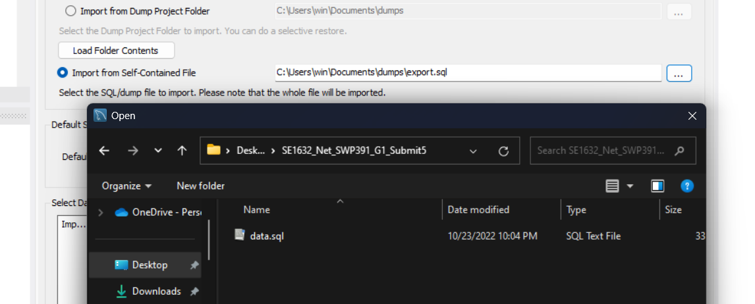

Step 3:Extract file code download already and open netbean 13 to run

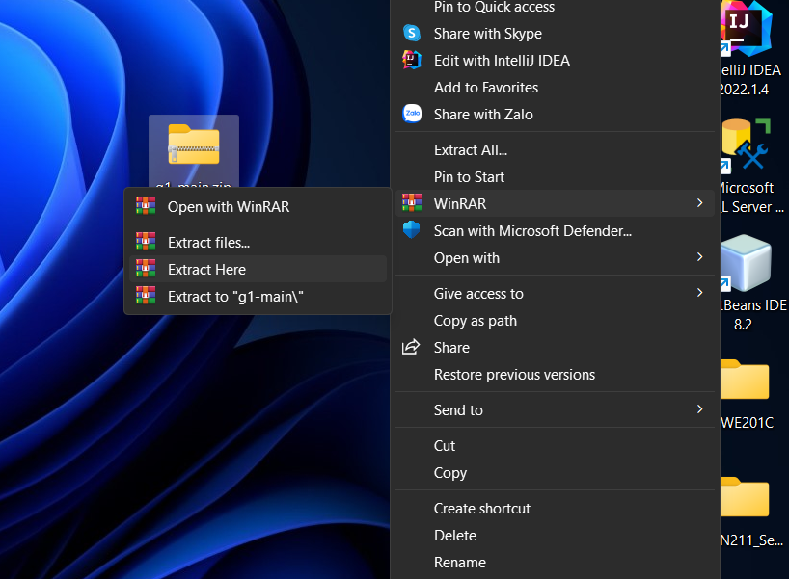

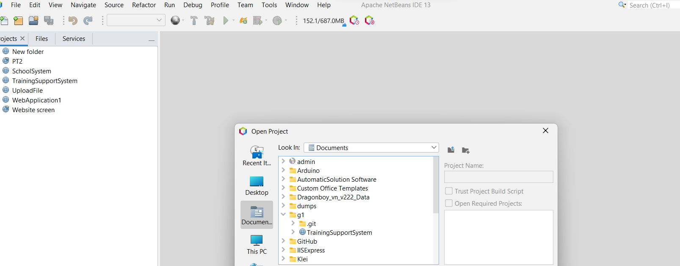

Step 4 Change user,password,url database from your local mysql

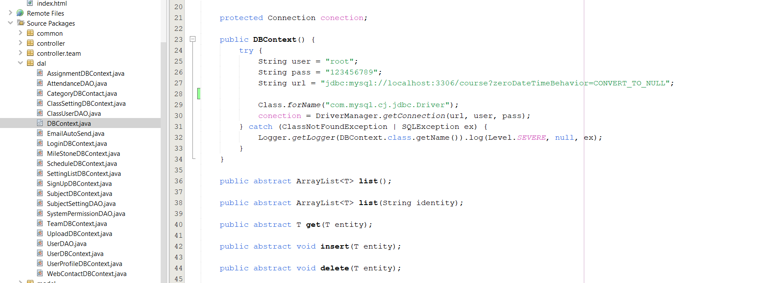

Step 5 Run project

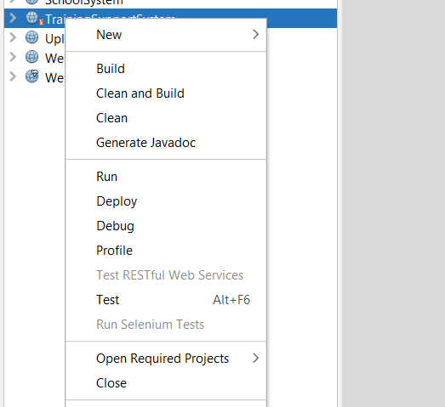

Step 6 Select * from user in db to choice role to login

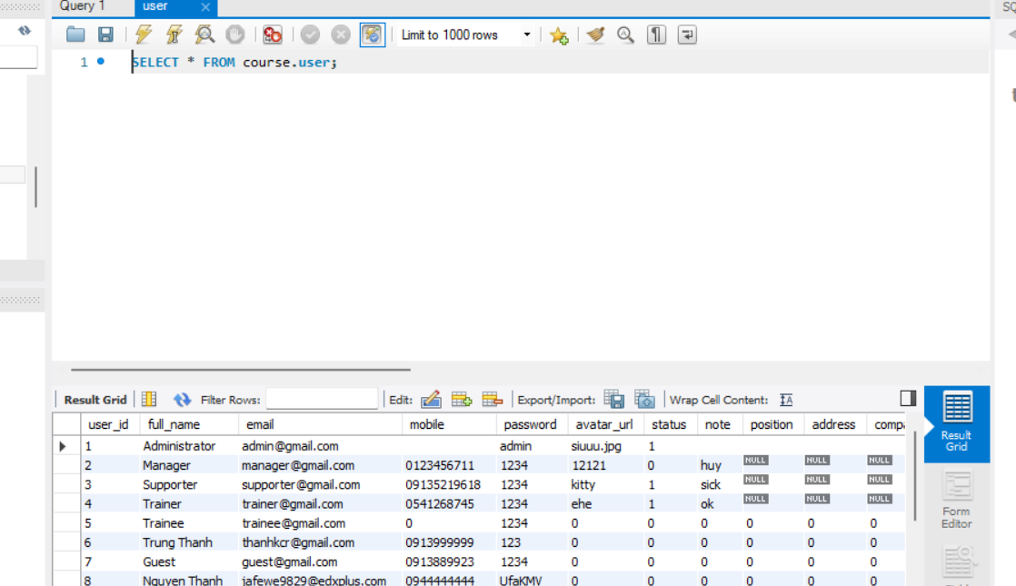

Step 7: Login with role you want

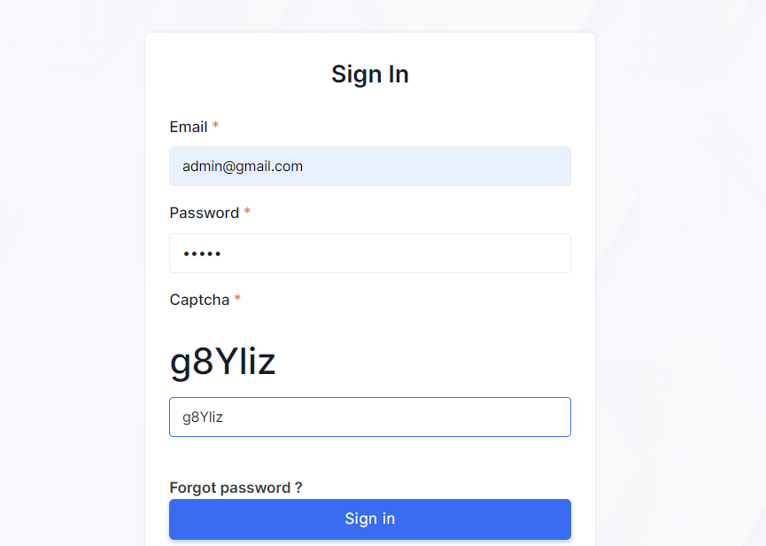

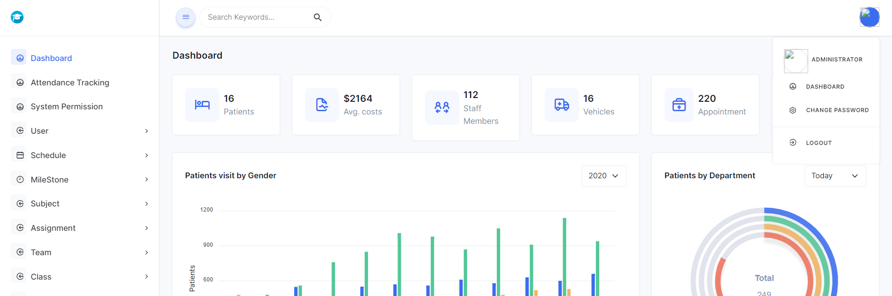

# **III. User Manual**

[In this part, you provide overall descriptions of the application, the briefs of the application’s workflows and the details guide of each workflow where the end user can use

## **1. Overview**

Our product provides services and supplies courses for purchasers and learning.

## **2. Admin**

Admin can manage user, settings, subjects and change permissions for each roles

**Subject:**

* Admin can view list of all subject by click on “Subject List” in dashboard

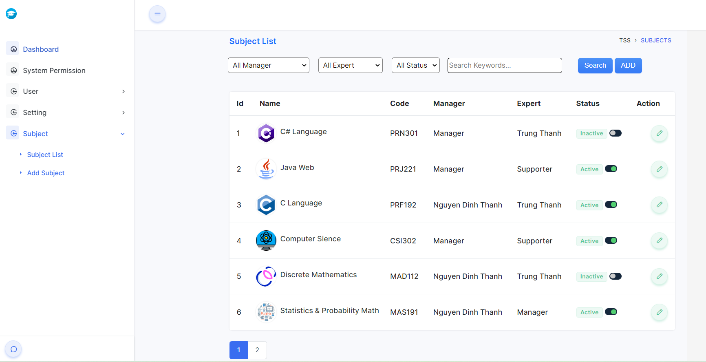

* Admin can click switch button to activate/deactivate subject
* Admin can filter and input search keyword to search subject
* By clicking on button in action column, admin can go to Subject Detail page and edit Subject details

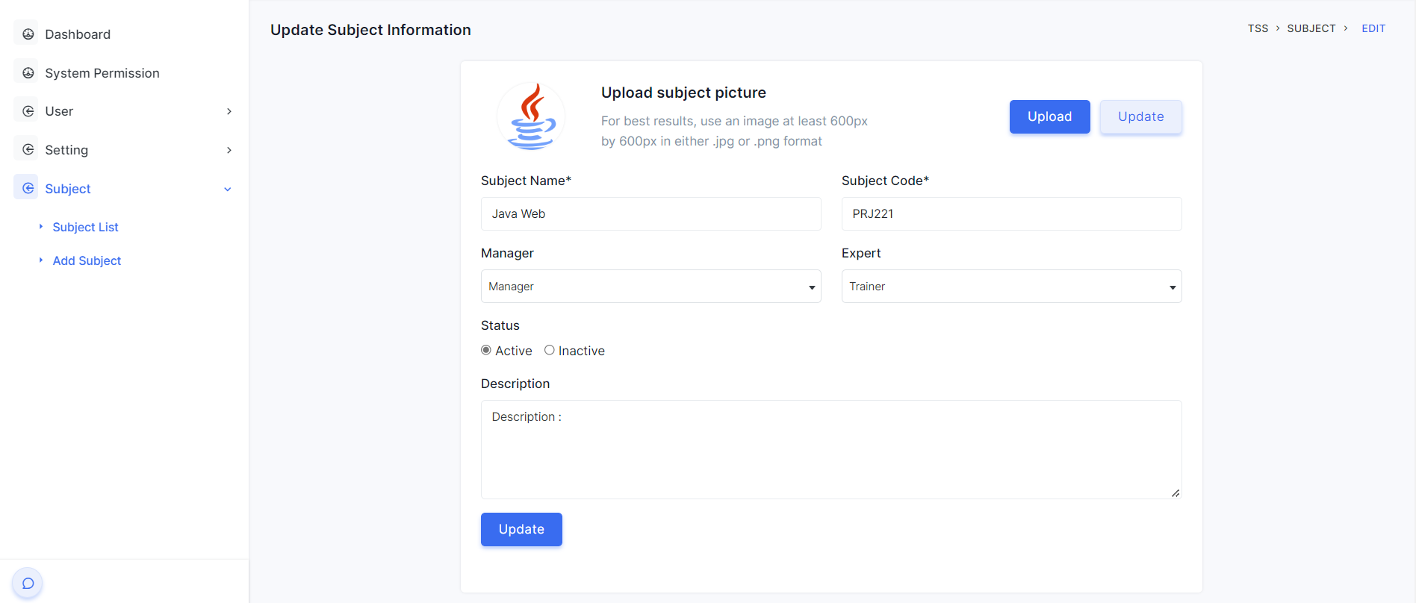

* User can upload image, change subject name, subject code, manager, expert, status and description of subject
* By clicking on “ADD” button or Add Subject in nav bar, admin can go to Add Subject page and add new Subject

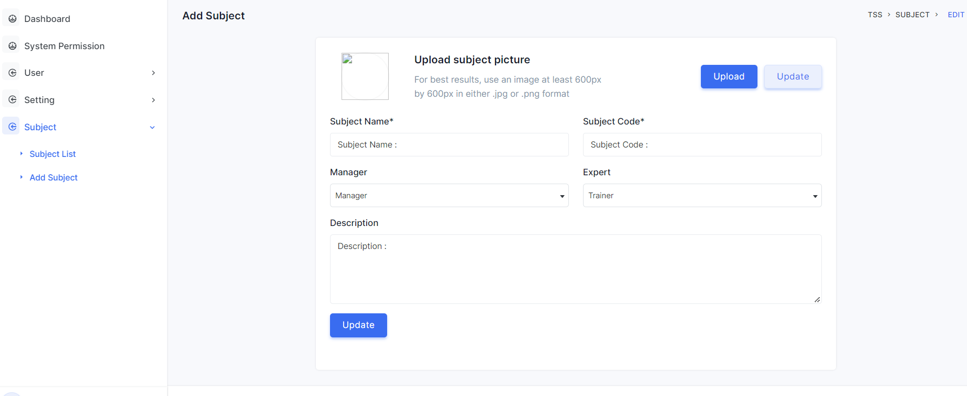

* Admin can add new subject here. Input Subject Code must be not duplicate with other subject existed

**System Permission**

* By clicking on button in action column, admin can go to System Permission page and edit Permission details

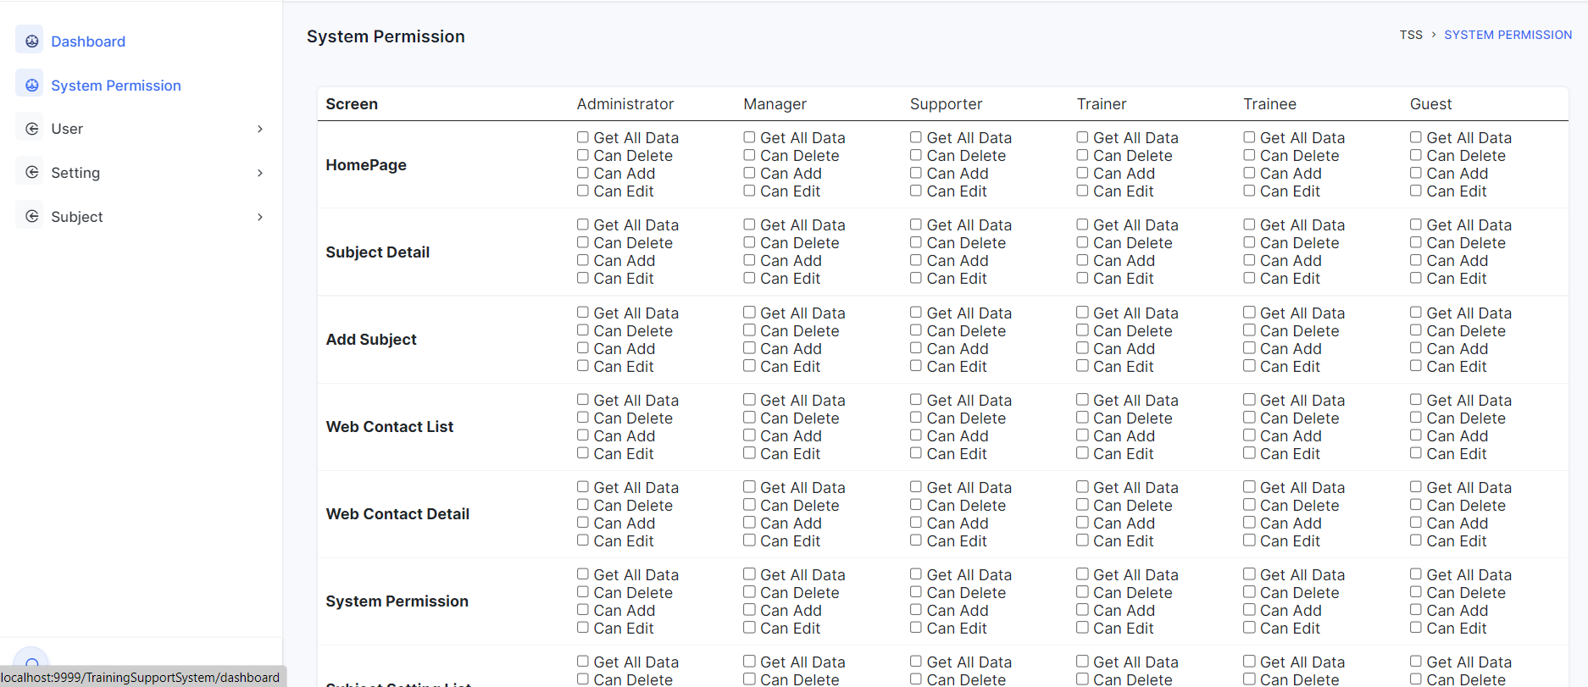

* Admin can edit Permission for each role and screen and press Save button to save all change to system

**User:**

* Admin can view list of all users by click on “User List” in dashboard

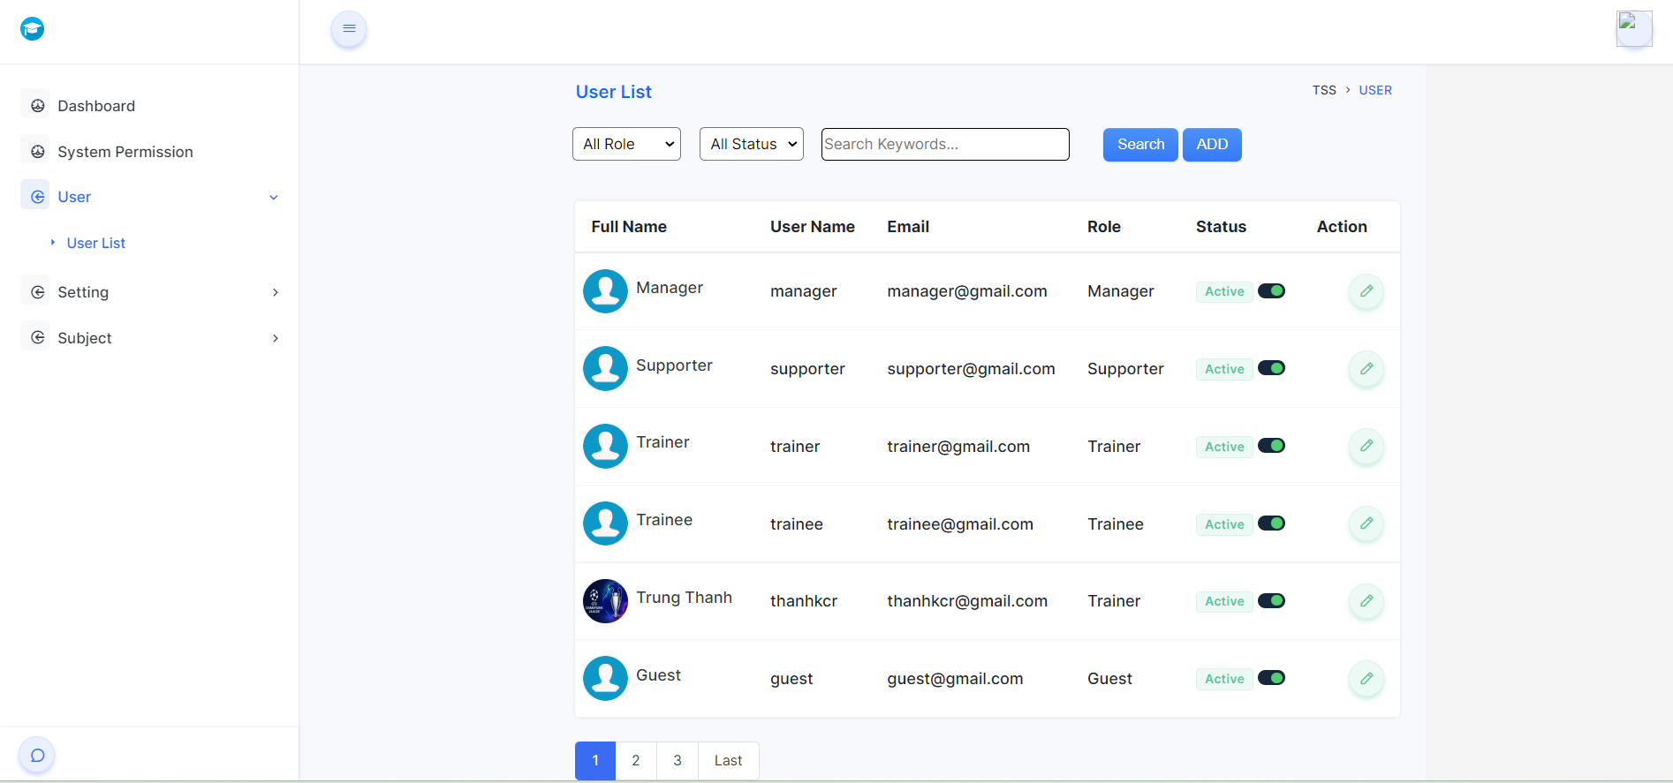

* Admin can click switch button to activate/deactivate user
* Admin can filter and input search keyword to search user

**Setting:**

Admin can view all setting by click on “Setting” in dashboard

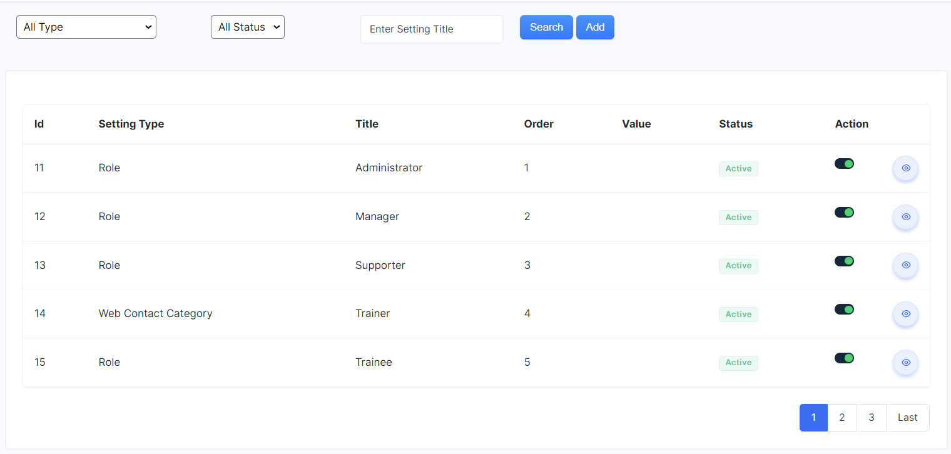

In this page,he/she can change the status of each assignment by clicking on the switch,they can filter settings by Type and Status and they can search titles on the search bar.

beside ,they can add a new setting by click button add or edit each setting by click on icon edit in this page:

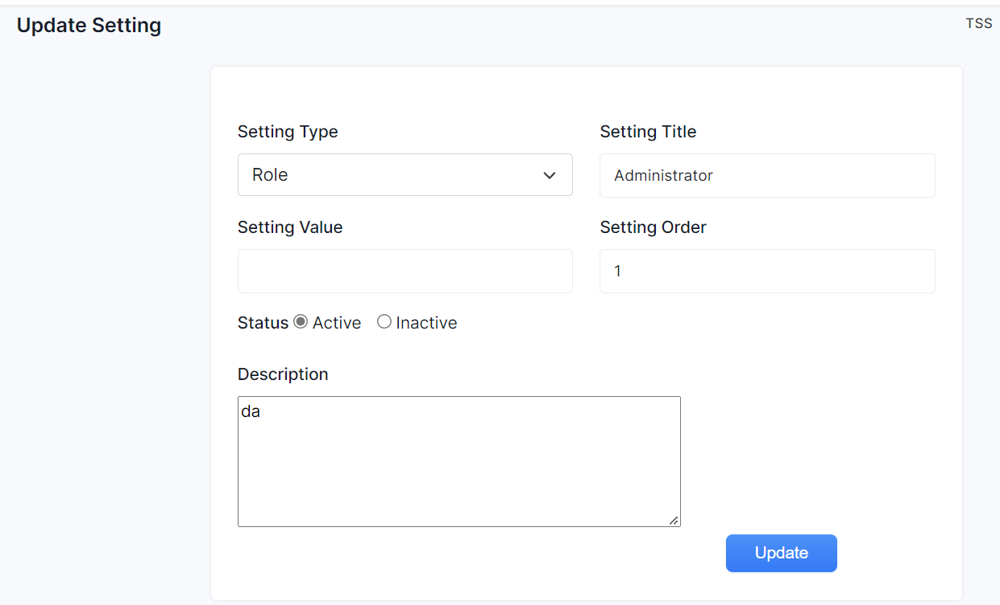

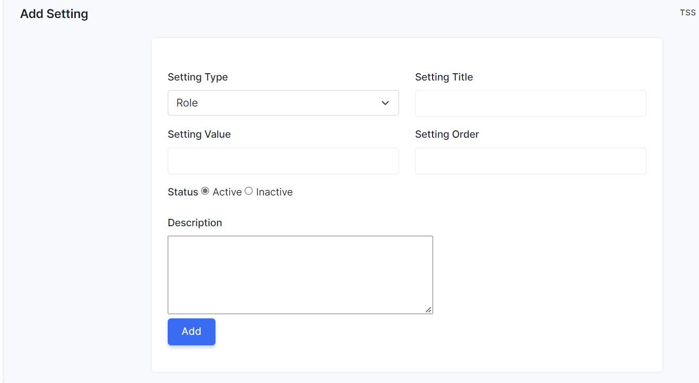

They can add/edit assignment when they input new property to this box and when they click on button,this page will reload to list setting

## **3. Manager**

Manager can manage assignment, class, eval criteria and subject setting

**Assignment:**

Manager can view all assignments by click on “Assignment List ” in dashboard

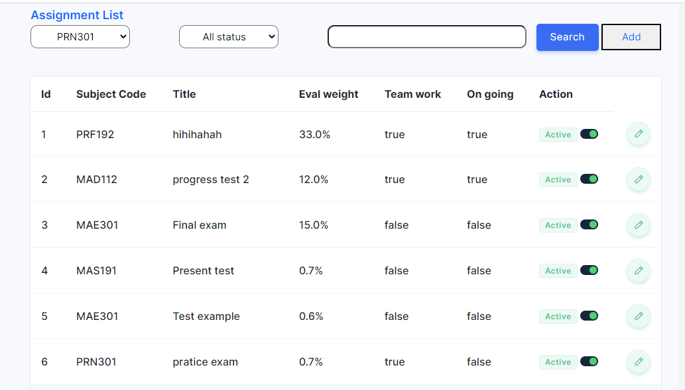

In this page,he/she can change the status of each assignment by clicking on the switch,they can filter assignment by subject and status and they can search the title of assignment on the search bar.

beside ,they can add a new assignment by click button add or edit each assignment by click on icon edit in this page:

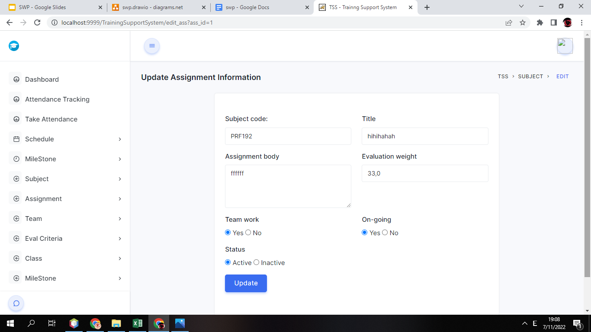

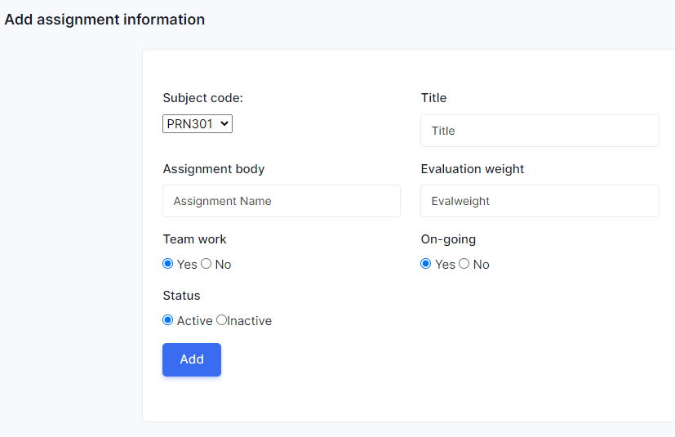

They can add/edit assignment when they input new property to this box and when they click on button,this page will reload to list assignment

**Eval Criteria**

Manager can view all eval criteria list:

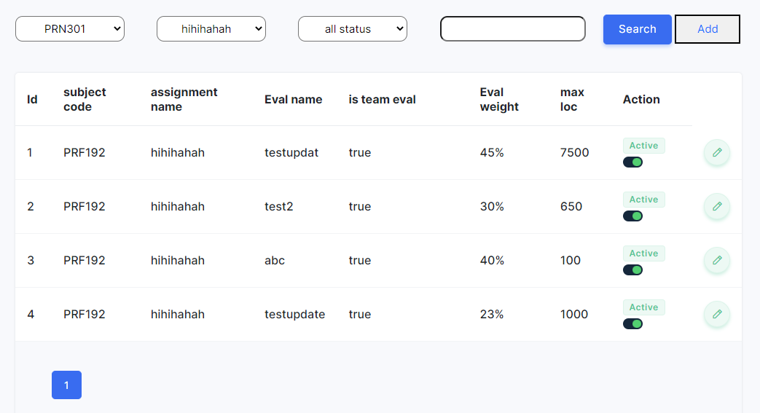

In this page, he/she can change the status of each eval by clicking on the switch,they can filter eval by subject , assignment and status and they can search eval name of the eval criteria on the search bar.

Beside ,they can add a new eval criteria by click button add or edit each eval criteria by click on icon edit in this page:

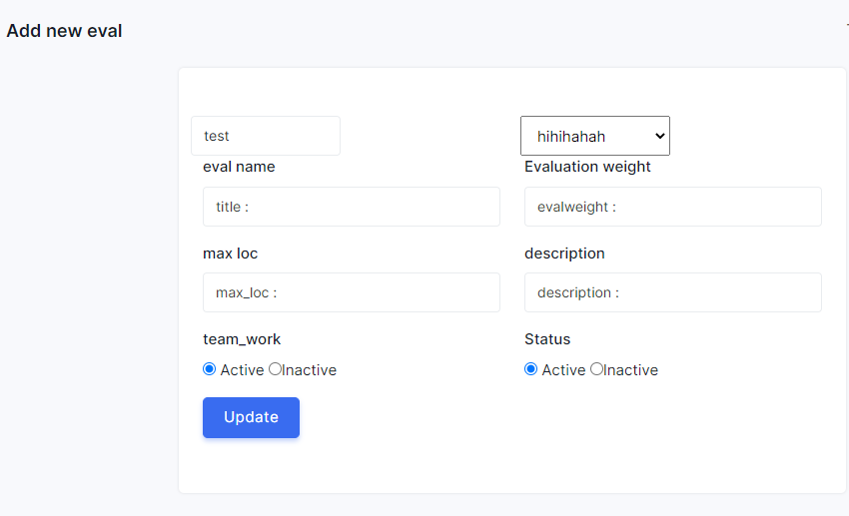

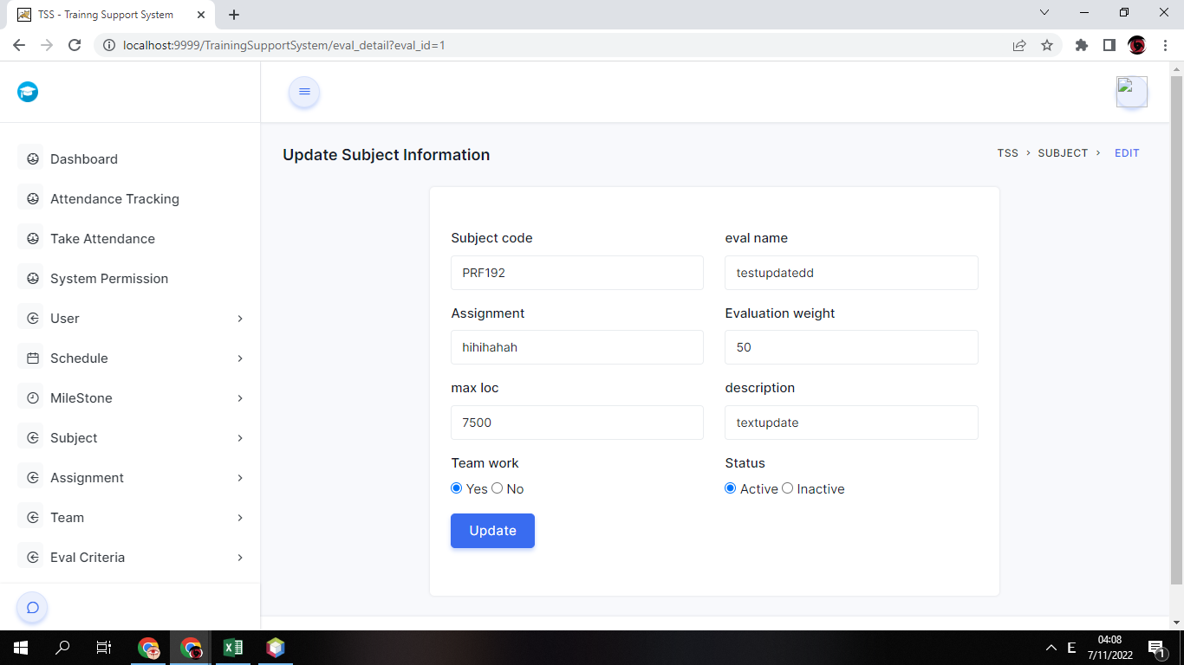

They can add/edit eval criteria when they input new property to this box and when they click on button,this page will reload to list eval criteria

**Subject Setting**

* Admin can view list of all subject setting by click on “Subject Setting List” in dashboard

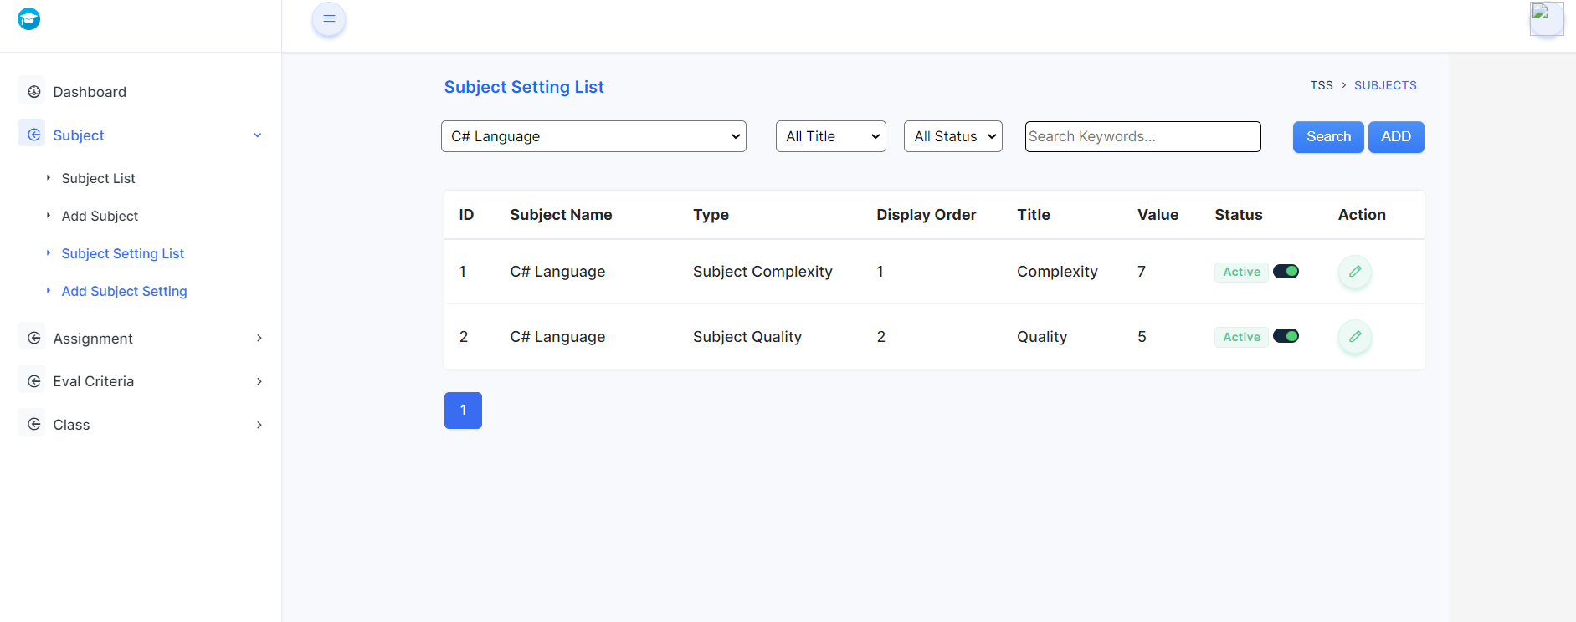

* Admin can click switch button to activate/deactivate subject setting
* Admin can filter and input search keyword to search subject setting
* By clicking on button in action column, admin can go to Subject Setting Detail page and edit Subject Setting details

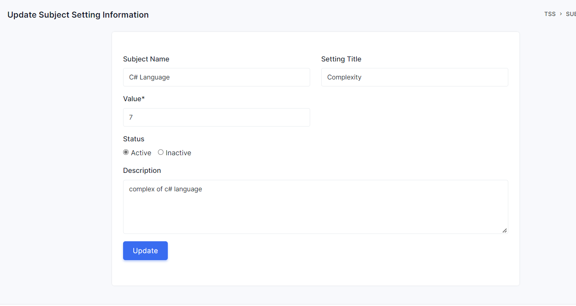

* User can change value, status and description of subject setting
* By clicking on “ADD” button or Add Subject in nav bar, admin can go to Add Subject Setting page and add new Subject Setting

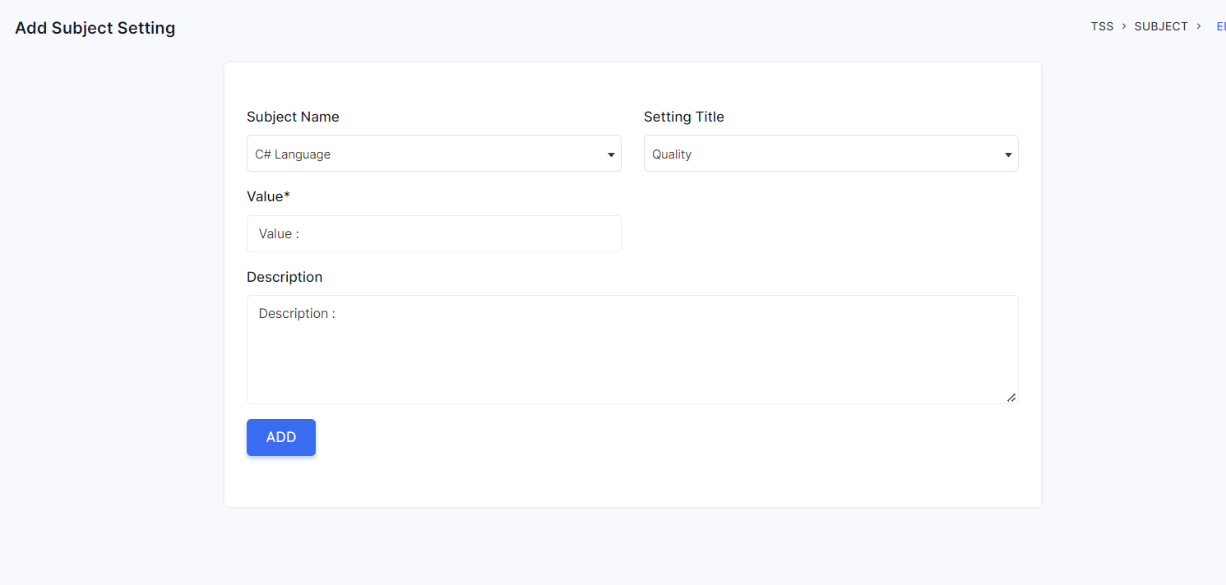

* Admin can add new subject here. Input Subject Name and Title must be not duplicate with other subject setting existed

**Class:**

Manager can view all class by click on “Class List ” in dashboard

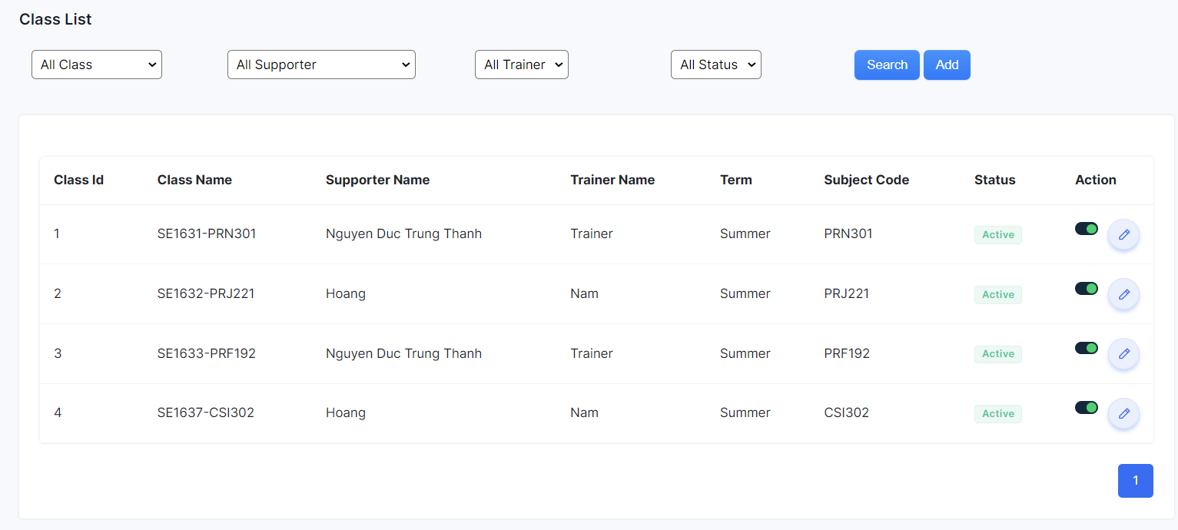

In this page,he/she can change the status of each class by clicking on the switch,they can filter class by class name ,supporter ,trainer and status .beside ,they can add a new class by click button add or edit each class by click on icon edit in this page:

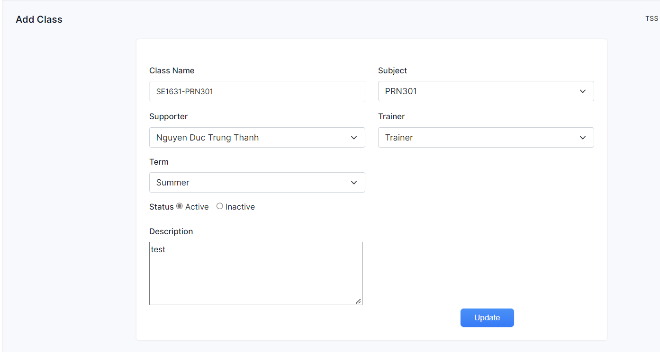

## **4. Supporter**

**Trainee**

Supporter can view all trainee by click on “Trainee List ” in dashboard:

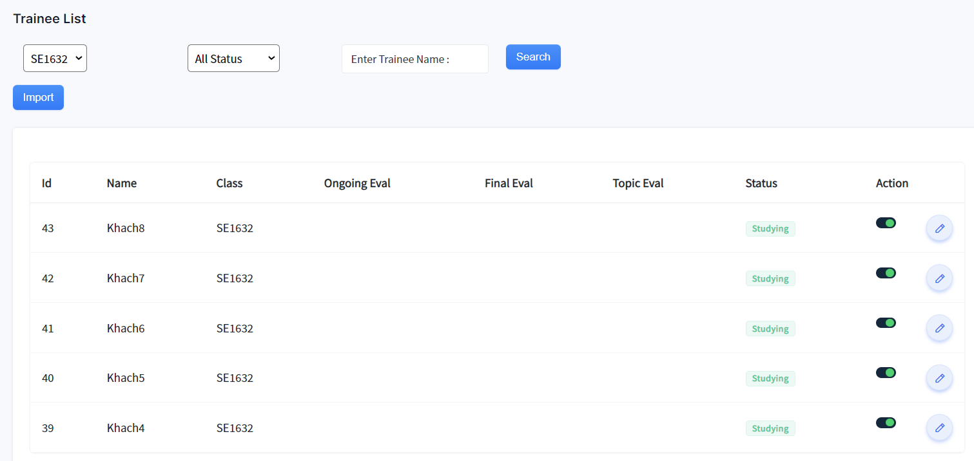

In this page,he/she can change the status of each trainee in class by clicking on the switch,they can filter settings by Class and Status and they can search trainees on the search bar.

beside ,they can import a new trainee by click button edit each trainee by click on icon edit in this page:

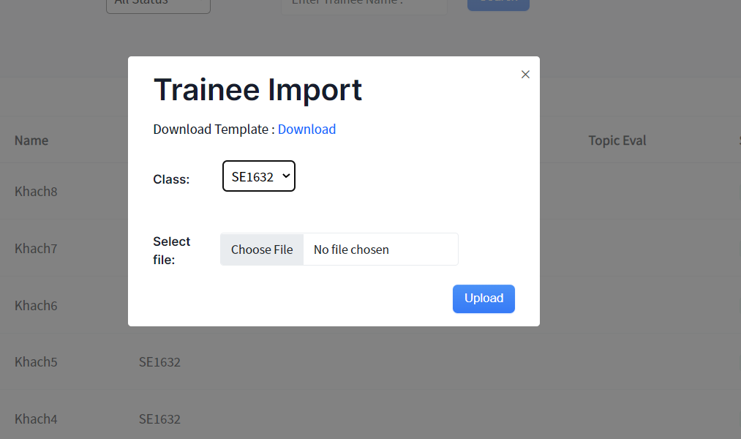

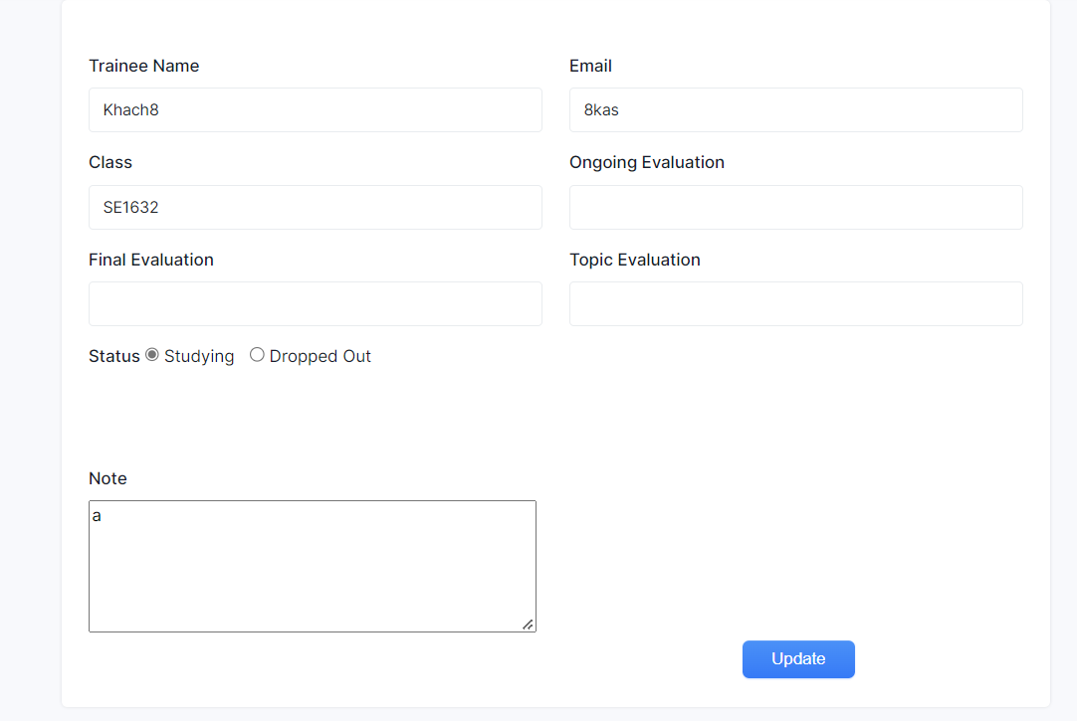

They can import/edit trainee in select class when they input new property to this box and when they click on button,this page will reload to list trainee

**Schedule:**

Supporter can view all milestone of his/her class by click on “Schedule List ” in dashboard:

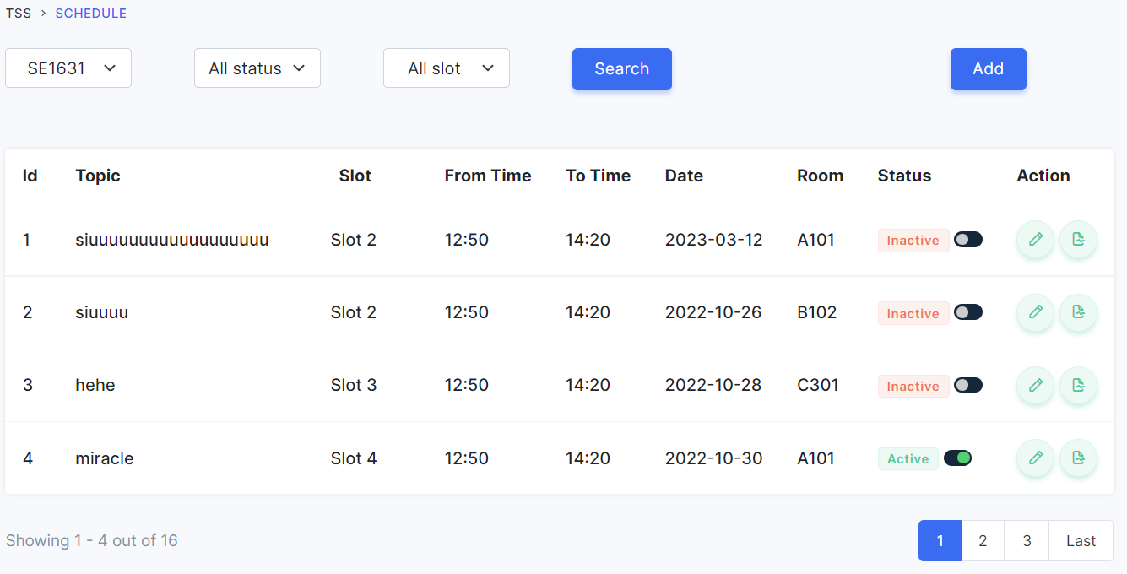

In this page,he/she can change the status of each schedule by clicking on the switch,they can filter milestone by class, status and they can search milestone name on the search bar.

beside ,they can add a new milestone by click button add or edit milestone by click on icon edit in this page:

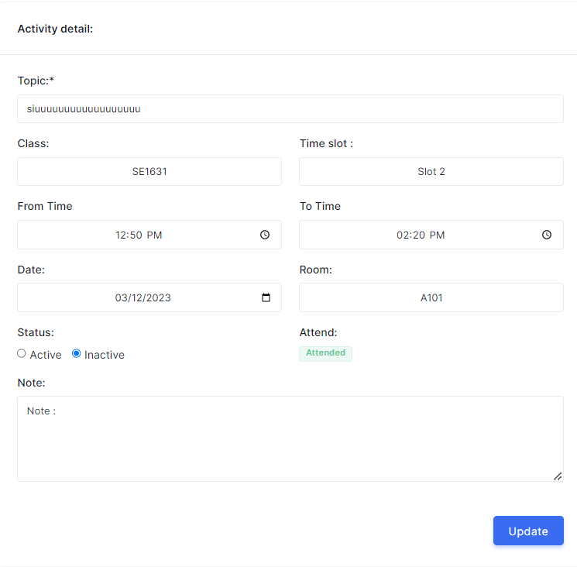

They can add/edit schedule when they input new property to this box and when they click on button,this page will reload to list schedules.

Note: The Trainer have similar permissions as the Supporter on this page

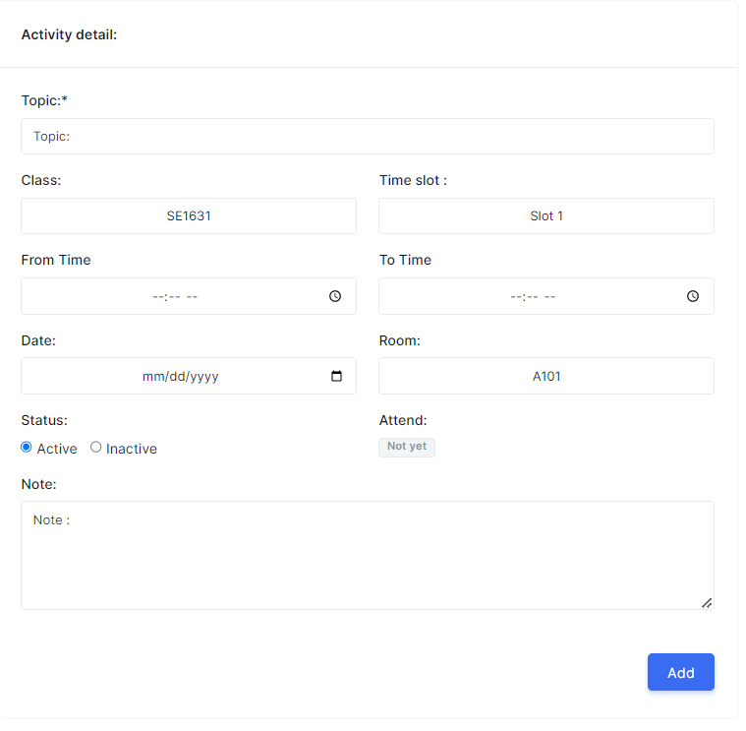

**Web Contact**

Supporter can view all contact by click on “WebContact List ” in dashboard:

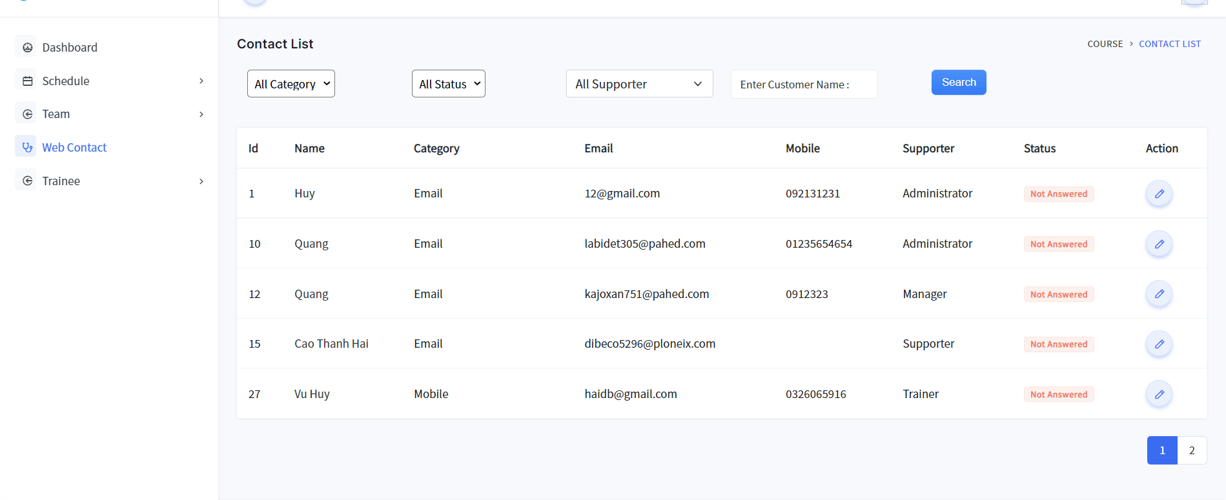

In this page,he/she can view all contact,.In this page they can edit each team by clicking on the icon edit of each contact ,filter contact by category,status and supporter.They also can search contact by of name of user send contact.

Screen when they edit contact:

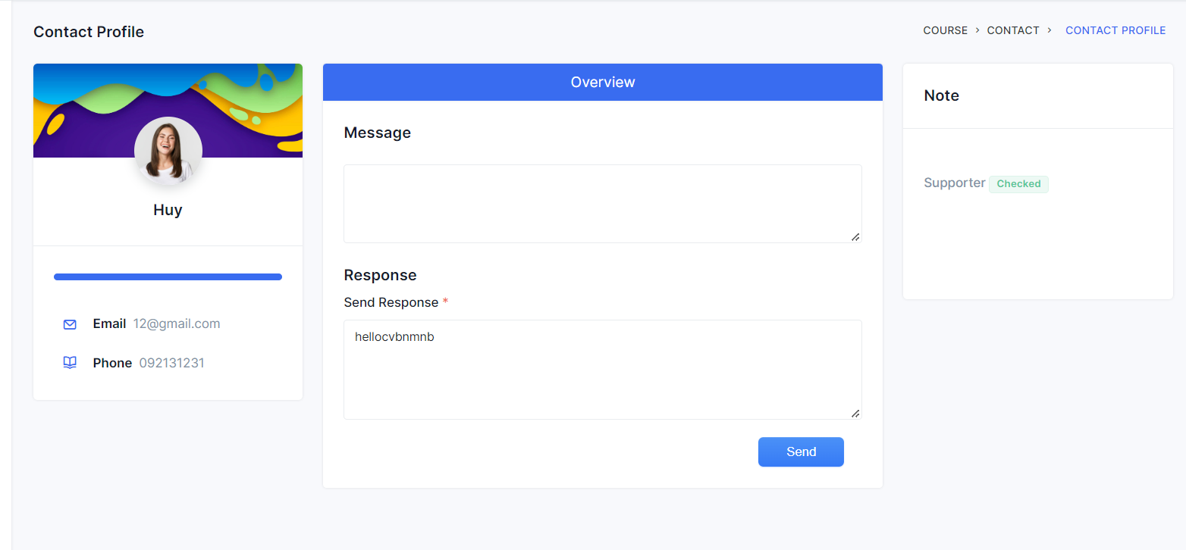

## **5. Trainer**

**Team List**

Manager can view all assignments by click on “Team List ” in dashboard:

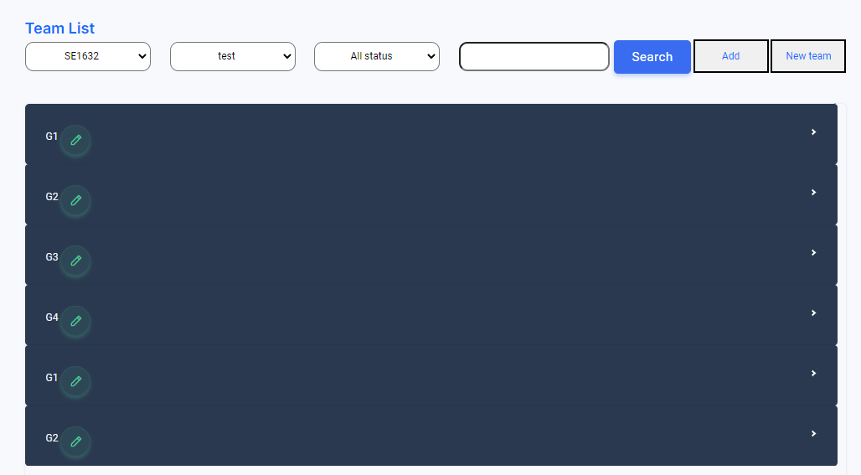

In this page,he/she can view all team of all class she/he teaching,they also view list member of team by click on dropdown.In this page they can edit each team by click on icon edit of each team,filter team by class,milestone and status.They also can search team by team_code of this team.

Screen when they add new team:

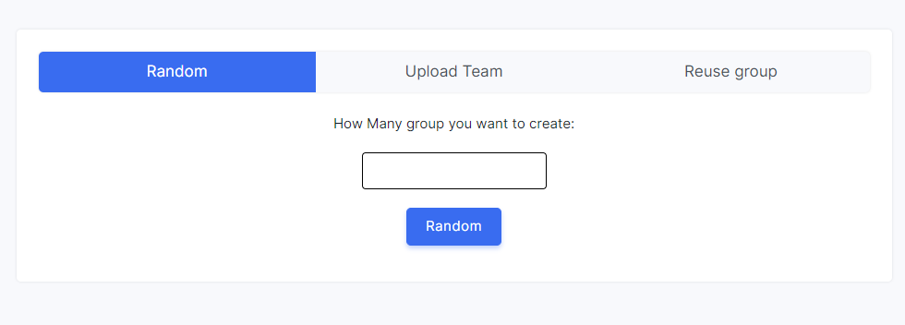

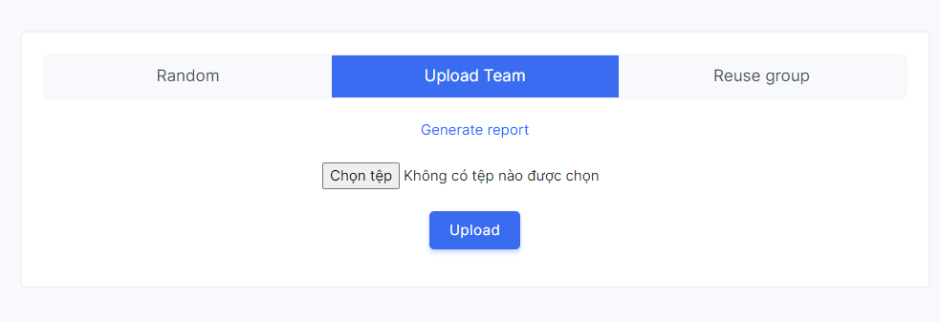

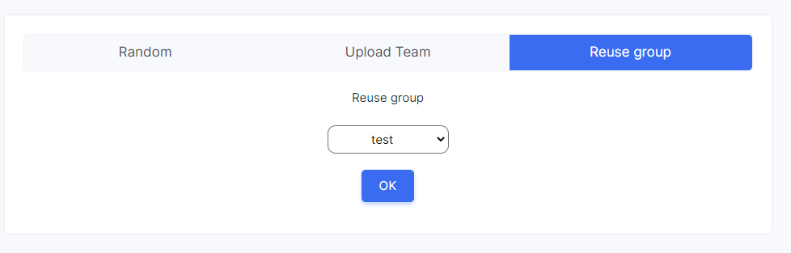

They also can edit and add each new team:

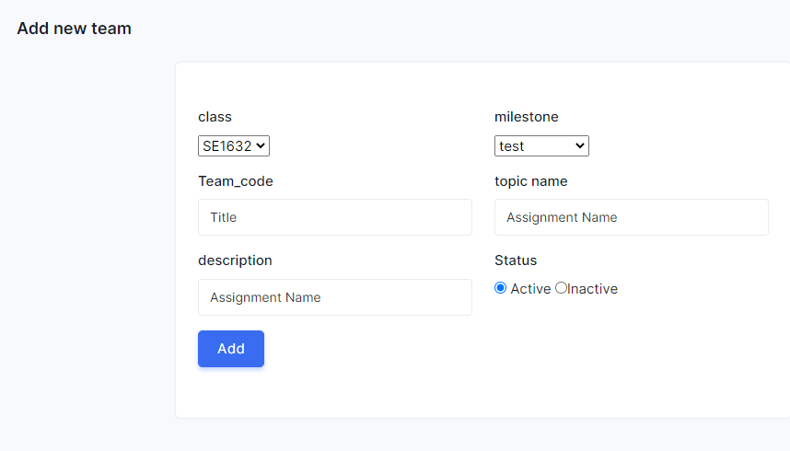

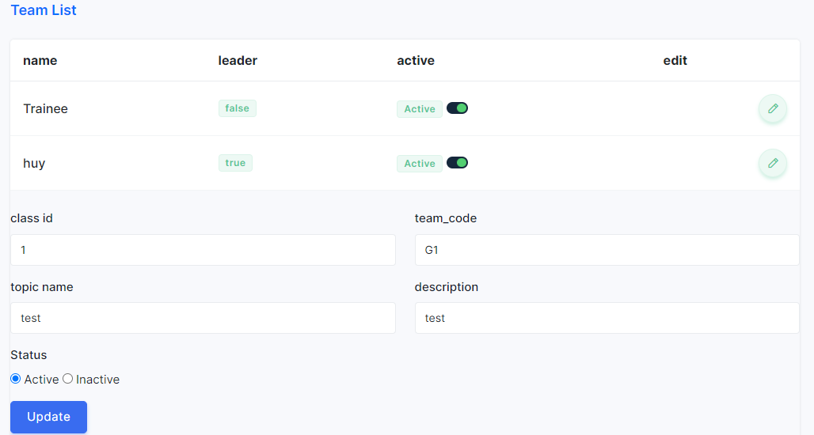

In screen edit and team list ,he/she can edit team Member:

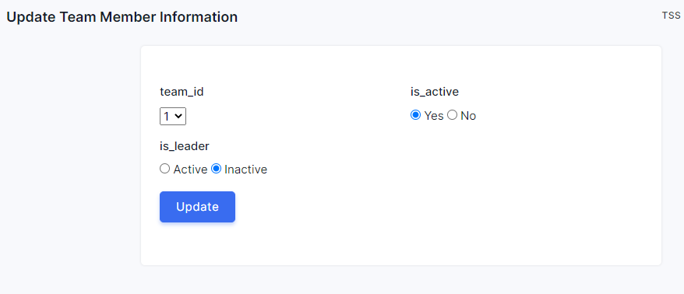

**Attendance Tracking**

* Trainer can click on Attendance Tracking on nav bar to tracking attendance of selected class

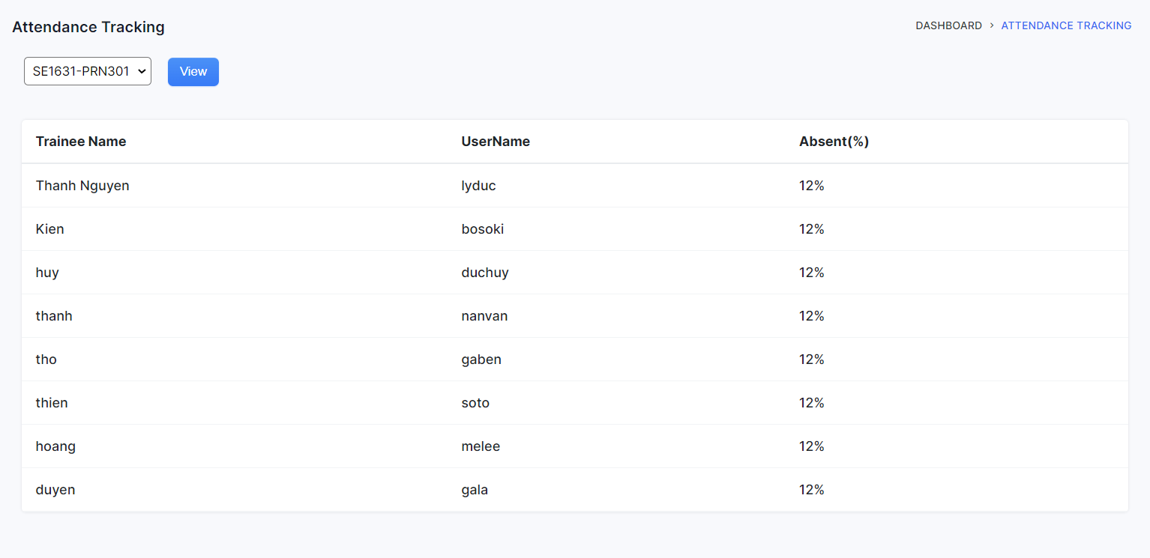

* Trainer can choose class to tracking and click on View button to tracking selected class attendance

**Take Attendance**

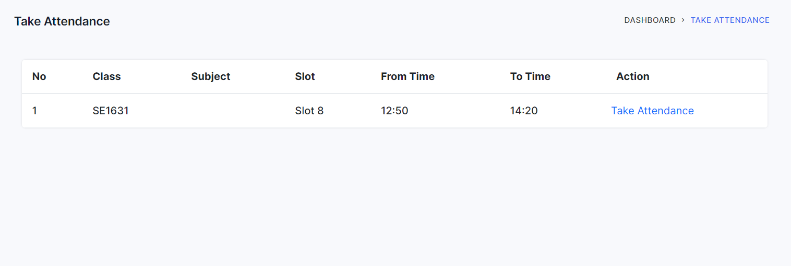

Trainer can click on Take Attendance and choose Class to take attendance

**Milestone**

Trainer can view all milestone of his/her class by click on “Milestone List ” in dashboard:

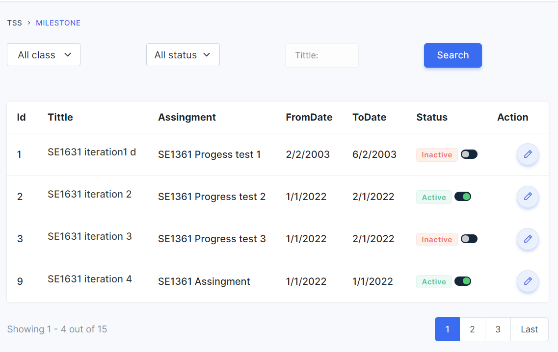

In this page,he/she can change the status of each milestone by clicking on the switch,they can filter milestone by class, status and they can search milestone name on the search bar.

beside ,they can add a new milestone by click button add or edit milestone by click on icon edit in this page:

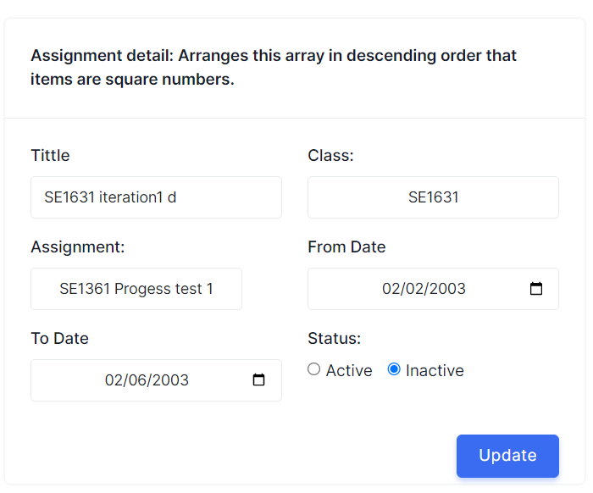

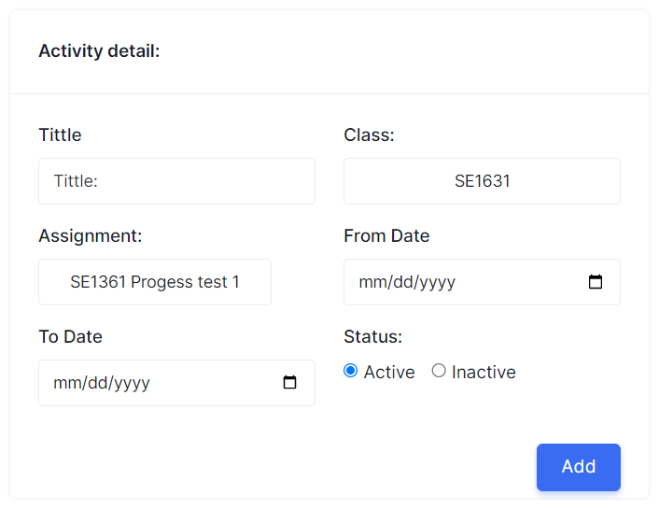

They can add/edit milestone when they input new property to this box and when they click on button,this page will reload to list milestone

**Trainer**

Trainer can view all class setting of his/her class by click on “Class Setting” in dashboard:

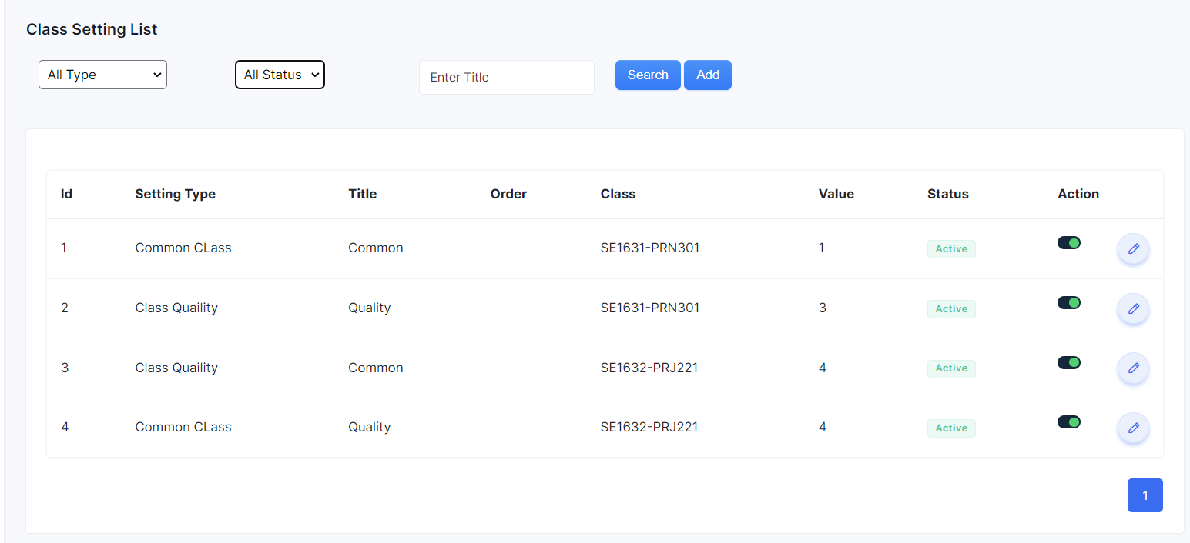

In this page,he/she can change the status of each class by clicking on the switch,they can filter class setting by type, status and they can search title on the search bar.

beside ,they can add a new class setting by click button add or edit class setting by click on icon edit in this page:

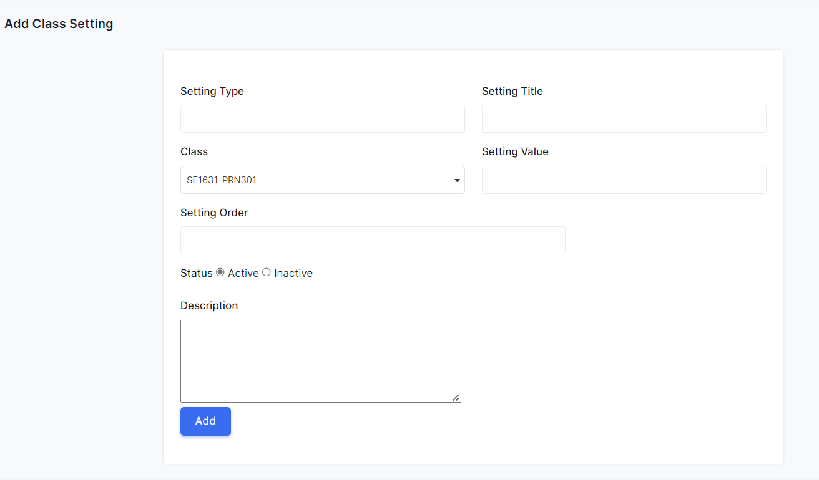

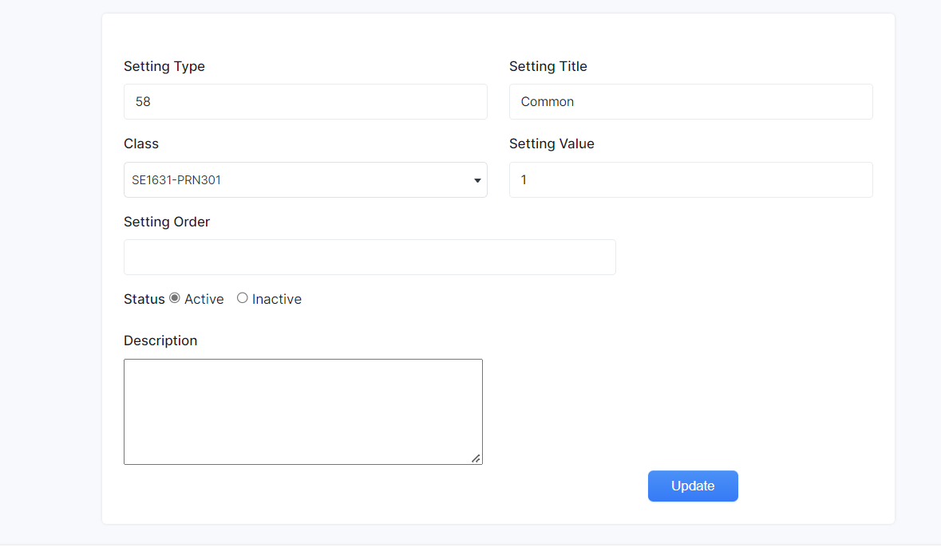

They can add/edit class setting when they input new property to this box and when they click on button,this page will reload to list class setting