演算法 12/30 課堂作業 圖的儲存結構

數位三 S10755044 鄭于萱

1. 相鄰矩陣

|  |  |  |  |  |  |
| --- | --- | --- | --- | --- | --- |
| \ | A | B | C | D | E |
| A | 0 | 1 | 0 | 1 | 0 |
| B | 1 | 0 | 1 | 1 | 0 |
| C | 0 | 1 | 0 | 0 | 1 |
| D | 1 | 1 | 0 | 0 | 1 |
| E | 0 | 0 | 1 | 1 | 0 |

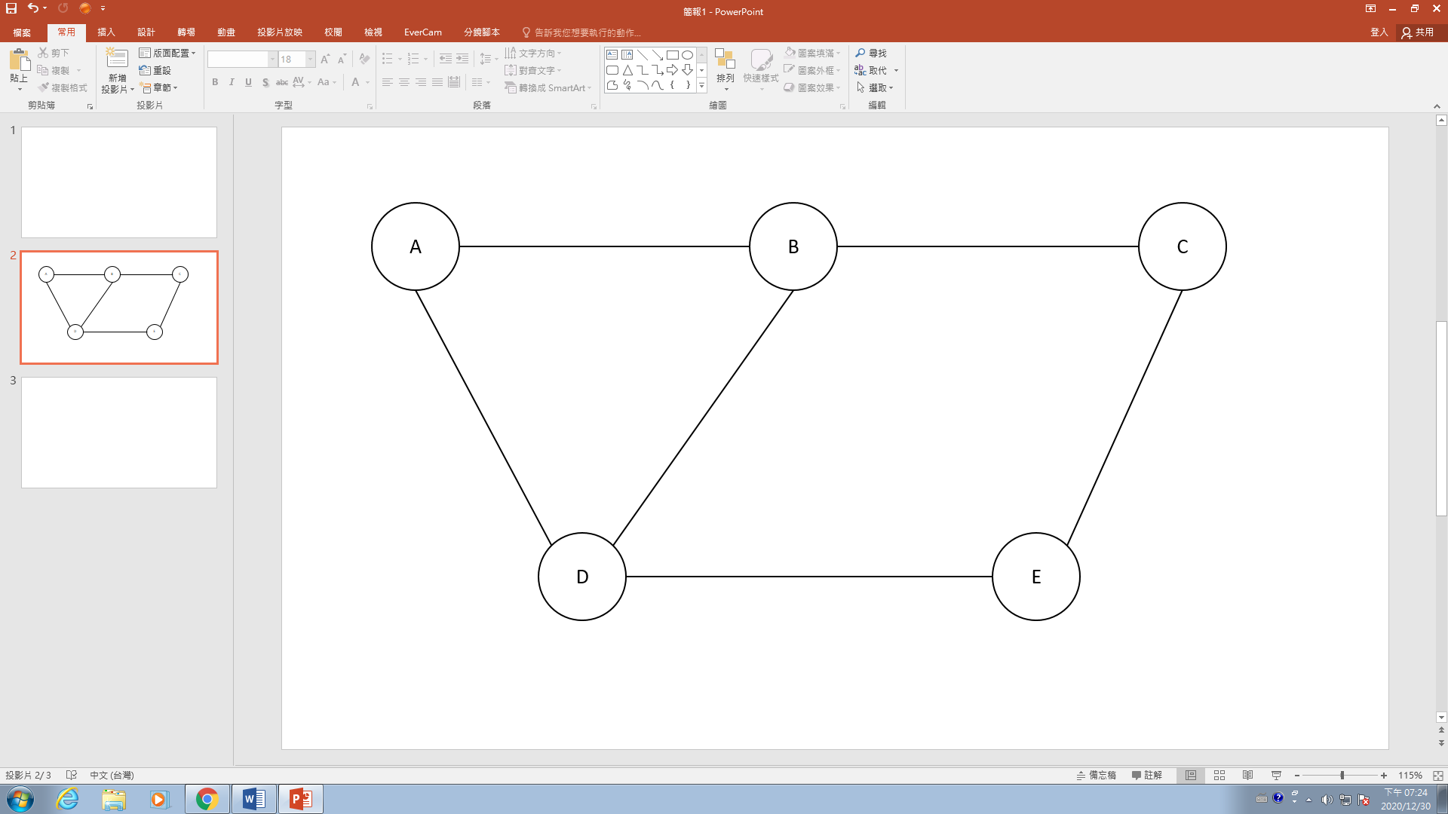

2.

相鄰矩陣

|  |  |  |  |  |  |
| --- | --- | --- | --- | --- | --- |
| \ | A | B | C | D | E |
| A | 0 | 1 | 0 | 0 | 0 |
| B | 0 | 0 | 1 | 1 | 0 |
| C | 0 | 0 | 0 | 0 | 1 |
| D | 1 | 0 | 0 | 0 | 0 |
| E | 0 | 0 | 0 | 1 | 0 |

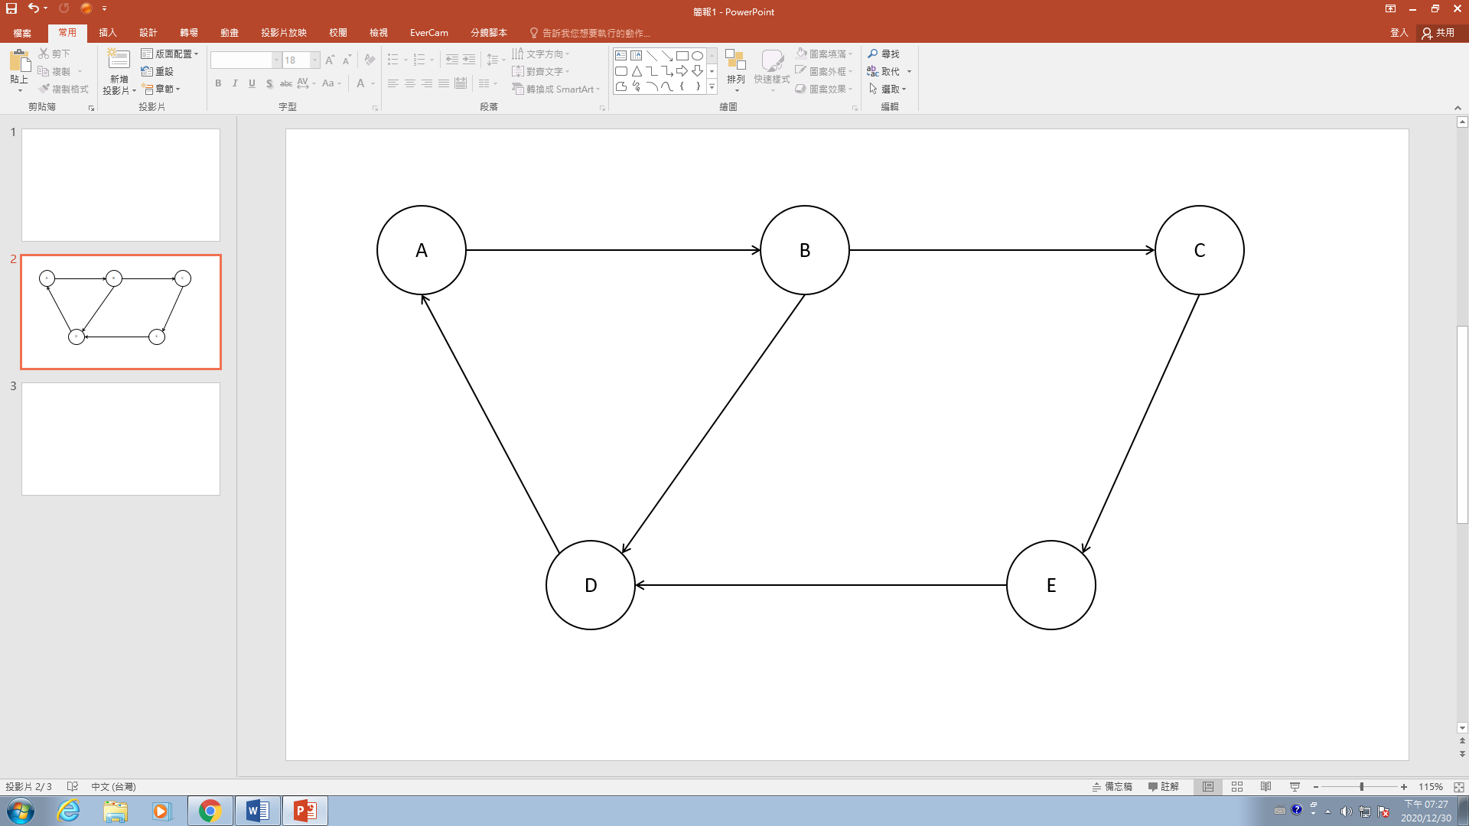

A：Outdegree-1、Indegree-1

B：Outdegree-2、Indegree-1

C：Outdegree-1、Indegree-1

D：Outdegree-1、Indegree-2

E：Outdegree-1、Indegree-1

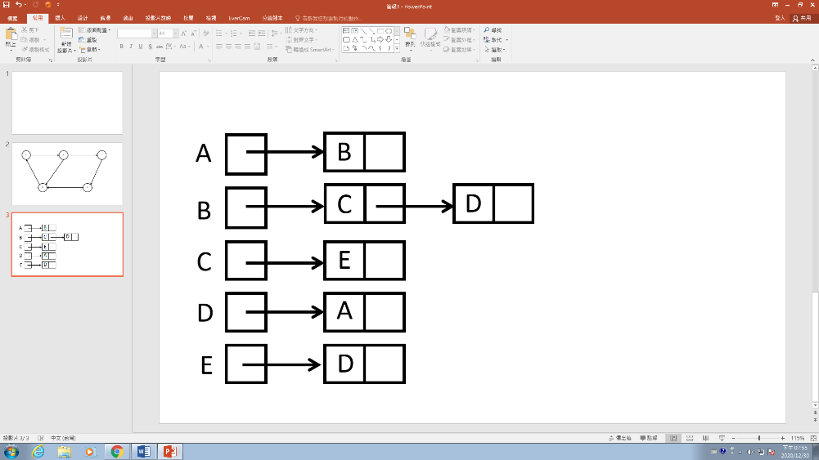

←相鄰串列