Assign#2

Yu-Hsuan Huang - 200443723

**PART 1**

1 c) In the video, we can see that PC0 window which can configure the DHCP or static IP, and IP address, Subnet Mask, Default Gateway, and DNS Server in the IP Configuration.

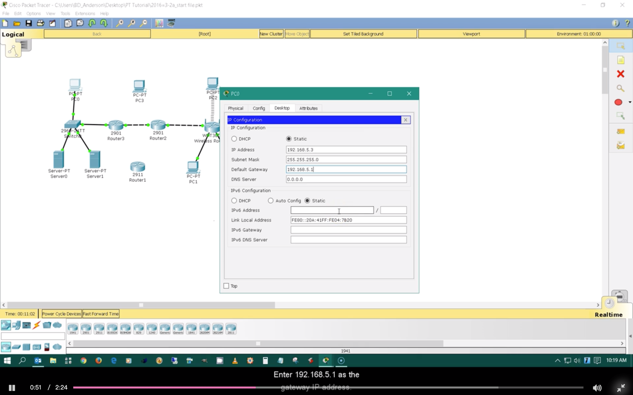

2 f)

## In Layers, ## Out Layers: One in layer and one out layer have information

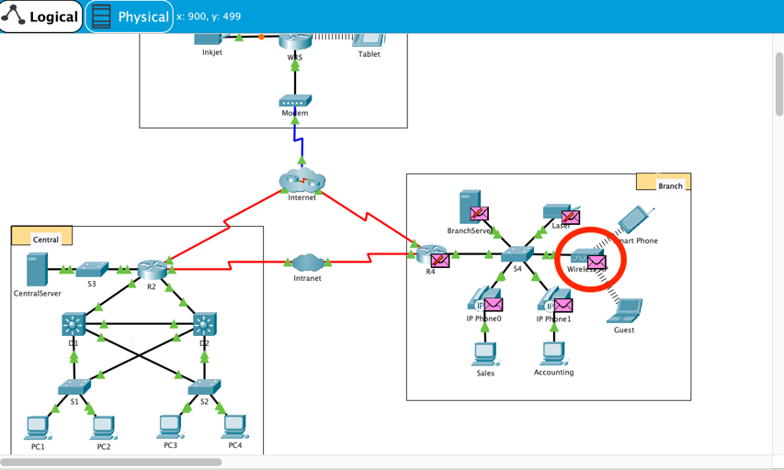 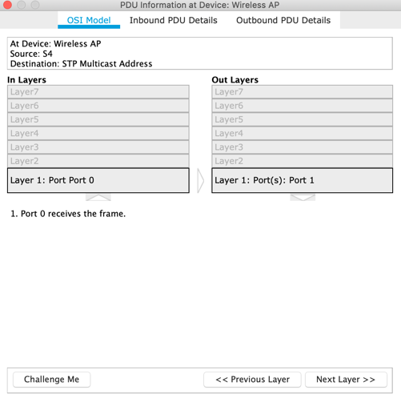

Inbound/Outbound PDU:

Inbound PDU : Ethernet 802.3, LLC, STP BPDU

Outbound PDU : 802.11 Wireless, LLC, STP BPDU

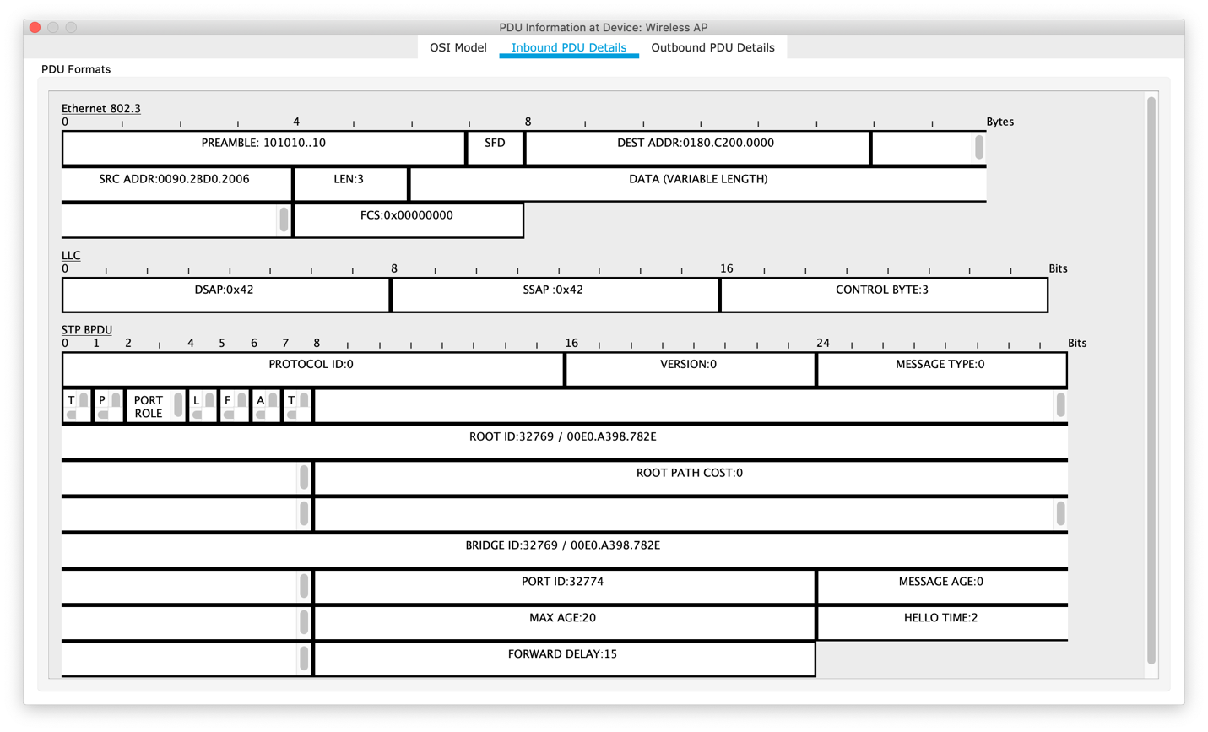

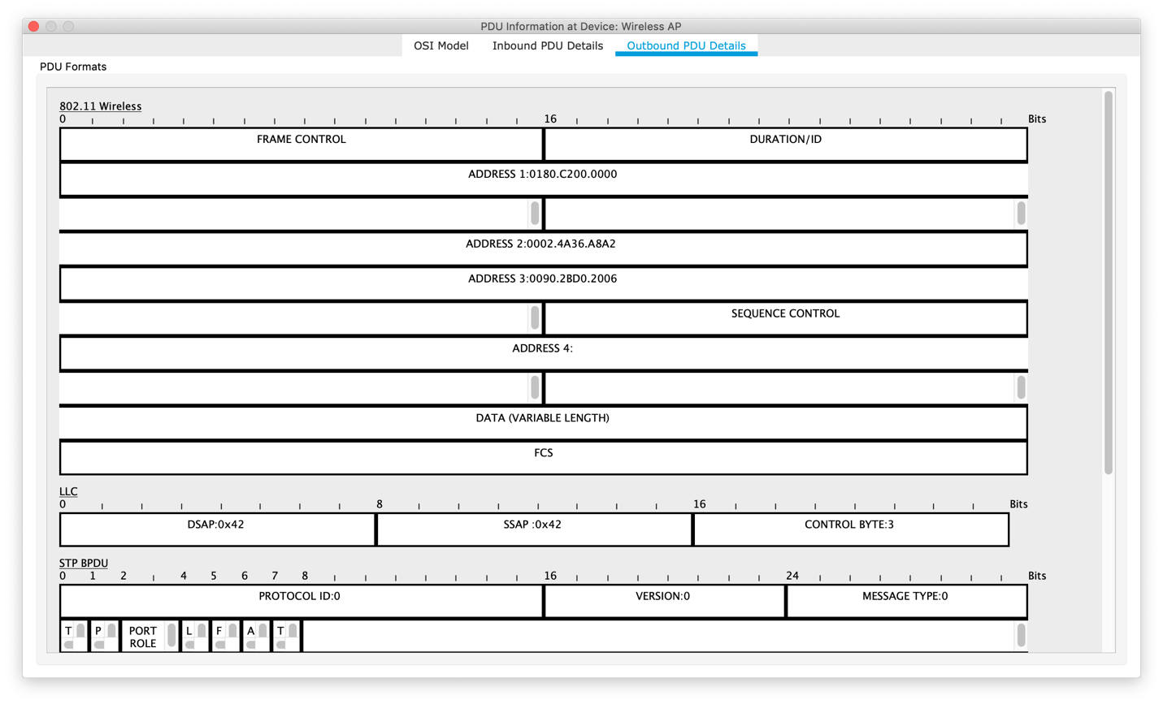

Changing: Yes, I find the different between Inbound PDU details and Outbound PDU details, because this “Wireless AP” use the Ethernet to get the information from the switch and use the Wireless to send the information to the smart phone or laptop.

**PART 2**

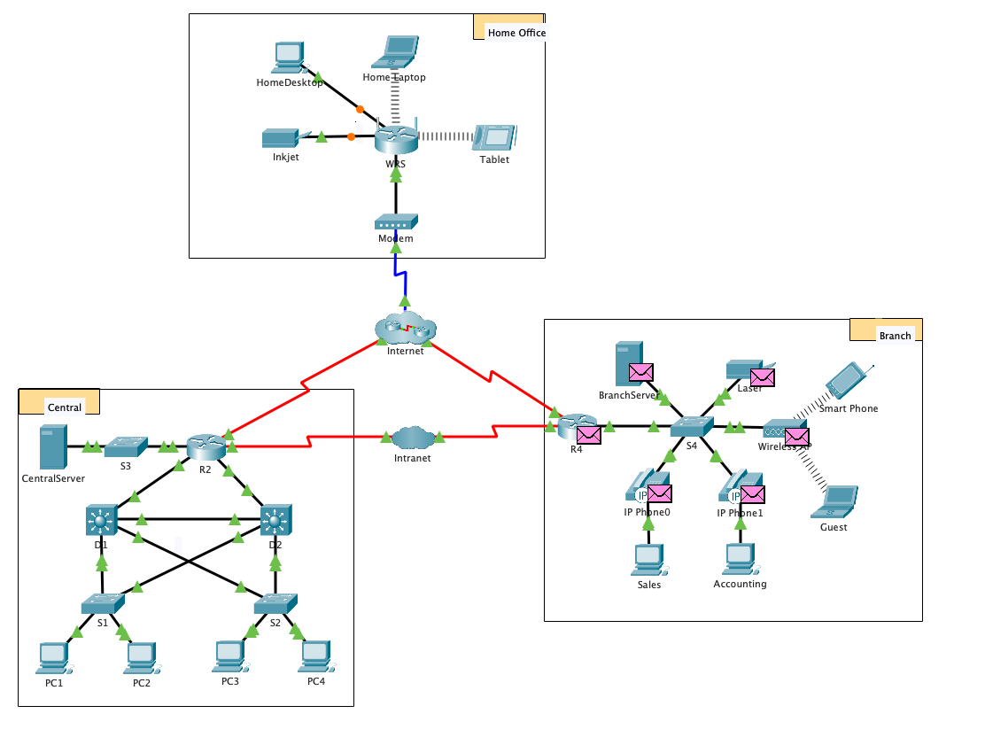

1 b) Router, Switch, Multilayer Switch, Modem, Wireless Device

1 c) 15 (5 in the central, 4 in the home office, 6 in the Branch)

1 d) 11 (6 in the central, 2 in the home office, 3 in the Branch)

1 e) 3 (each have 1: “R2” in the Central, “WRS” in the home office, “R4” in Branch)

1 f) 8 (1 in the central, 3 in the home office, 4 in the Branch)

1 g) 3 (Wireless, LAN, WAN: how different between blue and red? )

1 h) Wireless is not physical set up by network technician. Instead, your end device responsible for negotiating to connect the wireless device.

3 b) 5 (2 from the central, 1 from the home office, 2 from the Branch)

3 c) 24 (13 in the central, 3 in the home office, 8 in the Branch)

**Challenge**

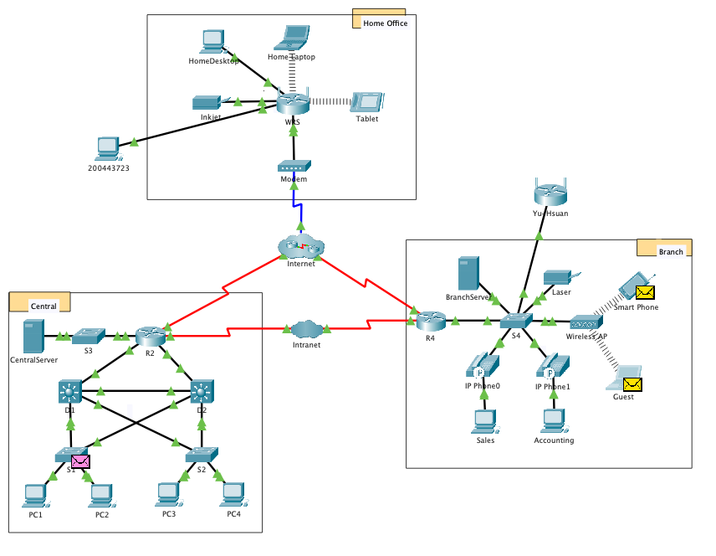

What else does this device need to send data to other end users? Can you provide the information?

In the simulation mode, we can’t see any envelope from this end device.

Is there a way to verify that you correctly connected the device?

In the simulation mode, we can see a envelop from WRS to this end device.

What else does this device need to serve as an intermediary to other devices in the network?

This device will not need serve other device in this situation. When end devices connect to this device. It will be an intermediary device to serve the end devices.