Lab – Designing and Implementing a VLSM Addressing Scheme

1. Topology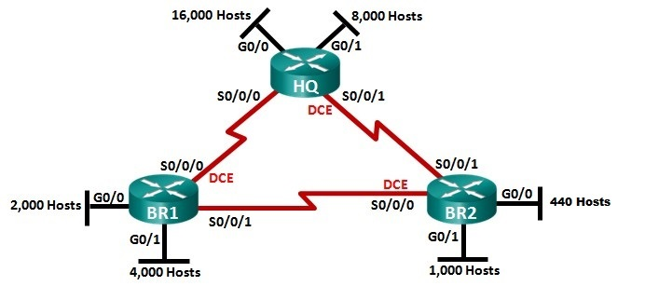
2. Objectives

Part 1: Examine Network Requirements

Part 2: Design the VLSM Address Scheme

1. Background / Scenario

Variable Length Subnet Mask (VLSM) was designed to avoid wasting IP addresses. With VLSM, a network is subnetted and then re-subnetted. This process can be repeated multiple times to create subnets of various sizes based on the number of hosts required in each subnet. Effective use of VLSM requires address planning.

In this lab, use the **177.61.128.0/17** network address to develop an address scheme for the network displayed in the topology diagram. VLSM is used to meet the IPv4 addressing requirements.

1. Examine Network Requirements

In Part 1, you will examine the network requirements to develop a VLSM address scheme for the network displayed in the topology diagram using the **177.61.128.0/17** network address.

* 1. Determine how many host addresses and subnets are available.

1. How many host addresses are available in a /17 network? ____32766____
2. What is the total number of host addresses needed in the topology diagram? ____31446____
3. How many subnets are needed in the network topology? ___9___
   1. Determine the largest subnet.
4. What is the subnet description (e.g. BR1 G0/1 LAN or BR1-HQ WAN link)? ____HQ G0/0____
5. How many IP addresses are required in the largest subnet? _____16,000_____
6. What subnet mask can support that many host addresses? _____255.255.192.0_____
7. How many total host addresses can that subnet mask support? _____16,382_____
8. Can you subnet the **177.61.128.0/17** network address to support this subnet? ___yes___
9. What are the two network addresses that would result from this subnetting?

_____________________177.61.128.0/18, 177.61.192.0/18_____________________

Use the first network address for this subnet.

* 1. Determine the second largest subnet.

1. What is the subnet description? _______HQ G0/1_______
2. How many IP addresses are required for the second largest subnet? ___8000___
3. What subnet mask can support that many host addresses? _____255.255.224.0_____
4. How many total host addresses can that subnet mask support? _____8,190_____
5. Can you subnet the remaining subnet again and still support this subnet? ___yes___
6. What are the two network addresses that would result from this subnetting?

_____________________177.61.192.0/19, 177.61.224.0/19_____________________

Use the first network address for this subnet.