Assign#4

200443723 – Yu-Hsuan Huang

PART 1

3 b) empty 

3 c) 1. The HTTP client sends a HTTP request to the server.

3 d) 80

3 e) 192.168.1.254

3 f) Layer 2 Ethernet II Header 0060.47CA.4DEE (inbound MAC address) >> 0001.96A9.401D (outbound MAC address)

3 h) SRC IP and DST IP in OSI model layer 3

3 i) Source port and destination port in OSI model layer 4

3 j) www.osi.local in OSI model layer 7

Step 3j: Rearrange the Packet Tracer windows so that both the PDU Information window AND both the Web Server and Web Client images are visible.

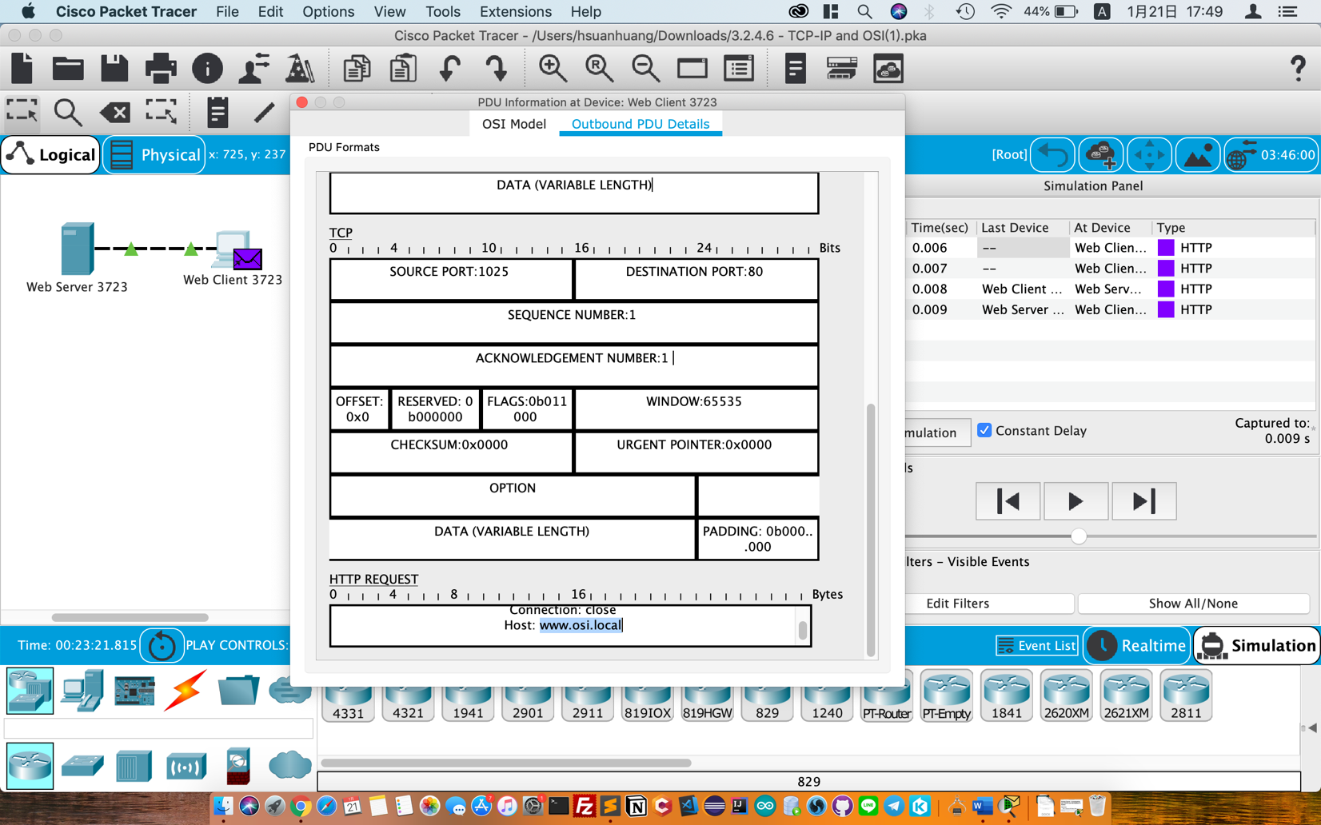

PART 2

1 b) DNS, ARP and TCP

1 d) www.osi.local

1 e) Web Client 3723. 192.168.1.254

1 f) 4. The TCP connection is successful. 5. The device sets the connection state to ESTABLISHED.

Step 1f: Rearrange the Packet Tracer windows so that both the PDU Information window AND Simulation Panel windows are visible.

