Assign#5

Yu-Hsuan Huang - 200443723

PART 4

After completing Step 3c:

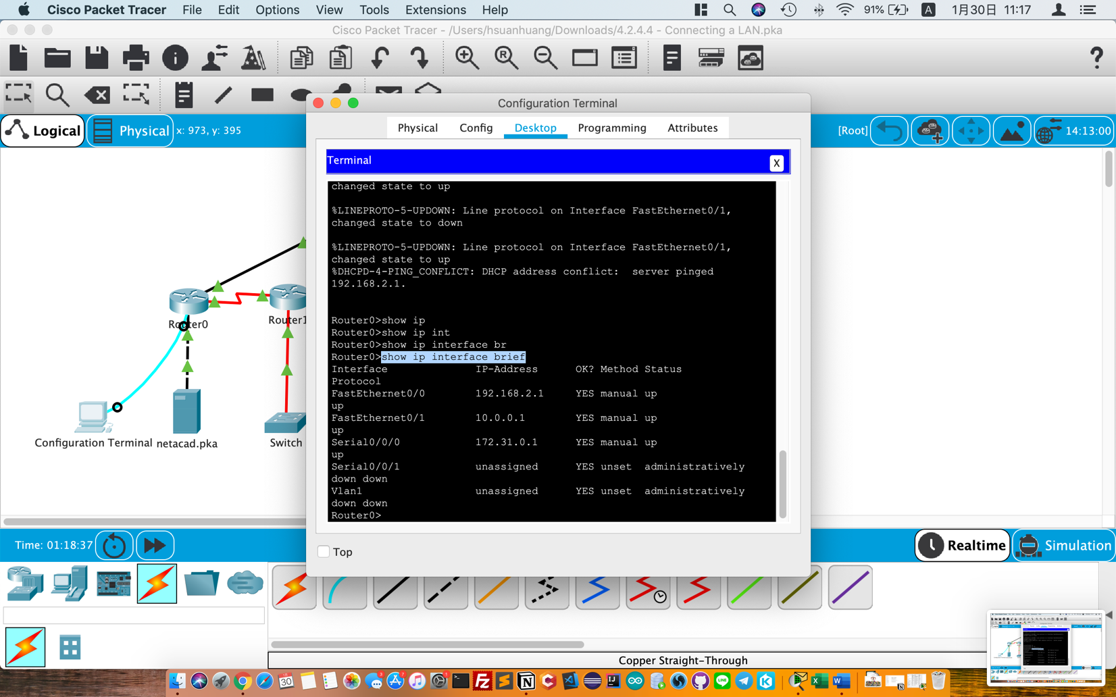

PART 5

1 c) 2

2 a) Configuration Terminal

3 a) The cable(Fiber) use to connect Router1 and Switch

4 a) We can see the oval mesh covering the home network because we have a Router Wireless.(WLAN)

4 b) Basically, Most home don’t have racks in their house. We just put the PCs, Routers or equipment on desk.