Assign#8

*Yu-Hsuan Huang - 200443723*

|  |  |  |  |  |
| --- | --- | --- | --- | --- |
| Device | Interface | IPv4 Address | Subnet Mask | Default Gateway |
| IPv6 Address/Prefix | |
| R1 | G0/0 | 10.10.1.97 | 255.255.255.224 | N/A |
| 2001:DB8:1:1::1/64 | | N/A |
| S0/0/1 | 10.10.1.6 | 255.255.255.252 | N/A |
| 2001:DB8:1:2::2/64 | | N/A |
| Link-local | FE80::1 | | N/A |
| R2 | S0/0/0 | 10.10.1.5 | 255.255.255.252 | N/A |
| 2001:DB8:1:2::1/64 | | N/A |
| S0/0/1 | 10.10.1.9 | 255.255.255.252 | N/A |
| 2001:DB8:1:3::1/64 | | N/A |
| Link-local | FE80::2 | | N/A |
| R3 | G0/0 | 10.10.1.17 | 255.255.255.240 | N/A |
| 2001:DB8:1:4::1/64 | | N/A |
| S0/0/1 | 10.10.1.10 | 255.255.255.252 | N/A |
| 2001:DB8:1:3::2/64 | | N/A |
| Link-local | FE80::3 | | N/A |
| PC1 | NIC | 10.10.1.100 | 255.255.255.224 | 10.10.1.97 |
| 2001:DB8:1:1::A/64 | | FE80::1 |
| PC2 | NIC | 10.10.1.20 | 255.255.255.240 | 10.10.1.17 |
| 2001:DB8:1:4::A/64 | | FE80::3 |

**PART 2**

Q1a: Yes

Q1b: Yes

Q2a: Yes

Q2b: Yes

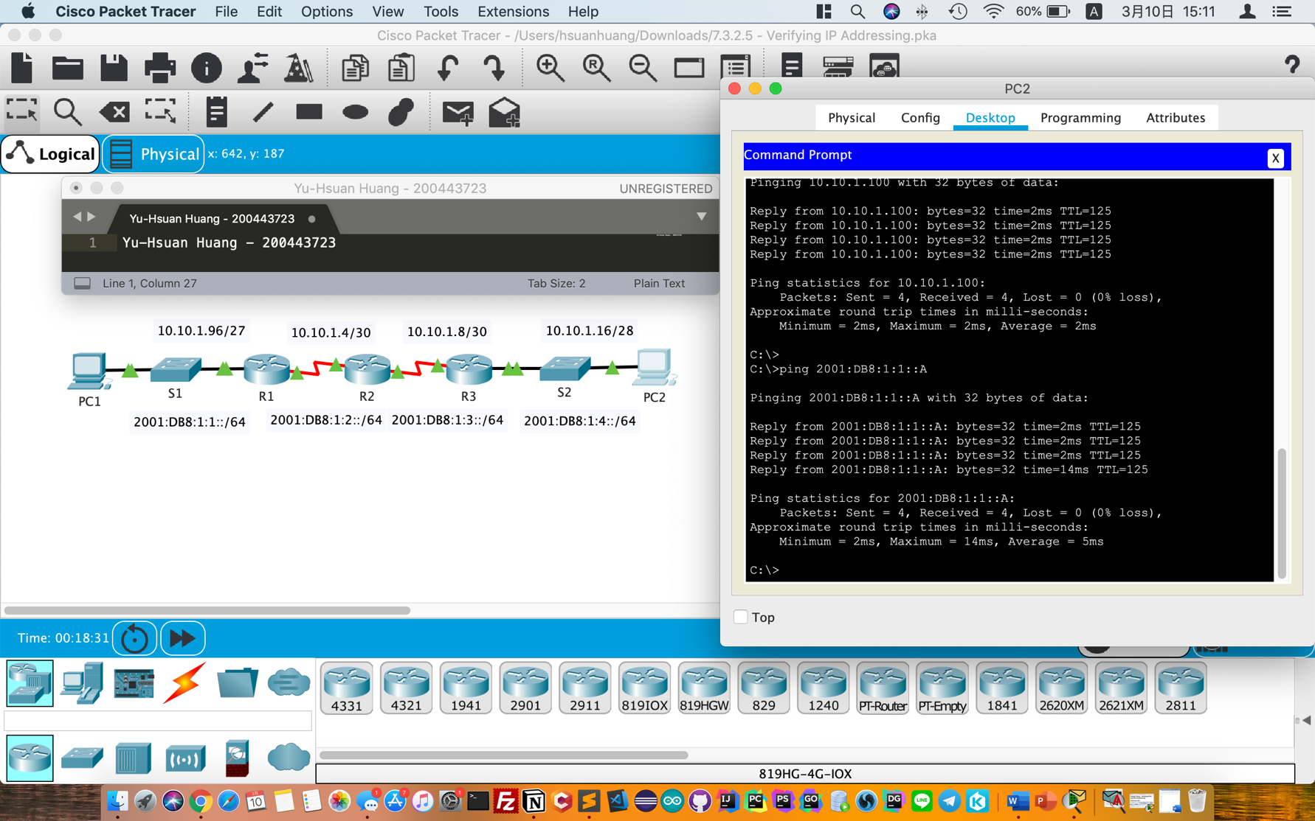

**PART 3**

Q1a-1:

10.10.1.97

10.10.1.5

10.10.1.10

10.10.1.20

Q1a-2:

G0/0 on R1

S0/0/0 on R2

S0/0/1 on R3

NIC on PC2

Q1b-1:

10.10.1.17

10.10.1.9

10.10.1.6

10.10.1.100

Q1b-2:

G0/0 on R3

S0/0/1 on R2

S0/0/1 on R1

NIC on PC1

Q2a-1:

2001:DB8:1:1::1

2001:DB8:1:2::1

2001:DB8:1:3::2

2001:DB8:1:4::A

Q2a-2:

G0/0 on R1

S0/0/0 on R2

S0/0/1 on R3

NIC on PC2

Q2b-1:

2001:DB8:1:4::1

2001:DB8:1:3::1

2001:DB8:1:2::2

2001:DB8:1:1::A

Q2b-2:

G0/0 on R3

S0/0/1 on R2

S0/0/1 on R1

NIC on PC1