Original Table structure and records – auto table

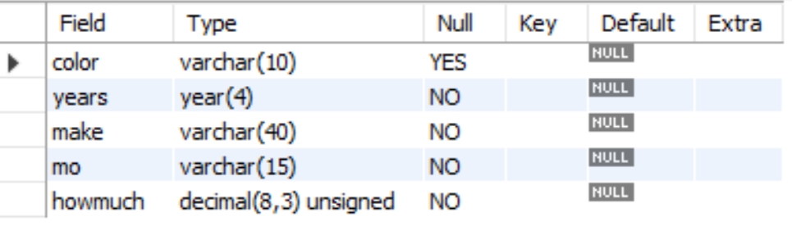

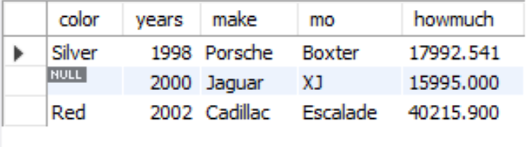

Altered table structure and contents – ‘tbl_auto’

