**zOS Lab1 - Exercises for Chapter 4 - TSO/E, ISPF, and UNIX**

**ANSWER SHEET**

**Logging on to z/OS and entering TSO commands**

Establish a 3270 connection with z/OS using a workstation 3270 emulator and log on with your user ID (we call this *yourid*). From the TSO READY prompt (after you have keyed in =x to exit out of ISPF into native TSO), enter the following commands:

1. PROFILE

What is the prefix value? **Make a note of it**; it is your user ID on the system.

KC03CCA 

2. PROFILE NOPREFIX

This changes your profile so TSO will not place a prefix at the beginning of your commands. Specifying PROFILE PREFIX(with a value) or NOPREFIX (by itself) tells the system whether to use a value (such as your user ID) to find files in the system. NOPREFIX tells the system not to bother limiting the results to files beginning with your user ID (for example), as it would otherwise do by default.



3. LISTC

The LISTCAT command (or LISTC, for short) lists the data sets in a particular catalog (we discuss catalogs in Chapter 5, “Working with data sets” on page 203). Your 3270 emulator has a PA1 (ESC) key. You can use the PA1 key to end the command output. When you see the three asterisks (***), it indicates that your screen is filled. Press Enter to continue or PA1 to discontinue display.

Copy and paste the first few lines displayed by the LISTC command.

LISTING FROM CATALOG -- MASTERV.CATALO

CLUSTER ------- 00000000000000000000000000000000000000000000

DATA ------- MASTERV.CATALOG

INDEX ------ MASTERV.CATALOG.CATINDEX

NONVSAM ------- $$DRIVER.INFO

ALIAS --------- ADBB10

ALIAS --------- ADBB20

ALIAS --------- ADBC10

NONVSAM ------- ADCD.LIB.JCL

NONVSAM ------- ADCD.Z21Z.CLIST

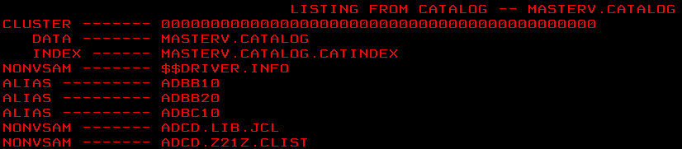

4. PROFILE PREFIX(userid)

This command specifies that your user ID be prefixed to all non-fully-qualified

data set names. This will filter the results of the next command:



5. LISTC

What is displayed? Copy and paste the first few lines displayed by the LISTC command.

IN CATALOG:USERCAT.KCTR2

KC03CCA.DDIR

KC03CCA.DDIR.D

KC03CCA.DDIR.I

KC03CCA.ES1016.LIB

KC03CCA.ISPF.ISPPROF

KC03CCA.JCL

KC03CCA.LANG.CNTL

KC03CCA.LANG.LOAD

KC03CCA.LANG.OBJ

KC03CCA.LANG.SOURCE

KC03CCA.S0W1.ISPF.ISPPROF

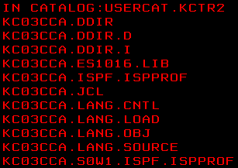

6. ISPF (or ISPPDF)

Enter the ISPF menu-driven interface of TSO.

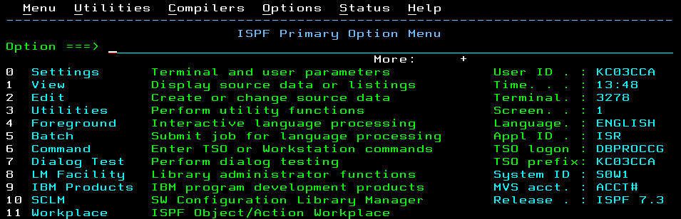

**Navigating through the ISPF menu options**

From the ISPF Primary Option Menu, perform the following steps:

1. Select Utilities, then select Dslist from the Utility Selection panel.



2. Enter SYS1 on the Dsname Level input field and press Enter.

What is displayed?

Data Sets which match name SYS1.

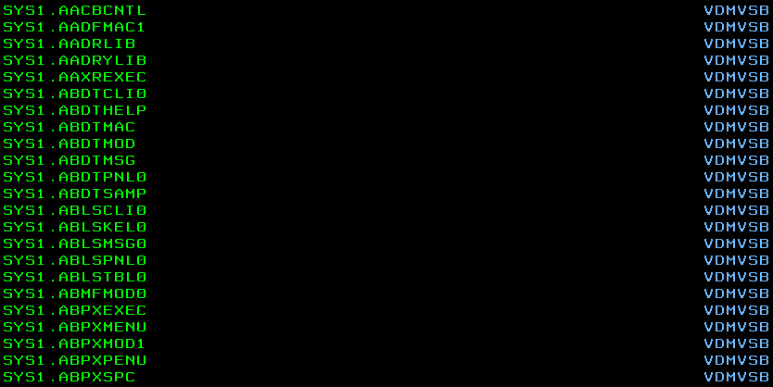

3. Use F8 to page down or forward, F7 to page up or backward, F10 to shift left, and F11 to shift right. Exit with F3.

4. Enter SYS1.PROCLIB on the Dsname Level input field and press Enter.

What is displayed?

It only displays one data set which name is SYS1.PROCLIB.



5. Enter v in the command column to the left of SYS1.PROCLIB. This is a partitioned data set with numerous members. Place an s to the left of any member to select the member for viewing.

Copy and paste the first few lines of member you selected.



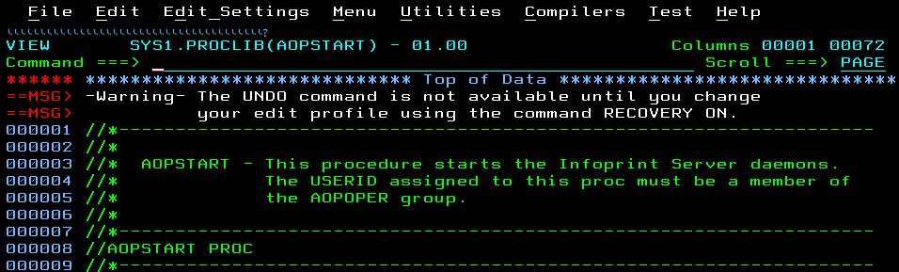

Now Press F1.

What specific help is provided?

It displays description of view and browse. And this tutorial provides 6 specific helps for us. Like, 0-General Introduction, 1-View entry panel, 2-SCLM View entry panel, 3-Ending a view session, 4-Using View, 5-Using Browse.

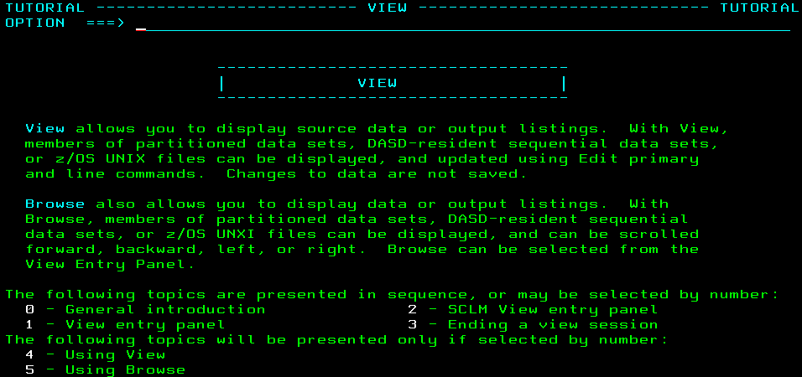

6. Enter =0 on the ISPF command or option line.

What is the first option listed in this ISPF Settings panel?

Command line at bottom



Change your settings to place the command line at the top of the panel. It is effective on exit from the Settings panel.

7. Enter PFSHOW OFF and then PFSHOW ON.

What is the difference? How is this useful?

PFSHOW OFF specifies that the function key area will not be displayed.

PFSHOW ON displays the long form of the function key area.

. If the function key area has been displayed, we can easily to understand the function for each function key.

8. Exit back to the ISPF Primary Option Menu.

What value is used to select Utilities?

Using 3 to select Utilities 

9. Select Utilities.

10.In the Utilities Selection panel,

what value is used to select Dslist?

Using 4 to select Dslist panel.



11. Exit back to the ISPF Primary Option Menu. On the option line, enter the Utilities selection value followed by a period, then enter the Dslist selection value.

What panel is displayed?

The Dslist panel will be displayed.



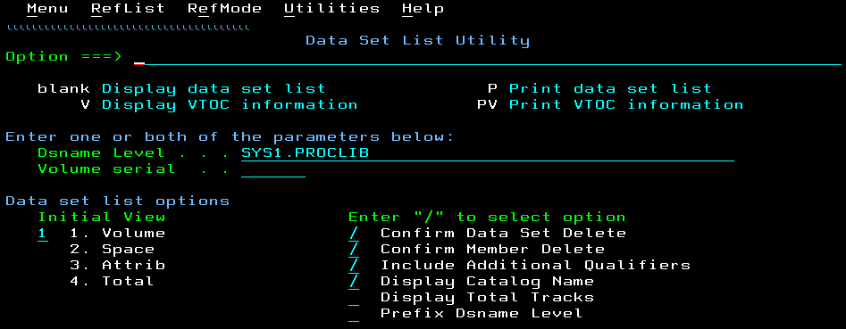

12.Exit back to the ISPF Primary Option Menu. Place the cursor on the Status

entry at the top of the panel and press Enter. Select the Calendar value and

press Enter.

What changed?

The calendar has been displayed in the right side.

. 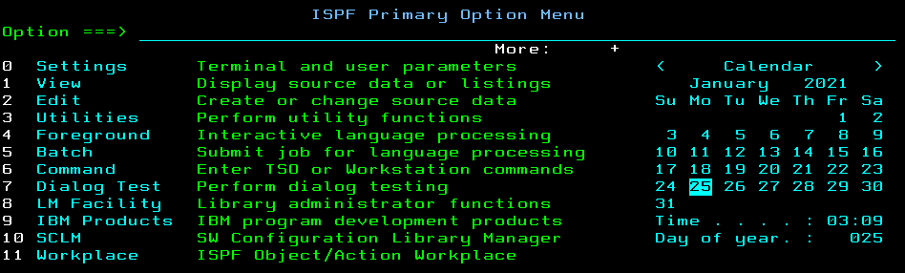

13.Now set your screen to the original configuration, using the Status drop-down

menu and selecting Session.

Copy and paste the Session information.

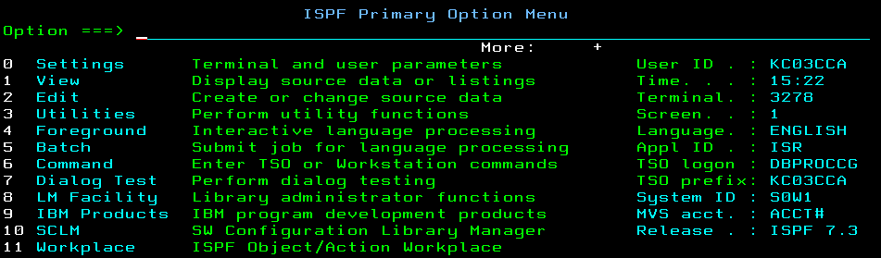

**Using the ISPF editor**

From the ISPF Primary Option Menu, perform the following steps:

1. Go to the DSLIST Utility panel and enter *yourid****.***JCL in the Dsname Level field. Press Enter.



2. Place e (edit) to the left of *yourid****.***JCL. Place s (select) to the left of member EDITTEST. Enter PROFILE on the edit command line, and observe the data that is preceded by the profile and message lines. Read the profile settings and messages.

What is the value of the AUTOSAVE setting?

The value of the AUTOSAVE is ON.



Now enter RESET on the command line.

What is the result?

The message lines and profile lines are disappeared. It only show the content in the data set.



3. Enter any string of characters at the end of the first data line, then press Enter. On the command line, enter CAN (cancel). Press Enter to confirm the cancel request. Again, edit EDITTEST in the data set.

Were your changes saved?

No. It did not save this file. So, It still one line in this data set file.

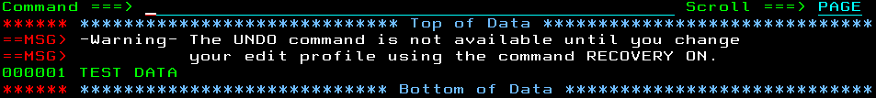

4. Move the cursor to one of the top lines on your display. Press F2. The result is a second ISPF panel.

What occurs when F9 is entered repeatedly?

Clicking F9 will swap between ISPF Primary Option Menu and ISPF Editor page.

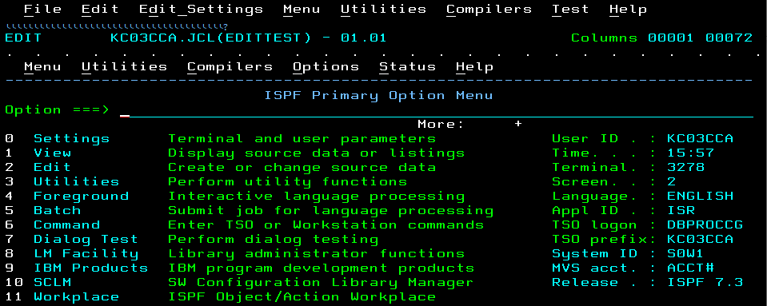

5. Using F9, switch to the ISPF Primary Option Menu, then press F1 to display the ISPF Tutorial panel.

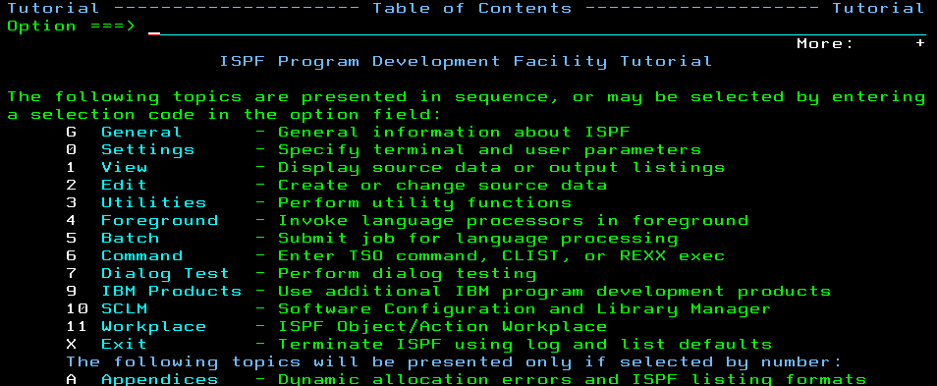

6. From the ISPF Tutorial panel, select Edit, then Edit Line Commands, then Basic Commands. Press Enter to scroll through the basic commands tutorial. As you do so, frequently switch (F9) to the edit session and exercise the commands in EDITTEST. Repeat this same scenario for Move/Copy

commands and shifting commands.

Copy and paste the new contents of the EDITTEST member.

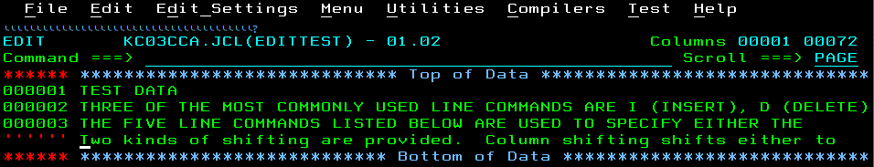

**Tip:** As you become more familiar with ISPF, you learn the letters and numbers for some of the commonly used options. Preceding an option with the = key takes you directly to that option, bypassing the menus in between. You can also go directly to nested options with the = sign. For example,

=3.4 takes you directly to a commonly used data set utility menu.

7. From the ISPF Tutorial panel, select Edit, then Edit Primary Commands, then FIND/CHANGE/EXCLUDE commands. Press Enter to scroll through the FIND/CHANGE/EXCLUDE commands tutorial. As you do so, frequently switch (F9) to the edit session and exercise the commands in EDITTEST.

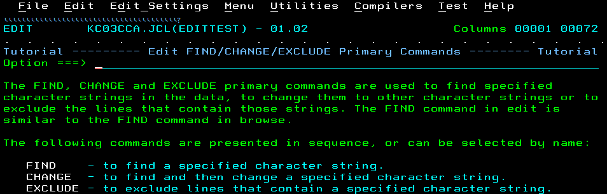

8. Enter =X on the ISPF help panel to end the second ISPF panel session. Save and exit the Edit Panel (F3) to return to the ISPF Primary Option Menu.

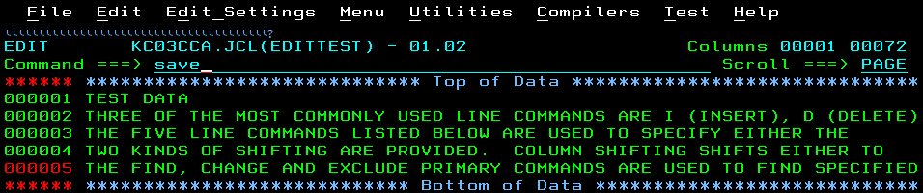

**Using SDSF**

From the ISPF Primary Option Menu, locate and select System Display and Search Facility (SDSF), which is a utility that lets you look at output data sets. On the Marist ISPF Primary Menu enter SD. From the SDSF Primary Menu Perform the following steps:

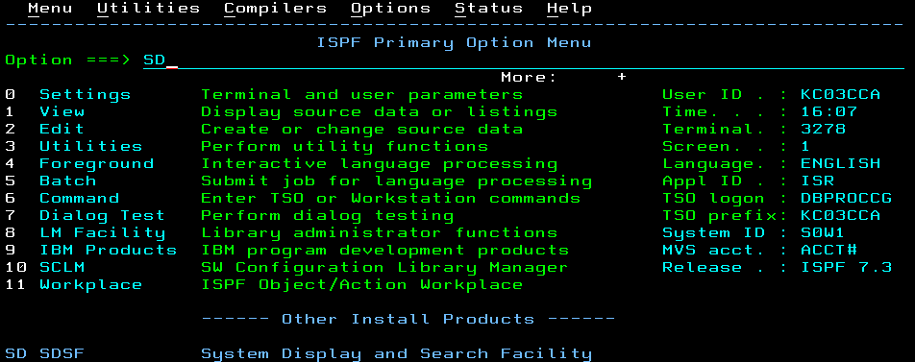

1. Enter LOG, then shift left (F10), shift right (F11), page up (F7), and page down (F8). Enter TOP, then BOTTOM on the command input line. Enter DOWN 500 and UP 500 on the command input line. You will learn how to read this system log later.

Copy and paste a few lines from the Log.

N C000000 S0W1 21025 16:15:30.31 00000090 $HASP309 INIT 3 INAC

NC0000000 S0W1 21025 16:16:07.53 INSTREAM 00000290 LOGON

N 4080000 S0W1 21025 16:16:19.88 00000090 IKJ606I TSOLOGON REJECT

N 0000000 S0W1 21025 16:16:21.46 TSU03598 00000290 IEA631I OPERATOR MARIS

******************************** BOTTOM OF DATA ********************************

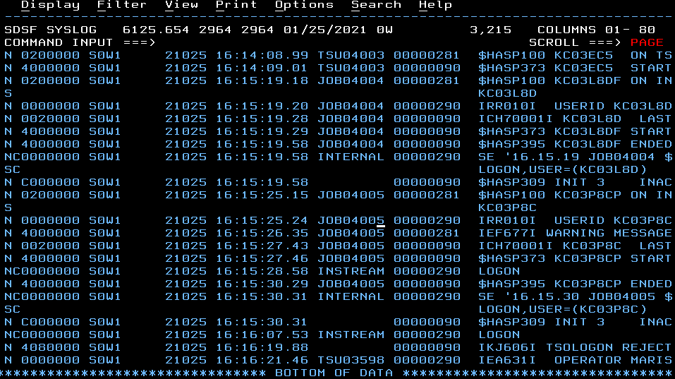

2. Review the SCROLL value to the far left on the command input line: Scroll ===> PAGE

Tab to the SCROLL value. The values for SCROLL can be:

**C or CSR** Scroll to where you placed the cursor

**P or PAGE** Full page or screen

**H or HALF** Half page or half screen

3. You will find the SCROLL value on many ISPF panels, including the editor. You can change this value by overwriting the first letter of the scroll mode over the first letter of the current value. Change the value to CSR, place the cursor on another line in the body of the system log, and press F7.

Did it place the line with the cursor at the top?

Yes. It place the cursor to the top.

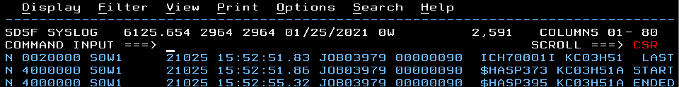

4. Enter ST (status) on the SDSF command input line to retrieve the status of all jobs

in the input, active, and output queues. You can scroll this information by pressing F7 (page up), F8

(page down), F10 (shift left), or F11 (shift right).

Copy and paste the first few jobs displayed.

NP JOBNAME JobID Owner Prty Queue C Pos SAff ASys Status

KC03A091 JOB00788 KC03A09 10 EXECUTION A HOLD

CICSTS52 JOB02942 KC02743 10 EXECUTION A 2964

KC03H29A JOB03062 KC03H29 15 EXECUTION A HOLD

XYMONZOS JOB03821 STCOPER 10 EXECUTION A 2964

KC03H22S JOB04321 KC03H22 10 EXECUTION A HOLD

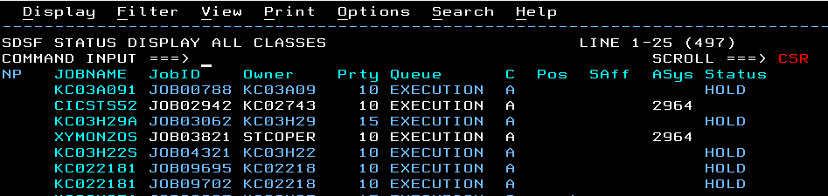

5. Now enter SET DISPLAY ON. Observe the values for Prefix, Best, Owner, and Sysname. An * tells SDSF to filter using any value. To display jobs that you have submitted Enter owner *yourid*.

Copy and paste the new filter values and the few lines of the status display.

PREFIX=* DEST=(ALL) OWNER=* SYSNAME=

NP JOBNAME JobID Owner Prty Queue C Pos SAff ASys Status

KC03A091 JOB00788 KC03A09 10 EXECUTION A HOLD

CICSTS52 JOB02942 KC02743 10 EXECUTION A 2964

KC03H29A JOB03062 KC03H29 15 EXECUTION A HOLD

XYMONZOS JOB03821 STCOPER 10 EXECUTION A 2964

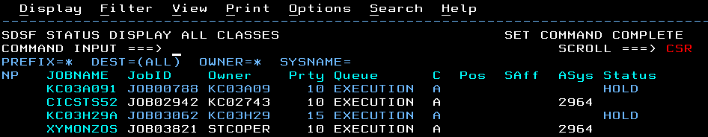

6. Enter DA to display only the active jobs. Once again scrolling can be performed using F7 (page up), F8

(page down), F10 (shift left), and F11 (shift right).

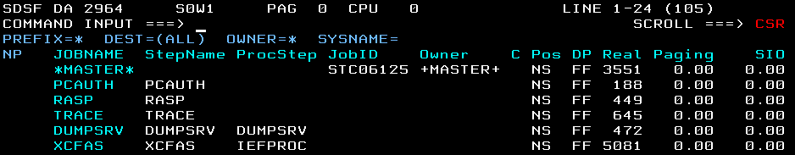

**Opening the z/OS UNIX shell and entering commands**

1. From the ISPF Primary Option Menu, select Option 6, then enter the OMVS command. The Unix shell will be displayed with your home directory.

What is your home directory?

KC03CCA:/u/kc03cca: 

2. Enter the **id** command.

Copy and paste the response to this command.

uid=1714(KC03CCA) gid=990011(KC81)



**3.** The **date** command shows the time and date. The **man date** command **s**hows the help menu for the **date** command. You can scroll through the panels by pressing Enter. The **man man** command provides Help for the help manual. Enter **quit** to exit the panels.



**5.** The **env** command displays **e**nvironment variables for this session.

What is specified for the PATH environment variable?

**6. ls** Lists the current directory, **ls -l** lists the current directory in verbose mode and **ls -l /etc.** lists the /etc. directory.

Copy and paste the contents of your home directory (in verbose mode).

/bin:. 

7. From your home directory, enter the following shell command: **oedit myfile.** This opens the ISPF edit panel and creates a new text file in the current path. Write some text into the editor. Save and exit (F3)…

Copy and paste the contents of ‘myfile’ before attempting to save.

my file

qwe

asd

zxc

123

456

789

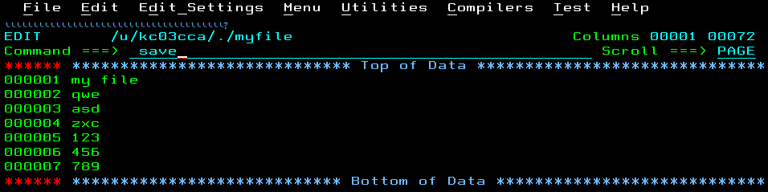

Now save and exit (F3).

Copy and paste the contents of your home directory (in verbose mode).

KC03CCA:/u/kc03cca: >



**8.** Enter **exit to e**nd the OMVS session.

