Part 2. Spanning Tree Protocol (STP) and Layer 2 Loop Prevention

Objectives
- To study and understand the basic principles of Spanning Tree Protocol (STP).
- To build a switched network topology and configure IP connectivity between hosts.
- To introduce redundant links between switches and observe how STP prevents Layer 2 loops.
- To analyze STP information and port roles using CLI commands.
- To understand the Root Bridge election process and influence it by modifying bridge priority.
- To observe how STP recalculates the topology and activates a backup path when a link failure occurs.

Preparation
- Cisco Packet Tracer (Lastest Version)
- Lab Manual with Student instruction and Packet tracer file used in the workshop

Experiment 1 Topology setup
Please complete the terminal device configuration according to the instructions below：

Build the network topology in Packet Tracer
- Open Cisco Packet Tracer.
- In the lower-left corner of the Packet Tracer window, locate the Device-Type Selection Box.
- Click Network Devices, then select Switches.
- From the device list, drag 2960 Switch into the workspace.
Place two switches and rename them as: Switch0, Switch1
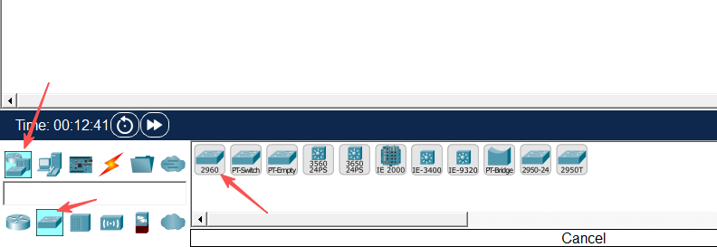
- In the Device-Type Selection Box, click End Devices.
- Drag PC into the workspace and place six PCs. Rename them from PC0 to PC5.
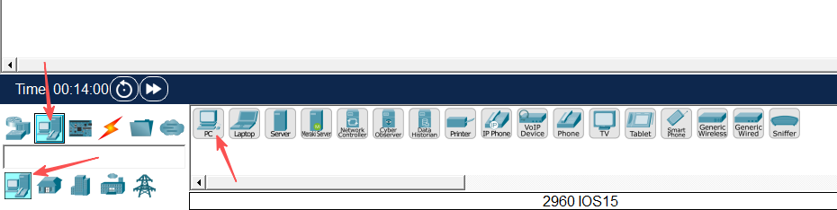
- Click Connections (the lightning icon).
- Select Copper Straight-Through cable and connect the PCs to the switches according to the following table:

Device | Interface | Connected Device | Interface
PC0 | FastEthernet0 | Switch0 | FastEthernet0/1
PC1 |  |  | FastEthernet0/2
PC2 |  |  | FastEthernet0/3
PC3 |  | Switch1 | FastEthernet0/1
PC4 |  |  | FastEthernet0/2
PC5 |  |  | FastEthernet0/3
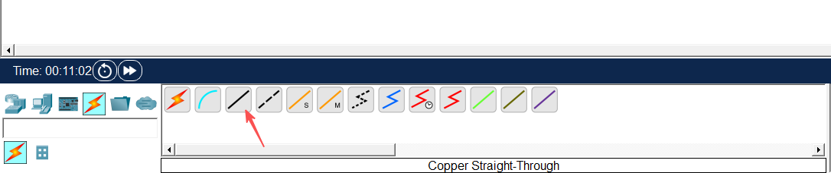
- Use Copper cross-over cable to connect the two switches:
Device | Interface | Connected Device | Interface
Swtich0 | FastEthernet0/4 | Swtich1 | FastEthernet0/4
After completing the connections, ensure that all link lights turn green, indicating that the connections are active.
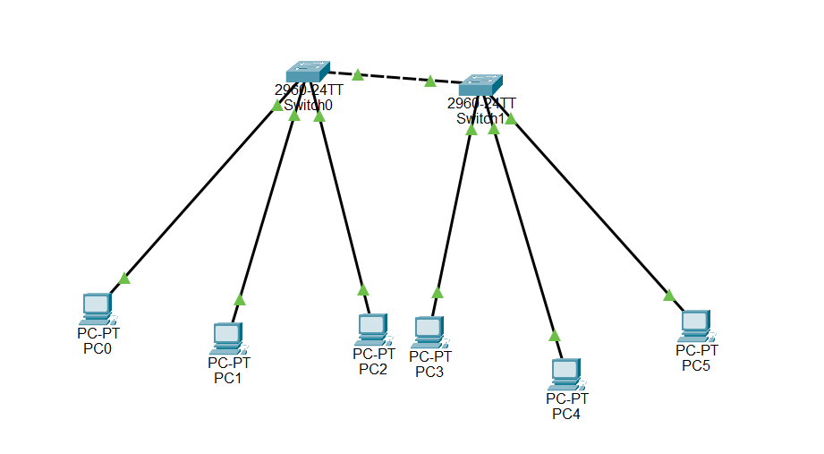

Configure PC IP address
- Click on PC0, navigate to the Desktop tab, and then click on IP Configuration.
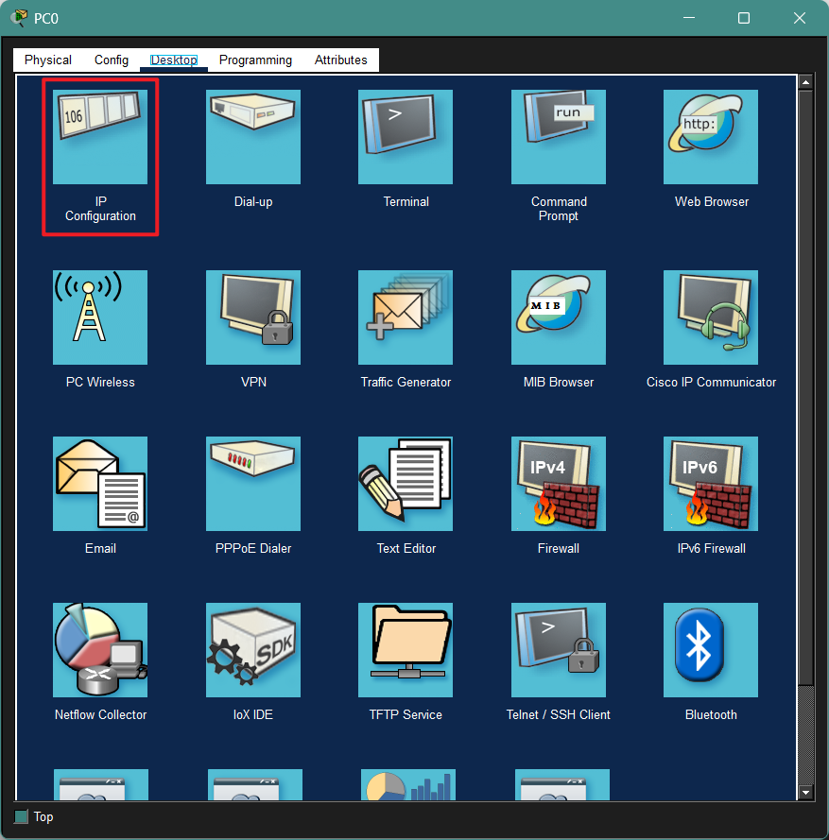
- Set the following parameters:
IPv4 Address: 192.168.10.1
Subnet Mask: 255.255.255.0
Default Gateway: 192.168.10.254
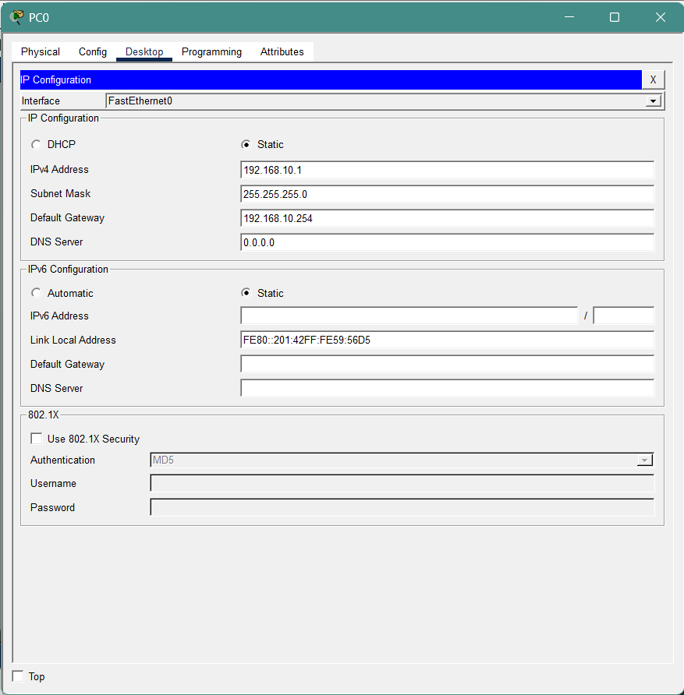
- Repeat this operation to configure PC1-PC5 with IPv4 addresses ranging from 192.168.10.2 to 192.168.10.6.
PC Configuration Reference:
PC No. | IPv4 Address | Subnet Mask | Default Gateway
PC0 | 192.168.10.1 | 255.255.255.0 | 192.168.10.254
PC1 | 192.168.10.2
…… | ……
PC5 | 192.168.10.6
Note: You can choose not to follow the table setup. But do configure all six PCs on the same network segment.

Experiment 2 Introduce Loop and Observe STP Blocking
In this experiment, an additional physical link will be introduced between the two switches to create a Layer 2 loop.

Add an additional link between the switches
- In Packet Tracer, click Connections (the lightning icon).
- Select Copper cross-over cable.
- Connect an additional link between the two switches using the following interfaces:
Device | Interface | Connected Device | Interface
Swtich0 | FastEthernet0/5 | Swtich1 | FastEthernet0/5
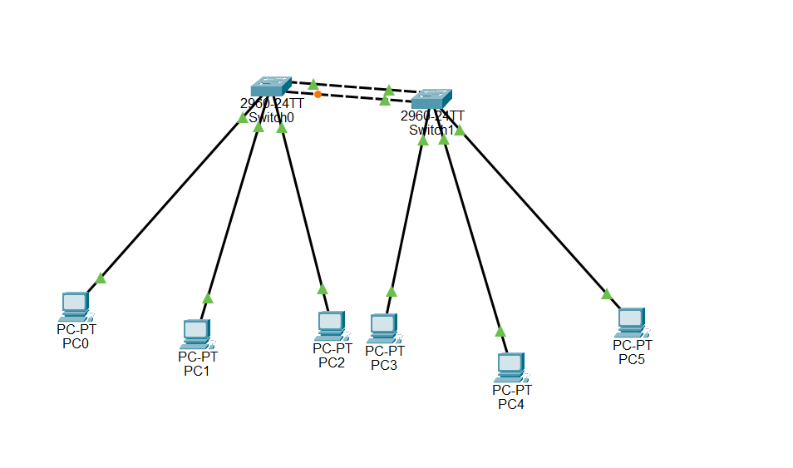
After completing the connection, there will now be two physical links between the two switches. Since there are now two parallel links between the switches, a Layer 2 loop is created in the network.

Observe the switch port status
When a loop appears in a Layer 2 network, the switch automatically uses the Spanning Tree Protocol (STP) to prevent network loops.
- Observe the port status indicators on the switch links in Packet Tracer.
- Among the two links connecting the switches, one of the ports will change to Orange/Green/Red
- This indicates that STP has automatically Blocked/Opened one of the redundant links to prevent a network loop.

Verify STP information using CLI
- Click Switch1 and open the CLI tab.
- Enter the following commands:
Switch> enable
Switch# show spanning-tree
- From the output, observe the following information:
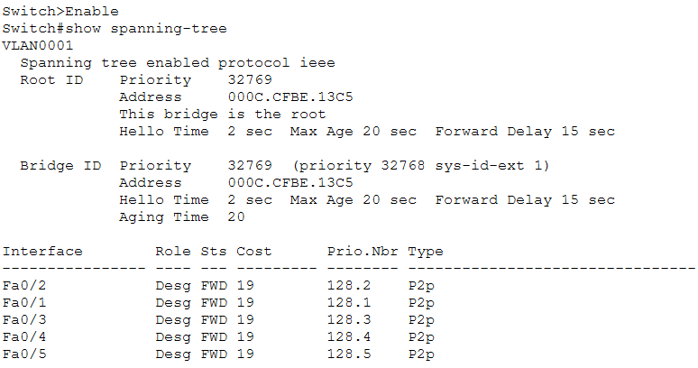
These values show how STP determines the forwarding path and which port should be blocked.

Practice & Thinking Questions
- Why does one of the switch ports enter the Blocking state after adding a second link?
After a second link is added between the two switches, a redundant Layer 2 path is created. This forms a potential network loop. To prevent frames from circulating endlessly in the loop, Spanning Tree Protocol (STP) automatically places one of the redundant ports into the Blocking state. In this way, only one active forwarding path remains between the switches.
- What problems might occur if the network operates without STP?(at least two points)
- Broadcast storm: broadcast frames may circulate endlessly in the network.
- MAC address table instability: switches may keep learning the same MAC address from different ports.
- Duplicate frames: devices may receive multiple copies of the same frame.
- Network congestion or failure: the network may become extremely slow or completely unavailable.
- What is the main purpose of Spanning Tree Protocol in a Layer 2 network?
The main purpose of Spanning Tree Protocol (STP) is to prevent Layer 2 switching loops while still allowing redundant physical links in the network. STP does this by automatically blocking unnecessary paths and keeping only one active forwarding path. If the active path fails, STP can recalculate the topology and enable a backup path.
- Complete the STP Information Table of Switch0:
Item | Value
Root Bridge Priority | 32769
Root Bridge MAC Address | The Root Bridge MAC address may vary depending on which switch is elected as the root bridge.
Root Path Cost | 19
Root Port | FastEthernet0/4
Designated Ports | Fa0/1, Fa0/2, Fa0/3
Blocking Port | Fa0/5

Experiment 3 Root Bridge Election
In this experiment, we will investigate how Spanning Tree Protocol (STP) elects the Root Bridge in a network and observe how changing the bridge priority can influence the election result.

Observe the current root bridge
- Click on Switch0 and open the CLI tab.
- Enter the following commands:
Switch> enable
Switch# show spanning-tree
- Repeat the same command on Switch1 and find the root bridge.

Change & Verify the bridge priority
STP selects the Root Bridge based on the Bridge ID, which is composed of:
Bridge ID = Priority + MAC Address
A switch with the lowest Bridge ID will become the Root Bridge.
- On Switch0, enter the following commands:
Switch> enable
Switch# configure terminal
Switch(config)# spanning-tree vlan 1 priority 4096
This command lowers the bridge priority of Switch0, increasing its chance of becoming the Root Bridge.
- On Switch0, run the following command again:
Switch# show spanning-tree
- Check whether the output now shows:
This bridge is the root
- Run the same command on Switch1 and observe how the Root Bridge information changes.

Practice & Thinking Questions
- What factor determines which switch becomes the Root Bridge?
The Root Bridge is determined by the Bridge ID, which consists of the bridge priority and the MAC address. The switch with the lowest Bridge ID will be elected as the Root Bridge. If multiple switches have the same priority, the switch with the lowest MAC address becomes the Root Bridge.
- After changing the Root Bridge, does the Blocking port change? Explain why.
Yes, the Blocking port may change. When the Root Bridge changes, STP recalculates the spanning tree topology. Each switch selects a new Root Port based on the shortest path cost to the new Root Bridge. As a result, the port roles may change and a different port may enter the Blocking state to prevent loops.

Experiment 4 Link Failure Recovery
In this experiment, we will observe how Spanning Tree Protocol (STP) responds to a link failure and automatically activates a backup path.

Disconnect the active link and observe STP reconvergence
- In Packet Tracer, select the Delete tool.
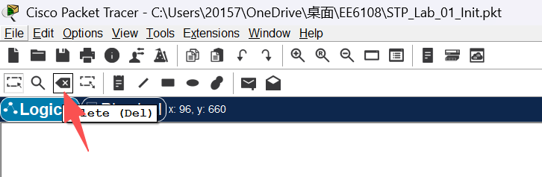
- Identify the port that is currently in the Blocking state.
- Remove the currently active link between the two switches. This link is the one whose ports are in the Forwarding state (Green).
- Identify the port that was previously in the Blocking state. After a short period of time, the port state will change from Blocking (Orange) to Forwarding (Green).
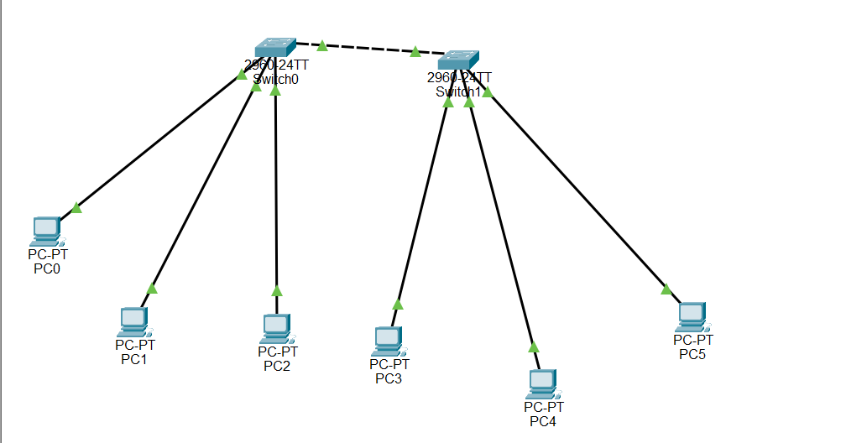
- Click Switch0 and open the CLI tab.
- Enter the following command to view the STP information:
Switch> enable
Switch# show spanning-tree
Observe the changes in the port roles and port states.

Practice & Thinking Questions
- What happens to the previously blocked port after the active link fails?
The previously blocked port transitions from Blocking to Forwarding state. STP recalculates the network topology and activates the backup path to maintain network connectivity.
- What is the advantage of having redundant links in a network?
Redundant links provide network reliability and fault tolerance. If one link fails, another link can automatically take over, ensuring continuous communication in the network.

