Part 2. Spanning Tree Protocol (STP) and Layer 2 Loop Prevention

Objectives
- To study and understand the basic principles of Spanning Tree Protocol (STP).
- To build a switched network topology and configure IP connectivity between hosts.
- To introduce redundant links between switches and observe how STP prevents Layer 2 loops.
- To analyze STP information and port roles using CLI commands.
- To understand the Root Bridge election process and influence it by modifying bridge priority.
- To observe how STP recalculates the topology and activates a backup path when a link failure occurs.

Preparation
- Cisco Packet Tracer (Lastest Version)
- Lab Manual with Student instruction and Packet tracer file used in the workshop

Experiment 1 Topology setup
Please complete the terminal device configuration according to the instructions below：

Build the network topology in Packet Tracer
- Open Cisco Packet Tracer.
- In the lower-left corner of the Packet Tracer window, locate the Device-Type Selection Box.
- Click Network Devices, then select Switches.
- From the device list, drag 2960 Switch into the workspace.
Place two switches and rename them as: Switch0, Switch1
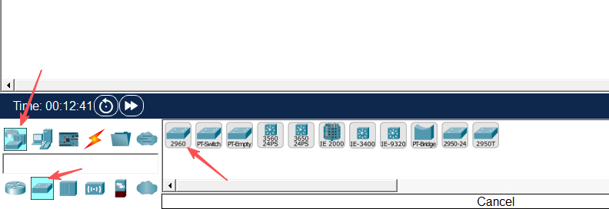
- In the Device-Type Selection Box, click End Devices.
- Drag PC into the workspace and place six PCs. Rename them from PC0 to PC5.
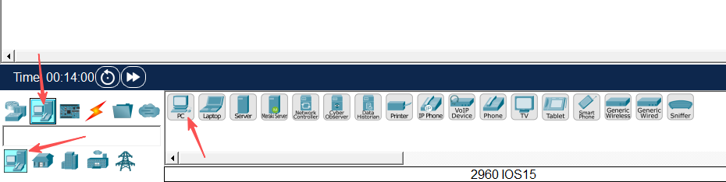
- Click Connections (the lightning icon).
- Select Copper Straight-Through cable and connect the PCs to the switches according to the following table:

Device | Interface | Connected Device | Interface
PC0 | FastEthernet0 | Switch0 | FastEthernet0/1
PC1 |  |  | FastEthernet0/2
PC2 |  |  | FastEthernet0/3
PC3 |  | Switch1 | FastEthernet0/1
PC4 |  |  | FastEthernet0/2
PC5 |  |  | FastEthernet0/3
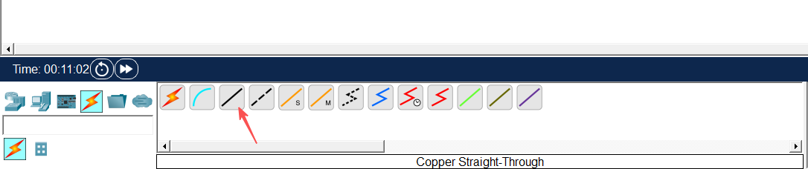
- Use Copper cross-over cable to connect the two switches:
Device | Interface | Connected Device | Interface
Swtich0 | FastEthernet0/4 | Swtich1 | FastEthernet0/4
After completing the connections, ensure that all link lights turn green, indicating that the connections are active.
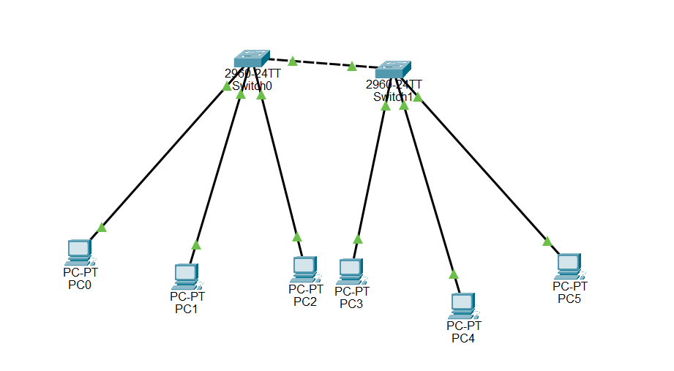

Configure PC IP address
- Click on PC0, navigate to the Desktop tab, and then click on IP Configuration.
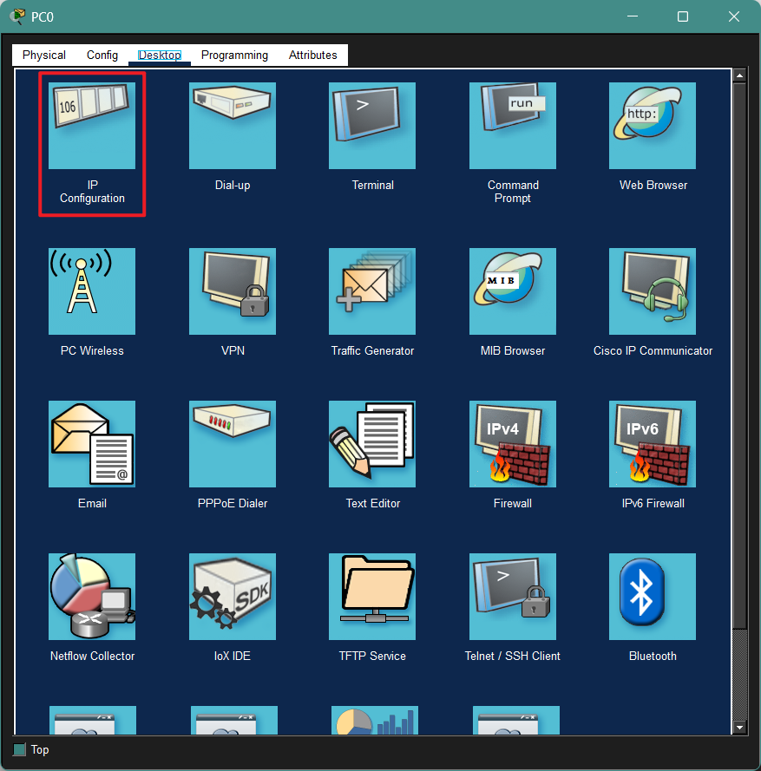
- Set the following parameters:
IPv4 Address: 192.168.10.1
Subnet Mask: 255.255.255.0
Default Gateway: 192.168.10.254
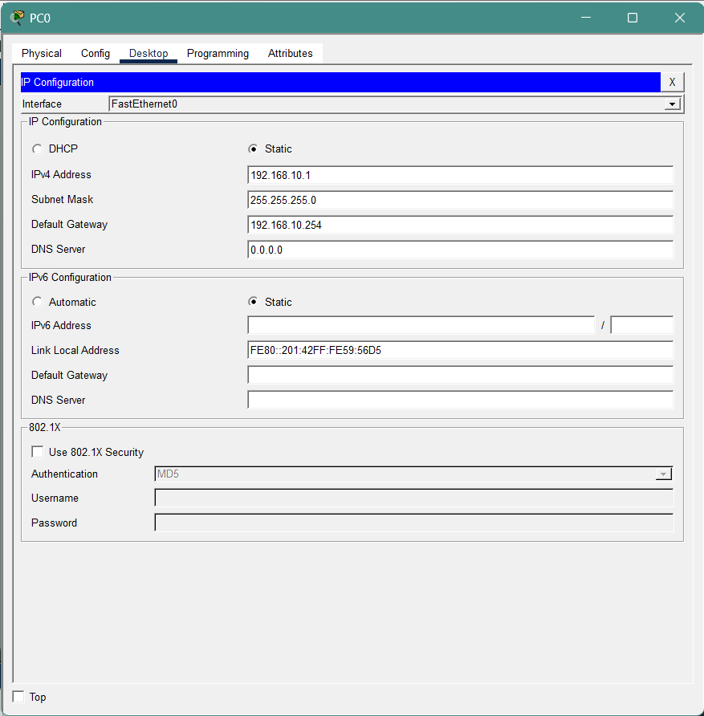
- Repeat this operation to configure PC1-PC5 with IPv4 addresses ranging from 192.168.10.2 to 192.168.10.6.
PC Configuration Reference:
PC No. | IPv4 Address | Subnet Mask | Default Gateway
PC0 | 192.168.10.1 | 255.255.255.0 | 192.168.10.254
PC1 | 192.168.10.2
…… | ……
PC5 | 192.168.10.6
Note: You can choose not to follow the table setup. But do configure all six PCs on the same network segment.

Experiment 2 Introduce Loop and Observe STP Blocking
In this experiment, an additional physical link will be introduced between the two switches to create a Layer 2 loop.

Add an additional link between the switches
- In Packet Tracer, click Connections (the lightning icon).
- Select Copper cross-over cable.
- Connect an additional link between the two switches using the following interfaces:
Device | Interface | Connected Device | Interface
Swtich0 | FastEthernet0/5 | Swtich1 | FastEthernet0/5
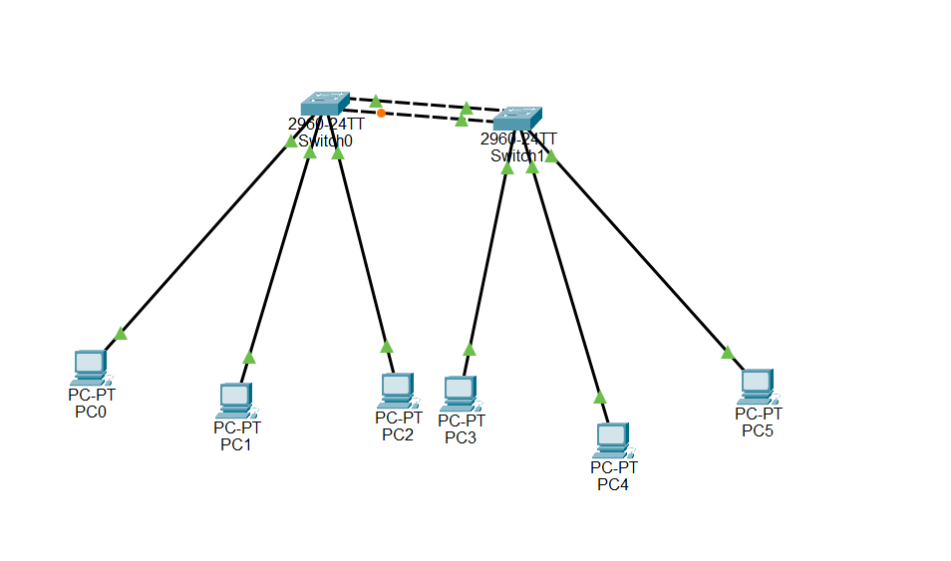
After completing the connection, there will now be two physical links between the two switches. Since there are now two parallel links between the switches, a Layer 2 loop is created in the network.

Observe the switch port status
When a loop appears in a Layer 2 network, the switch automatically uses the Spanning Tree Protocol (STP) to prevent network loops.
- Observe the port status indicators on the switch links in Packet Tracer.
- Among the two links connecting the switches, one of the ports will change to Orange/Green/Red
- This indicates that STP has automatically Blocked/Opened one of the redundant links to prevent a network loop.

Verify STP information using CLI
- Click Switch1 and open the CLI tab.
- Enter the following commands:
Switch> enable
Switch# show spanning-tree
- From the output, observe the following information:
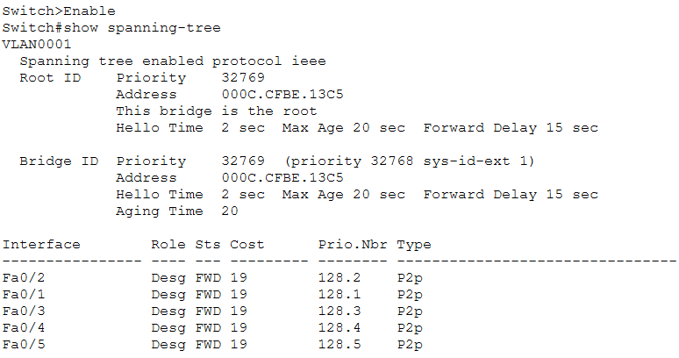
These values show how STP determines the forwarding path and which port should be blocked.

Practice & Thinking Questions
- Why does one of the switch ports enter the Blocking state after adding a second link?

- What problems might occur if the network operates without STP?(at least two points)

- What is the main purpose of Spanning Tree Protocol in a Layer 2 network?

- Complete the STP Information Table of Switch0:
Item | Value
Root Bridge Priority
Root Bridge MAC Address
Root Path Cost
Root Port
Designated Ports
Blocking Port

Experiment 3 Root Bridge Election
In this experiment, we will investigate how Spanning Tree Protocol (STP) elects the Root Bridge in a network and observe how changing the bridge priority can influence the election result.

Observe the current root bridge
- Click on Switch0 and open the CLI tab.
- Enter the following commands:
Switch> enable
Switch# show spanning-tree
- Repeat the same command on Switch1 and find the root bridge.

Change & Verify the bridge priority
STP selects the Root Bridge based on the Bridge ID, which is composed of:
Bridge ID = Priority + MAC Address
A switch with the lowest Bridge ID will become the Root Bridge.
- On Switch0, enter the following commands:
Switch> enable
Switch# configure terminal
Switch(config)# spanning-tree vlan 1 priority 4096
This command lowers the bridge priority of Switch0, increasing its chance of becoming the Root Bridge.
- On Switch0, run the following command again:
Switch# show spanning-tree
- Check whether the output now shows:
This bridge is the root
- Run the same command on Switch1 and observe how the Root Bridge information changes.

Practice & Thinking Questions
- What factor determines which switch becomes the Root Bridge?

- After changing the Root Bridge, does the Blocking port change? Explain why.

Experiment 4 Link Failure Recovery
In this experiment, we will observe how Spanning Tree Protocol (STP) responds to a link failure and automatically activates a backup path.

Disconnect the active link and observe STP reconvergence
- In Packet Tracer, select the Delete tool.
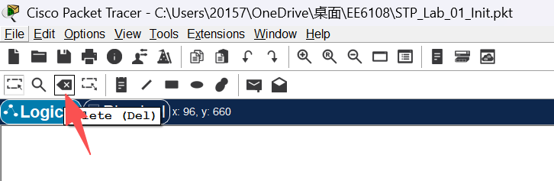
- Identify the port that is currently in the Blocking state.
- Remove the currently active link between the two switches. This link is the one whose ports are in the Forwarding state (Green).
- Identify the port that was previously in the Blocking state. After a short period of time, the port state will change from Blocking (Orange) to Forwarding (Green).
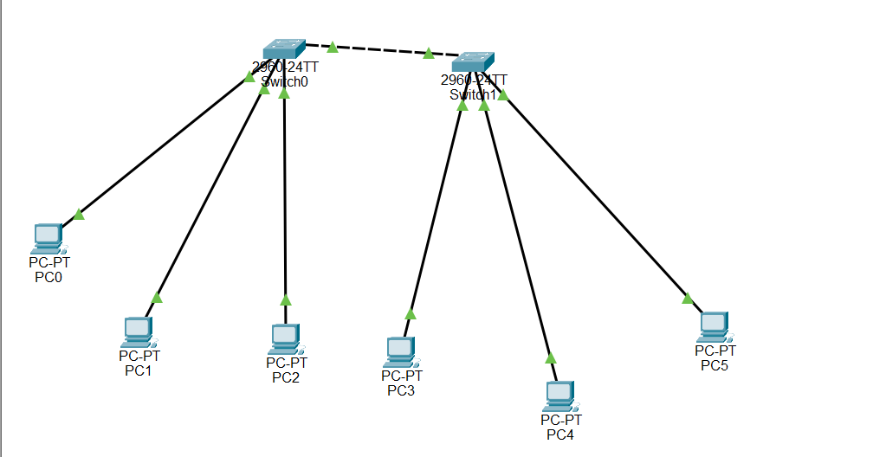
- Click Switch0 and open the CLI tab.
- Enter the following command to view the STP information:
Switch> enable
Switch# show spanning-tree
Observe the changes in the port roles and port states.

Practice & Thinking Questions
- What happens to the previously blocked port after the active link fails?

- What is the advantage of having redundant links in a network?

