
School of Electrical & Electronic Engineering

EE6108 Computer Networks
Academic Year 2025-2026

L6108
Enterprise Switched LAN Design and Implementation
Communication Research Laboratory (S2-B4c-17)

Dress Code in the Laboratory
• Work shirt that covers the upper torso and arms.
• Lower body clothing that covers the entire leg.
• Closed-toe shoes that cover the top of the foot.

Please access this link:
http://tiny.cc/f6f5001or scan the QR code below to access EEE CA Guidelines.
Request for MAKE-UP LAB SESSION must be submitted only after the online leave application form has been submitted.


Laboratory Manual

NANYANG TECHNOLOGICAL UNIVERSITY
SCHOOL OF ELECTRICAL AND ELECTRONIC ENGINEERING

ACADEMIC YEAR 2025/26

L6108 LABORATORY MANUAL

Enterprise Switched LAN Design and Implementation

Communication Lab
(S2 – B4c – 17)

Students are expected to read through all the theoretical parts of this manual before attending this laboratory session

NAME : ________________________________________

GROUP : ________________________________________

DATE : ________________________________________

INSTRUCTION
- This 1.5 tadays laboratory session consists of three main parts:
Part I: IP Networking Fundamentals including Subnetting, Routing and Switching
Part II: Spanning Tree Protocol (STP) and Layer 2 Loop Prevention
Part III: VLAN Configuration, EtherChannel, and Inter-VLAN Routing
- Enter your experimental results only in the space provided in this manual
- Students may ask the lecturer-in-charge questions concerning the theory, laboratory equipment and experiment procedures but not questions set out in this manual.
- Keep your answers short so that they can be written within the space provided in this manual.
- Make sure you understand what you are doing and know how to operate the instruments. If you don’t, please ask.

Part 1. IP Networking Fundamentals

Objectives
- To familiarize with Cisco Packet Tracer software interface and build a physical network topology independently.
- To perform IP Subnetting using standard formulas to divide a Class C network into multiple functional subnets.
- To study and understand the principles of Layer 2 Switching and Multi-link Physical Routing to enable cross-subnet communication.
- To configure DHCP (Dynamic Host Configuration Protocol) and utilize network troubleshooting skills to resolve broadcast domain conflicts.

Preparation
- Cisco Packet Tracer (Latest Version)
- 1 switch (Like 2960).
- 3 PC.
- 1 router (Like 2911).

Experiment 1 -- Topology Setup

Build the network topology in Packet Tracer
Please complete the physical topology connection according to the instructions below:
- Open Cisco Packet Tracer.
- In the lower-left corner of the Packet Tracer window, locate the Device-Type Selection Box.
- Click End Devices, drag PC into the workspace, and place 3 PCs. Rename them as: PC0, PC1, and PC2.
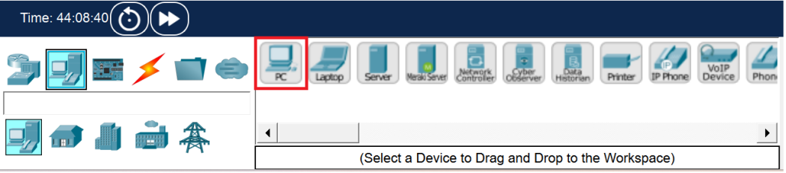
- Click Network Devices, then select Switches. Drag one 2960 Switch into the workspace.
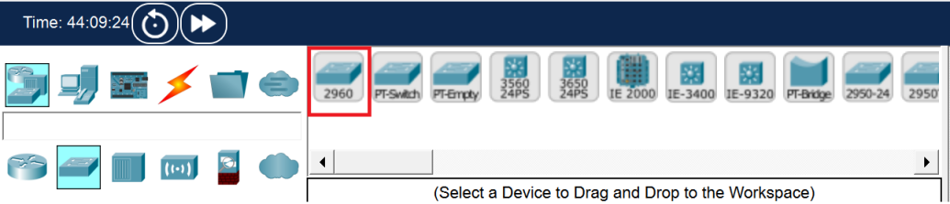
- Click Network Devices, then select Routers. Drag one 2911 Router (which provides 3 GigabitEthernet interfaces) and place it above the switch.
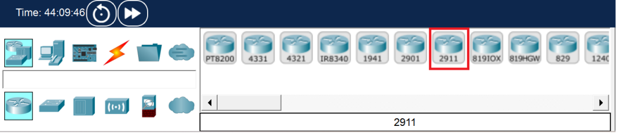

Cabling the Network
- Click Connections (the lightning icon) and select Copper Straight-Through cable.
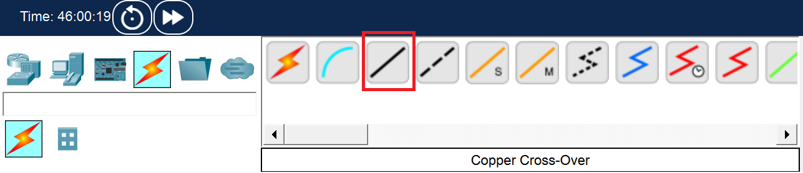
- Connect the devices according to the following tables to establish the 3 independent physical links:
Device | Interface | Connected Device | Interface
PC0 | FastEthernet0 | Switch0 | FastEthernet0/1
PC1 |  |  | FastEthernet0/2
PC2 |  |  | FastEthernet0/3
Switch0 | FastEthernet0/4 | Router0 | GigabitEthernet0/0
 | FastEthernet0/5 |  | GigabitEthernet0/1
 | FastEthernet0/6 |  | GigabitEthernet0/2
Note: The link lights on the router interfaces will initially appear as red triangles because the ports are administratively down by default. They will be activated in Experiment 3.

Experiment 2 -- IP Subnetting
In this experiment, the base network address is given as 192.168.10.0/24. You are required to design a network for 3 colleges of NTU (EEE, NIE, CCDS) , each requiring approximately 20 hosts.
Calculate the required host bits(n) using the formula: $2^{n}-2≥ required hosts$.

Calculation & Thinking
- In the host calculation formula $2^{n}-2≥ required hosts$, why must we subtract 2 from the total permutations?

- Based on the requirement of 20 hosts per college, calculate the required host bits (n) and derive the new subnet mask (please provide both CIDR notation and decimal format).

- Taking NIE as an example, if its starting network address is 192.168.10.32, what is its "Broadcast Address" based on the subnet size calculated in Q2? Can PC1 in NIE configure this broadcast address on its own network interface?

Complete the IP Allocation Table:
College | Network Address | Usable IP Range | Subnet Mask | Default Gateway
EEE  (PC0) | 192.168.10.0 | 192.168.10.1-.30 |  | 192.168.10.1
NIE  (PC1) | 192.168.10.32 |  |  | 192.168.10.33
CCDS  (PC2) | 192.168.10.64 |  |  | 192.168.10.65

Experiment 3 -- Switching & Routing Implementation
In this experiment, we will configure the end devices and the router to enable inter-subnet communication.

Configure PC IP address
- Click on PC0, navigate to the Desktop tab, and then click on IP Configuration.
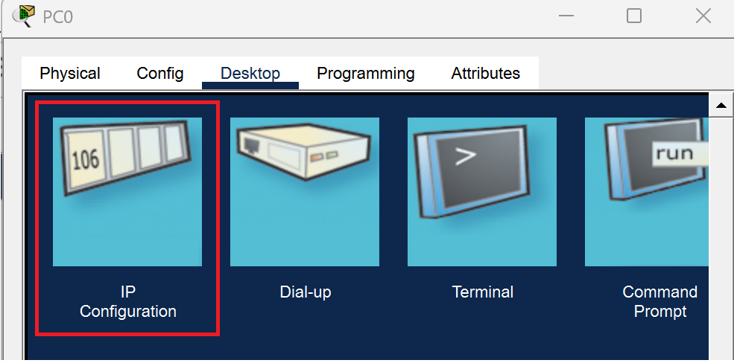
- Select Static. Set the IPv4 Address (e.g., 192.168.10.2), Subnet Mask (255.255.255.224), and Default Gateway (192.168.10.1) based on your calculation.
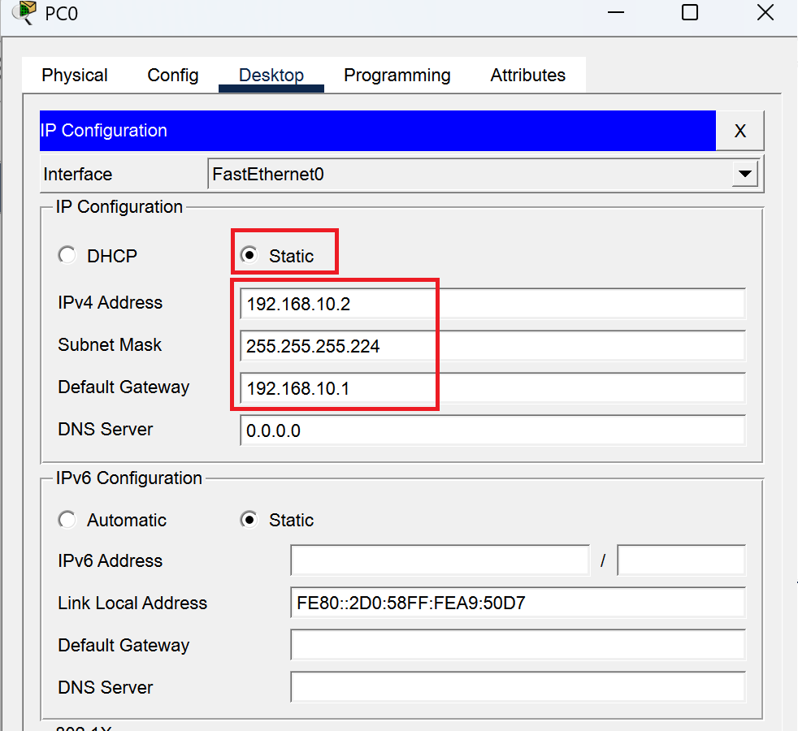
Note: When you click on this box, the software will automatically fill in 255.255.255.0. Please make sure to manually delete the last 0 and change it to 224, making it 255.255.255.224. (This is the result of your Experiment 2 !)
- Repeat this operation to configure PC1 and PC2 with their respective subnet data.

Configure the Layer 2 Switch
No configuration is required for the 2960 Switch. By default, all 24 interfaces are in the same broadcast domain (VLAN 1). It will automatically build its MAC address table to perform Layer 2 forwarding.

Configure the Layer 3 Router
- Click on PC0, navigate to the Desktop tab, and then click on IP Configuration.
Click on Router0, open the CLI tab.
If you see the prompt ’ Would you like to enter the initial configuration dialog? [yes/no]:’ , type ’ no’ and press Enter.
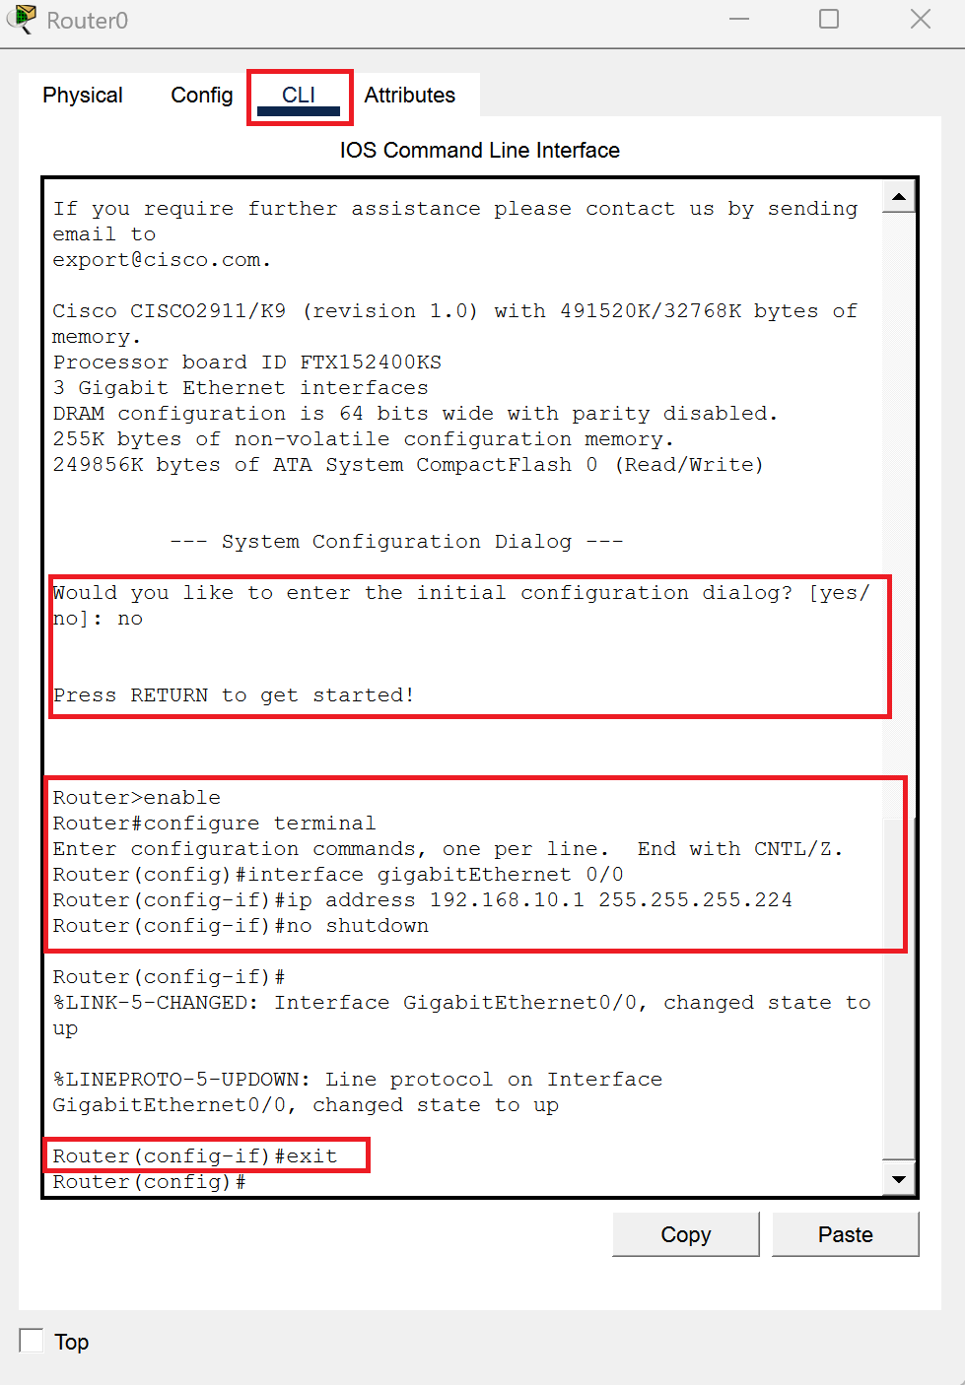
- Press Enter a few times until the Router> prompt appears.
Enter the following commands to activate the interfaces and set the gateways:
Router> enable
Router# configure terminal
! --- Configure EEE Gateway (G0/0) ---
Router(config)# interface gigabitEthernet 0/0
Router(config-if)# ip address 192.168.10.1 255.255.255.224
Router(config-if)# no shutdown
Router(config-if)# exit
! (Repeat the same logic to configure G0/1 for NIE and G0/2 for CCDS)
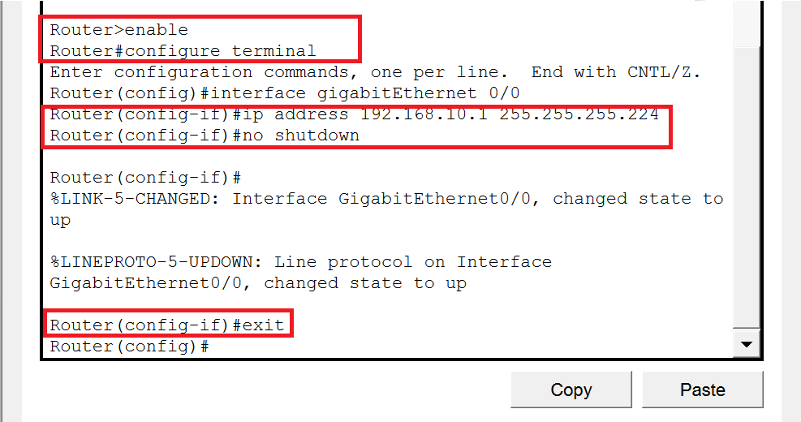

Connectivity Verification
- Open the Command Prompt on PC0.
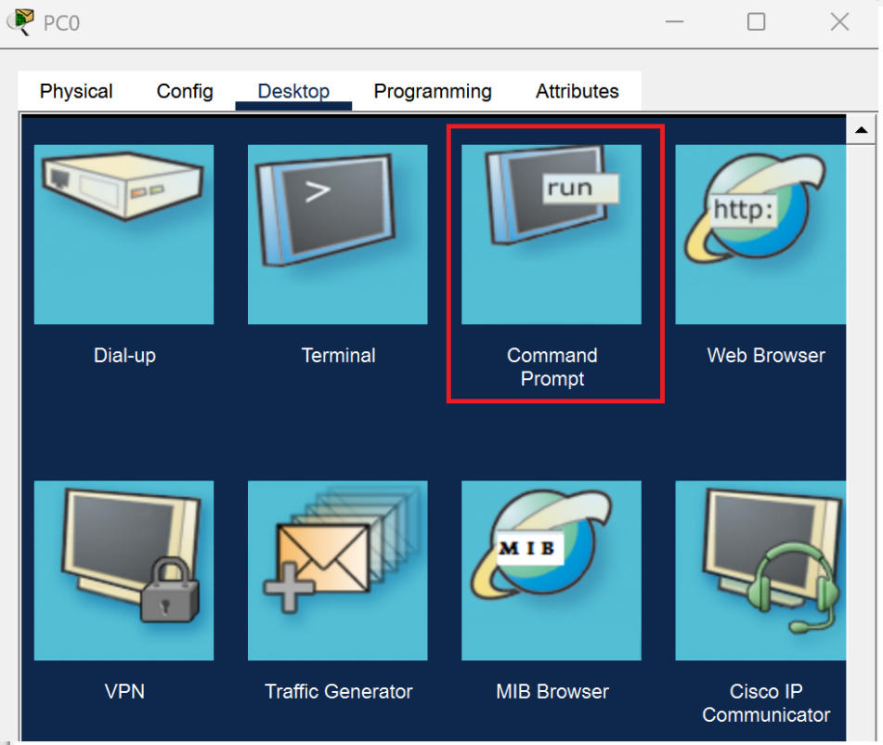
- Enter the command’ ping 192.168.10.34’ to test reachability to PC1.
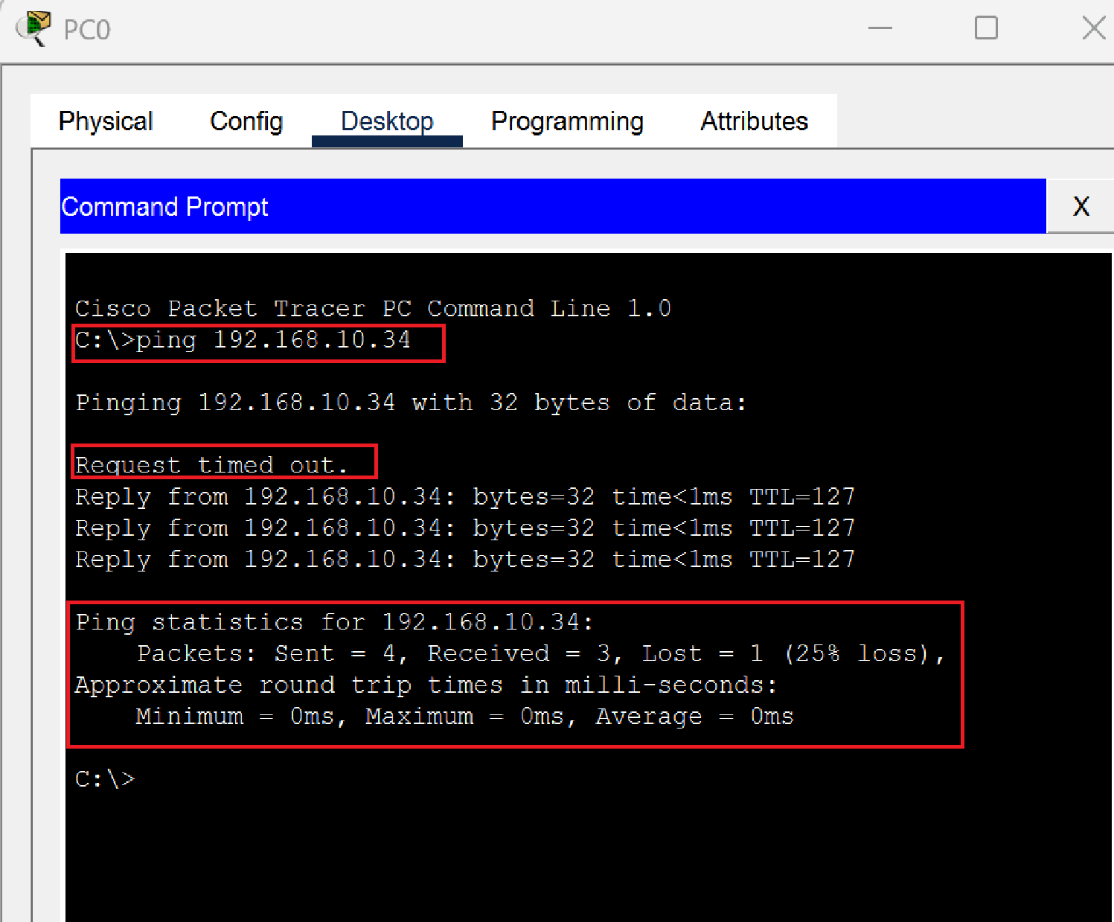
Note: The first one or two requests may display "Request timed out" due to the ARP resolution process. This is a normal phenomenon. A subsequent "Reply from..." indicates successful routing.

Experiment 4 -- DHCP & Broadcast Chaos
To improve efficiency, we will configure the router to act as a DHCP server. However, implementing this in a pure physical multi-link topology will trigger a network conflict.

Configure DHCP Pools
Enter the following commands in the Router CLI:
Router# configure terminal
! Exclude gateway IP addresses
Router(config)# ip dhcp excluded-address 192.168.10.1
Router(config)# ip dhcp excluded-address 192.168.10.33
Router(config)# ip dhcp excluded-address 192.168.10.65
! Create EEE DHCP Pool
Router(config)# ip dhcp pool Pool_EEE
Router(dhcp-config)# network 192.168.10.0 255.255.255.224
Router(dhcp-config)# default-router 192.168.10.1
Router(dhcp-config)# exit
! (Proceed to create Pool_NIE and Pool_CCDS...)

Observe the Bug & Physical Verification
- On PC0, switch the IP Configuration mode from Static to DHCP. Observe the obtained IP address and Gateway. (You will notice PC0 receives an incorrect IP and Gateway pairing ).
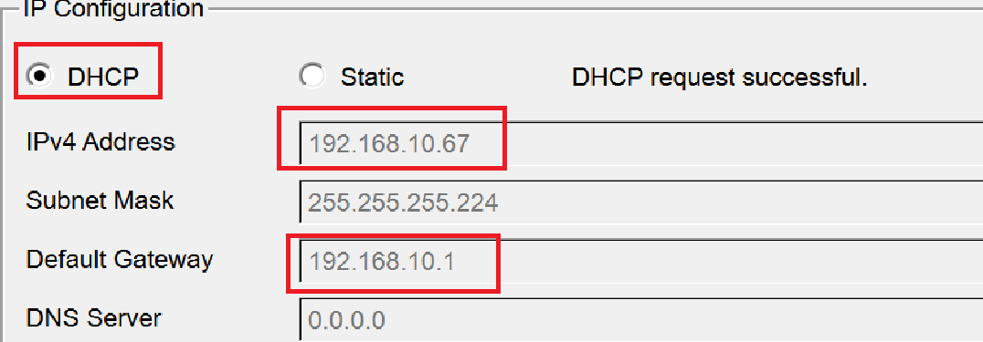
- Select the Delete tool in Packet Tracer. Remove two of the physical links between the switch and the router, keeping only the G0/0 link.
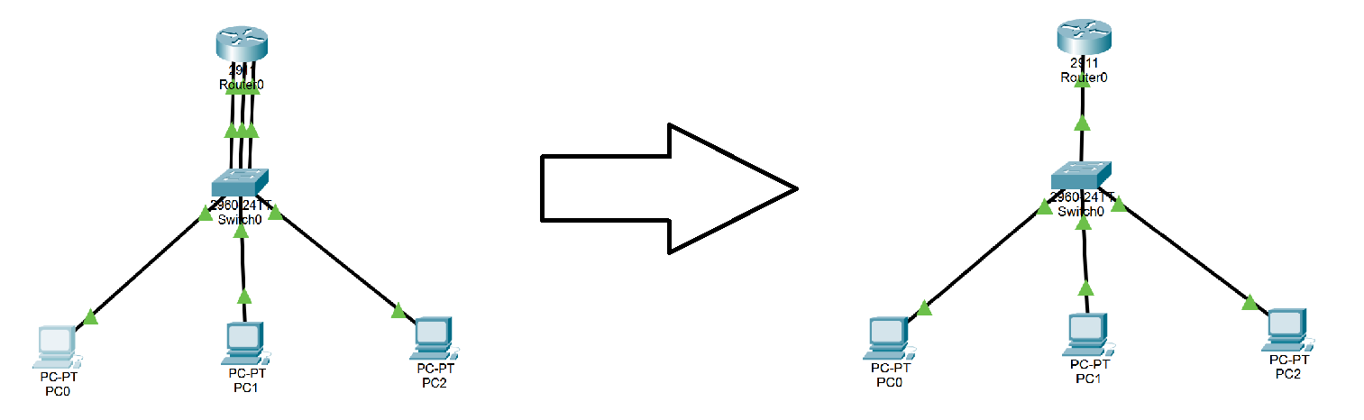
- Switch PC0 back to Static and then to DHCP again. Observe the successful allocation.
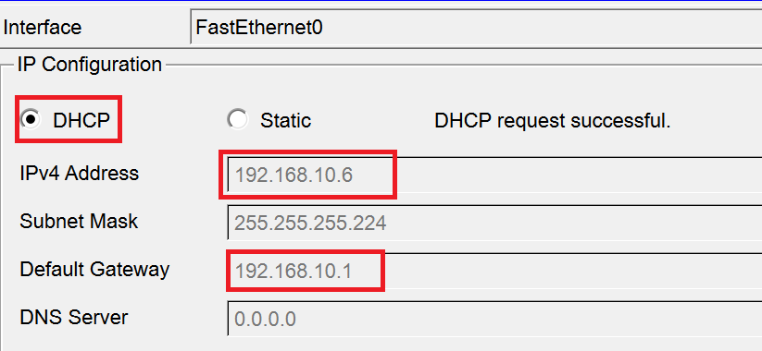

Practice & Thinking Question
Based on the concept of "Broadcast Domain", explain why the DHCP allocation fails when 3 links are connected, but succeeds when 2 links are removed?

Note: After completing this experiment, reconnect the 2 deleted links using Copper Straight-Through cables and set all PCs back to Static IP mode for the next phase.

Transition to Next Parts
By removing the physical cables in Experiment 4, we temporarily solved the DHCP broadcast conflict, but introduced critical engineering challenges:

Reliability Crisis:
Relying on a single switch creates a single point of failure. Introducing redundant switches will cause Layer 2 loops. (To be resolved in Part 2. Spanning Tree Protocol - STP ).

Scalability Crisis:
Unplugging cables disables other colleges. Managing a network without logical boundaries is unsustainable. (To be resolved in Part 3. Virtual LAN - VLAN ).

Part 2. Spanning Tree Protocol (STP) and Layer 2 Loop Prevention

Objectives
- To study and understand the basic principles of Spanning Tree Protocol (STP).
- To build a switched network topology and configure IP connectivity between hosts.
- To introduce redundant links between switches and observe how STP prevents Layer 2 loops.
- To analyze STP information and port roles using CLI commands.
- To understand the Root Bridge election process and influence it by modifying bridge priority.
- To observe how STP recalculates the topology and activates a backup path when a link failure occurs.

Preparation
- Cisco Packet Tracer (Lastest Version)
- Lab Manual with Student instruction and Packet tracer file used in the workshop

Experiment 1 Topology setup
Please complete the terminal device configuration according to the instructions below：

Build the network topology in Packet Tracer
- Open Cisco Packet Tracer.
- In the lower-left corner of the Packet Tracer window, locate the Device-Type Selection Box.
- Click Network Devices, then select Switches.
- From the device list, drag 2960 Switch into the workspace.
Place two switches and rename them as: Switch0, Switch1
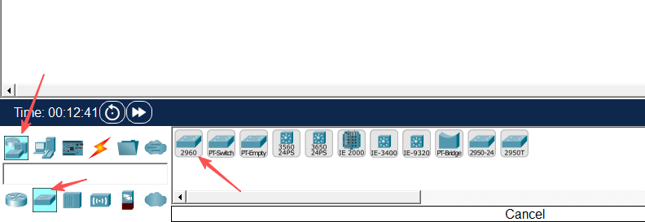
- In the Device-Type Selection Box, click End Devices.
- Drag PC into the workspace and place six PCs. Rename them from PC0 to PC5.
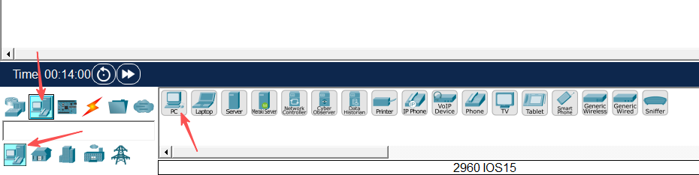
- Click Connections (the lightning icon).
- Select Copper Straight-Through cable and connect the PCs to the switches according to the following table:
Device | Interface | Connected Device | Interface
PC0 | FastEthernet0 | Switch0 | FastEthernet0/1
PC1 |  |  | FastEthernet0/2
PC2 |  |  | FastEthernet0/3
PC3 |  | Switch1 | FastEthernet0/1
PC4 |  |  | FastEthernet0/2
PC5 |  |  | FastEthernet0/3
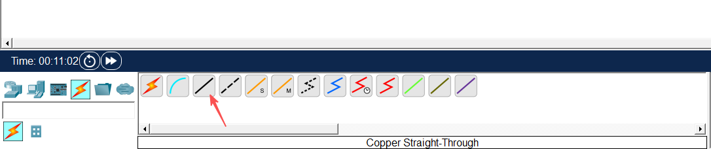
- Use Copper cross-over cable to connect the two switches:
Device | Interface | Connected Device | Interface
Swtich0 | FastEthernet0/4 | Swtich1 | FastEthernet0/4
After completing the connections, ensure that all link lights turn green, indicating that the connections are active.
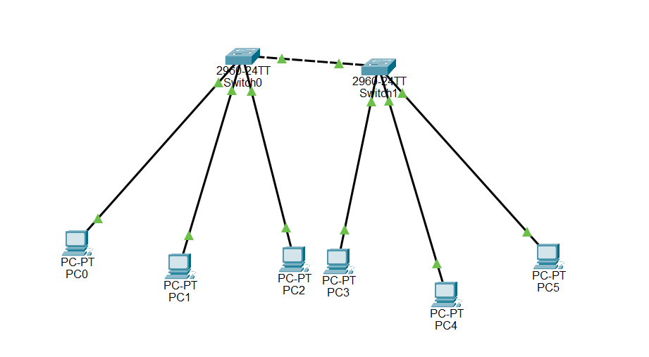

Configure PC IP address
- Click on PC0, navigate to the Desktop tab, and then click on IP Configuration.
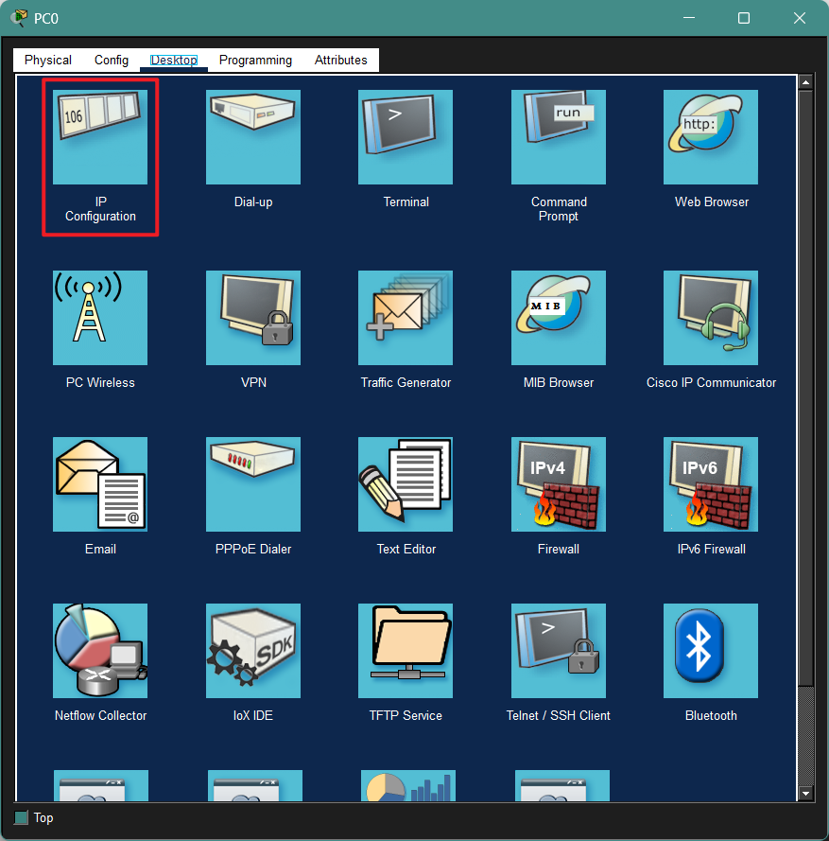
- Set the following parameters:
IPv4 Address: 192.168.10.1
Subnet Mask: 255.255.255.0
Default Gateway: 192.168.10.254
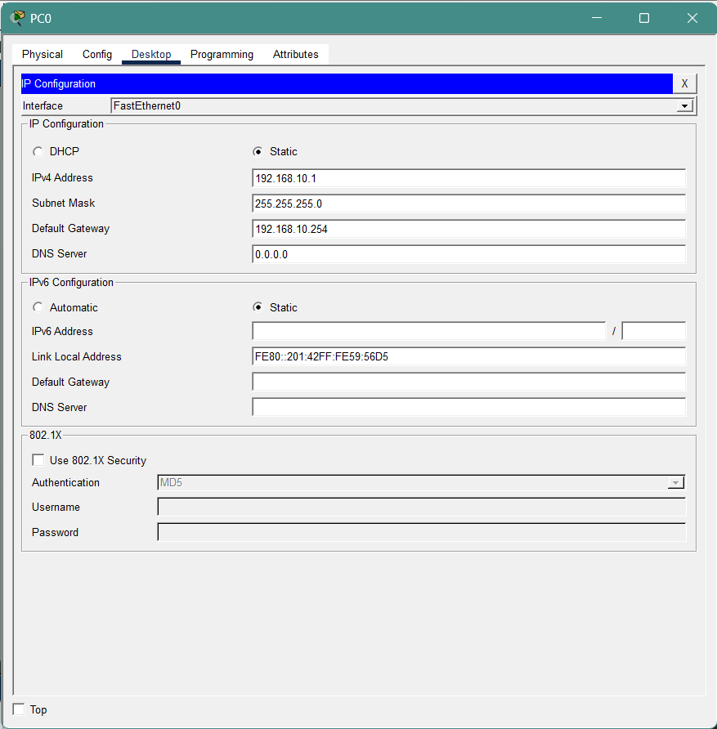
- Repeat this operation to configure PC1-PC5 with IPv4 addresses ranging from 192.168.10.2 to 192.168.10.6.
PC Configuration Reference:
PC No. | IPv4 Address | Subnet Mask | Default Gateway
PC0 | 192.168.10.1 | 255.255.255.0 | 192.168.10.254
PC1 | 192.168.10.2
…… | ……
PC5 | 192.168.10.6
Note: You can choose not to follow the table setup. But do configure all six PCs on the same network segment.

Experiment 2 Introduce Loop and Observe STP Blocking
In this experiment, an additional physical link will be introduced between the two switches to create a Layer 2 loop.

Add an additional link between the switches
- In Packet Tracer, click Connections (the lightning icon).
- Select Copper cross-over cable.
- Connect an additional link between the two switches using the following interfaces:
Device | Interface | Connected Device | Interface
Swtich0 | FastEthernet0/5 | Swtich1 | FastEthernet0/5
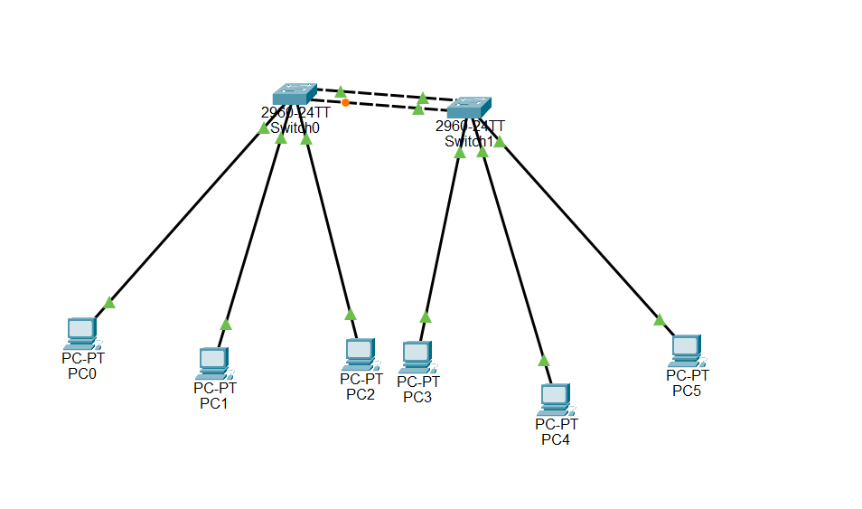
After completing the connection, there will now be two physical links between the two switches. Since there are now two parallel links between the switches, a Layer 2 loop is created in the network.

Observe the switch port status
When a loop appears in a Layer 2 network, the switch automatically uses the Spanning Tree Protocol (STP) to prevent network loops.
- Observe the port status indicators on the switch links in Packet Tracer.
- Among the two links connecting the switches, one of the ports will change to Orange/Green/Red
- This indicates that STP has automatically Blocked/Opened one of the redundant links to prevent a network loop.

Verify STP information using CLI
- Click Switch1 and open the CLI tab.
- Enter the following commands:
Switch> enable
Switch# show spanning-tree
- From the output, observe the following information:
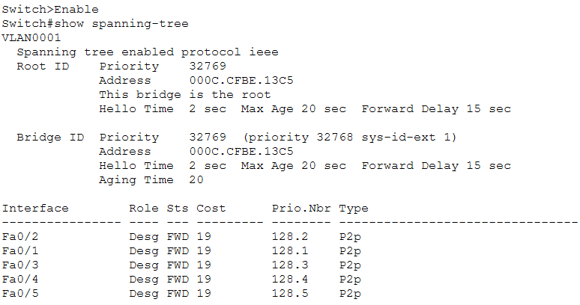
These values show how STP determines the forwarding path and which port should be blocked.

Practice & Thinking Questions
- Why does one of the switch ports enter the Blocking state after adding a second link?

- What problems might occur if the network operates without STP?(at least two points)

- What is the main purpose of Spanning Tree Protocol in a Layer 2 network?

- Complete the STP Information Table of Switch0:
Item | Value
Root Bridge Priority
Root Bridge MAC Address
Root Path Cost
Root Port
Designated Ports
Blocking Port

Experiment 3 Root Bridge Election
In this experiment, we will investigate how Spanning Tree Protocol (STP) elects the Root Bridge in a network and observe how changing the bridge priority can influence the election result.

Observe the current root bridge
- Click on Switch0 and open the CLI tab.
- Enter the following commands:
Switch> enable
Switch# show spanning-tree
- Repeat the same command on Switch1 and find the root bridge.

Change & Verify the bridge priority
STP selects the Root Bridge based on the Bridge ID, which is composed of:
Bridge ID = Priority + MAC Address
A switch with the lowest Bridge ID will become the Root Bridge.
- On Switch0, enter the following commands:
Switch> enable
Switch# configure terminal
Switch(config)# spanning-tree vlan 1 priority 4096
This command lowers the bridge priority of Switch0, increasing its chance of becoming the Root Bridge.
- On Switch0, run the following command again:
Switch# show spanning-tree
- Check whether the output now shows:
This bridge is the root
- Run the same command on Switch1 and observe how the Root Bridge information changes.

Practice & Thinking Questions
- What factor determines which switch becomes the Root Bridge?

- After changing the Root Bridge, does the Blocking port change? Explain why.

Experiment 4 Link Failure Recovery
In this experiment, we will observe how Spanning Tree Protocol (STP) responds to a link failure and automatically activates a backup path.

Disconnect the active link and observe STP reconvergence
- In Packet Tracer, select the Delete tool.
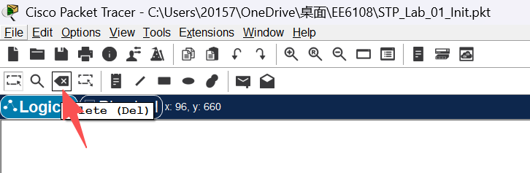
- Identify the port that is currently in the Blocking state.
- Remove the currently active link between the two switches. This link is the one whose ports are in the Forwarding state (Green).
- Identify the port that was previously in the Blocking state. After a short period of time, the port state will change from Blocking (Orange) to Forwarding (Green).
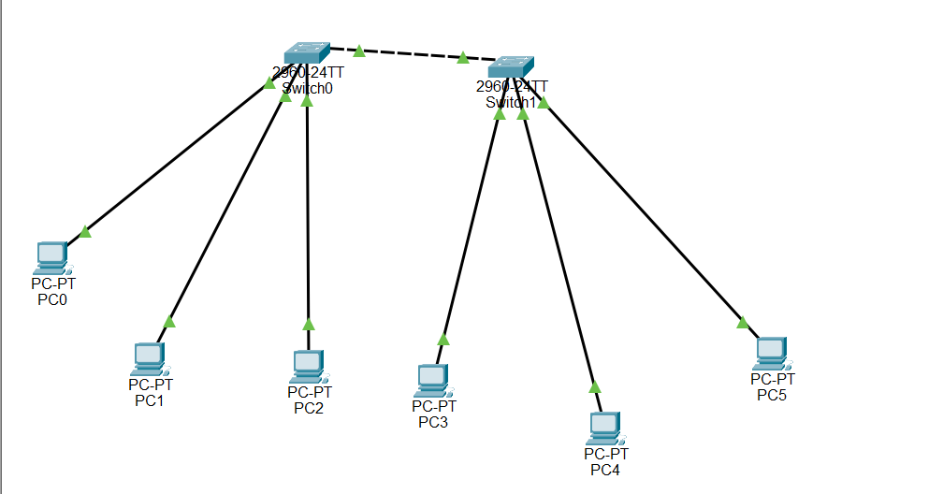
- Click Switch0 and open the CLI tab.
- Enter the following command to view the STP information:
Switch> enable
Switch# show spanning-tree
- Observe the changes in the port roles and port states.

Practice & Thinking Questions
- What happens to the previously blocked port after the active link fails?

- What is the advantage of having redundant links in a network?

Part 3. Virtual LAN(VLAN)Management, Link Aggregation, and Inter-VLAN Routing

Objectives
- To study and practice the principles of VLAN.
- Create multiple VLANs and assign corresponding ports.
- Create a trunk line between 2 switches for paired VLANs.
- By implementing the port security understands Layer 2 Security.
- Understand the implementation of EtherChannel.
- implement Single-Arm Routing for communication between different IP subnets.

Preparation
- 2 switches (Like 2960).
- 6 PC.
- Each switch is connected to 3 PCs.
- Connect the 2 switches.

Description of laboratory experiment set-up
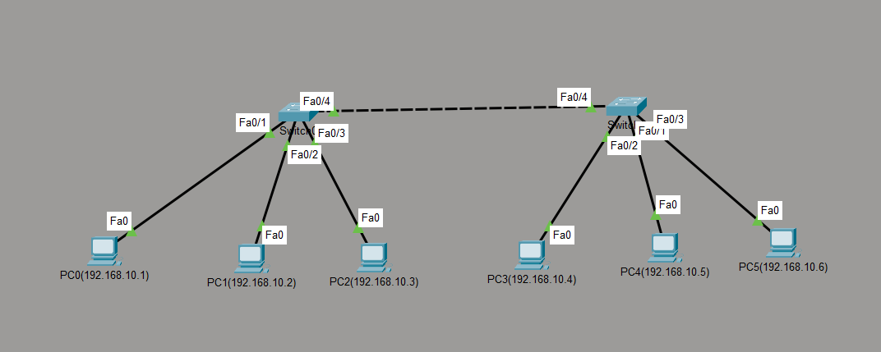

Experiment 1 – Basic Configuration

Create VLANs and name them
Repeat the following commands on both switches (Switch0 and Switch1):
Switch> enable
Switch# configure terminal
Switch(config)# vlan 10
Switch(config-vlan)# name EEE
Switch(config-vlan)# vlan 20
Switch(config-vlan)# name NIE
Switch(config-vlan)# vlan 30
Switch(config-vlan)# name CCDS
Switch(config-vlan)# exit
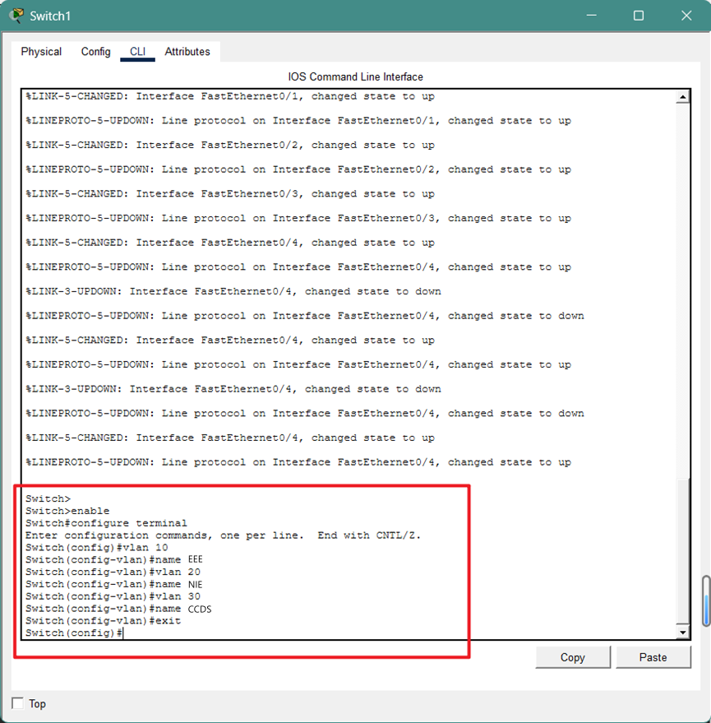
Or you can choose to change the config on both switches (Switch0 and Switch1):
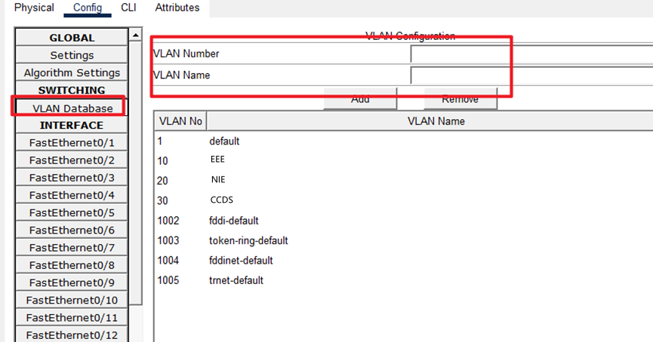

Assign access port
Execute on Switch0 and Switch1 respectively:
- Assign PC0 / PC3 to VLAN 10 (interface Fa0/1):
Switch(config)# interface FastEthernet0/1
Switch(config-if)# switchport mode access
Switch(config-if)# switchport access vlan 10
- Assign PC1 / PC4 to VLAN 20 (interface Fa0/2):
Switch(config)# interface FastEthernet0/2
Switch(config-if)# switchport mode access
Switch(config-if)# switchport access vlan 20
- Assign PC2 / PC5 to VLAN 30 (interface Fa0/3):
Switch(config)# interface FastEthernet0/3
Switch(config-if)# switchport mode access
Switch(config-if)# switchport access vlan 30
Or change according FastEthernet config:
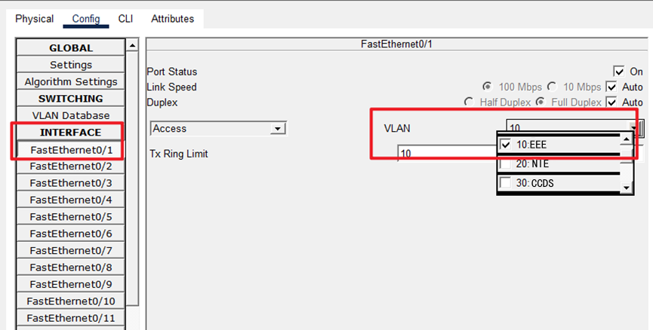

Configure trunk
Execute on Switch0 and Switch1 respectively:
Switch(config)# interface FastEthernet0/4
Switch(config-if)# switchport mode trunk
Or change according ethernet config:
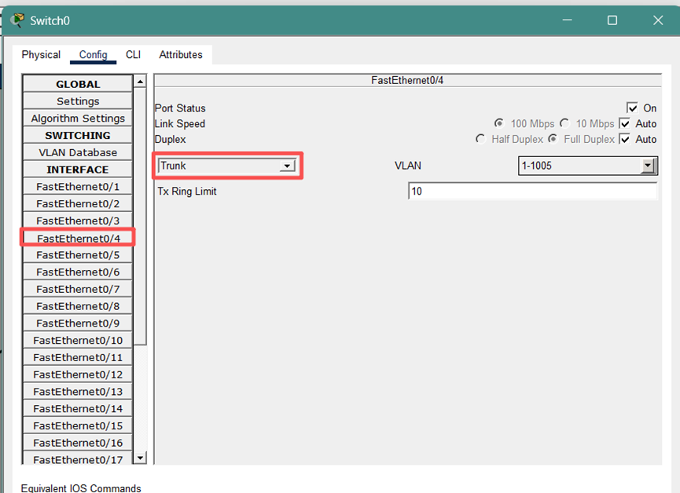
Note: After executing this command, the link lights in Packet Tracer may temporarily turn red and then green, indicating that the Spanning Tree Protocol (STP) is converging again.

View VLAN & trunk & interfaces information
Enter “enable” at the “Switch> ” (At Switch’s CLI interface),
- To view VLAN allocation, input: “show vlan brief”:
- Check whether Trunk is enabled: “show interfaces trunk”
- Check interface status: “show ip interface brief”

Practice & Thinking Questions
- Test 1 (VLAN Cross-Switch): Please ping the VLAN 10 host of Switch 1 from the VLAN 10 host of Switch 0. What is the result? What does this indicate about the role of the Trunk link?

- Test 2 (Communication across Different VLANs): Please ping the host on VLAN 20 of Switch 0 from the host on VLAN 10 of Switch 0. What is the result? Explain why this result occurs, taking into account the MAC address table (show mac address-table).

If you want to prove that "only VLAN 10 can receive", you can use the Simulation mode of Packet Tracer:
Click the clock icon in the lower right corner to switch to Simulation mode.
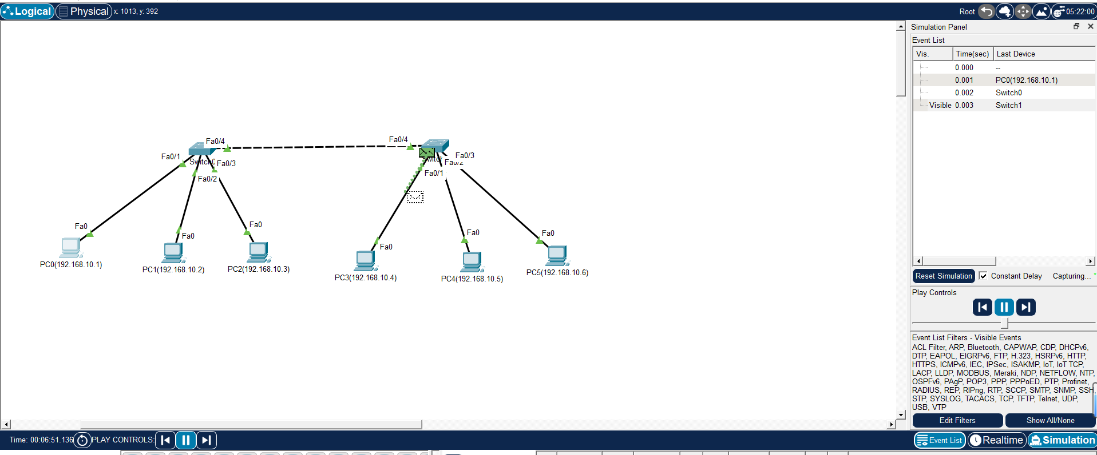
In the "Edit Filters" section, only check the ARP option.
Let PC0 ping PC3.
Click the "Play" button, and you will see the green packet (ARP) flying out like an envelope.
Observation: You will notice that the envelope only flies to ports within the same VLAN, while a red "X" appears above other VLAN ports, indicating that they have been blocked.
- Test 3: Change one end of the Trunk link between two switches back to Access mode, observe the changes in network communication, and consider what consequences would arise from a mismatch in negotiation between the two ends.

- Q1(Broadcast Domain Isolation): When no VLAN is configured, if a PC sends an ARP broadcast request, which devices in the network can receive it? After configuring VLANs 10, 20, and 30, if a PC within VLAN 10 sends an ARP broadcast, who else can receive it? Please briefly describe how VLAN improves network performance and security.

- Q2(The Essence of Trunk): If we do not configure a Trunk interface, but instead use three network cables to connect the VLAN 10, 20, and 30 interfaces of two switches respectively, can we achieve the same communication effect? If so, why do we still use Trunk technology?

- Q3(No routing state): In the experiment, different VLANs cannot communicate with each other. If we want VLAN 10 and VLAN 20 to communicate with each other, what type of device do we need to introduce into the network topology? (To pave the way for the next stage of the single-arm router/layer 3 switch experiment)

Note: Congratulations on completing Experiment 1！
The following 3 experiments are based on this experiment (Experiment 1). Please save the .pkt file current as a template for subsequent experimental operations.

Experiment 2 -- EtherChannel and Spanning Tree Protocol （STP）Observation

Upgrade Topology and Observe the initial state of STP
Connect an additional crossover cable between two 2960 switches. After connecting the cable without further configuration, one port on one of the links will turn orange (Blocking state).
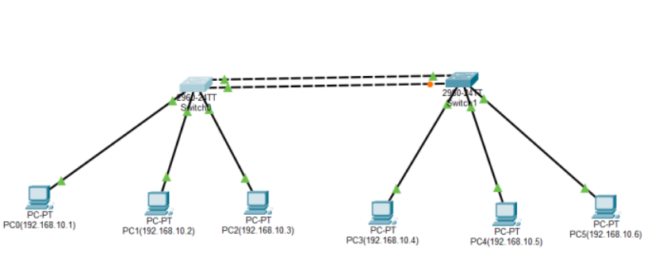
Enter show spanning-tree in the privileged mode to observe the root bridge election results and specific port statuses (blocked ports are displayed as BLK)
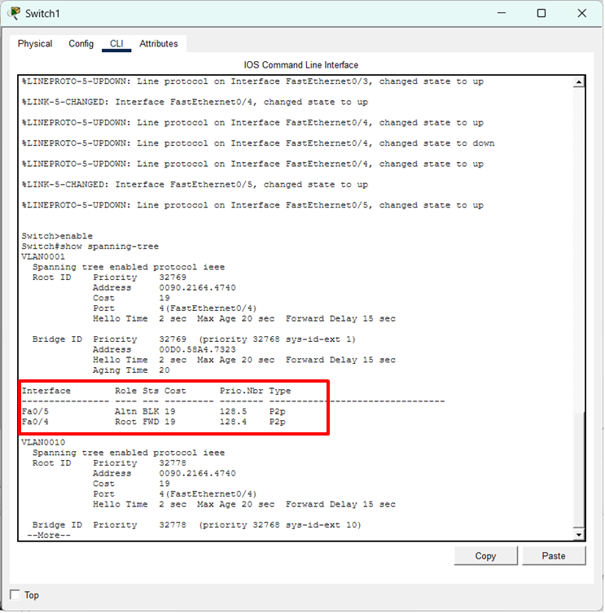

Configure EtherChannel
- In the global configuration mode of Switch 0 and Switch 1, enter the following identical configuration commands:
enable
show spanning-tree
# 1.Enter the two connected physical interfaces simultaneously.
interface range fastEthernet 0/4-5
# 2.Bundle these two ports into Channel Group 1 and set them to active negotiation mode.
channel-group 1 mode active
exit
# Enter the newly created logical interface Port-Channel 1.
interface port-channel 1
#Configure this logical interface as Trunk mode to carry all VLANs.
switchport mode trunk
End
- Use the Fast Forward Time feature in Packet Tracer to manually accelerate the convergence of STP and LACP (Link Aggregation Control Protocol). Once the network converges, all four port indicators between the switches turn green. Communication between PC1 and PC4 remains normal.
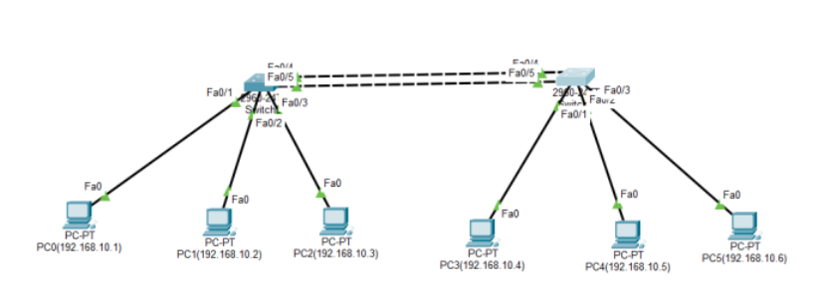

Verification Procedures
Execute the following three core commands in the privileged mode (Switch#) of Switch 0 or Switch 1:
- Check Aggregation Summary Status
Command: Switch# show etherchannel summary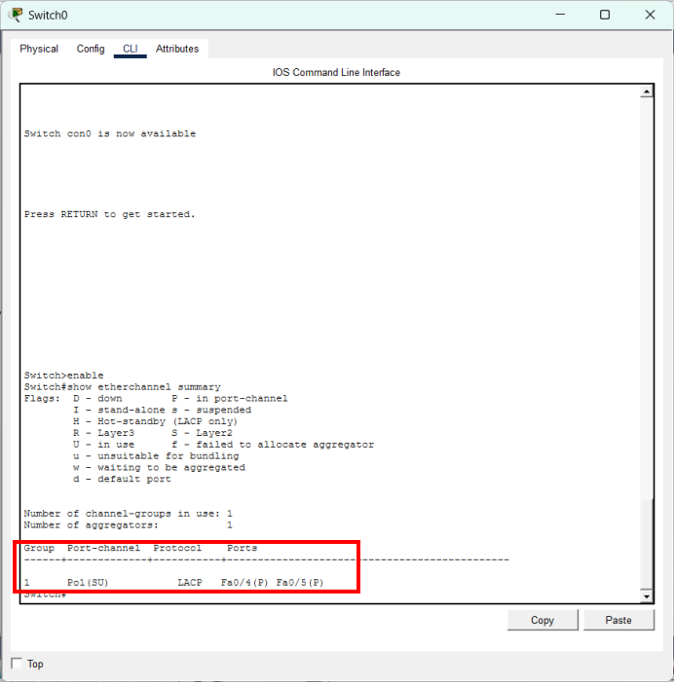
Check Group Status if Po1 is marked as (SU). S stands for Layer 2, and U stands for In Use, which signifies success.Check Ports Status if physical ports (e.g., Fa0/4, Fa0/5) are marked as (P), indicating they are successfully bundled into the Port-channel.

- Check Spanning Tree Protocol (STP) Status
command：Switch# show spanning-tree
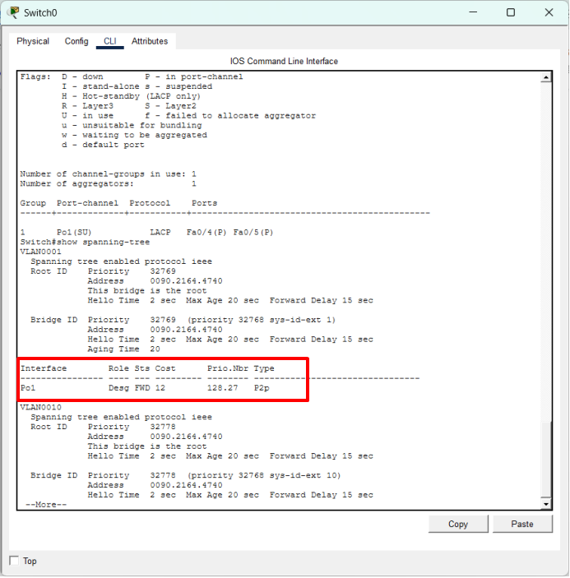
The original physical ports Fa0/4 and Fa0/5 should disappear from the list, replaced by the logical interface Po1 in the FWD (Forwarding) state.
- Final Connectivity Test
Perform a continuous Ping test from PC0 (VLAN 10) to PC3 (VLAN 10). Ping responses are normal with 0% loss.
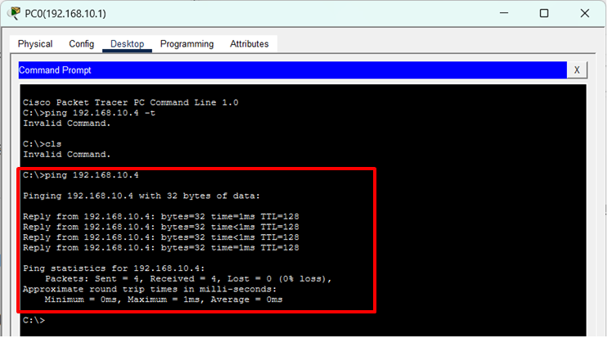
- Why did the orange port (blocked by STP) turn green after configuring EtherChannel?

Experiment 3 -- Port Security Configuration

Port security configuration command (CLI)
Please click on Switch0 to enter the CLI tab, and then enter the following commands in sequence:
Switch> enable
Switch# configure terminal
Switch(config)# interface FastEthernet0/3
# The port must first be set to Access mode (Port Security does not support Trunk or dynamic ports)
Switch(config-if)# switchport mode access
# Enable port security function
Switch(config-if)# switchport port-security
# Limit the maximum number of MAC addresses allowed to be learned to 1
Switch(config-if)# switchport port-security maximum 1
# Set to Sticky, permanently binding the currently connected PC's MAC address to the configuration
Switch(config-if)# switchport port-security mac-address sticky
# Set the violation triggering action (default is shutdown, which means closing the port)
Switch(config-if)# switchport port-security violation shutdown

Ensure that the switch "captures" the identity of legitimate hosts
Ping other PCs in the net. Making sure that the switch remember the MAC address.
You can confirm that the Sticky MAC Addresses has changed to 1 by entering "show port-security interface fa0/3" on the switch.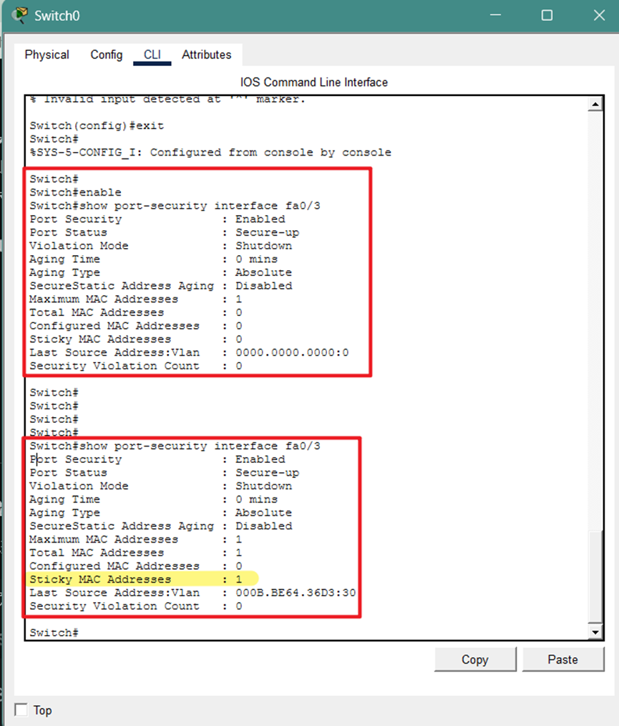

Simulating "hacker" access
Disconnect: Use the delete tool (shortcut key Del) to remove the connection between Switch0 and the original PC2.
Connect a new device: Add a new laptop or PC and connect it to Fa0/3 of Switch0.
Trigger: When configuring the IP address for the hacker's PC, you will notice that the light on the Fa0/3 interface instantly changes from green to red.
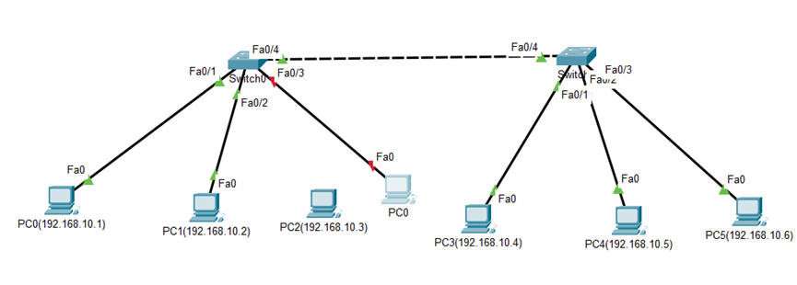
At this time, you can view the following information by checking the CLI interface of the switch:
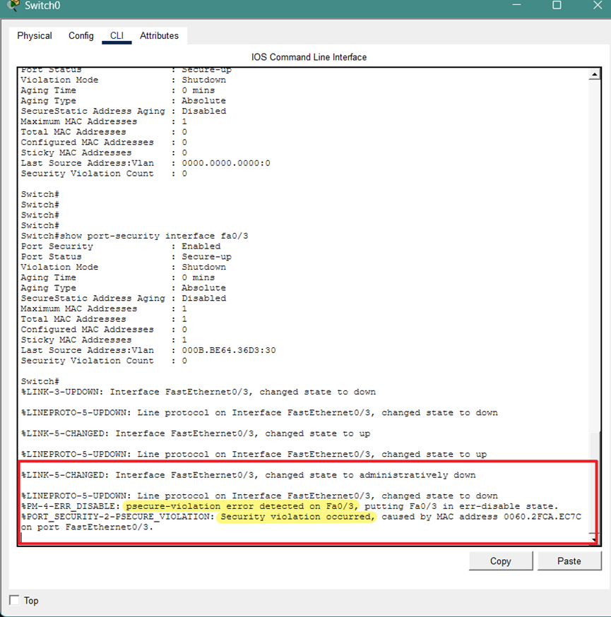

Phenomenon observation and recovery
When a port is disabled due to violations, it enters a special state known as "err-disabled".
- View violation records
Enter the follow commands at Switch’s CLI tab(Switch#):
Switch# show port-security interface FastEthernet0/3
You will see in the output:
Port Status: Security-shutdown
Security Violation Count: 1
Last Source Address: [The MAC address of the hacker's PC will be displayed here]
- Restore interface
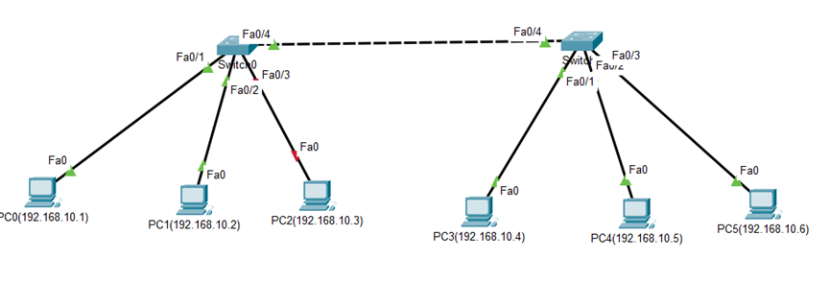
First, reconnect the originally legal PC.
Enter the following command at switch’s CLI tab:
Switch# configure terminal
Switch(config)# interface FastEthernet0/3
Switch(config-if)# shutdown
Switch(config-if)# no shutdown
It can be observed that the original PC has restored normal connection.
Question: If you directly enter "not shutdown" instead of "shutdown" first, will the original PC be able to restore normal connection? What is the status of the interface? Why?

Auto Recovery
In real-world production environments, manually closing and reopening hundreds of ports can be extremely cumbersome. Cisco provides an automatic recovery function:
Switch(config)# errdisable recovery cause psecure-violation
# Set the waiting time for automatic recovery (e.g. 30 seconds)
Switch(config)# errdisable recovery interval 30

Experiment 4 -- Single-Arm Routing Configuration

Upgrade Topology
Use a straight-through cable to connect Switch0 (Fa0/10) to Router 2911. (GigabitEthernet 0/0). Initially, both ends of the cable will appear red; this is normal because router interfaces are disabled by default.

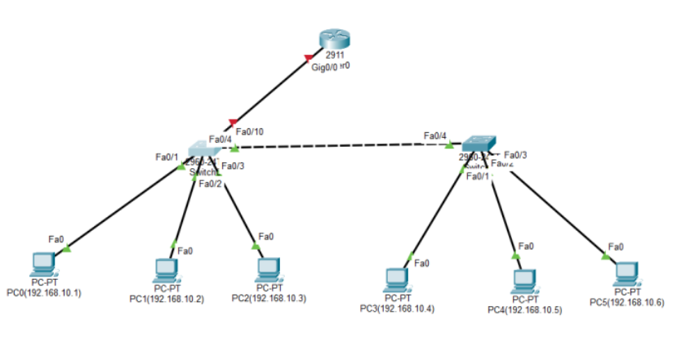

Configure Single-Arm Routing
- Switch Side: Backbone Link Configuration
To allow the link connecting to the router to carry tagged packets for multiple VLANs, the port must be set to Trunk mode. Enter the CLI for Switch0:
Switch>enable
#User Mode → Privileged Mode: Gain authorization to view and modify configurations.
Switch# configure terminal
#Privileged Mode → Global Configuration Mode: Prepare to modify switch parameters.
Switch(config)# interface fastEthernet 0/10
#Interface Configuration Mode: Specify the Fa0/10 port connected to the router.
Switch(config-if)# switchport mode trunk
#Configure Trunking: Allow the link to carry data for multiple VLANs (10 and 20).
Switch(config-if)# no shutdown
#Activate Interface: Ensure the physical port is turned on.
Switch(config-if)# exit
#Exit Interface: Return to the previous Global Configuration level.
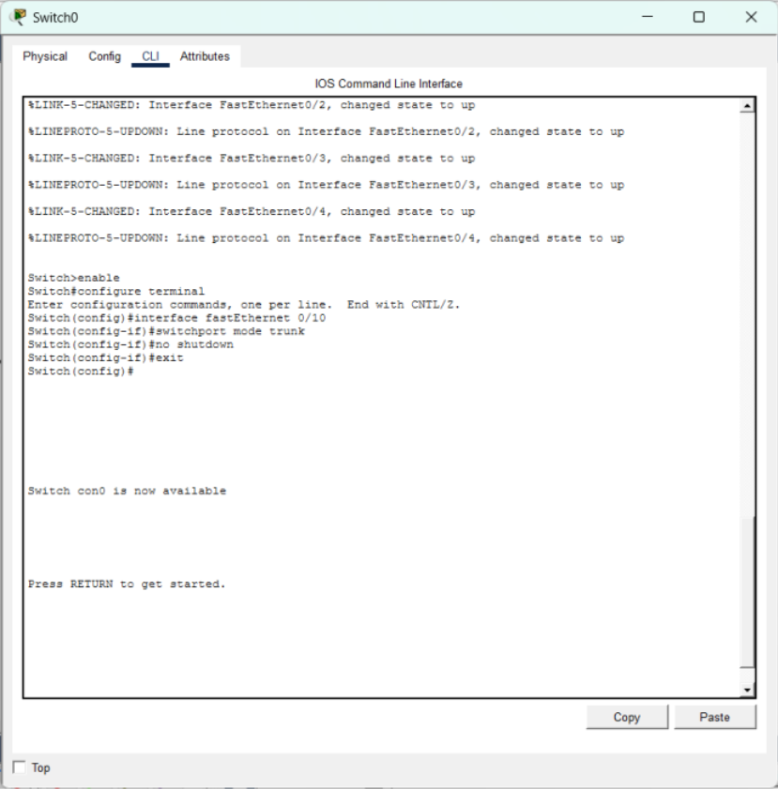
- Router Side: Sub-interface and Gateway Configuration
The router provides an independent Layer 3 entry point for each VLAN by dividing logical sub-interfaces.Enter the CLI for the Router:
Router> enable
# Enter privileged mode: Ready to start configuring the router.
Router# configure terminal
# Enter global configuration mode: Ready to enter configuration commands.
Router(config)# interface gigabitEthernet 0/0,
# Physical interface mode: Enter the main physical interface to perform the enable operation.
Router(config-if)# no shutdown
# Enable the physical master switch: The connection lines in the topology diagram will change from red to green at this point.
Router(config-if)# exit
# Return to global configuration mode: Ready to create subinterfaces.
--- Subinterface 10 ---
Router(config)# interface gigabitEthernet 0/0.10
#Enter subinterface mode: Create a logical interface dedicated to VLAN 10.
Router(config-subif)# encapsulation dot1Q 10
# Encapsulation protocol: Bind the 802.1Q protocol and specify that it belongs to VLAN 10.
Router(config-subif)# ip address 192.168.10.254 255.255.255.0
#Configure Gateway IP: Provide a routing exit for VLAN 10 hosts
Router(config-subif)# exit
#Return: Prepare to configure the next VLAN.
--- Sub-interface 20 ---
Router(config)# interface gigabitEthernet 0/0.20,
#Sub-interface Mode: Create a logical interface dedicated to VLAN 20.
Router(config-subif)# encapsulation dot1Q 20,
#Encapsulation Protocol: Bind the 802.1Q protocol to VLAN ID 20.
Router(config-subif)# ip address 192.168.20.254 255.255.255.0,
#Configure Gateway IP: Provide a routing exit for VLAN 20 hosts.
Router(config-subif)# end
#Finish Configuration: Exit back directly to Privileged Mode.
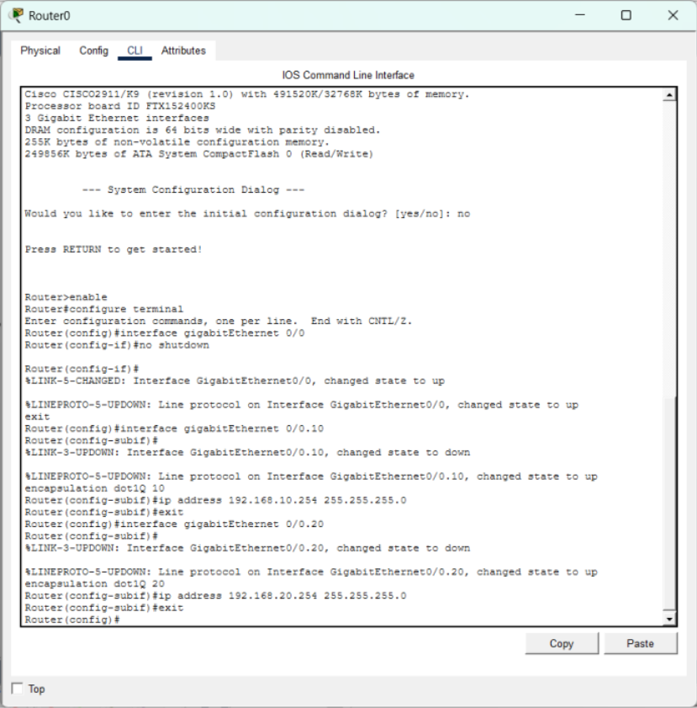

Verification Procedures
- Terminal Configuration Verification
Click the PC icon, select the Desktop tab, and click IP Configuration to enter details:
PC0 (VLAN 10): IP 192.168.10.1, Default Gateway must point to 192.168.10.254.
PC3 (VLAN 20): IP 192.168.20.1, Default Gateway must point to 192.168.20.254.
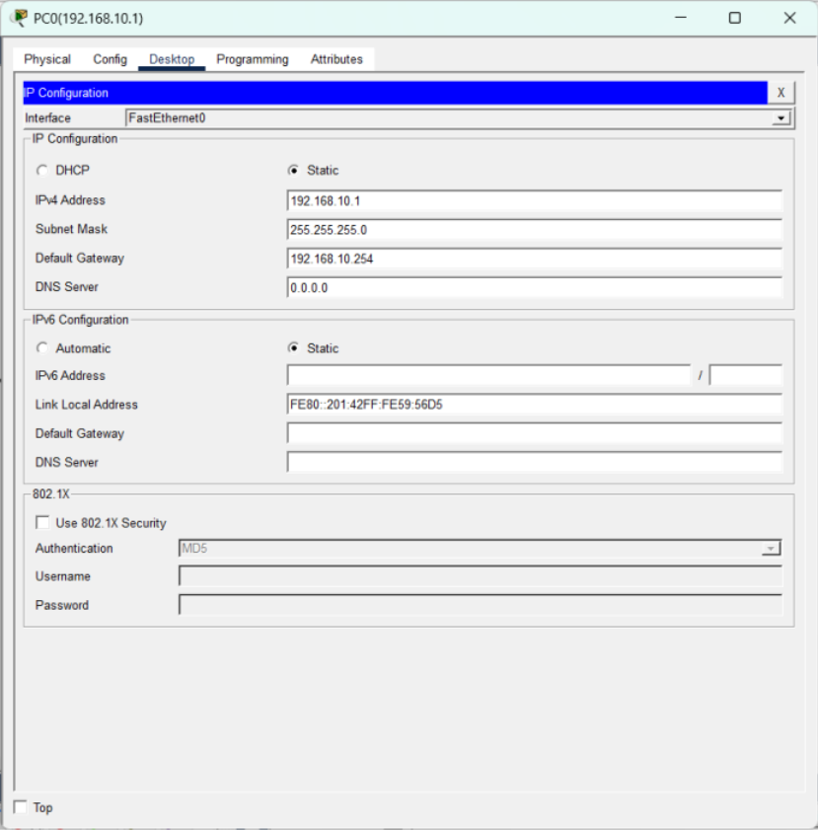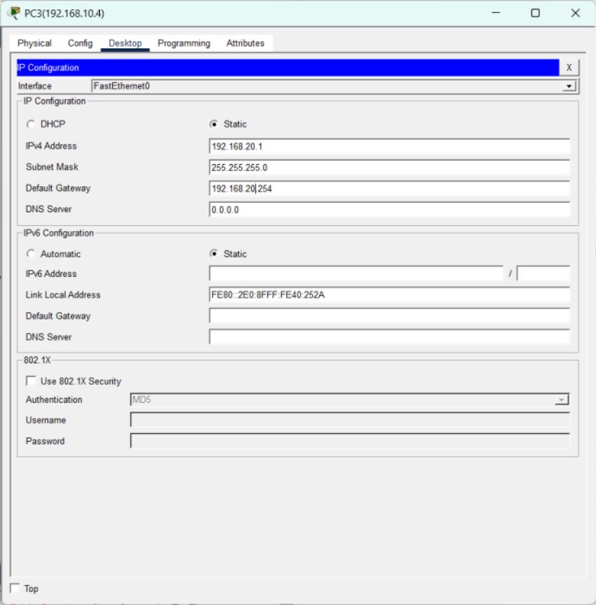
- Connectivity Test (Ping Test)
Open the Command Prompt on PC0 and enter ping 192.168.20.1. Due to ARP requests, the first 1-2 packets may "Timed out," followed by "Reply from...". Successful replies prove cross-segment communication is successful.
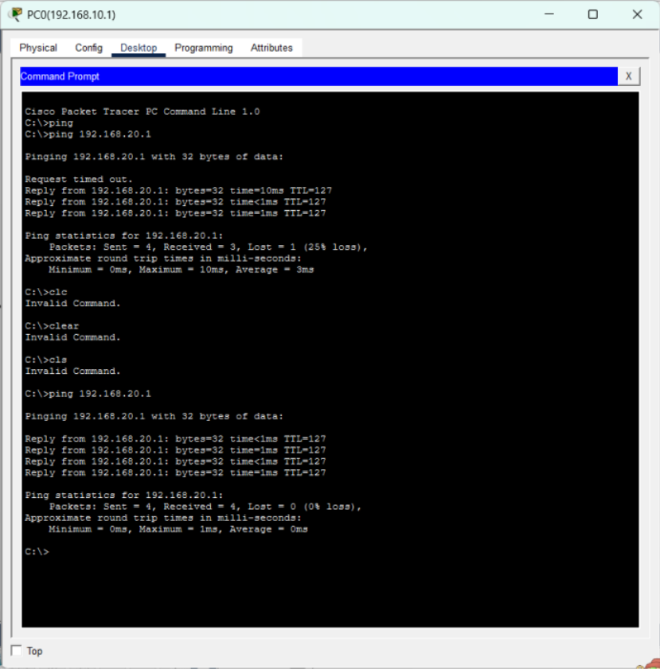
- Routing Table Verification
Enter show ip route on the router CLI. You should see two routes marked with C (Connected) pointing to Gi0/0.10 and Gi0/0.20 respectively.
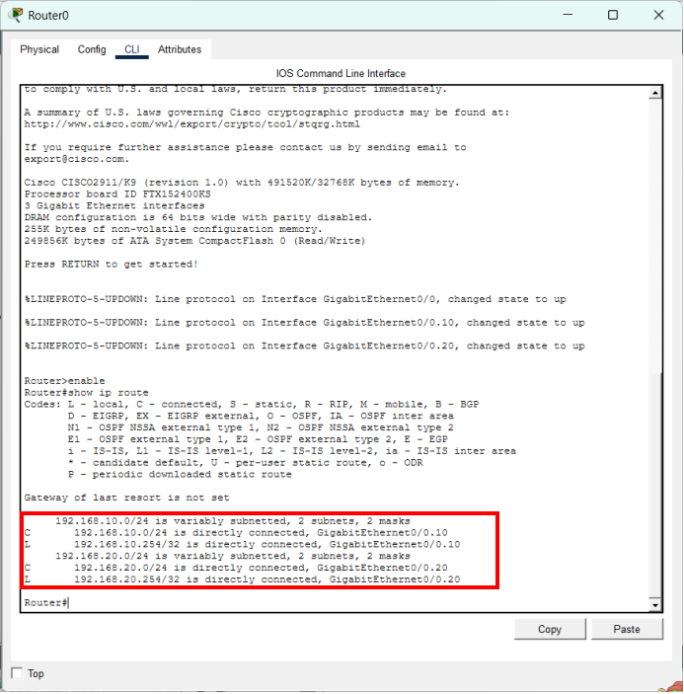
- Why is Trunk mode mandatory for the Switch-Router link?

- What happens if the Default Gateway on the PC is configured incorrectly?

- What are the limitations of the Single-Arm Routing approach in a high-traffic environment?

Part 4. Network Address Translation (NAT) Basics and Configuration (additional part)

Objectives
- Learn and understand the working principles of Network Address Translation (NAT), distinguishing between Private Networks and Public Networks.
- Master basic router configurations, including the setup of Serial communication and Static Routes.
- Configure Static NAT on the router to achieve one-to-one mapping from private IPs to public IPs.
- Verify NAT protection features and analyze the network communication process through packet tracing and the NAT Table.

Preparation
- Cisco Packet Tracer software
- 2 Routers (Model: Router-PT, providing serial modules)
- 2 Switches (Model: Switch-PT)
- 3 PCs (simulating public and private network terminals)
- 1 Server (simulating an external Web server, providing HTTP services)
(For the convenience of the experiment, the department has been simplified to a single host.)
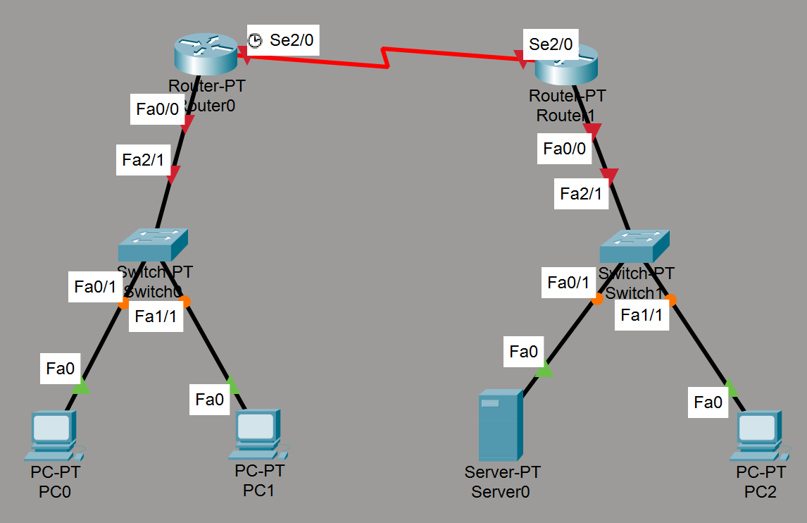

Experiment 1 Network Topology Setup and IP Address Allocation
In this experiment, we will build two isolated network environments: a private network and a public network, and allocate IP addresses to the devices.

Private Network IP Address Allocation
- PC2: Open Desktop > IP Configuration. Set the IPv4 address to 10.10.10.1, subnet mask to 255.0.0.0, and default gateway to 10.10.10.0.
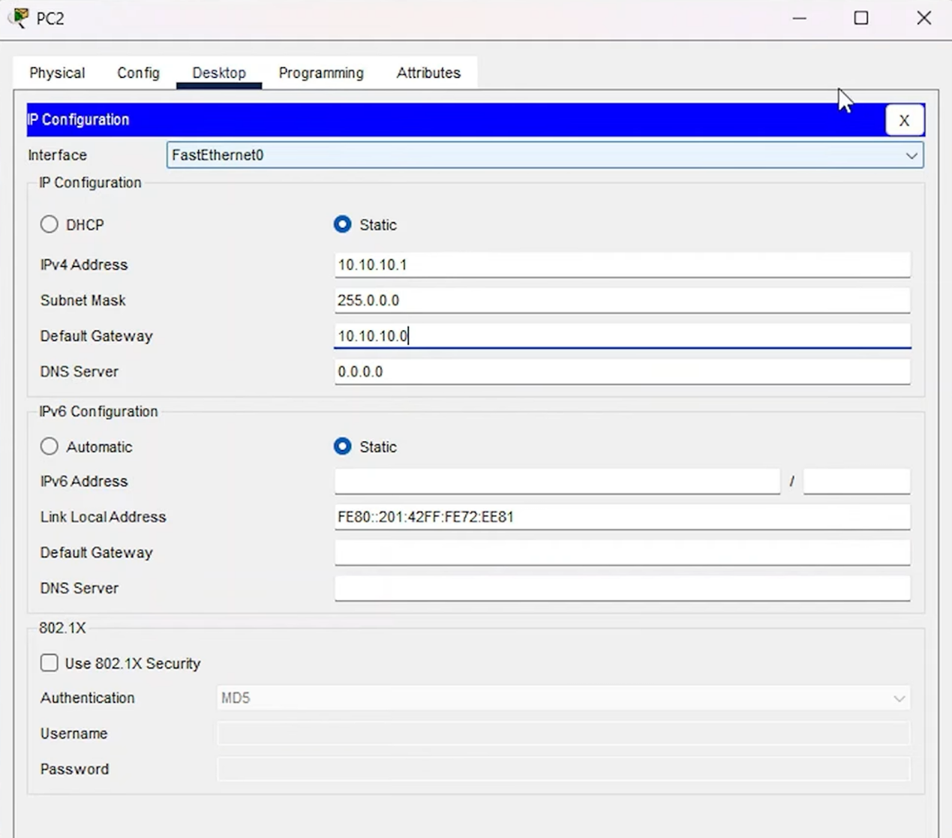
- Server (Server0): Open Desktop > IP Configuration. Set the IPv4 address to 10.10.10.2, subnet mask to 255.0.0.0, and default gateway to 10.10.10.0.
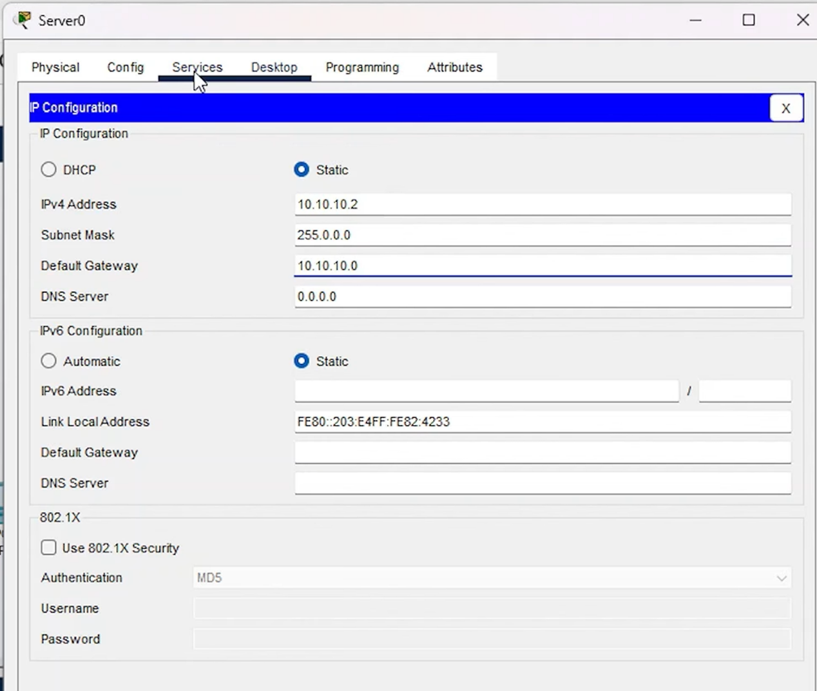
- Configure Web Service: Go to the Services tab of the server and ensure HTTP and HTTPS are turned on. Edit the index.html file, change its title text to "Youtube", and save it for subsequent testing.
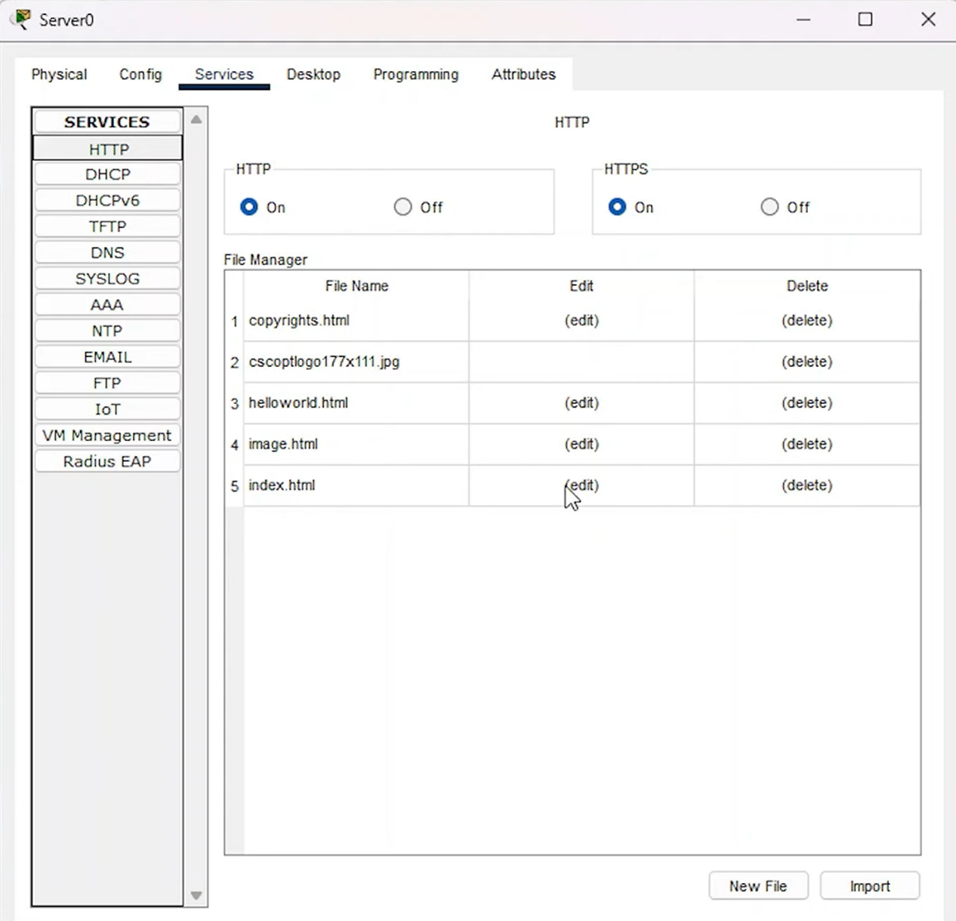
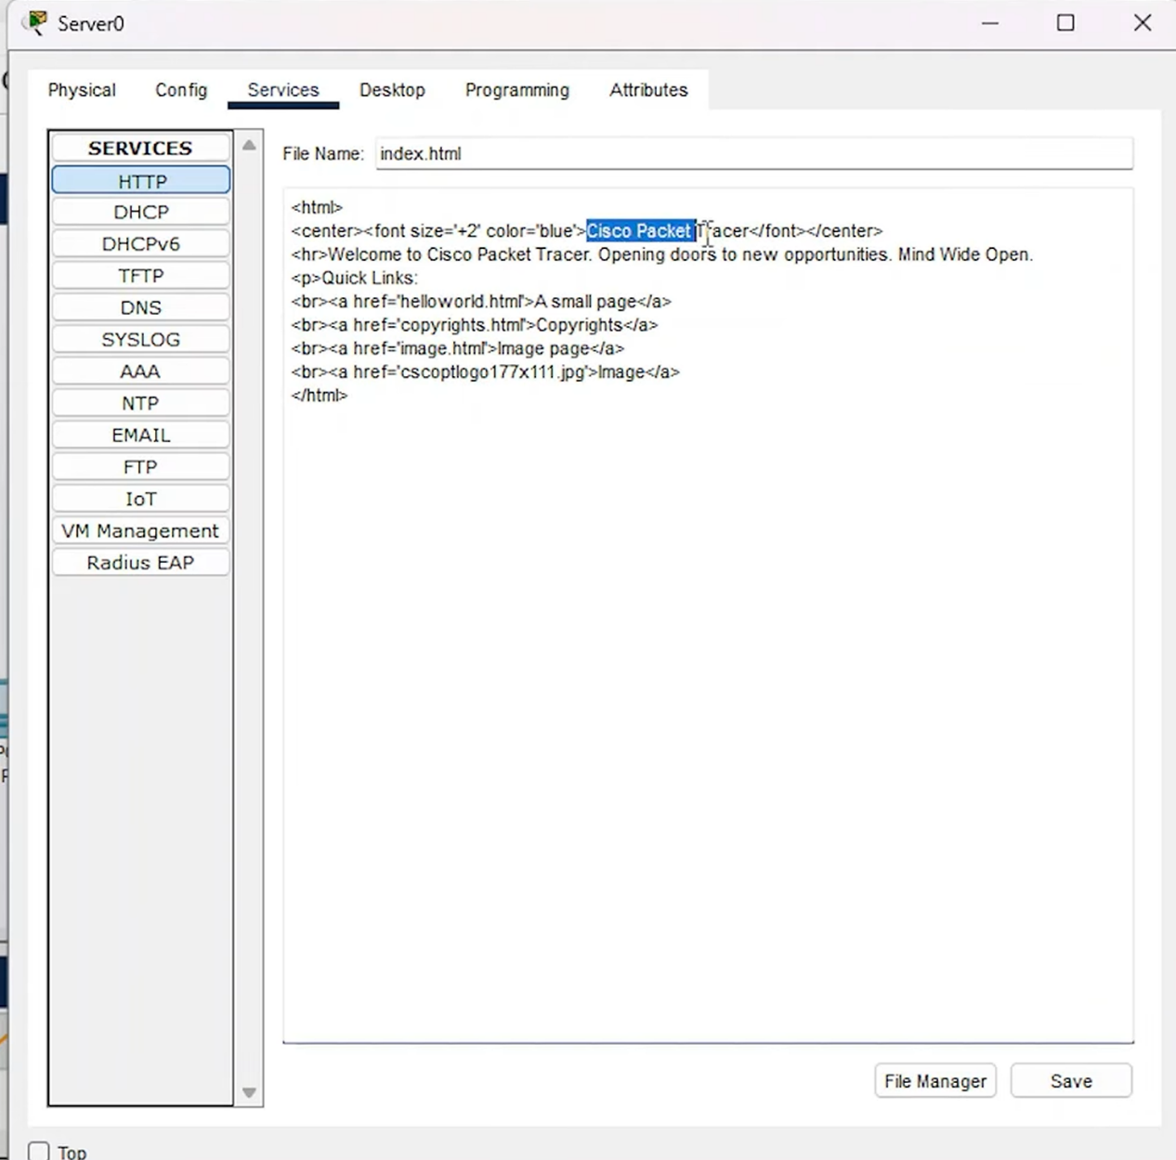
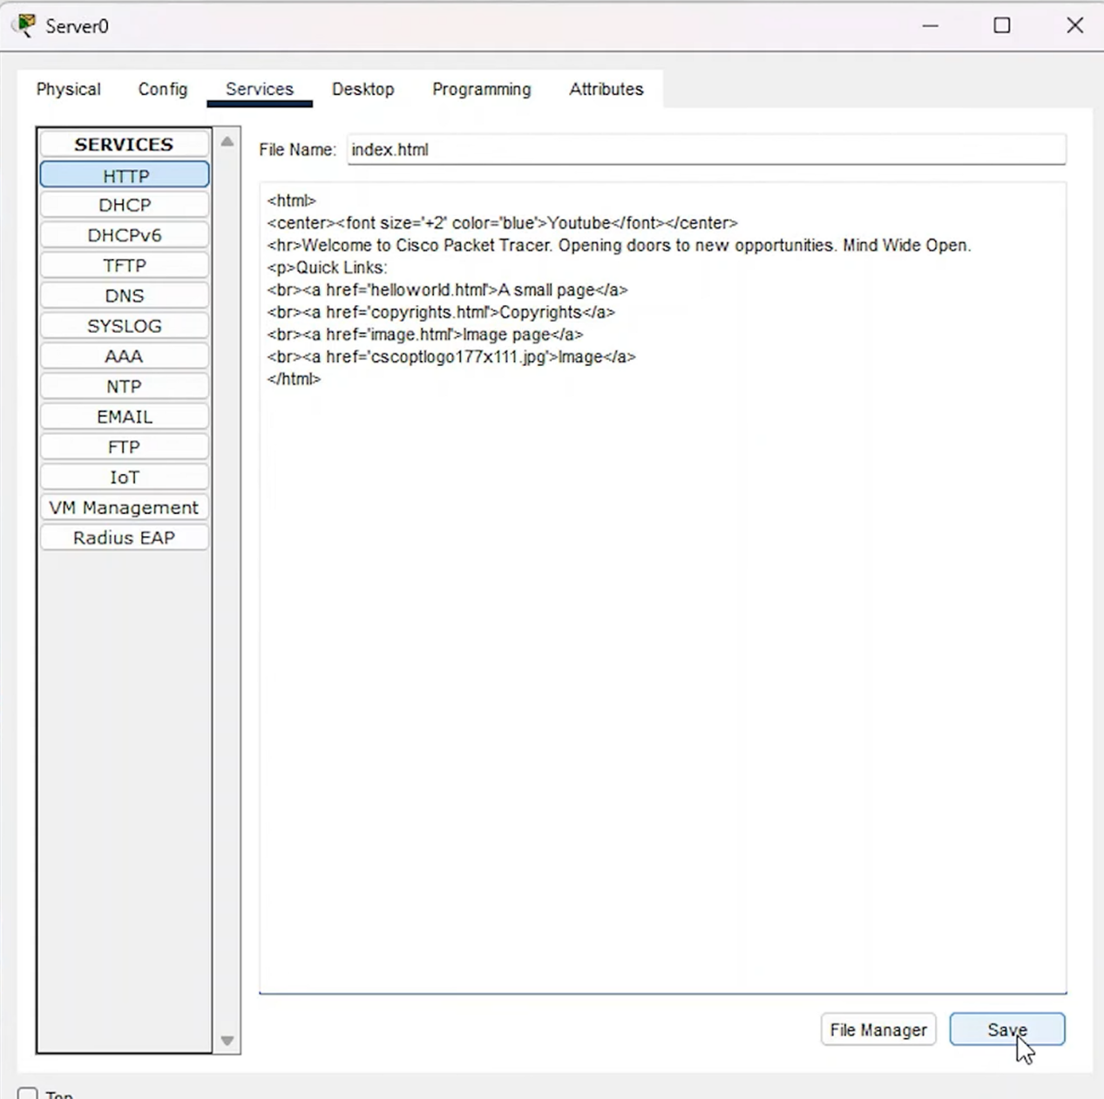

Public Network IP Address Allocation
- PC1: Open Desktop > IP Configuration. Set the IPv4 address to 20.20.20.1, subnet mask to 255.0.0.0, and default gateway to 20.20.20.0.
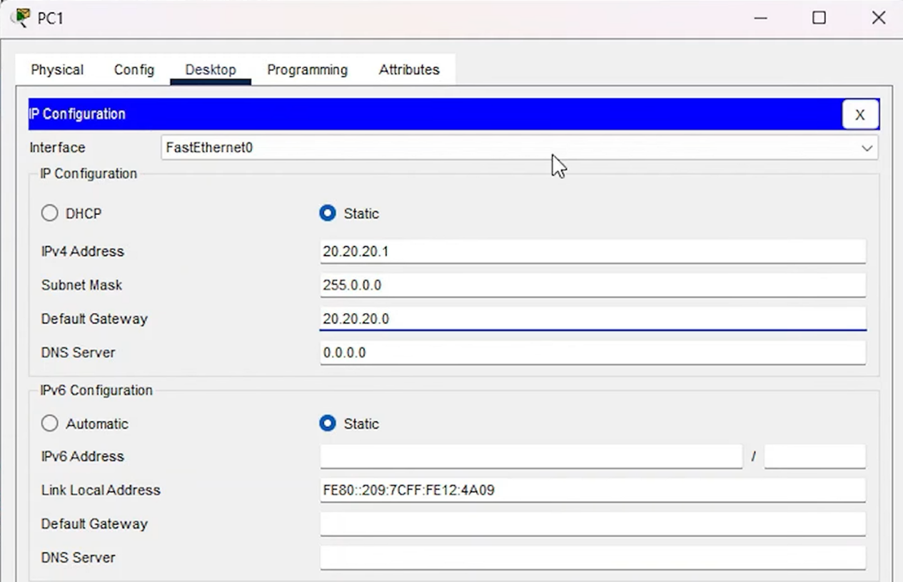
- PC0: Set the IPv4 address to 20.20.20.2, subnet mask to 255.0.0.0, and default gateway to 20.20.20.0.
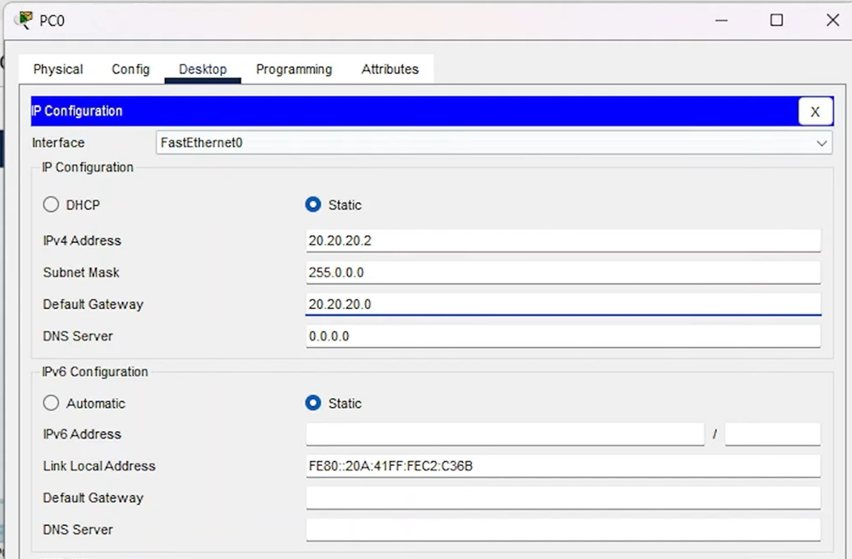

Experiment 2 Router Interface and Static NAT Configuration
This session will establish the physical links of the routers and configure static NAT translation rules on the boundary router.

Basic Router Configuration
- Router 1 (Private Network Side):
Go to the Config tab > Interface f0/0 (connected to the switch). Turn on Port Status and assign the IPv4 address 10.10.10.0 (which is the default gateway).
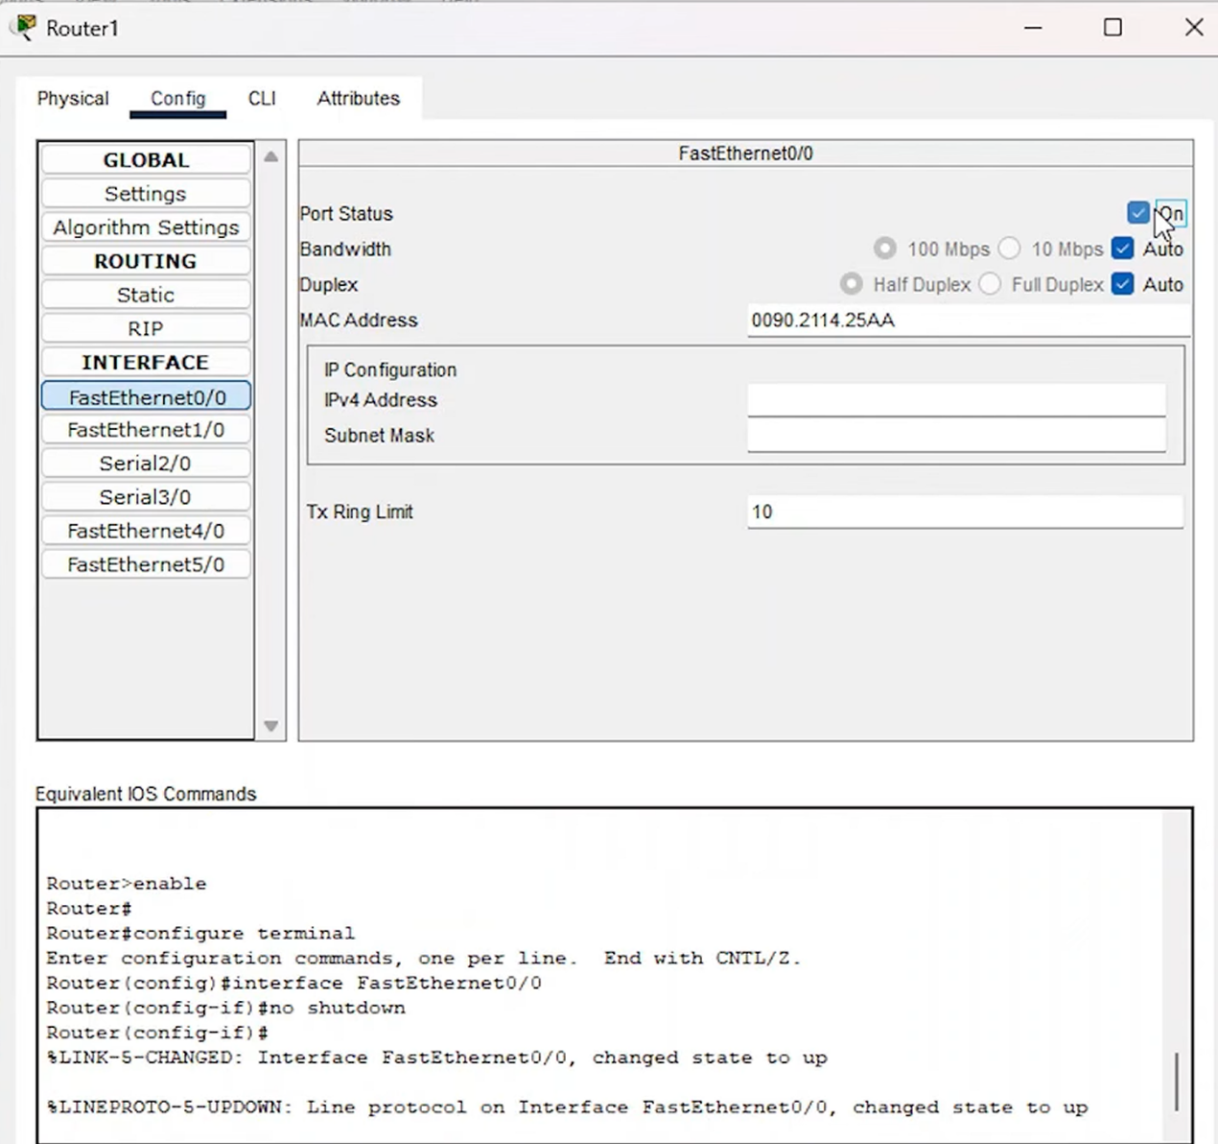
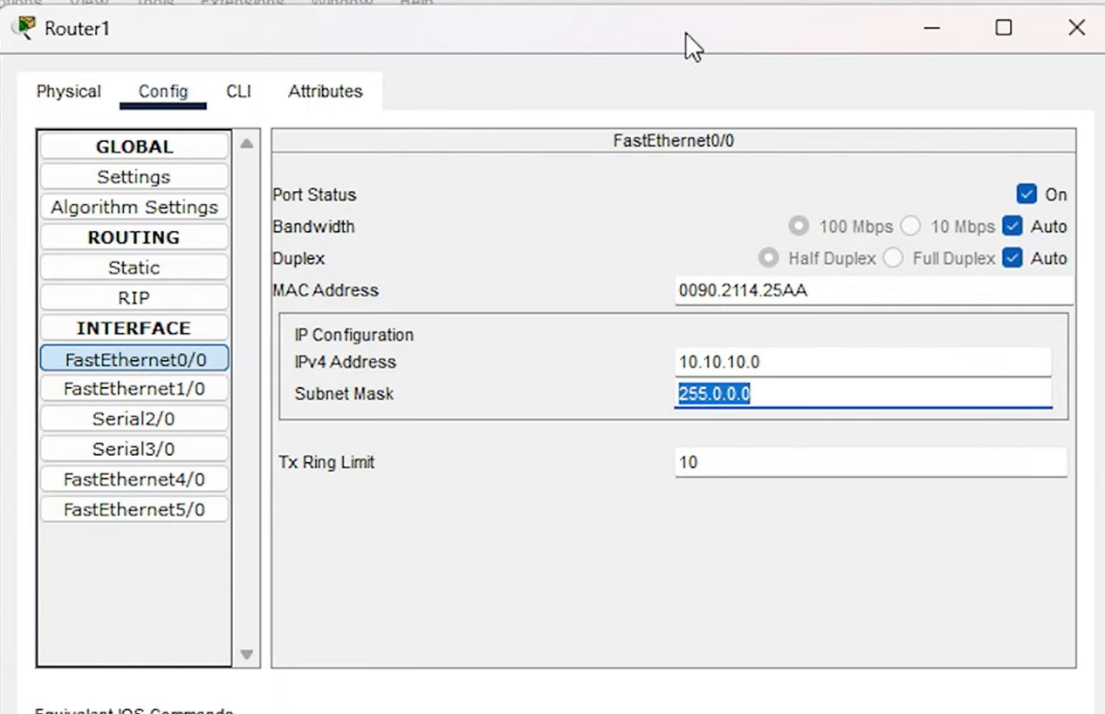
Go to Interface serial 2/0 (connected to Router 0). Turn on Port Status, assign the IPv4 address 30.30.30.1, and let it automatically generate the subnet mask.
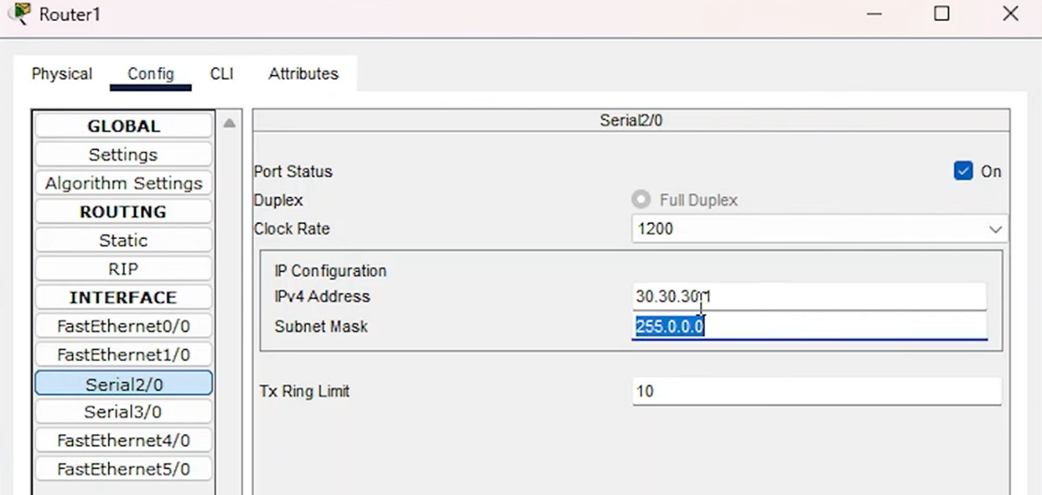
- Router 0 (Public Network Side):
Go to the Config tab > Interface f0/0. Turn on Port Status, assign the IPv4 address 20.20.20.0 (which is the default gateway), and set the subnet mask.
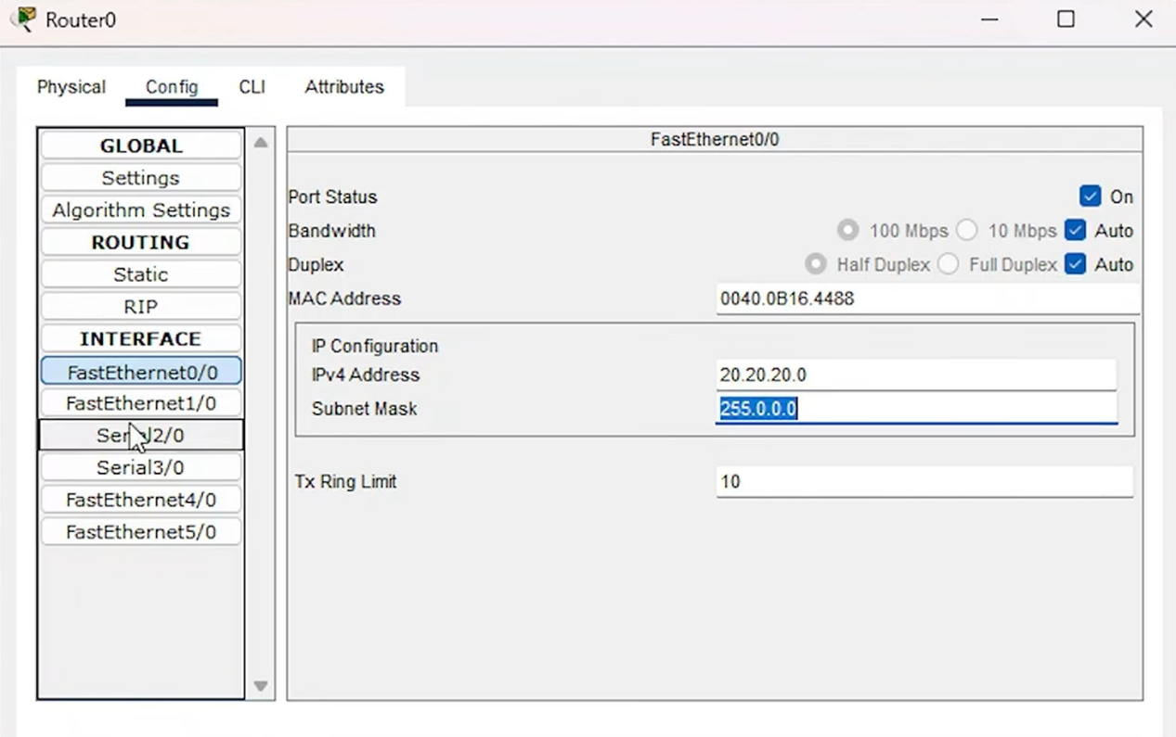
Turn on the Serial2/0 interface, and allocate IPv4 address 30.30.30.2, subnet mask 255.0.0.0.
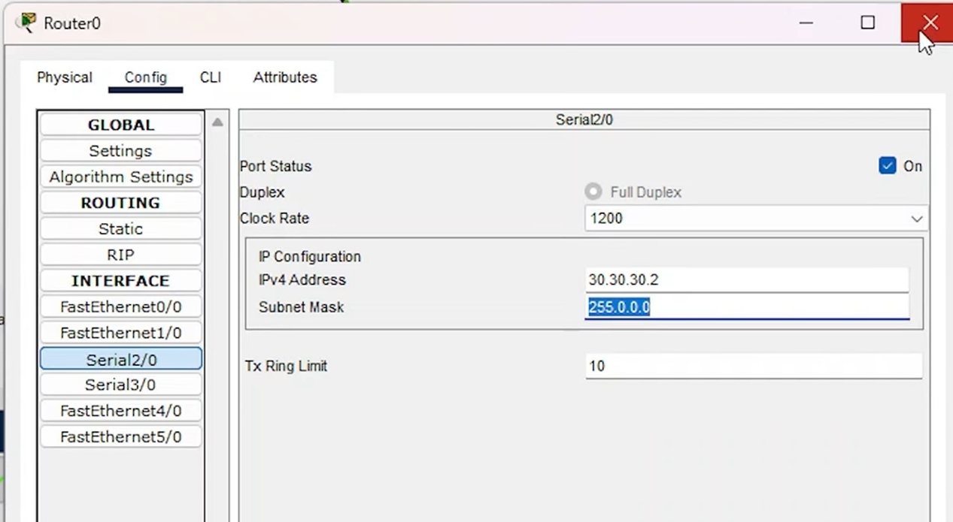

Configure Static NAT and Routing on Router 1
Open the CLI interface of Router 1 and enter the following core configuration commands to establish static mappings:
Router(config-if)# exit
Router(config)#ip nat inside source static 10.10.10.1 30.30.30.1
Router(config)#ip nat inside source static 10.10.10.2 30.30.30.1
Router(config)#int f0/0
Router(config-if)#ip nat inside
Router(config-if)#int s2/0
Router(config-if)#ip nat outside
Router(config-if)#exit
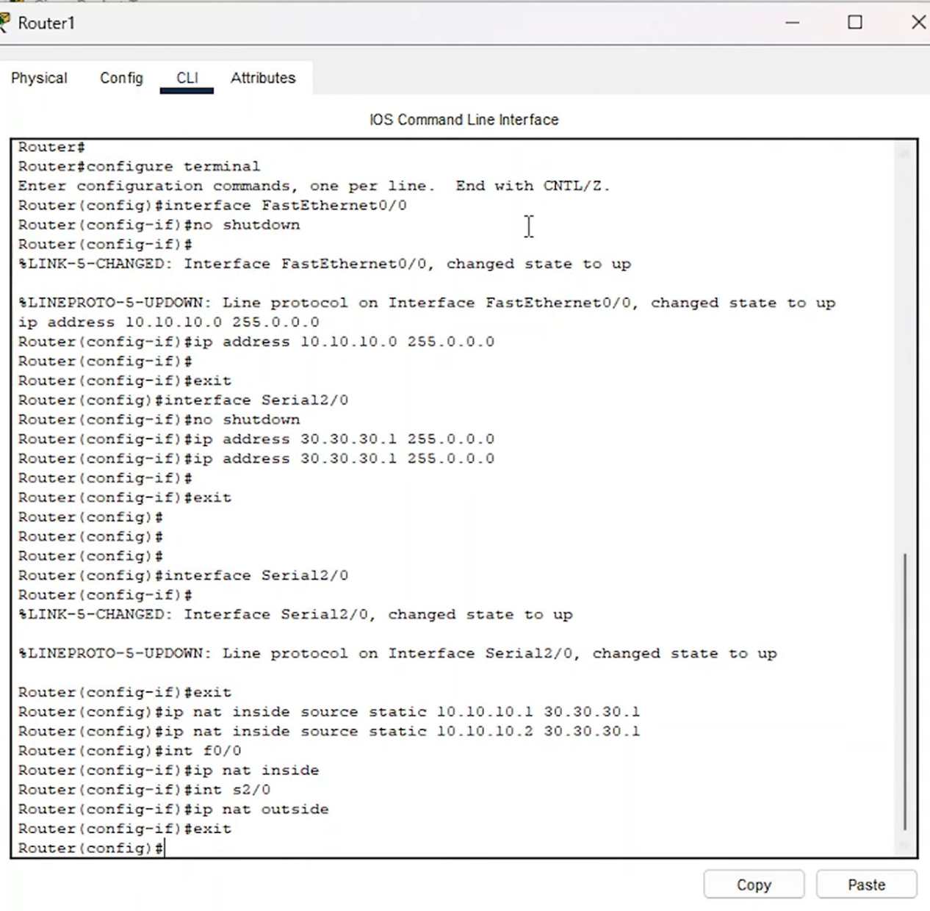
Configure Static NAT: Go to the Config tab > Static. Add the public network's IP range (20.0.0.0), subnet mask (255.0.0.0), and Next Hop address (30.30.30.2), then click Add.
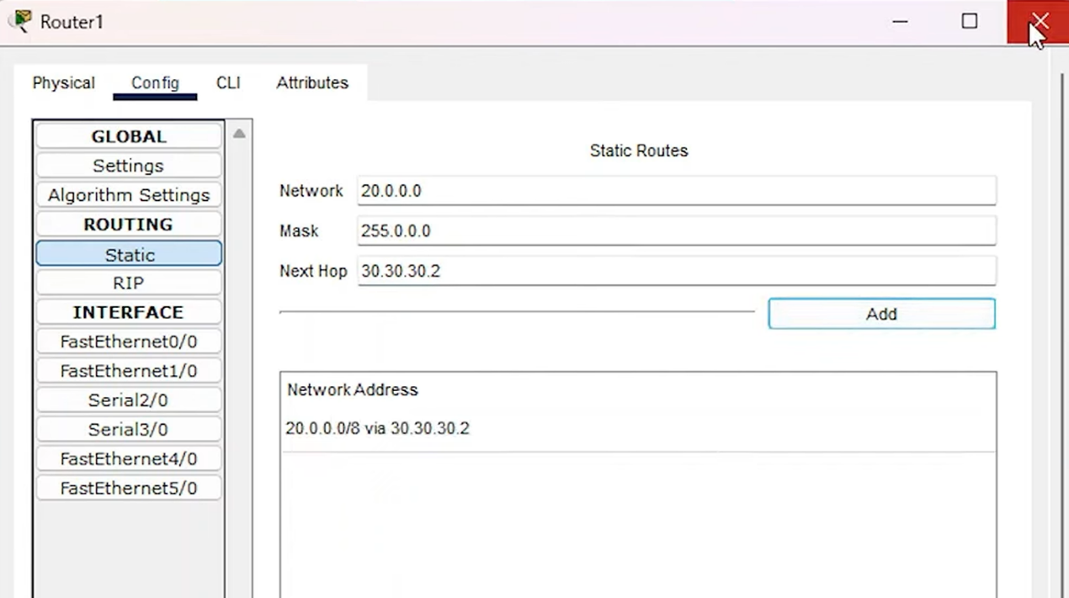

Experiment 3 -- Packet Testing, Ping Communication, and Web Testing

Connectivity Test (Ping Test)
- Select the packet icon on the toolbar, click PC2 then PC1, which means sending a packet from the private network (PC2) to the public network (PC1). The first attempt will fail, but the second attempt will succeed (as shown in the bottom right corner).
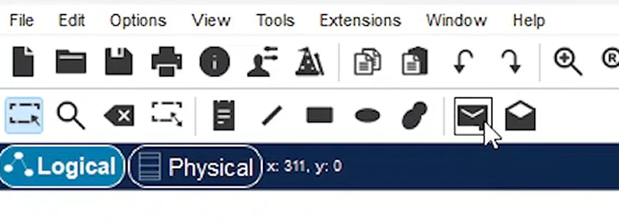
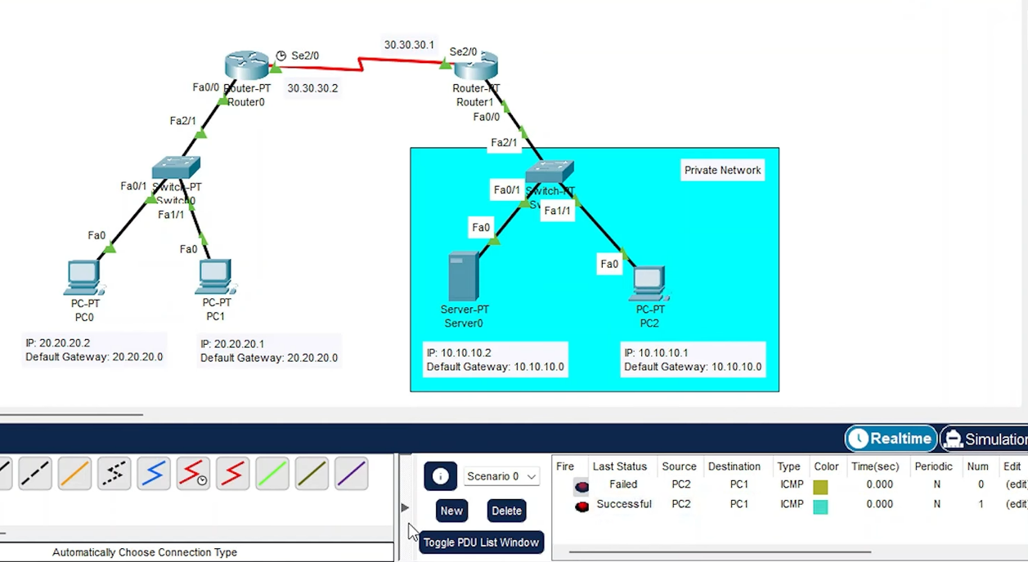
- Select the packet icon on the toolbar, click PC1 then PC2, sending a packet from the public network to the private network. Packets sent from the public network to the private network will always fail (because the public network cannot actively access the private network).
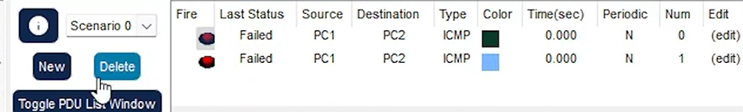
- Ping public network from private network: Open the Command Prompt of PC2 and execute ping 20.20.20.1. You should successfully receive a reply.
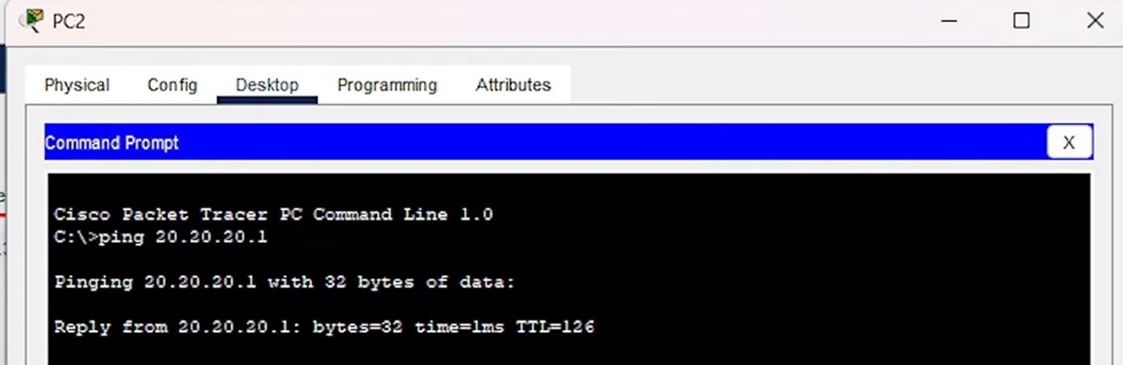
- Ping private network from public network: Open the Command Prompt of PC1 and execute ping 10.10.10.1. The result will show "Destination host unreachable", verifying the one-way protection of NAT.
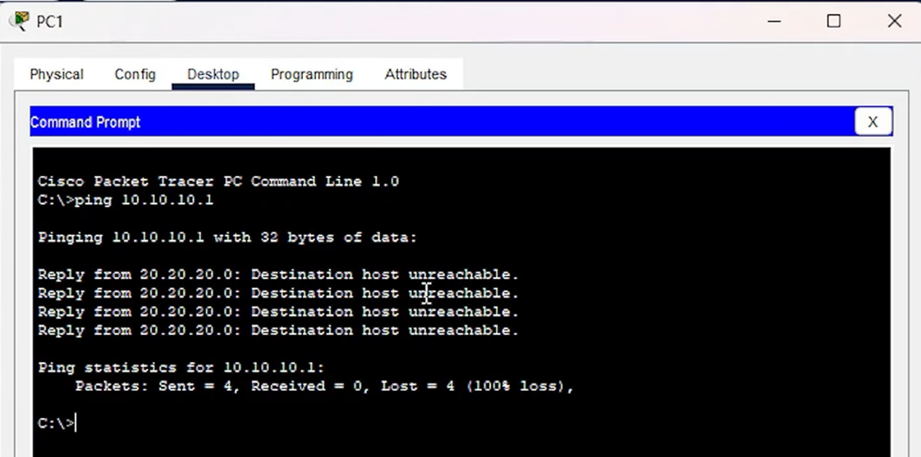
- Ping the public mapped IP: Execute ping 30.30.30.1 from PC1, and you should successfully receive a reply.
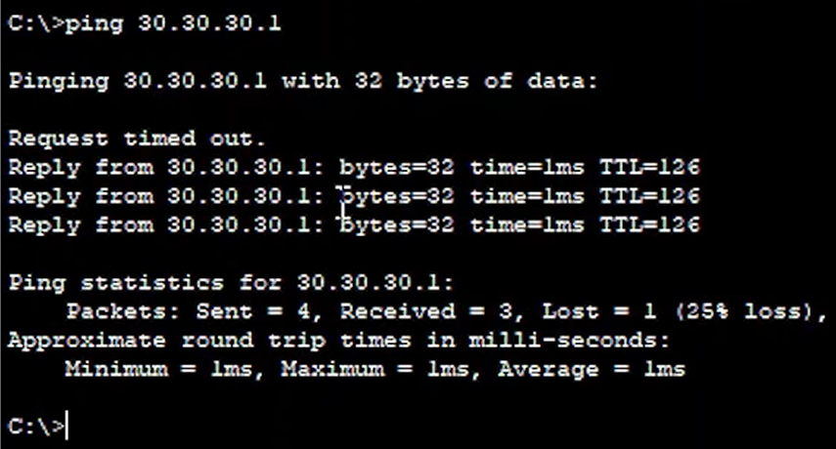

Web Application Layer Test (Web Test)
- Open the Web Browser on the public network PC1. Attempt to enter the server's private IP http://10.10.10.2; the web page will be inaccessible (Request Timeout).
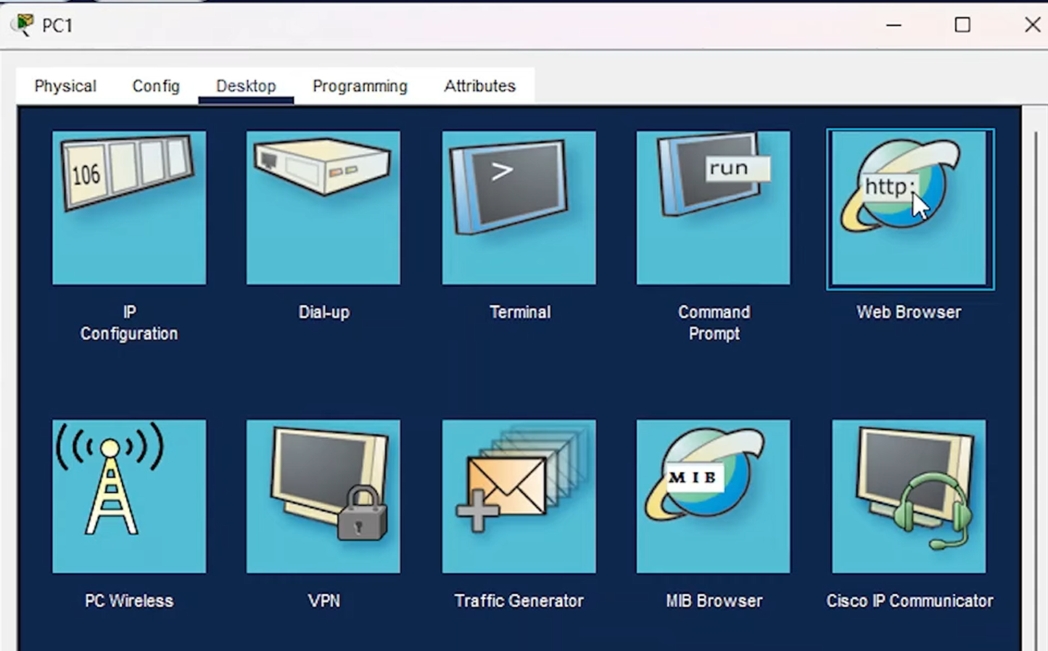
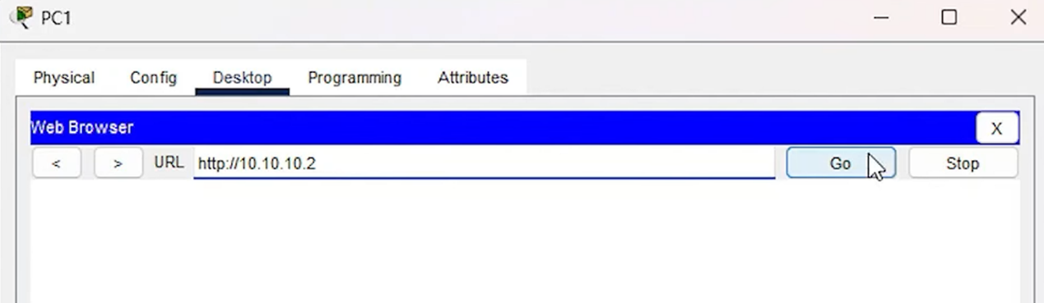
- Enter the mapped public IP http://30.30.30.1. The server's web page should load successfully and display the word "Youtube".
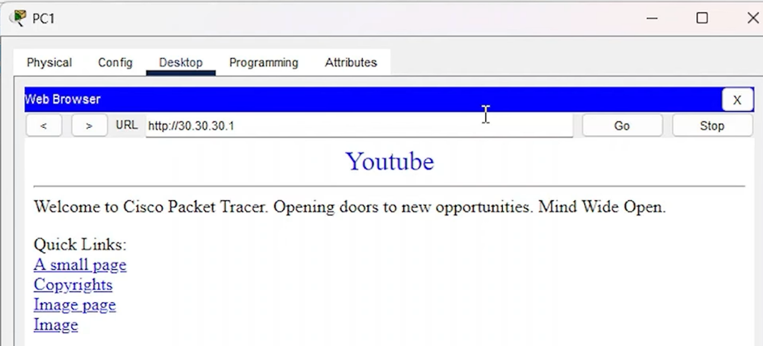

Check NAT Table
- Close the window and send a packet from PC2 to PC1. (Refer to Step 5) .
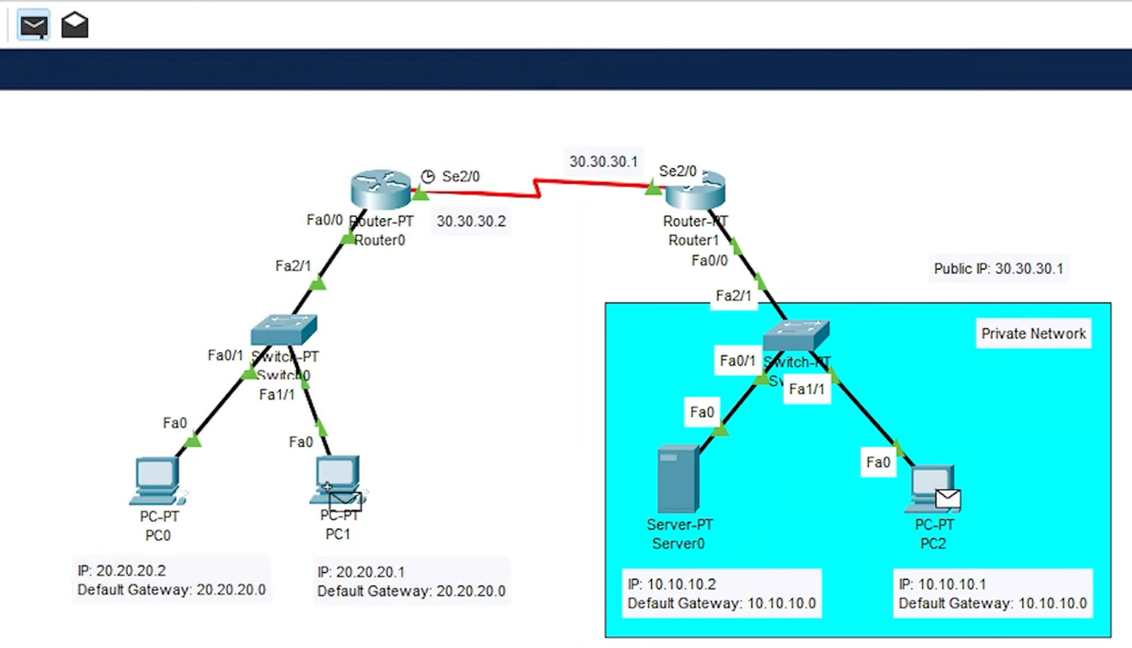
- Use the Inspect tool to click on Router 1, and then view the "NAT Table".
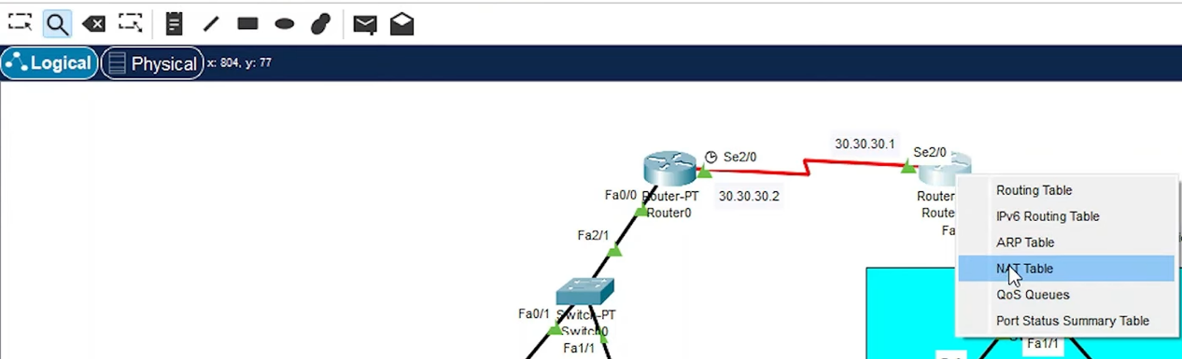
- Verify the entries under "Inside Global" and "Inside Local" to confirm that the private IP addresses have been successfully mapped to the public IP address.
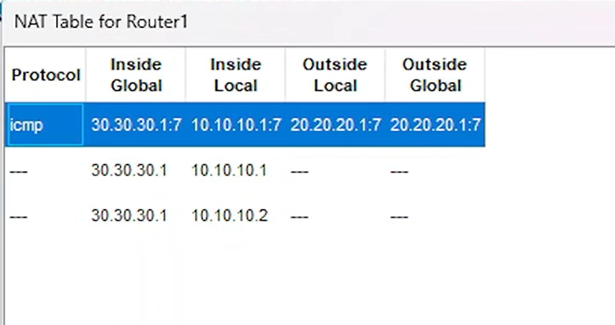

Supplementary Practice & Advanced Exploration
In the basic experiment above, we verified simple static NAT. Now suppose our network scale expands: the private network side is no longer just a few computers, but includes three core schools of the university (e.g., EEE, NIE, and CCDS), and these three schools are distributed in different subnets (VLANs). However, the school still only has one external public IP address.
- If all terminals in the three schools are required to access the internet simultaneously, is the "Static NAT" used in the experiment still applicable? If not, what technology should be introduced?

- If PAT is deployed on the router, what changes need to be made to the core configuration command logic?

