Part 1. IP Networking Fundamentals

Objectives
- To familiarize with Cisco Packet Tracer software interface and build a physical network topology independently.
- To perform IP Subnetting using standard formulas to divide a Class C network into multiple functional subnets.
- To study and understand the principles of Layer 2 Switching and Multi-link Physical Routing to enable cross-subnet communication.
- To configure DHCP (Dynamic Host Configuration Protocol) and utilize network troubleshooting skills to resolve broadcast domain conflicts.

Preparation
- Cisco Packet Tracer (Latest Version)
- 1 switch (Like 2960).
- 3 PC.
- 1 router (Like 2911).

Experiment 1 -- Topology Setup

Build the network topology in Packet Tracer
Please complete the physical topology connection according to the instructions below:
- Open Cisco Packet Tracer.
- In the lower-left corner of the Packet Tracer window, locate the Device-Type Selection Box.
- Click End Devices, drag PC into the workspace, and place 3 PCs. Rename them as: PC0, PC1, and PC2.
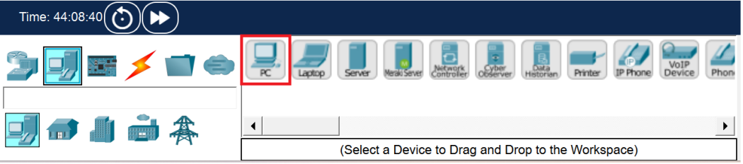
- Click Network Devices, then select Switches. Drag one 2960 Switch into the workspace.
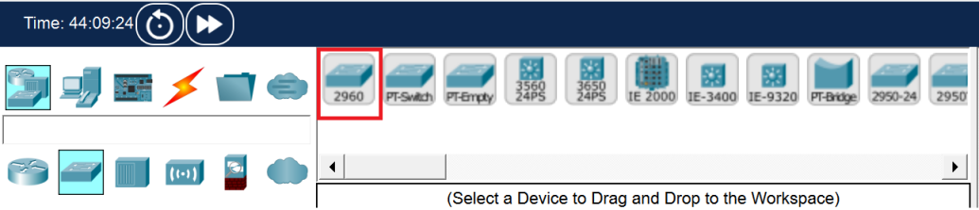
- Click Network Devices, then select Routers. Drag one 2911 Router (which provides 3 GigabitEthernet interfaces) and place it above the switch.
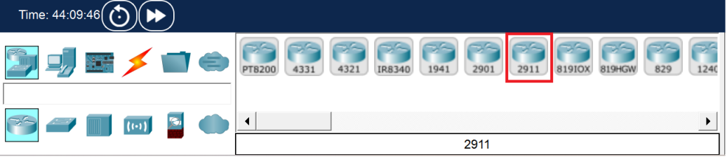

Cabling the Network
- Click Connections (the lightning icon) and select Copper Straight-Through cable.
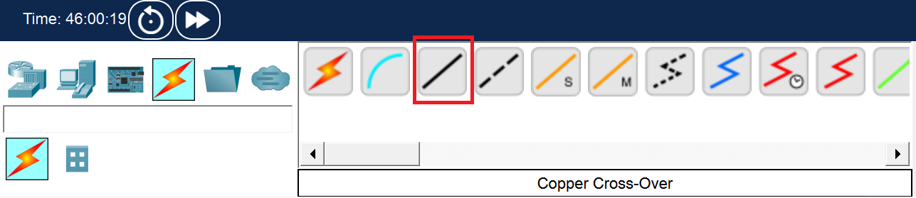
- Connect the devices according to the following tables to establish the 3 independent physical links for the departments:

Device | Interface | Connected Device | Interface
PC0 | FastEthernet0 | Switch0 | FastEthernet0/1
PC1 |  |  | FastEthernet0/2
PC2 |  |  | FastEthernet0/3
Switch0 | FastEthernet0/4 | Router0 | GigabitEthernet0/0
 | FastEthernet0/5 |  | GigabitEthernet0/1
 | FastEthernet0/6 |  | GigabitEthernet0/2
Note: The link lights on the router interfaces will initially appear as red triangles because the ports are administratively down by default. They will be activated in Experiment 3.

Experiment 2 -- IP Subnetting
In this experiment, the base network address is given as 192.168.10.0/24. You are required to design a network for 3 departments, each requiring approximately 20 hosts.
Calculate the required host bits(n) using the formula: $2^{n}−2≥ required hosts$.

Calculation & Thinking
- In the host calculation formula $2^{n}−2≥ required hosts$, why must we subtract 2 from the total permutations?
Because in any IPv4 subnet, two specific IP addresses are strictly reserved and cannot be assigned to any host computer or router interface:
1. Network Address: Where all host bits are 0, used to identify the subnet itself.
2. Broadcast Address: Where all host bits are 1, used to send broadcast messages simultaneously to all devices within that specific subnet.
- Based on the requirement of 20 hosts per department, calculate the required host bits ( n ) and derive the new subnet mask (please provide both CIDR notation and decimal format).
1. Calculate host bits: Using the formula, we get n=5.
2. Derive the mask: The total length of an IPv4 address is 32 bits. 32 - 5=27 network bits.
3. Final Result: The CIDR notation is /27, and the decimal format is 255.255.255.224.
- Taking the Marketing department as an example, if its starting network address is 192.168.10.32, what is its "Broadcast Address" based on the subnet size calculated in Q2? Can PC1 in the Marketing department configure this broadcast address on its own network interface?
The broadcast address for the Marketing department is 192.168.10.63.
Explanation: The subnet block starts from .32 and contains exactly 32 IPs. The last IP in this block is .63. PC1 cannot use this address. If configured, the operating system will reject it because it is strictly reserved for network broadcasting.

Complete the IP Allocation Table:
Department | Network Address | Usable IP Range | Subnet Mask | Default Gateway
Accounting  (PC0) | 192.168.10.0 | 192.168.10.1-.30 | 255.255.255.244 | 192.168.10.1
Marketing  (PC1) | 192.168.10.32 | 192.178.10.33-.62 | 255.255.255.244 | 192.168.10.33
Engineering  (PC2) | 192.168.10.64 | 192.168.10.65-.94 | 255.255.255.244 | 192.168.10.65

Experiment 3 -- Switching & Routing Implementation
In this experiment, we will configure the end devices and the router to enable inter-subnet communication.

Configure PC IP address
- Click on PC0, navigate to the Desktop tab, and then click on IP Configuration.
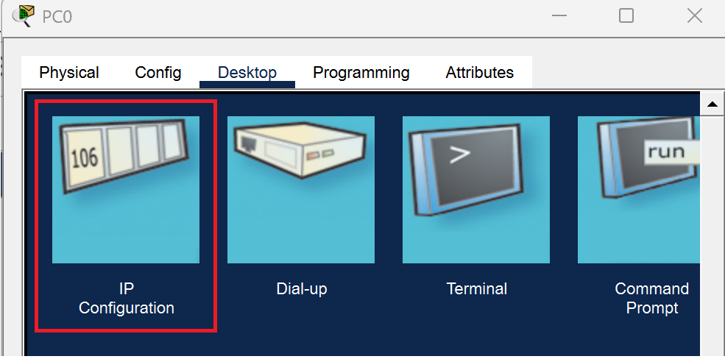
- Select Static. Set the IPv4 Address (e.g., 192.168.10.2), Subnet Mask (255.255.255.224), and Default Gateway (192.168.10.1) based on your calculation.
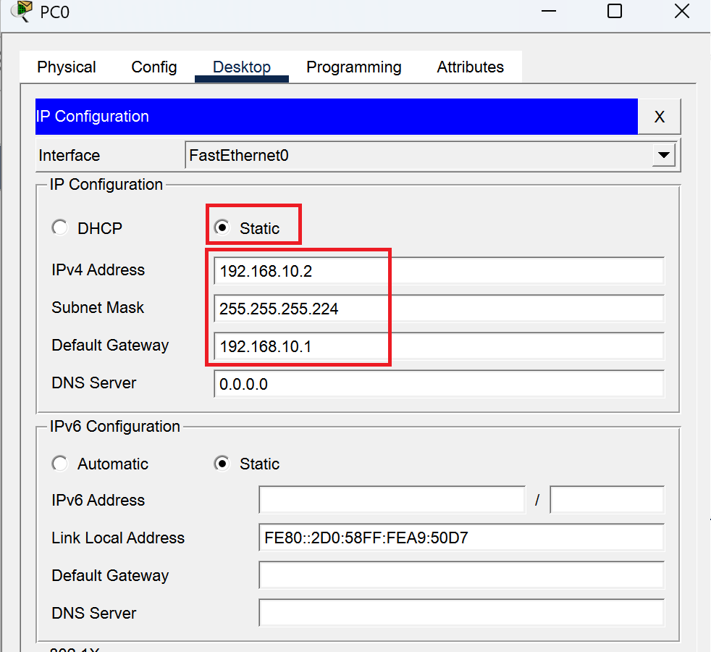
Note:When you click on this box, the software will automatically fill in 255.255.255.0. Please make sure to manually delete the last 0 and change it to 224, making it 255.255.255.224. (This is the result of your Experiment 2 !)
- Repeat this operation to configure PC1 and PC2 with their respective subnet data.

Configure the Layer 2 Switch
No configuration is required for the 2960 Switch. By default, all 24 interfaces are in the same broadcast domain (VLAN 1). It will automatically build its MAC address table to perform Layer 2 forwarding.

Configure the Layer 3 Router
- Click on Router0, open the CLI tab.
If you see the prompt ’ Would you like to enter the initial configuration dialog? [yes/no]:’ , type ’ no’ and press Enter.
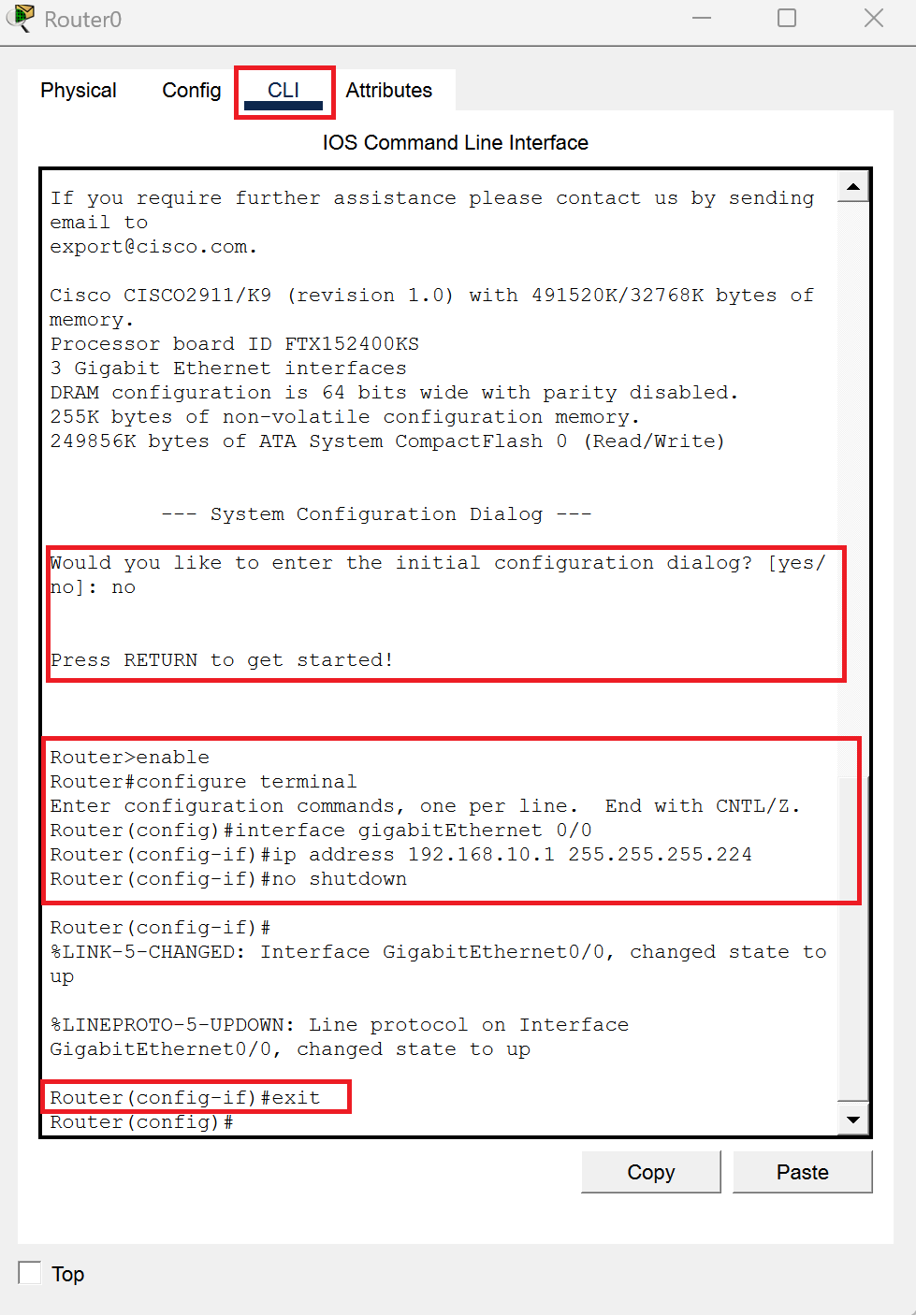
- Press Enter a few times until the Router> prompt appears.
Enter the following commands to activate the interfaces and set the gateways:
Router> enable
Router# configure terminal
! --- Configure Accounting Gateway (G0/0) ---
Router(config)# interface gigabitEthernet 0/0
Router(config-if)# ip address 192.168.10.1 255.255.255.224
Router(config-if)# no shutdown
Router(config-if)# exit
! (Repeat the same logic to configure G0/1 for Marketing and G0/2 for Engineering)
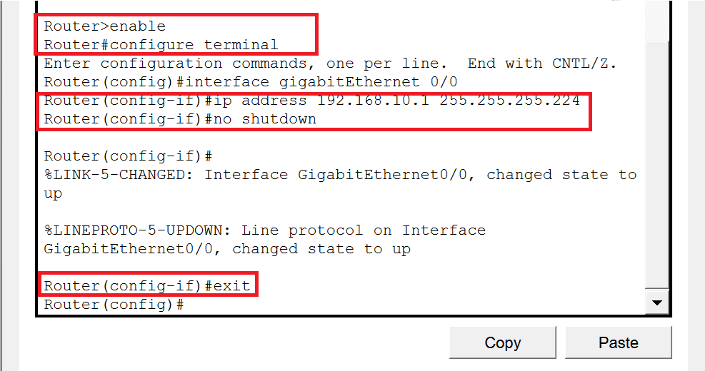

Connectivity Verification
- Open the Command Prompt on PC0.
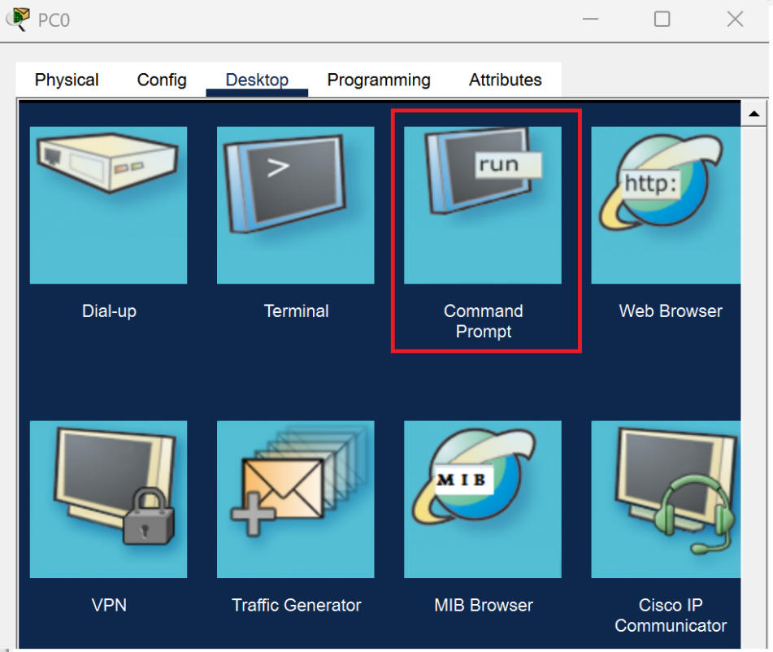
- Enter the command’ ping 192.168.10.34’ to test reachability to PC1.
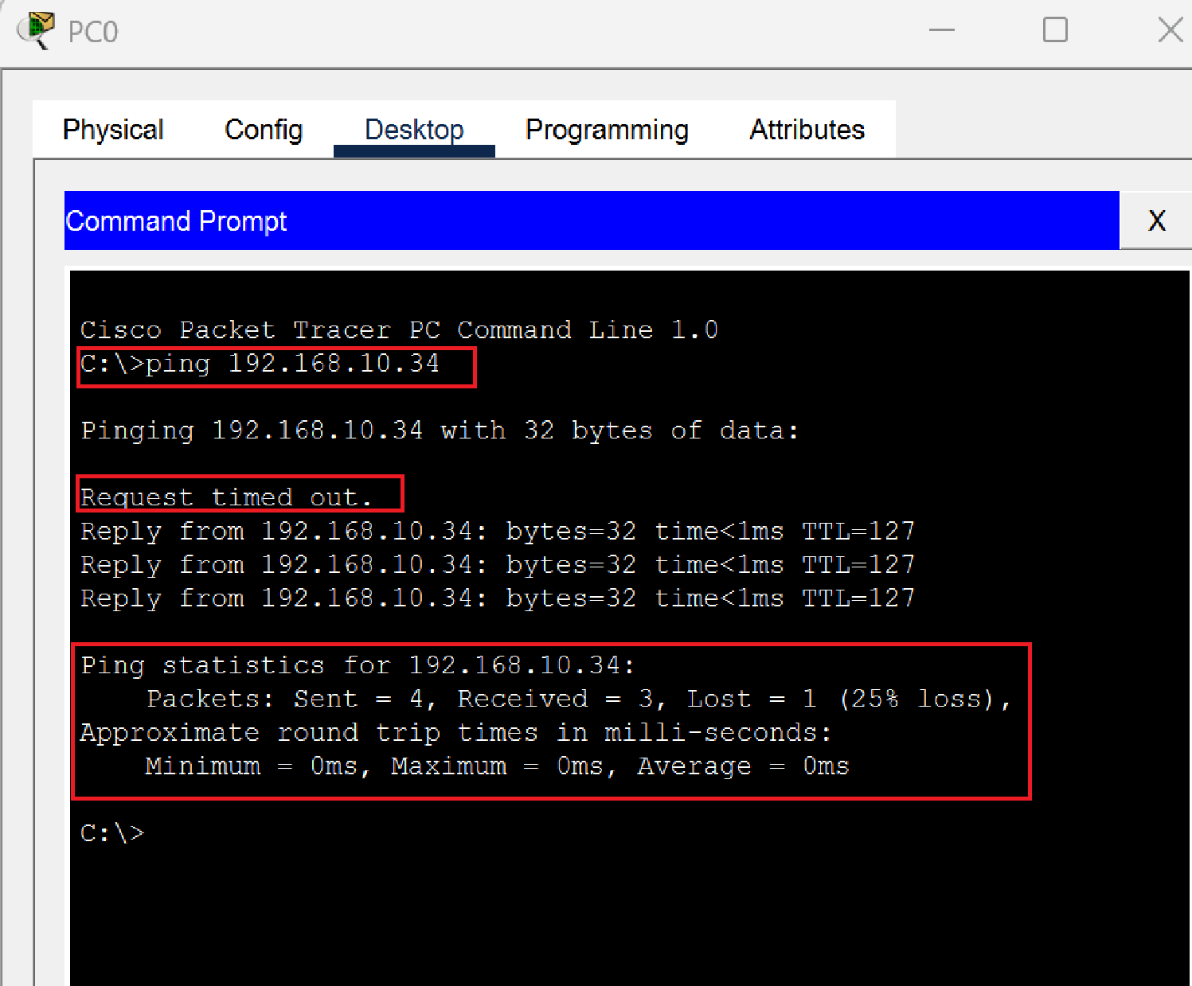
Note: The first one or two requests may display "Request timed out" due to the ARP resolution process. This is a normal phenomenon. A subsequent "Reply from..." indicates successful routing.

Experiment 4 -- DHCP & Broadcast Chaos
To improve efficiency, we will configure the router to act as a DHCP server. However, implementing this in a pure physical multi-link topology will trigger a network conflict.

Configure DHCP Pools
Enter the following commands in the Router CLI:
Router# configure terminal
! Exclude gateway IP addresses
Router(config)# ip dhcp excluded-address 192.168.10.1
Router(config)# ip dhcp excluded-address 192.168.10.33
Router(config)# ip dhcp excluded-address 192.168.10.65
! Create Accounting DHCP Pool
Router(config)# ip dhcp pool Pool_Acc
Router(dhcp-config)# network 192.168.10.0 255.255.255.224
Router(dhcp-config)# default-router 192.168.10.1
Router(dhcp-config)# exit
! (Proceed to create Pool_Mar and Pool_Eng...)

Observe the Bug & Physical Verification
- On PC0, switch the IP Configuration mode from Static to DHCP. Observe the obtained IP address and Gateway. (You will notice PC0 receives an incorrect IP and Gateway pairing ).
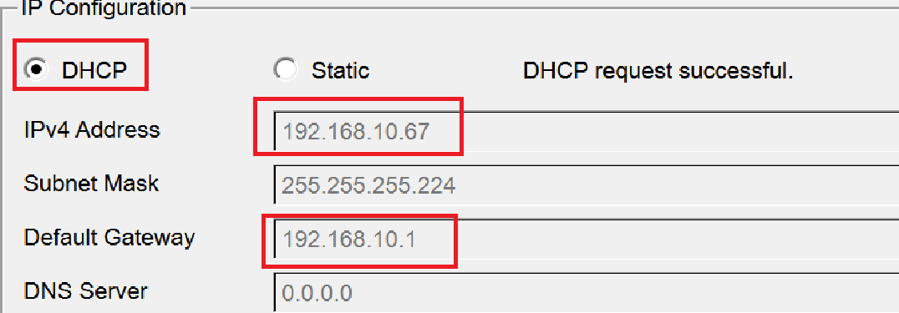
- Select the Delete tool in Packet Tracer. Remove two of the physical links between the switch and the router, keeping only the G0/0 link.
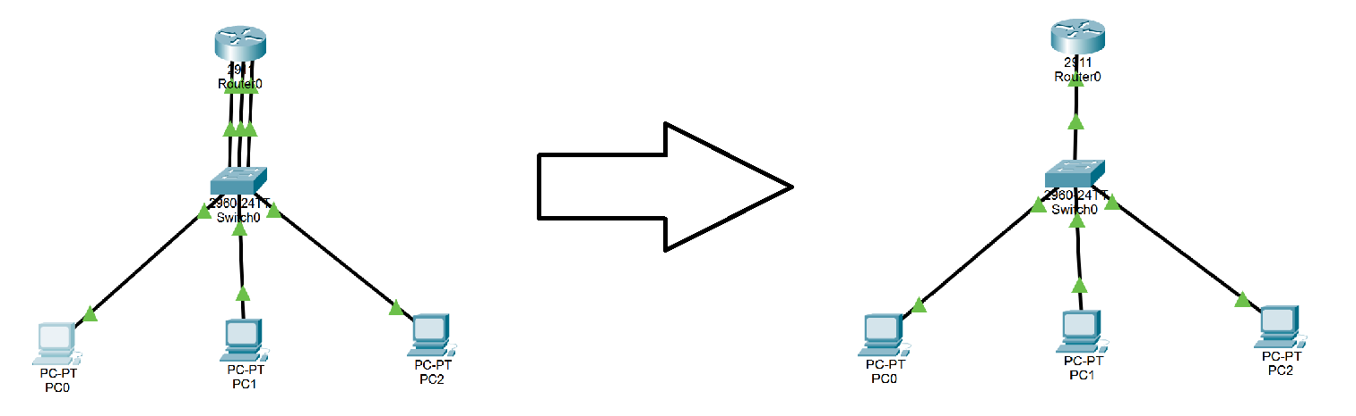
- Switch PC0 back to Static and then to DHCP again. Observe the successful allocation.
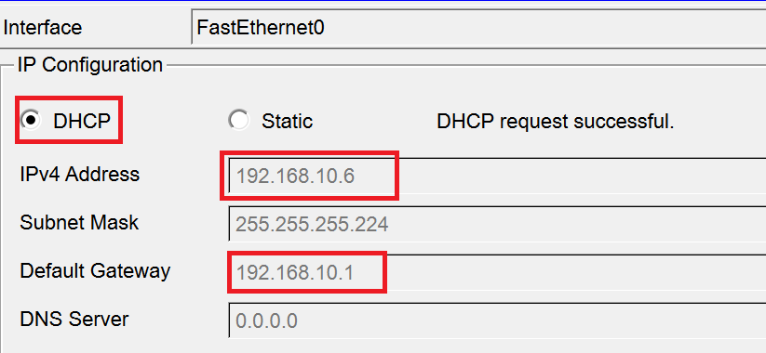

Practice & Thinking Question
Based on the concept of "Broadcast Domain", explain why the DHCP allocation fails when 3 links are connected, but succeeds when 2 links are removed?
3 Links Connected: By default, the entire 2960 switch operates in a single Broadcast Domain. A DHCP Discover message from a PC is a broadcast. It floods out of all switch ports, hitting all 3 router interfaces simultaneously. All 3 router interfaces respond with IPs from different pools, causing a "Race Condition" and IP mismatch.
2 Links Removed: Removing the cables physically isolates the broadcast. Only one specific router interface (the intended gateway) receives the broadcast and replies correctly.
Note: After completing this experiment, reconnect the 2 deleted links using Copper Straight-Through cables and set all PCs back to Static IP mode for the next phase.

Transition to Next Parts
By removing the physical cables in Experiment 4, we temporarily solved the DHCP broadcast conflict, but introduced critical engineering challenges:

Reliability Crisis: Relying on a single switch creates a single point of failure. Introducing redundant switches will cause Layer 2 loops. (To be resolved in Part 2. Spanning Tree Protocol - STP ).

Scalability Crisis: Unplugging cables disables other departments. Managing a network without logical boundaries is unsustainable. (To be resolved in Part 3. Virtual LAN - VLAN ).

