主题:SerializableStartCollectComplete[序列化/完成接口]
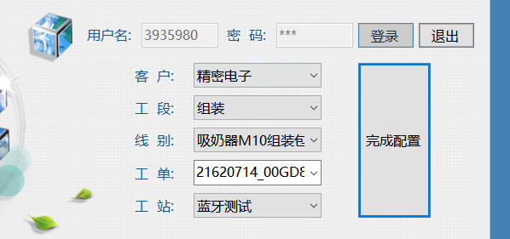

登录蓝牙测试后的mes_config.ini文件如下：
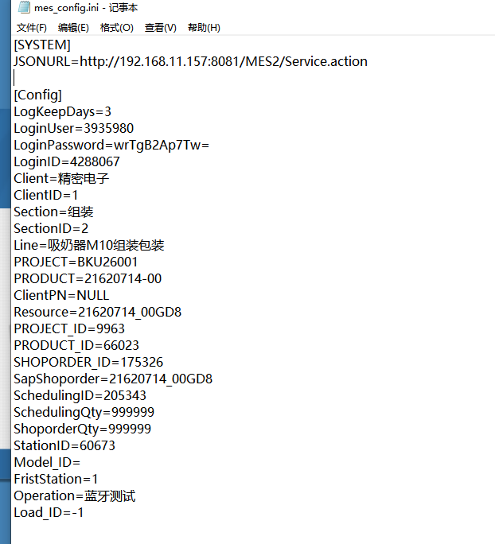

举例：

http://192.168.11.157:8081/MES2/Service.action?method=SerializableStartCollectComplete&param={
LOGIN_ID:登录ID(mes_config_ini的LoginID,建议此处固定为-1，【参数类型String】),
CLIENT_ID:1(mes_config_ini的ClientID),
LINE:线体(对应mes_config_ini的Line，【参数类型String】)
SHOPORDER:工单(对应mes_config_ini的Resource，【参数类型String】)
STATION:工站名称(对应mes_config_ini的Operation，【类型String】),
SCHEDULING_ID:排产ID(mes_config_ini的SchedulingID，类型String】),
OSFC:序列化前旧条码(【类型String】),
NSFC:序列化后的新条码(类型String[])
}

举例：
http://192.168.11.157:8080/MES2/Service.action?method=SerializableStartCollectComplete&param={
"LOGIN_ID":"-1",
"CLIENT_ID":"1",
"LINE":"吸奶器M10组装包装",
"SHOPORDER":"21620714_00GD8",
"STATION":"蓝牙测试",
"SCHEDULING_ID":"205343",
"OSFC":"M100DAC6200001E11AMB64D96637",
"NSFC":["M10LBBBBPH9DAC6200001E10B67X1N19001"]}

返回
:{"RESULT":"PASS","MESSAGE":"PASS","SERVICE_RUNTIME":140,"IP_ADDRESS":"192.168.53.237","TIME":"2026-08-07 17:09:15.249","SERVER_IP":"192.168.11.157"}

说明：举例中的OSFC传的扫描的主板条码【M100DAC6200001E11AMB64D96637】
NSFC传的蓝牙测试路特生成的主机SN【M10LBBBBPH9DAC6200001E10B67X1N19001】

