Name: Yuhui Wang

UID: 606332401

a.

|  | | *Not Excellent* | | *Excellent* | |  |
| --- | --- | --- | --- | --- | --- | --- |
| *N* | *%* | *N* | *%* | *P Value* |
| *1. Where Met Partner:* | *Bar* | 146 | 47.71 | 160 | 52.29 | 0.0105 |
| *Church* | 50 | 32.26 | 105 | 67.74 | 0.0235 |
| *Dating Service* | 63 | 46.67 | 72 | 53.33 | 0.0473 |
| *Other* | 401 | 42.26 | 548 | 54.74 | 0.3053 |
| *Private Party* | 126 | 41.72 | 176 | 58.28 | 0.7692 |
| *School* | 112 | 29.71 | 265 | 70.29 | 0.0000 |
| *Social Organization* | 54 | 43.90 | 69 | 56.10 | 0.4939 |
| *Vacation* | 10 | 27.03 | 27 | 72.97 | 0.0831 |
| *Work* | 193 | 43.27 | 253 | 56.73 | 0.2723 |
| *2. Who Introduced Partner:* | *Classmates* | 41 | 36.28 | 72 | 63.72 | 0.3037 |
| *Co-Workers* | 95 | 44.19 | 120 | 55.81 | 0.3128 |
| *Family* | 90 | 36.14 | 159 | 63.86 | 0.1062 |
| *Mutual Friends* | 368 | 42.59 | 496 | 57.41 | 0.2301 |
| *Neighbors* | 19 | 46.34 | 22 | 53.66 | 0.4784 |
| *Other* | 108 | 40.15 | 161 | 59.85 | 0.7809 |
| *Self or Partner* | 431 | 39.98 | 647 | 60.02 | 0.4081 |
| *3. Similar Age:* | *Age* | 741 | 39.37 | 1141 | 60.63 | 0.0078 |

1.

It’s on vacation or on the trip.

2.

It’s introduced by family.

3.

??. It is significant, as p-value=0.0078 < 0.05.

b.

Location:

1. work

1. School

1. Church

1. Dating Service or Internet

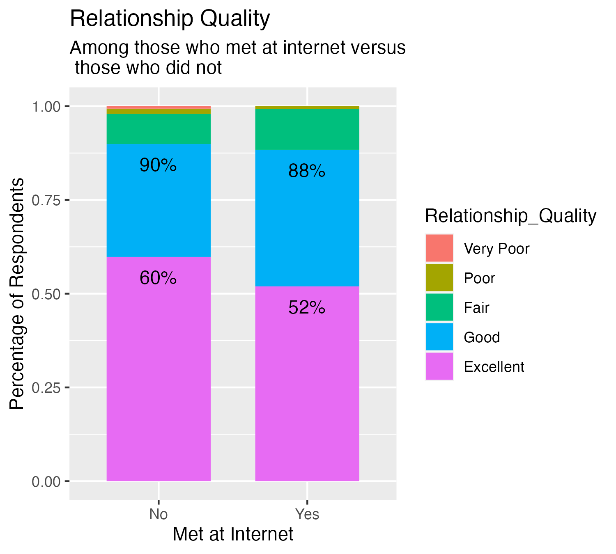

1. Vacation or trip

1. Bar or club

1. Social organization

1. Private party

1. Other places

c.

d.