Name: Yuhui Wang

ID: 606332401

**Exercise1**

Code:

libname npi "~/my_shared_file_links/u5338439";

proc contents data=npi.cms_providers_la;

run;

*1;

data cms_payment;

set npi.cms_providers_la;

keep npi total_drug_unique_benes total_drug_medicare_payment_amt;

run;

data cms_allowed;

set npi.cms_providers_la;

keep npi total_drug_unique_benes total_drug_medicare_allowed_amt;

run;

data cms_submitted;

set npi.cms_providers_la;

keep npi total_drug_unique_benes total_drug_submitted_chrg_amt;

run;

data cms_append;

set cms_submitted (in=in_sub rename=(total_drug_submitted_chrg_amt = amount))

cms_allowed (in=in_allow rename=(total_drug_medicare_allowed_amt = amount))

cms_payment (in=in_pay rename=(total_drug_medicare_payment_amt = amount));

if in_sub then amount_type = "Drug Medicare Submitted Amount";

else if in_allow then amount_type = "Drug Medicare Allowed Amount";

else if in_pay then amount_type = "Drug Medicare Payment Amount";

run;

proc sgplot data=cms_append;

title1 "Association of Total Charges/Payments and Number of Medicare Beneficiaries With Drug Services";

title2 "Best-Fit Line";

label amount_type = "Amount Type";

reg y=amount x=total_drug_unique_benes / group=amount_type nomarkers;

xaxis label="Number of Drug Medicare Beneficiaries";

yaxis label="Total Amount";

format amount dollar15.;

run;

Plot: 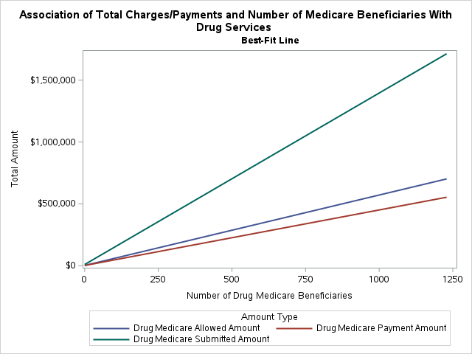

**Excercise2**

Code:

*2;

data adj_percent;

set npi.cms_providers_la;

beneficiary_cc_depr_percent=beneficiary_cc_depr_percent/100;

beneficiary_cc_diab_percent=beneficiary_cc_diab_percent/100;

beneficiary_cc_hypert_percent=beneficiary_cc_hypert_percent/100;

beneficiary_cc_strk_percent=beneficiary_cc_strk_percent/100;

beneficiary_cc_ost_percent=beneficiary_cc_ost_percent/100;

run;

proc transpose

data=adj_percent

out=cms_long (rename=(Col1=percent _label_=disease_type))

name=att;

by npi beneficiary_average_age;

var beneficiary_cc_depr_percent

beneficiary_cc_diab_percent

beneficiary_cc_hypert_percent

beneficiary_cc_strk_percent

beneficiary_cc_ost_percent;

run;

proc sgplot data=cms_long;

title1 "Association of Age and Disease";

title2 "Best-Fit Line";

label disease_type = "Disease Type";

reg y=percent x=beneficiary_average_age / group=disease_type nomarkers;

xaxis label="Average Age";

yaxis label="Disease Percent";

format percent percent10.3;

run;

Plot:

**Exercise3**

Code:

*3;

data family_practice;

set npi.cms_providers_la;

if provider_type = "Family Practice";

run;

data family_practice_total (keep=total_number);

set family_practice end=last;

total_number+total_services;

if last then output;

run;

data pct;

set family_practice (keep=npi total_services);

if _n_=1 then set family_practice_total;

pct_total=total_services / total_number;

format pct_total percent10.3;

run;

proc means data=pct;

var pct_total;

run;

Min value: 0.000049208

Max value: 0.1725054

Range: from 0.0049208% to 17.25054%

**Excercise4**

Code:

*4;

*family;

data family;

set npi.cms_providers_la;

if provider_type = "Family Practice";

run;

data family_benes (keep=total_benes);

set family end=last;

total_benes+total_unique_benes;

if last then output;

run;

data pct_family;

set family (keep=npi total_unique_benes provider_type);

if _n_=1 then set family_benes;

pct_family=total_unique_benes / total_benes;

format pct_family percent10.3;

run;

*psy;

data psy;

set npi.cms_providers_la;

if provider_type = "Psychiatry";

run;

data psy_benes (keep=total_benes);

set psy end=last;

total_benes+total_unique_benes;

if last then output;

run;

data pct_psy;

set psy (keep=npi total_unique_benes provider_type);

if _n_=1 then set psy_benes;

pct_psy=total_unique_benes / total_benes;

format pct_psy percent10.3;

run;

*emer;

data emer;

set npi.cms_providers_la;

if provider_type = "Emergency Medicine";

run;

data emer_benes (keep=total_benes);

set emer end=last;

total_benes+total_unique_benes;

if last then output;

run;

data pct_emer;

set emer (keep=npi total_unique_benes provider_type);

if _n_=1 then set emer_benes;

pct_emer=total_unique_benes / total_benes;

format pct_emer percent10.3;

run;

data pct_append;

set pct_family (rename=(pct_family = num_benes_relative_tot))

pct_psy (rename=(pct_psy = num_benes_relative_tot))

pct_emer (rename=(pct_emer = num_benes_relative_tot));

run;

proc means data=pct_append median;

class provider_type;

run;

Median

Emergency Medicine: 0.0028399

Family Practice: 0.0032028

Psychiatry: 0.0023218

**Excercise5**

*5;

data cms_deactivated;

length NPI $10;

informat NPPES_Deactivation_Date mmddyy10.;

infile "~/my_shared_file_links/u5338439/NPPES_Deactivated_NPI_Report_20171010.csv" dsd;

input NPI $

NPPES_Deactivation_Date;

format NPPES_Deactivation_Date mmddyy10.;

run;

title "Contents of the Deactivation NPI Report Data Set";

proc contents data=cms_deactivated;

run;

proc sort data=cms_deactivated;

by npi;

run;

data cms;

set npi.cms_providers_la;

run;

proc sort data=cms;

by npi;

run;

data combine;

merge cms (in=master)

cms_deactivated (in=deactivated);

by npi;

if master and deactivated;

run;

Total rows: 24, 24 records in total.

Earliest deactivation date is: 05/14/2015

Latest deactivation date is: 10/09/2017

**Exercise6**

Code:

*6;

data cms;

set npi.cms_providers_la;

run;

proc sort data=cms_deactivated;

by npi;

run;

proc sort data=cms;

by npi;

run;

data combine_update;

update cms (in=master)

cms_deactivated (in=deactivated);

by npi;

if master;

run;