Name: Yuhui Wang

UID: 606332401

1.

#1

dc <- ods[ods$STATE == "DC",]

dc <- dc[order(dc$DATA_DATE),]

plot(dc$DATA_DATE, dc$NUMBER_NATURAL_OPIOD_DEATHS,

type = "o",

main = "Natural and Synthetic Opiod Deaths in Wasington DC\n(2015-2018)",

xlab = "Year",

ylim = c(0,300),

ylab = "Number of Deaths",

col = "black")

lines(dc$DATA_DATE, dc$NUMBER_SYNTHETIC_OPIOD_DEATHS, type="o", lty=3, col="red")

legend("topleft", as.Date("01/01/2017", format="%m/%d/%Y"),

legend = c("Natural Opiods","Synthetic Opiods"),

col=c("black","red"),

lty=1:3)

2.

#2

data2 <- droplevels(ods[ods$STATE %in% c('VT','NH','ME','CT','RI'),])

proportion <- tapply(data2$NUMBER_DRUG_OVERDOSE_DEATHS/data2$NUMBER_DEATHS,

data2$STATE,

median, na.rm=T)

plot(proportion,

type = "p",

pch = 18,

col = "red",

cex = 2,

axes = FALSE,

ann = FALSE,

ylim = c(0.00, 0.05) )

axis(1, at=1:5, lab = names(proportion))

axis(2,seq(0.00, 0.05, by = 0.01))

box()

title (main = "Median Overdose Death Proportion by State\nNew England", col.lab = "black")

title (ylab = "Median Monthly Proportion of Overdose Deaths", col.lab = "blue")

title (xlab = "State", col.lab = "blue")

3.

#3

new <- droplevels(ods[ods$STATE %in% c('DC','MD','VA'),])

newmean <- tapply(new$NUMBER_COCAINE_DEATHS/new$NUMBER_DEATHS,

new$STATE,

mean, na.rm=T)

newmean

barplot(newmean,

main="Average Monthly Percent of Cocaine Deaths by State",

ylab="State",

xlab="Average Monthly Percent of Cocaine Deaths",

col = "forestgreen",

xlim = c(0,0.015),

width = 0.4,

space = 0.4,

horiz = TRUE)

box()

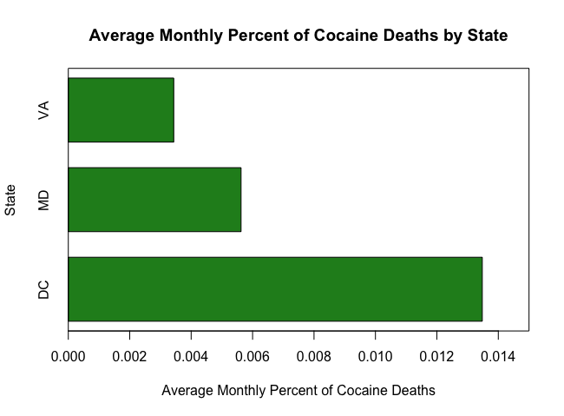

4.

#4

north <- c('CT', 'DC', 'MD', 'ME', 'NH', 'NY', 'OR', 'RI', 'VT', 'WA')

south <- c('NC', 'NM', 'NV', 'OK', 'SC', 'UT', 'VA', 'WV')

fall <- c('September', 'October', 'November')

spring <- c('March', 'April', 'May')

winter <- c('December', 'January', 'February')

summer <- c('June', 'July', 'August')

data4 <- ods %>%

mutate(REGION = 1*(STATE %in% north) + 2*(STATE %in% south),

SEASON = 1*(MONTH %in% spring) + 2*(MONTH %in% summer) + 3*(MONTH %in% fall) + 4*(MONTH %in% winter),

PROP = NUMBER_DRUG_OVERDOSE_DEATHS/NUMBER_DEATHS) %>%

group_by(SEASON,REGION) %>%

summarize(AVGPROP = mean(PROP))

data4

matrix <- matrix(as.matrix(data4[,3]),nrow = 2,ncol = 4, byrow = FALSE)

colnames(matrix) <- c("Spring","Summer","Fall","Winter")

row.names(matrix) <- c("Northern States","Southern States")

matrix

barplot(matrix,

beside= TRUE,

main = "Mean Proportion Drug Overdose Deaths\nby Region and Season",

xlab = "Season",

ylab = "Mean Proportion Drug Overdose Deaths",

col = c("blue","yellow"),

ylim = c(0.020,0.030),

xpd = FALSE)

box()

legend("topleft", legend=c("Northern States","Southern States"),

bty="n",

title = c("Region"),

fill=c("blue","yellow"))

5.

#5

opiod <- ods %>%

filter(YEAR %in% c(2015,2016,2017), STATE == "NC" ) %>%

group_by(YEAR) %>%

summarize(natural = sum(NUMBER_NATURAL_OPIOD_DEATHS), synthetic = sum(NUMBER_SYNTHETIC_OPIOD_DEATHS))

opiod

m <- matrix(as.matrix(opiod[,2:3]),nrow = 2,ncol = 3, byrow = TRUE)

colnames(m) <- c("2015","2016","2017")

row.names(m) <- c("Natural","Synthetic")

m

barplot(m,

beside = FALSE,

main = "Count of Opiod Overdose Deaths by Year and Opiod Type",

xlab = "Year",

ylab = "Count of Opiod Overdose Deaths",

col = c("blue","grey"),

ylim = c(0,20000))

box()

legend("topleft", legend=c("Natural","Synthetic"),

bty="n",

title = c("Opiod Type"),

fill=c("blue","grey"))

