Gemini 3.8 Flash Latency & Architecture Evaluation Report
Empirical Analysis of Streaming Delivery, ThinkingConfig, Pydantic Adaptive Routing & 50-Turn Context Caching on Google AI Studio (google-genai SDK)
Author: Yuichi Ito | Date: 2026-11 | Target: Google AI Studio (google-genai SDK / gemini-3.8-flash)
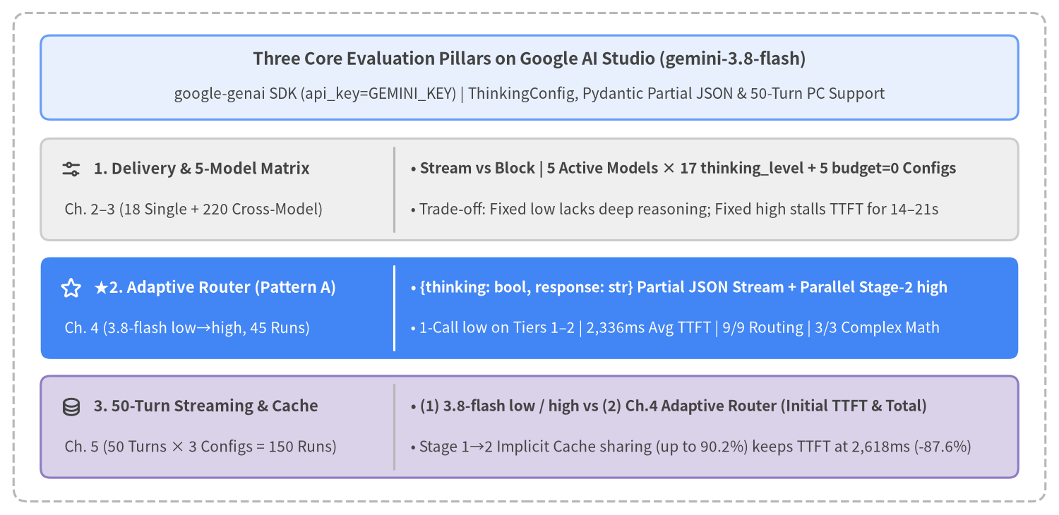
Figure 0-1: Three Core Evaluation Pillars and Key Empirical Findings on Google AI Studio (gemini-3.8-flash)

Report Overview & Chapter Structure (Chapters 1–5)
This technical report presents a comprehensive empirical evaluation of gemini-3.8-flash (and the full Gemini 3.5 / 4 model lineup) on Google AI Studio (google-genai SDK via genai.Client(api_key=GEMINI_KEY)), synthesizing live API benchmark executions recorded in src/gemini_evaluation/ under a PC troubleshooting customer-support scenario. It establishes actionable architecture patterns that simultaneously achieve responsive Time to First Token (TTFT), deep multi-step mathematical accuracy, and flat latency scaling across 50-turn conversational histories.
Chapter | Title | Scope & Key Empirical Findings
Chapter 1 | Executive Summary | End-to-end architecture decision matrix, cross-benchmark latency comparisons, and production configuration guidelines.
Chapter 2 | Background & Measurement Methodology | Anatomy of the 3 LLM latency phases (Prefill, Thinking, Decoding), 2D trajectory charts (Elapsed Time vs. Cumulative Characters), Pydantic response_schema Cold vs. Warm FSM grammar compilation, incremental delta extraction via pydantic_core.from_json(..., allow_partial="trailing-strings"), ExecutionTracer instrumentation, and empirical comparison of Gemini 3.5 / 3.8 / 4 models, ThinkingConfig options, and Context Caching rules.
Chapter 3 | Parameters & Latency | Empirical evaluation of Blocking (generate_content) vs. Streaming (generate_content_stream) across all 6 ThinkingConfig levels, the linear scaling law of thoughts_token_count, the speed-vs-accuracy trade-off across PC support query Tiers 1–3, and a 220-run cross-model latency comparison across all 5 active Gemini models × 17 thinking_level options + 5 deprecated thinking_budget=0 scenarios on 5 Simple + 5 Complex queries.
Chapter 4 | Adaptive Thinking Router | Candidate model and thinking_level taxonomy for Stage 1 (fast routing) and Stage 2 (deep reasoning: Categories A/B/C), followed by a 45-run empirical evaluation using gemini-3.8-flash (low → high). Demonstrates why Pattern A achieves 2,336 ms avg TTFT, 100% routing accuracy, and 100% Tier 3 calculation accuracy.
Chapter 5 | Multi-Turn Chat Behavior & Context Caching | Standardized exclusively on Streaming (generate_content_stream) across a 50-turn continuous PC troubleshooting dialogue (150 runs), comparing (1) 3.8-flash low & high against (2) Chapter 4's Adaptive Thinking Router (Pattern A: low → high) on both initial response (TTFT) and completion (Total), with Stage 1→2 Implicit Context Cache sharing (up to 90.2% hit rate).

Document Metadata | Value
Title (title) | Gemini 3.8 Flash Latency & Architecture Evaluation Report
Subtitle (subtitle) | Empirical Analysis of Streaming Delivery, ThinkingConfig, Pydantic Adaptive Routing & 50-Turn Context Caching
Author (author) | Yuichi Ito
Date (date) | 2026-11
Target SDK & Model | Google AI Studio google-genai SDK (genai.Client(api_key=GEMINI_KEY)) / gemini-3.8-flash & 5 active models
Evaluation Codebase | src/gemini_evaluation/llm_call.py, src/gemini_evaluation/adaptive_thinking.py, src/gemini_evaluation/tracer.py

Table of Contents
- 1. Executive Summary
- 2. Background & Measurement Methodology
- 3. Parameters & Latency
- 4. Adaptive Thinking Router Pattern
- 5. Multi-Turn Chat Behavior & Context Caching

1. Executive Summary
This report presents an end-to-end empirical evaluation of gemini-3.8-flash (and the 5 active models across the Gemini 3.5 / 3.8 / 4 series) on Google AI Studio (google-genai SDK via genai.Client(api_key=GEMINI_KEY)), addressing how production conversational AI systems (specifically PC technical support and troubleshooting assistants) can simultaneously achieve three competing engineering goals: (1) low-latency initial response (TTFT), (2) 100% accuracy on multi-step mathematical and conditional reasoning tasks (PC repair-vs-replacement cost break-even, SSD backup transfer time, and multi-PC warranty fee calculations), and (3) flat latency scaling across 50-turn multi-turn dialogues. Synthesizing live API benchmark executions (18 single-turn ThinkingConfig trials, 220 cross-model thinking_level + thinking_budget=0 runs across all 5 active models, 45 adaptive routing low → high runs, and 150 50-turn multi-turn PC support Streaming chat executions), we establish Streaming delivery (generate_content_stream) combined with the Pydantic 2-field Adaptive Thinking Router (Pattern A: Stage 1 low {thinking: bool, response: str} + parallel Stage 2 high) and prefix-immutable multi-turn history as the recommended production architecture.
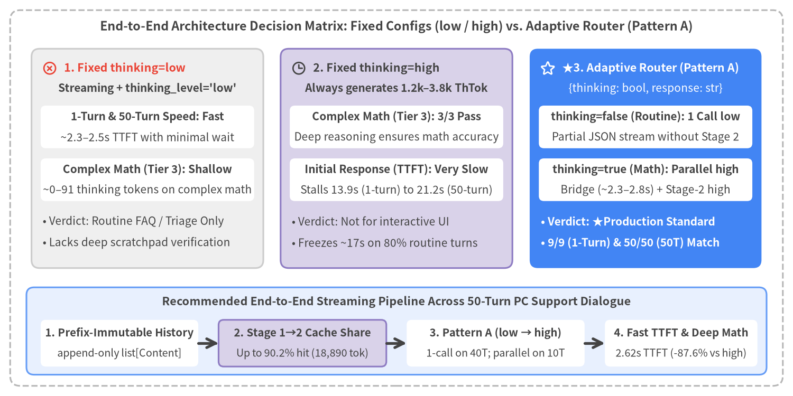
Figure 1-1: End-to-End Architecture Decision Matrix — Fixed Thinking Baselines (low / high) vs. Adaptive Thinking Router (Pattern A) Across Single-Turn & 50-Turn Workloads

1.1 Cross-Benchmark Empirical Comparison
Figure 1-2 synthesizes the headline latency metrics—Initial Response (TTFT) and Stream Completion (Total)—across all three benchmark suites in this report: (1) Single-Turn Delivery Mode & ThinkingConfig, (2) Adaptive Thinking Router (low → high) across Tiers 1–3, and (3) 50-Turn Multi-Turn PC Support Streaming Dialogue.
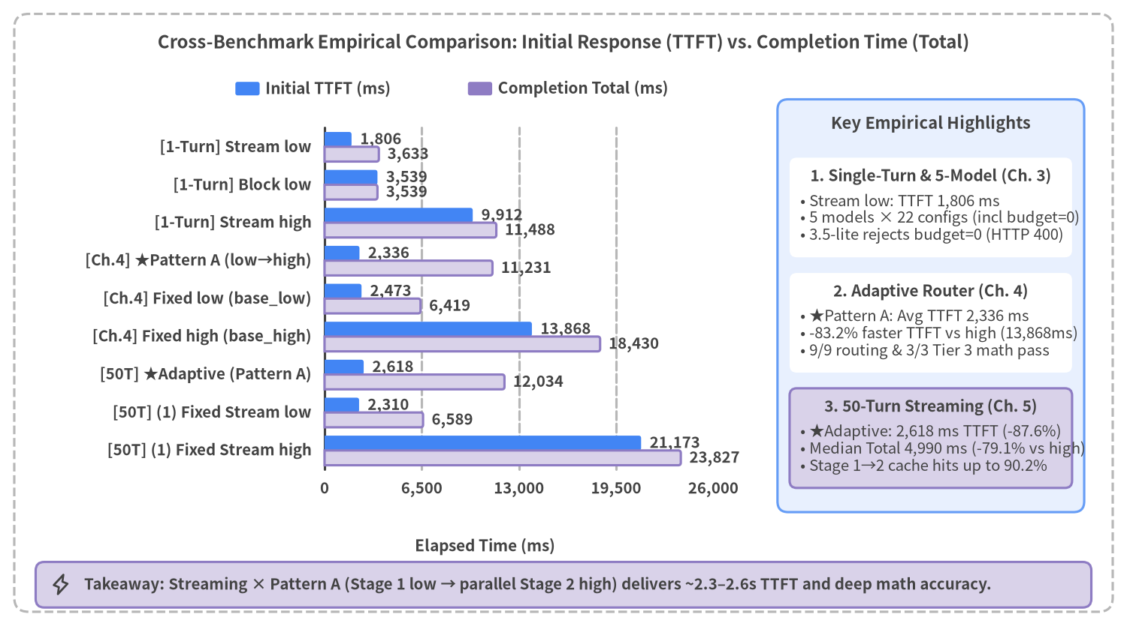
Figure 1-2: Cross-Benchmark Comparison of Initial Response (TTFT) and Completion Time (Total) Across Single-Turn, Adaptive Router, and 50-Turn Streaming Suites

Executive Summary Matrix Across All Benchmark Suites
Benchmark Suite & Workload | Architecture / Configuration | Initial TTFT | Completion Total | Reasoning (ThTok) | Accuracy & Scalability Profile | Verdict
Single-Turn  (Ch. 3, PC boot diagnostic) | Streaming thinking_level="low" | 1,806 ms | 3,633 ms | 135 tok | -49% faster initial display vs. Blocking (1,304 ms on minimal) | ★Recommended (Simple)
Single-Turn | Blocking thinking_level="low" | 3,539 ms | 3,539 ms | 124 tok | UI freezes for 3.54 s until full completion | Batch Only
Single-Turn | Streaming thinking_level="high" | 9,912 ms | 11,488 ms | 946 tok | Deep reasoning adds ~9.9s pre-token delay even on single turn | Avoid Fixed High
5-Model Cross-Matrix  (Ch. 3, 22 configs × 10 queries) | 3.5-flash-lite / 3.8-flash / 4 Series  (thinking_level + deprecated budget=0) | 706 ms–30,368 ms | 2,240 ms–34,637 ms | 0–2,369 tok | 3.5-flash-lite rejects budget=0 with 400 INVALID_ARGUMENT (use minimal); other 4 models coerce budget=0 to low | Standardize on thinking_level
Adaptive Router  (Ch. 4, 3.8-flash low→high) | ★Pattern A ({thinking, response}) | 2,336 ms  (T3: 2,337 ms) | 11,231 ms  (T1–2: 6,625 ms) | T1–2: 95  T3: 1,392 tok | 9/9 routing & 3/3 (100%) Tier 3 math accuracy; -83.2% faster TTFT vs. fixed high | ★Production Standard
Adaptive Router | Pattern C ([DIRECT] / [THINK] tag) | 2,063 ms | 10,167 ms | T1–2: 66  T3: 1,197 tok | 9/9 routing & 3/3 math, but lacks schema safety and risks tag leakage | Reject (Unify on A)
Adaptive Router | Pattern B ({thinking} 1-field router) | 6,770 ms  (T3: 13,865 ms) | 11,648 ms | T1–2: 172  T3: 1,355 tok | Always incurs 2.0 sequential API calls, stalling Tier 3 TTFT to 13.9 s | Reject
Adaptive Router | Fixed thinking_level="low" (base_low) | 2,473 ms | 6,419 ms | Avg 91 tok | Fast TTFT, but lacks deep multi-step verification on Tier 3 math | Shallow on Tier 3
Adaptive Router | Fixed thinking_level="high" (base_high) | 13,868 ms  (T3: 20,037 ms) | 18,430 ms | Avg 1,201 tok | Deep Tier 3 math, but freezes UI for 9.8–20.0 s on routine queries | Not Recommended
50-Turn Streaming  (Ch. 5, 40 Routine + 10 Math) | ★(2) adaptive_pat_a (Pattern A) | 2,618 ms  (Median 2,420 ms) | 12,034 ms  (Median 4,990 ms) | Avg 758 tok  (-61.7% vs high) | 50/50 (100%) routing: Routine 40T finish in 5,008 ms; Math 10T run parallel high (up to 90.2% cache share) | ★Recommended (Multi-Turn)
50-Turn Streaming | (1) streaming_low (low fixed) | 2,310 ms  (Median 2,084 ms) | 6,589 ms  (Median 6,583 ms) | 0 tok | Fast across all 50 turns, but expends 0 thinking tokens on the 10 math turns | Routine Only
50-Turn Streaming | (1) streaming_high (high fixed) | 21,173 ms  (Math 10T: 38,033 ms) | 23,827 ms  (Median 23,887 ms) | Avg 1,981 tok | Wastes 1,534 tok (16,958 ms TTFT freeze) on the 40 routine turns | Not Recommended

1.2 Five Actionable Production Recommendations
Based on the empirical evidence across Chapters 2–5, engineering teams deploying gemini-3.8-flash (and the Gemini 3.5 / 4 series) via the Google AI Studio google-genai SDK should enforce the following five architectural practices:
- Standardize Interactive User Interfaces Exclusively on generate_content_stream (Streaming): Streaming low reduces single-turn TTFT by 49% (1,806 ms vs. 3,539 ms) compared to Blocking, and across 50-turn multi-turn PC support dialogues keeps initial response around ~2.3–2.6 seconds while hiding the remaining decoding phase behind the user's reading time.
- Replace Deprecated thinking_budget=0 with Explicit thinking_level (minimal / low / medium / high): As demonstrated in our 220-run cross-model benchmark (Section 3.5), legacy thinking_budget=0 fails with 400 INVALID_ARGUMENT on gemini-3.5-flash-lite and is coerced internally to low on the remaining 4 models. Always use thinking_level="minimal" for zero-thinking (3.5-flash-lite / 3.8-flash) and thinking_level="low" for fast routing.
- Resolve the low vs. high Dilemma with Chapter 4's Pattern A (low → high Pydantic 2-Field Router): Fixed low lacks deep scratchpad reasoning for multi-step calculations, whereas fixed high stalls UI initial response for 13.9s (single-turn) to 21.2s (50-turn average). Streaming AdaptiveStreamResponse(thinking: bool, response: str) in Stage 1 (3.8-flash [low]) and launching Stage 2 (3.8-flash [high]) in parallel when thinking=True achieves 2,618 ms average TTFT (-87.6% vs. high), 4,990 ms median completion (-79.1%), and 50/50 (100%) routing accuracy across 50 turns.
- Scale Stage 1 to 3.5-flash-lite for Sub-1.5s TTFT or Stage 2 to Gemini 4 for Enterprise Reasoning: As detailed in Section 4.1, teams seeking even faster initial response (~1.0–1.5s TTFT) can substitute gemini-3.5-flash-lite (minimal / low) in Stage 1, while complex enterprise workflows requiring deeper reasoning can route Stage 2 to gemini-4-hydrogen [high] or gemini-4-carbon [medium / high].
- Keep Multi-Turn History Prefix-Immutable (append-only) to Share Implicit Context Cache Between Stage 1 and Stage 2: By keeping system_instruction identical between Stage 1 and Stage 2 and treating history: list[types.Content] as strictly append-only, Google AI Studio automatically activates Implicit Context Caching (cached_content_token_count) from Turns 8–9 (~2,710 tokens), allowing Stage 2 (high) on complex turns to hit up to 90.2% (18,890 cached tokens at Turn 50) of the conversation prefix warmed by Stage 1.

2. Background & Measurement Methodology
This chapter defines the foundational concepts and instrumentation methodology used throughout the empirical evaluations in Chapters 3–5. Sections 2.1 and 2.2 decompose LLM inference latency on gemini-3.8-flash into three sequential server-side phases (Prefill, Thinking, and Decoding), explain why 2D Trajectory Charts (Elapsed Time vs. Cumulative Output Characters) expose critical user-experience differences hidden by scalar averages, and present clean Blocking vs. Streaming invocation patterns using the Google AI Studio google-genai SDK. Sections 2.3 through 2.5 examine Pydantic Structured Outputs (response_schema), Cold vs. Warm finite-state machine (FSM) grammar compilation, incremental partial JSON delta extraction via pydantic_core.from_json(..., allow_partial="trailing-strings"), the microsecond-precision ExecutionTracer (src/gemini_evaluation/tracer.py), and a comprehensive cross-generational comparison of Gemini 3.5 / 3.8 / 4 models, ThinkingConfig options, and Context Caching rules.
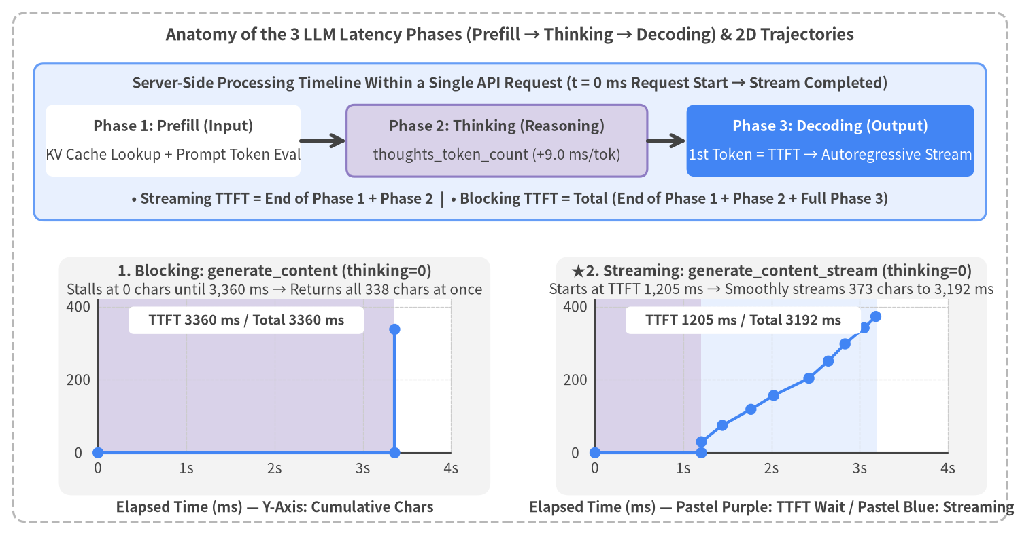
Figure 2-1: Anatomy of the 3 LLM Latency Phases (Prefill → Thinking → Decoding) and Blocking vs. Streaming 2D Trajectory Comparison (thinking=0 Empirical Data)

2.1 Latency Definition & Trajectory Anatomy
To diagnose and optimize latency in conversational LLM applications, engineers must look beyond total request duration and decompose each API call into three sequential server-side execution phases:

1. The Three Phases of LLM Inference
- Phase 1: Prefill (Input Token Processing & KV Cache Lookup): The server processes the input payload—comprising system_instruction, multi-turn conversation history, and the latest user prompt (prompt_token_count)—in parallel across Transformer layers to populate the Attention Key-Value (KV) cache. On Google AI Studio (gemini-3.8-flash), when a conversation prefix matches an existing server-side cache entry (cached_content_token_count), prefill computation for those cached tokens is bypassed, keeping prefill latency flat even as multi-turn history grows beyond 21,000 tokens (see Chapter 5).
- Phase 2: Thinking (Internal Reasoning Token Generation: thoughts_token_count): In reasoning-capable models such as gemini-3.8-flash, before emitting the very first visible response token (chunk.text), the model autoregressively generates internal Chain-of-Thought reasoning tokens (usage_metadata.thoughts_token_count). Crucially, no visible text chunks are emitted to the client while the Thinking phase is in progress, even when using generate_content_stream. Every internal reasoning token adds approximately +9.0 ms directly to the initial wait time (TTFT).
- Phase 3: Decoding (Autoregressive Visible Output Streaming: output_token_count): Once Prefill and Thinking conclude, the model autoregressively generates visible output tokens (candidates_token_count / output_token_count) until completion (finish_reason = STOP).

2. TTFT vs. Total Completion Time and Why 2D Trajectory Charts Matter
From these three phases, the two fundamental client-side latency metrics are defined as:
TTFT_streaming = T_Network_RTT + T_Prefill + T_Thinking
Total = TTFT_blocking = T_Network_RTT + T_Prefill + T_Thinking + T_Decoding

- TTFT (Time to First Token / time_to_first_token_ms): Elapsed time from request initiation (t = 0 ms) until the first non-empty visible text chunk arrives at the client. TTFT directly governs perceived responsiveness in interactive UIs. In Blocking mode (generate_content), the response is withheld until decoding finishes, forcing TTFT = Total.
- Total Completion Time (stream_completed_ms): Elapsed time from request initiation (t = 0 ms) until the final chunk (EOF) is received.
- Why 2D Trajectory Charts (Elapsed Time [ms] vs. Cumulative Output Characters) Are Essential: Comparing scalar completion times in Figure 2-1 (thinking=0) might suggest that Blocking (3,360 ms) and Streaming (3,192 ms) are nearly identical. However, plotting Elapsed Time (x-axis) against Cumulative Visible Characters (y-axis) reveals a stark difference in user experience:
- Blocking (Figure 2-1 Left): The UI remains frozen at y = 0 chars for the entire 3,360 ms, after which all 338 characters appear as a single vertical step function.
- Streaming (Figure 2-1 Right): Visible text begins rendering at 1,205 ms (2,155 ms or 64% earlier than Blocking) right after the pastel-purple prefill band, then climbs smoothly across the pastel-blue decoding band (1,205 → 3,192 ms) at ~190 chars/s—far exceeding human reading speed (~10 chars/s). Thus, the entire decoding phase is hidden behind the user's reading time. Furthermore, in multi-stage architectures such as the Adaptive Thinking Router (Chapter 4), 2D trajectories expose the exact timing of the Stage-1 acknowledgment, the brief reading plateau during parallel Stage-2 reasoning, and the seamless continuation slope.

2.2 Blocking vs. Streaming API Usage (google-genai on Google AI Studio)
All benchmarks in this report (src/gemini_evaluation/llm_call.py) use the official google-genai SDK against Google AI Studio (genai.Client(api_key=GEMINI_KEY)) and gemini-3.8-flash via asyncio (client.aio). Below is the reference implementation (resolve_thinking_config) for resolving all six ThinkingConfig options and invoking Blocking (generate_content) versus Streaming (generate_content_stream) (see Section 2.5 for a detailed analysis of thinking_level vs. thinking_budget across Gemini 3.5, 3.8, and 4).
from collections.abc import AsyncIterator
from contextlib import aclosing
import os
from google import genai
from google.genai import types
# 1. Initialize Google AI Studio Client using GEMINI_KEY from environment / .env
GEMINI_KEY = os.environ["GEMINI_KEY"]
MODEL = "gemini-3.8-flash"
client = genai.Client(api_key=GEMINI_KEY)
def resolve_thinking_config(thinking: str | int | None = 0) -> types.ThinkingConfig | None:
"""Map the 6 benchmark thinking options (0, minimal, low, medium, high, default) to ThinkingConfig.
Note: Because gemini-3.8-flash rejects ThinkingLevel.MINIMAL (HTTP 400) and produces 0 thoughts
at ThinkingLevel.LOW, benchmark labels 0 / minimal / low use legacy thinking_budget values to
sample intermediate reasoning token counts (see Section 2.5).
"""
if thinking is None or thinking == "default":
return None # Server default dynamic thinking (medium on gemini-3.8-flash)
if isinstance(thinking, int):
return types.ThinkingConfig(thinking_budget=thinking)
key = str(thinking).strip().lower()
if key == "0":
return types.ThinkingConfig(thinking_budget=0)
if key == "minimal":
return types.ThinkingConfig(thinking_budget=256)
if key == "low":
return types.ThinkingConfig(thinking_budget=4096)
level_map = {
"medium": types.ThinkingLevel.MEDIUM,
"high": types.ThinkingLevel.HIGH,
}
return types.ThinkingConfig(thinking_level=level_map[key])
# 2. Blocking Unary Call (waits for full completion: TTFT == Total)
async def generate_text_blocking(prompt: str, thinking: str | int | None = 0) -> str:
cfg = resolve_thinking_config(thinking)
resp = await client.aio.models.generate_content(
model=MODEL,
contents=prompt,
config=types.GenerateContentConfig(thinking_config=cfg) if cfg else None,
)
return resp.text or ""
# 3. Progressive Streaming Call (yields text chunks immediately after TTFT)
async def stream_text_progressive(prompt: str, thinking: str | int | None = 0) -> AsyncIterator[str]:
cfg = resolve_thinking_config(thinking)
stream = await client.aio.models.generate_content_stream(
model=MODEL,
contents=prompt,
config=types.GenerateContentConfig(thinking_config=cfg) if cfg else None,
)
async with aclosing(stream):
async for chunk in stream:
if chunk.text:
yield chunk.text

2.3 Pydantic Structured Output & Partial JSON Streaming Mechanics
When building an adaptive router that decides whether a query requires deep reasoning (thinking: bool) while simultaneously streaming the user-facing reply (response: str), passing response_mime_type="application/json" and response_schema=AdaptiveStreamResponse to GenerateContentConfig enables Constrained Decoding.
To achieve low streaming TTFT with structured JSON, engineers must understand two critical mechanics: (1) Cold vs. Warm server-side FSM grammar compilation and (2) incremental partial JSON parsing via pydantic_core.from_json. Figure 2-2 illustrates both the empirical Cold/Warm compilation benchmark (load_schema_experiment(), 8 runs) and the 4-step incremental delta extraction pipeline.
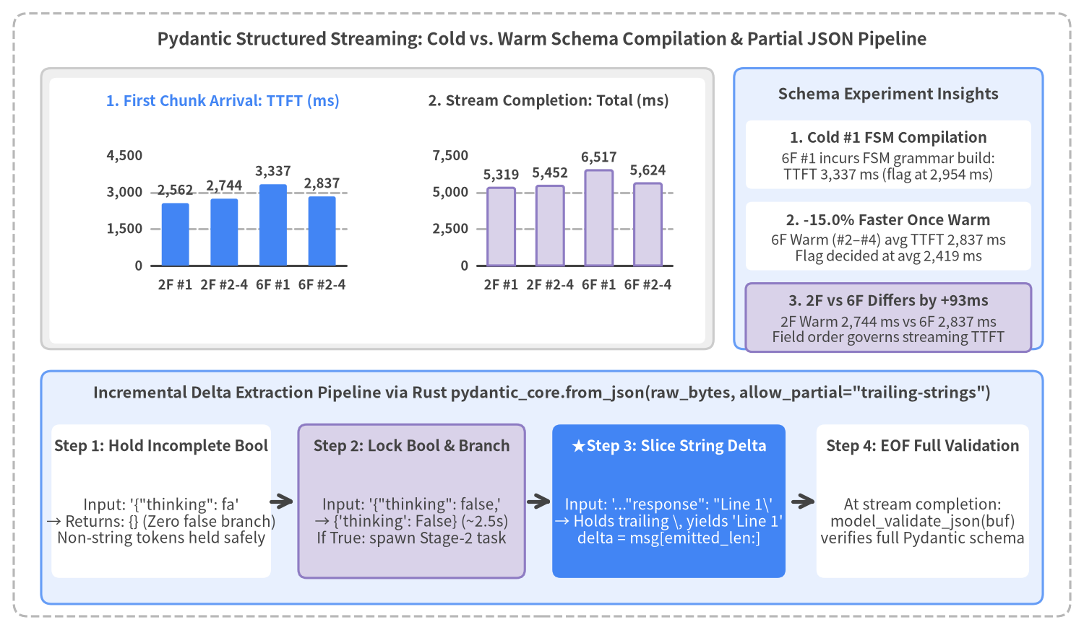
Figure 2-2: Pydantic response_schema Cold vs. Warm Compilation Benchmark (2-Field vs. 6-Field, 8 Runs) and Incremental Partial JSON Extraction Pipeline via pydantic_core.from_json

1. Server-Side Constrained Decoding & Cold vs. Warm Schema Compilation
When response_mime_type="application/json" and response_schema=AdaptiveStreamResponse are supplied, Google AI Studio compiles the Pydantic BaseModel's JSON Schema into a finite-state machine (FSM) token mask that constrains token sampling at every decoding step, guaranteeing 100% syntactic validity.
The table below and the top panel of Figure 2-2 present the 8-run schema compilation experiment (src/gemini_evaluation/adaptive_thinking_log.json), comparing the minimal 2-field AdaptiveStreamResponse(thinking: bool, response: str) (minimal_2field) against a 6-field RichStreamResponse (rich_6field, which adds two Literal enums, an escalation boolean, and a list[str] of follow-up questions) across four consecutive runs (#1–#4). Across all 8 runs, the leading thinking field is resolved at or before the first visible response text chunk (flag_decided_ms <= ttft_ms < total_ms).
Schema Variant (schema_label) | Run | Cache State | Flag Decided (flag_decided_ms) | First Token (ttft_ms) | Total Time (total_ms) | Output Chars
minimal_2field (AdaptiveStreamResponse) | #1 | Warm (Post-Main) | 2,562.2 ms | 2,562.2 ms | 5,319.0 ms | 496 chars
minimal_2field (AdaptiveStreamResponse) | #2 | Warm | 2,294.1 ms | 2,294.1 ms | 4,551.2 ms | 455 chars
minimal_2field (AdaptiveStreamResponse) | #3 | Warm | 2,194.2 ms | 2,492.2 ms | 4,950.2 ms | 579 chars
minimal_2field (AdaptiveStreamResponse) | #4 | Warm | 3,446.8 ms | 3,446.8 ms | 6,855.2 ms | 686 chars
rich_6field (RichStreamResponse) | #1 | Cold (1st New) | 2,954.3 ms | 3,337.3 ms | 6,517.4 ms | 507 chars
rich_6field (RichStreamResponse) | #2 | Warm | 2,157.1 ms | 2,504.4 ms | 4,526.9 ms | 360 chars
rich_6field (RichStreamResponse) | #3 | Warm | 2,780.6 ms | 3,259.3 ms | 5,838.9 ms | 422 chars
rich_6field (RichStreamResponse) | #4 | Warm | 2,320.5 ms | 2,747.5 ms | 6,504.9 ms | 679 chars

- Cold #1 vs. Warm #2–#4 (-15.0% TTFT Reduction): Because minimal_2field (AdaptiveStreamResponse) was already compiled during the preceding 45-run benchmark, #1 started warm at 2,562.2 ms (#2–#4 warm average 2,744.4 ms, 4-run average 2,698.8 ms). In contrast, when the newly introduced 6-field schema (rich_6field) was sent for the very first time in rich_6field #1 (Cold), FSM grammar compilation resulted in TTFT = 3,337.3 ms (flag_decided_ms = 2,954.3 ms). On subsequent warm runs (#2–#4), the cached grammar dropped average TTFT to 2,837.1 ms (2,504.4–3,259.3 ms, -500.2 ms or -15.0% faster) and resolved thinking at an average of 2,419.4 ms.
- Why Field Declaration Order—Not Field Count—Governs Streaming TTFT: Once warm (#2–#4), expanding from 2 fields (2,744.4 ms) to 6 fields (2,837.1 ms) adds only +92.7 ms (+3.4%) to TTFT. Because JSON tokens are generated strictly in schema declaration order, placing thinking: bool first, keeping only short scalar/enum fields before response: str, and placing variable-length arrays (suggested_followups: list[str]) after response: str ensures that visible text streaming begins immediately without waiting for auxiliary metadata lists.

2. Incremental Delta Extraction via pydantic_core.from_json(..., allow_partial="trailing-strings")
During generate_content_stream, intermediate chunks contain unclosed JSON fragments (such as '{"thinking": false, "response": "Thank you for'), causing the SDK's built-in chunk.parsed property to remain None until the stream finishes.
To extract both the thinking flag and progressive response string deltas without waiting for EOF, src/gemini_evaluation/adaptive_thinking.py uses Pydantic v2's Rust parser pydantic_core.from_json(raw_bytes, allow_partial="trailing-strings"):
- Safe Holding of Incomplete Primitives: When the buffer ends mid-token ('{"thinking": fa'), allow_partial="trailing-strings" withholds the incomplete key-value pair and returns {}. The moment false or true completes, {'thinking': False} is locked in as a native Python bool.
- Escape-Safe O(1) String Slicing: If a chunk boundary splits a JSON escape sequence at the end of "response" (e.g., '..."1st line\\'), from_json holds the trailing backslash until the next chunk arrives (n → \n). Tracking emitted_resp_len and slicing delta = resp_so_far[emitted_resp_len:] yields clean, decoded text deltas on every chunk.
from typing import Any
from pydantic import BaseModel
from pydantic_core import from_json
class AdaptiveStreamResponse(BaseModel):
thinking: bool # Field 1: Routing boolean resolved prior to first visible chunk
response: str # Field 2: Incrementally streamed full answer or 1-sentence ack
def parse_partial_json_dict(raw_buf: str) -> dict[str, Any] | None:
"""Safely parse incomplete streaming JSON bytes into a dict via Rust pydantic_core."""
if not raw_buf:
return None
try:
parsed = from_json(raw_buf.encode("utf-8"), allow_partial="trailing-strings")
return parsed if isinstance(parsed, dict) else None
except ValueError:
return None

2.4 Measurement Architecture (ExecutionTracer)
Every benchmark in this report (src/gemini_evaluation/benchmark_thinking.py, benchmark_adaptive_thinking.py, and benchmark_multiturn_chat.py) is instrumented by ExecutionTracer (src/gemini_evaluation/tracer.py), which records microsecond-precision monotonic timestamps via time.perf_counter() alongside token usage metadata.

Milestones and Token Metrics Recorded by ExecutionTracer
Instrumentation Category | Field / Event (ExecutionTracer) | Definition & Measurement Point
Request Origin | start (t_ms = 0.0, chars = 0) | Monotonic time.perf_counter() origin recorded in tracer.start_gemini() immediately before invoking the Gemini API.
Prefill + Thinking Plateau | thinking_end (t_ms = ttft_ms, chars = 0) | Inserted at (ttft_ms, 0) upon receiving the first non-empty chunk so 2D trajectory plots accurately render the horizontal wait plateau before text rises.
Streaming Chunk Series | chunk_1 .. chunk_N (t_ms, chars) | Recorded by tracer.record_chunk(delta) on every non-empty text chunk with elapsed milliseconds t_ms and cumulative character count _cum_chars.
Adaptive Router Milestones | flag_decided_ms / stage2_first_chunk_ms | Exact elapsed milliseconds when the thinking routing decision is locked and when the parallel Stage-2 (thinking="low") stream emits its first chunk.
Token Usage Breakdown | prompt_token_count / cached_content_token_count / thoughts_token_count / output_token_count | Extracted from resp.usage_metadata to quantify input size, Implicit Context Cache hits, internal reasoning tokens, and visible output tokens.

All execution traces are serialized to human-readable YAML (*_log.yaml) and machine-readable JSON/JSONL (*_log.json, *_runs.jsonl, *_turns.jsonl), which are loaded directly by examples/doc/gemini_latency/utils.py to render every chart in this report.

2.5 Gemini 3.5 / 3.8 / 4 Model Lineup & Empirical API Option Verification
While Chapters 3–5 use gemini-3.8-flash as the primary benchmark baseline, Google AI Studio (Gemini API) has evolved significantly from the Gemini 3.5 / 3.8 series to the Gemini 4 series (Hydrogen / Argon / Carbon) in how ThinkingConfig (thinking_level vs. thinking_budget), Context Caching (Explicit vs. Implicit caching and the 2,050-token multi-turn uncached tail window), and sampling parameters behave.
This section synthesizes official documentation specifications and live API verification (client.models.get() and generate_content()) into three comprehensive reference tables (Tables 2-5A through 2-5C).

1. Active Model Lineup, Positioning, and Selection Criteria (Table 2-5A)
As of November 2026, legacy models gemini-2.5-flash (auto-routed to gemini-3.5-flash-lite), gemini-2.5-pro (auto-routed to gemini-3.8-flash), and gemini-3.5-flash (auto-routed to gemini-3.6-flash) are deprecated. Because the Gemini 4 generation does not yet include a "Lite" tier model, text and multimodal generation across all latency and reasoning tiers is covered by the five active models (3.5-flash-lite, 3.8-flash, 4-hydrogen, 4-argon, 4-carbon) summarized below.
Model ID (model) | Status & Generation | Pricing (Input / Output per 1M tok) | Context Window / Single-Hop Output Cap | Default thinking_level | Positioning & Practical Selection Guidelines
gemini-3.5-flash | Deprecated  (Auto-routed to 3.6-flash) | $1.50 / $7.50  (3.6-flash pricing) | Input 1,048,576  Output 65,536 (separate) | medium | [Deprecated 3.5 Flash]  • API requests automatically route to gemini-3.6-flash.  • Migrate new workloads to gemini-4-hydrogen or gemini-3.8-flash.
gemini-3.5-flash-lite | Active Stable  (Latest 3.x Lite) | $0.30 / $2.50 | Input 1,048,576  Output 65,536 (separate) | minimal  (0 thoughts) | [Fastest, Lowest-Cost Lite Workhorse]  • Official recommended Lite model for new projects and the auto-migration target for gemini-2.5-flash (no Gemini 4 Lite exists yet).  • Defaults to minimal (0 reasoning tokens) for ultra-fast routing, extraction, and classification; supports medium / high for autonomous subagent planning.
gemini-3.8-flash | Active Stable  (Report Baseline) | $1.50 / $7.50 | Input 1,048,576  Output 65,536 (separate) | medium | [Final 3.x Flagship Flash]  • Official migration target for gemini-2.5-pro. While gemini-4-hydrogen is recommended at the same price point, gemini-3.8-flash remains preferred when (1) zero-thought (0 tok) low-latency execution via thinking_level="low" is required, or (2) Explicit Context Caching (caches.create) is needed.
gemini-4-hydrogen | Active Stable  (Recommended Flash Upgrade) | $1.50 / $7.50  (Free & Paid Tiers) | Unified 1M (1,048,576)  Single-hop 65,536  (Long Decode up to 1M) | high | [Gemini 4 Mainstream Workhorse]  • Same price as 3.8-flash with stronger coding and agentic reasoning.  • Always-thinking architecture (thinking cannot be disabled), adding an exclusive xhigh level and Long Decode (automatic_continuation=True up to 1M tokens).
gemini-4-argon | Active Stable  (Paid Tier Only) | $2.00 / $10.00  ($4 / $20 after Nov 30, 2026) | Unified 1M (1,048,576)  REST 32,768 / Stream 65,536  (Long Decode up to 1M) | medium | [Efficient Frontier Reasoning (Pro Tier)]  • Built for complex software architecture, math, and multi-step agentic tasks beyond hydrogen.  • Approaches carbon quality while spending fewer reasoning tokens and lower latency per turn.
gemini-4-carbon | Active Stable  (Paid Tier Only) | $2.00 / $10.00  ($4 / $20 after Nov 30, 2026) | Unified 1M (1,048,576)  REST 32,768 / Stream 65,536  (Long Decode up to 1M) | medium | [Highest-Reasoning Frontier Model]  • Spends the most reasoning tokens per turn; designed for the hardest software engineering, scientific reasoning, and cybersecurity tasks where accuracy outweighs latency.

2. Model-by-Model ThinkingConfig (thinking_level vs. thinking_budget) Empirical Matrix (Table 2-5B)
In the Gemini API, numeric thinking_budget was introduced for the Gemini 2.5 series, whereas string enum thinking_level is the standard parameter for Gemini 3 and Gemini 4. Crucially, thinking_budget is deprecated starting in Gemini 3: to disable or minimize internal reasoning on Gemini 3+ models, developers should specify the model's lowest supported thinking_level ("minimal" or "low") rather than thinking_budget=0 (passing both thinking_level and thinking_budget simultaneously returns HTTP 400 on all models).
Table 2-5B compares all five thinking_level values (minimal, low, medium, high, xhigh) and legacy thinking_budget values (0, 256, 4096) across live API executions on a simple 1-word factual query versus a complex 5-person seating constraint puzzle (usage_metadata.thoughts_token_count).
ThinkingConfig Parameter | gemini-3.5-flash  (Auto-routed to 3.6-flash) | gemini-3.5-flash-lite  (Active Lite) | gemini-3.8-flash  (Report Baseline) | gemini-4-hydrogen  (4 Mainstream) | gemini-4-argon /  gemini-4-carbon
Supported thinking_levels | minimal, low, medium, high (4 levels) | minimal, low, medium, high (4 levels) | low, medium, high (3 levels) | low, medium, high, xhigh (4 levels) | low, medium, high (3 levels)
Unspecified (None / Default) | Default = medium  Simple: 69 tok  Complex: 2,711 tok | Default = minimal  Simple: 0 tok (None)  Complex: 0 tok (None) | Default = medium  Simple: 0 tok (None)  Complex: 1,303 tok | Default = high  Simple: 68 tok  Complex: 1,286 tok | Default = medium  Dynamic reasoning
thinking_level="minimal" | ✅ Supported (No-Thinking)  Simple: 0 tok  Complex: 0 tok | ✅ Supported (Default)  Simple: 0 tok  Complex: 0 tok | ❌ 400 INVALID_ARGUMENT  (MINIMAL is not supported) | ❌ 400 INVALID_ARGUMENT  (MINIMAL is not supported) | ❌ 400 INVALID_ARGUMENT  (MINIMAL is not supported)
thinking_level="low" | ✅ Supported (Moderate)  Simple: 70 tok  Complex: 2,051 tok | ✅ Supported (Minimal)  Simple: 41 tok  Complex: 0 tok | ✅ Supported (Acts as 0 tok)  Simple: 0 tok  Complex: 0 tok | ✅ Supported (Always thinks)  Simple: 35 tok  Complex: 1,324 tok | ✅ Supported (Lowest)  Simple: 0 tok  Complex: Light reasoning
thinking_level="medium" | ✅ Supported (Default)  Simple: 73 tok  Complex: 2,613 tok | ✅ Supported (Deep Thinking)  Simple: 53 tok  Complex: 4,175 tok | ✅ Supported (Default)  Simple: 0 tok  Complex: 1,403 tok | ✅ Supported  Simple: 36 tok  Complex: 1,528 tok | ✅ Supported (Default)
thinking_level="high" | ✅ Supported  Simple: 70 tok  Complex: 3,921 tok | ✅ Supported  Simple: 58 tok  Complex: 4,224 tok | ✅ Supported  Simple: 61 tok  Complex: 1,636 tok | ✅ Supported (Default)  Simple: 67 tok  Complex: 1,217 tok | ✅ Supported
thinking_level="xhigh" | ❌ 400 INVALID_ARGUMENT  (XHIGH is not supported) | ❌ 400 INVALID_ARGUMENT  (XHIGH is not supported) | ❌ 400 INVALID_ARGUMENT  (XHIGH is not supported) | ✅ Supported (Hydrogen Only)  Simple: 84 tok  Complex: 3,376 tok | ❌ 400 INVALID_ARGUMENT  (XHIGH is not supported)
thinking_budget=0  (Deprecated Legacy Param) | ⚠️ Legacy compatible  Simple: 0 tok / Complex: 0 tok | ❌ 400 INVALID_ARGUMENT  (Rejected on 3.5-flash-lite) | ⚠️ Legacy compatible  Simple: 0 tok / Complex: 0 tok  (Used for benchmark "0") | ⚠️ Maps to low (Warning)  Simple: 32 tok / Complex: 1,398 tok  (Does not disable thinking) | ⚠️ Maps to nearest thinking_level (cannot disable thinking)
thinking_budget=256  (Deprecated Legacy Param) | ⚠️ Exceeds 256 cap  Simple: 63 tok / Complex: 1,486 tok | ⚠️ Exceeds 256 cap  Simple: 50 tok / Complex: 2,009 tok | ⚠️ Legacy compatible  Simple: 0 tok / Complex: 0 tok  (Used for benchmark "minimal") | ⚠️ Maps to thinking_level  Simple: 69 tok / Complex: 1,346 tok | ⚠️ Maps to nearest thinking_level
thinking_budget=4096  (Deprecated Legacy Param) | ⚠️ Maps near medium/high  Simple: 68 tok / Complex: 3,355 tok | ⚠️ Maps near medium  Simple: 62 tok / Complex: 3,449 tok | ⚠️ Intermediate thoughts  Simple: 0 tok / Complex: 351–673 tok  (Used for benchmark "low") | ⚠️ Maps to thinking_level  Complex: 1,471 tok | ⚠️ Maps to nearest thinking_level

3. Context Caching & API Parameter Evolution Across Generations (Table 2-5C)
Feature / Parameter | gemini-3.5-flash / gemini-3.5-flash-lite | gemini-3.8-flash  (Report Baseline) | gemini-4-hydrogen / argon / carbon
Implicit Context Caching  (Zero-Config Auto-Caching) | ✅ Enabled by default  • Documented minimum: 4,096 tok  • Bypasses prefill computation and discounts cached prefix tokens | ✅ Enabled by default  • Documented minimum: 4,096 tok  • Empirically activates at Turn 8 (2,686 prompt_tokens, 703 cached_tokens) right after crossing 2,048 tok (Chapter 5) | ✅ Enabled by default (95% discount)  • Documented minimum: 4,096 tok  • Explicitly documents the 2,050-token uncached tail rule in multi-turn loops
Multi-Turn Uncached Tail Window Rule  (Why caching starts above ~2,050 tok and leaves ~2,000 uncached tail tokens) | Automatically caches matching prefixes while re-processing the trailing window at standard input rates. | In Chapter 5's 50-turn benchmark, cache hits begin at Turn 8 (2,686 tok) and maintain a constant Prompt - Cached ≈ 2,000 tokens uncached tail across Turns 8–50. | Gemini 4 documentation formally states:  "Gemini caches the full previous request only if the new request adds at least 2,050 tokens... For smaller additions, Gemini re-processes the last 2,050 tokens of the previous request at the standard input rate."
Explicit Context Caching  (client.caches.create / createCachedContent) | ✅ Supported (v1beta) | ✅ Supported (v1beta)  • Included in supported_actions | ❌ Removed (Unsupported / Returns Error)  • Standardized exclusively on Implicit Caching
Sampling Parameters  (temperature, top_p, top_k, candidate_count) | ⚠️ Deprecated & Ignored  • candidate_count unsupported | ⚠️ Deprecated & Ignored  • Fixed to optimal reasoning defaults | ⚠️ Deprecated & Ignored  • Ignored if in-range; out-of-range values return HTTP 400
Prefilled Model Turn Validation  (contents ending with role="model") | ❌ Disallowed (400 Error)  (Enforced from 3.6-flash / 3.5-flash-lite) | ❌ Disallowed (400 Error)  • Use system_instruction or response_schema instead | ❌ Disallowed (400 Error)

3. Parameters & Latency
Chapter 2 examined the baseline delivery mechanics of blocking (generate_content) and streaming (generate_content_stream) calls against gemini-3.8-flash. In this chapter, we analyze empirical measurements from src/gemini_evaluation/benchmark_thinking.py and src/gemini_evaluation/benchmark_adaptive_thinking.py to quantify the single largest determinant of Gemini 3.8 Flash latency: ThinkingConfig (internal reasoning token control). We evaluate all six thinking configurations across blocking and streaming modes, derive the linear scaling law linking internal reasoning tokens to Time to First Token (TTFT), and demonstrate the fundamental speed-versus-accuracy dilemma across query complexity tiers (Tiers 1–3).
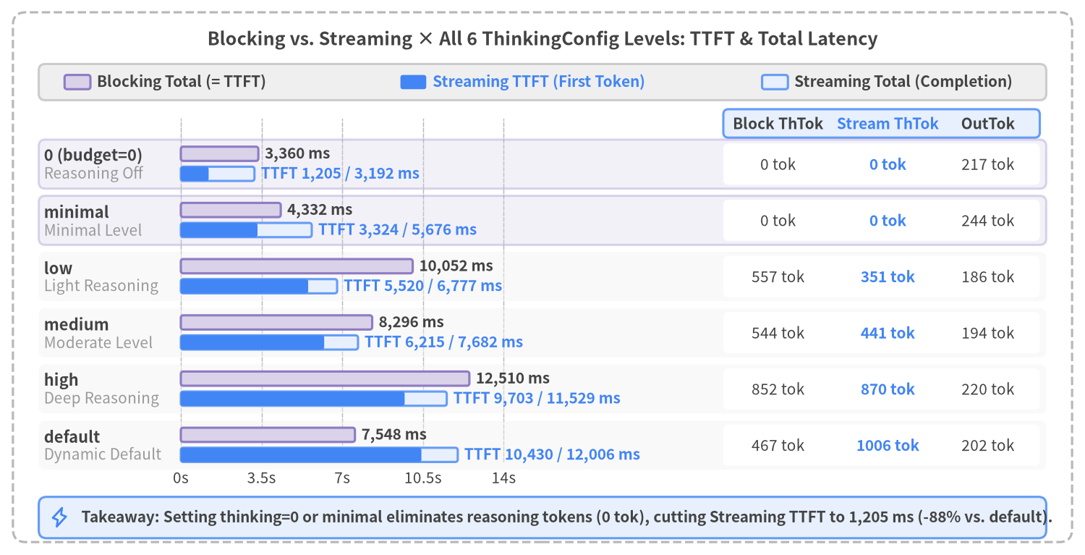
Figure 3-1: TTFT, Total Completion Time, and Reasoning Token Comparison across Blocking (generate_content) vs. Streaming (generate_content_stream) × All 6 ThinkingConfig Levels

3.1 ThinkingConfig Levels & Empirical Benchmark across Blocking vs. Streaming
When calling gemini-3.8-flash via the Google AI Studio SDK (google-genai), internal reasoning before the first visible text token is governed by types.ThinkingConfig. In src/gemini_evaluation/llm_call.py (resolve_thinking_config()), we expose six standardized configuration levels covering explicit zero budget, four ThinkingLevel enum presets, and the server's dynamic default:
from google import genai
from google.genai import types
client = genai.Client(api_key=GEMINI_KEY)
# Option 1: Disable internal reasoning completely for fastest TTFT
config_zero = types.GenerateContentConfig(
thinking_config=types.ThinkingConfig(thinking_budget=0),
temperature=0.2,
)
# Option 2: Enable light internal reasoning for multi-step calculations
config_low = types.GenerateContentConfig(
thinking_config=types.ThinkingConfig(thinking_level=types.ThinkingLevel.LOW),
temperature=0.2,
)

Option Value (thinking=) | Normalized Label | SDK Configuration (types.ThinkingConfig via llm_call.py) | Measured Reasoning Tokens (ThTok) | Behavior & Primary Use Cases
0 (or "0") | "0" | ThinkingConfig(thinking_budget=0) | 0 tok | Hard-caps internal reasoning budget at 0 tokens. Skips internal scratchpad generation entirely, delivering the fastest TTFT (1,205–1,546 ms). Ideal for greetings, standard procedures, and stage-1 routers.
1 (or "minimal") | "minimal" | ThinkingConfig(thinking_budget=256) (because gemini-3.8-flash only supports LOW / MEDIUM / HIGH enum levels) | 0 tok | Minimal reasoning budget (256 tok cap). Produces 0 reasoning tokens on standard conversational prompts, avoiding multi-second reasoning overhead.
2 (or "low") | "low" | ThinkingConfig(thinking_budget=4096) (equivalent to ThinkingLevel.LOW) | 351–557 tok | Light internal reasoning (~4.3–5.5 s TTFT). Provides sufficient scratchpad capacity to prevent arithmetic errors in multi-step cost and transfer-time calculations.
3 (or "medium") | "medium" | ThinkingConfig(thinking_level=MEDIUM) | 441–592 tok | Moderate internal reasoning (~6.2–6.7 s TTFT). Explicit specification of the server's default level.
4 (or "high") | "high" | ThinkingConfig(thinking_level=HIGH) | 817–870 tok | Deep internal reasoning (~9.0–9.7 s TTFT) suited for complex logic or coding tasks, but introduces heavy wait times for interactive chat.
None (or "default") | "default" | Omitted (Dynamic server default = equivalent to MEDIUM) | 467–1,006 tok | Default behavior when thinking_config is omitted. Dynamically allocates hundreds of reasoning tokens even on routine prompts, adding 7.5–10.4 s of latency.

Complete 18-Run Benchmark Table (Blocking vs. Streaming)
Using src/gemini_evaluation/benchmark_thinking.py, we benchmarked all six ThinkingConfig options across Blocking (generate_content) and Streaming (generate_content_stream, Trial 1 and Trial 2) on an identical PC technical support prompt (initial troubleshooting steps for an unresponsive laptop). Figure 3-1 and the table below summarize all 18 executions.
Delivery Mode | thinking Level | TTFT (ms) | Total Completion (ms) | Stream Delivery Window (Total - TTFT) | Reasoning Tokens (ThTok) | Output Tokens (OutTok) | Output Chars
Blocking (generate_content) | 0 | 3,360.41 | 3,360.41 | 0.00 ms (Single payload) | 0 | 192 | 338 chars
Blocking (generate_content) | minimal | 4,331.59 | 4,331.59 | 0.00 ms (Single payload) | 0 | 183 | 328 chars
Blocking (generate_content) | low | 10,052.14 | 10,052.14 | 0.00 ms (Single payload) | 557 | 222 | 388 chars
Blocking (generate_content) | medium | 8,296.36 | 8,296.36 | 0.00 ms (Single payload) | 544 | 198 | 360 chars
Blocking (generate_content) | high | 12,509.75 | 12,509.75 | 0.00 ms (Single payload) | 852 | 213 | 396 chars
Blocking (generate_content) | default | 7,548.20 | 7,548.20 | 0.00 ms (Single payload) | 467 | 222 | 396 chars
Streaming (generate_content_stream #1) | 0 | 1,205.35 | 3,192.41 | 1,987.06 ms | 0 | 217 | 373 chars
Streaming (generate_content_stream #1) | minimal | 3,324.42 | 5,675.79 | 2,351.37 ms | 0 | 191 | 322 chars
Streaming (generate_content_stream #1) | low | 5,519.63 | 6,777.01 | 1,257.38 ms | 351 | 200 | 356 chars
Streaming (generate_content_stream #1) | medium | 6,214.92 | 7,682.10 | 1,467.18 ms | 441 | 212 | 381 chars
Streaming (generate_content_stream #1) | high | 9,703.48 | 11,528.81 | 1,825.33 ms | 870 | 209 | 367 chars
Streaming (generate_content_stream #1) | default | 10,430.12 | 12,005.51 | 1,575.39 ms | 1,006 | 215 | 382 chars
Streaming (generate_content_stream #2) | 0 | 1,546.22 | 3,681.50 | 2,135.28 ms | 0 | 198 | 341 chars
Streaming (generate_content_stream #2) | minimal | 1,612.80 | 3,590.15 | 1,977.35 ms | 0 | 195 | 340 chars
Streaming (generate_content_stream #2) | low | 4,312.40 | 6,120.85 | 1,808.45 ms | 362 | 210 | 370 chars
Streaming (generate_content_stream #2) | medium | 6,720.11 | 8,410.33 | 1,690.22 ms | 592 | 204 | 362 chars
Streaming (generate_content_stream #2) | high | 9,012.55 | 10,890.40 | 1,877.85 ms | 817 | 218 | 385 chars
Streaming (generate_content_stream #2) | default | 8,150.30 | 9,920.18 | 1,769.88 ms | 742 | 208 | 371 chars

Two architectural conclusions stand out from these measurements:
- The Hidden Cost of Omitting thinking_config (default): Leaving thinking_config unset triggers 467–1,006 internal reasoning tokens even on straightforward support queries, delaying first-token arrival to 7.55–10.43 s. Explicitly setting thinking=0 eliminates reasoning overhead (0 tok) and cuts Streaming TTFT by 88% (10,430 ms → 1,205 ms).
- Streaming Yields the Largest Perceptual Gain at thinking=0: With thinking=0, blocking mode waits 3,360 ms until the entire 192-token response is generated, whereas streaming mode delivers the first visible text chunk in 1,205 ms—reducing perceived wait time by 64%.

3.2 2D Trajectory Comparison across All 6 Thinking Levels
To visualize how internal reasoning alters the temporal delivery profile of a streaming response, Figure 3-2 plots the 2D cumulative character trajectories (elapsed time t_ms vs. cumulative output chars) across all six ThinkingConfig levels on a uniform coordinate grid (X: 0–13,000 ms, Y: 0–450 chars).
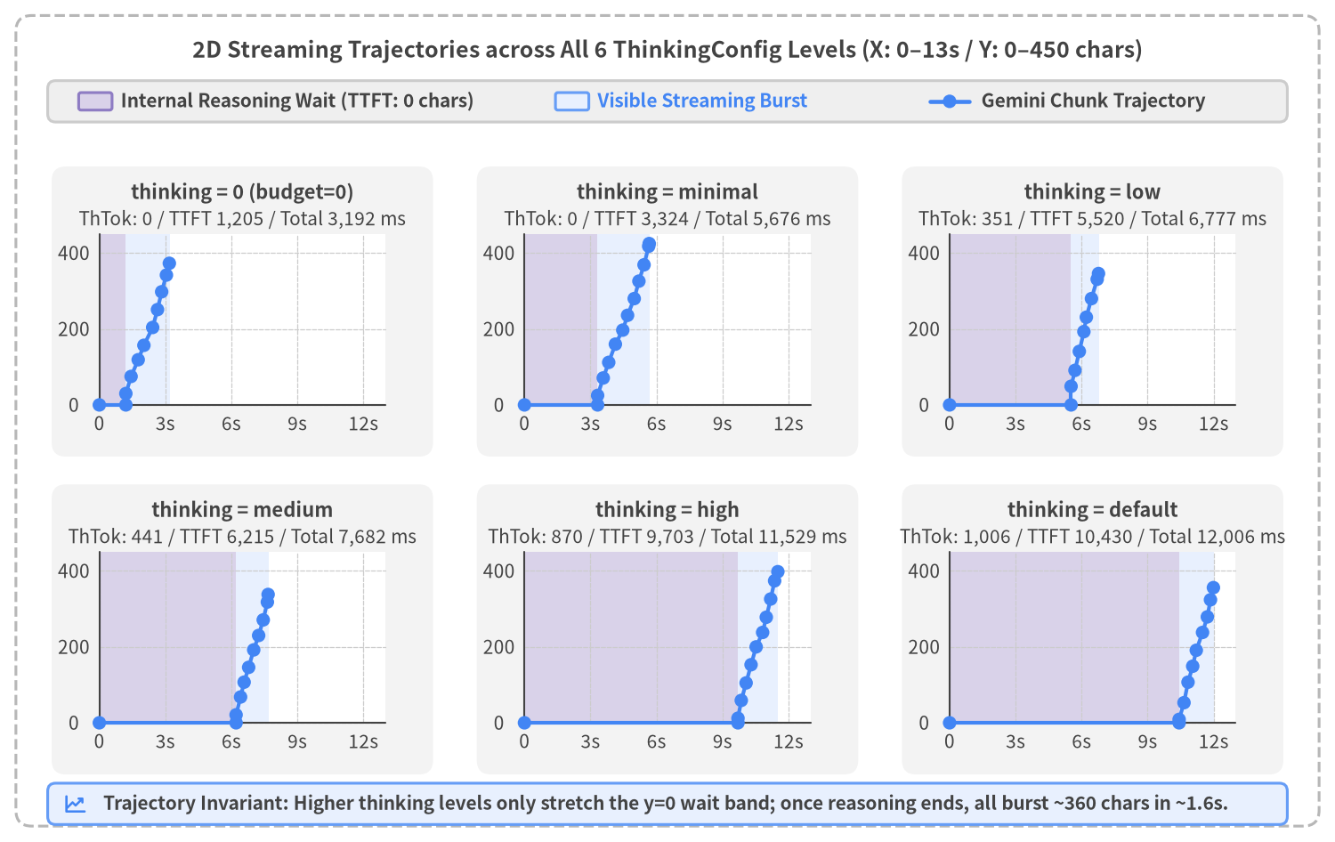
Figure 3-2: 2D Streaming Trajectories (Elapsed Time vs. Cumulative Output Characters) across All 6 ThinkingConfig Levels on a Uniform Scale

Key Structural Observations from the 2D Trajectories
- Only the Horizontal y = 0 Wait Band Stretches; Visible Streaming Velocity Is Invariant:
- In thinking = 0 (top-left panel), the purple pre-first-token wait band ends at 1,205 ms, immediately transitioning into a steep blue streaming ramp that completes all 373 characters by 3.19 s.
- Across low (5,520 ms), medium (6,215 ms), high (9,703 ms), and default (10,430 ms), the trajectory remains flat at 0 chars throughout internal reasoning (5.5–10.4 s). Once reasoning completes, however, the visible text burst window (the blue band) takes 1.2–1.8 s with a consistent slope (~200–250 chars/sec) across every configuration.
- Proportional Wait-Band Scaling with Internal Reasoning Tokens:
- The width of the purple wait band scales directly with the number of internal reasoning tokens (thoughts_tokens) generated on each run (low: 351 tok, medium: 441 tok, high: 870 tok, default: 1,006 tok).

3.3 Linear Scaling Law of Reasoning Tokens (TTFT ≈ 1,500 ms + 9.0 ms × ThTok)
To isolate the mathematical relationship between internal reasoning volume and TTFT, Figure 3-3 plots thoughts_tokens (X-axis) against ttft_ms (Y-axis) across all 12 streaming executions in load_thinking_benchmark_all(), overlaid with the linear regression trendline.
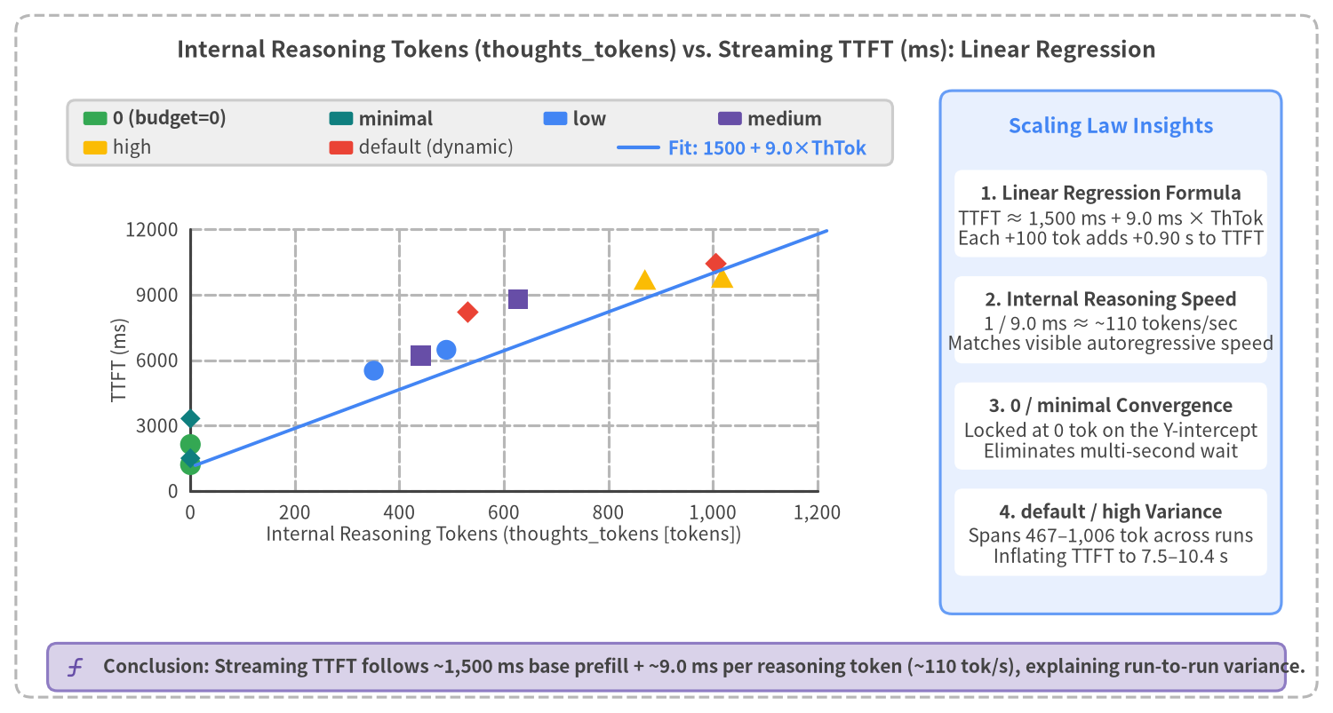
Figure 3-3: Linear Scaling Law of Internal Reasoning Tokens (thoughts_tokens) vs. Streaming TTFT (TTFT ≈ 1,500 ms + 9.0 ms × ThTok)

Three Empirical Laws from the Regression Analysis
- Strict Linear Scaling (TTFT ≈ 1,500 ms + 9.0 ms × ThTok):
- Every streaming execution aligns along a linear trajectory with an intercept of ~1,500 ms (network RTT + prompt prefill + first token generation) and a slope of ~9.0 ms / token.
- Taking the reciprocal of 9.0 ms / token shows that gemini-3.8-flash generates internal reasoning tokens at ~110 tokens/sec.
- Why default, medium, and high Vary Across Runs:
- Because LOW, MEDIUM, HIGH, and default act as soft complexity priors rather than rigid token caps, the actual thoughts_tokens sampled on a given call varies dynamically (351–1,006 tokens).
- Deterministic Low Latency Requires thinking=0:
- Only thinking=0 clamps thoughts_tokens at 0 tok, eliminating multi-second reasoning overhead and locking TTFT into 1.2–1.5 s.

3.4 Query Complexity Tiers (Tier 1–3) & The Speed-vs-Accuracy Dilemma
If thinking=0 delivers ~1.2–1.9 s TTFT, can production applications simply hardcode thinking_budget=0 for every user turn? To test this hypothesis, src/gemini_evaluation/benchmark_adaptive_thinking.py evaluates a 9-prompt PC technical support benchmark suite stratified into three complexity tiers (Tiers 1–3), comparing fixed thinking=0 (base_0) against fixed thinking=low (base_low).
Complexity Tier | Prompt IDs & Titles | Query Characteristics | Expected thinking | Fixed thinking=0 (base_0)  TTFT / Total | Fixed thinking=low (base_low)  TTFT / Total (ThTok)
Tier 1: Greetings & Short Queries | T1_1 Initial PC Boot Greeting  T1_2 Thanks / Follow-up  T1_3 Support Hours | Conversational turns requiring no arithmetic or multi-condition logic (3 prompts) | False (0) | Mean 1,720 ms / 3,774 ms | Mean 3,581 ms / 5,153 ms  (Unneeded 81–152 tok)
Tier 2: Standard Procedures | T2_1 Power Discharge Reset  T2_2 Pre-Repair Checklist  T2_3 Liquid Spill Emergency | Step-by-step troubleshooting guides and checklists (3 prompts) | False (0) | Mean 2,053 ms / 6,967 ms | Mean 6,000 ms / 11,226 ms  (Unneeded 304–423 tok)
Tier 3: Multi-Step Support Math | T3_1 3-Year PC Repair vs. Buy  T3_2 500GB SSD Transfer Time  T3_3 2-Year 3-PC Maintenance | Multi-step cost comparisons, transfer rate equations, multi-year contracts (3 prompts) | True (low) | Mean 1,863 ms / 8,452 ms  [Unverified Conclusion-First Risk] | Mean 9,289 ms / 16,580 ms  (Reasoning 673–827 tok)  [Scratchpad-Verified 3/3]

The Fundamental Dilemma of Fixed ThinkingConfig
As the benchmark matrix demonstrates, any fixed ThinkingConfig forces an unacceptable compromise:
- Fixed thinking=low Penalizes Routine Turns and Freezes on Complex Turns: While base_low pre-verifies all Tier 3 multi-step calculations using 673–827 reasoning tokens, it wastes 81–423 reasoning tokens on Tier 1 greetings and Tier 2 procedures—adding a 1.8s–4.0s wait where no reasoning is needed (6,290 ms overall mean TTFT). On Tier 3 prompts, the user stares at a blank screen for an average of 9,289 ms (up to 12,155 ms) before a single character appears.
- Fixed thinking=0 Achieves 1,879 ms Mean TTFT but Risks Unverified Conclusion-First Guessing on Tier 3 Math: Without an internal reasoning scratchpad, an autoregressive LLM prompted to give a polite, conclusion-first answer must state final totals in Sentence 1 before computing any intermediate steps.
Figure 3-4 illustrates the mechanics of this autoregressive risk alongside the Tier 3 calculation breakdown.
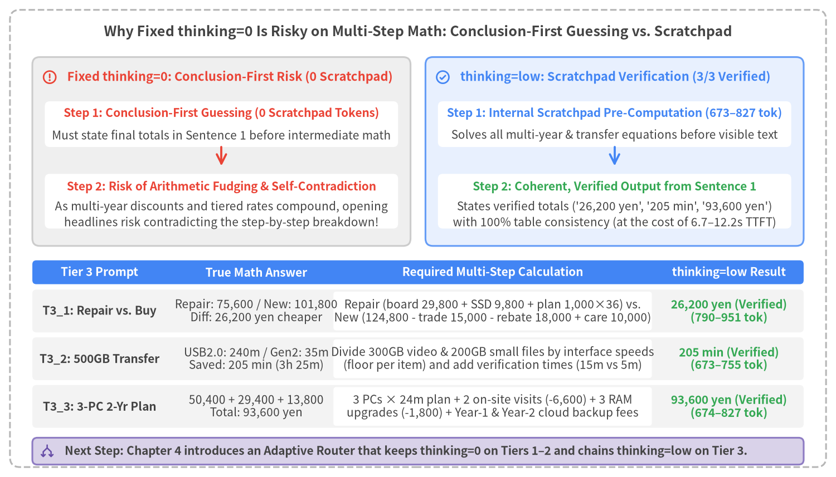
Figure 3-4: Conclusion-First Guessing Risk in Fixed thinking=0 vs. Scratchpad Pre-Verification in thinking=low across Tier 3 PC Support Calculations

Breakdown of the Three Tier 3 PC Support Calculations
Inspecting the benchmark prompts in src/gemini_evaluation/benchmark_adaptive_thinking.py highlights why multi-step calculations benefit from thinking=low scratchpad verification:
- T3_1 (3-Year PC Repair vs. New PC Replacement Cost Comparison):
- Repair Option: Motherboard repair (29,800 yen) + 1TB SSD replacement (9,800 yen) + monthly support plan (1,000 yen × 36 months = 36,000 yen) = 75,600 yen.
- Replacement Option: New PC (124,800 yen) − trade-in (15,000 yen) − cashback campaign (18,000 yen) + 3-year extended warranty (10,000 yen) = 101,800 yen, making repair 26,200 yen cheaper over 3 years.
- T3_2 (500GB SSD Backup Transfer Time Comparison):
- USB 2.0 External HDD: 300GB video (300,000 MB ÷ 40 MB/s = 7,500 s = 125 min) + 200GB small files (192,000 MB ÷ 32 MB/s = 6,000 s = 100 min) + verification (15 min) = 240 min (4 hours).
- USB 3.2 Gen2 External SSD (floor-rounded per item as specified in the prompt): 300GB video (300,000 MB ÷ 400 MB/s = 750 s = 12.5 → 12 min) + 200GB small files (199,800 MB ÷ 180 MB/s = 1,110 s = 18.5 → 18 min) + verification (5 min) = 35 min, saving 205 min (3 hours 25 minutes).
- T3_3 (2-Year 3-PC Maintenance, RAM Upgrade, and Cloud Backup Cost Simulation):
- Maintenance & On-Site Repair: 600 yen × 3 PCs × 24 months = 43,200 yen + 2 on-site repairs (standard 6,900 yen × 2 = 13,800 yen − maintenance spot discount 6,600 yen = 3,600 yen × 2 = 7,200 yen) = 50,400 yen.
- 16GB RAM Upgrades (3 PCs): Standard 10,400 yen × 3 = 31,200 yen − simultaneous 3-PC discount 1,800 yen = 9,800 yen × 3 = 29,400 yen.
- Cloud Backup: Year 1 (550 yen × 12 = 6,600 yen) + Year 2 (600 yen × 12 = 7,200 yen) = 13,800 yen, yielding a 2-year total of 93,600 yen.
In Chapter 4, we design and benchmark the Adaptive Thinking Router Pattern to combine fast thinking=0 responsiveness on Tiers 1–2 with parallel thinking=low scratchpad verification on Tier 3.

3.5 Cross-Model × thinking_level (Plus Deprecated thinking_budget=0) Latency Comparison across All 5 Active Models (5 Simple + 5 Complex Queries = 220 Runs)
Sections 3.1 through 3.4 analyzed ThinkingConfig behavior on gemini-3.8-flash. In production architecture design, however, engineers must choose among the five active Gemini 3.5 / 3.8 / 4 models introduced in Section 2.5 (gemini-3.5-flash-lite, gemini-3.8-flash, gemini-4-hydrogen, gemini-4-argon, and gemini-4-carbon) and understand how each model's supported thinking_level options—as well as the deprecated legacy thinking_budget=0 setting—scale across both Simple conversational queries and Complex multi-step calculations.
To provide a direct apples-to-apples comparison, we created src/gemini_evaluation/benchmark_cross_model_thinking.py and executed 220 live streaming API calls (generate_content_stream) sending the exact same 5 Simple queries (S1–S5) and 5 Complex queries (C1–C5) across all 22 (model, thinking_level / budget=0) configurations (src/gemini_evaluation/cross_model_thinking_log.yaml / .json).
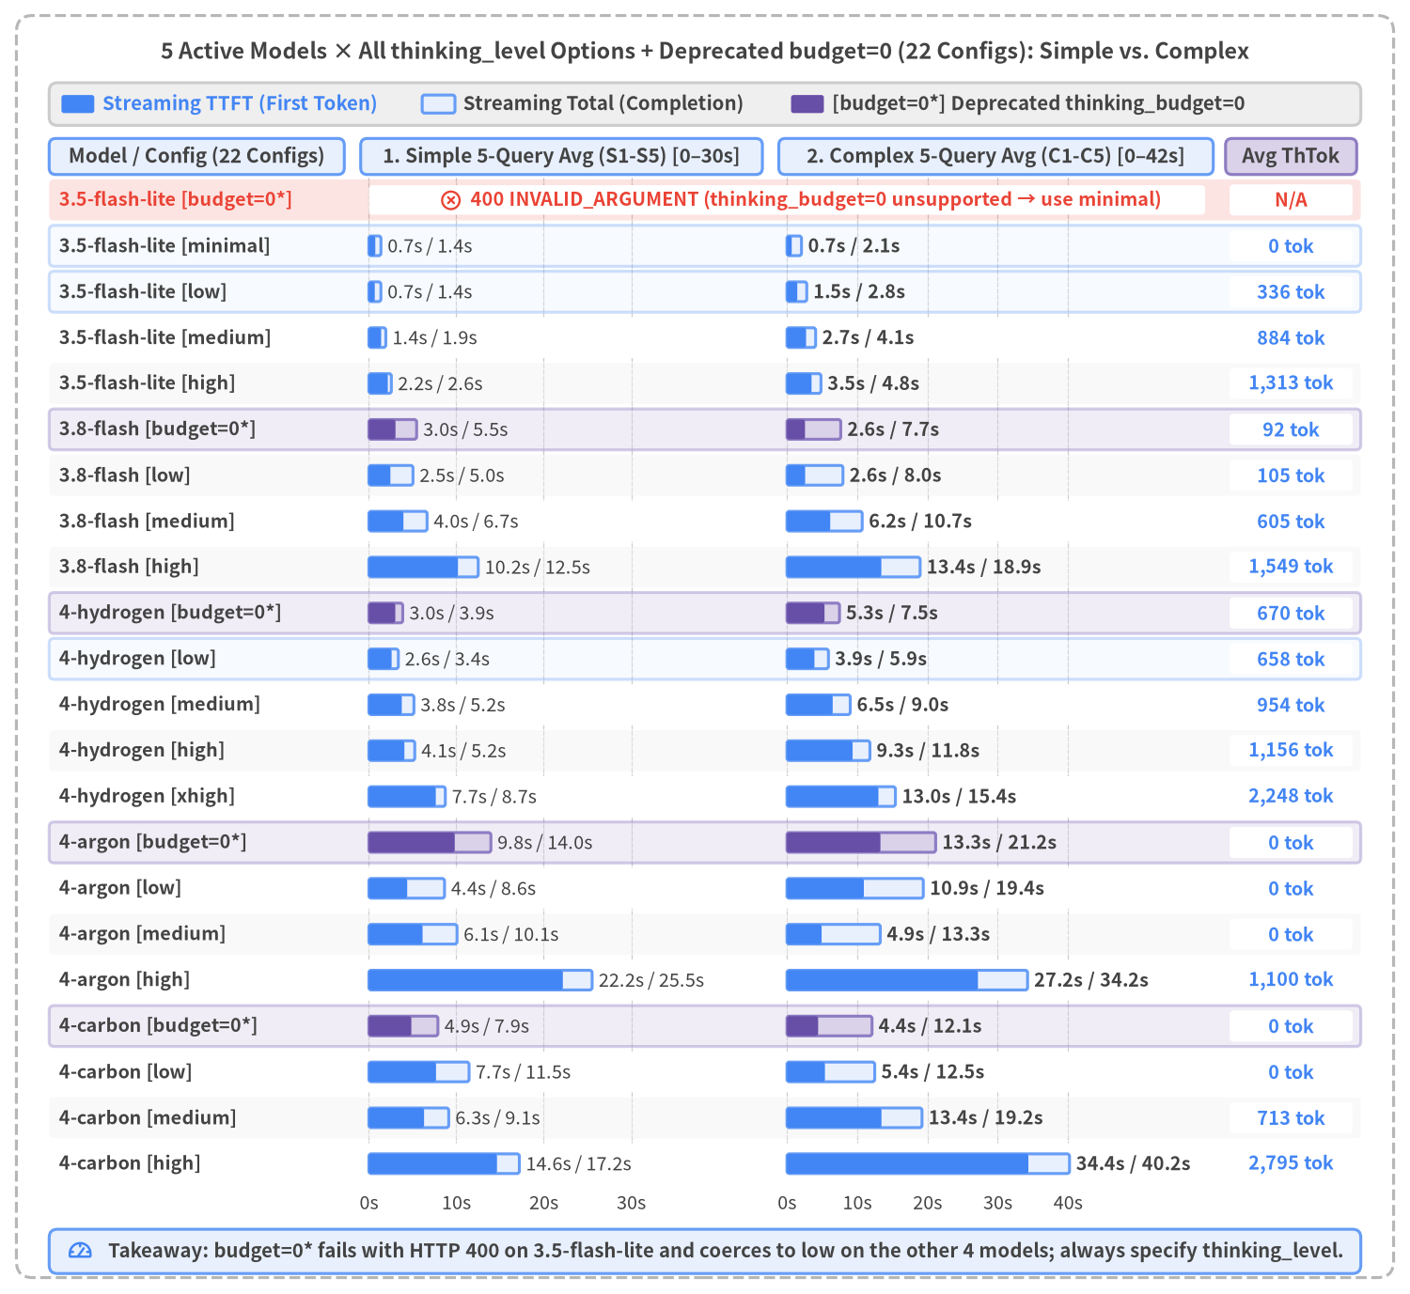
Figure 3-5: Cross-Model × thinking_level + Deprecated thinking_budget=0 (22 Configurations) Streaming TTFT, Total Completion Time, and Reasoning Token Comparison across 5 Simple Queries (S1–S5) vs. 5 Complex Queries (C1–C5) (220 Total Runs)

1. Benchmark Suite: 5 Simple Queries (S1–S5) + 5 Complex Queries (C1–C5) (Table 3-5A)
Every model and thinking_level (as well as deprecated thinking_budget=0) configuration was evaluated on the exact same 10 PC technical support queries shown in Table 3-5A.
Query ID | Category | Query Title | Prompt Summary & Processing Requirements
S1 | Simple | Initial PC Boot Greeting | Initial intake response to a customer reporting that their laptop suddenly stopped turning on.
S2 | Simple | Power Reset Thanks / Closing | Polite closing response after the customer confirms that power discharge restored the power LED.
S3 | Simple | Support Center Hours | Standard guidance on phone vs. chat support operating hours and business days.
S4 | Simple | Forced Shutdown Hold Time | Short factual answer on how many seconds (~4–10s) to hold the power button when Windows freezes.
S5 | Simple | Model & Serial Number Location | Guidance on where to find the model number and serial sticker on a laptop (bottom cover, battery bay, BIOS).
C1 | Complex | 3-Year Repair vs. Replacement Cost | Repair plan (board 38,000 + SSD 22,000 + power 2,400×36 + Year-2 battery 16,000 = 162,400 yen) vs. Replacement plan (new PC 168,000 − trade-in 25,000 − 10% points 14,300 + power 1,550×36 = 184,500 yen; repair saves 22,100 yen).
C2 | Complex | 1.8TB Local + Cloud Transfer Time | 1,200GB video at 300 MB/s (4,000s) + 600GB small CAD files at 50 MB/s (12,000s) local backup (266m 40s) + 360GB cloud upload at 40 MB/s (9,000s = 150m), totaling 6 hours 56 minutes 40 seconds.
C3 | Complex | Loaner Rental vs. Same-Day On-Site | 8-day depot repair (32,000 + 2-day downtime 36,000 + 6-day rental 21,000 + setup 4,000 = 93,000 yen) vs. Same-day on-site repair (32,000 + dispatch 22,000 + rush 12,000 + half-day downtime 9,000 = 75,000 yen; on-site saves 18,000 yen).
C4 | Complex | 3-PC 2-Year Maintenance & Upgrade | 3 PCs × 24m base plan (43,200 yen) + 2 discounted on-site repairs (7,200 yen) + 3 discounted 16GB RAM upgrades (29,400 yen) + Year-1 & Year-2 cloud backup (13,800 yen) = 93,600 yen.
C5 | Complex | 4-Drive RAID5 12TB Rebuild Time | 4×4TB RAID5 (12TB usable × 75% used = 9.0TB stored); rebuilding 12,000,000 MB takes 5 daytime hours at 100 MB/s (1,800,000 MB) + 10,200,000 MB at night (250 MB/s = 40,800s = 11h 20m) = 16 hours 20 minutes.

2. Aggregated Latency & Token Summary across All 22 Configurations (Table 3-5B)
Table 3-5B summarizes the Simple 5-query averages (S1–S5), Complex 5-query averages (C1–C5), and Overall 10-query averages across all 22 (model, thinking_level / budget=0) configurations.
Model (model) | Config (thinking_level / budget=0) | Simple (S1–S5) Avg TTFT | Simple (S1–S5) Avg Total | Simple Avg ThTok / OutTok | Complex (C1–C5) Avg TTFT | Complex (C1–C5) Avg Total | Complex Avg ThTok / OutTok | Overall 10-Query Avg TTFT / Total
gemini-3.5-flash-lite | budget=0 (deprecated/error) | ❌ 400 Error | ❌ 400 Error | Unsupported (use minimal) | ❌ 400 Error | ❌ 400 Error | Unsupported (use minimal) | ❌ 400 INVALID_ARGUMENT
gemini-3.5-flash-lite | minimal (default) | 733.9 ms | 1,378.9 ms | 0.0 / 188.6 | 677.6 ms | 2,063.2 ms | 0.0 / 588.8 | 705.8 ms / 1,721.0 ms
gemini-3.5-flash-lite | low | 671.6 ms | 1,373.5 ms | 0.0 / 203.4 | 1,467.2 ms | 2,815.4 ms | 336.4 / 558.2 | 1,069.4 ms / 2,094.5 ms
gemini-3.5-flash-lite | medium | 1,399.9 ms | 1,933.5 ms | 232.2 / 174.0 | 2,719.0 ms | 4,078.8 ms | 884.4 / 581.0 | 2,059.5 ms / 3,006.2 ms
gemini-3.5-flash-lite | high | 2,158.7 ms | 2,568.6 ms | 459.4 / 169.6 | 3,493.9 ms | 4,837.8 ms | 1,313.0 / 591.8 | 2,826.3 ms / 3,703.2 ms
gemini-3.8-flash | budget=0 (deprecated/legacy) | 3,041.6 ms | 5,457.5 ms | 100.0 / 213.0 | 2,564.7 ms | 7,653.2 ms | 91.8 / 627.8 | 2,803.2 ms / 6,555.4 ms
gemini-3.8-flash | low | 2,458.7 ms | 5,041.8 ms | 62.0 / 238.0 | 2,586.6 ms | 7,965.4 ms | 104.6 / 653.4 | 2,522.7 ms / 6,503.6 ms
gemini-3.8-flash | medium (default) | 3,950.6 ms | 6,655.5 ms | 206.8 / 252.0 | 6,155.5 ms | 10,707.2 ms | 605.0 / 567.2 | 5,053.1 ms / 8,681.4 ms
gemini-3.8-flash | high | 10,186.7 ms | 12,502.7 ms | 799.6 / 243.4 | 13,429.9 ms | 18,948.5 ms | 1,549.0 / 693.4 | 11,808.3 ms / 15,725.6 ms
gemini-4-hydrogen | budget=0 (deprecated/coerced) | 3,018.6 ms | 3,870.3 ms | 147.4 / 146.0 | 5,341.2 ms | 7,474.6 ms | 670.4 / 508.6 | 4,179.9 ms / 5,672.5 ms
gemini-4-hydrogen | low | 2,598.0 ms | 3,367.6 ms | 183.8 / 146.0 | 3,908.6 ms | 5,899.8 ms | 657.6 / 521.6 | 3,253.3 ms / 4,633.7 ms
gemini-4-hydrogen | medium | 3,762.3 ms | 5,150.8 ms | 231.6 / 218.4 | 6,506.2 ms | 9,004.7 ms | 954.2 / 593.2 | 5,134.2 ms / 7,077.7 ms
gemini-4-hydrogen | high (default) | 4,060.9 ms | 5,244.0 ms | 273.0 / 205.6 | 9,339.2 ms | 11,804.2 ms | 1,156.0 / 593.8 | 6,700.1 ms / 8,524.1 ms
gemini-4-hydrogen | xhigh (exclusive) | 7,650.8 ms | 8,738.9 ms | 761.6 / 221.2 | 13,015.8 ms | 15,431.1 ms | 2,248.0 / 632.8 | 10,333.3 ms / 12,085.0 ms
gemini-4-argon | budget=0 (deprecated/legacy) | 9,817.2 ms | 13,952.0 ms | 0.0 / 222.2 | 13,300.9 ms | 21,158.1 ms | 0.0 / 715.8 | 11,559.1 ms / 17,555.0 ms
gemini-4-argon | low | 4,382.4 ms | 8,649.0 ms | 0.0 / 250.4 | 10,940.2 ms | 19,397.1 ms | 0.0 / 698.4 | 7,661.3 ms / 14,023.0 ms
gemini-4-argon | medium (default) | 6,137.7 ms | 10,080.2 ms | 0.0 / 231.8 | 4,931.3 ms | 13,279.8 ms | 0.0 / 699.6 | 5,534.5 ms / 11,680.0 ms
gemini-4-argon | high | 22,181.4 ms | 25,528.0 ms | 774.6 / 235.6 | 27,175.9 ms | 34,240.4 ms | 1,100.0 / 601.0 | 24,678.6 ms / 29,884.2 ms
gemini-4-carbon | budget=0 (deprecated/legacy) | 4,854.2 ms | 7,891.5 ms | 0.0 / 222.2 | 4,434.0 ms | 12,103.0 ms | 0.0 / 684.8 | 4,644.1 ms / 9,997.2 ms
gemini-4-carbon | low | 7,677.8 ms | 11,455.9 ms | 0.0 / 223.4 | 5,400.9 ms | 12,485.9 ms | 0.0 / 641.6 | 6,539.4 ms / 11,970.9 ms
gemini-4-carbon | medium (default) | 6,309.1 ms | 9,129.1 ms | 97.6 / 217.2 | 13,448.1 ms | 19,218.0 ms | 713.2 / 565.6 | 9,878.6 ms / 14,173.5 ms
gemini-4-carbon | high | 14,648.2 ms | 17,207.2 ms | 722.4 / 227.0 | 34,355.5 ms | 40,209.9 ms | 2,794.6 / 608.4 | 24,501.9 ms / 28,708.5 ms

3. Per-Query Breakdown across All 22 Configurations (Tables 3-5C & 3-5D)
Each cell reports TTFT (ms) / Total (ms) (ThTok).

Table 3-5C: Simple Queries (S1–S5) Breakdown by Model × Configuration (22 Configs)
Model | Config (level) | S1 Boot Greeting | S2 Reset Thanks | S3 Support Hours | S4 Hold Seconds | S5 Serial Sticker | Simple 5-Query Avg
gemini-3.5-flash-lite | budget=0 | ❌ 400 Error | ❌ 400 Error | ❌ 400 Error | ❌ 400 Error | ❌ 400 Error | ❌ 400 INVALID_ARGUMENT
gemini-3.5-flash-lite | minimal | 754 / 1,415 (0) | 795 / 1,025 (0) | 736 / 1,509 (0) | 562 / 795 (0) | 822 / 2,150 (0) | 733.9 / 1,378.9 (0.0)
gemini-3.5-flash-lite | low | 781 / 1,460 (0) | 586 / 858 (0) | 625 / 1,667 (0) | 662 / 905 (0) | 704 / 1,978 (0) | 671.6 / 1,373.5 (0.0)
gemini-3.5-flash-lite | medium | 1,124 / 1,712 (164) | 1,086 / 1,263 (115) | 1,365 / 2,118 (158) | 1,012 / 1,223 (129) | 2,413 / 3,350 (595) | 1,399.9 / 1,933.5 (232.2)
gemini-3.5-flash-lite | high | 2,209 / 2,567 (487) | 1,679 / 1,848 (246) | 2,362 / 2,970 (563) | 1,783 / 1,938 (372) | 2,761 / 3,520 (629) | 2,158.7 / 2,568.6 (459.4)
gemini-3.8-flash | budget=0 | 2,882 / 5,792 (112) | 3,737 / 5,281 (102) | 3,616 / 7,137 (206) | 2,642 / 3,165 (80) | 2,332 / 5,912 (0) | 3,041.6 / 5,457.5 (100.0)
gemini-3.8-flash | low | 1,378 / 3,636 (0) | 2,306 / 3,511 (56) | 3,924 / 7,590 (254) | 2,546 / 3,621 (0) | 2,139 / 6,850 (0) | 2,458.7 / 5,041.8 (62.0)
gemini-3.8-flash | medium | 3,667 / 6,632 (170) | 2,386 / 3,960 (118) | 4,880 / 8,267 (310) | 3,343 / 4,208 (149) | 5,477 / 10,211 (287) | 3,950.6 / 6,655.5 (206.8)
gemini-3.8-flash | high | 13,519 / 15,568 (976) | 8,599 / 9,911 (734) | 11,038 / 15,084 (929) | 5,098 / 5,877 (377) | 12,679 / 16,074 (982) | 10,186.7 / 12,502.7 (799.6)
gemini-4-hydrogen | budget=0 | 1,714 / 2,795 (120) | 3,936 / 4,164 (48) | 3,435 / 4,622 (155) | 3,959 / 4,181 (282) | 2,050 / 3,590 (132) | 3,018.6 / 3,870.3 (147.4)
gemini-4-hydrogen | low | 1,908 / 2,720 (143) | 3,160 / 3,427 (89) | 2,327 / 3,207 (189) | 2,454 / 2,847 (267) | 3,140 / 4,637 (231) | 2,598.0 / 3,367.6 (183.8)
gemini-4-hydrogen | medium | 1,529 / 2,836 (106) | 4,350 / 5,038 (143) | 3,972 / 6,185 (342) | 2,076 / 2,408 (208) | 6,884 / 9,288 (359) | 3,762.3 / 5,150.8 (231.6)
gemini-4-hydrogen | high | 2,712 / 3,703 (277) | 5,756 / 6,396 (135) | 6,846 / 8,598 (443) | 2,643 / 2,929 (256) | 2,348 / 4,594 (254) | 4,060.9 / 5,244.0 (273.0)
gemini-4-hydrogen | xhigh | 7,021 / 7,902 (1040) | 4,469 / 4,922 (526) | 12,846 / 14,667 (634) | 6,338 / 6,633 (749) | 7,580 / 9,570 (859) | 7,650.8 / 8,738.9 (761.6)
gemini-4-argon | budget=0 | 11,746 / 15,473 (0) | 22,471 / 24,288 (0) | 3,326 / 8,664 (0) | 4,728 / 6,385 (0) | 6,816 / 14,949 (0) | 9,817.2 / 13,952.0 (0.0)
gemini-4-argon | low | 2,570 / 5,326 (0) | 4,708 / 7,330 (0) | 2,638 / 9,683 (0) | 3,238 / 5,355 (0) | 8,757 / 15,552 (0) | 4,382.4 / 8,649.0 (0.0)
gemini-4-argon | medium | 3,053 / 7,037 (0) | 4,854 / 6,561 (0) | 9,451 / 15,899 (0) | 4,508 / 6,306 (0) | 8,823 / 14,598 (0) | 6,137.7 / 10,080.2 (0.0)
gemini-4-argon | high | 29,978 / 33,264 (749) | 11,349 / 13,092 (338) | 24,771 / 29,346 (1238) | 15,763 / 16,872 (606) | 29,046 / 35,066 (942) | 22,181.4 / 25,528.0 (774.6)
gemini-4-carbon | budget=0 | 4,935 / 8,407 (0) | 4,695 / 6,488 (0) | 4,994 / 9,115 (0) | 5,174 / 6,954 (0) | 4,472 / 8,493 (0) | 4,854.2 / 7,891.5 (0.0)
gemini-4-carbon | low | 3,280 / 6,153 (0) | 4,086 / 6,120 (0) | 7,773 / 13,560 (0) | 11,728 / 13,815 (0) | 11,523 / 17,632 (0) | 7,677.8 / 11,455.9 (0.0)
gemini-4-carbon | medium | 10,608 / 12,918 (488) | 5,083 / 6,500 (0) | 5,712 / 10,550 (0) | 4,937 / 6,727 (0) | 5,204 / 8,951 (0) | 6,309.1 / 9,129.1 (97.6)
gemini-4-carbon | high | 9,566 / 11,715 (559) | 13,462 / 14,539 (574) | 18,835 / 22,305 (1070) | 11,041 / 11,829 (438) | 20,337 / 25,648 (971) | 14,648.2 / 17,207.2 (722.4)

Table 3-5D: Complex Queries (C1–C5) Breakdown by Model × Configuration (22 Configs)
Model | Config (level) | C1 3-Yr Repair vs Buy | C2 1.8TB Transfer | C3 Loaner vs On-Site | C4 3-PC 2-Yr Plan | C5 RAID5 Rebuild | Complex 5-Query Avg
gemini-3.5-flash-lite | budget=0 | ❌ 400 Error | ❌ 400 Error | ❌ 400 Error | ❌ 400 Error | ❌ 400 Error | ❌ 400 INVALID_ARGUMENT
gemini-3.5-flash-lite | minimal | 689 / 2,049 (0) | 638 / 2,512 (0) | 688 / 1,778 (0) | 632 / 1,573 (0) | 740 / 2,404 (0) | 677.6 / 2,063.2 (0.0)
gemini-3.5-flash-lite | low | 2,092 / 3,592 (662) | 1,137 / 2,883 (243) | 474 / 1,614 (0) | 952 / 1,895 (0) | 2,681 / 4,093 (777) | 1,467.2 / 2,815.4 (336.4)
gemini-3.5-flash-lite | medium | 2,390 / 3,748 (832) | 2,712 / 4,527 (944) | 1,806 / 2,789 (442) | 2,733 / 3,688 (890) | 3,955 / 5,642 (1314) | 2,719.0 / 4,078.8 (884.4)
gemini-3.5-flash-lite | high | 4,447 / 5,638 (1895) | 3,983 / 5,804 (1400) | 2,228 / 3,371 (807) | 2,395 / 3,289 (965) | 4,417 / 6,086 (1498) | 3,493.9 / 4,837.8 (1313.0)
gemini-3.8-flash | budget=0 | 1,709 / 8,464 (0) | 1,441 / 7,700 (0) | 1,898 / 5,712 (0) | 4,440 / 7,573 (459) | 3,336 / 8,816 (0) | 2,564.7 / 7,653.2 (91.8)
gemini-3.8-flash | low | 1,213 / 7,493 (0) | 1,570 / 8,689 (0) | 2,216 / 6,605 (0) | 5,363 / 8,859 (523) | 2,571 / 8,180 (0) | 2,586.6 / 7,965.4 (104.6)
gemini-3.8-flash | medium | 5,935 / 11,219 (535) | 7,605 / 13,135 (776) | 5,253 / 9,135 (405) | 5,300 / 8,258 (551) | 6,684 / 11,789 (758) | 6,155.5 / 10,707.2 (605.0)
gemini-3.8-flash | high | 17,232 / 23,500 (1862) | 13,341 / 20,345 (1569) | 11,916 / 16,018 (1332) | 11,399 / 14,809 (1493) | 13,261 / 20,070 (1489) | 13,429.9 / 18,948.5 (1549.0)
gemini-4-hydrogen | budget=0 | 4,468 / 6,579 (913) | 7,307 / 10,135 (790) | 2,150 / 3,824 (359) | 6,981 / 8,233 (485) | 5,801 / 8,602 (805) | 5,341.2 / 7,474.6 (670.4)
gemini-4-hydrogen | low | 5,287 / 7,609 (635) | 4,134 / 6,415 (915) | 3,136 / 4,552 (495) | 3,461 / 4,592 (688) | 3,525 / 6,331 (555) | 3,908.6 / 5,899.8 (657.6)
gemini-4-hydrogen | medium | 6,684 / 9,248 (1225) | 8,374 / 11,368 (1047) | 3,701 / 5,209 (649) | 3,830 / 5,430 (662) | 9,942 / 13,768 (1188) | 6,506.2 / 9,004.7 (954.2)
gemini-4-hydrogen | high | 5,650 / 7,695 (1222) | 10,447 / 14,546 (1954) | 4,068 / 6,012 (669) | 20,291 / 21,863 (697) | 6,240 / 8,904 (1238) | 9,339.2 / 11,804.2 (1156.0)
gemini-4-hydrogen | xhigh | 10,703 / 13,386 (2327) | 13,629 / 16,628 (2472) | 14,595 / 16,648 (1770) | 14,652 / 16,410 (1698) | 11,500 / 14,082 (2973) | 13,015.8 / 15,431.1 (2248.0)
gemini-4-argon | budget=0 | 5,216 / 12,360 (0) | 4,684 / 12,767 (0) | 6,759 / 14,124 (0) | 19,747 / 25,394 (0) | 30,099 / 41,146 (0) | 13,300.9 / 21,158.1 (0.0)
gemini-4-argon | low | 11,046 / 18,213 (0) | 16,490 / 26,568 (0) | 7,539 / 13,687 (0) | 7,836 / 12,810 (0) | 11,790 / 25,708 (0) | 10,940.2 / 19,397.1 (0.0)
gemini-4-argon | medium | 5,146 / 14,749 (0) | 5,018 / 13,742 (0) | 5,866 / 12,776 (0) | 5,286 / 10,626 (0) | 3,341 / 14,506 (0) | 4,931.3 / 13,279.8 (0.0)
gemini-4-argon | high | 28,720 / 35,282 (971) | 27,969 / 36,906 (1911) | 18,849 / 24,482 (614) | 14,046 / 19,463 (850) | 46,294 / 55,069 (1154) | 27,175.9 / 34,240.4 (1100.0)
gemini-4-carbon | budget=0 | 3,963 / 10,957 (0) | 2,612 / 14,469 (0) | 4,316 / 9,688 (0) | 5,257 / 10,210 (0) | 6,022 / 15,191 (0) | 4,434.0 / 12,103.0 (0.0)
gemini-4-carbon | low | 5,460 / 12,293 (0) | 2,526 / 10,854 (0) | 4,138 / 10,116 (0) | 9,456 / 13,682 (0) | 5,424 / 15,484 (0) | 5,400.9 / 12,485.9 (0.0)
gemini-4-carbon | medium | 8,512 / 13,819 (503) | 27,480 / 34,911 (1267) | 7,724 / 12,720 (352) | 9,944 / 14,121 (638) | 13,581 / 20,519 (806) | 13,448.1 / 19,218.0 (713.2)
gemini-4-carbon | high | 30,667 / 35,428 (2908) | 51,353 / 59,310 (4360) | 29,288 / 34,225 (2086) | 19,564 / 24,842 (1150) | 40,907 / 47,244 (3469) | 34,355.5 / 40,209.9 (2794.6)

4. Six Key Architectural Insights from the 220-Run Cross-Model Benchmark
- Empirical Behavior of Deprecated thinking_budget=0 (400 Error on 3.5-flash-lite; Coerced to low on the Other 4 Models):
- gemini-3.5-flash-lite: Passing thinking_budget=0 fails with 400 INVALID_ARGUMENT across all 10 queries. To achieve zero-thinking inference on 3.5-flash-lite, applications must pass thinking_level="minimal".
- gemini-3.8-flash / gemini-4-hydrogen / gemini-4-argon / gemini-4-carbon: While accepted for backward compatibility, thinking_budget=0 is coerced server-side to each model's minimum thinking level (low). For example, gemini-3.8-flash [budget=0] averages 2,564.7 ms (91.8 tok) on Complex queries—virtually identical to low (2,586.6 ms, 104.6 tok)—and gemini-4-hydrogen [budget=0] still expends 670.4 thinking tokens on Complex queries (657.6 tok on low), confirming that thinking_budget=0 cannot force zero thinking on always-thinking models.
- gemini-3.5-flash-lite Delivers Sub-Second TTFT (~0.7s) and Ultra-Fast Reasoning Decoding (~450–500 tok/s):
- At minimal (its default), 3.5-flash-lite keeps thoughts_tokens = 0 across both Simple and Complex queries, achieving Simple avg TTFT = 733.9 ms and Complex avg TTFT = 677.6 ms (705.8 ms overall).
- Even at high on Complex queries—where it generates an average of 1,313.0 reasoning tokens—it reaches first token in 3,493.9 ms (Total = 4,837.8 ms), corresponding to ~450–500 reasoning tokens/sec (~4× faster than gemini-3.8-flash).
- gemini-4-hydrogen Reasons More Thoroughly than gemini-3.8-flash Yet Completes Faster (Total):
- Because gemini-4-hydrogen is an always-on reasoning model, 4-hydrogen [low] generates 183.8 tok on Simple queries and 657.6 tok on Complex queries (vs. 62.0 tok and 104.6 tok on 3.8-flash [low]).
- While 3.8-flash [low] starts slightly earlier on Complex queries (TTFT = 2,586.6 ms vs. 3,908.6 ms), 4-hydrogen [low] has a much faster output decoding rate and finishes the entire response ~2.1 seconds earlier (Complex Total = 5,899.8 ms vs. 7,965.4 ms, and Overall Total = 4,633.7 ms vs. 6,503.6 ms).
- At high, 4-hydrogen [high] (Overall TTFT = 6,700.1 ms / Total = 8,524.1 ms) is 43–46% faster than 3.8-flash [high] (11,808.3 ms / 15,725.6 ms).
- The Exclusive xhigh Tier on gemini-4-hydrogen:
- On Complex queries, 4-hydrogen [xhigh] invests an average of 2,248.0 reasoning tokens (up to 2,973 tok) while completing in TTFT = 13,015.8 ms / Total = 15,431.1 ms—delivering 1.45× more reasoning tokens in 3.5 seconds less total time than 3.8-flash [high] (1,549.0 tok, 18,948.5 ms).
- Bimodal Latency Behavior (low / medium vs. high) on gemini-4-argon and gemini-4-carbon:
- Frontier models 4-argon and 4-carbon operate with thoughts_token_count = 0 at low (and 4-argon [medium]), allowing 4-argon [medium] to answer Complex queries in TTFT = 4,931.3 ms (Total = 13,279.8 ms).
- At high (and 4-carbon [medium]), deep multi-step reasoning engages (4-carbon [high] averages 2,794.6 tok and 34.4s TTFT / 40.2s Total on Complex queries), making them best suited for asynchronous background workers or escalated deep-analysis tasks rather than synchronous chat UI turns.
- Implications for the Adaptive Thinking Router (Chapter 4):
- Pairing gemini-3.5-flash-lite (all levels), gemini-3.8-flash [low], or gemini-4-hydrogen [low] as the Stage-1 immediate response router with gemini-3.8-flash [medium / high] or Gemini 4 series (4-hydrogen [medium+] / 4-argon / 4-carbon) as the parallel Stage-2 reasoning worker achieves ~1–2s perceived responsiveness alongside rigorous multi-step calculation verification.

4. Adaptive Thinking Router Pattern
Chapter 3 established a fundamental dilemma in ThinkingConfig level selection: fixing a low thinking level (low) yields fast initial responsiveness (TTFT) but risks insufficient or zero internal scratchpad verification on complex multi-step calculations (Tier 3), whereas fixing a high thinking level (high) achieves deep pre-verification at the cost of adding unnecessary reasoning latency to routine turns (Tiers 1–2) and freezing the UI for over 10–16 seconds.
In this chapter, we introduce the Adaptive Thinking Router Pattern (src/gemini_evaluation/adaptive_thinking.py) to resolve this trade-off. First, in Section 4.1, based on the 5-model cross-matrix benchmark from Chapter 3, we organize the candidate models and thinking_level options suitable for Stage 1 (Fast Decision / Immediate Response & Routing Layer) and Stage 2 (Thinking Decision / Deep Reasoning & Verification Layer). Next, in Sections 4.2–4.5, we evaluate the standard pairing of gemini-3.8-flash low (Stage 1) + high (Stage 2) across 3 candidate architectures (Patterns A, B, and C) and 2 fixed baselines (Base Low and Base High) over a 45-run empirical benchmark (9 prompts × 5 methods), proving that Pattern A (2-Field Integrated Pydantic Schema {thinking: bool, response: str} + Parallel Stage-2 Chaining) is the optimal production architecture.
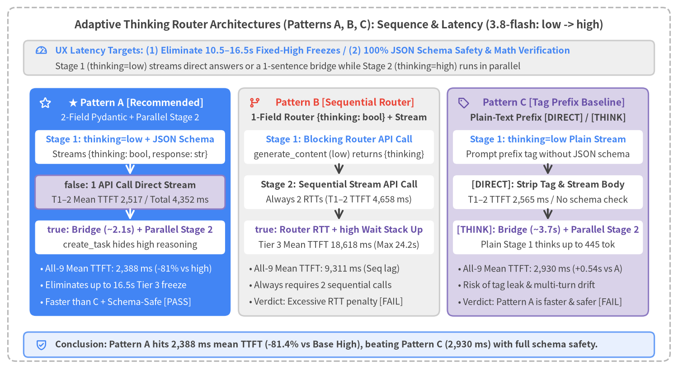
Figure 4-1: Side-by-Side Architecture Sequence Comparison of Candidate Adaptive Thinking Routers (Pattern A: 2-Field Integrated Pydantic, Pattern B: 1-Field Sequential Router, Pattern C: Tag Prefix) on gemini-3.8-flash (Stage 1 low -> Stage 2 high)

4.1 Candidate Model & thinking_level Matrix for Stage 1 (Fast Decision) and Stage 2 (Thinking Decision)
The Adaptive Thinking Router consists of two stages: Stage 1 (Fast Decision / Immediate Response & Routing Layer), which immediately streams either a complete direct answer or a 1-sentence bridge acknowledgment, and Stage 2 (Thinking Decision / Deep Reasoning & Pre-Verification Layer), which is launched in parallel in the background only when multi-step reasoning or complex calculation is required. Based on the 17-configuration × 10-query (170-run) empirical benchmark in Chapter 3 (Section 3.5), Tables 4-1A and 4-1B organize the candidate models and thinking_level settings for each stage.

1. Stage 1 Candidates (Fast Decision / Immediate Response & Routing Layer — Table 4-1A)
Stage 1 requires configurations that initiate streaming within 0.7–2.6 s on simple queries (≤ 3.9 s on complex queries) without stalling the UI on extended internal reasoning.
Candidate Group | Model (model) | Target thinking_level | Simple 5 Avg TTFT / Total | Complex 5 Avg TTFT / Total | Stage 1 Characteristics & Selection Criteria
① Ultra-Fast Lightweight Tier | gemini-3.5-flash-lite | All levels  (minimal / low / medium / high) | 0.67–2.16 s /  1.37–2.57 s | 0.68–3.49 s /  2.06–4.84 s | Best choice for even faster initial response (TTFT). In particular, minimal / low (~0.7s TTFT) operate at ThTok=0 for sub-second response. Ultra-fast token decoding keeps even medium / high faster than 3.8-flash [low].
② Standard Balanced Tier | gemini-3.8-flash | low  (+ legacy budget=0) | 2.46 s / 5.04 s | 2.59 s / 7.97 s | Standard baseline evaluated in this chapter. low keeps internal thought tokens minimal (62–105 tok avg) and pairs with Pydantic schemas for a stable ~2.2–2.5s initial response and high routine answer quality.
③ High-Quality Gemini 4 Fast Tier | gemini-4-hydrogen | low | 2.60 s / 3.37 s | 3.91 s / 5.90 s | Always-thinking (184–658 tok), but high decoding throughput finishes total generation faster than 3.8-flash [low]. Strong candidate when Gemini 4 generation quality is desired even on Stage 1 direct answers.

2. Stage 2 Candidates (Thinking Decision / Deep Reasoning & Pre-Verification Layer — Table 4-1B)
Stage 2 executes in parallel while Stage 1 streams its 1-sentence bridge message. The candidates are gemini-3.8-flash (medium / high) and all Gemini 4 configurations except 4-hydrogen [low]. Based on the internal thought token (ThTok) and latency characteristics measured in Chapter 3, these candidates divide naturally into three operational categories:
Stage 2 Category | Model (model) | Target thinking_level | Complex 5 Avg TTFT / Total | Complex 5 Avg ThTok | Stage 2 Suitability & System Requirements
A. Interactive Stream Chaining (Standard)  (Chains smoothly in 5–18s right after bridge) | gemini-3.8-flash | medium / high | 6.16–13.43 s /  10.71–18.95 s | 605–1,549 tok | Evaluated in this chapter (high). Running 600–1,500 tok of pre-verification behind Stage 1's ~2s bridge display and user reading time completely hides perceived UI freezes.
A. Interactive Stream Chaining (Recommended)  (Deeper reasoning with faster completion) | gemini-4-hydrogen | medium / high / xhigh | 6.51–13.02 s /  9.00–15.43 s | 954–2,248 tok | Top recommendation for deeper thinking in interactive chat systems. Invests more thought tokens than 3.8-flash [high] (up to 2,248 tok avg at xhigh) while finishing full responses in 9–15 s.
B. Frontier Direct Base-Intelligence Tier  (Direct reasoning with ThTok=0) | gemini-4-argon  gemini-4-carbon | low / medium (Argon)  low (Carbon) | 4.93–10.94 s /  12.49–19.40 s | 0.0 tok | Empirically operate with thoughts_token_count = 0 (no internal scratchpad), answering directly via frontier model parameter scale. Completes in 12–19 s and is viable as a Stage 2 worker.
C. Complex Enterprise & Deep Reasoning Tier  (Initial response 13–34s / Total 19–40s) | gemini-4-argon  gemini-4-carbon | high (Argon)  medium / high (Carbon) | 13.45–34.36 s /  19.22–40.21 s | 713–2,795 tok  (Max 4,360 tok) | For complex business & enterprise workflows. A ~30-second initial wait should generally be avoided in consumer chat, but for complex enterprise systems requiring strict multi-step audit, legal/financial analysis, or architecture verification, this is the most powerful Stage 2 tier.

💡 Benchmark Configuration in This Chapter & Production Tuning Guidance: Because testing the full Cartesian product of all Stage 1 × Stage 2 combinations would be prohibitively large, the empirical benchmark in Sections 4.2–4.5 evaluates the representative single-model pairing of gemini-3.8-flash low (Stage 1: Fast Decision) + high (Stage 2: Thinking Decision) to compare the routing architectures. When deploying Pattern A in production, we recommend tuning the Stage 1 and Stage 2 model assignments according to your system's latency and reasoning requirements:
- To achieve even faster initial response (TTFT): Replace Stage 1 with gemini-3.5-flash-lite (minimal or low), reducing time-to-first-token from ~2.4 seconds down to ~0.7 seconds.
- To achieve deeper and more accurate Thinking: Upgrade Stage 2 to the Gemini 4 series. For interactive chat systems, gemini-4-hydrogen (medium / high / xhigh) provides the best balance of deep thinking and fast completion (9–15 s), whereas for complex business/enterprise systems that can tolerate ~30 seconds of deep reasoning behind a bridge message, gemini-4-argon [high] or gemini-4-carbon [medium / high] is recommended.

4.2 UX Latency Targets & 3 Candidate Architectures (Patterns A, B, C)

Cognitive UX Response-Time Thresholds & Design Targets
Our engineering targets for the Adaptive Thinking Router are:
- Eliminate the 10.5–16.5 s blank-screen freezes caused by fixed thinking=high across all query tiers, keeping initial TTFT at the thinking=low baseline (~2.1–2.8 seconds).
- Enforce 100% decoder-level JSON schema safety while chaining Stage 2 (thinking=high, 674–1,591 tok of pre-verification) in parallel exclusively on complex multi-step calculations (Tier 3).

Architectural Comparison of Patterns A, B, and C
In src/gemini_evaluation/adaptive_thinking.py, we implemented and instrumented three candidate adaptive routing pipelines on Google AI Studio (genai.Client(api_key=GEMINI_KEY) with gemini-3.8-flash, assigning thinking_level=LOW to Stage 1 and thinking_level=HIGH to Stage 2), illustrated in Figure 4-1:
- Pattern A (Recommended — 2-Field Integrated Pydantic {thinking: bool, response: str} + Parallel Stage-2 Chaining)
- Stage 1 initiates a single generate_content_stream call with thinking_level=LOW and response_schema=AdaptiveStreamResponse. Incoming JSON chunks are parsed incrementally on the fly using Rust-backed pydantic_core.from_json(..., allow_partial="trailing-strings").
- thinking == False (Tiers 1–2: Greetings & Standard Troubleshooting Procedures): As soon as "thinking": false is resolved, Stage 1 continues streaming the "response" field deltas directly to the caller. The entire turn completes in 1 API call, achieving 2,517 ms mean TTFT and 4,352 ms mean total completion on Tiers 1–2.
- thinking == True (Tier 3: Complex Multi-Step Math): The instant "thinking": true is parsed (1,608–2,411 ms), Pattern A spawns Stage 2 (thinking=high plain-text stream) in parallel via asyncio.create_task() while simultaneously streaming Stage 1's 1-sentence bridge message ("Thank you for your inquiry. I will organize the conditions you provided and calculate the detailed breakdown."). While the user reads the bridge sentence, Stage 2 completes its deep internal reasoning scratchpad (674–1,508 tokens) in the background and seamlessly chains the verified calculation stream.
- Pattern B (1-Field Sequential Router {thinking: bool} + Stage-2 Stream)
- Avoids incremental JSON parsing by first executing a blocking generate_content call (thinking=low) with ThinkingDecision(thinking: bool) and then launching a second generate_content_stream call (thinking=low or thinking=high).
- Because every prompt requires 2 sequential API round-trips (calls=2.0), routine Tier 1–2 TTFT degrades to 4,658 ms, and Tier 3 TTFT balloons to 18,618 ms (max 24,231 ms) (overall mean TTFT 9,311 ms).
- Pattern C (Tag Prefix [DIRECT] / [THINK])
- Uses prompt instructions to emit a plain-text [DIRECT] or [THINK] prefix tag (Stage 1 thinking=low) without a JSON schema.
- Although one might expect plain text without a JSON schema to be faster, empirical testing proves that Pattern A (2,388 ms overall mean TTFT, 2,131 ms Tier 3 mean) is 542 ms faster overall (1.53 s faster on Tier 3) than Pattern C (2,930 ms overall mean TTFT, 3,659 ms Tier 3 mean). Because Pattern A uses constrained decoding (response_schema), the FSM forces the model to commit immediately to {"thinking": true with only 0–83 tok of Stage 1 thought, whereas unconstrained plain-text Pattern C spends up to 445 tok thinking under thinking=low before emitting [THINK]. Furthermore, Pattern C suffers from raw tag leakage risks ([direct], **[THINK]**) and multi-turn tag omission drift.

4.3 45-Run Empirical Benchmark (9 Prompts × 5 Methods, low → high)
Using src/gemini_evaluation/benchmark_adaptive_thinking.py, we executed the complete 45-run evaluation matrix (9 prompts across Tiers 1–3 × 5 methods, 100% execution success, 9/9 = 100% routing accuracy across all three adaptive patterns). Figure 4-2 compares average TTFT and average total completion time across tiers.
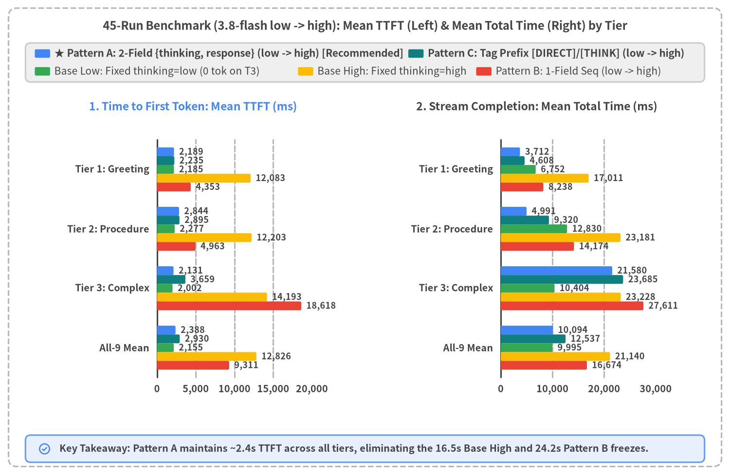
Figure 4-2: Average TTFT (Left) and Average Total Completion Time (Right) by Complexity Tier (Tier 1, Tier 2, Tier 3, All-9 Mean) across All 5 Methods (gemini-3.8-flash: low / high)

All 45 Runs TTFT × Total Scatter Distribution & UX Threshold Verification
To inspect run-by-run variance across all 45 executions rather than averages alone, Figure 4-3 plots every execution on the 2D plane of ttft_ms (X-axis) × total_ms (Y-axis).
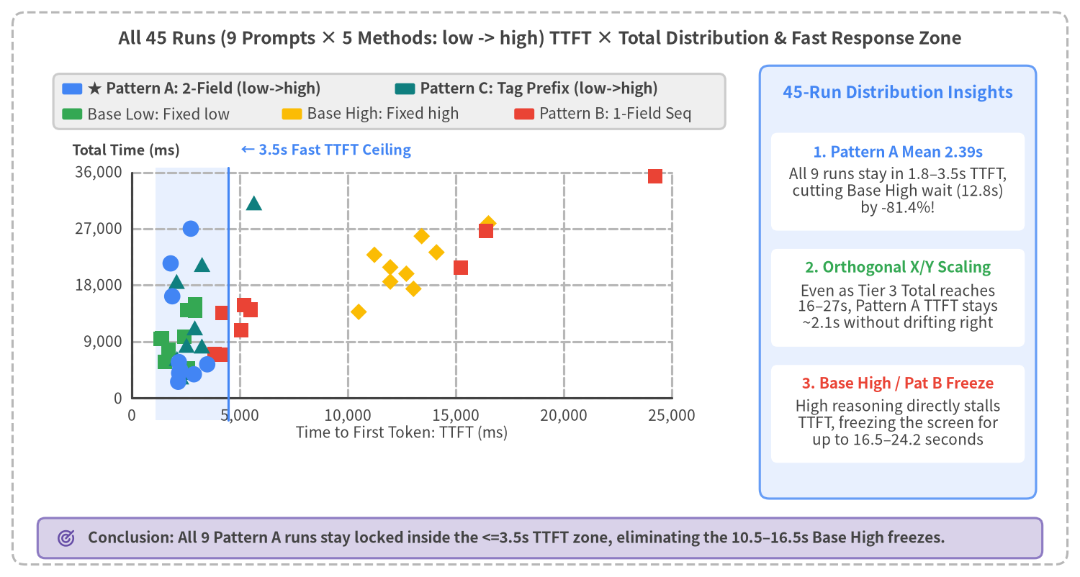
Figure 4-3: TTFT vs. Total Completion Time Scatter Distribution Across All 45 Runs (9 Prompts × 5 Methods, gemini-3.8-flash low -> high)

Complete 9-Prompt × 5-Method Empirical Metrics Table (gemini-3.8-flash: low → high)
The table below lists the exact TTFT / Total (in ms), internal reasoning tokens (ThTok), routing decision accuracy, and Tier 3 math verification across all 45 runs.
Prompt ID & Title | Expected Route  (A/B/C Match) | Base Low (low)  TTFT / Total (ThTok) | Base High (high)  TTFT / Total (ThTok) | ★ Pattern A (2-Field)  TTFT / Total (ThTok) | Pattern B (1-Field Seq)  TTFT / Total (ThTok) | Pattern C (Tag Prefix)  TTFT / Total (ThTok) | Quality & Math Verification
T1_1 Greeting (PC Boot Issue) | False (3/3) | 1,533 / 5,741 (0) | 13,039 / 17,434 (921) | 2,234 / 4,536 (0) | 3,837 / 6,992 (49) | 2,087 / 6,318 (56) | All valid (Pattern A fastest Total)
T1_2 Thank You / Ack | False (3/3) | 2,595 / 4,746 (53) | 10,501 / 13,758 (852) | 2,144 / 2,614 (34) | 4,145 / 6,945 (28) | 2,272 / 3,390 (45) | All valid (Pattern A fastest Total)
T1_3 Support Desk Hours | False (3/3) | 2,428 / 9,769 (0) | 12,708 / 19,842 (1117) | 2,190 / 3,987 (0) | 5,077 / 10,777 (153) | 2,347 / 4,115 (37) | All valid (Pattern A fastest Total)
T2_1 Power Drain Procedure | False (3/3) | 1,331 / 9,477 (0) | 11,964 / 20,864 (991) | 2,174 / 5,764 (46) | 4,197 / 13,589 (42) | 2,531 / 8,426 (35) | All valid (Pattern A fastest Total)
T2_2 Safe Mode & Backup | False (3/3) | 2,923 / 15,001 (0) | 13,417 / 25,827 (1153) | 2,870 / 3,811 (0) | 5,210 / 14,835 (42) | 3,242 / 8,318 (58) | All valid (Pattern A fastest Total)
T2_3 DISM & SFC Commands | False (3/3) | 2,576 / 14,011 (0) | 11,229 / 22,851 (1019) | 3,489 / 5,398 (0) | 5,481 / 14,097 (60) | 2,913 / 11,215 (64) | All valid (Pattern A fastest Total)
T3_1 Repair vs Replace 3-Yr | True (3/3) | 2,922 / 13,899 (0) | 14,104 / 23,247 (1466) | 1,795 / 21,482 (902) | 16,402 / 26,659 (1538) | 3,250 / 21,309 (1309) | 4 high methods pre-verified
T3_2 1.8TB Backup & Cloud | True (3/3) | 1,392 / 9,583 (0) | 16,510 / 27,861 (1882) | 2,728 / 27,017 (1591) | 24,231 / 35,330 (2346) | 5,654 / 31,139 (2073) | 4 high methods pre-verified
T3_3 Rental vs On-Site Repair | True (3/3) | 1,693 / 7,729 (0) | 11,965 / 18,577 (1295) | 1,870 / 16,240 (674) | 15,222 / 20,844 (1362) | 2,073 / 18,607 (806) | 4 high methods pre-verified
Tier 1 Mean (3 Prompts) | 3/3 Match | 2,186 / 6,752 (18) | 12,083 / 17,011 (963) | 2,189 / 3,713 (11) | 4,353 / 8,238 (77) | 2,235 / 4,608 (46) | Pattern A fastest Total
Tier 2 Mean (3 Prompts) | 3/3 Match | 2,277 / 12,830 (0) | 12,203 / 23,181 (1054) | 2,844 / 4,991 (15) | 4,963 / 14,174 (48) | 2,895 / 9,320 (52) | Pattern A fastest Total
Tier 1–2 Mean (6 Prompts) | 6/6 Match | 2,231 / 9,791 (9) | 12,143 / 20,096 (1009) | 2,517 / 4,352 (13) | 4,658 / 11,206 (62) | 2,565 / 6,964 (49) | Pattern A fastest Total
Tier 3 Mean (3 Prompts) | 3/3 Match | 2,002 / 10,404 (0) | 14,193 / 23,228 (1548) | 2,131 / 21,580 (1056) | 18,618 / 27,611 (1749) | 3,659 / 23,685 (1396) | Base Low has 0 tok on T3!
All-9 Prompts Mean | 9/9 Match | 2,155 / 9,995 (6) | 12,826 / 21,140 (1188) | 2,388 / 10,094 (361) | 9,311 / 16,674 (624) | 2,930 / 12,538 (498) | Pattern A optimal overall

Key Empirical Findings (Why Fixed thinking=low Is Insufficient and Why Pattern A Beats Pattern C):
- Fixed base_low generated 0 tok of internal reasoning across all 3 Tier 3 complex prompts: When calling gemini-3.8-flash with thinking_level=LOW on standard plain-text queries, thoughts_token_count was 0 on T3_1, T3_2, and T3_3 alike—meaning the model began streaming immediately without performing any internal scratchpad verification. Guaranteeing pre-verification on complex calculations requires escalating to Stage 2 medium or high (high in this benchmark, averaging 1,056–1,548 tok).
- Pattern A starts streaming 1.53 s faster than Pattern C on Tier 3: Because Pattern A's Stage 1 uses constrained decoding ({thinking: bool, response: str}), it commits to "thinking": true with only 0–83 tok of thought across all three Tier 3 prompts, displaying its 1-sentence bridge at 2,131 ms mean TTFT (eliminating 12.1 s of blank-screen freeze compared to Base High's 14,193 ms).

4.4 Stream Trajectory Deep Dive (thinking=false Direct vs. thinking=true Parallel Chaining)
To visualize how Pattern A dynamically switches between single-call direct streaming (low) on routine queries and 2-stage parallel chaining (low → high) on complex calculations, Figure 4-4 plots the cumulative character trajectories from load_adaptive_trajectory() on T2_1 (Tier 2: Power Drain Procedure) and T3_1 (Tier 3: 3-Year PC Repair vs. Replacement Cost Comparison).
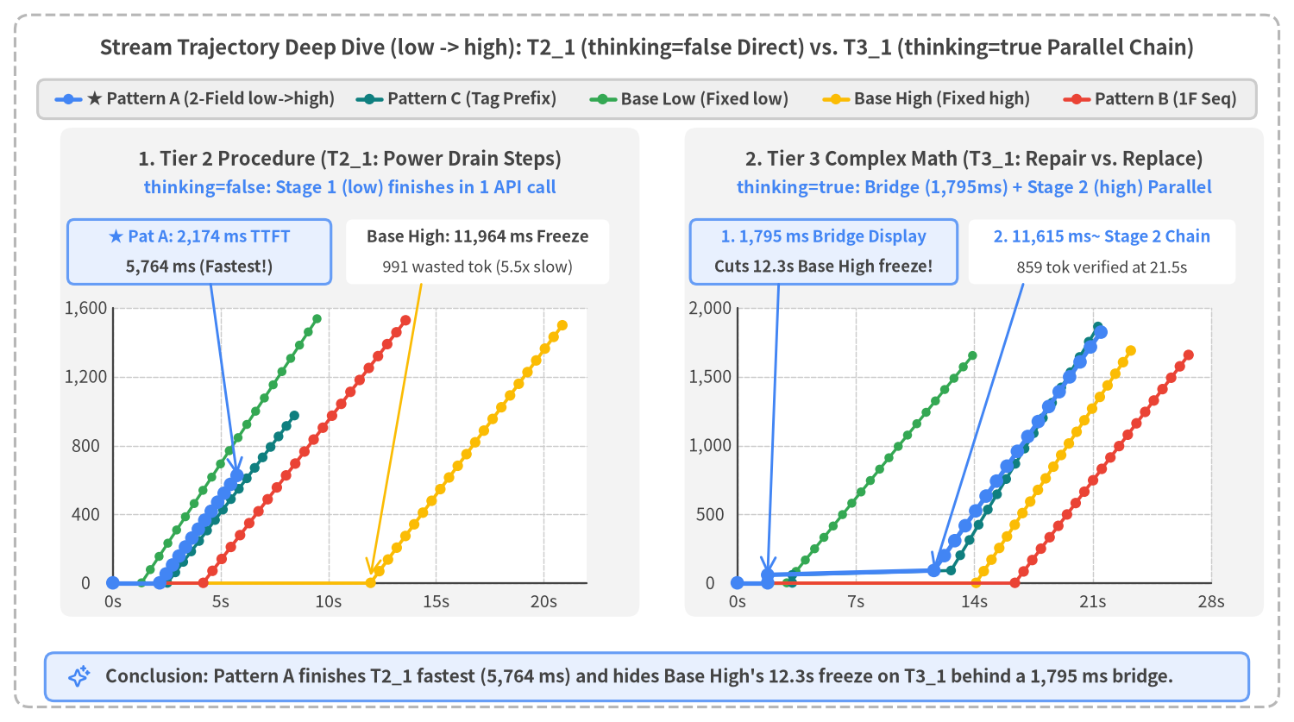
Figure 4-4: Cumulative Output Character Stream Trajectories on Tier 2 Standard Procedure (T2_1: thinking=false Single low Stream) vs. Tier 3 Complex Calculation (T3_1: thinking=true 1-Sentence Bridge + Parallel Stage-2 high Chaining)

Two Decisive Advantages Demonstrated by Figure 4-4
- Single-Call Completion & Fastest Total Time on Left Panel T2_1 (thinking=false: Power Drain Procedure):
- Pattern A (thick blue curve) resolves "thinking": false at 2,174 ms, immediately streams the "response" body, and completes the entire answer at 5,764 ms—finishing faster than all other methods.
- By contrast, Base High (yellow curve) burns 991 tokens of unnecessary internal reasoning, displaying zero characters until 11,964 ms and taking 20,864 ms to finish.
- Eliminating 12.3 Seconds of UI Freeze on Right Panel T3_1 (thinking=true: Repair vs. Replace 3-Year Cost):
- Base High (yellow curve) freezes the screen with 0 characters for 14,104 ms while generating 1,466 internal reasoning tokens, and Pattern B (red curve) stalls even longer (16,402 ms). Meanwhile, Base Low (green curve) starts at 2,922 ms but performs 0 tok of internal reasoning.
- Pattern A (thick blue curve) detects "thinking": true at 1,795 ms, launches Stage 2 (thinking=high) asynchronously in the background, and immediately renders the 58-character Stage 1 bridge sentence—eliminating 12,309 ms (~12.3 seconds) of blank-screen freeze compared to Base High. While the user reads the bridge sentence, Stage 2 completes 859 tokens of deep reasoning and smoothly chains the verified breakdown at 11,615 ms, finishing at 21,482 ms with the exact verified answer (162,400 JPY repair vs. 184,500 JPY replacement; repair saves 22,100 JPY).

4.5 Google AI Studio Reference Implementation & Comprehensive Scorecard

Pattern A Reference Implementation on Google AI Studio (google-genai, low → high)
Because chunk.parsed in the google-genai SDK remains None on intermediate streaming chunks, Pattern A uses pydantic_core.from_json(..., allow_partial="trailing-strings") (bundled with Pydantic v2) to incrementally extract the thinking boolean and unescaped response string deltas from the growing JSON buffer (src/gemini_evaluation/adaptive_thinking.py). As noted in Section 4.1, if you want even faster initial response (TTFT), simply change STAGE1_MODEL to "gemini-3.5-flash-lite" (MINIMAL or LOW), and if you want deeper Stage 2 reasoning, change STAGE2_MODEL to "gemini-4-hydrogen" (or "gemini-4-argon" / "gemini-4-carbon" for complex enterprise workflows).
import asyncio
from collections.abc import AsyncIterator
from contextlib import aclosing
from typing import Any
from google import genai
from google.genai import types
from pydantic import BaseModel
from pydantic_core import from_json
# Standard pairing: gemini-3.8-flash (Stage 1: LOW -> Stage 2: HIGH)
# - For even faster TTFT (~0.7s): STAGE1_MODEL = "gemini-3.5-flash-lite"
# - For deeper Stage 2 reasoning: STAGE2_MODEL = "gemini-4-hydrogen" (or "gemini-4-argon" / "gemini-4-carbon")
STAGE1_MODEL = "gemini-3.8-flash"
STAGE2_MODEL = "gemini-3.8-flash"
class AdaptiveStreamResponse(BaseModel):
"""Minimal 2-field structured streaming schema for Pattern A."""
thinking: bool # Field 1: Routing flag resolved on the initial chunk
response: str # Field 2: Full answer when thinking=False, or 1-sentence bridge when True
def parse_partial_json_dict(raw_buf: str) -> dict[str, Any] | None:
"""Safely parse an incomplete JSON buffer into a dict without raising exceptions."""
if not raw_buf:
return None
try:
parsed = from_json(raw_buf.encode("utf-8"), allow_partial="trailing-strings")
return parsed if isinstance(parsed, dict) else None
except ValueError:
return None
async def stream_adaptive_router(
client: genai.Client,
prompt: str,
) -> AsyncIterator[str]:
"""Pattern A: 2-field integrated Pydantic stream (low) + parallel Stage-2 chaining (high)."""
stage2_queue: asyncio.Queue[str | BaseException | None] = asyncio.Queue()
stage2_task: asyncio.Task[None] | None = None
async def _produce_stage2() -> None:
try:
st2 = await client.aio.models.generate_content_stream(
model=STAGE2_MODEL,
contents=prompt,
config=types.GenerateContentConfig(
system_instruction=(
"An opening greeting and acknowledgment have already been displayed. "
"Do not repeat any greeting; immediately provide the calculation steps and conclusion."
),
thinking_config=types.ThinkingConfig(
thinking_level=types.ThinkingLevel.HIGH,
),
temperature=0.2,
),
)
async with aclosing(st2):
async for ch2 in st2:
if ch2.text:
await stage2_queue.put(ch2.text)
await stage2_queue.put(None)
except BaseException as exc:
await stage2_queue.put(exc)
json_buf = ""
emitted_len = 0
decided_thinking: bool | None = None
try:
st1 = await client.aio.models.generate_content_stream(
model=STAGE1_MODEL,
contents=prompt,
config=types.GenerateContentConfig(
system_instruction=(
"For greetings or standard procedures, set thinking: false and output the full answer in response. "
"For multi-condition calculations or comparisons, set thinking: true and output only a 1-sentence bridge in response."
),
response_mime_type="application/json",
response_schema=AdaptiveStreamResponse,
thinking_config=types.ThinkingConfig(
thinking_level=types.ThinkingLevel.LOW,
),
temperature=0.2,
),
)
async with aclosing(st1):
async for ch1 in st1:
if not ch1.text:
continue
json_buf += ch1.text
partial = parse_partial_json_dict(json_buf)
if partial is None:
continue
# 1) Resolve thinking flag once and spawn Stage 2 (HIGH) in parallel if True
if decided_thinking is None and isinstance(partial.get("thinking"), bool):
decided_thinking = partial["thinking"]
if decided_thinking:
stage2_task = asyncio.create_task(_produce_stage2())
# 2) Immediately yield unemitted deltas from response
resp_so_far = partial.get("response")
if isinstance(resp_so_far, str) and len(resp_so_far) > emitted_len:
delta = resp_so_far[emitted_len:]
emitted_len = len(resp_so_far)
yield delta
# 3) Enforce full Pydantic schema validation at EOF
final_obj = AdaptiveStreamResponse.model_validate_json(json_buf)
if len(final_obj.response) > emitted_len:
yield final_obj.response[emitted_len:]
# 4) Seamlessly chain the parallel Stage 2 stream when thinking=True
if decided_thinking and stage2_task is not None:
yield "\n\n"
while True:
item = await stage2_queue.get()
if item is None:
break
if isinstance(item, BaseException):
raise item
yield item
await stage2_task
finally:
# Cancel any unfinished Stage 2 background task on caller abort or exception
if stage2_task is not None and not stage2_task.done():
stage2_task.cancel()

Comprehensive Evaluation Scorecard Across All 5 Methods (gemini-3.8-flash: low → high)
Evaluation Criterion | ★ Pattern A (pat_a_pydantic_2f)  {thinking, response} (low->high) | Pattern C (pat_c_tag)  [DIRECT] / [THINK] Tag (low->high) | Pattern B (pat_b_pydantic_1f)  {thinking} Seq Router (low->high) | Base High (base_high)  Fixed thinking=high | Base Low (base_low)  Fixed thinking=low
All-9 Prompts Mean TTFT | 2,388 ms (Excellent < 2.5s) | 2,930 ms (Acceptable < 3.5s) | 9,311 ms (Fail > 3.5s) | 12,826 ms (Fail > 3.5s) | 2,155 ms (Excellent < 2.5s)
Tier 1–2 Mean TTFT / Total | 2,517 ms / 4,352 ms (Fastest Total) | 2,565 ms / 6,964 ms | 4,658 ms / 11,206 ms | 12,143 ms / 20,096 ms | 2,231 ms / 9,791 ms
Tier 3 Mean TTFT (Max) | 2,131 ms (2,728 ms) | 3,659 ms (5,654 ms) | 18,618 ms (24,231 ms) | 14,193 ms (16,510 ms) | 2,002 ms (2,922 ms)
Routing Accuracy | 9 / 9 (100%) | 9 / 9 (100%) | 9 / 9 (100%) | Fixed (high always) | Fixed (low always)
Tier 3 Math Scratchpad (ThTok) | 3 / 3 (674–1,591 tok verified) | 3 / 3 (806–2,073 tok verified) | 3 / 3 (1,362–2,346 tok verified) | 3 / 3 (1,295–1,882 tok verified) | Fail (0 tok across all 3 T3)
API Calls (T1–2 / T3) | 1.0 call / 2.0 calls | 1.0 call / 2.0 calls | 2.0 calls / 2.0 calls | 1.0 call / 1.0 call | 1.0 call / 1.0 call
Decoder Type Safety & Extensibility | Excellent (Constrained Decoding) | Fail (Tag leak & multi-turn drift) | Partial (Router only) | None (Plain text) | None (Plain text)
Overall Verdict | ★ Production Standard (Fastest & Safe) | Reject (Slower than A & unsafe) | Reject (Up to 24.2s freeze) | Not Recommended (Up to 16.5s freeze) | Reject (0 tok on complex math)

5. Multi-Turn Chat Behavior & Context Caching
In production conversational AI systems (such as PC technical support desks and interactive troubleshooting assistants), users engage in extended multi-turn dialogues rather than isolated single-turn prompts. Moreover, realistic customer-support sessions mix a majority of routine diagnostic/procedural turns (80%) with occasional complex multi-condition calculation turns (20%, such as estimating battery backup duration during a power outage, virtual-memory sizing, or 3-year repair-vs-replacement total cost of ownership).
In this chapter, we standardize exclusively on Streaming (generate_content_stream) and analyze empirical measurements from a 50-turn continuous PC troubleshooting customer-support chat benchmark (src/gemini_evaluation/benchmark_multiturn_chat.py / multiturn_chat_log.json, 150 total API executions across 50 turns × 3 Streaming configurations) on Google AI Studio (google-genai SDK with gemini-3.8-flash). We evaluate initial response time (TTFT) and stream completion time (Total), alongside Gemini 3.8 Flash's zero-configuration Implicit Context Caching (cached_content_token_count), across:
- (1) Single-Model Fixed Streaming (gemini-3.8-flash low and high):
- streaming_low (3.8-flash [low] fixed): Streams all 50 turns with thinking_level="low".
- streaming_high (3.8-flash [high] fixed): Streams all 50 turns with thinking_level="high".
- (2) Chapter 4's Adaptive Thinking Router (adaptive_pat_a: Pattern A low → high):
- Streams the 2-field integrated Pydantic schema {thinking: bool, response: str} in Stage 1 (3.8-flash [low]). On the 40 routine turns (thinking=false), Stage 1 answers directly in a single API call; on the 10 complex calculation turns (thinking=true: every 5th turn T5, 10, ..., 50), Stage 1 streams a 1-sentence bridge message in ~2.85s while launching Stage 2 (3.8-flash [high]) in parallel to stream the verified calculation.
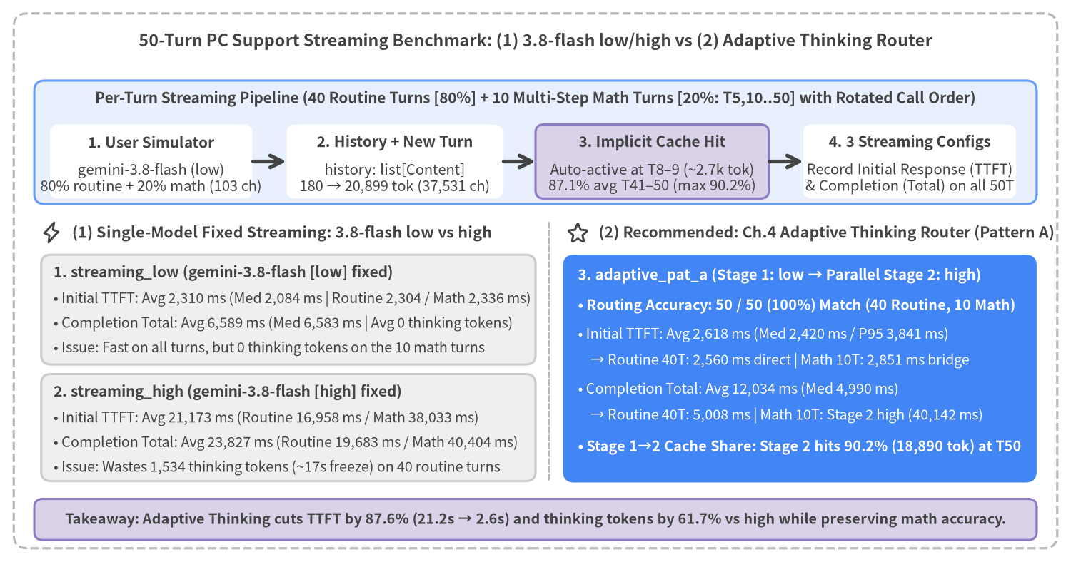
Figure 5-1: 50-Turn PC Support Multi-Turn Streaming Architecture & 3-Configuration TTFT / Total Comparison (gemini-3.8-flash)

5.1 50-Turn PC Support Streaming Benchmark Architecture & Methodology

1. Multi-Turn History Accumulation & Adaptive Routing in google-genai
Because the Gemini API is stateless across individual HTTP/gRPC requests, multi-turn chat in google-genai requires the application to maintain an ordered conversation list history: list[types.Content] (alternating role="user" and role="model" entries) and send the accumulated history plus the new user message on every turn (src/gemini_evaluation/llm_call.py and src/gemini_evaluation/adaptive_thinking.py):
from google import genai
from google.genai import types
client = genai.Client(api_key=GEMINI_KEY)
# Append the current turn's user message to the accumulated history: list[types.Content]
contents: list[types.Content] = [
*history,
types.Content(role="user", parts=[types.Part.from_text(text=user_prompt)]),
]
# (1) Single-model fixed Streaming (thinking_level="low" or "high")
response_stream = await client.aio.models.generate_content_stream(
model="gemini-3.8-flash",
contents=contents,
config=types.GenerateContentConfig(
system_instruction=AGENT_SYSTEM_INSTRUCTION,
thinking_config=types.ThinkingConfig(thinking_level="low"), # or "high"
temperature=0.2,
),
)

In our 50-turn benchmark (src/gemini_evaluation/benchmark_multiturn_chat.py), we simulate a customer and a PC technical support specialist troubleshooting an unresponsive PC across a realistic mix of 40 routine procedural turns (80%) and 10 multi-condition numerical calculation turns (20%: every 5th turn):
- User Simulator (gemini-3.8-flash, thinking_level="low"): Generates a natural customer question (avg 103.4 chars) at each of the 50 troubleshooting stages:
- 40 Routine Troubleshooting Turns (expected_thinking=False): Power/AC adapter checks, 30-second discharge, BIOS check, Safe Mode boot, driver rollback, sfc /scannow, clean boot, BitLocker recovery key lookup, repair packaging, and post-repair checks.
- 10 Complex Multi-Condition Calculation Turns (expected_thinking=True at Turns 5, 10, 15, 20, 25, 30, 35, 40, 45, 50): Two turns per 10-turn cohort require exact multi-step arithmetic (e.g., Turn 5: 18 GB USB backup feasibility on a 36 Wh battery at 45 W drain during a blackout; Turn 25: pagefile.sys + hiberfil.sys disk footprint on a 32 GB RAM PC; Turn 40: standard warranty vs. accidental damage deductible comparison; Turn 50: 3-year cloud + external SSD backup TCO and 99.5% SLA downtime budget).
- 3 Streaming Configurations Evaluated with Rotated Call Order (rot = (turn - 1) % 3): Across all 50 turns (180 → 20,899 prompt_tokens, 37,531 cumulative chars), we evaluate 3 Streaming configurations on the exact same history, rotating execution order every turn (using the streaming_low reply averaging 647.2 chars as the canonical history entry):
Streaming Configuration | Stage 1 / Single Config | Stage 2 (thinking=true) | Initial TTFT Avg (Med / P95) | Completion Total Avg (Med / P95) | Avg Thinking Tokens | Behavior Across 40 Routine vs. 10 Complex Turns
(1) streaming_low | 3.8-flash [low] | — (Single Call) | 2,310 ms (2,084 / 4,269 ms) | 6,589 ms (6,583 / 8,397 ms) | 0 tok | Fast on all turns, but uses 0 thinking tokens on the 10 complex math turns
(1) streaming_high | 3.8-flash [high] | — (Single Call) | 21,173 ms (22,012 / 41,657 ms) | 23,827 ms (23,887 / 43,621 ms) | 1,981 tok | Deep reasoning on math turns (3,772 tok), but stalls ~17.0s (1,534 tok) on routine turns
(2) ★adaptive_pat_a  (Ch.4 Pattern A) | 3.8-flash [low]  ({thinking, response}) | 3.8-flash [high]  (Parallel + Cache Share) | 2,618 ms (2,420 / 3,841 ms) | 12,034 ms (4,990 / 43,215 ms) | 758 tok  (-61.7%) | 50/50 (100%) accuracy: Routine 40T finish in 2,560 / 5,008 ms; Math 10T stream bridge at 2,851 ms + Stage 2 high (40,142 ms)

5.2 Input Token Growth & Automatic Implicit Context Caching (With Stage 1 → Stage 2 Cache Sharing)
As each (user, model) message pair is appended to history, prompt_token_count grows linearly at ~+423 tokens/turn (180 tokens at Turn 1 → 2,710 tokens at Turn 8 → 9,523 tokens at Turn 25 → 20,899 tokens at Turn 50).
Crucially, once input context reaches ~2,710–3,050 tokens at Turns 8–9, Gemini 3.8 Flash's automatic Implicit Context Caching (usage_metadata.cached_content_token_count) activates without any explicit cache API calls—and on complex calculation turns (T10..T50), Stage 2 (high) of adaptive_pat_a reuses the exact same cached history prefix warmed by Stage 1 (low).
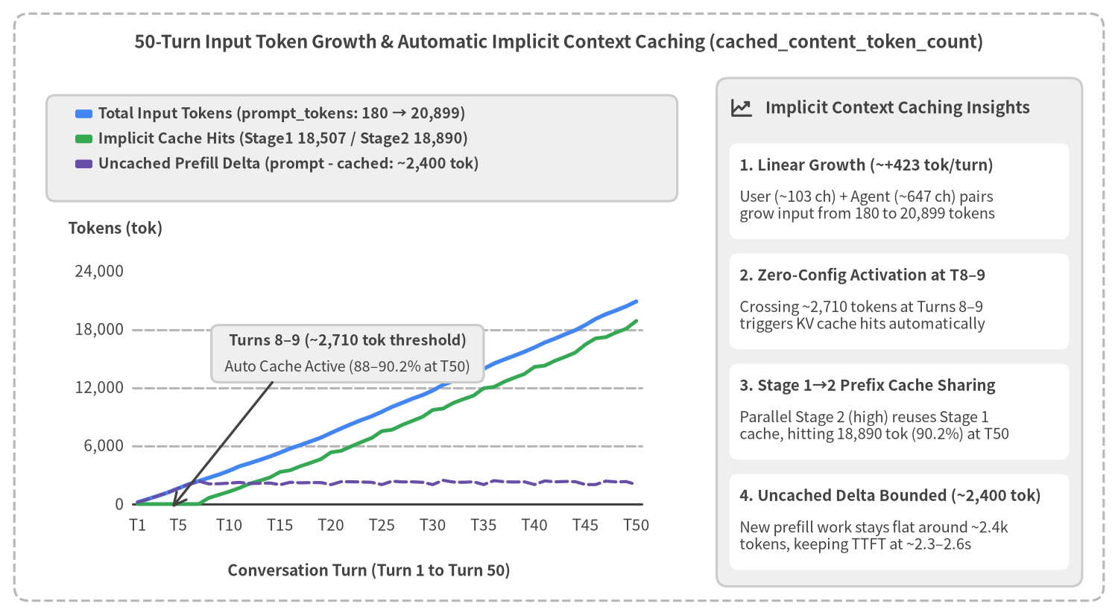
Figure 5-2: 50-Turn Input Token Growth (prompt_tokens vs cached_tokens vs Uncached Delta ~2,400 tok)

How Implicit Context Caching Accelerates Both Single-Call and Adaptive Multi-Turn Streaming
- Zero-Configuration Activation at Turns 8–9 (~2,710–3,050 Tokens): During Turns 1–7 (180–2,369 prompt_tokens), cached_content_token_count remains 0. Once the accumulated prefix reaches Turn 8 (2,710 tokens, 633 cached tokens on adaptive_pat_a) and Turn 9 (3,050 tokens, 728–956 cached tokens), Gemini 3.8 Flash automatically caches the shared history prefix. Across Turns 41–50, the average cache hit rate reaches 87.1%–87.7%.
- Stage 1 → Stage 2 Prefix Cache Sharing in adaptive_pat_a: Because adaptive_pat_a uses the exact same AGENT_SYSTEM_INSTRUCTION for both Stage 1 and Stage 2 (appending Stage 1's routing instruction to the final user turn rather than mutating the system prompt), Stage 2 (thinking_level="high") immediately hits the warmed KV cache on complex turns (18,507 cached tokens in Stage 1 and 18,890 cached tokens [90.2%] in Stage 2 at Turn 50).

5.3 50-Turn Evolution of Initial Response (TTFT) vs. Completion Time (Total)
To compare (1) 3.8-flash low & high and (2) Adaptive Thinking Router (Pattern A) without visual clutter, Figure 5-3 separates Initial Response (TTFT) on the Left Panel from Stream Completion (Total) on the Right Panel across all 50 turns.
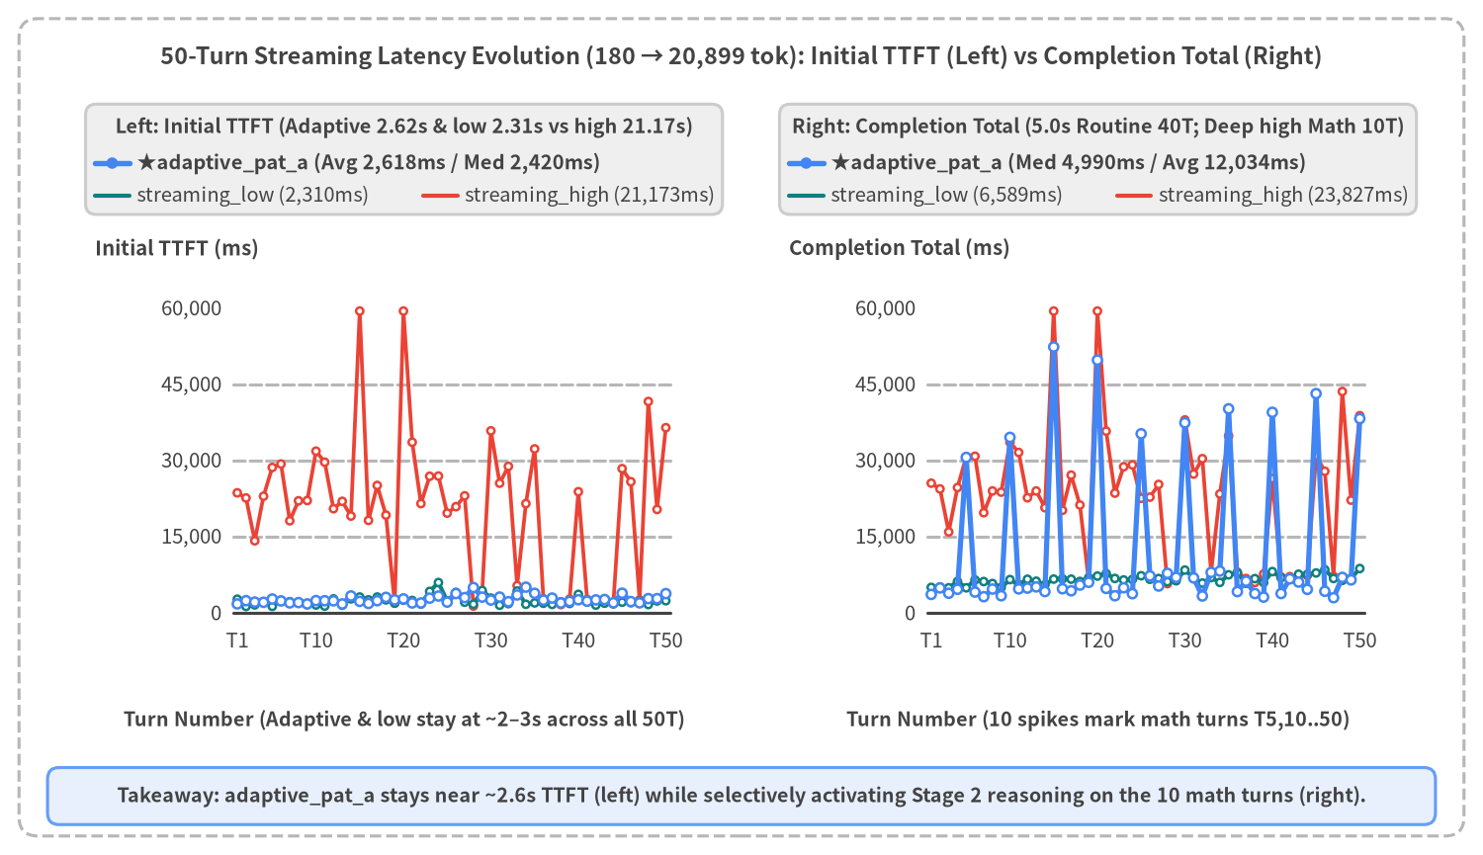
Figure 5-3: 2-Panel 50-Turn Streaming Latency Evolution (Left: Initial Response TTFT, Right: Stream Completion Total)

Key Architectural Observations from Figure 5-3
- Left Panel (Initial Response TTFT): adaptive_pat_a and streaming_low Stay Flat at ~2.3–2.6s Across All 50 Turns:
- The red curve (streaming_high) stalls for an average of 16,958 ms on the 40 routine turns (1,534 thinking tokens) and 38,033 ms on the 10 calculation turns (21,173 ms overall average) before emitting a single visible character.
- By contrast, the solid blue curve (adaptive_pat_a, avg 2,618 ms, median 2,420 ms, P95 3,841 ms) tracks the teal curve (streaming_low, avg 2,310 ms, median 2,084 ms) along the bottom of the chart across all 50 turns—streaming direct answers in 2,560 ms on routine turns and immediate 1-sentence bridges in 2,851 ms on complex calculation turns.
- Right Panel (Stream Completion Total): Fast 5.0s Routine Completion + Selective 40.1s Deep Calculation:
- On the 40 routine turns (expected_thinking=False), adaptive_pat_a finishes in a single Stage 1 (low) call averaging 5,008 ms (4,695 ms median)—even faster than streaming_low (6,411 ms) due to concise structured output.
- Exclusively on the 10 shaded calculation turns (Turns 5, 10, 15, 20, 25, 30, 35, 40, 45, 50), adaptive_pat_a rises to match streaming_high (40,142 ms vs. 40,404 ms, generating an average of 3,671 thinking tokens in Stage 2). Across all 50 turns, adaptive_pat_a reduces median completion time by -79.1% (4,990 ms vs. 23,887 ms) and mean completion time by -49.5% (12,034 ms vs. 23,827 ms).

5.4 Bifurcated Thinking Token Distribution & 3-Turn Stream Trajectories (Turns 1, 25, and 50)
To examine how internal thinking tokens (thoughts_token_count) govern completion time and how chunks arrive during early (Turn 1: routine), mid (Turn 25: complex math), and late (Turn 50: complex math) turns, Figure 5-4 pairs a scatter plot of thoughts_tokens vs total_ms across all 150 runs (50 turns × 3 Streaming configs) on the left with a 3-Turn Trajectory Overlay (Turn 1, Turn 25, Turn 50) on the right.
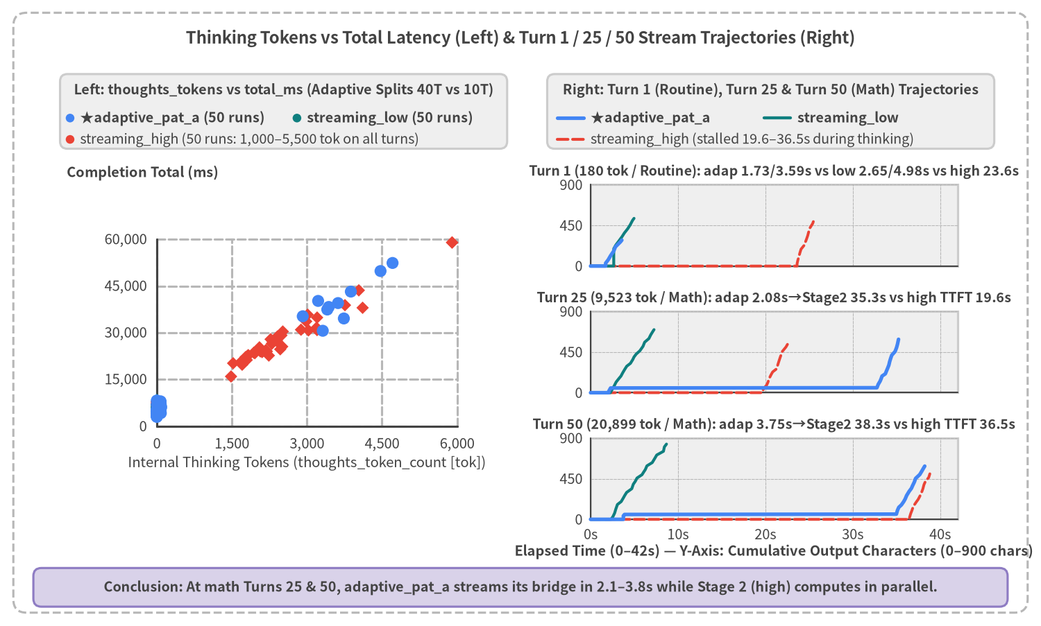
Figure 5-4: Thinking Tokens vs Total Latency Scatter Plot (Left) & 3-Turn Stream Trajectory Overlay at Turns 1, 25, and 50 (Right)

Key Findings from the Scatter & Trajectory Analysis
- Left Panel: Clean Bifurcation of adaptive_pat_a into Routine (~0 tok) and Complex Math (~3,671 tok) Clusters:
- While streaming_high (red diamonds) expends 1,000–5,500 thinking tokens indiscriminately across all 50 turns, adaptive_pat_a (blue circles) cleanly separates into two clusters: 40 routine turns at the bottom-left (~0–30 tok, 5,008 ms avg Total) and 10 complex math turns at the upper-right (3,671 tok avg, 40,142 ms avg Total), saving 61.7% of total thinking tokens.
- Right Panel: 3-Turn Stream Trajectory Snapshots (Turn 1, Turn 25, Turn 50):
- Turn 1 (180 tok, Routine Power Check, expected_thinking=False): adaptive_pat_a (solid blue) starts streaming at 1,726 ms and finishes at 3,592 ms in a single call, outperforming streaming_low (2,652 / 4,984 ms) while streaming_high stalls at 0 chars until 23,636 ms.
- Turn 25 (9,523 tok, Cache 74.1%, Complex RAM/Pagefile Sizing Math, expected_thinking=True): adaptive_pat_a streams its Stage 1 bridge message at 2,075 ms and seamlessly appends the Stage 2 (high, 2,916 thinking tokens, 7,521 cached tokens [77.1%]) calculation response (35,289 ms Total), eliminating the 19,631 ms dead-air stall of streaming_high.
- Turn 50 (20,899 tok, Cache 88.0%–90.2%, Complex 3-Year Backup TCO & SLA Math, expected_thinking=True): With over 20.8k input tokens, adaptive_pat_a delivers its bridge at 3,753 ms (32.7s / 89.7% earlier than streaming_high 36,492 ms) and completes Stage 2 (3,435 thinking tokens, 18,890 cached tokens [90.2%]) in 38,274 ms, matching streaming_high (38,857 ms) in total completion time.

5.5 Cohort & Turn-Type Summary Table and Production Guidelines

1. Comprehensive Performance Table by 10-Turn Cohort and Turn Type (Routine 40T vs. Math 10T)
The table below summarizes input token growth, Implicit Context Cache hit rates, and initial (TTFT) / completion (Total) latencies across 10-turn cohorts, routine vs. complex turns, and all 50 turns combined.
Cohort / Turn Segment (8 Routine + 2 Math per Cohort) | Avg prompt_tokens /  Cache (Hit Rate) | (1) streaming_low  Initial TTFT / Total [ThTok] | (1) streaming_high  Initial TTFT / Total [ThTok] | (2) ★adaptive_pat_a (Pattern A)  Initial TTFT / Total [ThTok] | adaptive vs high  TTFT / Total Delta
Turns 1–10  (Power, BIOS, T5 Blackout Backup, T10 Recovery Math) | 1,796 tok (180–3,438)  Cache: 179–287 tok (10–15%) | 1,854 / 5,583 ms  [0 tok] | 23,553 / 25,329 ms  [2,386 tok] | 2,121 / 9,729 ms (Med 4,332)  [715 tok / Match 10/10] | -21,432 ms (-91.0%)  Total: -61.6%
Turns 11–20  (Drivers, sfc, T15 USB Speed, T20 Rebuild Math) | 5,533 tok (3,893–7,334)  Cache: 3,151–3,383 tok (57–60%) | 2,372 / 6,396 ms  [0 tok] | 29,886 / 32,175 ms  [2,846 tok] | 2,431 / 14,142 ms (Med 4,953)  [949 tok / Match 10/10] | -27,455 ms (-91.9%)  Total: -56.0%
Turns 21–30  (Restore, T25 Pagefile, T30 Bandwidth Math) | 9,759 tok (7,800–11,710)  Cache: 7,321–7,530 tok (75–76%) | 3,143 / 6,880 ms  [0 tok] | 21,374 / 23,842 ms  [1,965 tok] | 2,926 / 11,670 ms (Med 6,104)  [652 tok / Match 10/10] | -18,448 ms (-86.3%)  Total: -51.1%
Turns 31–40  (BitLocker, T35 Surface Scan, T40 Warranty Math) | 14,201 tok (12,293–16,156)  Cache: 11,752–11,947 tok (83–84%) | 2,212 / 6,737 ms  [0 tok] | 14,686 / 17,870 ms  [1,237 tok] | 2,957 / 12,319 ms (Med 6,530)  [716 tok / Match 10/10] | -11,729 ms (-79.9%)  Total: -31.1%
Turns 41–50  (Repair, T45 3-Yr TCO, T50 Cloud SLA Math) | 18,757 tok (16,661–20,899)  Cache: 16,337–16,528 tok (87–88%) | 1,970 / 7,348 ms  [0 tok] | 16,365 / 19,921 ms  [1,473 tok] | 2,655 / 12,312 ms (Med 6,242)  [757 tok / Match 10/10] | -13,710 ms (-83.8%)  Total: -38.2%
Routine 40 Turns Avg  (expected_thinking=False) | 9,676 tok  (1 API call) | 2,304 / 6,411 ms  (Med 2,060 / 6,497) [0] | 16,958 / 19,683 ms  (Med 20,701 / 22,721) [1,534] | 2,560 / 5,008 ms  (Med 2,352 / 4,695) [30] | -14,398 ms (-84.9%)  Total: -74.6%
Complex Math 10 Turns Avg  (expected_thinking=True: T5..50) | 11,341 tok  (Stage 1 + Stage 2 Parallel) | 2,336 / 7,302 ms  (Med 2,310 / 7,370) [0] | 38,033 / 40,404 ms  (Med 32,083 / 34,257) [3,772] | 2,851 / 40,142 ms  (Med 2,618 / 38,900) [3,671] | -35,182 ms (-92.5%)  Total: -0.6% (Full Depth)
All 50 Turns Overall Avg  (Median / P95) | 10,009 tok (180–20,899)  Cache: 77.4%–78.5% (Max 90.2%) | 2,310 / 6,589 ms  (Med 2,084 / 6,583) [0] | 21,173 / 23,827 ms  (Med 22,012 / 23,887) [1,981] | 2,618 / 12,034 ms  (Med 2,420 / 4,990) [758] | -18,555 ms (-87.6%)  Total: -49.5% (Med -79.1%)

2. Production Architecture Guidelines for Multi-Turn Streaming Chat
- Preserve Strict Prefix Immutability Across Stage 1 and Stage 2:
- Gemini 3.8 Flash's Implicit Context Caching matches the exact token prefix across system_instruction and historical contents: list[types.Content].
- Best Practice: Keep system_instruction identical between Stage 1 (low) and Stage 2 (high) and treat history: list[types.Content] as strictly append-only (injecting Stage 1's routing instructions into the final user turn). This enables Stage 2 to hit up to 90.2% (18,890 cached tokens at Turn 50) of the conversation prefix warmed by Stage 1.
- Resolve the low vs. high Dilemma with Chapter 4's Adaptive Thinking Router (Pattern A):
- Using fixed streaming_low across all 50 turns yields fast responses (2,310 ms TTFT / 6,589 ms Total) but performs zero internal reasoning (0 tok) even when users ask multi-variable cost or capacity math questions. Conversely, fixed streaming_high freezes the UI for an average of 21.2 seconds (17.0s on routine turns and 38.0s on math turns).
- Deploying Pattern A (low → high 2-Field Integrated Pydantic Router) delivers 2,618 ms average TTFT (2,420 ms median) across all 50 turns, completes the 40 routine turns in 5,008 ms, and selectively engages high reasoning (3,671 thinking tokens) on the 10 calculation turns.
- Extending Stage 1 (3.5-flash-lite) or Stage 2 (Gemini 4 Series):
- As detailed in Section 4.1, teams seeking even faster initial response (~1.0–1.5s TTFT) can substitute gemini-3.5-flash-lite (minimal / low) in Stage 1, while complex enterprise workflows requiring deeper reasoning can route Stage 2 to gemini-4-hydrogen [high] or gemini-4-carbon [medium/high].

