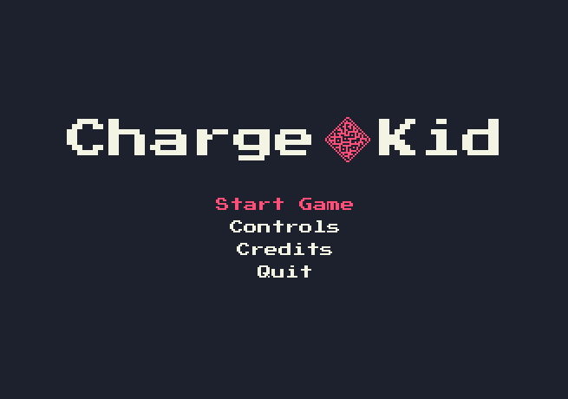

Charge Kid
Game Design Document

- Description
Charge Kid is a puzzle-platformer for PC being developed by USPGameDev, consisting in traversing each level from left to right using mechanics that utilize the same limited resource. The player must find a way to jump from platform to platform, go through gates and recharge its resources to be able to beat the obstacles. Knowing when to use each resource is what turns each obstacle into a puzzle.
The goals of the game is to challenge the player and give them a “Aha!” moments. The simple and open ended puzzles encourage experimentation, and there is no “intended” way to solve each puzzle.

- Gameplay
Charge Kid is supposed to be simple, with few game mechanics as possible, all of which are exploitable, and exploiting them is the focus. The idea is to be intuitive for the player, to convey messages of what can and can’t be done without explaining it directly. The levels teach each exploit and train the player on their applications on each other level.
There are only exploits, the player gets no upgrade whatsoever. Everything the player learns could be learned and done as early as the first level, so the game progress is not on the character in the form of level ups, new items and upgrades, but within the player themselves, in the form of knowledge of how the game works.
In addition to this, there are secret rooms to be found, with keys that unlock a secret final level for the attentive, perceptive player.

- Player Resources
Projectile: Can be shot at other objects to interact with them. It is the player’s main resource. You only have one projectile, which comes back to you like a boomerang after reaching its maximum range or hitting something. Can also be held in the air where it currently is by holding down the shoot button.
Charge: An energy charge the player needs to do other actions. Like the projectile, you can only have one charge at a time. You can get recharges on other interactables on the level. The player knows it has a charge because the player character turns pink and starts letting out multiple pink particles when it has a charge. Otherwise, the player character is white.
Boost: Spending a charge, the player character is launched upwards, higher than a jump. Serves as a double jump when used on the air.

Bullet Boost: Spending a charge, the player flies straight to the projectile, if it is being held in the air somewhere on the level. The player character is still subject to other physical objects, so it might bump into walls and other objects if they are on the way between the player character and the projectile.

- Interactables
Objects that react in a certain way when in contact with the projectile or the player character. Some may affect other interactables on the level.
Charge Tank: If touched by the projectile or the player character, the player regains a charge. It is the main interactable on each level.

Spikes: If the player character touches them, it dies and is sent back to the last safe position it has been before touching it.

Switch: Starts turned off, and turns on when touched by the projectile. They are usually linked to other interactables, activating them when it is turned on. After being activated, it can’t be deactivated again unless the player character dies before touching the ground after activating it.
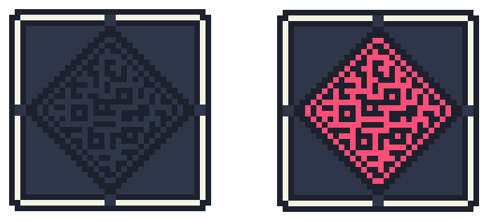
Lever: Turns on and off when touched by either the player or the projectile. Is also linked to other interactables to activate them.


Triggered Platform: Linked to a switch or a lever. When activated, it becomes solid and can be walked on, or turns into a wall. Or can be deactivated to open a new path if it was a wall or a platform previously.
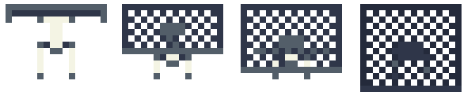

Energy Gate: Kills the player character on contact unless it is in the middle of a boost or bullet boost. The projectile passes through it normally. Can also be turned on or off by switches and levers.


Portal: Teleports both the player and/or the projectile from one end to the other.


Teleporter: When shot at, the player character and the projectile exchange places. It enters a short cooldown period in which it doesn’t work right after.
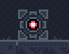

Secret Key: Key that unlocks the secret level. It needs to be shot five times to break and activate it. There are a total of five hidden in the levels. These are optional, and you can beat the game without ever touching one.
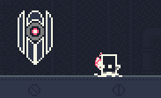

- Goals
Each level, the goal is to reach the other side of the level (at the right), as the standard in 2D platformers. To do this, the player must use the charges to make high and/or long jumps to reach distant platforms, while also avoiding some sort of obstacle on the way. Since the player can only have one charge at a time, they must think of ways to circumvent this limitation. On the levels section are more examples of this, as it contains the solution to each level.

- Permanence
Charge Kid will save levels beat, keys found, speedrun times and graphical, audio and control settings. It shall also save the number of shots fired, charges taken and deaths, for Steam achievement purposes.

- Level Design
Each level is horizontal, where the camera only moves left and right, and all vertical information is always present, like where the player character lands if it falls, what is above it. The levels are somewhat short, with two to three puzzles each level to beat.
Charge Kid has no lives system or a “game over” screen. Each death simply returns the player where it was before attempting the jump, to stop the game from being repetitive by forcing the player to do everything it has done again before it died. Charge Kid’s focus is on puzzle solving instead of dexterity and precise movement, although there are some sections that require reflexes and skill to do. We do not want to punish the player for failing a jump, we just want to show them that their idea does not work. Most of the time, the solutions are simple to do. Some puzzles might be solvable with pixel/frame perfect inputs, but all of them have a much easier solution, so if you are trying to do something and keeps failing, odds are that there is a much easier way to solve it.
As a comparison, think of Portal and Celeste. Portal is very similar to what Charge Kid is trying to do. The player has a simple mechanic of shooting portals and has to reach platforms, and does so by exploiting physics and being creative with the portals. Celeste can be similar, but its focus is on platforming instead of puzzles. In Celeste, there are many ways to do each jump, but each of them can be incredibly hard. On Charge Kid, what happens is the opposite: finding a way to do the jump is the hard part, not actually doing the jump.
Recalling what was said on the opening section, the goal of the game is to give the player “Aha!” moments, and the open ended nature of the puzzles are meant to encourage experimentation. That’s the spirit of the game, and the level design and game mechanics are supposed to achieve this.
With the mechanics that we have, it is possible to do very high/long jumps, and each puzzle has many different solutions. In some cases, the levels have ways to skip its parts or even entire puzzles, more so on early levels if you use tricks taught on later levels. The skips are intentional. The idea is that the player finds a skip and feels rewarded for thinking and doing it. When the player finds one, a message will show up on top of the player character, as an easter egg of sorts, to show that we acknowledge the player’s creativity. Of course, we can’t know all skips, but we tried leaving as many messages as possible. Some skips might not save time like an actual speedrun skip usually does, but it still is a way for the player to express and challenge itself, so we try to leave as many as possible.
Lastly, the final level isn’t really a puzzle, it’s more of a skill based one. It’s an autoscroller, balancing both problem solving and manual reflexes, meant to be a final challenge to the player, putting everything the player has learned to the test. The puzzles are also very open ended and not so hard to find the solution, since the auto scrolling aspect puts a time constraint on the player, the puzzles are meant to test the player’s ability to think fast. The thing is, after going through the whole game, the last level’s puzzles are easy to the point of knowing the solution just by looking at it. The same is true for the secret level, but it is much harder.

- Secrets
As mentioned earlier, the game has five secret keys that unlock a secret final level. As stated earlier, the goal of the game is to give the player those “Aha!” moments by thinking about how to overcome each obstacle, but the addition of these secret rooms don’t really help achieve that. However, they do reward attention to detail, and make the player go “Aha!” when they suspect something is odd and turns out they were right. It’s borrowed from exploration games, and since Charge Kid is also about experimentation, their addition is far off.
Four of the keys are not visible on the level, only one is. It’s at the end of the final level, where the player will probably see it, but probably won’t be able to reach it when it reaches the level’s end on its first time due to needing a charge. If they do the level again, they can find a way to get to the end with a charge and reach the key successfully. Shooting at it five times will break it, and tell the player that one out of five keys were found (supposing they haven’t found the hidden ones on the previous levels). This key is supposed to tell the player that there are keys to search for. After finding all, the player is sent to the secret level and it gets unlocked on the menu. The level is an auto scroller, and has quite a few of RNG sections. This level is meant to test quick thinking and adaptation instead of repeated attempts of the same jump until you get it. The intention behind it is that the player should be able to beat it by being good, not by knowing what’s ahead.
The remaining four keys are on levels 3, 7, 11 and 13. On levels 3 and 7, they are out of camera bounds, through a hole in the ceiling on level 3 and through a patch without spikes between spikes on the floor on level 7. The ones on levels 11 and 13 are behind blocks. You can see the oddity by noticing that in the whole game, walkable platforms have a specific lighter color on top of them.

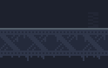 This is a walkable beam, has a lighter tone on top of it.
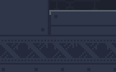 This one is not, it has other blocks on top of it.

So, it should be odd to see this on level 11:
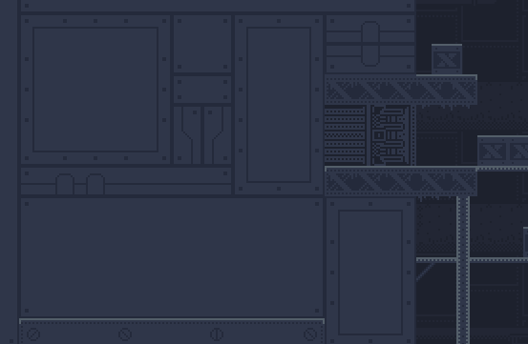

When the player approaches from the right, the blocks fade, revealing the secret room.
