**Lab Report**

Major: Embedded Systems Design

Student number: 192050196

Student name: Yujiabin

Teacher: Arkady Kluchev and Sergei Bykovskii

Date: 28 June 20

1.two tasks

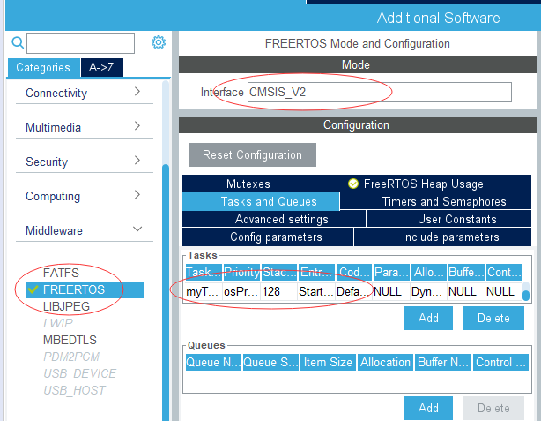

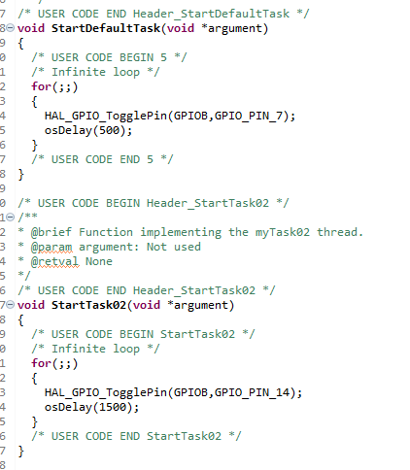

2.What features of FreeRTOS do you remember?

Pre-emptive or co-operative operation

Very flexible task priority assignment

Flexible, fast and light weight task notification mechanism

Counting semaphores

Recursive Mutexes

Software timers

Event groups

Tick hook functions

Stack overflow checking

Trace recording

Task run-time statistics gathering

Optional commercial licensing and support

Full interrupt nesting model (for some architectures)

A tick-less capability for extreme low power applications

Software managed interrupt stack when appropriate (this can help save RAM)

3.What are the differences between FreeRTOS, OpenRTOS and SafeRTOS?

FreeRTOS and OpenRTOS have the same source code, but OpenRTOS is used for commercial purposes. SafeRTOS design is also based on FreeRTOS, but it has been redesigned by security experts

4.Why do we need the vTaskStartScheduler() function?

When using the vTaskStartScheduler function, a task is created to ensure that no errors occur in the program, which is mainly a protection of the program.

5.Why do we need the xTaskCreate() function?

When the task needs RAM to save the task's state and use it as a stack, we need to use the xTaskCreate function to dynamically request memory to save various running states.