Gao Yujia

11 June 2021

Foundations of Programming: Python

Assignment08

Github link:

**Classes and Objects**

**Introduction:**

**Classes and objects touch on an area that was first introduced in the previous modules, but explained in a little more detail here.**

**The whole premise of having classes is so that we can organise our codes and create shortcuts for us to use. As functions are a way to organise codes that perform a specific task, classes are meant to organise functions that perform a specific role in the script. However, a class is seen as a group in the script. This means that unless we tell Python to, it will take each class as a whole and that may cause problems when we are looking to changes individual items in the class.**

**This is where objects come in. Objects allow us to go into the individual components of the class to make changes to the data, without confusing Python. This is extremely useful when we are dealing with large volumes of data and need to make sure that they are organised correctly.**

**Creating the Python File**

**In this assignment, I had a difficult time understanding how to use the various objects and products and method and ‘self’ and took a while to write the codes.**

**As usual, we needed to create the log and some important rules that we will need later (Fig. 1)**

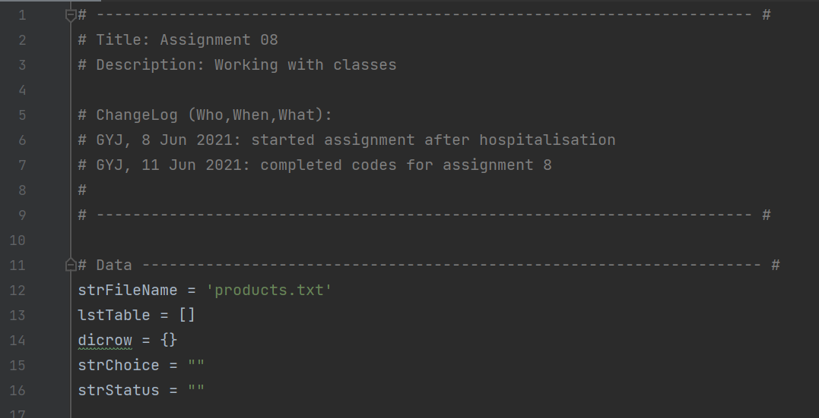

**Fig. 1**

**Next, the first Class to be created is the ‘Product’ class, where the functions for definitions of the products are created (Fig. 2)**

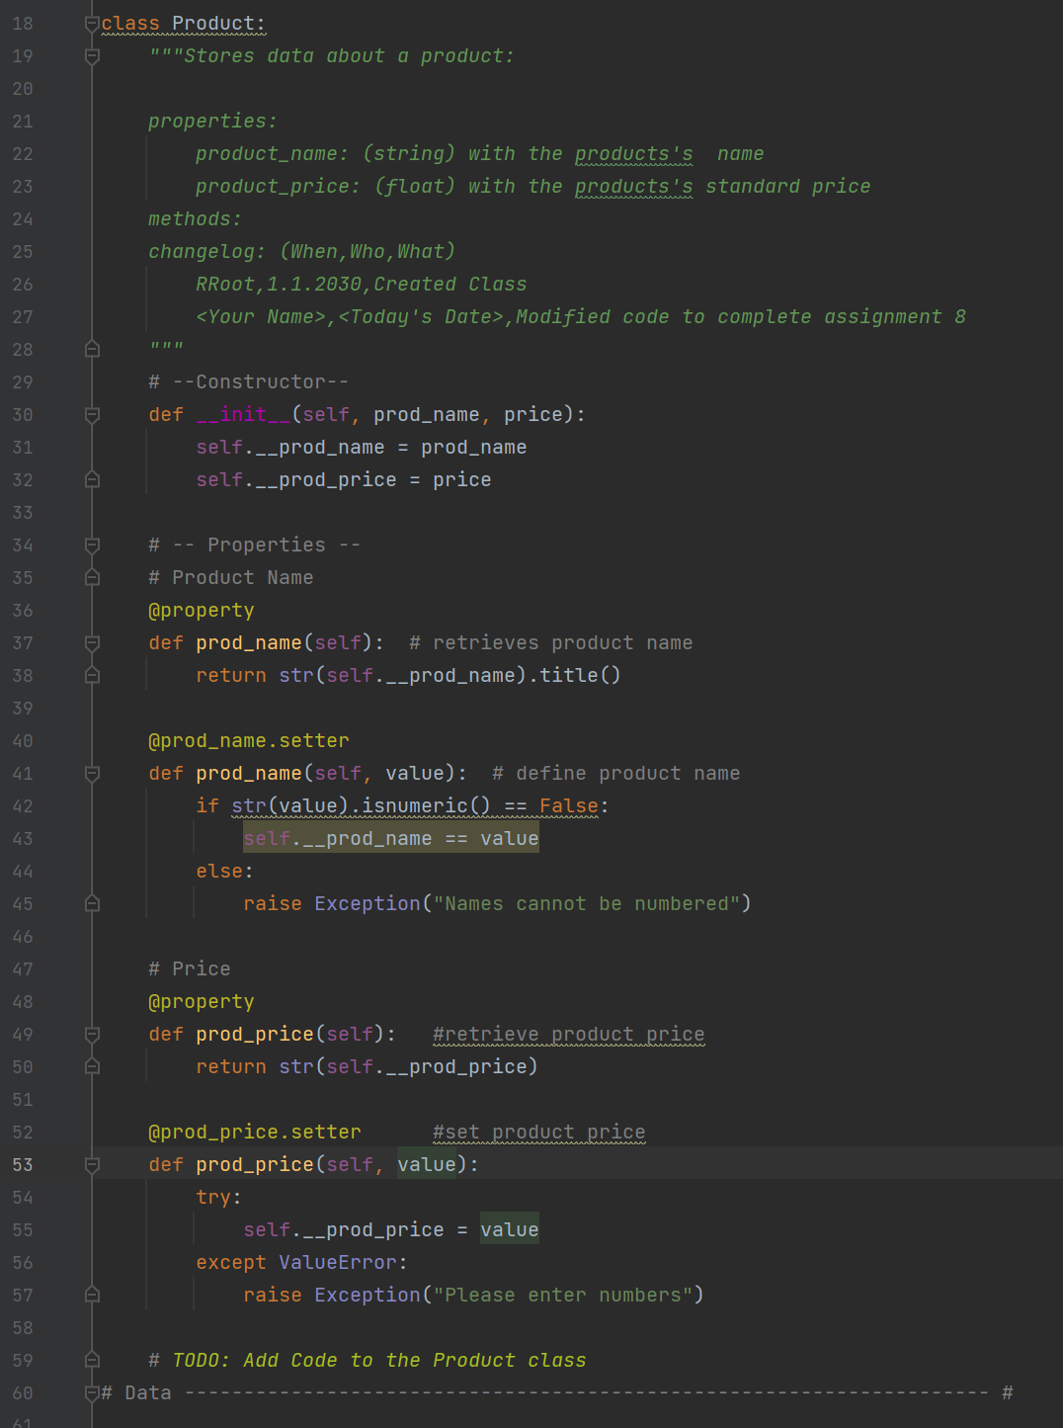

**Fig. 2**

**Next comes the Class for the various file processors (Fig. 3)**

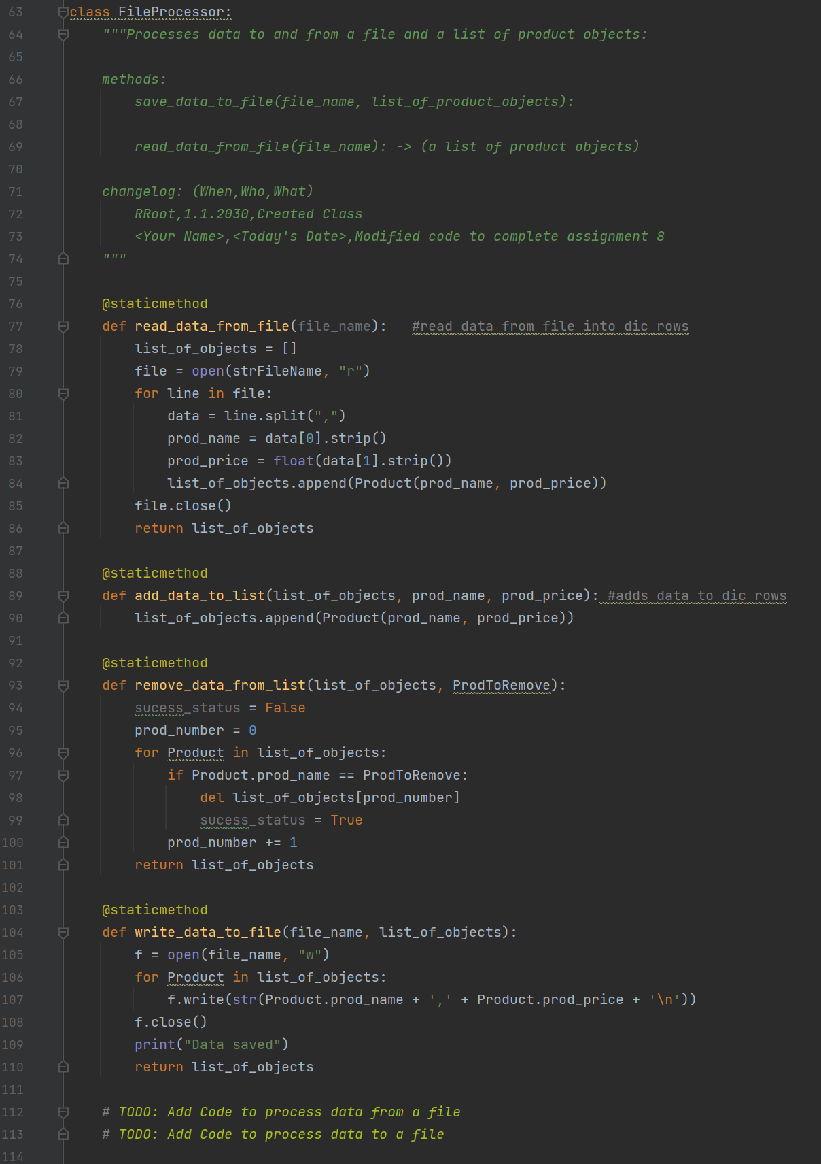

**Fig. 3**

**The next section involves the class of functions that is involved in the input/output portions of the script (Fig. 4)**

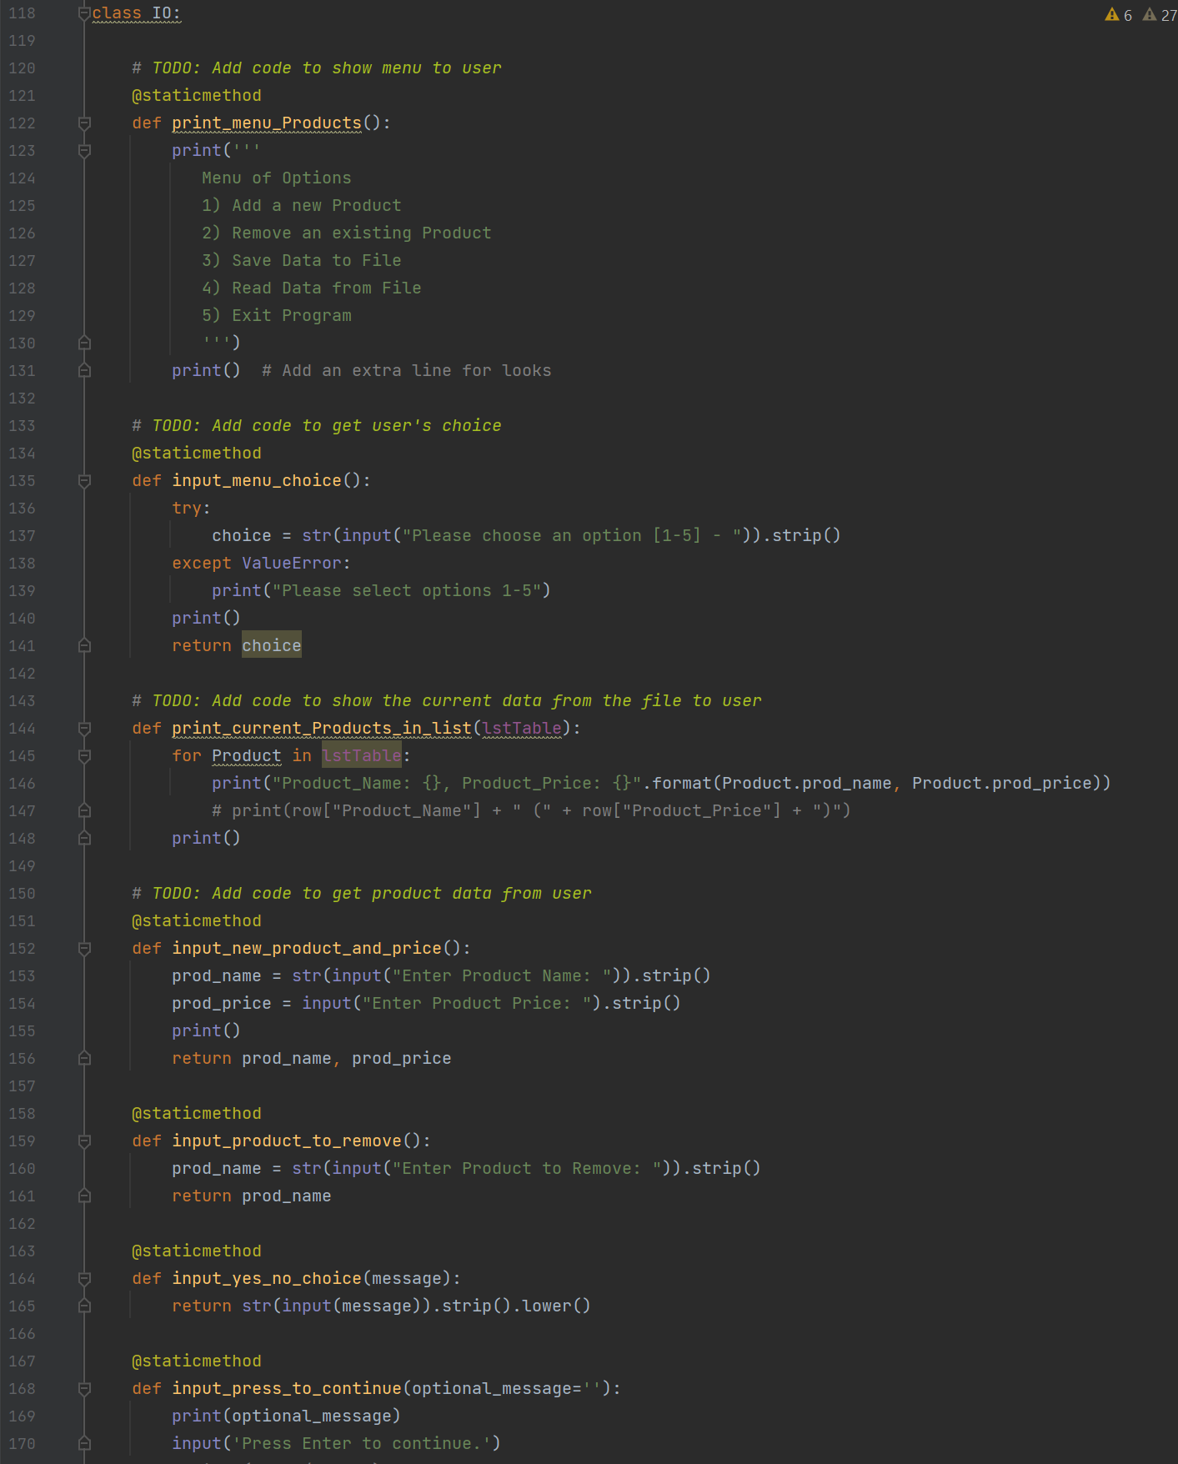

**Fig. 4**

**And of course lastly the main portion of the script (Fig. 5)**

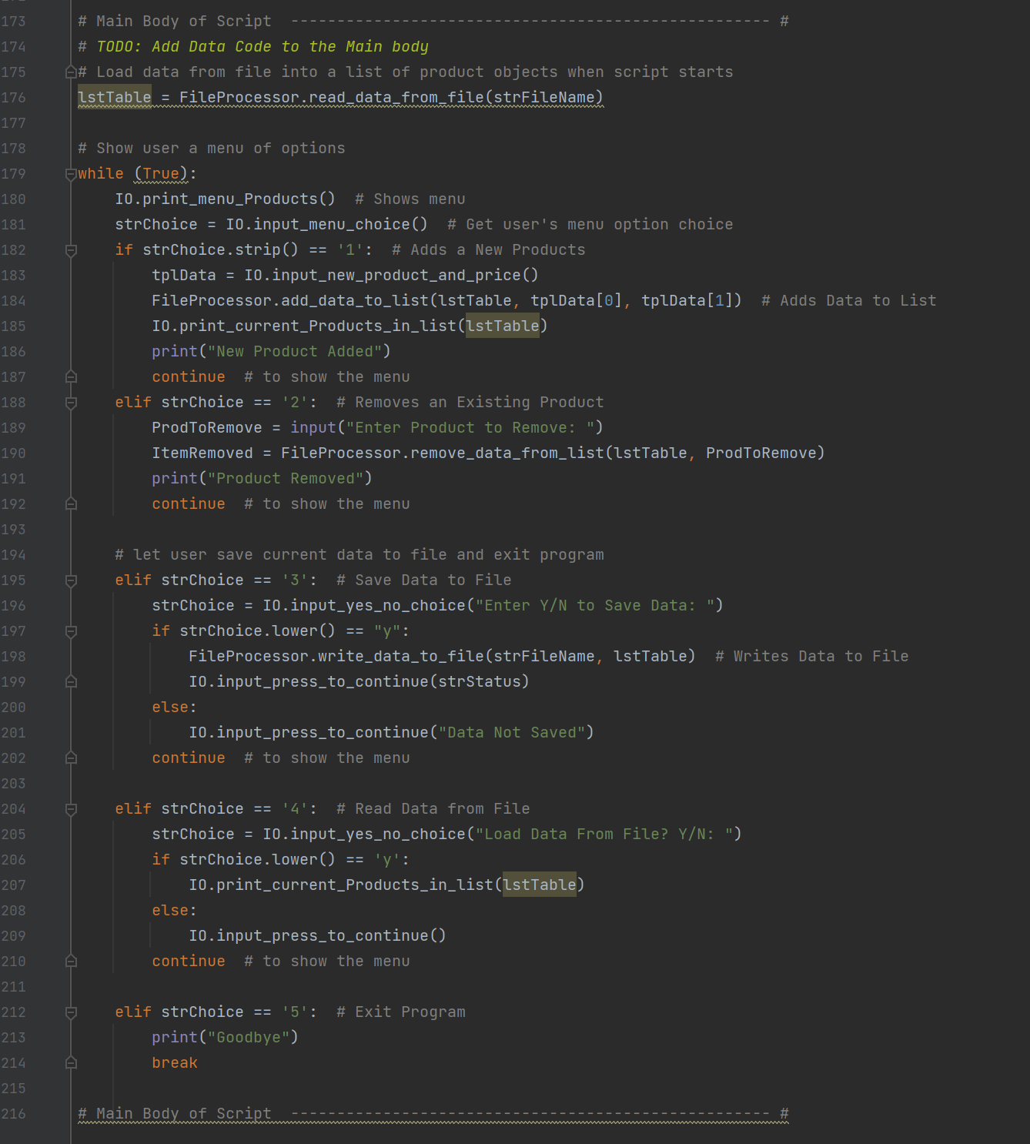

**Fig. 5**

**Using these set of Classes, I was able to create a simple script that allows users to input data, as well as to remove and extract data (Fig. 6 and Fig. 7)**

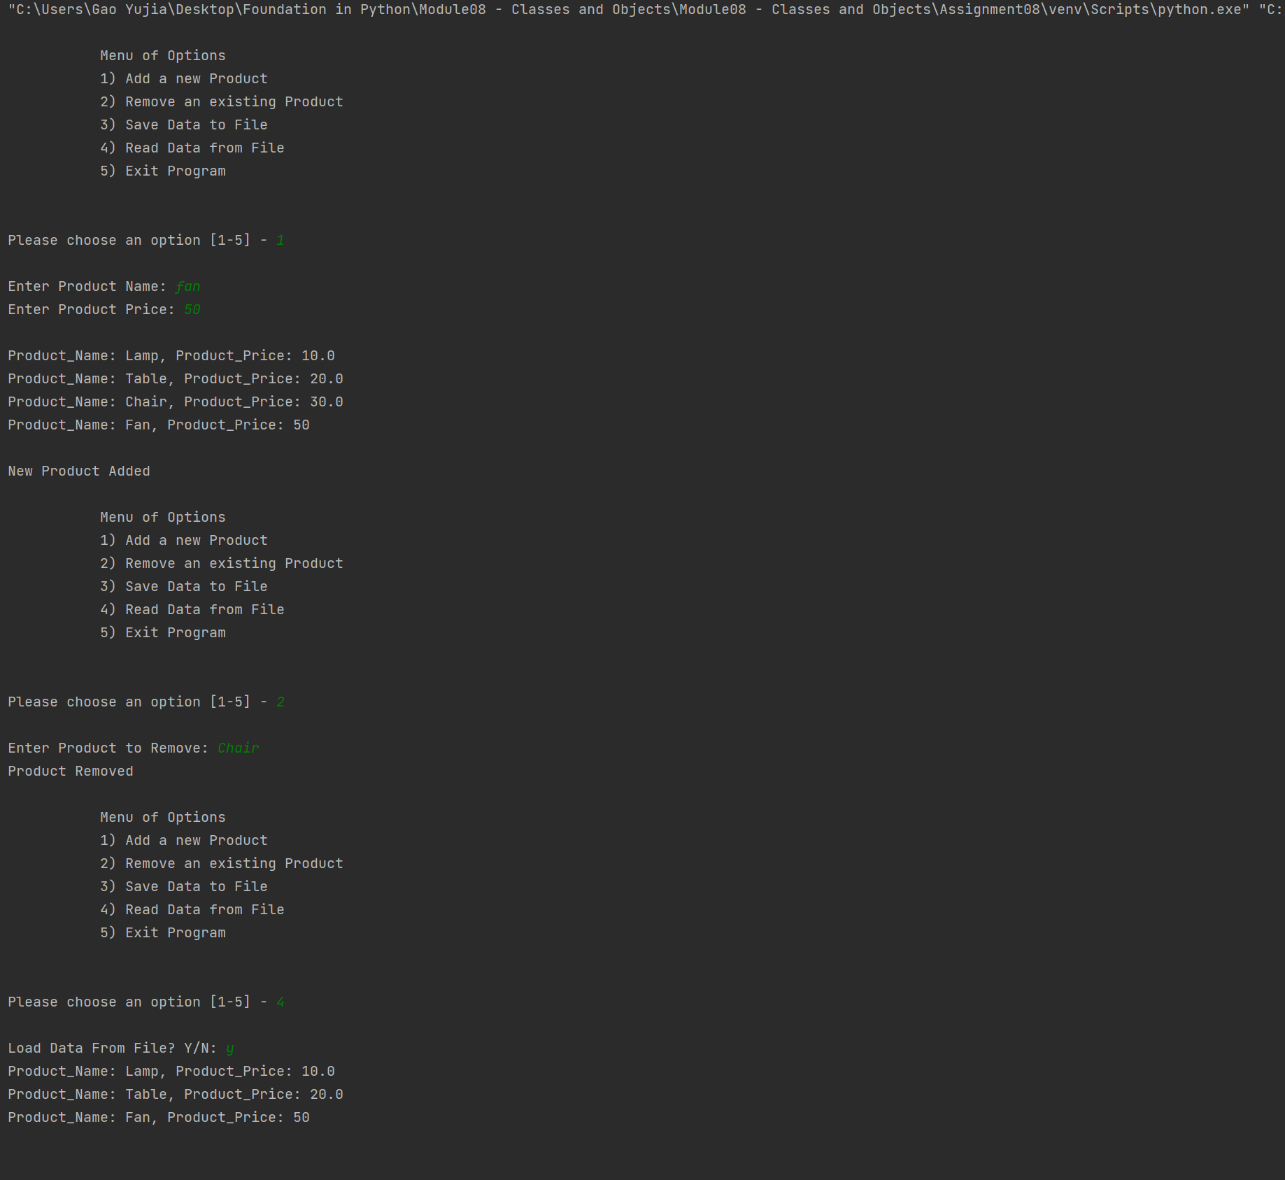

**Fig. 6**

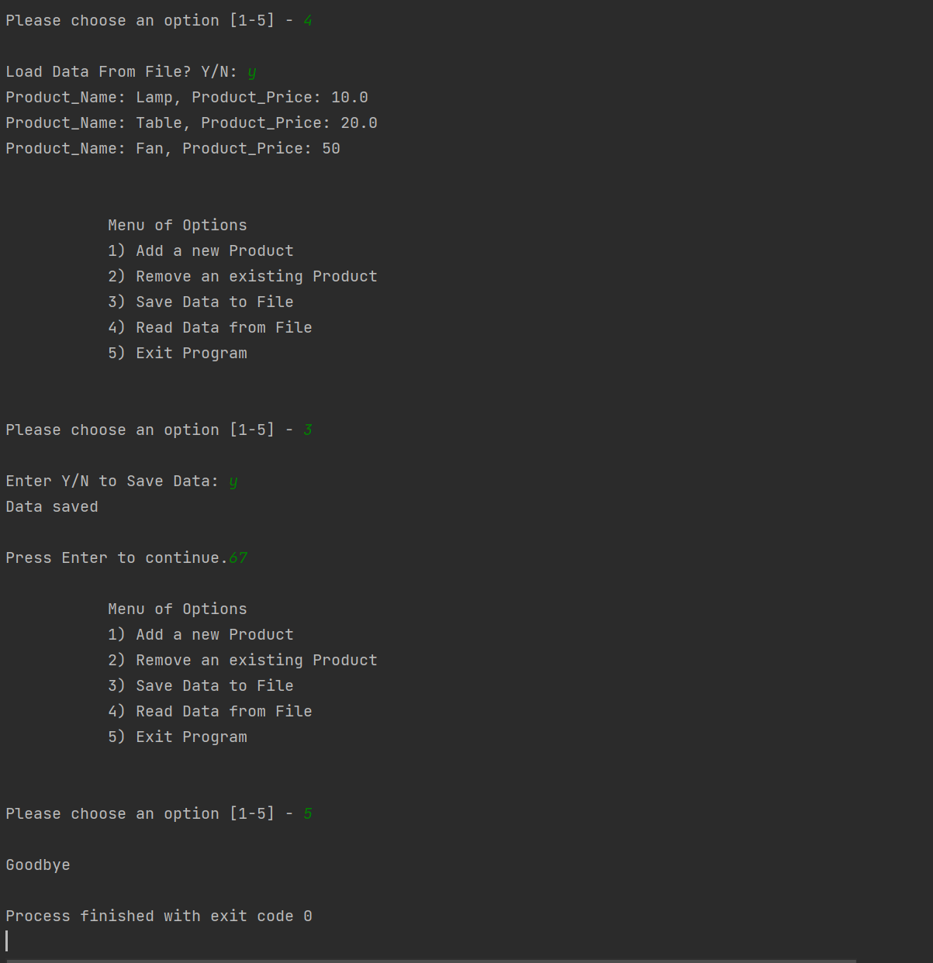

**Fig. 7**

**And this ultimately gave me the output .txt file (Fig. 8)**

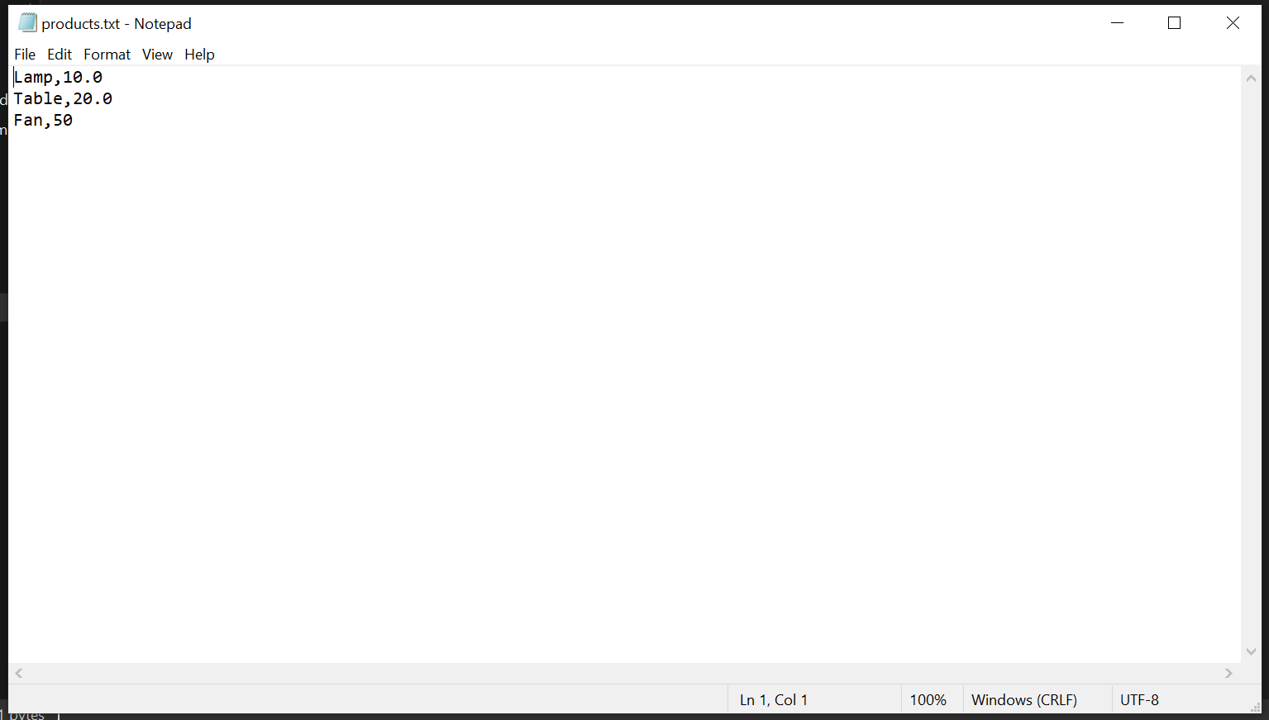

**Fig. 8**

**Conclusion:**

**Learning how to use Classes and all the configurators is indeed challenging and not as straight forward. However I think given time I should be able to grasp the concept and become comfortable with using them.**