Gao Yujia

23 May 2021

Foundations of Programming: Python

Assignment07

Github link:

**Files and Exception**

**Introduction:**

**This module talks about the use of binary files and exceptions. Binary files, as mentioned in the tutorial, are not encrypted files, but are files that have a certain level of security in them. In order to read or write binary files, we need to use the ‘pickle’ function of Python in order to make sense of the data.**

**‘Try and Except’ are a way for us to deal with the inconsistent and variable way users input data into the script. Instead of crashing the whole script with an incorrect input, ‘Try and Except’ is an automated way for the script to try and correct for this errors by prompting the users where their error is. We can either use a pre-existing library of exceptions, or if we are adventurous enough we can create custom exceptions as well.**

**Creating the Python File**

**In this assignment, I have decided to include a little bit of everything I’ve learnt so far. This starts with creating the log, and importing the ‘pickle’ function (Fig. 1).**

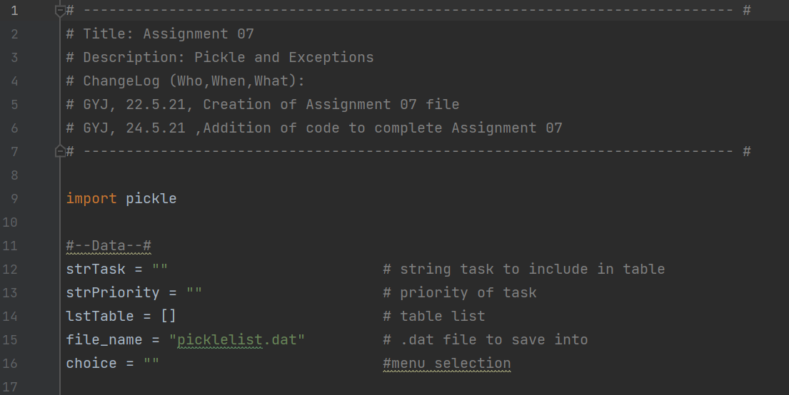

**Fig. 1**

**I next created a set of functions which I will use for the processing part of the script (Fig. 2)**

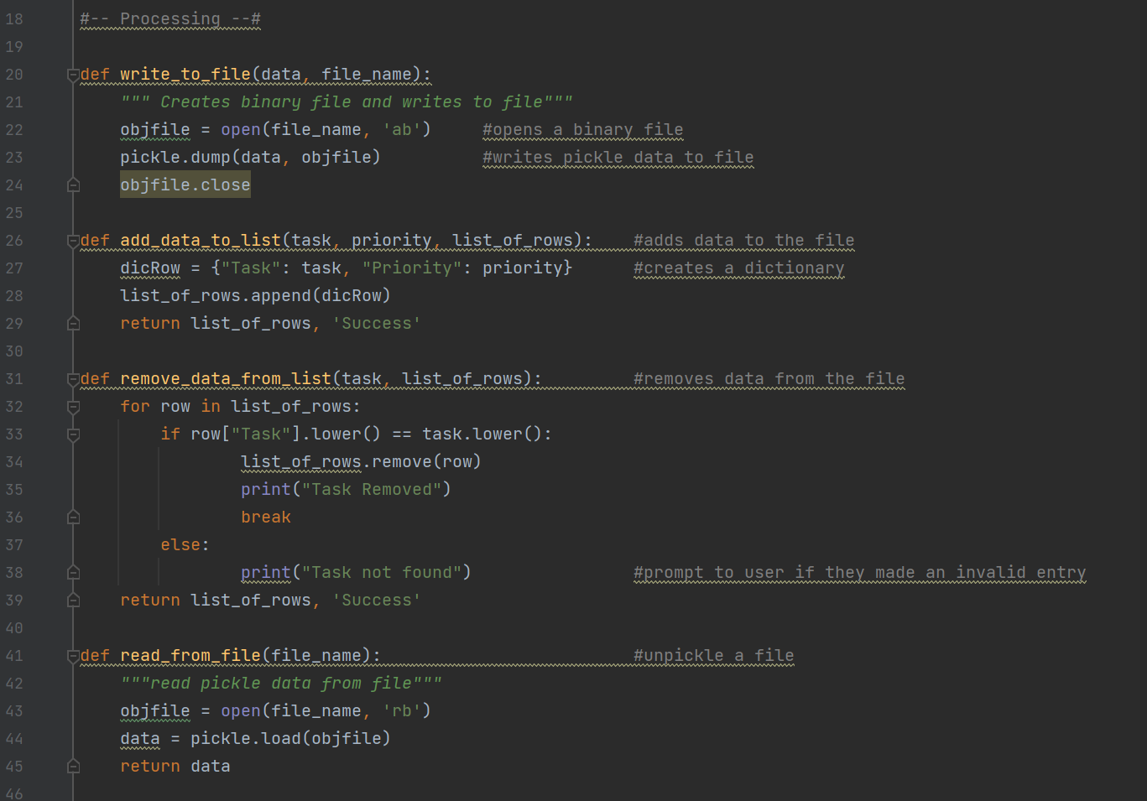

**Fig. 2**

**Once this is done, I created the main script. Instead of creating functions for the input and output part, I kept them as individual scripts (Fig. 3)**

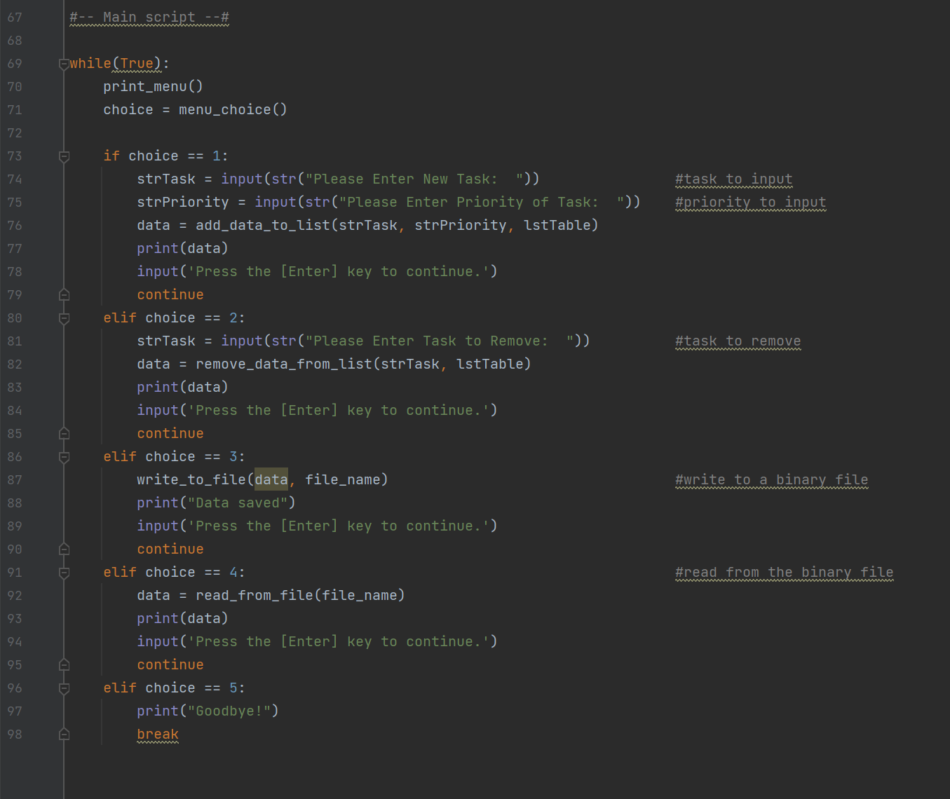

**Fig. 3**

**When the script is run, the first part of entering data into the table is straightforward (Fig. 4)**

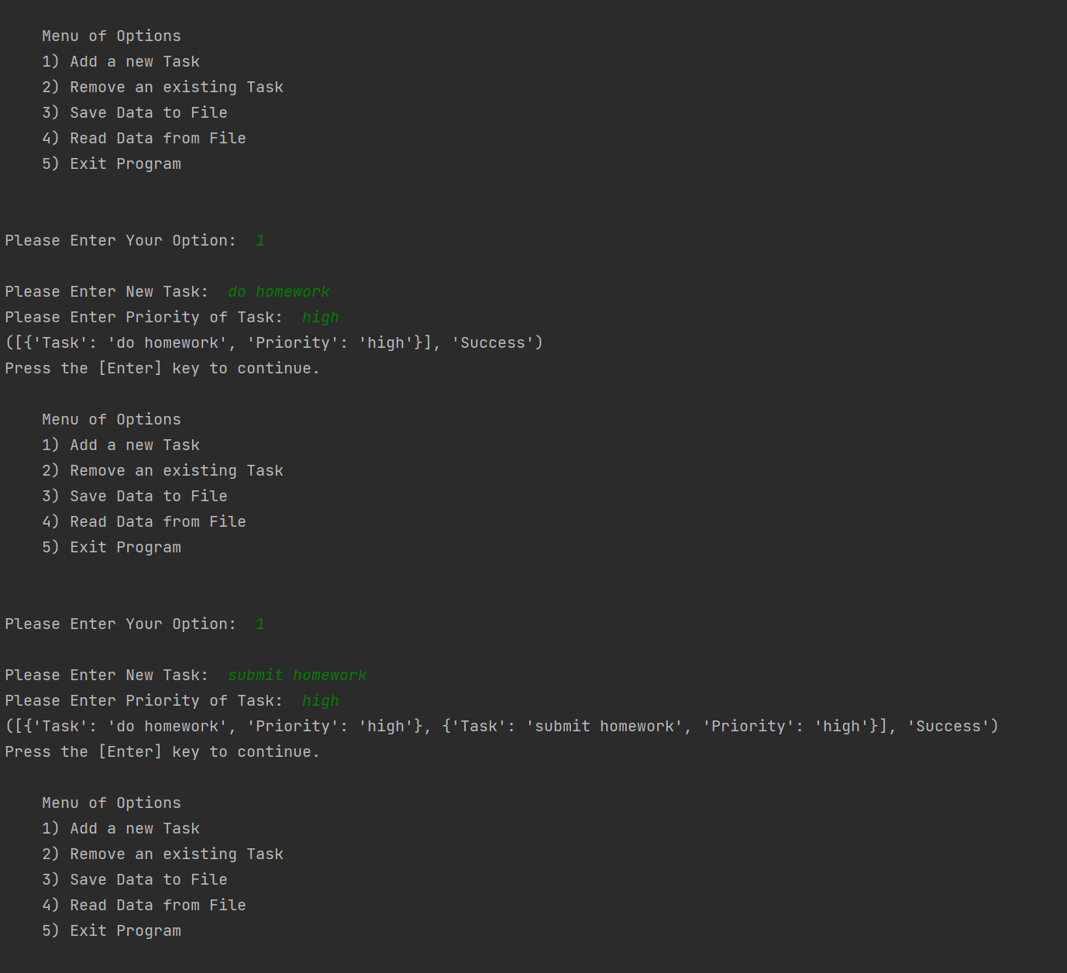

**Fig. 4**

**Next is removing data from the table (Fig. 5)**

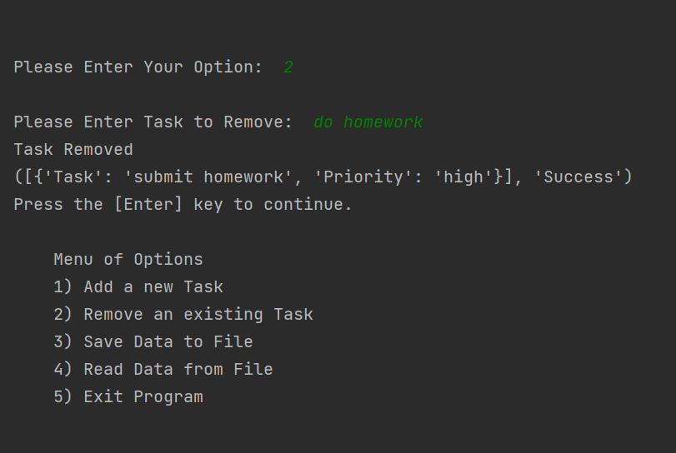

**Fig. 5**

**In order to test the try-except part of the code, I deliberately entered a string input when the code is expecting an integer input, resulting in the except error message being displayed ((Fig. 6)**

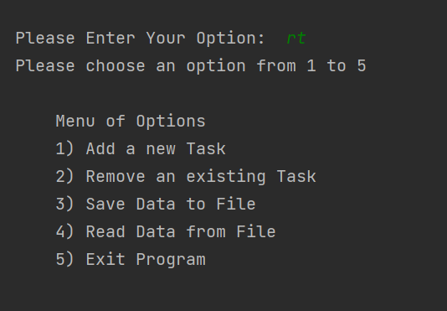

**Fig. 6**

**Saving the data using pickle and subsequently unpickling it is also performed (Fig. 7)**

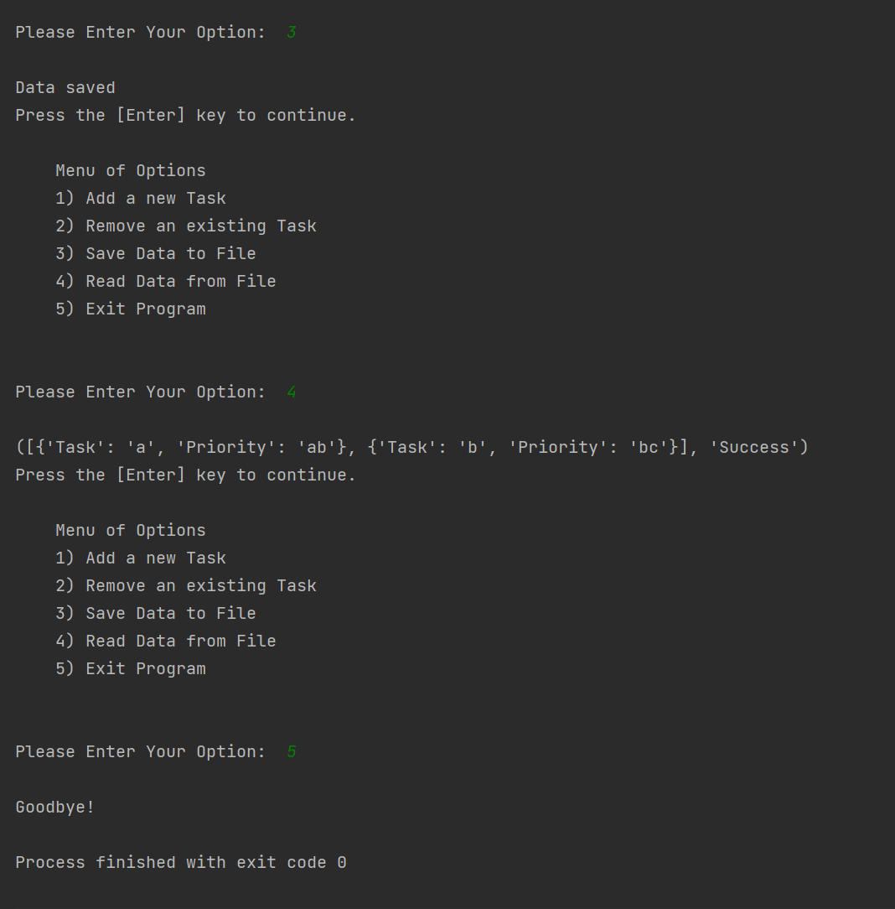

**Fig. 7**

**As this data was saved as a binary file using the pickle function, it appears very differently compared to a standard .txt file (Fig. 8)**

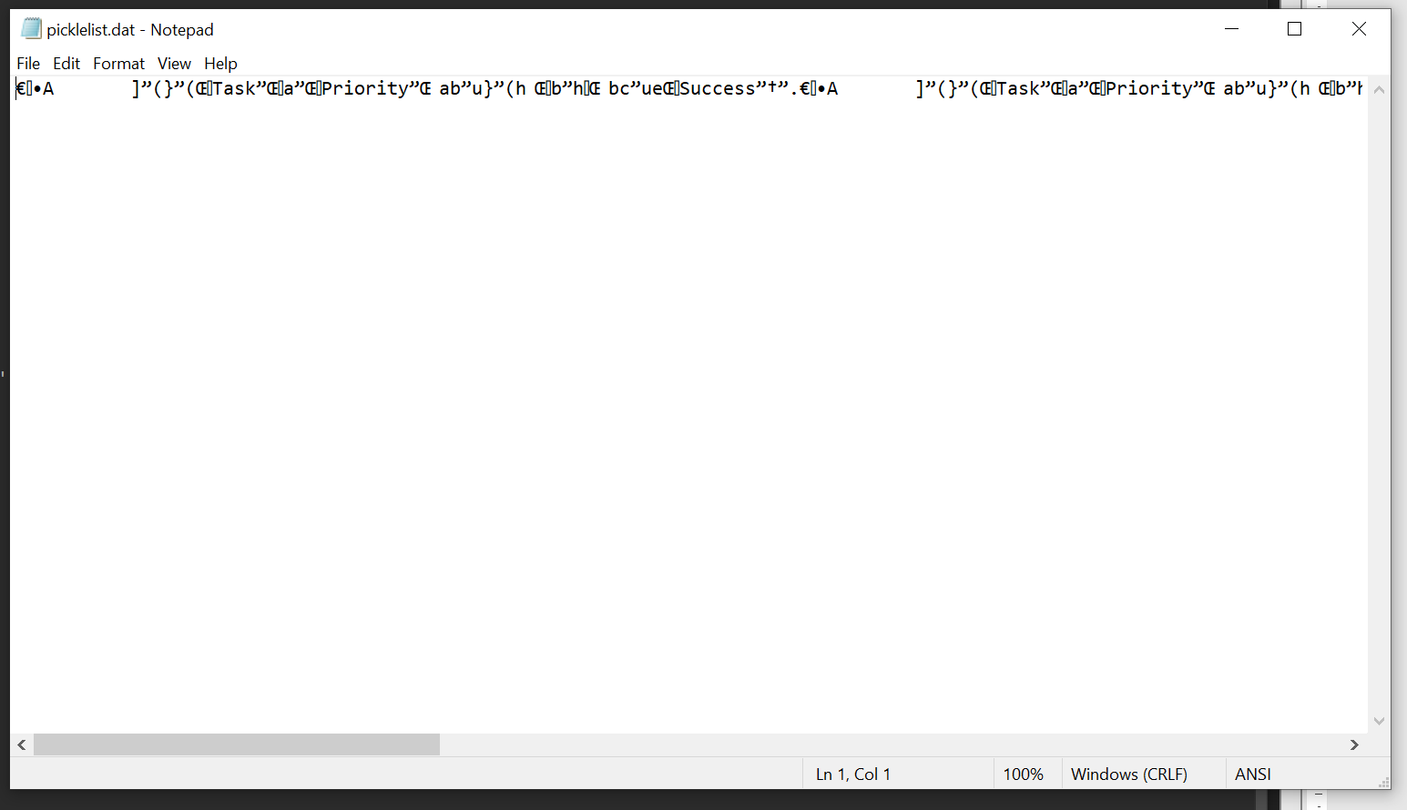

**Fig. 8**

**Conclusion:**

**Exceptions allow us to cater for user input errors without it crashing the entire script. It is extremely useful as there is already an existing library of standard exception messages, depending on what error is received. The ability to customise those messages are also a plus point and sometimes the standard messages may not always communicate what we want.**

**Saving in binary may seem as an unnecessary step, however sometimes we do want to add an extra layer of security to our files, without having to encrypt it. This is an extremely useful function and will serve well to provide some level of protection to our data.**