# Introduction

In this function we remove the impact of narrowband interference using a time domain approach. The algorithm is blind to the properties of the interferer and adapts to cancel it. It follows the general philosophy of property restoration as used by the constant modulus algorithm (CMA). The technique appears to be limited in that it appears to require proper timing (but not a training sequence), but can effectively cancel interference provided that the time-domain correlation is stationary over the length of the equalizing filter. CMA seeks to minimize a cost function defined by the CM-criterion. The CM criterion penalizes deviations in the modulus (i.e., magnitude) of the equalized signal away from a fixed value. In certain ideal conditions, minimizing the CM cost can be shown to result in perfect (zero-forcing) equalization of the received signal. Note that ideally, the filter length should be at least equal to the pulse shaping length.

## Features

* Accepts a complex vector of input samples (ideally oversampled) and outputs the equalized signal. If oversampling isn’t used, symbol timing could be an issue for the equalization approach.
* The technique will remove both narrowband interference as well as ISI due to frequency selective fading.
* It is blind to the properties of the interferer and adapts to cancel it.
* It could be extended to many other different CM-criterions (Normalized CMA, Orthogonal CMA and Least Squares CMA) for different requirements.

# Interface Description

## Generics

The function calls for the equalization approach are:

[c, X, e] = myCMA(N, L, EqD,x1, R2, mu)

## Inputs

The function inputs to the Equalization approach are defined in Table 1.

Table 1: Function Inputs

|  |  |  |
| --- | --- | --- |
| Input Name | Type | Description |
|  |  |  |
| N |  | number of samples |
| *L* |  | length of filter |
| *EqD* |  | equalization delay |
| *X1* |  | The received signal samples |
| *R2* |  | Modulus which is determined by modulation |
| *mu* |  | step size |

The signal outputs from the equalization approach are defined in Table 2

Table 2: CMA Output Signals

|  |  |  |
| --- | --- | --- |
| Output Name | Type | Description |
| c |  | weights of the adaptive filter |
| X |  | Estimated signals |
| e |  | Error rate |

## File List

Table 3 lists the files provided with the functions.

Table 3: Time Domain NBI Cancellation Source File List

|  |  |
| --- | --- |
| File Name | Description |
| CMA.m | Constant Modulus Algorithm – this is the main function provided |
| TestCMA.m | This function performs an CMA update to a set of weights for MMSE-based equalization and combines the received signal using those weights to obtain the decision statistic for the current symbol. |

# Functional Description – Equalization-based Cancellation

This technique is based on classic linear equalization. Specifically, linear equalization applies a weight vector to a vector of received samples in order to cancel the inter-symbol (or other) interference. A common solution for choosing the weights is the zero-forcing (ZF) solution which minimizes the error between a known symbol sequence and the received vector of samples which is contaminated by ISI and other interference.

**Functional Description – CMA Filter**

This technique is based on blind Equalization filtering with an adaptive technique to determine the filter coefficients. Specifically, we implement the filter with the following transfer function:







Where  is output from the filter,  is the tap-gain input vector and  is the parameters of filter.  is a positive real constant :



Example Performance:

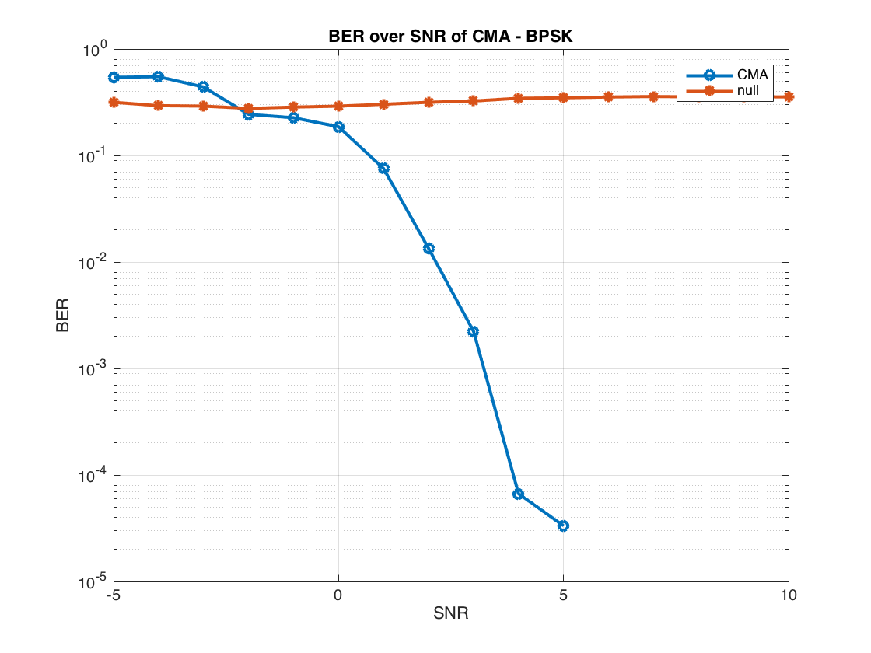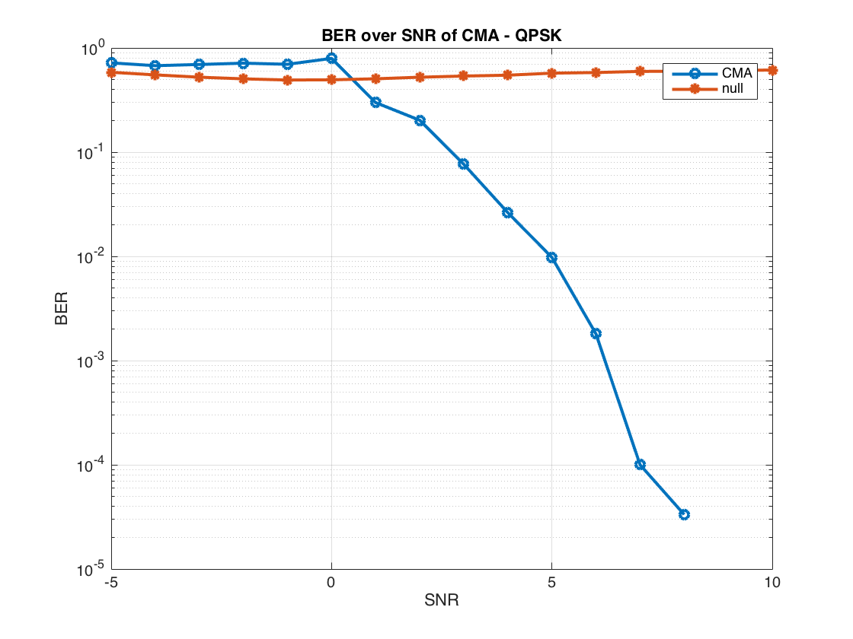

**Figure 1 a,b - Performance of the Time-Domain NBI Cancellation with Tone Interferer (fc = 0.01, SIR = 10dB, filter length = 10, Training Sequence Length = 10, mu = 0.001, BPSK/QPSK modulation)**

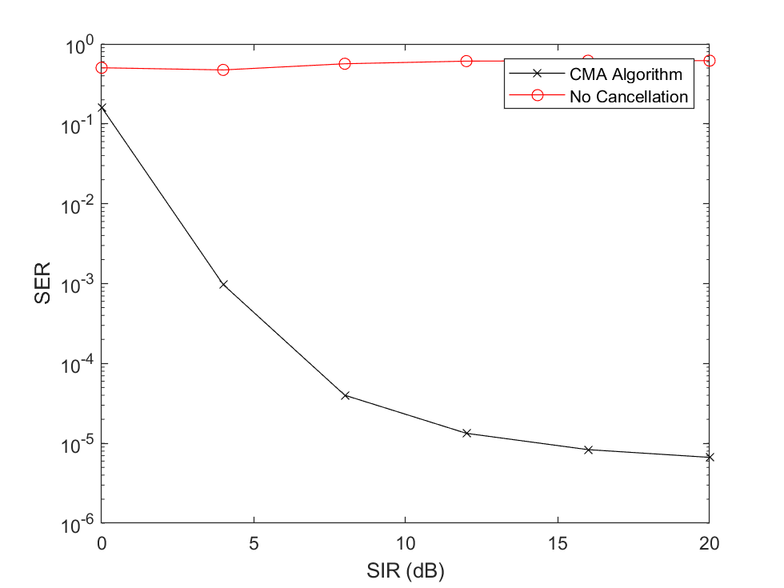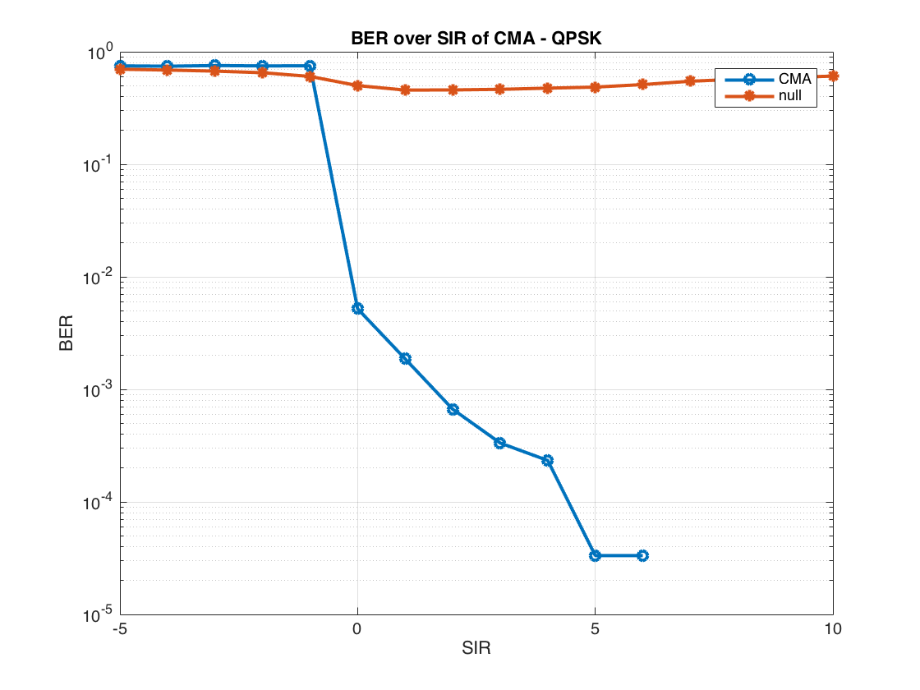

**Figure 2 a,b - Performance of the Time-Domain NBI Cancellation with Tone Interferer (fc = 0.1, SNR = 10dB, filter length = 10, Training Sequence Length = 10, mu = 0.001, BPSK (left) and QPSK (right) modulation)**

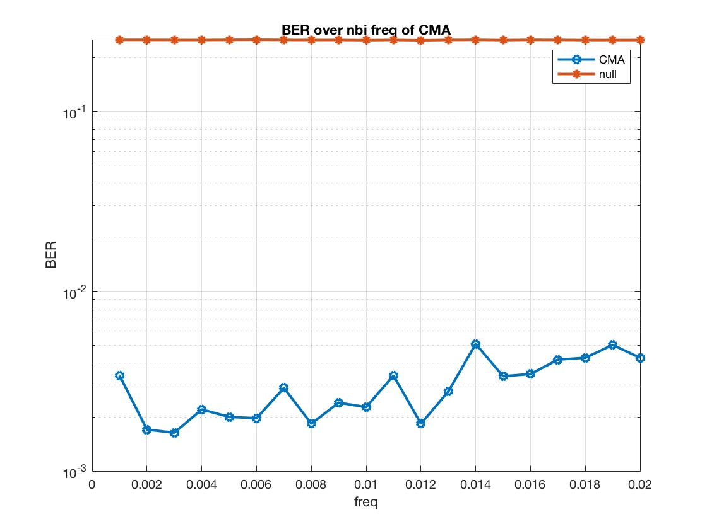

**Figure 3 - Performance of the Time-Domain NBI Cancellation with Tone Interferer (SIR= 10dB, SNR = 10dB, filter length = 10, Training Sequence Length = 10, mu = 0.001, BPSK modulation)**