**EFOLIO TASK 3.1**

**EFOLIO TASK 3.2**

GitHub commit history:

Screenshots of front-end demonstrating the form support on different devices:

Code for implementing the Bootstrap's breakpoints. (Edited codes are highlighted in blue):

**Task 4.1**

Activity 2:

Activity 3:

Empty input: Incorrect inputs:

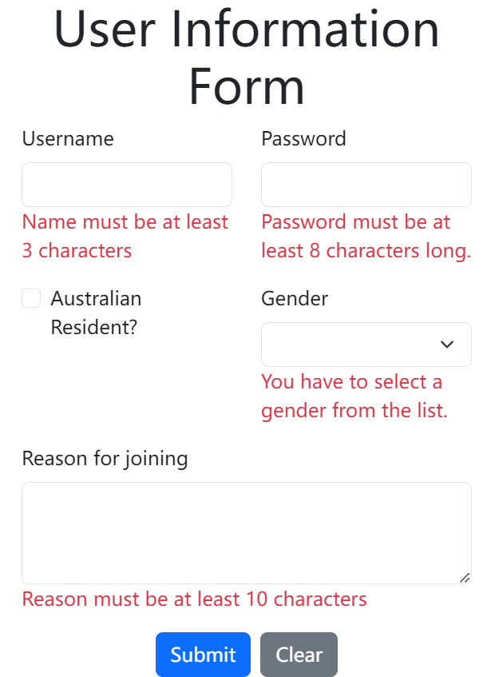

Correct Inputs:

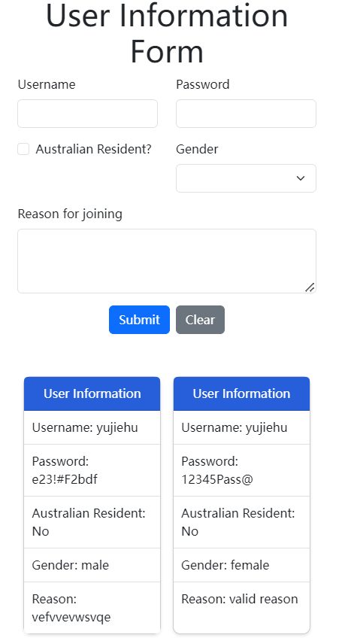

**Task 4.2**

Extra validations of:

* no duplicate name
* must select a gender from the list
* minimum 10 characters length for join reason

PrimeVue DataTable with submitted user information:

Codes for extra validation:

Codes for PrimeVue DataTable:

GitHub commit history:

