**EFOLIO TASK 5.1**

Modified Library form:

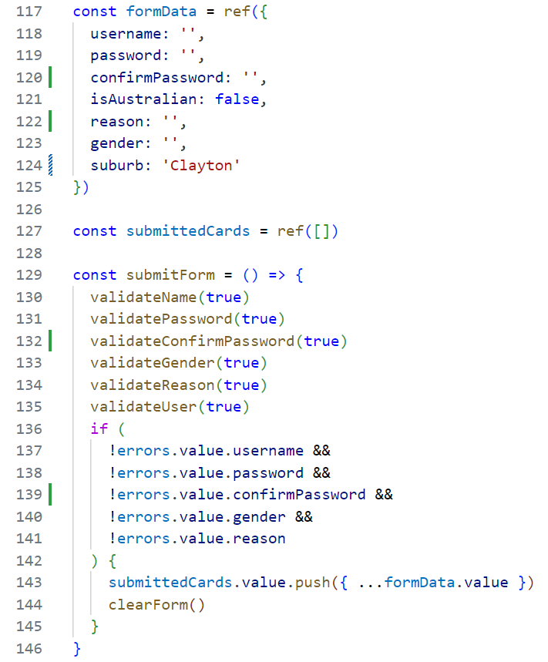

Password mismatch message and DevTools to test the suburb component:

