# EFolio 7.1

Screenshot of the registration page on the browser and Visual Studio code:

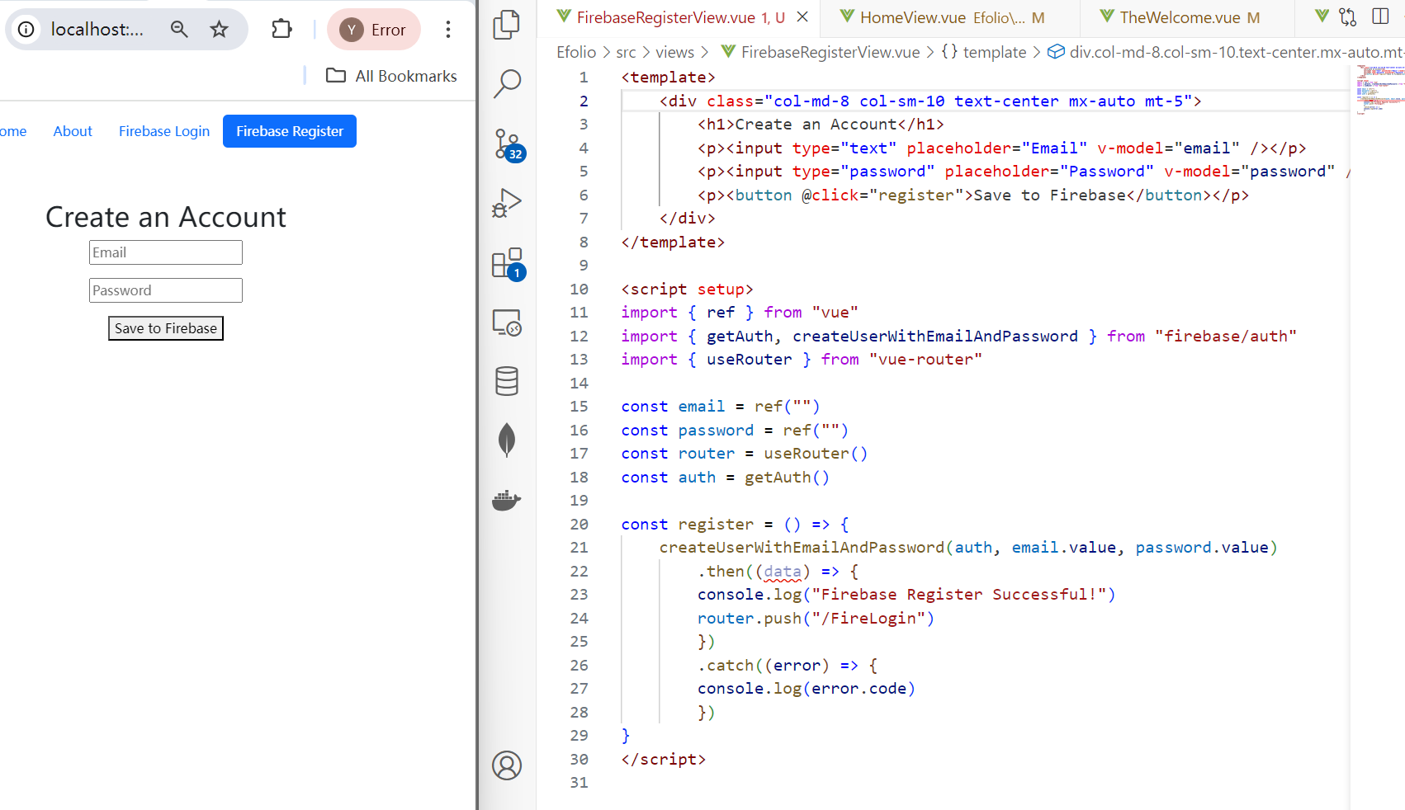

Screenshot of the login page on the browser and Visual Studio code:

Console panel after logging in (shows the current user):

Registered User:

# EFolio 7.2

sign in by multiple roles:

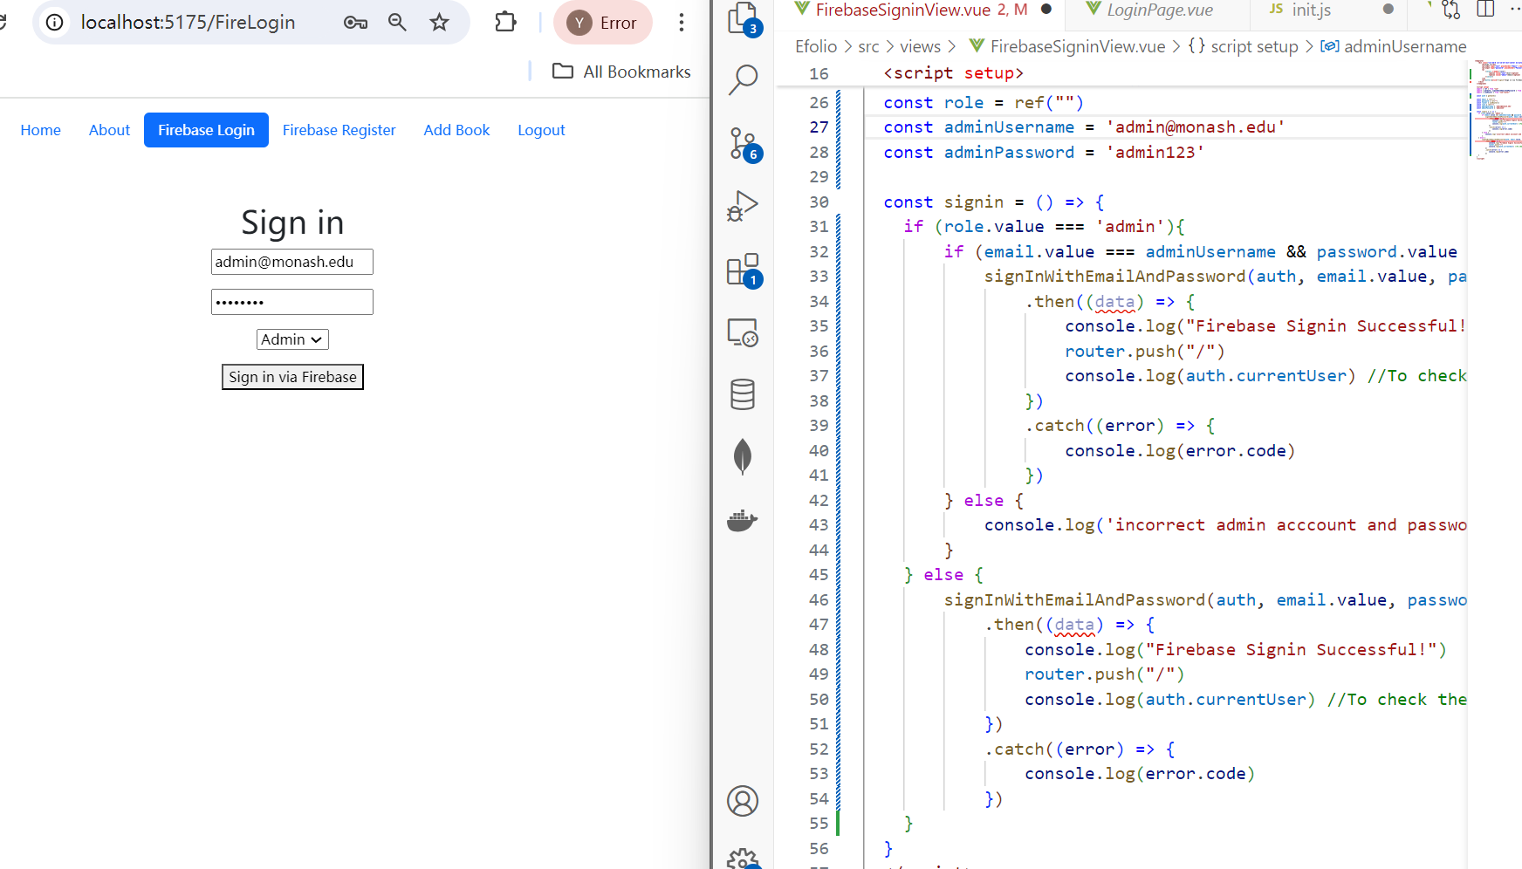

Console after logout:

# EFolio 8.1

The AddBook page on the browser with the Visual Studio code aside:

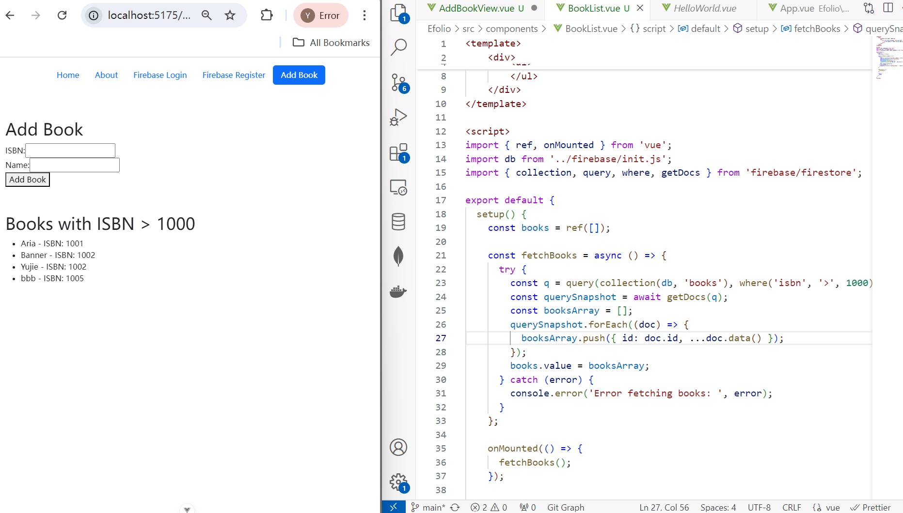

The Firestore page that contains newly added data:

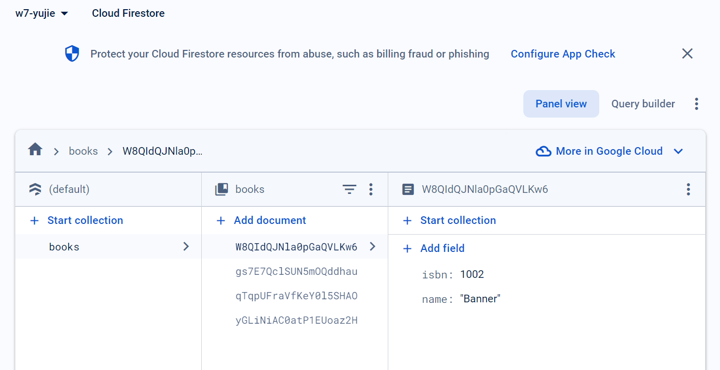

# EFolio 8.2

Delete the book named ‘bbb’:

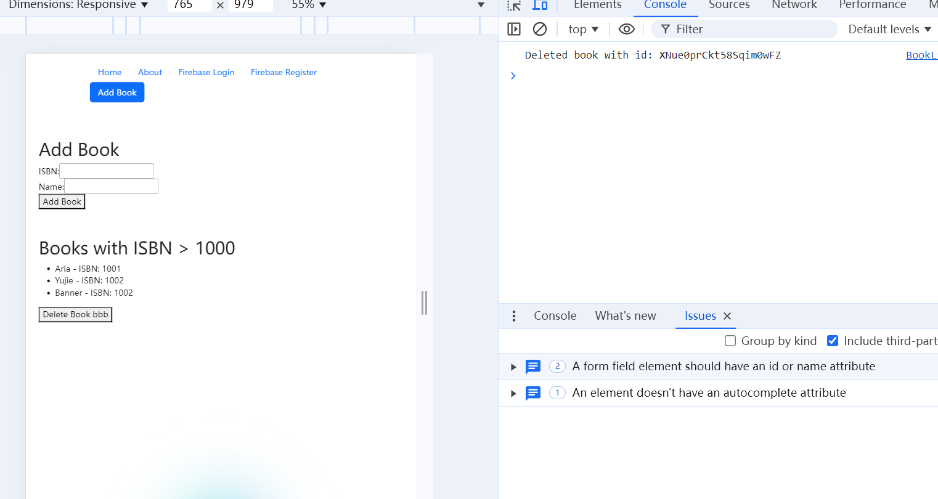

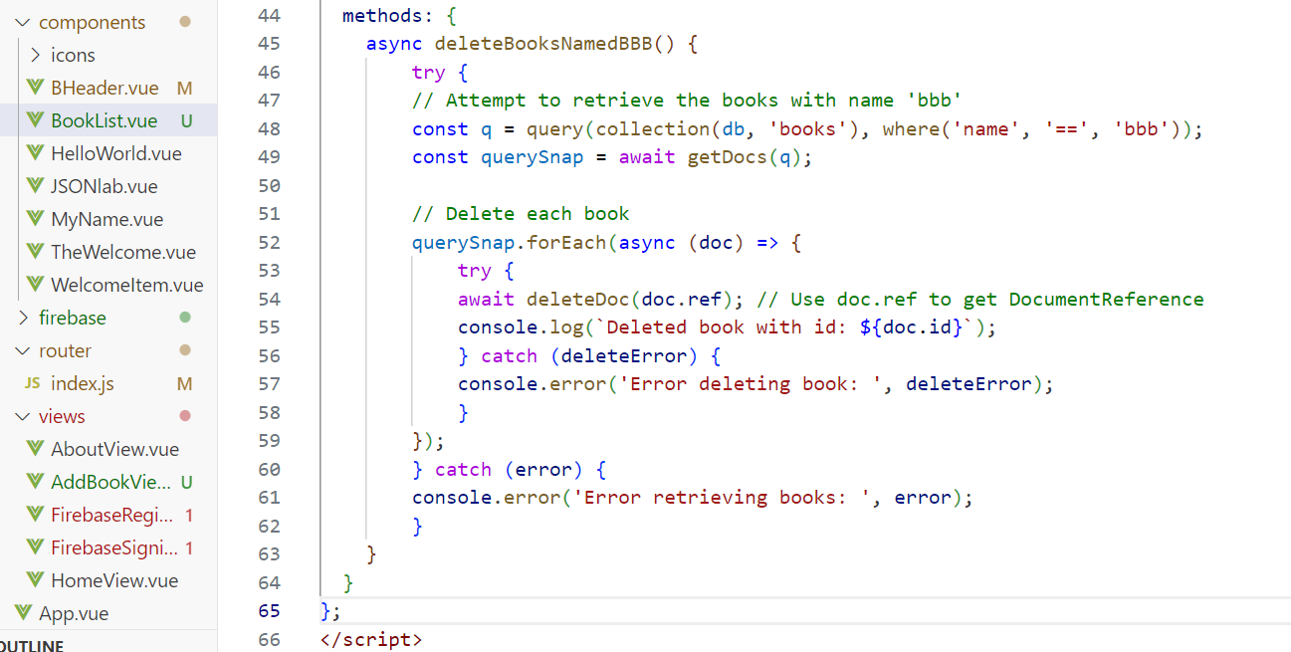

Update ISBN for book named Yujie:

Retrieve the database using where, orderby and limit:

