WIREFRAME

Loading Screen / Splash Screen
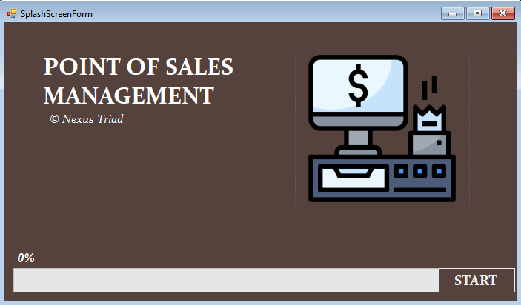
Login Form
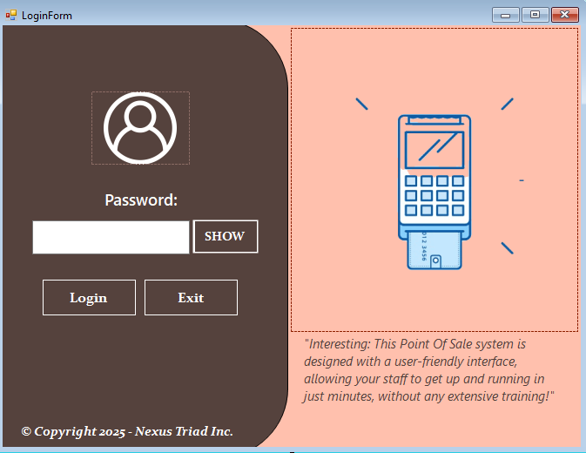
DASHBOARD/POS
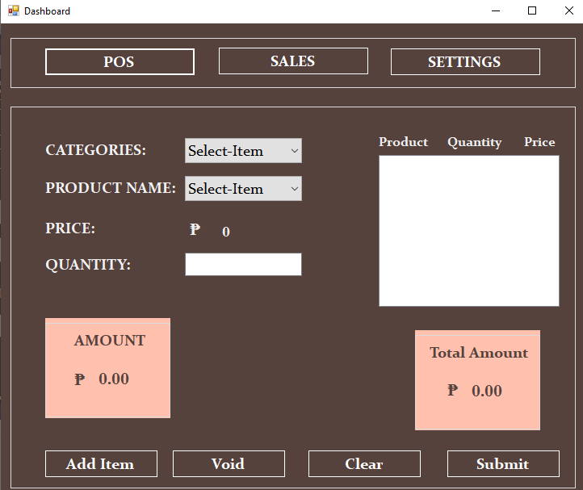

PAYMENT
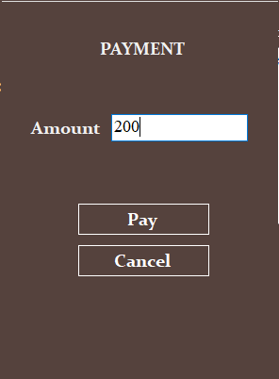
RECEIPT
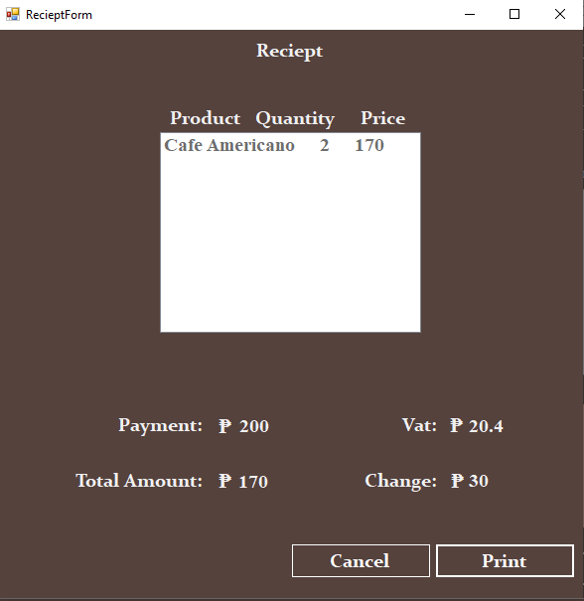
ADD ANORTHER SPLASH FOR PRINT RECEIPT USING POSGIF IN RESOURCES
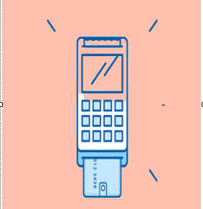

DASHBOARD/SALES
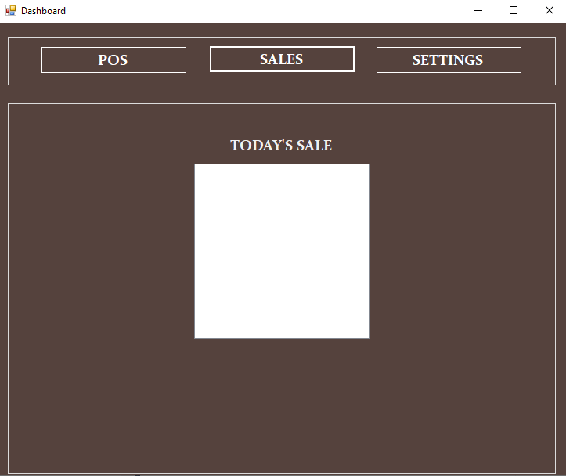
DASHBOARD SETTINGS
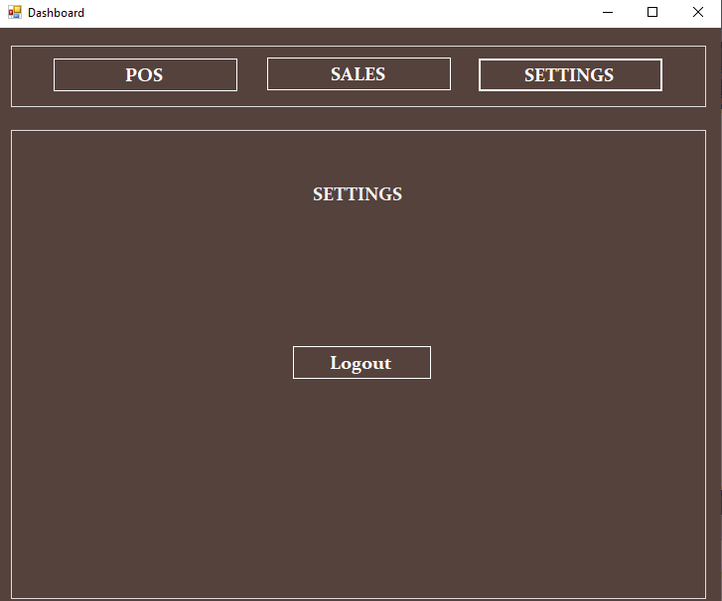

Color Pallete & Fonts
Primary Color: RGB = 85, 66, 61
Secondary Color: RGB = 255, 192, 173
Third Color: White

Primary Font: Constantia BOLD
Secondary Font: TimesNewRoman
Additional:
Add Mouse Hover of Each Button
BackGroundColor = 255, 192, 173
FontColor = 85, 66, 61
Example:

PasswordChar = “•”

