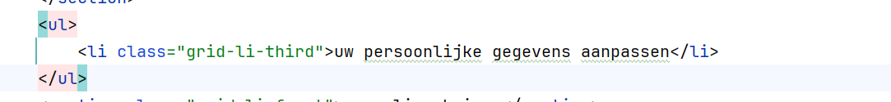

Door deze code past het zwarte bolletje niet de witte achtergrond

Kleurgerbeutik

Kleurenpalet

* **OBA Rood**
  + #E61C24
  + 230, 28, 36
  + 0, 100, 100, 0
* **Zwart**
  + #000000
  + 0, 0, 0
  + 0, 0, 0, 100
* **Grijs**
  + #D9D9D9
  + 217, 217, 217
  + 15, 15, 15, 0
* **Licht grijs**
  + #F2F2F2
  + 242, 242, 242
  + 5, 5, 5, 0
* **Wit**
  + #FFFFFF
  + 255, 255, 255
  + 0, 0, 0, 0

