CWk1
Part1
Q1: The number of team numbers: 5
Q2: The Belbin roles of every team members
Names | Project Roles | Belbin roles
Jingkun Yu | Scrum master | Chair(CH)
Zhicheng Zhang | Frontend engineer | Shaper(SH)
Chenhao Liu | Backend engineer | Company Worker(CW)
Liheng Jin | Test engineer | Moniter(ME)
Kecen Liu | Product owner | Team Worker(TW)
Q3: Team strengths
One strength of our team is our ability to develop software efficiently as a coordinated team. This strength can be explained by the Belbin roles of our members.
First, our Scrum master is the Chair (CH), who helps organize the team and coordinate different tasks. This makes our teamwork more structured. Second, our frontend engineer is the Shaper (SH), who can push the team forward and keep the project moving. Third, our backend engineer is the Company Worker (CW), who is practical and good at turning plans into actual development work. Our test engineer plays the role of Monitor Evaluator (ME), which means he can carefully check the system, evaluate solutions, and help avoid mistakes. Finally, our product owner is the Team Worker (TW), who supports communication and cooperation in the team.
With these different roles, our team can work effectively from planning to implementation and testing. In addition, we are familiar with technologies such as Vue, SSM, Git, Linux, and Docker, and some members also have internship or open-source experience. Therefore, our team has a strong advantage in both collaboration and practical software development.
Q4: Team weakness
One weakness of our team is the lack of standardized experience in Agile software development. Although our team has solid technical skills, some members have limited experience with formal Agile practices, Test-Driven Development (TDD), and highly standardized development workflows.
This weakness can also be understood through our Belbin role profiles. Our team includes a Chair (CH), Shaper (SH), Company Worker (CW), Monitor Evaluator (ME), and Team Worker (TW), which gives us good coordination, execution, communication, and basic evaluation ability. However, we do not have a strong Completer/Finisher (CF) role in the team. According to the Belbin role definitions, a Completer/Finisher is usually detail-oriented, careful about quality, and focused on making sure work is completed in a thorough and disciplined way. Without this type of role, the team may be less effective in maintaining highly standardized processes, such as strict testing practices, complete documentation, and systematic quality control.
As a result, while we can develop and collaborate efficiently, we may not always follow a fully mature Agile process, and our development practices may sometimes rely more on personal experience than on a well-defined engineering standard. This is an important weakness that could affect long-term project quality and process consistency.

Q5. Mitigation strategy
To mitigate the risks caused by our limited experience in standardized Agile development, we will adopt two mitigation strategies during the project.
First, we will establish a lightweight Agile workflow. The Scrum Master as the Chair (CH) will organize sprint planning meetings, weekly progress tracking, and short retrospectives. Tasks will be clearly divided and recorded on a shared board, so that each member understands their responsibilities and deadlines. This strategy can reduce the risk of poor coordination and unclear task management.
Second, we will strengthen quality control in development. We will define basic coding standards, use Git branch management rules, and require code review before merging important features. In addition, the team will write unit tests for core modules and perform testing before each release. The Monitor Evaluator (ME) and test engineer will help check whether functions meet quality requirements. This strategy can reduce the risks caused by insufficient testing experience and unstandardized development practices.
Through these two strategies, our team can gradually compensate for the weakness in Agile and standardized development, while improving both collaboration efficiency and software quality.

Part2
Github structure:
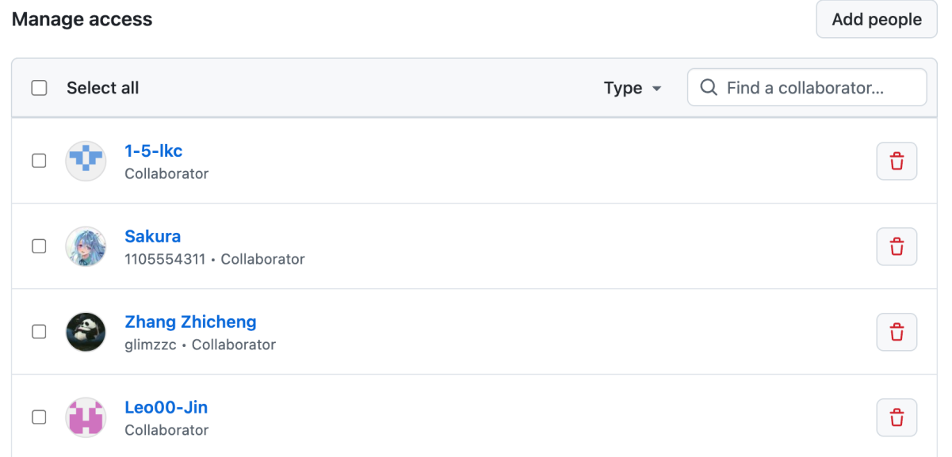
Issue tracker:
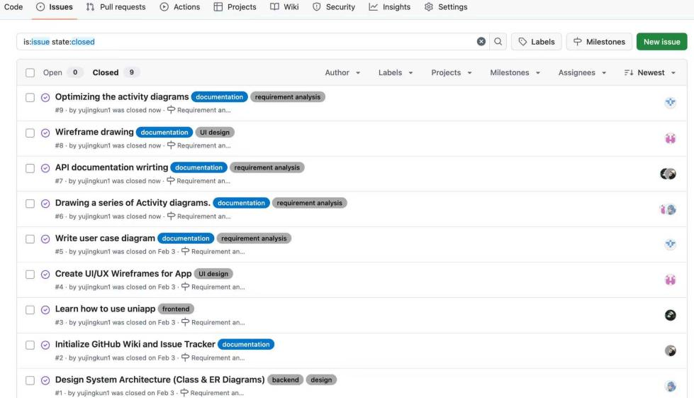
Wiki for sprint1 plan and initial design:
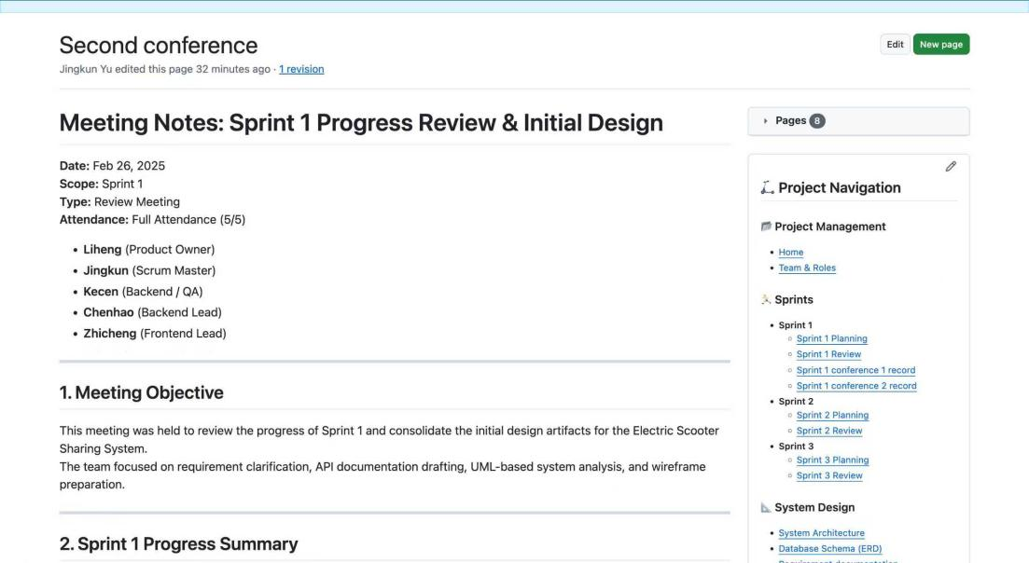

Wiki for sprint1 outcomes:
API documents
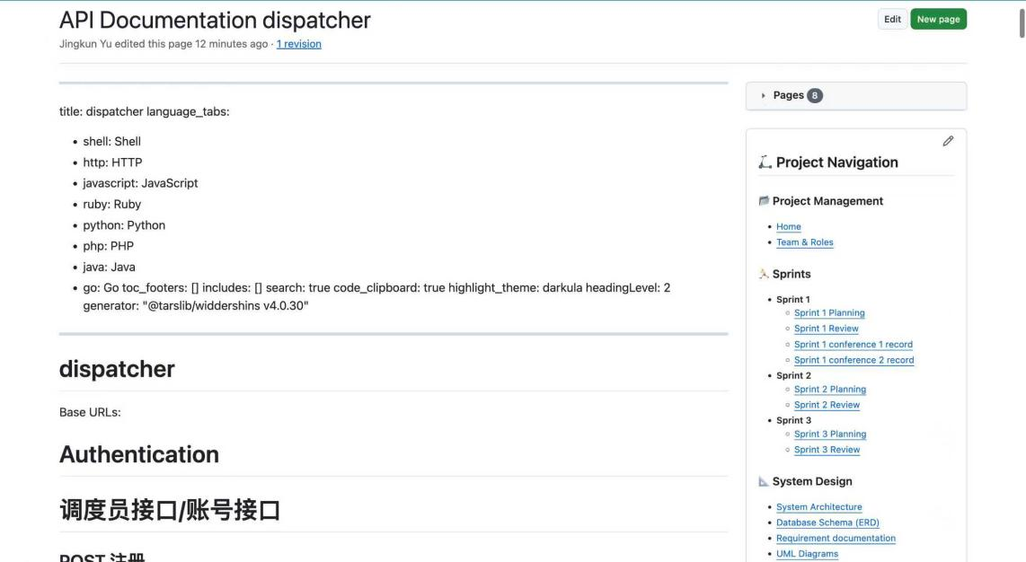
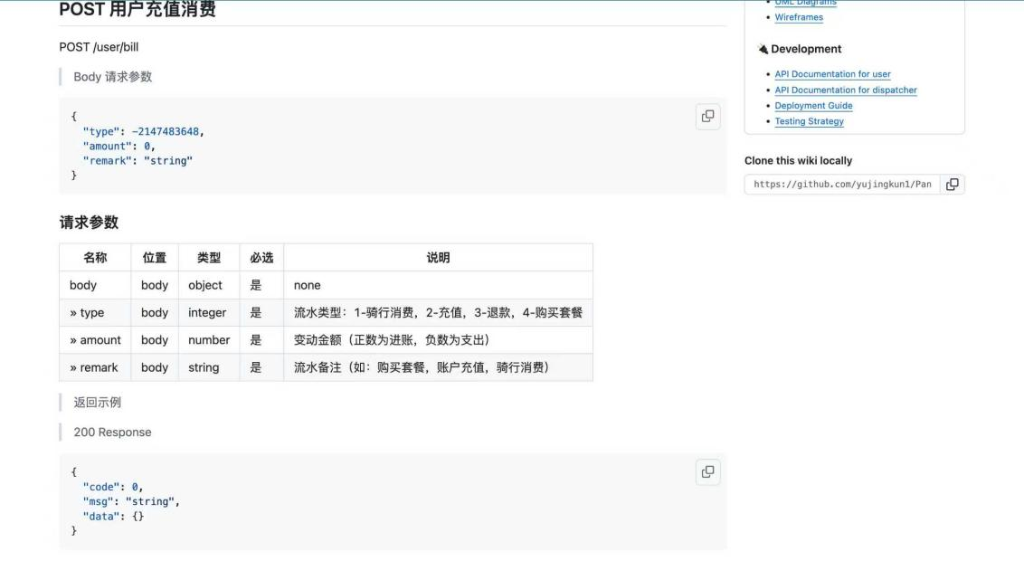

Requirement document
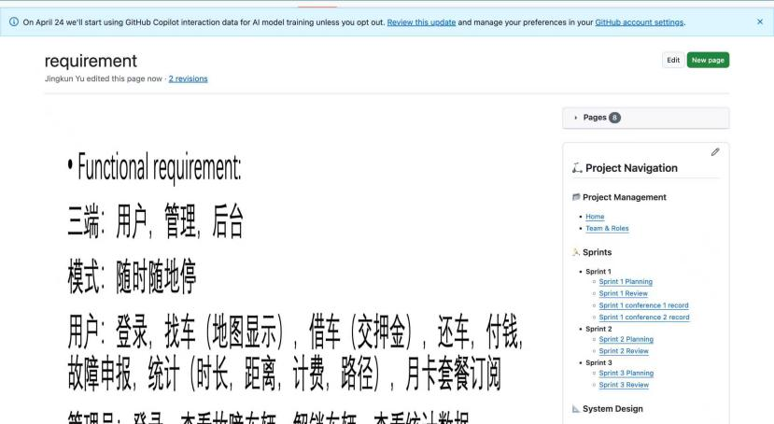
Wireframes
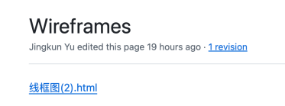
Wiki for meeting minutes and attendance:
