##### **R code and the output of the final project**

Yujing Ma

> MDN = read.csv("MDN.csv")

>

>

> ##descriptive statistics##

> summary(MDN)

MRC.Code BU.Code Company Department

Min. :1154 1270 :319500 JSC :221408 PRD :350126

1st Qu.:1270 3290 : 36100 Pharm Commercial:130853 NACP : 94182

Median :1290 154G : 35576 Pharm R&D :373153 Puerto Rico : 68122

Mean :1559 174Q : 35455 JSC : 59725

3rd Qu.:1660 1154 : 35382 Noramco USA : 49996

Max. :3291 174M : 35273 Janssen Pharmaceuticals: 43173

(Other):228128 (Other) : 60090

PO.No Supplier.Country.Code PO.Create

992881146: 190 US :677507 1/10/2012 0:00: 2944

992961742: 188 CA : 37872 1/19/2010 0:00: 2847

PC1129527: 168 GB : 3309 1/9/2012 0:00 : 2281

PCO061170: 168 PR : 1753 1/17/2012 0:00: 2250

PCO060592: 138 CN : 953 1/5/2012 0:00 : 2247

PC1122227: 120 DE : 893 1/11/2012 0:00: 2238

(Other) :724442 (Other): 3127 (Other) :710607

PO.Line.Descn.Text Linkage.Id Supplier.No

SAS Programmer III : 1341 R006116:147677 Min. : -99999

Assistant Scientist-Puerto Rico: 1154 R343516:122356 1st Qu.: 6116401

Scientific Process Operator : 1008 : 36669 Median : 149431401

GLOVE BLACK PF NITRILE M PK100 : 713 R002123: 26578 Mean : 368349313

WIPER WYPALL X60 TERI PK126 : 649 R006362: 22244 3rd Qu.: 343516401

GLOVE BLACK PF NITRILE L PK100 : 586 R030099: 11660 Max. :4260006970

(Other) :719963 (Other):358230

Universal.Calendar.Month Payment.Distr.Amt Category.Name

12-Mar : 31485 Min. :-18343388 Research & Development (Products & Packaging):336102

12-Feb : 27267 1st Qu.: 97 Capital Construction & Facilities Services :221124

12-Jun : 26384 Median : 733 Consulting- Labor and Professional Services : 61574

12-Apr : 26049 Mean : 31893 Marketing Services : 49851

12-Jan : 26012 3rd Qu.: 6432 IT : 27249

12-May : 24326 Max. :150000000 Exclusions - Other : 15968

(Other):563891 (Other) : 13546

Subcategory.Name PO.Total.Amount Requester.WWID

R&D Lab Supplies - Consumables :179276 Min. :0.000e+00 Min. :1.941e+03

Office Supplies :130934 1st Qu.:4.580e+02 1st Qu.:1.591e+05

R&D Lab Supplies - Equipment and Instrumentation: 64493 Median :3.465e+03 Median :1.942e+05

Temporary Staffing : 30470 Mean :1.150e+06 Mean :2.947e+07

R&D Lab Supplies - Chemicals & Life Science Chem: 27263 3rd Qu.:6.160e+04 3rd Qu.:3.684e+05

Consulting : 16473 Max. :8.690e+09 Max. :1.000e+09

(Other) :276505

Preparer.WWID Requester.Supervisor.WWID Business.Size.Code Credo.Spend.Ind Dept.Code

Min. :2.073e+03 Min. : 1941 D:127032 N:536519 :130052

1st Qu.:1.677e+05 1st Qu.: 151292 L:452665 Y:188895 56758 : 19192

Median :3.348e+05 Median : 185174 S:145717 56482 : 11973

Mean :1.293e+08 Mean : 3686454 56306 : 10334

3rd Qu.:1.021e+06 3rd Qu.: 367915 60071 : 9898

Max. :1.000e+09 Max. :146000228 11321 : 9016

NA's :14 NA's :8724 (Other):534949

Account.Code Order.Type.Code JNJ.Site.Code Requester.NameB

Min. : 600046 92: 16436 127012 : 83519 KEVIN JIANMING : 19885

1st Qu.:62501011 97: 30958 127002 : 68202 DIANE LESIA : 6587

Median :62501024 99:325422 127003 : 59389 Ray MARLENE : 6307

Mean :60244016 CR: 28118 127001 : 57108 CAROLE Andrea : 6129

3rd Qu.:63070001 PC:324480 127004 : 39188 FRANK SANDRA : 4719

Max. :99991001 115402 : 35269 LAURENT REBECCA: 4675

NA's :7 (Other):382739 (Other) :677112

Preparer.NameB Requester.Supervisor.NameB

LAURA Stephanie: 11804 DAVID MICHAEL : 14364

DIANE MICHAEL : 9502 Myriam JONATHAN: 8628

KATIE Jessica : 8685 LESLIE MICHAEL : 7655

ANGEL Michael : 8526 SILAS JOE : 7063

SCOTT GERARD : 7154 TROY KRISTEN : 6575

KAREN Yvette : 6610 (Other) :678768

(Other) :673133 NA's : 2361

> dim(MDN)

[1] 725414 27

> names(MDN)

[1] "MRC.Code" "BU.Code" "Company"

[4] "Department" "PO.No" "Supplier.Country.Code"

[7] "PO.Create" "PO.Line.Descn.Text" "Linkage.Id"

[10] "Supplier.No" "Universal.Calendar.Month" "Payment.Distr.Amt"

[13] "Category.Name" "Subcategory.Name" "PO.Total.Amount"

[16] "Requester.WWID" "Preparer.WWID" "Requester.Supervisor.WWID"

[19] "Business.Size.Code" "Credo.Spend.Ind" "Dept.Code"

[22] "Account.Code" "Order.Type.Code" "JNJ.Site.Code"

[25] "Requester.NameB" "Preparer.NameB" "Requester.Supervisor.NameB"

> #the main company and the branch

> # note:The ID number that uniquely identifies umbrella of supplier working for same Supplier Company "Parent/Child - relationship"

> #table(MDN$Company, MDN$Department)

> length(table(MDN$Supplier.No))

[1] 15864

> length(table(MDN$Linkage.Id))

[1] 10581

> #table(table(MDN$Linkage.Id))

> #table(MDN$Supplier.No,MDN$Linkage.Id)

> #link each branches to the main company

> linka = sort(unique(MDN$Linkage.Id))

> linkano= list()

> for(i in linka) linkano[[i]]= sort(unique(

+ MDN$Supplier.No[MDN$Linkage.Id==i]))

|  |
| --- |
| > ##################################  > #part 1:suppliers and departments#  > #################################  > ###clustering###  > #cluster the suppliers with the department to find the most frequency suppliers for each departments  > table(MDN$Linkage.Id,MDN$Department) -> tt  > #quantile(tt)-quantile(x) using the same idea of the qq-plot  > c1 = cor(tt)  > #shrink the correlation  > c1[c1 < 0.013 ] = 0#multivariate media=0.013  >  > dim(c1)  [1] 11 11  > c2 = c1  > dimnames(c2) = NULL  > pairs(c2,pch=".",col=2)    > round(c2,2)  [,1] [,2] [,3] [,4] [,5] [,6] [,7] [,8] [,9] [,10] [,11]  [1,] 1 0.00 0.00 0.00 0 0.00 0.00 0.00 0.00 0.00 0.00  [2,] 0 1.00 0.86 0.81 0 0.86 0.29 0.85 0.36 0.43 0.19  [3,] 0 0.86 1.00 0.89 0 0.96 0.48 0.93 0.54 0.62 0.29  [4,] 0 0.81 0.89 1.00 0 0.87 0.34 0.84 0.40 0.47 0.29  [5,] 0 0.00 0.00 0.00 1 0.00 0.00 0.00 0.00 0.00 0.00  [6,] 0 0.86 0.96 0.87 0 1.00 0.42 0.95 0.50 0.58 0.21  [7,] 0 0.29 0.48 0.34 0 0.42 1.00 0.31 0.97 0.95 0.53  [8,] 0 0.85 0.93 0.84 0 0.95 0.31 1.00 0.40 0.48 0.13  [9,] 0 0.36 0.54 0.40 0 0.50 0.97 0.40 1.00 0.94 0.53  [10,] 0 0.43 0.62 0.47 0 0.58 0.95 0.48 0.94 1.00 0.50  [11,] 0 0.19 0.29 0.29 0 0.21 0.53 0.13 0.53 0.50 1.00 |
| > ###part of bayesian network-precision matrix###  > library(glasso)  Warning message:  package 慻lasso?was built under R version 3.1.3  > glasso(s=c2[c(1:11),c(1:11)], 0.05)# get the 0 in precision matrix  $w  [,1] [,2] [,3] [,4] [,5] [,6] [,7] [,8] [,9] [,10]  [1,] 1.05 0.0000000 0.0000000 0.0000000 0.00 0.0000000 0.0000000 0.0000000 0.0000000 0.0000000  [2,] 0.00 1.0500000 0.8135471 0.7552011 0.00 0.8073101 0.3359262 0.7953130 0.3635058 0.4284760  [3,] 0.00 0.8135471 1.0500000 0.8422285 0.00 0.9114559 0.4696638 0.8815982 0.4944803 0.5739862  [4,] 0.00 0.7552011 0.8422285 1.0500000 0.00 0.8161843 0.3857446 0.7885748 0.4093061 0.4727408  [5,] 0.00 0.0000000 0.0000000 0.0000000 1.05 0.0000000 0.0000000 0.0000000 0.0000000 0.0000000  [6,] 0.00 0.8073101 0.9114559 0.8161843 0.00 1.0500000 0.4265859 0.8963980 0.4534242 0.5258705  [7,] 0.00 0.3359262 0.4696638 0.3857446 0.00 0.4265859 1.0500000 0.3621548 0.9189183 0.9029085  [8,] 0.00 0.7953130 0.8815982 0.7885748 0.00 0.8963980 0.3621548 1.0500000 0.3917640 0.4633782  [9,] 0.00 0.3635058 0.4944803 0.4093061 0.00 0.4534242 0.9189183 0.3917640 1.0500000 0.8860397  [10,] 0.00 0.4284760 0.5739862 0.4727408 0.00 0.5258705 0.9029085 0.4633782 0.8860397 1.0500000  [11,] 0.00 0.1879150 0.2542166 0.2438588 0.00 0.2297862 0.4820629 0.1839684 0.4797164 0.4473253  [,11]  [1,] 0.0000000  [2,] 0.1879150  [3,] 0.2542166  [4,] 0.2438588  [5,] 0.0000000  [6,] 0.2297862  [7,] 0.4820629  [8,] 0.1839684  [9,] 0.4797164  [10,] 0.4473253  [11,] 1.0500000  $wi  [,1] [,2] [,3] [,4] [,5] [,6] [,7] [,8]  [1,] 0.952381 0.00000000 0.00000000 0.000000000 0.000000 0.00000000 0.00000000 0.0000000  [2,] 0.000000 2.82865671 -0.76296037 -0.499353222 0.000000 -0.63577179 0.09270532 -0.6151700  [3,] 0.000000 -0.76287658 5.66978894 -1.180865604 0.000000 -1.90285439 0.00000000 -1.3622099  [4,] 0.000000 -0.49927284 -1.18038874 3.041951323 0.000000 -0.61282586 0.01182063 -0.3711306  [5,] 0.000000 0.00000000 0.00000000 0.000000000 0.952381 0.00000000 0.00000000 0.0000000  [6,] 0.000000 -0.63570674 -1.90303070 -0.612686257 0.000000 5.28365459 0.00000000 -1.8616928  [7,] 0.000000 0.08965947 0.00000000 0.009806039 0.000000 0.00000000 5.31990035 0.1481461  [8,] 0.000000 -0.61524017 -1.36134714 -0.371228153 0.000000 -1.86151297 0.15342713 4.3613400  [9,] 0.000000 0.00000000 -0.07960748 0.000000000 0.000000 -0.07514878 -2.66793836 0.0000000  [10,] 0.000000 0.00000000 -0.63479386 0.000000000 0.000000 -0.18501661 -2.31309236 0.0000000  [11,] 0.000000 0.00000000 0.00000000 -0.136778288 0.000000 0.00000000 -0.28426496 0.1010919  [,9] [,10] [,11]  [1,] 0.00000000 0.00000000 0.00000000  [2,] 0.00000000 0.00000000 0.00000000  [3,] -0.08279368 -0.63699930 0.00000000  [4,] 0.00000000 0.00000000 -0.13670559  [5,] 0.00000000 0.00000000 0.00000000  [6,] -0.07813473 -0.18737043 0.00000000  [7,] -2.66793997 -2.31297755 -0.28433585  [8,] 0.00000000 0.00000000 0.10143811  [9,] 4.78857764 -1.54889571 -0.26581439  [10,] -1.54897856 4.70787782 -0.04086625  [11,] -0.26591358 -0.04095488 1.23575166  $loglik  [1] -15.83855  $errflag  [1] 0  $approx  [1] FALSE  $del  [1] 2.121324e-05  $niter  [1] 8  > ###cluster using c3###  > c3 = sqrt(1 -c2^2)#similarity, square(1-corr^2)=distance, produce the correlation distance to cluster  > round(c3,2)  [,1] [,2] [,3] [,4] [,5] [,6] [,7] [,8] [,9] [,10] [,11]  [1,] 0 1.00 1.00 1.00 1 1.00 1.00 1.00 1.00 1.00 1.00  [2,] 1 0.00 0.50 0.59 1 0.51 0.96 0.53 0.93 0.90 0.98  [3,] 1 0.50 0.00 0.45 1 0.27 0.88 0.36 0.84 0.78 0.96  [4,] 1 0.59 0.45 0.00 1 0.50 0.94 0.54 0.92 0.88 0.96  [5,] 1 1.00 1.00 1.00 0 1.00 1.00 1.00 1.00 1.00 1.00  [6,] 1 0.51 0.27 0.50 1 0.00 0.91 0.32 0.86 0.82 0.98  [7,] 1 0.96 0.88 0.94 1 0.91 0.00 0.95 0.25 0.30 0.85  [8,] 1 0.53 0.36 0.54 1 0.32 0.95 0.00 0.92 0.88 0.99  [9,] 1 0.93 0.84 0.92 1 0.86 0.25 0.92 0.00 0.35 0.85  [10,] 1 0.90 0.78 0.88 1 0.82 0.30 0.88 0.35 0.00 0.87  [11,] 1 0.98 0.96 0.96 1 0.98 0.85 0.99 0.85 0.87 0.00  > hc = hclust(as.dist(c3), method="ward")  The "ward" method has been renamed to "ward.D"; note new "ward.D2"  > plot(hc) |
| |  | | --- | | > ff = function(x,rango= c(2:12)) {  library(cluster)    sl = rango  i0 = rango[1]-1  for(i in rango)  sl[i-i0]=mean(silhouette(pam(x, k=i))[,3])  names(sl) = rango  uu = rango[which.max(sl)]  attr(uu,"a")=sl  uu  }  > ff(tt)  [1] 2  attr(,"a")  2 3 4 5 6 7 8 9 10  11 12  0.9990718 0.9987755 0.9980332 0.9903960 0.6208657 0.6211538 0.4596610 0.4929278 0.5334980 0.50576  54 0.5110368 | |

> ## Adding date

> dd=unlist(strsplit(as.character(MDN$PO.Create)," "))

> dd = dd[2*(1:(length(dd)/2))-1]

> dd = as.Date(dd,"%m/%d/%Y")

>

> d0 =as.numeric(strsplit(as.character(min(dd)),"-")[[1]][1:2])

> d1 = matrix(as.numeric(unlist(strsplit(as.character(dd),"-"))),ncol=3,byrow=T)

> month = d1[,2] # month of the year

> dmonth = (d1[,1]-d0[1])*12+d1[,2]-d0[2]+1 # Months since the begining of the data

> ###analysis data of each

> ttn = names(tt) [tt >20]

> ttni = match (MDN$Requester.Supervisor.WWID,ttn)

> i = MDN$Requester.Supervisor.WWID == ttn[1]

> i[is.na(i)]=F

> plot(dd[i],pch=".",ylab="time",xlab="purchase request",main="Each supervisor's purchase records") ##check each supervisor's purchase records

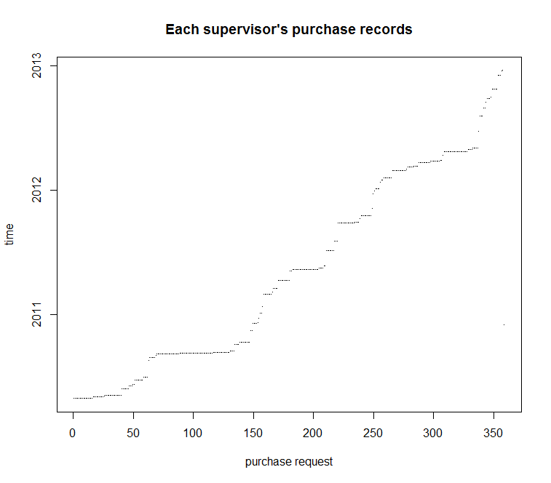

> nm = names(MDN)

> ##analysis the type of the suppliers

> y = MDN[,21] # "Credo.Spend.Ind" or women minority owned

> #0-n 1-y change logistic to number

|  |
| --- |
| > Y=(y=="N")*1  > y = (MDN[,21] =="Y")*1  > yy = (MDN[,20] =="S")*1 # "Business.Size.Code" Small or nor small  > table(y,yy)/length(yy)  yy  y 0 1  0 0.59014714 0.14945672  1 0.20897860 0.05141754  > categ = MDN[,14]  > typ= MDN[,24]  > tot = MDN[,16]  > site= MDN[,3]  > ##plot each type by month  > tt = table(y,yy,dmonth)  > for(i in 1:36) tt[,,i] = tt[,,i]/sum(tt[,,i]) # Over time  > plot(tt[1,1,],type="l",ylim=range(tt),xlab="time(month)",ylab="proportion",main="the proportion of different suppliers over time")  > lines(tt[1,2,],col=2); lines(tt[2,1,],col=3); lines(tt[2,2,],col=4)  > legend("topright",col=c(1:4),lty=1,cex=.7,legend=c("large & No M/WBE","small &No M/WBE","large M/WBE","small M/WBE")) |

> par(mfrow=c(1,1))

> plot(tt[2,1,]+tt[2,2,],ylim=c(0,.7))

> plot(tt[2,2,]+tt[1,2,],ylim=c(0,.4))

> plot(tt[2,2,],ylim=c(0,.2))

> plot(tt[2,1,])

> par(mfrow=c(2,3))

> plot(tt[2,1,]+tt[2,2,],xlab="Index(month)", ylab="M/WBE suppliers")

> plot(tt[1,1,],xlab="Index(month)", ylab="Not M/WBE & large suppliers")

> title(main="Size & Type of suppliers")

> plot(tt[2,1,],xlab="Index(month)", ylab=" M/WBE & large suppliers")

> plot(tt[2,2,]+tt[1,2,],xlab="Index(month)", ylab="small suppliers")

> plot(tt[1,2,],xlab="Index(month)", ylab="NotM/WBE & small suppliers")

> plot(tt[2,2,],xlab="Index(month)", ylab="M/WBE & small suppliers")

> #w/m suppliers and the type of purchase over time

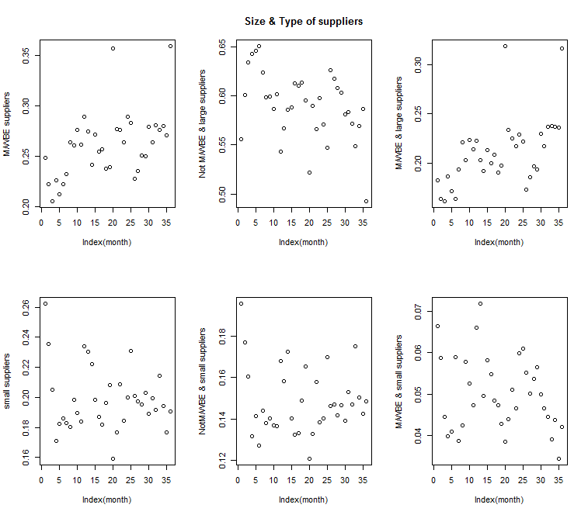

> tt = table(y,typ,dmonth)

> for(i in 1:36) tt[,,i] = tt[,,i]/sum(tt[,,i]) # Over time

> par(mfrow=c(2,5),mar=c(1,1,3,3))

> for(i in 1:2) for(j in 1:5) plot(tt[i,j,])

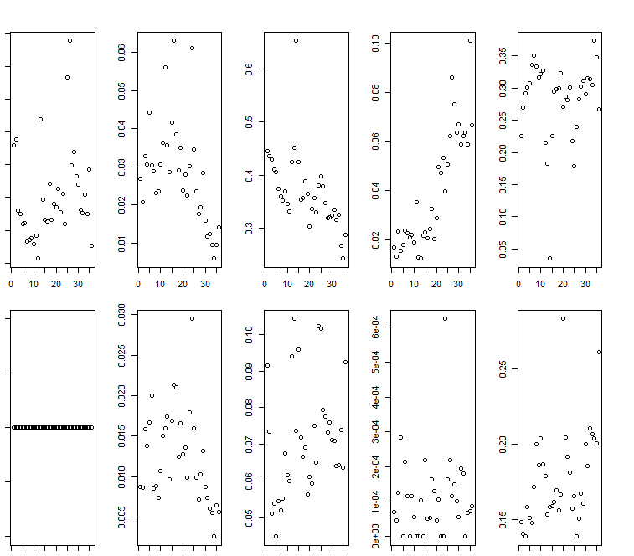

> ### BICLUSTERS ###

> library(biclust)

>

> tt =as.matrix(table(site,categ))

> tt1 = array(unlist(sqrt(tt)),dim=dim(tt))

> tt2 = array(unlist(tt),dim=dim(tt))

>

> biclust(tt1,method=BCCC(), delta=1.5, alpha=1, number=10)-> bb

>

> tt[bb@RowxNumber[,1], bb@NumberxCol[1,]]

categ

site All Check Req payment types API Biologics Check Reqs Chemicals External Manufacturing

1155 0 0 0 1 0 0

1271 0 0 0 5 0 0

1290 3 0 0 5 0 1

129G 1 0 2 26 0 38

129T 0 0 4 0 9 1

129V 0 0 0 0 0 0

129Y 0 0 0 0 9 0

1305 0 2 0 0 0 0

156T 0 0 0 0 0 0

166S 2 0 0 6 8 0

174H 0 0 0 0 4 0

1861 0 0 19 16 0 47

1960 1 0 34 5 0 0

250T 1 0 0 7 0 0

255T 0 0 0 4 0 8

275T 5 0 0 43 0 0

3291 2 0 0 0 0 0

6139 0 0 2 6 0 0

6203 23 1 5 61 0 0

P205 0 0 0 0 0 0

categ

site Fiber Non Wovens Media Metals N/A Not assigned a category Packaging Plastics

1155 0 0 0 0 0 0 0

1271 0 0 0 0 0 0 0

1290 0 9 0 3 3 0 0

129G 0 40 0 6 8 27 0

129T 0 0 0 3 0 3 0

129V 0 0 0 0 0 1 1

129Y 0 0 0 0 0 3 1

1305 0 0 0 0 0 0 0

156T 0 0 0 0 0 0 0

166S 1 0 1 3 0 13 0

174H 0 0 0 0 0 1 0

1861 0 2 0 4 0 8 5

1960 0 18 0 6 34 7 0

250T 0 0 0 0 0 0 0

255T 0 11 0 3 8 1 0

275T 0 0 0 1 0 0 0

3291 0 0 0 17 0 0 0

6139 0 0 0 0 0 0 0

6203 0 0 0 8 1 23 0

P205 0 0 0 0 0 0 0

> #cluster 2,3,4…

> tt[bb@RowxNumber[,2], bb@NumberxCol[2,]]

categ

site All Check Req payment types Check Reqs Chemicals Fiber Non Wovens Metals N/A

1154 0 44 2 30 0 1

154K 0 16 0 0 0 0

154Y 0 0 4 0 0 0

1860 0 7 2 0 0 1

6202 0 1 0 0 0 1

P275 0 5 0 0 0 3

categ

site Not assigned a category Plastics

1154 30 2

154K 0 0

154Y 0 0

1860 0 9

6202 12 0

P275 12 0

> tt[bb@RowxNumber[,3], bb@NumberxCol[3,]]

categ

site All Check Req payment types API Check Reqs External Manufacturing Fiber Non Wovens

129P 0 0 0 2 1

154M 0 2 0 9 17

166W 0 23 0 24 49

174A 0 0 0 0 0

174M 0 0 0 14 4

categ

site Not assigned a category Plastics

129P 0 1

154M 0 25

166W 0 6

174A 0 17

174M 0 8

> tt[bb@RowxNumber[,4], bb@NumberxCol[4,]]

categ

site All Check Req payment types API Fiber Non Wovens Metals Plastics

154G 5 0 5 1 5

174Q 5 0 2 0 0

3290 34 10 0 0 0

P175 35 0 0 0 0

> heatmapBC(x = tt1, bicResult = bb)

[1] "yto 0"

[1] "xlo 8"

[1] "yto 0"

[1] "xlo 0"

[1] "yto 0"

[1] "xlo 0"

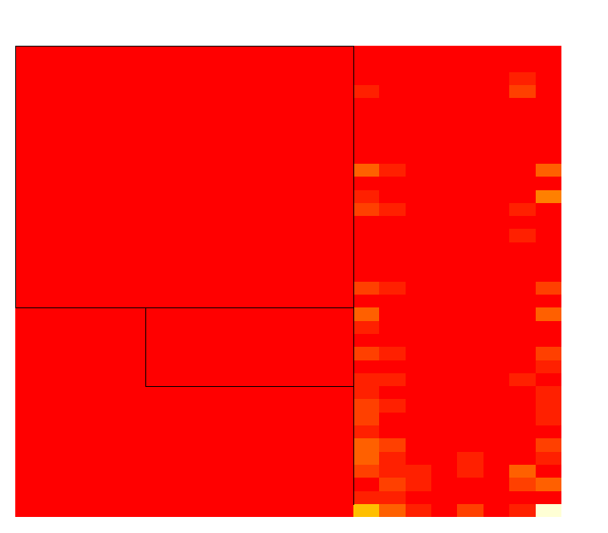

> image(tt[bb@RowxNumber[,1], bb@NumberxCol[1,]],main="Partition of bicluster 1")

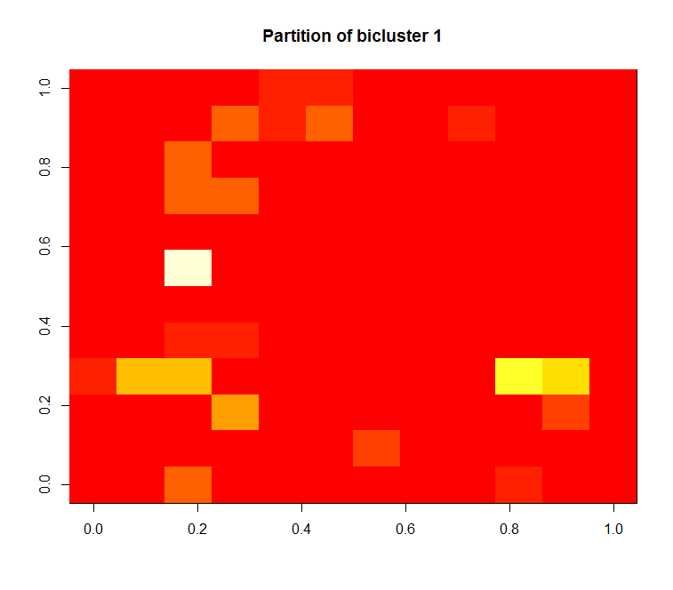

> image(tt[bb@RowxNumber[,2], bb@NumberxCol[2,]],main="Partition of bicluster 2")

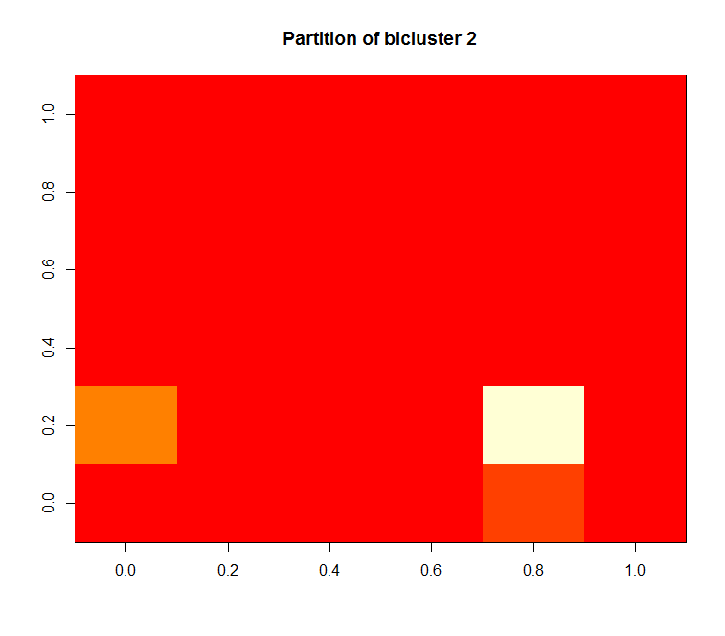

> image(tt[bb@RowxNumber[,3], bb@NumberxCol[3,]],main="Partition of bicluster 3")

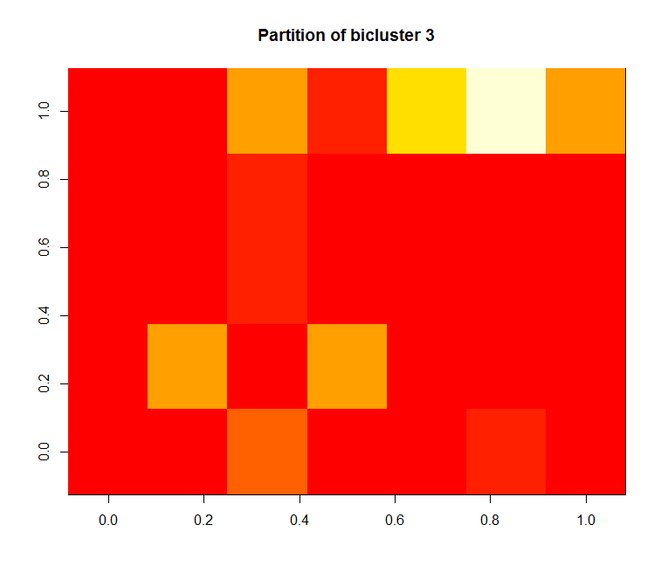

> image(tt[bb@RowxNumber[,4], bb@NumberxCol[4,]],main="Partition of bicluster 4")

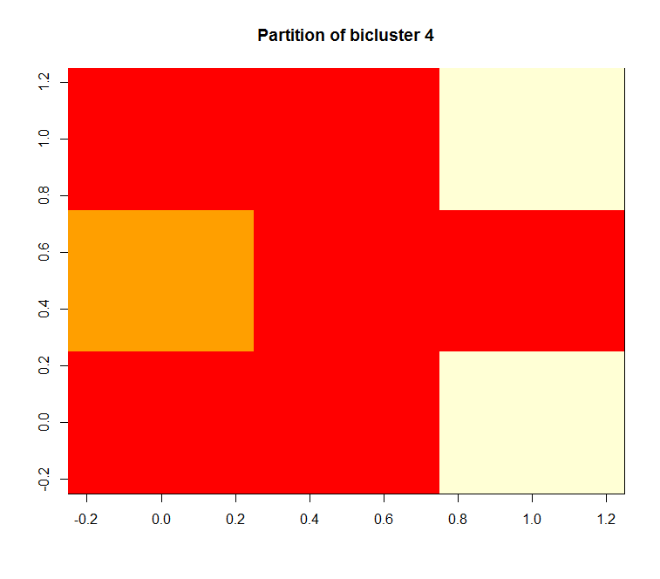

> categ1 = substring( as.character(categ),1,5)

> datt = data.frame(y,yy,categ=categ1,typ,tot,site)

>

> library(rpart)

> for(j in 1:36) print(rpart( y~categ+typ+tot+ site, data=datt[dmonth==(j-1),]))

> for(j in 1:36) print(rpart( yy~categ+typ+tot+ site, data=datt[dmonth==(j-1),]))

n= 0

node), split, n, deviance, yval

* denotes terminal node

1) root 0 0 NaN *

n= 28285

node), split, n, deviance, yval

* denotes terminal node

1) root 28285 5286.27100 0.24878910

2) categ=All C,API,Biolo,Check,Consu,Exclu,Exter,Fiber,Fleet,IT,Logis,Marke,Media,Metal,N/A,Packa,Plast,Resea 19109 1476.01500 0.08435816

4) site=1154,1270,1290,129G,129P,129V,129Y,154G,154K,154Y,166S,166W,174H,174M,174Q,1860,1861,250T,255T,275T,3290,3291,6203,P175 18325 1212.92300 0.07126876 *

5) site=1271,129T,154M,156T,174A,1960,6202,P275 784 186.56630 0.39030610 *

3) categ=Capit,Chemi 9176 2217.65200 0.59121620

6) typ=92,99 4502 909.99020 0.28120840

12) site=1270,1271,129G,129T,129V,129Y,154K,166S,174A,174H,1860,1861,255T,3290 1110 27.29369 0.02522523 *

13) site=1154,129P,154G,154M,154Y,166W,174M,174Q,1960,6203,P175,P275 3392 786.15920 0.36497640 *

7) typ=97,PC 4674 458.25520 0.88981600

14) site=129P,129T,129Y,154M,174M 209 18.88995 0.10047850 *

15) site=1154,1270,1271,1290,129G,129V,154G,154K,154Y,156T,166S,166W,174Q,1860,1861,1960,250T,6203,P175,P275 4465 303.05170 0.92676370 *

n= 20992

node), split, n, deviance, yval

* denotes terminal node

1) root 20992 3631.6400 0.22251330

2) categ=API,Biolo,Check,Consu,Exclu,Exter,Fiber,Fleet,IT,Logis,Marke,Media,N/A,Packa,Plast,Resea 15037 1025.5040 0.07361841

4) categ=API,Biolo,Check,Exter,Fiber,Logis,Marke,Media,N/A,Plast,Resea 11988 469.0533 0.04079079 *

5) categ=Consu,Exclu,Fleet,IT,Packa 3049 492.7379 0.20268940 *

3) categ=Capit,Chemi 5955 1430.9860 0.59848870

6) typ=92,99,CR 2635 505.9643 0.25920300

12) site=1154,1155,1270,1271,129G,129T,154K,154M,166S,166W,1860,1861,255T,3290,6202,6203,P275 1567 196.9470 0.14741540 *

13) site=129P,129Y,154G,154Y,174A,174M,174Q,1960 1068 260.7041 0.42322100 *

7) typ=97,PC 3320 380.9515 0.86777110

14) site=129P,129T,154M,166W,174M,1860 495 111.9273 0.34545450 *

15) site=1154,1270,1271,1290,129G,129Y,154G,154K,154Y,156T,166S,174Q,1861,1960,250T,255T,275T,6202,6203,P175,P275 2825 110.3186 0.95929200 *

n= 23938

node), split, n, deviance, yval

* denotes terminal node

1) root 23938 3911.14300 0.20569810

2) categ=API,Biolo,Check,Consu,Exclu,Exter,Fiber,Fleet,IT,Logis,Marke,Media,Metal,N/A,Not a,Packa,Plast,Resea 17747 1127.50200 0.06818054

4) categ=API,Biolo,Check,Exclu,Exter,Fiber,Fleet,Logis,Marke,Media,Metal,N/A,Not a,Packa,Plast,Resea 14647 390.96680 0.02744589 *

5) categ=Consu,IT 3100 597.39870 0.26064520 *

3) categ=Capit,Chemi 6191 1485.96000 0.59990310

6) typ=92,99,CR 2315 372.19610 0.20129590

12) site=1154,1271,129G,129Y,154G,154K,154Y,156T,166S,166W,174A,174Q,1860,1861,250T,3290,6202,6203,P175,P275 1204 78.13953 0.06976744 *

13) site=1270,129P,129T,154M,174H,174M,1960 1111 250.65530 0.34383440 *

7) typ=97,PC 3876 526.24970 0.83797730

14) site=1154,129P,129T,154M,166W,174M,1860 840 198.09520 0.38095240

28) site=129P,129T,154M,174M 306 25.43791 0.09150327 *

29) site=1154,166W,1860 534 132.32960 0.54681650 *

15) site=1270,1271,1290,129G,129V,154G,154K,154Y,166S,174Q,1861,1960,250T,255T,275T,6202,6203,P175,P275 3036 104.15810 0.96442690 *

n= 21132

node), split, n, deviance, yval

* denotes terminal node

1) root 21132 3698.2300 0.22614990

2) categ=API,Biolo,Check,Consu,Exclu,Exter,Fiber,Fleet,IT,Logis,Marke,Media,N/A,Not a,Packa,Plast,Resea 15371 990.3486 0.06922126

4) categ=API,Biolo,Check,Exclu,Exter,Fiber,Fleet,Logis,Marke,Media,N/A,Not a,Packa,Plast,Resea 12920 390.4296 0.03119195 *

5) categ=Consu,IT 2451 482.7377 0.26968580 *

3) categ=Capit,Chemi 5761 1319.3700 0.64485330

6) typ=92,99,CR 1913 337.7156 0.22895970

12) site=1154,1270,1271,129G,129V,129Y,154K,154Y,166S,166W,174A,174H,174Q,1860,1861,1960,3290,6202,P275 1078 101.9443 0.10575140 *

13) site=129P,129T,154G,154M,174M,P175 835 198.2802 0.38802400 *

7) typ=97,PC 3848 486.2700 0.85161120

14) site=129P,129T,154M,166S,166W,174M,1860 728 168.8077 0.36538460 *

15) site=1154,1270,1271,1290,129G,129V,154G,154K,154Y,156T,174Q,1861,1960,250T,255T,275T,6202,6203,P175,P275 3120 105.1920 0.96506410 *

n= 19644

node), split, n, deviance, yval

* denotes terminal node

1) root 19644 3287.67400 0.21253310

2) categ=All C,API,Biolo,Check,Consu,Exclu,Exter,Fleet,Logis,Marke,Media,N/A,Not a,Packa,Plast,Resea 13119 593.41470 0.04748838

4) categ=All C,API,Biolo,Check,Exclu,Exter,Media,N/A,Not a,Plast,Resea 10263 160.41120 0.01588230 *

5) categ=Consu,Fleet,Logis,Marke,Packa 2856 385.91040 0.16106440 *

3) categ=Capit,Chemi,IT,Metal 6525 1618.40600 0.54436780

6) typ=92,97,99,CR 2769 464.28670 0.21307330

12) site=1154,1155,1271,129G,129Y,154G,154K,154Y,166S,166W,174A,1860,1960,255T,275T,3290,6202,P175,P275 1189 84.03532 0.07653490 *

13) site=1270,129P,129T,154M,174M,174Q,1861,6203 1580 341.40440 0.31582280 *

7) typ=PC 3756 626.15230 0.78860490

14) site=129P,129T,154M,166S,166W,174M 707 111.67190 0.19660540 *

15) site=1154,1270,1271,1290,129G,129V,154G,154K,154Y,156T,174Q,1860,1861,1960,250T,255T,275T,6202,6203,P175,P275 3049 209.24830 0.92587730

30) categ=IT 193 47.67876 0.44559590 *

31) categ=Capit 2856 114.04170 0.95833330 *

n= 18730

node), split, n, deviance, yval

* denotes terminal node

1) root 18730 3241.602000 0.22263750

2) categ=API,Biolo,Check,Chemi,Consu,Exclu,Exter,Fiber,Fleet,Logis,Marke,Media,N/A,Packa,Plast,Resea 13198 867.902400 0.07076830

4) categ=API,Biolo,Check,Chemi,Exclu,Exter,Fiber,Logis,Media,N/A,Packa,Plast,Resea 10699 330.131600 0.03187214 *

5) categ=Consu,Fleet,Marke 2499 452.284100 0.23729490

10) site=1290,129G,129P,154G,154Y,166S,166W,174Q,1861,275T,3290,3291,6202,6203,P175 1242 112.419500 0.10064410 *

11) site=1154,1270,129T,154K,154M,174A,174M,1860,1960,250T,255T,P275 1257 293.756600 0.37231500 *

3) categ=Capit,IT,Metal 5532 1343.069000 0.58496020

6) typ=92,99,CR 2087 328.846200 0.19597510

12) site=1154,1270,129G,129Y,154G,154K,154Y,156T,166S,174A,174Q,1860,1861,275T,3290,P275 1313 117.929900 0.09977152 *

13) site=1290,129P,129T,154M,166W,174M,1960,255T,6202,6203,P175 774 178.149900 0.35917310 *

7) typ=97,PC 3445 507.136700 0.82060960

14) site=1154,129P,129T,154M,166S,166W,174M,1860 794 196.867800 0.45465990

28) site=129P,129T,154M,174M 186 3.913978 0.02150538 *

29) site=1154,166S,166W,1860 608 147.379900 0.58717110 *

15) site=1270,1271,1290,129G,129V,154G,154K,154Y,174Q,1861,1960,250T,255T,275T,6202,6203,P175,P275 2651 172.089800 0.93021500 *

n= 17203

node), split, n, deviance, yval

* denotes terminal node

1) root 17203 3068.32400 0.23234320

2) categ=API,Biolo,Check,Chemi,Consu,Exclu,Exter,Fiber,Logis,Marke,Media,N/A,Not a,Packa,Plast,Resea 11848 578.59390 0.05148548

4) categ=API,Biolo,Check,Chemi,Exclu,Exter,Fiber,Logis,Media,N/A,Not a,Packa,Plast,Resea 9862 237.96310 0.02474143 *

5) categ=Consu,Marke 1986 298.54980 0.18429000 *

3) categ=Capit,Fleet,IT 5355 1244.74600 0.63249300

6) typ=92,99,CR 1714 314.00230 0.24154030

12) site=1154,1270,154K,154M,154Y,166S,166W,174Q,1860,1861,1960,3290,6202,P175 1134 123.46830 0.12433860 *

13) site=1290,129G,129P,129T,129Y,154G,174A,174M,255T,275T,6203,P275 580 144.50170 0.47068970 *

7) typ=97,PC 3641 545.44470 0.81653390

14) site=129P,129T,154M,166S,166W,174M 643 126.91450 0.27060650

28) tot>=199.935 417 31.22782 0.08153477 *

29) tot< 199.935 226 53.27434 0.61946900 *

15) site=1154,1270,1290,129G,129V,129Y,154G,154K,154Y,174Q,1860,1861,1960,250T,255T,275T,6202,6203,P175,P275 2998 185.79090 0.93362240 *

n= 18976

node), split, n, deviance, yval

* denotes terminal node

1) root 18976 3683.965000 0.26364880

2) categ=API,Biolo,Check,Consu,Exclu,Exter,Fiber,Fleet,Marke,Media,N/A,Not a,Packa,Plast,Resea 12214 615.408500 0.05321762

4) categ=API,Biolo,Check,Exclu,Exter,Fiber,Media,N/A,Not a,Plast,Resea 10162 199.904700 0.02007479 *

5) categ=Consu,Fleet,Marke,Packa 2052 349.062400 0.21734890 *

3) categ=Capit,Chemi,IT,Logis,Metal 6762 1550.780000 0.64374450

6) typ=92,97,99,CR 2236 423.713800 0.25402500

12) site=1154,1270,129T,129Y,154G,154K,154Y,166S,166W,174A,174Q,1860,1861,1960,3290,6202,P175,P275 1451 154.652000 0.12129570 *

13) site=129G,129P,154M,174M,6203 785 196.249700 0.49936310

26) categ=Capit 584 132.436600 0.34760270 *

27) categ=Chemi,IT,Logis,Metal 201 11.283580 0.94029850 *

7) typ=PC 4526 619.682900 0.83627930

14) site=1154,129P,129T,154M,166S,166W,174M,1860 997 244.680000 0.43229690

28) site=129P,129T,154M,174M 213 2.957746 0.01408451 *

29) site=1154,166S,166W,1860 784 194.346900 0.54591840 *

15) site=1270,1290,129G,154G,154K,154Y,174Q,1861,1960,250T,255T,275T,6202,6203,P175,P275 3529 166.321900 0.95041090

30) categ=IT 166 41.445780 0.48192770 *

31) categ=Capit 3363 86.644660 0.97353550 *

n= 17171

node), split, n, deviance, yval

* denotes terminal node

1) root 17171 3309.23200 0.26067210

2) categ=API,Biolo,Check,Consu,Exclu,Exter,Fiber,Fleet,Logis,Media,N/A,Not a,Packa,Plast,Resea 10357 438.65810 0.04431785

4) categ=API,Biolo,Check,Exclu,Exter,Fiber,Logis,Media,N/A,Not a,Plast,Resea 9047 137.83350 0.01547474 *

5) categ=Consu,Fleet,Packa 1310 241.31980 0.24351150

10) site=1154,1290,129G,154K,154M,156T,166S,166W,174A,250T,255T,3290,6202,6203,P275 537 23.83613 0.04655493 *

11) site=1270,129P,129T,154G,154Y,174M,174Q,1860,1861,1960,P175 773 182.18110 0.38033640 *

3) categ=Capit,Chemi,IT,Marke,Metal 6814 1648.89200 0.58952160

6) typ=92,97,99,CR 3051 603.74890 0.27171420

12) site=1154,1290,129Y,154G,154K,154Y,166S,166W,174A,1860,1861,1960,275T,3290,6202,P175,P275 1479 141.12100 0.10682890 *

13) site=1270,129G,129P,129T,154M,174M,174Q,255T,6203 1572 384.58720 0.42684480 *

7) typ=PC 3763 487.13790 0.84719640

14) site=129P,129T,154M,166W,174M 319 42.16301 0.15673980 *

15) site=1154,1270,1290,129G,154G,154K,154Y,156T,166S,174Q,1860,1861,1960,250T,255T,275T,6202,6203,P175,P275 3444 278.81180 0.91114980

30) categ=IT 197 48.57868 0.44162440 *

31) categ=Capit 3247 184.16880 0.93963660

62) site=1154,166S,1860 360 83.33056 0.63611110 *

63) site=1270,1290,129G,154G,154K,154Y,156T,174Q,1861,1960,250T,255T,275T,6202,6203,P175,P275 2887 63.53654 0.97748530 *

n= 17465

node), split, n, deviance, yval

* denotes terminal node

1) root 17465 3492.4600 0.27632410

2) categ=Biolo,Check,Chemi,Consu,Exclu,Exter,Fleet,Logis,Marke,Media,N/A,Not a,Packa,Plast,Resea 11389 754.1069 0.07129687

4) categ=Biolo,Check,Exclu,Exter,Logis,Media,N/A,Not a,Packa,Plast,Resea 9161 292.0443 0.03296583 *

5) categ=Chemi,Consu,Fleet,Marke 2228 393.2585 0.22890480 *

3) categ=Capit,IT,Metal 6076 1362.2230 0.66063200

6) typ=92,97,99,CR 2017 364.1943 0.23648980 *

7) typ=PC 4059 454.8692 0.87139690

14) site=129P,129T,154M,166S,166W,174M 476 105.5546 0.33193280 *

15) site=1154,1270,1290,129G,129Y,154G,154K,154Y,156T,174Q,1860,1861,1960,250T,255T,275T,6202,6203,P175,P275 3583 192.3852 0.94306450 *

n= 19063

node), split, n, deviance, yval

* denotes terminal node

1) root 19063 3683.3230000 0.261711200

2) categ=API,Biolo,Check,Consu,Exclu,Exter,Fleet,Logis,Marke,Media,N/A,Not a,Packa,Plast,Resea 12756 940.9579000 0.080197550

4) categ=API,Biolo,Check,Exclu,Exter,Media,N/A,Not a,Plast,Resea 9830 252.1759000 0.026347910 *

5) categ=Consu,Fleet,Logis,Marke,Packa 2926 564.5140000 0.261107300

10) site=129P,154K,154Y,156T,166W,250T,3290,3291,6202,6203,P175 580 18.3775900 0.032758620 *

11) site=1154,1270,1290,129G,129T,154G,154M,166S,174A,174M,174Q,1860,1861,1960,255T,275T,P275 2346 508.4165000 0.317561800 *

3) categ=Capit,Chemi,IT,Metal 6307 1472.0800000 0.628825100

6) typ=92,97,99,CR 2169 396.3734000 0.240663900

12) site=1154,1270,129G,129T,129V,154G,154K,154M,154Y,166S,166W,174H,174Q,1860,1861,1960,255T,3290,6202 1649 221.7344000 0.160097000 *

13) site=1290,129P,129Y,174A,174M,6203,P175 520 129.9923000 0.496153800 *

7) typ=PC 4138 577.6066000 0.832286100

14) site=129P,129T,154M,174M 291 0.9965636 0.003436426 *

15) site=1154,1270,1290,129G,129V,129Y,154G,154K,154Y,166S,166W,174Q,1860,1861,1960,250T,275T,6202,6203,P175,P275 3847 361.5732000 0.894983100

30) site=1154,166S,166W,1860,275T 738 168.9864000 0.644986400 *

31) site=1270,1290,129G,129V,129Y,154G,154K,154Y,174Q,1861,1960,250T,6202,6203,P175,P275 3109 135.5143000 0.954326100 *

n= 21144

node), split, n, deviance, yval

* denotes terminal node

1) root 21144 4343.96600 0.28892360

2) categ=API,Biolo,Check,Chemi,Consu,Exclu,Exter,Fleet,Logis,Marke,Media,N/A,Not a,Packa,Plast,Resea 13067 1216.07600 0.10384940

4) categ=API,Biolo,Check,Exclu,Exter,Logis,Media,N/A,Not a,Plast,Resea 8820 353.56220 0.04183673 *

5) categ=Chemi,Consu,Fleet,Marke,Packa 4247 758.15680 0.23263480 *

3) categ=Capit,IT,Metal 8077 1956.22100 0.58833730

6) typ=92,97,99,CR 3833 749.50220 0.26663190

12) site=1154,1270,1290,129G,129T,129Y,154G,154K,154M,154Y,166S,166W,174A,1860,1861,1960,255T,275T,3290,6202,6203,P175 3002 474.04400 0.19653560 *

13) site=129P,174M,174Q,P275 831 207.42240 0.51985560 *

7) typ=PC 4244 451.74840 0.87888780

14) site=129P,129T,154M,166S,166W,174M 451 88.53659 0.26829270 *

15) site=1154,1270,1290,129G,129V,129Y,154G,154K,154Y,174Q,1860,1960,250T,6202,6203,P175,P275 3793 175.07410 0.95148960 *

n= 29109

node), split, n, deviance, yval

* denotes terminal node

1) root 29109 5800.91700 0.27479470

2) categ=Biolo,Check,Chemi,Consu,Exclu,Exter,Fiber,Fleet,IT,Logis,Marke,Media,Metal,N/A,Not a,Packa,Plast,Resea 19810 1997.53800 0.11378090

4) categ=Biolo,Check,Exclu,Exter,Fiber,Fleet,Logis,Marke,Media,Metal,N/A,Not a,Packa,Plast,Resea 14887 857.88420 0.06139585 *

5) categ=Chemi,Consu,IT 4923 975.26310 0.27219180

10) site=1154,154K,154Y,166W,174Q,1860,1960,255T,275T,3290,3291,6203,P175,P275 1758 149.51370 0.09385666 *

11) site=1270,1290,129G,129P,129T,129Y,154G,154M,166S,174A,174M,250T,6202 3165 738.78360 0.37124800 *

3) categ=Capit 9299 2195.69100 0.61780840

6) typ=92,99,CR 4591 1002.53700 0.32215200

12) site=1154,1270,129G,129T,129Y,154K,154Y,166S,166W,174A,174H,1860,3290,6203,P275 2460 336.30730 0.16341460 *

13) site=129P,154G,154M,174M,174Q,1960,6202 2131 532.68790 0.50539650 *

7) typ=97,PC 4708 400.50380 0.90611720

14) site=129P,129T,154M,166S,166W,174M,1860 736 183.60730 0.47690220 *

15) site=1154,1270,1290,129G,129V,154G,154K,154Y,174A,174Q,1960,250T,275T,6202,6203,P175,P275 3972 56.18202 0.98564950 *

n= 20649

node), split, n, deviance, yval

* denotes terminal node

1) root 20649 3781.02400 0.24136760

2) typ=92,97,99,CR 16668 1542.51000 0.10319170

4) categ=All C,Biolo,Check,Exclu,Exter,Fiber,Fleet,Media,N/A,Packa,Resea 9243 179.37680 0.01979877 *

5) categ=Capit,Chemi,Consu,IT,Logis,Marke,Metal,Not a 7425 1218.83600 0.20700340

10) site=1290,129Y,154K,154Y,166S,166W,174H,1860,1960,250T,275T,3290,3291 1944 129.06120 0.07150206 *

11) site=1154,1270,129G,129P,129T,154G,154M,156T,174A,174M,174Q,255T,6202,6203,P175,P275 5481 1041.42200 0.25506290 *

3) typ=PC 3981 587.86440 0.81989450

6) categ=Resea 695 53.15971 0.08345324 *

7) categ=Capit,IT 3286 78.05234 0.97565430 *

n= 22783

node), split, n, deviance, yval

* denotes terminal node

1) root 22783 4508.672000 0.27173770

2) categ=All C,API,Biolo,Check,Chemi,Consu,Exclu,Exter,Fleet,Logis,Marke,Media,N/A,Not a,Plast,Resea 15439 1152.984000 0.08128765

4) categ=All C,API,Biolo,Check,Chemi,Exclu,Exter,Media,N/A,Not a,Plast,Resea 11225 254.931300 0.02325167 *

5) categ=Consu,Fleet,Logis,Marke 4214 759.534900 0.23588040 *

3) categ=Capit,IT,Metal,Packa 7344 1618.449000 0.67211330

6) typ=92,97,99,CR 3583 845.929700 0.38208210

12) site=1154,129G,129T,129V,129Y,154K,154Y,166S,166W,174A,1860,255T,3290 1290 164.824800 0.15038760 *

13) site=1270,1290,129P,154G,154M,174M,174Q,1960,6202,6203,P175,P275 2293 572.895800 0.51242910

26) tot>=871.7 1840 448.095700 0.41956520 *

27) tot< 871.7 453 44.481240 0.88962470 *

7) typ=PC 3761 183.993100 0.94841800

14) site=129P,154M,174M 61 3.737705 0.06557377 *

15) site=1154,1270,1290,129G,129V,129Y,154G,154K,154Y,166S,166W,174Q,1860,1960,250T,255T,275T,6202,6203,P175,P275 3700 131.927300 0.96297300 *

n= 19793

node), split, n, deviance, yval

* denotes terminal node

1) root 19793 3758.10900 0.25478700

2) categ=All C,API,Biolo,Check,Chemi,Consu,Exclu,Exter,Fleet,Logis,Marke,Media,N/A,Not a,Packa,Plast,Resea 13707 1046.85400 0.08331509

4) categ=All C,API,Biolo,Check,Chemi,Exclu,Exter,Logis,Media,N/A,Not a,Plast,Resea 10067 202.74360 0.02056223 *

5) categ=Consu,Fleet,Marke,Packa 3640 694.82830 0.25686810

10) site=1154,129G,129P,154G,154M,166W,174A,174M,174Q,1860,1960,275T,3290,3291,6202,6203,P175,P275 2647 366.86060 0.16622590 *

11) site=1270,1290,129T,154K,166S,250T,255T 993 248.24770 0.49848940 *

3) categ=Capit,IT,Metal 6086 1400.54000 0.64097930

6) typ=92,99,CR 2451 487.30310 0.27376580 *

7) typ=97,PC 3635 359.87620 0.88858320

14) site=129P,129T,154M,166S,166W,174M 404 93.78218 0.36633660 *

15) site=1154,1270,1290,129G,129Y,154G,154K,156T,174Q,1860,1960,250T,275T,6202,6203,P175,P275 3231 142.12880 0.95388420 *

n= 18722

node), split, n, deviance, yval

* denotes terminal node

1) root 18722 3571.797000 0.25664990

2) categ=All C,Biolo,Check,Chemi,Consu,Exclu,Exter,Fleet,Logis,Marke,Media,N/A,Not a,Packa,Plast,Resea 12975 862.484300 0.07159923

4) categ=All C,Biolo,Check,Exclu,Exter,Fleet,Logis,Media,N/A,Not a,Packa,Plast,Resea 10083 219.979200 0.02231479 *

5) categ=Chemi,Consu,Marke 2892 532.625200 0.24343020 *

3) categ=Capit,IT,Metal 5747 1261.875000 0.67443880

6) typ=92,99,CR 2226 484.981100 0.32075470

12) site=1270,1290,129G,129P,129Y,154K,154Y,156T,166S,166W,174A,1860,3290,6203 1214 197.337700 0.20428340 *

13) site=1154,129T,129V,154G,154M,174M,174Q,1960,6202,P175,P205,P275 1012 251.419000 0.46047430 *

7) typ=97,PC 3521 322.396500 0.89804030

14) site=129P,129T,154M,174M 178 6.724719 0.03932584 *

15) site=1154,1270,1290,129G,154G,154K,166S,166W,174Q,1860,1960,250T,275T,6202,6203,P175,P275 3343 177.427500 0.94376310 *

n= 18381

node), split, n, deviance, yval

* denotes terminal node

1) root 18381 3328.42800 0.23747350

2) categ=All C,Biolo,Check,Chemi,Consu,Exclu,Exter,Fiber,Fleet,Logis,Marke,Media,N/A,Not a,Packa,Plast,Resea 12829 731.69770 0.06072180

4) categ=All C,Exclu,Exter,Fiber,Logis,Media,N/A,Not a,Packa,Plast,Resea 10113 147.77510 0.01483239 *

5) categ=Biolo,Check,Chemi,Consu,Fleet,Marke 2716 483.32950 0.23159060 *

3) categ=Capit,IT,Metal 5552 1269.82600 0.64589340

6) site=1154,129P,129T,129V,154K,154M,154Y,166S,166W,174A,174M,1860,3290,6202 2175 458.14440 0.30160920

12) tot>=605.3 1699 306.35550 0.23602120 *

13) tot< 605.3 476 118.39290 0.53571430 *

7) site=1270,1290,129G,129Y,154G,174Q,1960,250T,275T,6203,P175,P275 3377 387.83240 0.86763400

14) typ=99,CR 737 182.81680 0.45590230 *

15) typ=97,PC 2640 45.19848 0.98257580 *

n= 15206

node), split, n, deviance, yval

* denotes terminal node

1) root 15206 2771.26400 0.23970800

2) categ=All C,API,Biolo,Check,Chemi,Consu,Exclu,Exter,Fiber,Fleet,Logis,Marke,Media,N/A,Not a,Packa,Plast,Resea 10454 607.83320 0.06198584

4) categ=All C,API,Biolo,Check,Exclu,Exter,Fiber,Logis,Media,N/A,Not a,Packa,Plast,Resea 8341 182.80760 0.02241937 *

5) categ=Chemi,Consu,Fleet,Marke 2113 360.42210 0.21817320 *

3) categ=Capit,IT,Metal 4752 1106.84700 0.63068180

6) typ=92,97,99,CR 1859 363.19530 0.26627220

12) categ=Capit 1416 231.19700 0.20550850 *

13) categ=IT,Metal 443 110.05870 0.46049660

26) tot>=4795.26 268 41.91045 0.19402990 *

27) tot< 4795.26 175 19.97714 0.86857140 *

7) typ=PC 2893 338.15490 0.86484620

14) site=129P,129T,154M,166S,166W,174M,1860 455 89.74945 0.27032970 *

15) site=1154,1270,1290,129G,154G,154K,156T,174Q,1960,250T,275T,6202,6203,P175,P275 2438 57.57219 0.97579980 *

n= 21953

node), split, n, deviance, yval

* denotes terminal node

1) root 21953 5039.84200 0.35708100

2) categ=All C,API,Biolo,Check,Chemi,Consu,Exclu,Exter,Fleet,Logis,Marke,Media,N/A,Not a,Packa,Plast,Resea 12642 745.00590 0.06288562

4) categ=All C,API,Biolo,Check,Chemi,Exclu,Exter,Media,N/A,Not a,Plast,Resea 9983 170.00200 0.01732946 *

5) categ=Consu,Fleet,Logis,Marke,Packa 2659 476.50020 0.23392250 *

3) categ=Capit,IT,Metal 9311 1715.04100 0.75652450

6) typ=92,97,99,CR 2711 592.93990 0.32312800

12) site=1154,129P,129Y,154K,154Y,166S,166W,174A,174H,1860,250T,3290,6203,P275 1198 161.90730 0.16110180 *

13) site=1270,1290,129G,129T,129V,154G,154M,174M,174Q,1960,255T,6202,P175 1513 374.67940 0.45142100 *

7) typ=PC 6600 403.72360 0.93454550

14) site=129P,129T,154M,166S,166W,174M 649 162.16330 0.48844380

28) tot>=761.22 272 25.90809 0.10661760 *

29) tot< 761.22 377 67.98939 0.76392570 *

15) site=1154,1270,1290,129G,129V,129Y,154G,154K,156T,174Q,1860,1960,250T,275T,6202,6203,P175,P275 5951 98.31961 0.98319610 *

n= 18880

node), split, n, deviance, yval

* denotes terminal node

1) root 18880 3783.89700 0.27733050

2) categ=All C,API,Biolo,Check,Chemi,Consu,Exclu,Exter,Fiber,Fleet,Logis,Marke,Media,N/A,Not a,Packa,Plast,Resea 12236 658.18270 0.05704479

4) categ=All C,API,Biolo,Check,Exclu,Exter,Fiber,Logis,Media,N/A,Not a,Plast,Resea 9480 198.65310 0.02141350 *

5) categ=Chemi,Consu,Fleet,Marke,Packa 2756 406.09400 0.17960810

10) site=1154,1155,1290,129T,154K,154M,166W,174Q,1860,255T,275T,3290,3291,6202,P175,P275 1459 88.81426 0.06511309 *

11) site=1270,129G,129P,154G,154Y,166S,174A,174M,1960,250T,6203 1297 276.63840 0.30840400 *

3) categ=Capit,IT,Metal 6644 1438.44500 0.68302230

6) typ=92,99,CR 2288 460.97900 0.27972030

12) categ=Capit 1887 319.78380 0.21621620 *

13) categ=IT,Metal 401 97.77556 0.57855360

26) tot>=4424.34 190 35.37368 0.24736840 *

27) tot< 4424.34 211 22.79621 0.87677730 *

7) typ=97,PC 4356 409.84480 0.89485770

14) site=129P,129T,154M,166S,174M 454 75.70044 0.21145370 *

15) site=1154,1270,1290,129G,129Y,154G,154K,166W,174Q,1860,1960,250T,275T,6202,6203,P175,P275 3902 97.43721 0.97437210 *

n= 18954

node), split, n, deviance, yval

* denotes terminal node

1) root 18954 3789.11900 0.27619500

2) categ=All C,API,Biolo,Check,Consu,Exclu,Exter,Fleet,Logis,Marke,Media,N/A,Not a,Packa,Plast,Resea 12170 689.73080 0.06031224

4) categ=All C,API,Check,Exclu,Exter,Logis,N/A,Not a,Packa,Plast,Resea 9567 245.36220 0.02634055 *

5) categ=Biolo,Consu,Fleet,Marke,Media 2603 392.74760 0.18517100 *

3) categ=Capit,Chemi,IT,Metal 6784 1514.70900 0.66347290

6) typ=92,97,99,CR 2843 622.63880 0.32395360

12) categ=Capit 2076 366.85930 0.22928710

24) site=1154,1270,1290,129G,129Y,154G,154Y,166S,166W,174Q,1860,1960,3290,P175,P275 1135 103.34800 0.10132160 *

25) site=129P,129T,154K,154M,174A,174M,6203 941 222.50800 0.38363440 *

13) categ=Chemi,IT,Metal 767 186.81880 0.58018250 *

7) typ=PC 3941 327.93200 0.90839890

14) site=129P,129T,154M,174M 195 0.00000 0.00000000 *

15) site=1154,1270,1290,129G,129Y,154G,154K,156T,166S,166W,174Q,1860,1960,250T,6203,P175,P275 3746 158.64390 0.95568610

30) site=166S,166W,1860 364 85.43681 0.62362640 *

31) site=1154,1270,1290,129G,129Y,154G,154K,156T,174Q,1960,250T,6203,P175,P275 3382 28.75133 0.99142520 *

n= 19206

node), split, n, deviance, yval

* denotes terminal node

1) root 19206 3730.20500 0.26382380

2) categ=All C,API,Biolo,Check,Chemi,Consu,Exclu,Exter,Fleet,Logis,Marke,Media,N/A,Not a,Plast,Resea 12407 627.57090 0.05343758

4) typ=92,99,CR,PC 11636 393.69410 0.03506360 *

5) typ=97 771 170.66150 0.33073930 *

3) categ=Capit,IT,Metal,Packa 6799 1551.34300 0.64774230

6) typ=92,97,99,CR 3038 658.47430 0.31764320

12) site=129G,129Y,154G,154K,154M,154Y,166S,166W,174Q,1860,3290,6203 1312 201.12200 0.18902440 *

13) site=1154,1270,1290,129P,129T,174A,174M,1960,P175,P275 1726 419.15010 0.41541140 *

7) typ=PC 3761 294.43180 0.91438450

14) site=129P,129T,154M,166S,166W,174M,1860 469 116.52030 0.46055440 *

15) site=1154,1270,129G,129Y,154G,154K,174Q,1960,250T,6202,6203,P175,P275 3292 67.55377 0.97904010 *

n= 25593

node), split, n, deviance, yval

* denotes terminal node

1) root 25593 5261.19600 0.28921970

2) categ=All C,API,Biolo,Check,Chemi,Consu,Exclu,Exter,Fiber,Fleet,Logis,Marke,Media,N/A,Not a,Packa,Plast,Resea 15904 1387.65400 0.09657948

4) typ=92,99,CR,PC 13641 769.82760 0.06003959 *

5) typ=97 2263 489.82850 0.31683610

10) site=1154,129P,129V,154K,174M 591 32.92724 0.05922166 *

11) site=1270,154G,154M,166S,174A,174Q,1860,1960,6203,P175,P275 1672 403.81580 0.40789470 *

3) categ=Capit,IT,Metal 9689 2314.55400 0.60542880

6) typ=92,99,CR 5002 1161.29100 0.36645340

12) site=1154,1270,1290,129G,129T,129Y,1305,154K,154M,154Y,166S,166W,174A,174M,174Q,1860,255T,3290,6203,P175 3668 733.68480 0.27644490 *

13) site=129P,154G,1960,P275 1334 316.18070 0.61394300 *

7) typ=97,PC 4687 562.74420 0.86046510

14) site=129P,129T,166S,174M 544 70.33640 0.15257350 *

15) site=1154,1270,1290,129G,129Y,154G,154K,154M,156T,166W,174Q,1860,1960,250T,6203,P175,P275 4143 184.00920 0.95341540 *

n= 36566

node), split, n, deviance, yval

* denotes terminal node

1) root 36566 7421.73600 0.28313190

2) categ=All C,Biolo,Check,Consu,Exclu,Exter,Fiber,Fleet,IT,Logis,Marke,Media,N/A,Not a,Packa,Plast,Resea 23972 2331.30500 0.10916900

4) categ=All C,Biolo,Check,Exclu,Exter,Fiber,Fleet,Logis,Marke,Media,N/A,Not a,Plast,Resea 18142 881.42860 0.05120714 *

5) categ=Consu,IT,Packa 5830 1199.26200 0.28953690

10) site=1154,129P,154K,154M,166W,250T,255T,3290,3291 1403 49.14612 0.03635068 *

11) site=1270,1290,129G,129T,154G,154Y,166S,174A,174M,174Q,1860,1960,275T,6203,P175,P275 4427 1031.67600 0.36977640 *

3) categ=Capit,Chemi,Metal 12594 2984.07900 0.61426080

6) typ=92,99,CR 6077 1216.00700 0.27661680 *

7) typ=97,PC 6517 429.24810 0.92910850

14) site=129P,129T,154M,174M 206 17.24757 0.09223301 *

15) site=1154,1270,1290,129G,129Y,154G,154K,166S,166W,174Q,1860,1960,250T,275T,6203,P175,P275 6311 263.01700 0.95642530 *

n= 27331

node), split, n, deviance, yval

* denotes terminal node

1) root 27331 4811.52700 0.22805610

2) categ=All C,API,Biolo,Check,Consu,Exclu,Exter,Fiber,Fleet,Logis,Marke,Media,N/A,Not a,Plast,Resea 19265 1119.99900 0.06197768

4) categ=All C,API,Biolo,Check,Exclu,Fiber,Logis,Marke,Media,N/A,Not a,Plast,Resea 16480 425.41210 0.02651699 *

5) categ=Consu,Exter,Fleet 2785 551.23730 0.27181330

10) site=129G,129T,154G,154Y,166W,1860,275T,3290,3291,P175 1024 54.71484 0.05664062 *

11) site=1154,1270,1290,129P,154K,154M,166S,174A,174M,174Q,1960,255T,6203,P275 1761 421.54340 0.39693360 *

3) categ=Capit,Chemi,IT,Metal,Packa 8066 1891.03100 0.62472110

6) typ=92,99,CR 3741 824.90350 0.32825450

12) site=1290,129G,129P,154G,154K,154Y,166S,166W,174Q,1860,3290 1327 190.78820 0.17407690 *

13) site=1154,1270,129T,129Y,154M,174A,174M,1960,6203,P175,P275 2414 585.23160 0.41300750 *

7) typ=97,PC 4325 452.91420 0.88115610

14) site=129P,154M,166W,174M,1860 530 109.25280 0.29056600 *

15) site=1154,1270,129G,129V,154G,154K,166S,174Q,1960,250T,275T,6203,P175,P275 3795 132.98180 0.96363640 *

n= 25628

node), split, n, deviance, yval

* denotes terminal node

1) root 25628 4613.32100 0.23544560

2) categ=All C,Biolo,Check,Consu,Exclu,Exter,Fleet,Logis,Marke,Media,N/A,Not a,Packa,Resea 17835 1040.91700 0.06223717

4) categ=All C,Biolo,Check,Exclu,Logis,N/A,Not a,Resea 12984 249.03110 0.01956254 *

5) categ=Consu,Exter,Fleet,Marke,Media,Packa 4851 704.95160 0.17645850

10) site=1290,129G,129T,154G,154K,154Y,166W,174A,174M,174Q,1860,1960,255T,3290,3291,P175,P275 3840 407.93330 0.12083330 *

11) site=1154,1270,129P,154M,166S,250T,275T,6203 1011 240.00790 0.38773490 *

3) categ=Capit,Chemi,IT,Metal 7793 1812.77500 0.63184910

6) typ=92,99,CR 3328 713.49520 0.31129810

12) site=1154,129G,129Y,154G,154K,154Y,166S,1860,255T,3290,6203,P275 1240 105.14840 0.09354839 *

13) site=1270,1290,129P,129T,154M,166W,174A,174M,174Q,1960,P175 2088 514.63600 0.44061300 *

7) typ=97,PC 4465 502.43580 0.87077270

14) site=129P,154M,166W,174M 514 76.80934 0.18287940 *

15) site=1154,1270,129G,154G,154K,156T,166S,174Q,1860,1960,250T,275T,6203,P175,P275 3951 150.76130 0.96026320 *

n= 20025

node), split, n, deviance, yval

* denotes terminal node

1) root 20025 3761.0540 0.25063670

2) categ=All C,API,Biolo,Check,Chemi,Consu,Exclu,Exter,Fleet,Logis,Marke,Media,N/A,Not a,Packa,Resea 13498 701.2114 0.05497111

4) categ=All C,API,Biolo,Check,Exclu,Logis,Media,N/A,Not a,Resea 10045 124.4195 0.01254355 *

5) categ=Chemi,Consu,Exter,Fleet,Marke,Packa 3453 506.1083 0.17839560

10) site=1290,129G,154K,154Y,174Q,250T,255T,3290,P175 1990 147.9744 0.08090452 *

11) site=1154,1270,129P,129T,154G,154M,166S,166W,174A,174M,1860,1960,275T,6203,P275 1463 313.4928 0.31100480 *

3) categ=Capit,IT,Metal 6527 1474.3760 0.65527810

6) typ=92,97,99,CR 2808 633.6795 0.34401710

12) site=1154,1290,129G,154K,154Y,166S,166W,174A,1860,255T,3290 1068 108.0637 0.11423220 *

13) site=1270,129P,129T,154G,154M,174M,174Q,1960,6203,P175,P275 1740 434.6115 0.48505750 *

7) typ=PC 3719 363.2396 0.89029310

14) site=129P,154M,174A,174M 219 0.0000 0.00000000 *

15) site=1154,1270,129G,154G,154K,166S,166W,174Q,1860,1960,250T,275T,6203,P175,P275 3500 178.7940 0.94600000 *

n= 19870

node), split, n, deviance, yval

* denotes terminal node

1) root 19870 3724.87500 0.24992450

2) categ=All C,API,Biolo,Check,Chemi,Consu,Exclu,Exter,Fleet,Logis,Marke,Media,N/A,Not a,Packa,Resea 13167 743.48110 0.06007443

4) categ=All C,API,Biolo,Check,Chemi,Exclu,Exter,Fleet,Logis,Marke,Media,N/A,Not a,Packa,Resea 11523 377.73250 0.03393214 *

5) categ=Consu 1644 302.67640 0.24330900 *

3) categ=Capit,IT,Metal 6703 1574.57900 0.62285540

6) typ=92,99,CR 2893 642.10920 0.33252680

12) site=1154,1290,129G,154G,154K,154M,154Y,156T,166S,166W,1860,1960,250T,255T,3290 1352 205.65610 0.18713020 *

13) site=1270,129P,129T,174A,174M,174Q,6203,P175,P275 1541 382.79560 0.46009090 *

7) typ=97,PC 3810 503.45430 0.84330710

14) site=129P,154M,166W,174A,174M 495 74.90101 0.18585860 *

15) site=1154,1270,1290,129G,154G,154K,156T,166S,174Q,1860,1960,250T,275T,6203,P175,P275 3315 182.64680 0.94147810 *

n= 17614

node), split, n, deviance, yval

* denotes terminal node

1) root 17614 3546.61200 0.27943680

2) categ=All C,Biolo,Check,Consu,Exclu,Exter,Fleet,Logis,Marke,Media,N/A,Not a,Packa,Plast,Resea 11324 512.43980 0.04750971

4) categ=All C,Biolo,Check,Exclu,N/A,Not a,Packa,Plast,Resea 8968 95.95083 0.01081624 *

5) categ=Consu,Exter,Fleet,Logis,Marke,Media 2356 358.45290 0.18718170 *

3) categ=Capit,Chemi,IT,Metal 6290 1328.44300 0.69697930

6) typ=92,97,99,CR 2467 563.77790 0.35346570 *

7) typ=PC 3823 285.70020 0.91865030

14) site=154M,174M 160 0.00000 0.00000000 *

15) site=1154,1270,129G,154G,154K,166S,166W,174Q,1860,1960,250T,6203,P175,P275 3663 144.77530 0.95877700 *

n= 15393

node), split, n, deviance, yval

* denotes terminal node

1) root 15393 2990.09400 0.26388620

2) categ=All C,API,Biolo,Check,Consu,Exclu,Exter,Fiber,Fleet,Logis,Marke,Media,N/A,Not a,Packa,Plast,Resea 9833 476.37160 0.05105258

4) categ=All C,API,Biolo,Check,Exclu,Exter,Fiber,Logis,Media,N/A,Not a,Packa,Plast,Resea 7995 133.68660 0.01701063 *

5) categ=Consu,Fleet,Marke 1838 293.11860 0.19912950 *

3) categ=Capit,Chemi,IT,Metal 5560 1280.57600 0.64028780

6) tot>=3357.65 1980 382.48280 0.26161620

12) site=1154,129G,154G,154M,154Y,166S,166W,174A,174M,250T,255T,3290,P275 1425 214.46040 0.18456140 *

13) site=1270,1290,129P,129T,154K,174Q,1860,1960,6139,6203,P175 555 137.83780 0.45945950

26) typ=99 398 83.81910 0.30150750 *

27) typ=97,PC 157 18.91720 0.85987260 *

7) tot< 3357.65 3580 457.14970 0.84972070

14) site=1154,129P,154M,154Y,166S,166W,174A,174M,1860,3290 984 245.95020 0.50711380

28) typ=92,99,CR 333 64.27027 0.26126130 *

29) typ=PC 651 151.25650 0.63287250

58) site=129P,154M,174M 74 0.00000 0.00000000 *

59) site=1154,166S,166W,1860 577 117.81630 0.71403810 *

15) site=1270,129G,154G,154K,174Q,1960,250T,275T,6139,6203,P175,P275 2596 51.91795 0.97958400 *

n= 16516

node), split, n, deviance, yval

* denotes terminal node

1) root 16516 3337.31600 0.28106080

2) categ=All C,API,Biolo,Check,Chemi,Consu,Exclu,Exter,Fleet,Logis,Marke,Media,N/A,Not a,Packa,Plast,Resea 10284 412.93690 0.04190976

4) categ=All C,API,Biolo,Check,Exclu,N/A,Not a,Plast,Resea 8439 103.69360 0.01244223 *

5) categ=Chemi,Consu,Exter,Fleet,Logis,Marke,Media,Packa 1845 268.39780 0.17669380 *

3) categ=Capit,IT,Metal 6232 1365.60200 0.67570600

6) typ=92,97,99,CR 2362 508.90770 0.31414060

12) categ=Capit 1801 302.12550 0.21321490

24) site=1154,1270,129G,154G,154K,154Y,166S,166W,174Q,250T,255T,3290,6139 964 73.36100 0.08298755 *

25) site=129P,154M,174A,174H,174M,1860,1960 837 193.58660 0.36320190 *

13) categ=IT,Metal 561 129.54370 0.63814620

26) tot>=15535.77 217 40.56221 0.24884790 *

27) tot< 15535.77 344 35.34884 0.88372090 *

7) typ=PC 3870 359.44940 0.89638240

14) site=129P,154M,166S,166W,174A,174M,1860 667 166.74060 0.49625190 *

15) site=1154,1270,129G,154G,154K,174Q,1960,250T,275T,6139,6203,P175,P275 3203 63.68092 0.97970650 *

n= 13623

node), split, n, deviance, yval

* denotes terminal node

1) root 13623 2724.01600 0.276297400

2) categ=All C,API,Biolo,Check,Consu,Exclu,Exter,Fiber,Fleet,Logis,Marke,Media,N/A,Packa,Plast,Resea 8643 304.44660 0.036561380

4) categ=All C,API,Biolo,Check,Exclu,Fiber,Logis,Media,N/A,Packa,Plast,Resea 7140 70.29398 0.009943978 *

5) categ=Consu,Exter,Fleet,Marke 1503 205.06320 0.163007300 *

3) categ=Capit,Chemi,IT,Metal 4980 1060.71000 0.692369500

6) typ=92,97,99,CR 1879 423.59230 0.343267700

12) categ=Capit 1266 204.23380 0.202211700 *

13) categ=Chemi,IT,Metal 613 142.14680 0.634584000

26) tot>=7231.68 298 68.58054 0.359060400 *

27) tot< 7231.68 315 29.54286 0.895238100 *

7) typ=PC 3101 269.36280 0.903902000

14) site=154M,166S,166W 427 105.45670 0.555035100 *

15) site=1154,1270,129G,129P,154G,154K,156T,174A,174M,174Q,1860,1960,250T,275T,6139,6203,P175,P275 2674 103.63800 0.959611100 *

n= 14798

node), split, n, deviance, yval

* denotes terminal node

1) root 14798 2985.28200 0.28030810

2) categ=All C,API,Biolo,Check,Consu,Exclu,Exter,Fiber,Fleet,Logis,Marke,Media,N/A,Packa,Plast,Resea 9271 329.38390 0.03688922 *

3) categ=Capit,Chemi,IT,Metal 5527 1185.11400 0.68861950

6) tot>=1250.5 1935 426.61500 0.32816540

12) site=1154,1290,154K,154M,154Y,166S,166W,174H,255T,3290,6139,6203,P275 871 113.38460 0.15384620 *

13) site=1270,129G,129P,129T,154G,174A,174M,174Q,1860,1960,P175 1064 265.09680 0.47086470

26) typ=97,99 890 209.63600 0.37977530 *

27) typ=PC 174 10.30460 0.93678160 *

7) tot< 1250.5 3592 371.65670 0.88279510

14) site=1154,1290,154M,166S,166W,174A,174M,1860,3290 923 219.14410 0.61213430

28) typ=92,99,CR 239 47.32218 0.27196650 *

29) typ=PC 684 134.50290 0.73099420 *

15) site=1270,129G,129P,154G,154K,174Q,1960,250T,6139,6203,P175,P275 2669 61.51293 0.97639570 *

n= 13761

node), split, n, deviance, yval

* denotes terminal node

1) root 13761 2716.67000 0.270692500

2) categ=All C,API,Biolo,Check,Chemi,Consu,Exclu,Exter,Fiber,Fleet,Logis,Marke,Media,N/A,Packa,Plast,Resea 8914 286.17100 0.033206190

4) categ=All C,API,Biolo,Check,Exclu,Fiber,Logis,N/A,Plast,Resea 7376 57.54393 0.007863341 *

5) categ=Chemi,Consu,Exter,Fleet,Marke,Media,Packa 1538 201.17040 0.154746400 *

3) categ=Capit,IT 4847 1003.16100 0.707447900

6) typ=92,97,99,CR 1839 429.33550 0.371397500

12) categ=Capit 1343 264.42440 0.269545800 *

13) categ=IT 496 113.25600 0.647177400

26) tot>=9399.6 193 34.50777 0.233160600 *

27) tot< 9399.6 303 24.59406 0.910891100 *

7) typ=PC 3008 239.17950 0.912898900

14) site=129P,154M,166S,166W,1860 500 116.80800 0.628000000 *

15) site=1154,1270,129G,154G,154K,156T,174A,174M,174Q,1960,250T,6139,6203,P175,P275 2508 73.69697 0.969697000 *

n= 0

node), split, n, deviance, yval

* denotes terminal node

1) root 0 0 NaN *

n= 28285

node), split, n, deviance, yval

* denotes terminal node

1) root 28285 5471.13500 0.26215310

2) typ=92,97,CR,PC 13083 540.60000 0.04318581 *

3) typ=99 15202 3763.40000 0.45059860

6) site=1271,1290,129G,129T,129Y,154G,154Y,174A,174H,174M,174Q,1860,1861,275T,6203,P175,P275 8321 1951.13900 0.37543560

12) tot>=1.729507e+07 601 44.16639 0.07986689 *

13) tot< 1.729507e+07 7720 1850.38100 0.39844560 *

7) site=1154,1270,129P,129V,154K,154M,156T,166S,166W,1960,250T,255T,6202 6881 1708.40400 0.54149110 *

n= 20992

node), split, n, deviance, yval

* denotes terminal node

1) root 20992 3781.7130 0.23570880

2) typ=92,97,CR,PC 10297 397.3548 0.04020589 *

3) typ=99 10695 2611.8720 0.42393640

6) categ=Chemi,Exclu,Exter,Fleet,Logis,Marke,Media,Plast,Resea 6729 1533.7880 0.35146380

12) site=1271,129T,129Y,154G,154K,154Y,174Q,1860,6202,P175,P275 2493 429.2186 0.22101890 *

13) site=1154,1270,1290,129G,129P,129V,154M,156T,166S,166W,174M,1861,1960,255T,275T,6203 4236 1037.1830 0.42823420 *

7) categ=API,Biolo,Capit,Consu,Fiber,IT,Packa 3966 982.7769 0.54689860

14) site=1290,129T,129Y,174M,6203 753 159.7477 0.30544490 *

15) site=1154,1155,1270,1271,129G,129P,154G,154K,154M,154Y,166S,166W,174A,174Q,1860,1861,1960,255T,6202,P175,P275 3213 768.8410 0.60348580 *

n= 23938

node), split, n, deviance, yval

* denotes terminal node

1) root 23938 3902.3040 0.2050714

2) typ=92,97,CR,PC 12421 489.0597 0.0410595 *

3) typ=99 11517 2718.7710 0.3819571

6) categ=Biolo,Chemi,Exter,Logis,Marke,Metal,Not a,Packa,Plast,Resea 7240 1500.4680 0.2932320

12) tot>=298278 2020 291.3124 0.1747525 *

13) tot< 298278 5220 1169.8280 0.3390805 *

7) categ=API,Capit,Consu,Exclu,Fiber,Fleet,IT,Media 4277 1064.8300 0.5321487 *

n= 21132

node), split, n, deviance, yval

* denotes terminal node

1) root 21132 2999.22100 0.1712569

2) typ=92,97,CR,PC 11310 341.04470 0.0311229 *

3) typ=99 9822 2180.32800 0.3326206

6) categ=Logis,Marke,Media,Not a,Packa,Plast,Resea 6323 1179.66600 0.2481417

12) tot>=302605.5 1777 200.23070 0.1294316 *

13) tot< 302605.5 4546 944.60470 0.2945447 *

7) categ=API,Biolo,Capit,Chemi,Consu,Exclu,Exter,Fiber,Fleet,IT 3499 873.99200 0.4852815

14) site=1271,129Y,154K,174H,255T,6203 260 25.76538 0.1115385 *

15) site=1154,1270,1290,129G,129P,129T,129V,154G,154M,154Y,166S,166W,174A,174M,174Q,1860,1861,1960,275T,6202,P175,P275 3239 808.99350 0.5152825 *

n= 19644

node), split, n, deviance, yval

* denotes terminal node

1) root 19644 2928.2020 0.18229480

2) typ=92,97,CR,PC 10788 436.7253 0.04226919 *

3) typ=99 8856 2022.2870 0.35286810

6) categ=Chemi,Exter,Logis,Not a,Plast,Resea 4616 885.6358 0.25888210 *

7) categ=All C,API,Biolo,Capit,Consu,Exclu,Fleet,IT,Marke,Media,Metal,Packa 4240 1051.4860 0.45518870

14) site=1155,1271,129Y,174Q,255T,275T,6202,6203,P175,P275 944 196.5413 0.29555080 *

15) site=1154,1270,1290,129G,129P,129T,154G,154K,154M,154Y,166S,166W,174A,174M,1860,1861,1960,250T 3296 823.9973 0.50091020 *

n= 18730

node), split, n, deviance, yval

* denotes terminal node

1) root 18730 2836.5630 0.18606510

2) typ=92,CR,PC 9749 297.3324 0.03149041 *

3) typ=97,99 8981 2053.4390 0.35385810

6) categ=API,Chemi,Consu,Exter,Logis,Media,Packa,Plast,Resea 5831 1154.1610 0.27182300

12) site=1270,1290,129P,129T,154G,154K,154Y,166W,174M,1960,275T,P175,P275 4079 689.5808 0.21549400 *

13) site=1154,129G,129V,129Y,154M,166S,174A,174Q,1860,1861,250T,255T,6202,6203 1752 421.5046 0.40296800 *

7) categ=Biolo,Capit,Exclu,Fiber,Fleet,IT,Marke,Metal 3150 787.3971 0.50571430

14) site=129G,154G,154K,154Y,156T,174A,174M,174Q,275T,6202,6203,P175,P275 1316 306.5198 0.36930090 *

15) site=1154,1270,1290,129P,129T,129Y,154M,166S,166W,1860,1861,1960,250T,255T 1834 438.8162 0.60359870 *

n= 17203

node), split, n, deviance, yval

* denotes terminal node

1) root 17203 2568.772000 0.18270070

2) typ=92,97,CR,PC 10129 397.996800 0.04097147

4) categ=Capit,Check,Chemi,Consu,Exclu,Fleet,IT,Logis,Marke,Not a,Resea 10069 344.342400 0.03545536 *

5) categ=N/A 60 1.933333 0.96666670 *

3) typ=99 7074 1675.981000 0.38563750

6) categ=Chemi,Consu,Exter,Media,Not a,Plast,Resea 4415 901.693300 0.28607020

12) site=1154,1270,129P,154K,275T,P175 2850 497.381100 0.22526320 *

13) site=1290,129G,129T,129Y,154G,154M,154Y,156T,166S,166W,174A,174M,174Q,1860,1861,1960,255T,6202,6203,P275 1565 374.584000 0.39680510 *

7) categ=API,Biolo,Capit,Exclu,Fiber,Fleet,IT,Logis,Marke,Packa 2659 657.845100 0.55095900

14) site=1290,129G,129T,129V,154G,154K,154M,154Y,174Q,1960,250T,6203,P175 1044 254.079500 0.41858240 *

15) site=1154,1270,129P,129Y,166S,166W,174A,174M,1860,1861,255T,275T,6202,P275 1615 373.644600 0.63653250 *

n= 18976

node), split, n, deviance, yval

* denotes terminal node

1) root 18976 2805.5400 0.18038580

2) typ=92,97,CR,PC 11248 295.7838 0.02702703 *

3) typ=99 7728 1860.1800 0.40359730

6) categ=Chemi,Exter,Not a,Plast,Resea 4054 816.7933 0.27972370 *

7) categ=API,Biolo,Capit,Consu,Exclu,Fiber,Fleet,IT,Logis,Marke,Media,Metal,Packa 3674 912.5381 0.54028310 *

n= 17171

node), split, n, deviance, yval

* denotes terminal node

1) root 17171 2728.5830 0.19818300

2) typ=92,97,CR,PC 9675 320.6073 0.03431525 *

3) typ=99 7496 1812.8570 0.40968520

6) categ=Chemi,Logis,Media,Not a,Plast,Resea 3533 686.6119 0.26408150 *

7) categ=API,Biolo,Capit,Consu,Exclu,Exter,Fiber,Fleet,IT,Marke,Metal,Packa 3963 984.5698 0.53949030

14) site=129T,154K,154Y,156T,166S,166W,174M,174Q,1860,1960,275T,6202,6203,P175,P275 1823 448.5584 0.43719140 *

15) site=1154,1270,1290,129G,129P,129Y,154G,154M,174A,1861,255T 2140 500.6818 0.62663550 *

n= 17465

node), split, n, deviance, yval

* denotes terminal node

1) root 17465 2683.9240 0.18963640

2) typ=92,97,CR,PC 10349 286.5910 0.02850517 *

3) typ=99 7116 1737.8700 0.42397410

6) categ=Media,Not a,Plast,Resea 3429 698.6305 0.28492270 *

7) categ=Biolo,Capit,Chemi,Consu,Exclu,Exter,Fleet,IT,Logis,Marke,Metal,Packa 3687 911.2775 0.55329540

14) site=154G,154K,154Y,166W,1861,1960,275T,6202,6203,P175 871 197.2882 0.34672790 *

15) site=1154,1270,1290,129G,129P,129T,129Y,154M,166S,174A,174M,174Q,1860,250T,255T,P275 2816 665.3281 0.61718750 *

n= 19063

node), split, n, deviance, yval

* denotes terminal node

1) root 19063 2861.8210 0.18396890

2) typ=92,97,CR,PC 11601 507.6035 0.04585812 *

3) typ=99 7462 1788.9070 0.39868670

6) categ=API,Chemi,Not a,Plast,Resea 3420 682.0874 0.27514620 *

7) categ=Biolo,Capit,Consu,Exclu,Exter,Fleet,IT,Logis,Marke,Media,Metal,Packa 4042 1010.4580 0.50321620

14) site=129P,129T,129V,129Y,154G,154K,154M,154Y,156T,174H,174Q,1960,250T,6202,6203,P175,P275 1633 386.9504 0.38579300 *

15) site=1154,1270,1290,129G,166S,166W,174A,174M,1860,1861,255T,275T 2409 585.7285 0.58281440 *

n= 21144

node), split, n, deviance, yval

* denotes terminal node

1) root 21144 3791.6920 0.23415630

2) typ=92,97,CR,PC 10162 447.3546 0.04615233 *

3) typ=99 10982 2652.7950 0.40812240

6) categ=Consu,IT,Logis,Not a,Plast,Resea 5977 1275.0970 0.30851600 *

7) categ=Biolo,Capit,Chemi,Exclu,Exter,Fleet,Marke,Media,Metal,Packa 5005 1247.5820 0.52707290

14) site=1270,129P,129T,154K,154M,154Y,1960,275T,6202,P275 1464 346.9501 0.38592900 *

15) site=1154,1290,129G,129Y,154G,166S,166W,174A,174M,174Q,1860,1861,250T,255T,6203,P175 3541 859.4081 0.58542780 *

n= 29109

node), split, n, deviance, yval

* denotes terminal node

1) root 29109 5159.4840 0.23027240

2) typ=92,97,CR,PC 12945 606.5559 0.04928544 *

3) typ=99 16164 3789.3120 0.37521650

6) site=1270,1290,129G,129P,129T,154G,154Y,156T,174H,174Q,255T,6202,6203,P175,P275 11415 2423.3630 0.30582570 *

7) site=1154,129V,129Y,154K,154M,166S,166W,174A,174M,1860,1960,250T,275T 4749 1178.8690 0.54200880

14) categ=Chemi,Exter,Logis,Metal,Packa,Resea 1055 213.3896 0.28151660 *

15) categ=Biolo,Capit,Consu,Exclu,Fiber,Fleet,IT,Marke,Media 3694 873.4459 0.61640500 *

n= 20649

node), split, n, deviance, yval

* denotes terminal node

1) root 20649 3566.9250 0.22204470

2) typ=92,97,CR,PC 5625 233.4158 0.04337778 *

3) typ=99 15024 3086.7210 0.28893770

6) categ=Biolo,Chemi,Exter,Logis,Resea 8501 1112.9660 0.15492300 *

7) categ=All C,Capit,Consu,Exclu,Fiber,Fleet,IT,Marke,Media,Metal,Not a,Packa 6523 1622.1030 0.46359040

14) site=1154,1290,129G,154K,154M,154Y,166W,174M,174Q,1860,1960,255T,6202,6203,P275 4117 984.0248 0.39519070

28) tot>=385300 1136 201.0343 0.22975350 *

29) tot< 385300 2981 740.0503 0.45823550 *

15) site=1270,129P,129T,129Y,154G,156T,166S,174A,174H,250T,275T,P175 2406 585.8574 0.58063180 *

n= 22783

node), split, n, deviance, yval

* denotes terminal node

1) root 22783 3625.0700 0.19852520

2) typ=92,97,CR,PC 10922 243.3233 0.02279802 *

3) typ=99 11861 2733.9040 0.36034060

6) categ=All C,API,Check,Chemi,Exter,IT,Plast,Resea 6052 1159.3370 0.25826170 *

7) categ=Biolo,Capit,Consu,Exclu,Fleet,Logis,Marke,Media,Metal,Not a,Packa 5809 1445.8040 0.46668960

14) site=1270,1290,129T,154G,154Y,156T,166W,174Q,1860,1960,P175,P275 3382 790.3185 0.37226490 *

15) site=1154,129G,129P,129V,129Y,154K,154M,166S,174A,174M,255T,275T,6203 2427 583.3127 0.59826950 *

n= 19793

node), split, n, deviance, yval

* denotes terminal node

1) root 19793 3008.3410 0.18693480

2) typ=92,97,CR,PC 11366 513.4395 0.04742214 *

3) typ=99 8427 1975.2970 0.37510380

6) categ=All C,API,Check,Exclu,IT,Logis,Marke,Not a,Plast,Resea 5644 1189.9350 0.30209070

12) site=1270,129T,129V,129Y,166S,166W,1860,1960,275T,6202,6203,P175,P275 4404 851.1360 0.26180740 *

13) site=1154,1290,129G,129P,154G,154K,154M,174A,174H,174M,174Q,250T,255T 1240 306.2710 0.44516130 *

7) categ=Biolo,Capit,Chemi,Consu,Exter,Fleet,Media,Metal,Packa 2783 694.2551 0.52317640 *

n= 18722

node), split, n, deviance, yval

* denotes terminal node

1) root 18722 2782.5450 0.1816045

2) typ=92,97,CR,PC 10790 514.7744 0.0502317 *

3) typ=99 7932 1828.2260 0.3603127

6) site=1270,1290,129G,129T,129Y,154G,154Y,156T,166W,1860,1960,250T,275T,6202,6203,P175,P205 5542 1095.8410 0.2713822

12) categ=All C,Biolo,Chemi,Fleet,IT,Logis,Marke,Metal,Not a,Packa,Plast,Resea 4582 821.1960 0.2339590 *

13) categ=Capit,Consu,Exclu,Exter,Media 960 237.6000 0.4500000 *

7) site=1154,129P,129V,154K,154M,166S,174A,174M,174Q,255T,P275 2390 586.9222 0.5665272 *

n= 18381

node), split, n, deviance, yval

* denotes terminal node

1) root 18381 2897.9640 0.19612640

2) typ=92,97,CR,PC 9978 494.6915 0.05231509 *

3) typ=99 8403 1951.8700 0.36689280

6) site=1270,154G,154Y,156T,1960,255T,6203 4807 860.6474 0.23361760 *

7) site=1154,1290,129G,129P,129T,129V,129Y,154K,154M,166S,166W,174A,174M,174Q,1860,250T,275T,6202,P175,P275 3596 891.7019 0.54505010

14) tot>=140.19 3340 834.2515 0.51497010 *

15) tot< 140.19 256 15.0000 0.93750000 *

n= 15206

node), split, n, deviance, yval

* denotes terminal node

1) root 15206 2504.4800 0.20794420

2) typ=92,97,CR,PC 8819 550.5284 0.06690101 *

3) typ=99 6387 1536.2740 0.40269300

6) categ=All C,API,IT,Logis,Plast,Resea 3678 725.3660 0.27025560 *

7) categ=Biolo,Capit,Chemi,Consu,Exclu,Exter,Fiber,Fleet,Marke,Media,Metal,Not a,Packa 2709 658.8106 0.58250280 *

n= 21953

node), split, n, deviance, yval

* denotes terminal node

1) root 21953 2938.5830 0.15920380

2) typ=92,97,CR,PC 13982 541.2496 0.04033758 *

3) typ=99 7971 1853.2480 0.36770790

6) categ=All C,API,Chemi,Exter,IT,Not a,Plast,Resea 4222 743.8920 0.22832780 *

7) categ=Biolo,Capit,Consu,Exclu,Fleet,Logis,Marke,Media,Metal,Packa 3749 934.9677 0.52467320

14) site=1270,129G,129P,129T,154G,154K,174A,174H,174M,1860,1960,250T,6203 2047 501.9687 0.43087450 *

15) site=1154,1290,129V,129Y,154M,154Y,166S,166W,174Q,255T,275T,P175,P275 1702 393.3284 0.63748530 *

n= 18880

node), split, n, deviance, yval

* denotes terminal node

1) root 18880 2747.8390 0.17680080

2) typ=92,97,CR,PC 11408 580.0609 0.05373422 *

3) typ=99 7472 1731.2070 0.36469490

6) categ=All C,API,Chemi,IT,Logis,Plast,Resea 3879 736.8420 0.25496260 *

7) categ=Biolo,Capit,Consu,Exclu,Exter,Fiber,Fleet,Marke,Media,Metal,Not a,Packa 3593 897.2313 0.48316170

14) tot>=210926.5 969 206.7389 0.30856550 *

15) tot< 210926.5 2624 650.0454 0.54763720 *

n= 18954

node), split, n, deviance, yval

* denotes terminal node

1) root 18954 3130.3200 0.2087158

2) typ=92,97,CR,PC 10761 480.3948 0.0468358 *

3) typ=99 8193 1997.5510 0.4213353

6) categ=All C,IT,Logis,Plast,Resea 4349 943.5640 0.3182341 *

7) categ=Biolo,Capit,Chemi,Consu,Exclu,Exter,Fleet,Marke,Media,Metal,Not a,Packa 3844 955.4547 0.5379813 *

n= 19206

node), split, n, deviance, yval

* denotes terminal node

1) root 19206 2891.30300 0.18462980

2) typ=92,97,CR,PC 11612 552.82980 0.05012056

4) categ=All C,API,Capit,Check,Consu,Exclu,Fleet,Logis,Marke,Media,Not a,Resea 11400 469.85250 0.04307018 *

5) categ=IT,N/A 212 51.93868 0.42924530 *

3) typ=99 7594 1807.12700 0.39030810

6) categ=API,Chemi,Consu,IT,Logis,Not a,Plast,Resea 4420 923.36740 0.29728510 *

7) categ=All C,Biolo,Capit,Exclu,Exter,Fleet,Marke,Media,Metal,N/A,Packa 3174 792.24950 0.51984880 *

n= 25593

node), split, n, deviance, yval

* denotes terminal node

1) root 25593 4096.3200 0.2000938

2) typ=92,97,CR,PC 13235 433.7676 0.0339252 *

3) typ=99 12358 2905.7280 0.3780547

6) site=1154,1155,1270,1305,154G,156T,174A,1860,275T,6203,P175 8178 1751.1030 0.3105894

12) categ=All C,Biolo,Capit,Exclu,Exter,Fleet,IT,Logis,Not a,Resea 7470 1500.8300 0.2784471 *

13) categ=Chemi,Consu,Marke,Media,Metal,Packa 708 161.1299 0.6497175 *

7) site=1290,129G,129P,129T,129V,129Y,154K,154M,154Y,166S,166W,174M,174Q,1960,250T,255T,P275 4180 1044.5780 0.5100478 *

n= 36566

node), split, n, deviance, yval

* denotes terminal node

1) root 36566 6494.6080 0.23095230

2) typ=92,97,CR,PC 18336 493.9258 0.02770506 *

3) typ=99 18230 4481.3790 0.43538120

6) categ=Biolo,Chemi,Exter,IT,Logis,Marke,Media,Plast,Resea 9924 2307.8120 0.36789600 *

7) categ=Capit,Consu,Exclu,Fiber,Fleet,Metal,Packa 8306 2074.3700 0.51601250

14) site=129P,129T,129Y,154G,154M,154Y,1860,1960,6203,P275 3163 759.8754 0.40120140 *

15) site=1154,1270,1290,129G,154K,166S,166W,174A,174M,174Q,255T,P175 5143 1247.1600 0.58662260 *

n= 27331

node), split, n, deviance, yval

* denotes terminal node

1) root 27331 4392.0030 0.20116350

2) typ=92,97,CR,PC 14822 501.7568 0.03508298 *

3) typ=99 12509 2996.9880 0.39795350

6) categ=API,Chemi,IT,Logis,Marke,Media,Not a,Packa,Plast,Resea 8259 1770.6560 0.31129680

12) site=1154,1270,1290,129G,129P,129V,154G,154K,154Y,166S,174A,174M,1860,1960,255T,6203,P175 6595 1296.8090 0.26899170 *

13) site=129T,154M,166W,174H,174Q,P275 1664 415.2638 0.47896630 *

7) categ=Biolo,Capit,Consu,Exclu,Exter,Fiber,Fleet,Metal,N/A 4250 1043.7880 0.56635290 *

n= 25628

node), split, n, deviance, yval

* denotes terminal node

1) root 25628 4055.5030 0.19708910

2) typ=92,97,CR,PC 14726 550.7041 0.03891077 *

3) typ=99 10902 2638.6600 0.41075030

6) site=1270,129G,129P,129Y,154M,154Y,156T,1960,250T,255T,275T,6203,P175 6299 1411.0350 0.33878390

12) tot>=549433 1441 220.0347 0.18806380 *

13) tot< 549433 4858 1148.5560 0.38349110 *

7) site=1154,1290,129T,154G,154K,166S,166W,174A,174M,174Q,1860,P275 4603 1150.3580 0.50923310 *

n= 20025

node), split, n, deviance, yval

* denotes terminal node

1) root 20025 3148.9860 0.19545570

2) typ=92,97,CR,PC 12169 508.7422 0.04371764 *

3) typ=99 7856 1926.0520 0.43049900

6) site=1154,1270,1305,154K,154Y,174A,174M,174Q,1860,1960,6203,P175,P275 6058 1427.9740 0.38048860

12) categ=API,Biolo,Chemi,Fleet,IT,Logis,Media,Resea 3212 697.1815 0.31849320 *

13) categ=Capit,Consu,Exclu,Exter,Marke,Metal,Packa 2846 704.5144 0.45045680

26) tot>=166282.5 1092 216.6777 0.27289380 *

27) tot< 166282.5 1754 431.9726 0.56100340 *

7) site=1290,129G,129P,129T,154G,154M,166S,166W,250T,255T,275T 1798 431.8782 0.59899890 *

n= 19870

node), split, n, deviance, yval

* denotes terminal node

1) root 19870 3216.8000 0.20317060

2) typ=92,97,CR,PC 12007 596.0491 0.05238611 *

3) typ=99 7863 1930.8970 0.43342240

6) categ=All C,API,Chemi,Exclu,Exter,IT,Logis,Not a,Resea 3744 839.2041 0.33920940 *

7) categ=Biolo,Capit,Consu,Fleet,Marke,Media,Metal,Packa 4119 1028.2540 0.51905800

14) site=129G,154G,154M,154Y,1860,1960,250T,275T,P175 1133 262.4537 0.36451900 *

15) site=1154,1270,1290,129P,129T,154K,166S,166W,174A,174M,174Q,255T,6203,P275 2986 728.4745 0.57769590 *

n= 17614

node), split, n, deviance, yval

* denotes terminal node

1) root 17614 2699.82800 0.188997400

2) typ=92,97,CR,PC 10676 111.80400 0.010584490

4) categ=All C,Biolo,Capit,Check,Consu,Exclu,Exter,Fleet,Logis,Marke,Media,N/A,Not a,Resea 10519 45.79884 0.004373039 *

5) categ=IT 157 38.40764 0.426751600 *

3) typ=99 6938 1725.27400 0.463534200

6) categ=Biolo,Chemi,Consu,Exclu,IT,Logis,Media,Packa,Plast,Resea 4266 1023.76000 0.399906200 *

7) categ=Capit,Exter,Fleet,Marke,Metal 2672 656.66920 0.565119800

14) tot>=237500 423 91.91489 0.319148900 *

15) tot< 237500 2249 534.34860 0.611382800 *

n= 15393

node), split, n, deviance, yval

* denotes terminal node

1) root 15393 2457.11400 0.199376300

2) typ=92,97,CR,PC 9154 106.72580 0.011798120

4) categ=All C,API,Biolo,Capit,Check,Chemi,Consu,Exclu,Exter,Logis,Marke,Media,N/A,Not a,Resea 9049 45.76616 0.005083435 *

5) categ=IT 105 25.39048 0.590476200 *

3) typ=99 6239 1555.72300 0.474595300

6) categ=Chemi,Exclu,Exter,Fleet,IT,Logis,Packa,Plast 773 140.20180 0.238033600 *

7) categ=Biolo,Capit,Consu,Fiber,Marke,Media,Metal,Resea 5466 1366.14600 0.508049800

14) site=1154,1270,1290,129P,154G,154M,154Y,166W,174A,174M,1860,1960,6139,6203,P175,P275 4694 1171.69700 0.480400500 *

15) site=129G,129T,154K,166S,174Q,250T,255T,275T 772 169.04150 0.676165800 *

n= 16516

node), split, n, deviance, yval

* denotes terminal node

1) root 16516 2557.86700 0.191571800

2) typ=92,97,CR,PC 10245 120.54720 0.011908250

4) categ=All C,Biolo,Capit,Check,Consu,Exclu,Fleet,Logis,Marke,Media,N/A,Not a,Resea 10145 59.64515 0.005914243 *

5) categ=IT 100 23.56000 0.620000000 *

3) typ=99 6271 1566.35600 0.485090100

6) categ=Biolo,Capit,Consu,Exclu,IT,Logis,Media,Not a,Packa,Plast,Resea 5548 1376.18100 0.455839900

12) site=1270,129P,154G,154K,154M,174A,174H,174M,1860,1960,275T,6203,P175,P275 4445 1083.92700 0.421597300 *

13) site=1154,1290,129G,154Y,166S,166W,174Q,250T,255T,6139 1103 266.03810 0.593835000 *

7) categ=API,Chemi,Exter,Fleet,Marke,Metal 723 149.00410 0.709543600 *

n= 13623

node), split, n, deviance, yval

* denotes terminal node

1) root 13623 2292.97400 0.214196600

2) typ=92,97,CR,PC 8318 483.11430 0.061913920

4) categ=All C,Biolo,Capit,Check,Consu,Exclu,Fleet,Logis,Marke,Media,N/A,Resea 8207 423.54480 0.054587550

8) site=1154,1290,129G,129P,154G,154K,154M,156T,166S,166W,174M,174Q,1860,1960,250T,255T,275T,3290,3291,6139,6203,P175,P275 3771 25.82074 0.006894723 *

9) site=1270,174A 4436 381.85480 0.095130750

18) tot< 3310.12 3518 181.52130 0.054576460 *

19) tot>=3310.12 918 172.37470 0.250544700

38) tot>=4084.545 720 85.38750 0.137500000 *

39) tot< 4084.545 198 44.32828 0.661616200

78) tot< 4050.9 83 12.91566 0.192771100 *

79) tot>=4050.9 115 0.00000 1.000000000 *

5) categ=IT 111 26.55856 0.603603600 *

3) typ=99 5305 1314.51600 0.452968900

6) categ=API,Chemi,IT,Logis,Media,Plast,Resea 2947 677.31930 0.357991200

12) site=129P,154G,166S,174A,174M,174Q,1860,1960,250T,6203,P175,P275 703 105.32860 0.183499300 *

13) site=1154,1270,129G,154K,154M,154Y,166W,255T,6139 2244 543.88060 0.412656000

26) tot>=115558 434 67.74194 0.193548400 *

27) tot< 115558 1810 450.30720 0.465193400

54) categ=Chemi,IT,Logis,Plast 317 44.13880 0.167192400 *

55) categ=Media,Resea 1493 372.04020 0.528466200 *

7) categ=Biolo,Capit,Consu,Exclu,Exter,Fiber,Fleet,Marke,Metal,Packa 2358 577.38760 0.571670900

14) site=1154,129P,154G,1860,1960,250T,6203,P175 575 136.28870 0.386087000 *

15) site=1270,1290,129G,154K,154M,154Y,166S,166W,174A,174M,174Q,255T,275T,6139,P275 1783 414.90860 0.631519900 *

n= 14798

node), split, n, deviance, yval

* denotes terminal node

1) root 14798 2314.60100 0.194080300

2) typ=92,97,CR,PC 9768 586.75340 0.064189190

4) categ=All C,Biolo,Capit,Check,Consu,Exclu,Fleet,Logis,Marke,Media 4253 22.87562 0.005407947 *

5) categ=IT,N/A,Resea 5515 537.85020 0.109519500 *

3) typ=99 5030 1243.00700 0.446322100

6) categ=API,Chemi,Exter,IT,Logis,Plast,Resea 2394 485.55100 0.282790300 *

7) categ=Biolo,Capit,Consu,Exclu,Fiber,Fleet,Marke,Media,Metal,Packa 2636 635.28980 0.594840700 *

n= 13761

node), split, n, deviance, yval

* denotes terminal node

1) root 13761 2002.836000 0.17680400

2) typ=92,97,CR,PC 9555 550.061100 0.06132915

4) site=1154,129G,154G,154K,154M,156T,166S,166W,174A,174M,174Q,1860,1960,250T,255T,275T,3290,3291,6139,6203,P175,P275 4549 49.450430 0.01099143 *

5) site=1270,129P 5006 478.609700 0.10707150

10) tot< 40501.6 4864 409.182400 0.09272204 *

11) tot>=40501.6 142 34.119720 0.59859150

22) categ=Consu 59 1.932203 0.03389831 *

23) categ=IT,Resea 83 0.000000 1.00000000 *

3) typ=99 4206 1035.918000 0.43913460

6) categ=IT,Logis,Plast,Resea 1992 395.891100 0.27359440 *

7) categ=Biolo,Capit,Chemi,Consu,Exclu,Exter,Fiber,Fleet,Marke,Media,Packa 2214 536.325200 0.58807590 *

> ####glm##

> table(categ)

categ

All Check Req payment types API

143 133

Biologics Capital Construction & Facilities Services

1040 221124

Check Reqs Chemicals

884 557

Consulting- Labor and Professional Services Exclusions - Other

61574 15968

External Manufacturing Fiber Non Wovens

913 109

Fleet - Travel - Meeting Services IT

2845 27249

Logistics Marketing Services

3012 49851

Media Metals

1042 299

N/A Not assigned a category

501 240

Packaging Plastics

1725 103

Research & Development (Products & Packaging)

336102

>

> c1 = as.character(datt$categ)

> c2 = as.numeric(factor(datt$categ))

> table(c2)[10:20]

c2

10 11 12 13 14 15 16 17 18 19 20

109 2845 27249 3012 49851 1042 299 501 240 1725 103

> c1[c2 <=3] = "Other"

> c1[c2==6 | c2 ==5] = "Other"

> c1[c2>=9 & c2 <=11] = "Other"

> c1[c2>=15 & c2 <=20] = "Other"

> table(c2)

c2

1 2 3 4 5 6 7 8 9 10 11 12 13 14

143 133 1040 221124 884 557 61574 15968 913 109 2845 27249 3012 49851

15 16 17 18 19 20 21

1042 299 501 240 1725 103 336102

> for( i in 1:21) if (table(c2)[i]<500) c1[c2==i]="Other"

> dattt = datt

> names(dattt)

[1] "y" "yy" "categ" "typ" "tot" "site"

> hist(log(1+datt$tot),200)

> dattt$tot = cut(log(1+datt$tot),c(-Inf,4,7,9,14,Inf))

> dattt$categ= factor(c1)

> table(dattt$categ, dattt$tot)

(-Inf,4] (4,7] (7,9] (9,14] (14, Inf]

Capit 19386 103696 45107 48726 4209

Consu 6141 700 2964 40911 10858

Exclu 7317 683 1605 5547 816

IT 779 6654 4352 13390 2074

Logis 113 114 548 1890 347

Marke 1584 2423 5610 33403 6831

Other 1692 509 1979 5920 434

Resea 23512 86494 106464 103832 15800

> summary( glm(y~yy+categ*typ+categ*site + tot,data=dattt[dmonth==26,],family=binomial))

Call:

glm(formula = y ~ yy + categ * typ + categ * site + tot, family = binomial,

data = dattt[dmonth == 26, ])

Deviance Residuals:

Min 1Q Median 3Q Max

-8.49 0.00 0.00 0.00 8.49

Coefficients: (79 not defined because of singularities)

Estimate Std. Error z value Pr(>|z|)

(Intercept) -3.398e+15 3.139e+07 -108259465 <2e-16 ***

yy 3.293e+14 1.230e+06 267734252 <2e-16 ***

categConsu 1.436e+15 3.371e+07 42594009 <2e-16 ***

categExclu -1.732e+15 4.555e+07 -38021613 <2e-16 ***

categIT -5.327e+15 6.954e+07 -76603532 <2e-16 ***

categLogis -2.412e+15 2.532e+07 -95241622 <2e-16 ***

categMarke -6.051e+15 4.237e+07 -142797901 <2e-16 ***

categOther -4.888e+15 8.239e+07 -59324850 <2e-16 ***

categResea 1.452e+15 2.329e+07 62358997 <2e-16 ***

typ97 9.445e+15 5.997e+07 157512390 <2e-16 ***

typ99 1.519e+15 3.123e+07 48637295 <2e-16 ***

typCR 7.473e+14 3.711e+07 20137249 <2e-16 ***

typPC 4.411e+15 3.128e+07 141047884 <2e-16 ***

site1270 -4.002e+14 3.517e+06 -113783327 <2e-16 ***

site1290 -4.077e+15 1.538e+07 -264994660 <2e-16 ***

site129G 1.349e+15 8.181e+06 164931117 <2e-16 ***

site129P -3.644e+15 6.055e+06 -601706885 <2e-16 ***

site129T 1.914e+14 1.657e+07 11553163 <2e-16 ***

site129V -1.092e+15 4.758e+07 -22950652 <2e-16 ***

site129Y 1.051e+15 3.370e+07 31182433 <2e-16 ***

site154G -8.465e+14 4.009e+06 -211142678 <2e-16 ***

site154K 2.611e+14 6.511e+06 40101569 <2e-16 ***

site154M -4.569e+14 4.661e+06 -98010171 <2e-16 ***

site154Y -3.992e+15 1.497e+07 -266669455 <2e-16 ***

site166S -9.646e+14 4.569e+06 -211116129 <2e-16 ***

site166W -1.791e+15 4.413e+06 -405984397 <2e-16 ***

site174A 1.022e+15 6.373e+06 160290002 <2e-16 ***

site174H 2.527e+15 4.836e+07 52248571 <2e-16 ***

site174M -4.638e+14 4.008e+06 -115719839 <2e-16 ***

site174Q 2.483e+15 5.320e+06 466656244 <2e-16 ***

site1860 -1.594e+15 5.644e+06 -282439201 <2e-16 ***

site1960 2.225e+14 5.692e+06 39096760 <2e-16 ***

site250T 3.412e+15 1.218e+07 280193924 <2e-16 ***

site255T -1.374e+15 4.217e+07 -32579040 <2e-16 ***

site275T 1.620e+15 2.398e+07 67557093 <2e-16 ***

site3290 -3.100e+14 2.157e+07 -14371687 <2e-16 ***

site3291 -4.355e+15 4.042e+07 -107742359 <2e-16 ***

site6203 1.913e+15 5.448e+06 351228640 <2e-16 ***

siteP175 2.538e+15 8.141e+06 311767699 <2e-16 ***

siteP275 2.697e+15 6.738e+06 400181198 <2e-16 ***

tot(4,7] 7.847e+13 4.311e+06 18202590 <2e-16 ***

tot(7,9] 1.873e+15 4.327e+06 432780737 <2e-16 ***

tot(9,14] 1.566e+15 4.392e+06 356590671 <2e-16 ***

tot(14, Inf] 1.570e+15 4.633e+06 338794145 <2e-16 ***

categConsu:typ97 -8.769e+15 6.078e+07 -144258346 <2e-16 ***

categExclu:typ97 NA NA NA NA

categIT:typ97 NA NA NA NA

categLogis:typ97 NA NA NA NA

categMarke:typ97 NA NA NA NA

categOther:typ97 NA NA NA NA

categResea:typ97 NA NA NA NA

categConsu:typ99 -6.801e+14 3.272e+07 -20788281 <2e-16 ***

categExclu:typ99 -2.925e+15 3.440e+07 -85037891 <2e-16 ***

categIT:typ99 6.424e+15 6.661e+07 96448757 <2e-16 ***

categLogis:typ99 -3.694e+15 5.400e+07 -68415121 <2e-16 ***

categMarke:typ99 -9.967e+14 4.144e+07 -24049476 <2e-16 ***

categOther:typ99 2.068e+15 7.567e+07 27335955 <2e-16 ***

categResea:typ99 -1.896e+15 2.371e+07 -79957027 <2e-16 ***

categConsu:typCR 8.898e+14 3.724e+07 23896150 <2e-16 ***

categExclu:typCR 8.421e+14 3.732e+07 22565431 <2e-16 ***

categIT:typCR 4.994e+15 5.057e+07 98741750 <2e-16 ***

categLogis:typCR 8.582e+14 7.746e+07 11078635 <2e-16 ***

categMarke:typCR 8.261e+14 4.080e+07 20250016 <2e-16 ***

categOther:typCR 8.900e+14 7.734e+07 11507030 <2e-16 ***

categResea:typCR -2.997e+15 3.733e+07 -80276480 <2e-16 ***

categConsu:typPC NA NA NA NA

categExclu:typPC NA NA NA NA

categIT:typPC 6.863e+15 6.774e+07 101313612 <2e-16 ***

categLogis:typPC NA NA NA NA

categMarke:typPC NA NA NA NA

categOther:typPC NA NA NA NA

categResea:typPC -4.834e+15 2.375e+07 -203554576 <2e-16 ***

categConsu:site1270 -8.292e+14 9.724e+06 -85275251 <2e-16 ***

categExclu:site1270 2.443e+15 3.216e+07 75951083 <2e-16 ***

categIT:site1270 -1.449e+15 2.075e+07 -69833253 <2e-16 ***

categLogis:site1270 2.338e+15 5.054e+07 46261022 <2e-16 ***

categMarke:site1270 7.455e+15 1.044e+07 714310183 <2e-16 ***

categOther:site1270 1.514e+15 3.466e+07 43688011 <2e-16 ***

categResea:site1270 4.428e+14 4.738e+06 93454282 <2e-16 ***

categConsu:site1290 5.022e+15 2.367e+07 212146291 <2e-16 ***

categExclu:site1290 3.120e+15 5.969e+07 52278795 <2e-16 ***

categIT:site1290 -1.210e+15 2.954e+07 -40950058 <2e-16 ***

categLogis:site1290 8.286e+15 5.137e+07 161281071 <2e-16 ***

categMarke:site1290 1.078e+16 1.875e+07 574587443 <2e-16 ***

categOther:site1290 2.379e+15 4.996e+07 47613124 <2e-16 ***

categResea:site1290 NA NA NA NA

categConsu:site129G -1.968e+15 1.342e+07 -146593611 <2e-16 ***

categExclu:site129G -2.307e+15 3.607e+07 -63961410 <2e-16 ***

categIT:site129G -2.548e+15 2.724e+07 -93540861 <2e-16 ***

categLogis:site129G NA NA NA NA

categMarke:site129G 2.664e+15 1.179e+07 225922089 <2e-16 ***

categOther:site129G -2.979e+15 3.749e+07 -79467575 <2e-16 ***

categResea:site129G NA NA NA NA

categConsu:site129P 3.129e+15 2.023e+07 154652673 <2e-16 ***

categExclu:site129P 3.800e+15 4.288e+07 88621125 <2e-16 ***

categIT:site129P 2.346e+15 2.519e+07 93137570 <2e-16 ***

categLogis:site129P NA NA NA NA

categMarke:site129P NA NA NA NA

categOther:site129P 2.107e+15 5.851e+07 36011626 <2e-16 ***

categResea:site129P 4.071e+15 9.164e+06 444231121 <2e-16 ***

categConsu:site129T -5.137e+15 6.976e+07 -73643847 <2e-16 ***

categExclu:site129T NA NA NA NA

categIT:site129T NA NA NA NA

categLogis:site129T NA NA NA NA

categMarke:site129T NA NA NA NA

categOther:site129T NA NA NA NA

categResea:site129T -1.931e+15 3.047e+07 -63392411 <2e-16 ***

categConsu:site129V NA NA NA NA

categExclu:site129V NA NA NA NA

categIT:site129V NA NA NA NA

categLogis:site129V NA NA NA NA

categMarke:site129V NA NA NA NA

categOther:site129V NA NA NA NA

categResea:site129V -1.124e+15 4.989e+07 -22529876 <2e-16 ***

categConsu:site129Y NA NA NA NA

categExclu:site129Y NA NA NA NA

categIT:site129Y NA NA NA NA

categLogis:site129Y NA NA NA NA

categMarke:site129Y NA NA NA NA

categOther:site129Y NA NA NA NA

categResea:site129Y -3.264e+15 7.517e+07 -43428354 <2e-16 ***

categConsu:site154G -4.137e+14 1.132e+07 -36562363 <2e-16 ***

categExclu:site154G 1.098e+15 3.253e+07 33742449 <2e-16 ***

categIT:site154G -1.815e+15 2.266e+07 -80085814 <2e-16 ***

categLogis:site154G 5.387e+14 7.321e+07 7357984 <2e-16 ***

categMarke:site154G 4.159e+15 1.560e+07 266668740 <2e-16 ***

categOther:site154G 2.817e+15 3.666e+07 76843371 <2e-16 ***

categResea:site154G -2.122e+13 7.081e+06 -2996521 <2e-16 ***

categConsu:site154K 9.195e+13 1.883e+07 4883764 <2e-16 ***

categExclu:site154K NA NA NA NA

categIT:site154K -1.259e+15 2.782e+07 -45260983 <2e-16 ***

categLogis:site154K 5.931e+15 5.248e+07 113024619 <2e-16 ***

categMarke:site154K 3.765e+15 4.013e+07 93837263 <2e-16 ***

categOther:site154K -2.269e+15 7.537e+07 -30110263 <2e-16 ***

categResea:site154K -4.008e+15 2.835e+07 -141399377 <2e-16 ***

categConsu:site154M -9.671e+14 2.200e+07 -43966628 <2e-16 ***

categExclu:site154M 8.170e+14 3.346e+07 24416365 <2e-16 ***

categIT:site154M 8.624e+14 3.157e+07 27315301 <2e-16 ***

categLogis:site154M 1.105e+16 5.339e+07 207043192 <2e-16 ***

categMarke:site154M NA NA NA NA

categOther:site154M 5.197e+15 3.733e+07 139216779 <2e-16 ***

categResea:site154M -6.028e+14 9.040e+06 -66678349 <2e-16 ***

categConsu:site154Y -1.285e+15 5.063e+07 -25371875 <2e-16 ***

categExclu:site154Y NA NA NA NA

categIT:site154Y NA NA NA NA

categLogis:site154Y NA NA NA NA

categMarke:site154Y NA NA NA NA

categOther:site154Y 2.622e+15 7.656e+07 34251461 <2e-16 ***

categResea:site154Y 2.444e+14 4.166e+07 5865750 <2e-16 ***

categConsu:site166S -1.235e+15 1.349e+07 -91538444 <2e-16 ***

categExclu:site166S 5.614e+15 4.090e+07 137277624 <2e-16 ***

categIT:site166S 3.762e+15 2.520e+07 149280002 <2e-16 ***

categLogis:site166S 2.557e+15 5.104e+07 50099922 <2e-16 ***

categMarke:site166S 8.827e+15 3.485e+07 253272140 <2e-16 ***

categOther:site166S -1.044e+15 7.522e+07 -13875311 <2e-16 ***

categResea:site166S -2.504e+15 6.093e+06 -410985101 <2e-16 ***

categConsu:site166W -3.104e+15 1.758e+07 -176572825 <2e-16 ***

categExclu:site166W 2.098e+15 3.954e+07 53052133 <2e-16 ***

categIT:site166W 5.521e+15 2.672e+07 206613879 <2e-16 ***

categLogis:site166W 3.707e+15 6.733e+07 55063303 <2e-16 ***

categMarke:site166W NA NA NA NA

categOther:site166W 1.879e+14 4.239e+07 4433228 <2e-16 ***

categResea:site166W -1.316e+15 6.964e+06 -188893145 <2e-16 ***

categConsu:site174A -3.076e+15 1.776e+07 -173182519 <2e-16 ***

categExclu:site174A -8.839e+14 3.497e+07 -25274134 <2e-16 ***

categIT:site174A 2.366e+15 7.039e+07 33614478 <2e-16 ***

categLogis:site174A NA NA NA NA

categMarke:site174A NA NA NA NA

categOther:site174A NA NA NA NA

categResea:site174A -4.769e+15 3.431e+07 -138995776 <2e-16 ***

categConsu:site174H NA NA NA NA

categExclu:site174H NA NA NA NA

categIT:site174H NA NA NA NA

categLogis:site174H NA NA NA NA

categMarke:site174H NA NA NA NA

categOther:site174H NA NA NA NA

categResea:site174H NA NA NA NA

categConsu:site174M -1.365e+15 1.173e+07 -116328510 <2e-16 ***

categExclu:site174M 1.900e+15 3.161e+07 60105490 <2e-16 ***

categIT:site174M -6.682e+14 2.310e+07 -28930001 <2e-16 ***

categLogis:site174M 8.060e+15 5.274e+07 152831769 <2e-16 ***

categMarke:site174M 5.949e+15 2.147e+07 277128849 <2e-16 ***

categOther:site174M 5.925e+15 3.621e+07 163634899 <2e-16 ***

categResea:site174M -2.769e+15 6.367e+06 -434927234 <2e-16 ***

categConsu:site174Q -3.321e+15 1.176e+07 -282450108 <2e-16 ***

categExclu:site174Q -3.022e+15 3.364e+07 -89815385 <2e-16 ***

categIT:site174Q -3.320e+15 2.263e+07 -146730623 <2e-16 ***

categLogis:site174Q 2.385e+15 5.053e+07 47187794 <2e-16 ***

categMarke:site174Q 1.701e+15 9.803e+06 173554951 <2e-16 ***

categOther:site174Q 1.226e+15 3.522e+07 34820192 <2e-16 ***

categResea:site174Q 2.447e+15 2.811e+07 87034926 <2e-16 ***

categConsu:site1860 -3.655e+15 1.400e+07 -261010971 <2e-16 ***

categExclu:site1860 6.326e+14 7.489e+07 8447581 <2e-16 ***

categIT:site1860 -1.007e+15 3.453e+07 -29157354 <2e-16 ***

categLogis:site1860 3.452e+15 5.045e+07 68432349 <2e-16 ***

categMarke:site1860 5.239e+15 2.187e+07 239524205 <2e-16 ***

categOther:site1860 4.033e+15 4.260e+07 94664648 <2e-16 ***

categResea:site1860 5.617e+14 7.603e+06 73873515 <2e-16 ***

categConsu:site1960 -2.938e+14 1.128e+07 -26052853 <2e-16 ***

categExclu:site1960 -5.040e+14 3.425e+07 -14716845 <2e-16 ***

categIT:site1960 -1.726e+14 2.456e+07 -7026184 <2e-16 ***

categLogis:site1960 2.679e+15 5.137e+07 52164419 <2e-16 ***

categMarke:site1960 3.065e+15 1.038e+07 295259697 <2e-16 ***

categOther:site1960 2.128e+15 3.748e+07 56776006 <2e-16 ***

categResea:site1960 -4.303e+15 3.931e+07 -109453282 <2e-16 ***

categConsu:site250T NA NA NA NA

categExclu:site250T -4.373e+15 4.606e+07 -94923361 <2e-16 ***

categIT:site250T NA NA NA NA

categLogis:site250T NA NA NA NA

categMarke:site250T NA NA NA NA

categOther:site250T -1.264e+15 7.648e+07 -16522465 <2e-16 ***

categResea:site250T NA NA NA NA

categConsu:site255T 1.148e+15 5.125e+07 22391000 <2e-16 ***

categExclu:site255T NA NA NA NA

categIT:site255T NA NA NA NA

categLogis:site255T NA NA NA NA

categMarke:site255T 4.987e+15 4.355e+07 114509270 <2e-16 ***

categOther:site255T NA NA NA NA

categResea:site255T NA NA NA NA

categConsu:site275T NA NA NA NA

categExclu:site275T NA NA NA NA

categIT:site275T NA NA NA NA

categLogis:site275T NA NA NA NA

categMarke:site275T NA NA NA NA

categOther:site275T -2.987e+15 7.883e+07 -37897399 <2e-16 ***

categResea:site275T NA NA NA NA

categConsu:site3290 -3.817e+15 2.499e+07 -152751927 <2e-16 ***

categExclu:site3290 -6.524e+14 3.960e+07 -16473600 <2e-16 ***

categIT:site3290 2.961e+15 6.353e+07 46613215 <2e-16 ***

categLogis:site3290 NA NA NA NA

categMarke:site3290 3.682e+15 3.587e+07 102631050 <2e-16 ***

categOther:site3290 2.457e+15 7.852e+07 31286103 <2e-16 ***

categResea:site3290 NA NA NA NA

categConsu:site3291 1.785e+14 4.769e+07 3743555 <2e-16 ***

categExclu:site3291 NA NA NA NA

categIT:site3291 NA NA NA NA

categLogis:site3291 NA NA NA NA

categMarke:site3291 NA NA NA NA

categOther:site3291 NA NA NA NA

categResea:site3291 NA NA NA NA

categConsu:site6203 -2.652e+15 1.093e+07 -242681384 <2e-16 ***

categExclu:site6203 -2.875e+15 3.845e+07 -74764120 <2e-16 ***

categIT:site6203 -3.182e+15 2.759e+07 -115321850 <2e-16 ***

categLogis:site6203 NA NA NA NA

categMarke:site6203 2.127e+15 4.000e+07 53168145 <2e-16 ***

categOther:site6203 -3.284e+15 7.529e+07 -43614440 <2e-16 ***

categResea:site6203 -5.271e+15 9.259e+06 -569355893 <2e-16 ***

categConsu:siteP175 -5.296e+15 1.839e+07 -287946876 <2e-16 ***

categExclu:siteP175 -2.072e+15 3.917e+07 -52897846 <2e-16 ***

categIT:siteP175 1.772e+15 5.223e+07 33925323 <2e-16 ***

categLogis:siteP175 NA NA NA NA

categMarke:siteP175 5.015e+15 2.076e+07 241632918 <2e-16 ***

categOther:siteP175 -3.910e+15 4.201e+07 -93066272 <2e-16 ***

categResea:siteP175 -6.295e+15 1.490e+07 -422374004 <2e-16 ***

categConsu:siteP275 -4.255e+15 1.528e+07 -278553290 <2e-16 ***

categExclu:siteP275 -1.341e+15 3.592e+07 -37346101 <2e-16 ***

categIT:siteP275 -5.856e+14 2.631e+07 -22256157 <2e-16 ***

categLogis:siteP275 NA NA NA NA

categMarke:siteP275 NA NA NA NA

categOther:siteP275 -4.975e+14 4.092e+07 -12159298 <2e-16 ***

categResea:siteP275 NA NA NA NA

---

Signif. codes: 0 ?**?0.001 ?*?0.01 ??0.05 ??0.1 ??1

(Dispersion parameter for binomial family taken to be 1)

Null deviance: 29349 on 27330 degrees of freedom

Residual deviance: 222245 on 27149 degrees of freedom

AIC: 222609

Number of Fisher Scoring iterations: 25

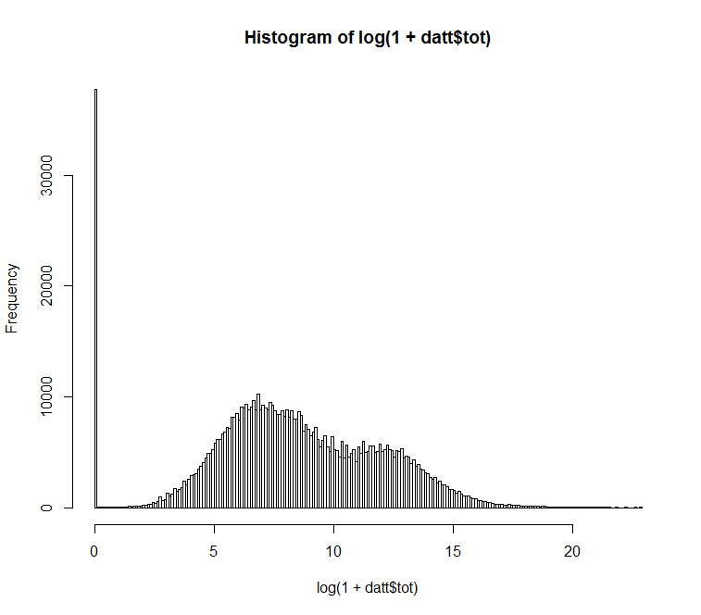

> summary( glm(y~.,data=dattt,family=binomial))

Call:

glm(formula = y ~ ., family = binomial, data = dattt)

Deviance Residuals:

Min 1Q Median 3Q Max

-2.7200 -0.3872 -0.1409 0.3582 4.4002

Coefficients:

Estimate Std. Error z value Pr(>|z|)

(Intercept) -4.00211 36.71594 -0.109 0.913201

yy 1.10805 0.01039 106.655 < 2e-16 ***

categConsu -0.85302 0.01751 -48.719 < 2e-16 ***

categExclu -2.73530 0.05082 -53.821 < 2e-16 ***

categIT -0.30197 0.01675 -18.029 < 2e-16 ***

categLogis -1.62279 0.06238 -26.015 < 2e-16 ***

categMarke -1.83604 0.01964 -93.485 < 2e-16 ***

categOther -1.54546 0.03233 -47.801 < 2e-16 ***

categResea -5.01230 0.01491 -336.144 < 2e-16 ***

typ97 3.99342 36.71594 0.109 0.913389

typ99 3.34350 36.71593 0.091 0.927442

typCR -0.25168 36.71578 -0.007 0.994531

typPC 5.22074 36.71594 0.142 0.886928

tot(4,7] -0.28396 0.02166 -13.110 < 2e-16 ***

tot(7,9] -1.02119 0.02274 -44.901 < 2e-16 ***

tot(9,14] -1.21515 0.02330 -52.146 < 2e-16 ***

tot(14, Inf] -1.22153 0.02817 -43.357 < 2e-16 ***

site1155 -15.21856 630.80401 -0.024 0.980752

site1270 1.34748 0.02009 67.063 < 2e-16 ***

site1271 0.73502 0.19751 3.721 0.000198 ***

site1290 1.15911 0.05450 21.268 < 2e-16 ***

site129G 1.47259 0.03185 46.236 < 2e-16 ***

site129P 0.20834 0.03479 5.988 2.12e-09 ***

site129T 0.01007 0.07227 0.139 0.889195

site129V 0.93985 0.13641 6.890 5.59e-12 ***

site129Y 0.17922 0.08998 1.992 0.046389 *

site1305 -14.25853 710.54904 -0.020 0.983990

site154G 1.18421 0.02245 52.738 < 2e-16 ***

site154K 0.17832 0.03773 4.726 2.29e-06 ***

site154M -0.06175 0.02743 -2.251 0.024364 *

site154Y -0.47867 0.06940 -6.897 5.31e-12 ***

site156T 1.46790 0.16148 9.090 < 2e-16 ***

site166S -0.42777 0.02501 -17.106 < 2e-16 ***

site166W -0.41457 0.02783 -14.894 < 2e-16 ***

site174A 0.57543 0.03806 15.120 < 2e-16 ***

site174H 0.30579 0.43741 0.699 0.484488

site174M 0.57092 0.02269 25.161 < 2e-16 ***

site174Q 1.36872 0.02548 53.720 < 2e-16 ***

site1860 -0.14143 0.02764 -5.116 3.12e-07 ***

site1861 0.35461 0.03373 10.514 < 2e-16 ***

site1960 1.74484 0.03069 56.854 < 2e-16 ***

site250T 1.95962 0.09693 20.217 < 2e-16 ***

site255T 1.48064 0.05579 26.538 < 2e-16 ***

site275T 2.17047 0.09443 22.985 < 2e-16 ***

site3290 -10.99461 23.52450 -0.467 0.640236

site3291 -11.05483 137.34221 -0.080 0.935847

site6139 1.64689 0.14397 11.439 < 2e-16 ***

site6202 1.68237 0.06706 25.089 < 2e-16 ***

site6203 1.77935 0.03049 58.364 < 2e-16 ***

siteP175 1.60875 0.03913 41.117 < 2e-16 ***

siteP205 18.22468 3956.18043 0.005 0.996324

siteP275 1.49464 0.03109 48.067 < 2e-16 ***

---

Signif. codes: 0 ?**?0.001 ?*?0.01 ??0.05 ??0.1 ??1

(Dispersion parameter for binomial family taken to be 1)

Null deviance: 832008 on 725413 degrees of freedom

Residual deviance: 405614 on 725362 degrees of freedom

AIC: 405718

Number of Fisher Scoring iterations: 16

> ####bayesian network####

>library(bnlearn)

>datt = data.frame(y,yy,categ,typ,tot,site)

>dattt=datt

>dattt$categ<-as.numeric(factor(datt$categ))

>dattt$y<-as.numeric(factor(datt$y))

>dattt$y<-as.numeric(factor(datt$yy))

>dattt$typ<-as.numeric(factor(datt$typ))

>dattt$tot<-as.numeric(factor(datt$tot))

>dattt$site<-as.numeric(factor(datt$site))

>for(i in 1:36)plot(mmpc(dattt[dmonth==i,]))

>pdf("bayesn2.pdf",width=9,height=9)

>par(mfrow=c(6,6),mar=c(0,0,0,0),cex=0.5)

>for(i in 1:36)

> plot(mmpc(dattt[dmonth==i,]))

>dev.off ()

