PBL Scenario 1 Report Template
Data-Driven YouTube/Netflix Content Planning
How to Use This Template
This template gives you a suggested structure for your PBL report. You do not have to follow it exactly. Change the order, rename sections, add or remove parts so the flow fits your own analysis.
There is one rule you should follow carefully: the way you mark images and links. Anywhere you want a visual to appear in your final web page, write a marker inside angle brackets. The chatbot will read these markers as instructions.
<image: genre_frequency.png>
<image: theme_wordcloud.png>
<image: https://example.com/sentiment_chart.png>
For an image marker, write the filename of the image you will upload to the chatbot, or paste a full image link inside the angle brackets where you want it to appear. You can also use angle brackets to flag things for the chatbot, for example <emphasize this section> or <keep this paragraph short>.
When you open the chatbot, upload this filled-in report and all of your image files at the same time.
Title
Data-Driven Streaming Content Planning Through Audience Reaction Analysis
Team Members
2026390071 이가원
2026390118 옥윤수
2026390125 편서욱
2026390146 안유정

GitHub Repository
Create a GitHub repository for this project and paste its link here. This is required. The repository should hold the data files you collected and the code you used for text mining, so that your work can be checked and reproduced.
1. Introduction
In recent years, streaming platforms such as Netflix, YouTube, and other digital media services have changed the way people consume entertainment content. Unlike traditional television, streaming services allow viewers to immediately react to movies and series through comments, reviews, recommendation videos, and social media discussions. As a result, online audience reactions have become an important source of information for media companies when planning future content. Today, successful streaming content is often influenced not only by production quality, but also by emotional audience engagement and online shareability. Many popular series become viral because viewers actively discuss characters, create theories, share emotional reactions, and recommend content to others through online platforms. Because of this environment, entertainment companies increasingly use data analysis and audience research to understand viewer preferences more accurately. Our team focused on this trend and decided to analyze online viewer reactions related to popular movies and streaming series between 2018 and 2025. Instead of only examining box office numbers or critic ratings, we concentrated mainly on user-generated reactions such as YouTube comments, online reviews, Reddit discussions, and recommendation posts. We believed that these reactions would provide deeper insight into the emotional reasons behind content popularity. For this project, we selected films and streaming series that generated strong online discussions and viral reactions. Some examples included Inside Out 2, Parasite, Wednesday, Squid Game, and several emotional youth dramas and thriller series. These contents were selected because audiences frequently discussed emotional scenes, character relationships, plot twists, and relatable life experiences online.

Our team especially focused on three major categories that appeared repeatedly in viral content discussions:

Emotional healing animations
Youth and coming-of-age dramas
Psychological thriller and mystery series
We noticed that these genres often created strong emotional reactions and high audience engagement on social media platforms. For example, emotional animation films frequently received comments related to comfort, healing, and personal reflection, while thriller series generated online theory discussions and speculation videos.
The main purpose of this project was to identify patterns in viewer reactions through text mining analysis and use those findings to suggest future content ideas for StreamKUS. By analyzing large amounts of viewer comments and reviews, we hoped to better understand:
What kinds of emotions audiences respond to most strongly
Which themes appear repeatedly in successful streaming content
Why certain movies and series become viral online
How audience emotions influence online sharing behavior
In addition, this project aimed to demonstrate how data-driven decision making can support content planning in the entertainment industry. Traditionally, media companies often relied heavily on intuition, trends, or producer experience when creating new content. However, audience reaction analysis allows companies to make more informed decisions based on actual viewer behavior and preferences. Another reason we chose this topic was because streaming audiences have changed significantly after global events such as the COVID-19 pandemic. During this period, many viewers searched for emotionally comforting or relatable content that could reduce stress and anxiety. We believed this social change would appear clearly in online audience reactions.
Through this project, our team hoped to combine media studies and data analysis in order to understand modern streaming culture more deeply. By applying text mining techniques to real audience reactions, we aimed to discover meaningful patterns that could help predict future successful content trends.

2. Data Collection
To conduct this project, our team collected large amounts of viewer reaction data from multiple online platforms. Since the main goal of the analysis was to understand emotional audience responses and viral content patterns, we focused primarily on platforms where viewers actively express their opinions and feelings.
The main data sources included: YouTube comment sections, Netflix-related review pages, IMDb user reviews, Reddit discussion communities, TikTok recommendation posts and comments, Online movie communities and fan discussions
These platforms were selected because they contain spontaneous and emotionally expressive audience reactions. Unlike formal critic reviews, online comments often include honest personal opinions, emotional responses, and direct explanations about why viewers enjoyed or disliked specific content. Our team selected movies and streaming series that became highly popular online or generated strong discussion trends between 2018 and 2025. We mainly focused on content that showed:
High viewer engagement, Viral recommendation trends, Large amounts of online discussion, Strong emotional audience reactions, Frequent appearance in recommendation videos and social media discussions

Some representative examples included:

Inside Out 2(2024)
Soul(2021)
Swapped(2026)
UP(2009)
Everything Everywhere All at Once(2022)
These works were chosen because viewers actively shared emotional reactions, discussed character relationships, and created theory discussions online. In many cases, audiences continued discussing the content weeks or even months after release, which suggested strong emotional engagement and long-term online visibility.
The total dataset included approximately: Around 4,000 viewer comments and reviews, 18 movies and streaming series, Online reactions uploaded between 2018 and 2025, Multiple genres including animation, thriller, drama, and mystery
During the data collection process, we faced several challenges. Online comments often included spam messages, repeated symbols, internet slang, emojis, and unrelated advertisements. Because of this, data cleaning became an important part of the project.
The preprocessing and cleaning stage included: Removing duplicate comments, Deleting spam and unrelated advertisements, Removing emojis and repeated punctuation, Filtering meaningless short comments, Standardizing repeated emotional words, Correcting basic formatting problems

For example, words such as: “comforting”, “healing”, “heartwarming”, “emotionally warm” were grouped into similar emotional categories to improve analysis accuracy.
We also noticed that many viewers used internet slang and abbreviated emotional expressions. Some comments included sarcasm or memes, which occasionally made automatic analysis more difficult. Despite these limitations, online comments still provided valuable insight because they reflected real-time audience reactions more naturally than formal surveys. Another important reason for choosing online reaction data was that modern streaming culture is highly connected to social media algorithms and recommendation systems. Content becomes successful not only because people watch it, but also because audiences actively share and discuss it online. Therefore, analyzing audience discussions allowed us to understand not only viewer satisfaction, but also the viral potential of different content types. We believe this dataset was meaningful because it represented a wide range of viewer emotions and online behaviors. Through this process, we were able to collect realistic audience opinions that helped reveal patterns behind successful streaming content.

3. Text Mining Methods
To analyze the collected viewer reaction data, our team applied several basic text mining techniques. Since most of the data consisted of large amounts of unstructured text, text mining methods were useful for organizing comments, identifying repeated patterns, and understanding emotional audience responses more systematically.
The overall analysis process consisted of: Data preprocessing, Keyword frequency analysis, Sentiment analysis, Word cloud visualization, Theme interpretation
The first stage was preprocessing the text data. This process was necessary because online comments often contain unnecessary symbols, repeated expressions, internet slang, and inconsistent formatting. Without preprocessing, the analysis results could become inaccurate or difficult to interpret.
The preprocessing stage included: Tokenization, Removing stop words, Converting all words into lowercase, Removing punctuation and symbols, Eliminating repeated characters, Filtering meaningless expressions
For example, commonly repeated words such as:

“the”, “and”, “really”, “very”
were removed because they did not contribute meaningful information to the analysis.

because they could distort keyword frequency results.
After preprocessing, we conducted keyword frequency analysis. This method helped identify which words appeared most frequently in viewer discussions related to successful streaming content.
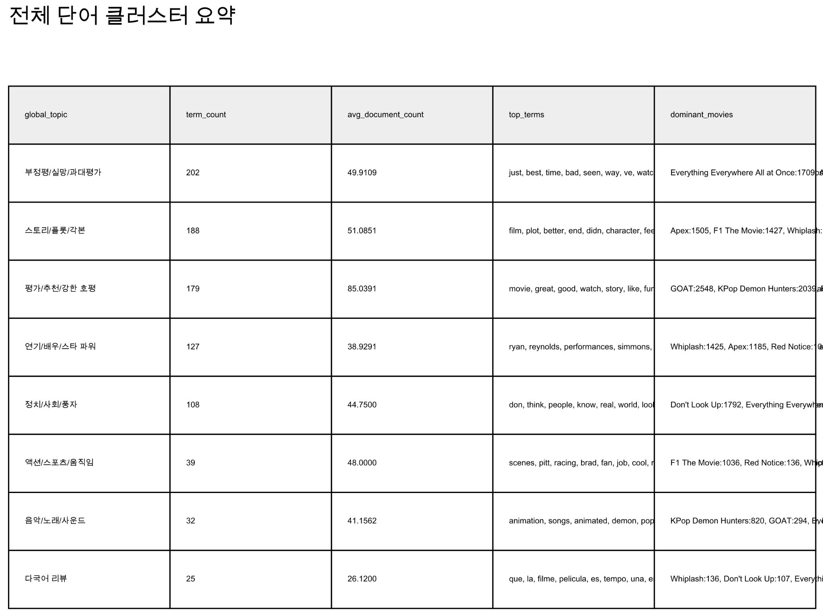

The frequency analysis revealed several repeated emotional keywords, including:
“relatable”, “sad”, “emotional”, “comforting”, “plot twist”, “lonely”, “friendship”, “healing”
These keywords suggested that audiences strongly respond to emotionally relatable storytelling rather than only visual spectacle or action scenes.

Next, we used sentiment analysis to classify comments into:Positive reactions, Negative reactions, Neutral reactions
This method helped us understand overall audience emotional responses toward different genres and content types.
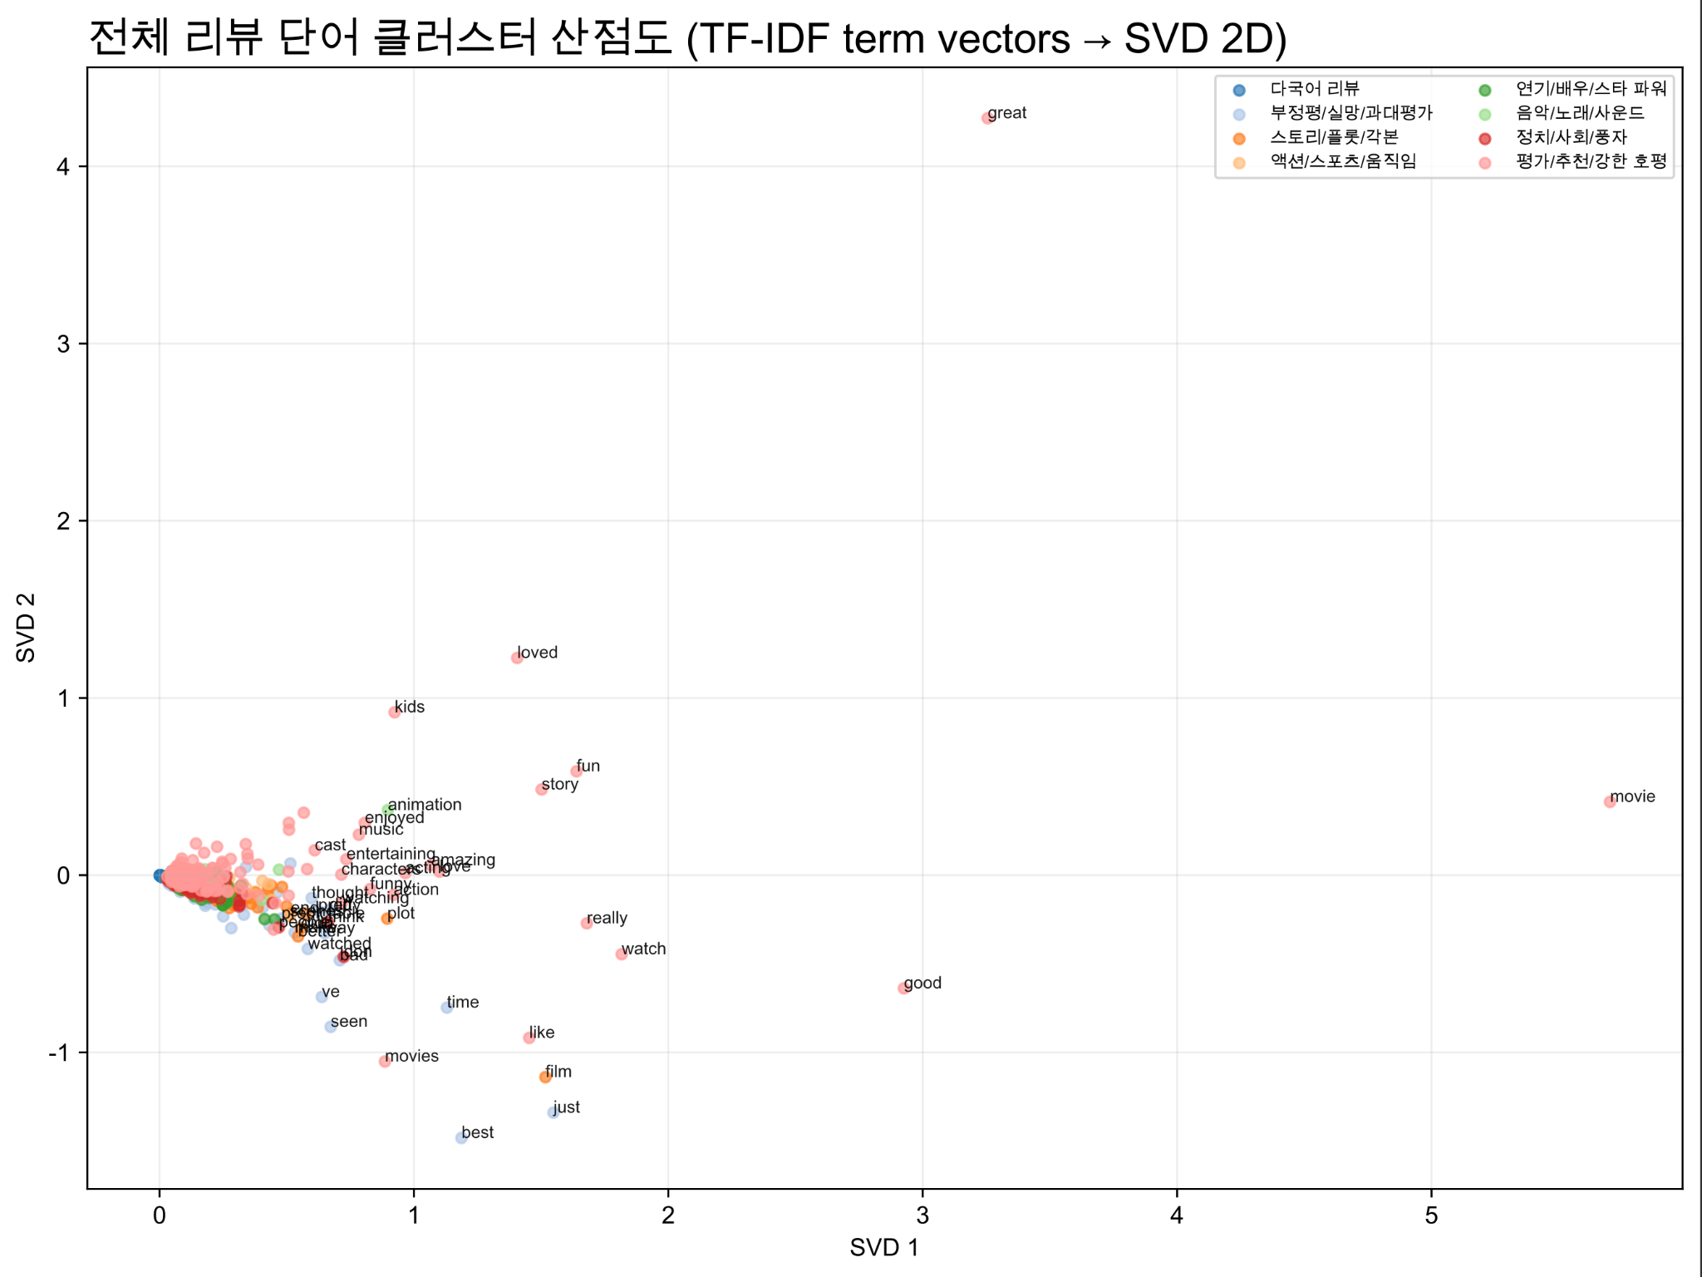
The sentiment analysis showed that highly successful streaming content generally had a large proportion of positive emotional reactions. Emotional animation films and healing-related stories especially received strong positive responses from viewers. Meanwhile, thriller and mystery series often generated mixed emotional reactions, but still maintained high engagement because viewers actively discussed theories and plot interpretations.
Another important method used in this project was word cloud visualization.
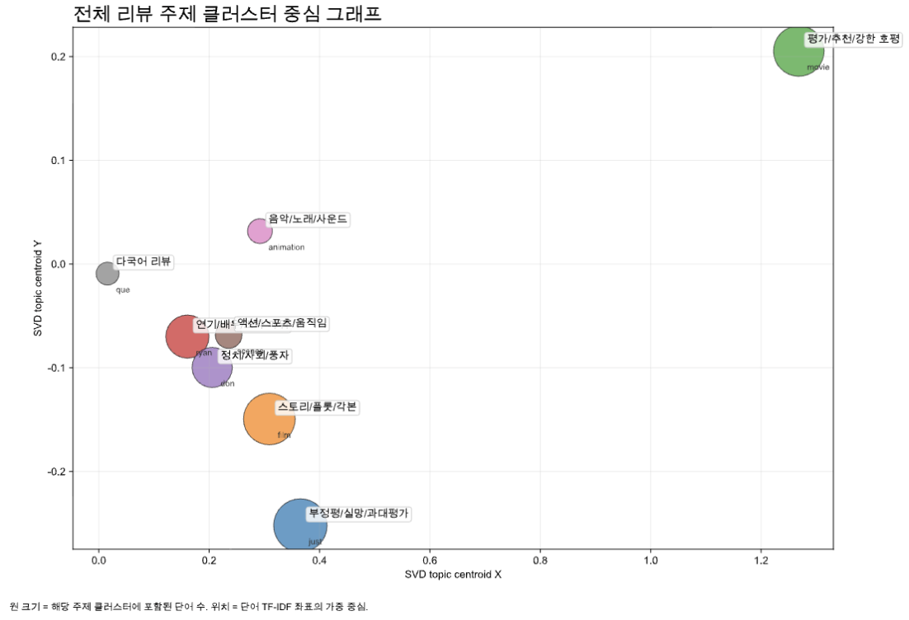
Word clouds visually represent the most frequently discussed themes and emotional keywords. Larger words represent themes that appeared more often in audience reactions.
The word cloud analysis clearly showed repeated emotional concepts such as:

“healing”, “family”, “friendship”, “trauma”, “comfort”,“identity”, “growth”
This visualization helped us recognize broader thematic patterns more intuitively. Our team selected these text mining methods because our goal was not only to count viewer reactions, but also to understand why audiences emotionally connect with specific content. Compared to traditional rating systems, text mining allows researchers to explore deeper emotional responses and recurring discussion themes. We also considered using more advanced machine learning methods, but due to time limitations and dataset size, we focused on simpler techniques that still provided meaningful insights. Even basic text mining methods proved effective in identifying major audience reaction trends.
Additionally, text mining was particularly useful because modern streaming audiences often communicate through short emotional expressions online. While traditional surveys may ask viewers directly about preferences, text mining analyzes naturally occurring audience behavior, which can sometimes provide more realistic insights. Overall, the analysis methods allowed us to transform thousands of unstructured comments into organized patterns that could support future content planning decisions.

4. Findings
After analyzing the collected viewer reaction data, our team discovered several important patterns related to successful streaming content
and audience engagement. The first major finding was that emotionally relatable stories consistently received the strongest audience
reactions. Across many different genres, viewers responded positively to themes connected to:

Loneliness, Friendship, Anxiety, Personal growth, Emotional healing, Family relationships, Identity struggles
For example, comments related to Inside Out 2 frequently included expressions such as:
“I cried so much”, “This felt too real”, “I related to this character”, “This movie comforted me”
These reactions suggest that audiences strongly value emotional realism and personal connection in storytelling.
Second, we found that viewers often discussed character emotions more than visual effects or action scenes. Even in
high-budget productions, audiences tended to focus on:

Character relationships, Emotional struggles, Psychological growth, Dialogue and interactions
This pattern appeared especially clearly in youth dramas and emotional animation films. Another important finding was that
online discussion itself plays a major role in content popularity. Series that encouraged fan theories, speculation, and emotional
debates tended to remain popular online for longer periods. For example, Wednesday generated large amounts of online
discussion related to:

Character theories, Hidden clues, Romantic relationships, Future story predictions
Similarly, thriller and mystery series often maintained long-term online engagement because viewers continuously shared
interpretations and theories after watching the content. Our team also discovered that emotionally healing content became
especially popular after stressful social events such as the COVID-19 pandemic. Many viewers mentioned wanting:
“comforting stories”, “warm characters”, “relaxing emotional content”, “healing dramas”

This suggests that audience preferences are influenced not only by entertainment trends, but also by broader
social and emotional conditions.

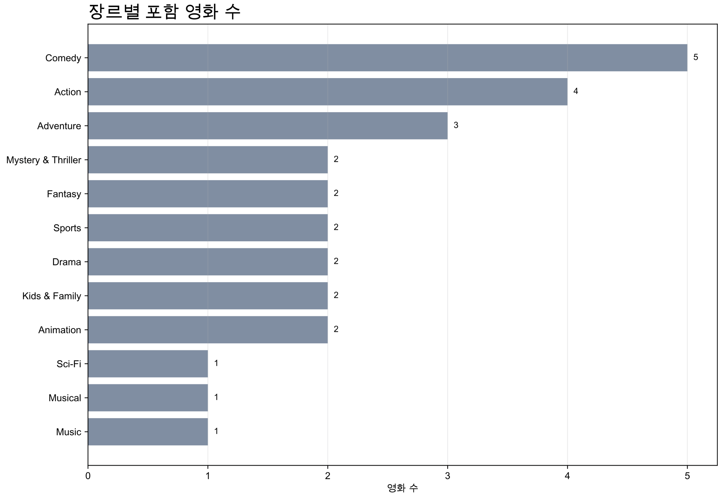

Another noticeable pattern was that positive emotional expressions appeared much more frequently than strongly negative
reactions in successful content discussions. Even when stories contained sadness or trauma, audiences still reacted positively
if the emotional experience felt meaningful or relatable.

For example, comments often described emotional stories as:

“sad but beautiful”, “painful but healing”, “emotionally comforting”. This indicates that audiences do not necessarily avoid sad
stories. Instead, they prefer stories that provide emotional understanding, empathy, or hope. We also observed differences
between genres:

Animation films generated strong emotional empathy, Youth dramas created relatability and personal reflection, Mystery series
encouraged online discussion and sharing, Thriller content increased long-term audience engagement through speculation
One especially interesting finding was that audiences frequently shared content that reflected their own personal experiences.
Many comments included: Personal memories, School-related stress, Mental health struggles, Friendship experiences, Family conflict.
This suggests that viewers often use entertainment content as a way to emotionally process real-life experiences.
Additionally, we found that viral content often included highly shareable emotional moments. Scenes that caused strong
emotional reactions were frequently clipped, reposted, or discussed on short-form video platforms such as TikTok and YouTube
Shorts. This online sharing behavior likely contributed significantly to continued popularity. Overall, the analysis demonstrated
that emotional connection, relatability, and online discussion potential are major factors behind successful streaming content
in modern digital culture.

5. Content Proposals
Based on the findings from our text mining analysis, our team developed several original content proposals for StreamKUS.
These proposals were designed directly from audience reaction patterns rather than intuition alone.

Proposal 1: Healing Animation about Loneliness
Genre: Animation / Slice of Life
Main Themes: Loneliness, Friendship, Emotional healing, Self-acceptance
This proposal was inspired by the strong positive reactions toward emotional animation films. Many viewers responded positively
to stories that emotionally reflected real-life struggles while still providing warmth and comfort.
The story could follow several teenagers experiencing social isolation, academic stress, and emotional anxiety in modern
society. Through unexpected friendships and emotional growth, the characters gradually learn how to support each other and
overcome loneliness.

The reason this idea appears promising is because online audiences repeatedly used emotional keywords such as:

“comforting”, “healing”, “relatable”, “warm”, “emotional support”
in discussions related to successful animation content.
Additionally, animation allows emotional symbolism and visual creativity that can strengthen audience empathy.

Proposal 2: Youth Drama about Academic Pressure
Genre: Drama / Coming-of-Age
Main Themes: School pressure, Burnout, Identity, Friendship, Family expectations
This proposal was inspired by audience comments discussing stress, competition, and emotional exhaustion related to school life.
Many younger viewers strongly reacted to realistic portrayals of: Academic anxiety, Social pressure,Mental exhaustion,
Communication struggles
The story could focus on high school or university students attempting to balance academic expectations with personal
identity and emotional well-being. Unlike traditional school dramas that focus mainly on romance, this series would emphasize
emotional realism and psychological struggles faced by modern students.

Because many viewers described relatable youth stories as:
“too real”, “exactly my life”, “emotionally accurate”
we believe this genre has strong streaming potential among younger audiences.

Proposal 3: Psychological Mystery Series
Genre: Thriller / Mystery
Main Themes: Hidden secrets, Emotional trauma, Psychological conflict, Memory and identity
This proposal was based on the popularity of online theory discussions and audience speculation culture.
Our analysis showed that viewers enjoy discussing: Plot twists, Character motives, Hidden clues
Unexplained mysteries on online platforms long after episodes are released.

The story could follow several interconnected characters whose hidden emotional traumas slowly become connected through
mysterious events. Each episode could reveal new information while still leaving unanswered questions that encourage viewers
to create online theories and discussions.

This format would likely increase: Viewer engagement, Social media discussion, Online sharing, Long-term audience retention
because audiences enjoy participating in theory-building communities.

Proposal 4: Emotional Sci-Fi Drama

Genre: Science Fiction / Emotional Drama
Main Themes: Human memory, Emotional connection, Technology and loneliness
Our team additionally noticed increasing audience interest in emotionally philosophical stories that combine futuristic settings with
human emotions. Instead of focusing only on action or technology, this series would explore emotional themes such as:
Memory loss, Artificial relationships, Isolation in digital society, Human emotional dependence. Because many viewers reacted positively to emotionally meaningful science fiction stories, this genre could attract both emotional audiences and thriller fans simultaneously.
All of these proposals were directly connected to audience reaction patterns discovered through text mining analysis. Rather than depending entirely on intuition, our team attempted to create data-driven content ideas based on actual viewer emotions and online behavior patterns.

7. References
https://www.netflix.com/tudum/top10/most-popular
https://www.netflix.com/browse/genre/34399
https://www.rottentomatoes.com/m/dont_look_up_2021/reviews/all-audience
Red Notice | Audience Reviews | Rotten Tomatoes
GOAT | Audience Reviews | Rotten Tomatoes
Project Hail Mary | Audience Reviews | Rotten Tomatoes
Reminder Before You Submit to the Chatbot
Make sure every angle bracket marker in this report points to a real file or a real link. Upload all of those image files to the
chatbot together with this report.

