**TNTP Coding Exercise**

local database in MongoDB

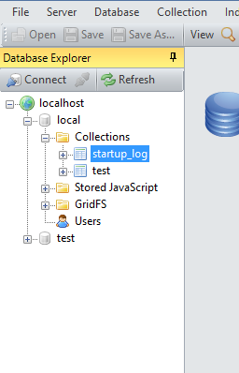

.NET webpage- Click "Insert bios Data to MongoDB"

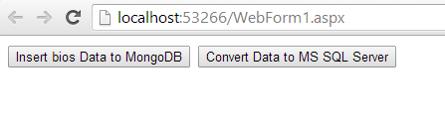

Insert successfully!

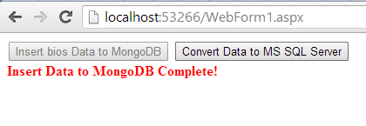

10 documents in MongoDB

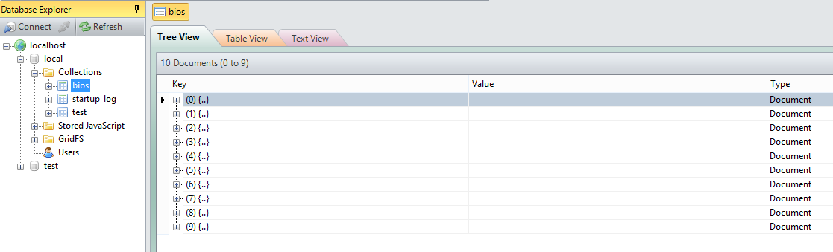

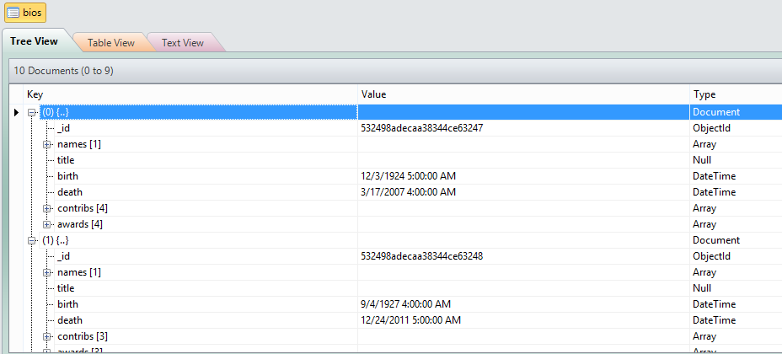

In SQL server, three tables and tree stored procedure.

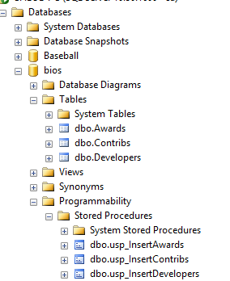

.NET webpage- Click "Convert Data to MS SQL server"

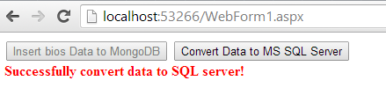

Data in MS SQL server:

