SWINBURNE VIETNAM
HO CHI MINH CAMPUS


COS30018 - COS30018-Intelligent Systems
Week3: Report

INSTRUCTOR: MR. KY TRUNG PHAM
STUDENT NAME: LÊ TIẾN DŨNG-SWS00683

HO CHI MINH CITY – JAN-2026

Contents
1. Environment Setup Summary 3
2.Testing Code Bases (v0.1 and P1) 3
3. Understanding of v0.1 Code Base 4
4.Comparison Between v0.1 and P1 4
5. Defining "Better" Prediction 4
6. Conclusion 5

1. Environment Setup Summary
A new Anaconda environment was created and the required dependencies were installed using pip, including:
- Numpy, matplotlib, pandas, tensorflow, scikit-learn, pandas-datareader, yfinance, jupyter, and ipykernel.
This environment configuration enabled the execution of the v0.1 code base without compatibility issues.

2.Testing Code Bases (v0.1 and P1)
v0.1: Executed successfully after installing the correct libraries. The model ran end to end, producing stock price predictions using an LSTM-based architecture.
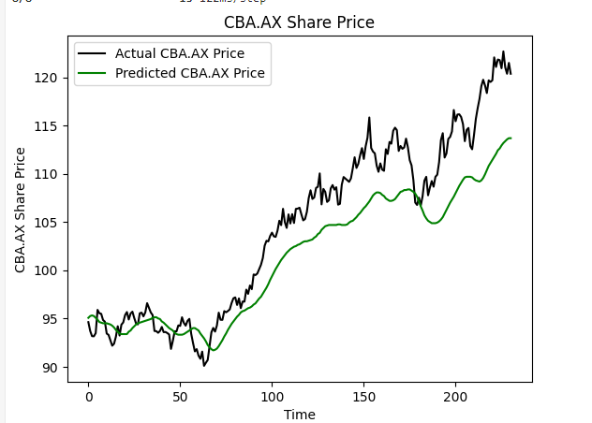
P1: Execution encountered missing dependency issues, specifically due to 'websync' not being included in the supplied requirements file and the deprecation of yahoo-fin. Replacing yahoo-fin with yfinance resolved the data loading problem.
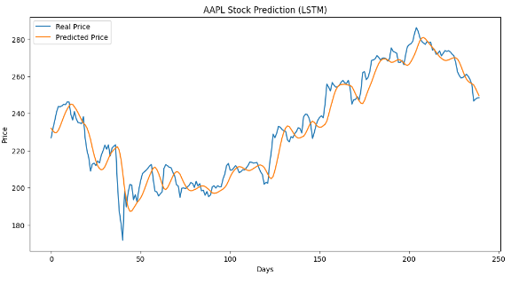

3. Understanding of v0.1 Code Base
The v0.1 code implements a conventional time-series forecasting pipeline consisting of data loading, scaling, window sequence generation, model architecture construction using stacked LSTMs, model training, and visualization of predictions. The architecture is simple, interpretable, and suitable for introductory experimentation.

4.Comparison Between v0.1 and P1
Both models were tested with stock price data. The v0.1 model displayed noticeable lag and smoothing effects, failing to capture short-term fluctuations. In contrast, the P1 model tracked the actual price movement more closely with reduced lag and improved responsiveness to turning points.

5. Defining "Better" Prediction
For this course task, a “better” prediction is defined based on the following criteria:
(1) Lower prediction error (e.g., MAE, RMSE, MAPE).
(2) Reduced lag and improved ability to reflect short-term movements.
(3) Better alignment between predicted and actual price curves during visual inspection.
Under these criteria, P1 provides a better prediction than v0.1 because it preserves the shape and
timing of price movements more accurately.

6. Conclusion
This week’s task was focused solely on setting up the environment and executing the provided
code bases for COS30018, which is separate from my main project. v0.1 served as a functional
baseline once dependencies were installed. P1 required minor environment fixes but demonstrated superior predictive behaviour after adjustments. No further project development was required for this task.

