SWINBURNE VIETNAM
HO CHI MINH CAMPUS


COS30018 - COS30018-Intelligent Systems
Week 7: Report

INSTRUCTOR: MR. KY TRUNG PHAM
STUDENT NAME: LÊ TIẾN DŨNG-SWS00683

HO CHI MINH CITY – MAR-2026

Contents
1. Describe the function you wrote to construct DL models dynamically. How does it allow you to swap between LSTM, RNN, and GRU layers without rewriting the whole training script? 3
2. What is “Multistep Prediction”? How does the output layer of your model change when you want to predict a sequence of k future days instead of just tomorrow? 3
3. Explain “Multivariate Prediction.” When predicting the ‘Close’ price, how do you structure the input array to include other time series like ‘Trading Volume’? 3

1. Describe the function you wrote to construct DL models dynamically. How does it allow you to swap between LSTM, RNN, and GRU layers without rewriting the whole training script?

I wrote a function called build_dynamic_dl_model() to build the deep learning model dynamically. Instead of hard-coding only one model type, the function takes a parameter called model_type. Inside the function, I use a mapping that connects the string value to the correct recurrent layer type: LSTM, GRU, or SimpleRNN. After choosing the layer type, the function builds the model using the same overall structure, including the input shape, number of layers, number of units, dropout rate, and output layer. Because of this design, I can switch between LSTM, RNN, and GRU simply by changing one argument, while keeping the rest of the training script unchanged. The data loading, training, and prediction pipeline do not need to be rewritten.

2. What is “Multistep Prediction”? How does the output layer of your model change when you want to predict a sequence of k future days instead of just tomorrow?

Multistep prediction means the model predicts more than one future value at the same time. Instead of predicting only tomorrow’s closing price, the model predicts the next k future closing prices in one output. In my implementation, this changes the target data from a single value to a sequence of k values. It also changes the output layer of the model. For one-step prediction, the final layer is Dense(1) because the model outputs only one value. For multistep prediction, the final layer becomes Dense(k) so the model can return a sequence of k future prices. For example, when I set future_days = 5, the output layer becomes Dense(5) and the model predicts the next 5 closing prices.

3. Explain “Multivariate Prediction.” When predicting the ‘Close’ price, how do you structure the input array to include other time series like ‘Trading Volume’?

Multivariate prediction means the model uses multiple input features rather than only one time series. In my notebook, I still predict the Close price, but the input includes several related features such as Close, Volume, High, and Low. The input array is structured as a 3D tensor with shape:
samples, prediction_days, number_of_features

For example, if I use 60 past days and 4 features, then each input sample has shape (60, 4). That means for each of the 60 days, the model sees a full feature vector containing the selected values for that day. This allows the model to learn from both price information and market activity, rather than relying only on the closing price.

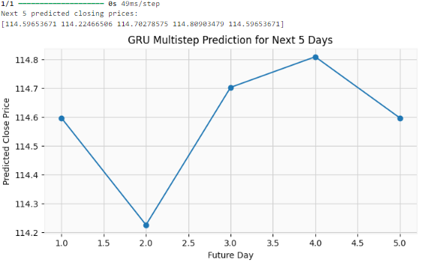
Figure 1: GRU multistep forecast for the next 5 trading days, showing the model’s predicted future closing prices after the end of the available dataset.
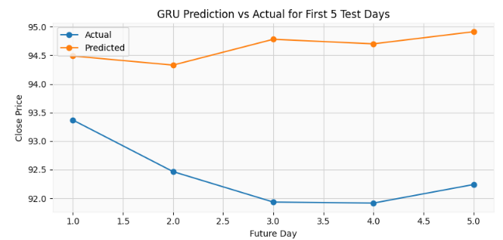
Figure 2: Comparison between the GRU model’s predicted closing prices and the actual closing prices for the first 5 days of the test set, used to evaluate short-term prediction accuracy.

