SWINBURNE VIETNAM
HO CHI MINH CAMPUS


COS30018 - COS30018-Intelligent Systems
Week 6: Report

INSTRUCTOR: MR. KY TRUNG PHAM
STUDENT NAME: LÊ TIẾN DŨNG-SWS00683

HO CHI MINH CITY – FEB-2026

Contents
1. Explain the implementation of your Candlestick chart. What information do the "wicks" and the "body" of the candle provide compared to a standard line chart? 3
2. In your Boxplot visualization, you use a "moving window." How does visualizing the distribution of prices over n days help in identifying market volatility? 3
3. Why is it useful to save these visualizations as images if you were to use a CNN-based approach for prediction in the future? 4
Saving these charts as images is useful because a CNN works on image input rather than raw numeric tables. In my notebook, both the candlestick chart and the moving-window boxplot are saved as .png files using fig.savefig(...) and plt.savefig(...). That means the charts are already being prepared in a format that could later become a dataset for a CNN-based model. 4
This matters because a CNN can learn visual patterns such as upward trends, reversals, tight trading ranges, long shadows, and periods of high or low spread. In other words, instead of learning directly from rows of numbers, a CNN could learn from the visual structure of the charts. Saving the images now also makes the workflow more efficient, because the visual data is already available for later experiments without needing to redraw every chart again. 4

1. Explain the implementation of your Candlestick chart. What information do the "wicks" and the "body" of the candle provide compared to a standard line chart?

The function plot_and_save_candlestick_chart() creates a candlestick chart which I built in my notebook. The function first cleans the Yahoo Finance column format using flatten_yfinance_columns(), then keeps the OHLC data needed for candlestick plotting: Open, High, Low, and Close. The function adds Volume as a lower panel when Volume data exists. The function selects the last_n_days=60 most recent rows to create a chart which mplfinance renders with type='candle' and saves as a PNG file. I developed the implementation through actual stock data which I obtained from Yahoo Finance to build full_data, which I used for plotting.

A candlestick chart provides more comprehensive information about each trading day than a standard line chart. The candle body displays how opening and closing prices differ from each other, which lets traders see whether prices increased or decreased during the trading session. The wicks show the highest and lowest prices reached during the day, so they reveal the full intraday range. A line chart usually only shows one value, often the closing price, so it hides that extra information. The candlestick chart better shows daily price movements because it shows short-term reversals and the total price changes that occurred throughout the day.

2. In your Boxplot visualization, you use a "moving window." How does visualizing the distribution of prices over n days help in identifying market volatility?

In my notebook, the boxplot is created in the plot_and_save_moving_window_boxplot() function. It uses the Close price, takes a window_size=20, and moves forward with step=5. For each window, it collects the closing prices over that period and stores them in a list, then uses plt.boxplot(windows, showfliers=False) to draw a sequence of boxplots across time. So instead of showing one single line of prices, this visualization summarizes the distribution of prices inside each rolling 20-day segment.
The boxplot displays price distribution across different time windows which aids in recognizing market volatility patterns. Price fluctuations increase when box and whisker widths expand because wider box and whisker ranges indicate greater price movement. The time period experienced for price movement because of these factors leads to price movement. The moving window method enables analysis of price changes for different parts of the dataset because price movements show different patterns throughout the dataset. The time window allows me to observe market behavior changes between two distinct periods. A standard line chart only displays price movement and market trends whereas this method shows price movement patterns throughout each time period.

3. Why is it useful to save these visualizations as images if you were to use a CNN-based approach for prediction in the future?

Saving these charts as images is useful because a CNN works on image input rather than raw numeric tables. In my notebook, both the candlestick chart and the moving-window boxplot are saved as .png files using fig.savefig(...) and plt.savefig(...). That means the charts are already being prepared in a format that could later become a dataset for a CNN-based model.
This matters because a CNN can learn visual patterns such as upward trends, reversals, tight trading ranges, long shadows, and periods of high or low spread. In other words, instead of learning directly from rows of numbers, a CNN could learn from the visual structure of the charts. Saving the images now also makes the workflow more efficient, because the visual data is already available for later experiments without needing to redraw every chart again.

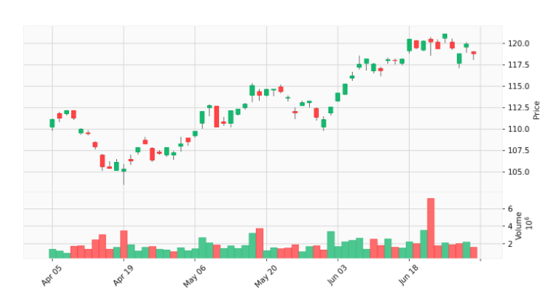
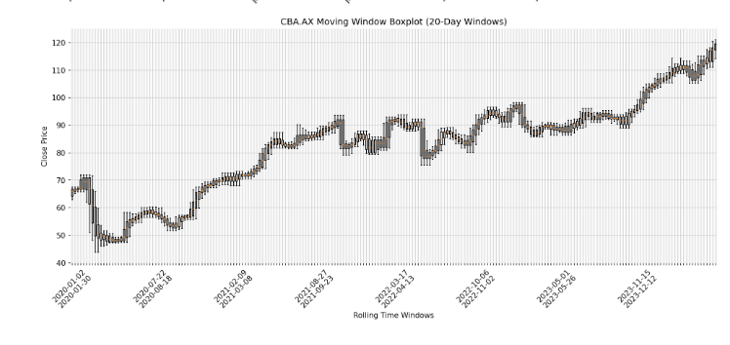
Output image from the Candlestick chart function

