**Ridge Regression**

9 questions

1. **Which of the following is NOT a valid measure of overfitting?**

**Sum of parameters (w1+w2+...+wn)**  
Sum of squares of parameters (w1^2 + w2^2 + … +wn^2)  
Range of parameters, i.e., difference between maximum and minimum parameters  
Sum of absolute values of parameters (|w1| + |w2| + … + |wn|)

2. **In ridge regression, choosing a large penalty strength λ tends to lead to a model with (choose all that apply):**

**High bias**  
Low bias  
High variance  
**Low variance**

3. **Which of the following plots best characterize the trend of bias, variance, and generalization error (all plotted over λ)?**

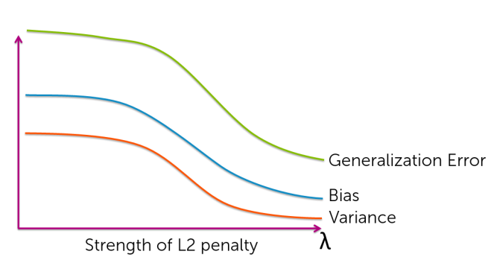

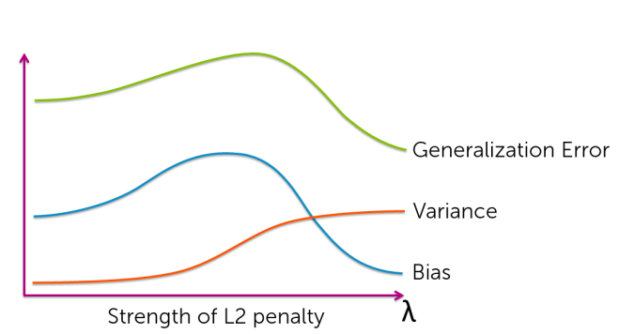

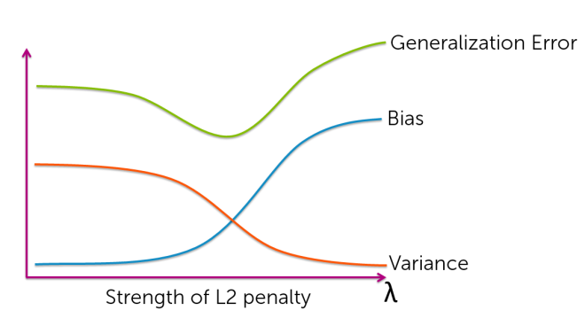

4. **In ridge regression using unnormalized features, if you double the value of a given feature (i.e., a specific column of the feature matrix), what happens to the estimated coefficients for every other feature? They:**

Double  
Half  
**Stay the same** (wrong)  
**Impossible to tell from the information provided (w may have opposite sign)**

5. **If we only have a small number of observations, K-fold cross validation provides a better estimate of the generalization error than the validation set method.**  
**True**False

6. **10-fold cross validation is more computationally intensive than leave-one-out (LOO) cross validation.**  
True  
**False**

7. **Assume you have a training dataset consisting of N observations and D features. You use the closed-form solution to fit a multiple linear regression model using ridge regression. To choose the penalty strength λ, you run leave-one-out (LOO) cross validation searching over L values of λ. Let Cost(N,D) be the computational cost of running ridge regression with N data points and D features. Assume the prediction cost is negligible compared to the computational cost of training the model. Which of the following represents the computational cost of your LOO cross validation procedure?**

~~L* N * Cost(N,D)~~**L* N * Cost(N-1,D)**L* D * Cost(N-1,D)  
~~L* D * Cost(N,D)~~L* Cost(N-1,D)  
~~L* Cost(N,D)~~

8. **Assume you have a training dataset consisting of 1 million observations. Suppose running the closed-form solution to fit a multiple linear regression model using ridge regression on this data takes 1 second. Suppose you want to choose the penalty strength λ by searching over 100 possible values. How long will it take to run leave-one-out (LOO) cross-validation for this selection task?**

About 3 hours  
About 3 days  
**About 3 years** **(10^6*100/3600/24/365 = ~3.17 years)**  
About 3 decades

9. **Assume you have a training dataset consisting of 1 million observations. Suppose running the closed-form solution to fit a multiple linear regression model using ridge regression on this data takes 1 second. Suppose you want to choose the penalty strength λ by searching over 100 possible values. If you only want to spend about 1 hour to select λ, what value of k should you use for k-fold cross-validation?**

k=6  
**k=36**k=600  
k=3600