Yuka Murata

USC ID: 6434262018

Email: [ymurata@usc.edu](mailto:ymurata@usc.edu)

March 11, 2020

**CSCI 520 Assignment 2 Report**

1. **Overview**

This program has four interpolating methods: linear Euler (program given), Bezier Euler, SLERP quaternion, and Bezier SLERP quaternion. In this report, I will discuss the similarities and differences between each interpolating method, especially between the following four pairs.

* Linear Euler and Bezier Euler
* SLERP quaternion and Bezier SLERP quaternion
* Linear Euler and SLERP quaternion
* Bezier Euler and Bezier SLERP quaternion

1. **Contents of Project Folder**

Please find videos for each required motions under “video-xxx” within the “mocapPlayer-starter” folder where xxx indicates the interpolating method such that be40 means Bezier Euler with N=40, lq40 means linear quaternion with N=40, bq40 means Bezier quaternion with N=40.

1. **Discussion**

* C**omparison between linear Euler and Bezier Euler**

The graph shows that both linear Euler and Bezier Euler almost fits to the input rotation except the missing details due to the interpolation. Also, as expected, Bezier Euler shows a smooth interpolation around key frames unlike linear Euler that has hard edges at key frames.

* **Comparison between SLERP quaternion and Bezier SLERP quaternion**

The graph shows that SLERP quaternion and Bezier SLERP quaternion seem alike except the smoothness and both almost fit to the input. As expected, Bezier SLERP quaternion has smooth transition around key frames. Yet, SLERP quaternion shows a hard transition around each key frame.

* **Comparison between linear Euler and SLERP quaternion**

The graph shows that linear Euler and SLERP quaternion almost fit to the input. If you take a closer look, especially around frame #250 and #300, SLERP quaternion nicely fits to the curve of input, while linear Euler failed to do so. SLERP quaternion also shows a better result in the last part of interpolation.

* **Comparison between Bezier Euler and Bezier SLERP quaternion**

The graph shows that Bezier Euler and Bezier SLERP quaternion almost fit to the input. Because both uses Bezier splines, they both show a very smooth curve. If you take a coloser look around frame #275 to #300, you can see that Bezier SLERP quaternion better fits to the input curve. This is more obvious after frame #450.

1. **Additional Discussion**

I compared the execution time difference between different interpolating methods and different N. Each execution time show below is the average of multiple executions, though usually I get the same execution time.

* Same input motion, different interpolating methods

|  |  |
| --- | --- |
| Interpolation | Execution Time (s) |
| Linear Euler | 0.02 |
| Linear SLERP quaternion | 0.08 |
| Bezier Euler | 0.05 |
| Bezier SLERP quaternion | 0.33 |

Using dance

|  |  |
| --- | --- |
| Interpolation | Execution Time (s) |
| Linear Euler | 0.04 |
| Linear SLERP quaternion | 0.25 |
| Bezier Euler | 0.14 |
| Bezier SLERP quaternion | 1.02 |

Using martialArts

One thing we can notice is that using quaternion instead of Euler generally takes more execution time. This is probably because we need to convert the data back and forth. Another notice is that Bezier takes more execution time than linear when comparing the same rotation type. This is because Bezier takes more complex calculation rather than simply interpolating linearly.

* Same input motion, different N

Using Bazier SLERP quaternion and different N on martialArts

Using Bazier SLERP quaternion and different N on dance

First observation is that the execution time initially grows as N increases. The interesting thing is that the execution time decreases as seen in the first graph as N increases more. This is probably because interpolation calculation was faster than processing more frames from input. Another notice is that execution time grows almost linearly to the input frame numers. For example, dance has 1086 frame total and martialArts has 3261 frames total. If you look at the graph above, the execution time of martialArts is almost 3 times longer than dance, given that martialArts has almost 3 times more frames than dance.

1. **Hermite Interpolation**

I referred to two course slides:

* Prof. Barbic’s CSCI 420 [<http://barbic.usc.edu/cs420-s20/10-splines/10-splines.pdf>]
* From UC Davis [<https://faculty.engineering.ucdavis.edu/farouki/wp-content/uploads/sites/41/2013/02/Interpolation-with-PH-curves.pdf>]

Hermite splines also take four control points. I chose the four control points as follows.

* P0: The previous key frame of startKeyframe. If this does not exist because startKeyframe is the first frame, then I used Double from endKeyframe to startKeyframe.
* P1: startKeyframe
* P2: endKeyframe
* P3: The next key frame of endKeyframe. If this does not exist because endKeyframe is the last frame, then I used Double from startKeyframe to endKeyframe.

The result seems unstable, but I assume that is the result of my basic implementation of Hermite splines if you see page 7 of the slides from UC Davis. The interpolated curve is not always a smooth curve, but it can be quite curvy. Another reason would be that interpolating rotation angle often changes the direction as seen in the graph. This causes the up and down in between frames to preserve its starting and ending velocity. I might have needed to use other control points instead of just the sequence of four control points. Another reason would be that because Hermite splines preserves the starting and ending velocity, the intermediate can be messed up in order to fit to this constrain. Please see the diagram below.

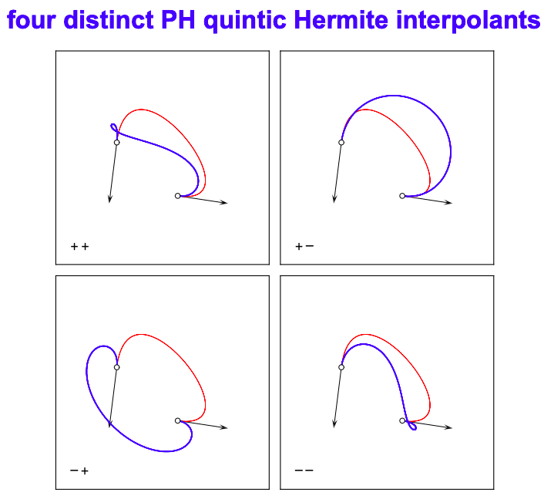

Snapshot from course slides from UC Davis

For the quaternion, it has three values: s, x, y, and z. So I extended the control matrix from 4x3 to 4x4, realizing that this will not affect the mathematical formula itself but rather preserves.

Below is the comparison with other interpolating methods.

Another observation was that Hermite SLERP quaternion showed more stable result than Hermite Euler when you actually play the motion capture data in the GUI. You can find these amc files to play in the project folder named 131_04-dance_he20.amc and 131_04-dance_hq20.amc.

1. **List of additional Features**

* Analyze the computation time of the different interpolation techniques (see section 4)
* Implemented Hermite interpolation for both Euler and quaternion with deeper discussion (see section 5)