SIMATS ENGINEERING
ASSESSMENT TOOL 3
Course Name: Artificial Intelligence Course Code: CSA17
CO2: Experiment search and game-solving techniques such as Greedy Search, A*, CSP, Minimax, and Alpha-Beta pruning with heuristic functions for solving complex AI problems efficiently. (BL3)
Weightage: 40% Duration: 1 Hour Questions: 3 Total Marks: 30
Annexure A – Dry Run Evaluation (Answers)
I Yukesh kumar (192524464) (Name / Reg No) certify that this submission is my original work and that I have adhered to the guidelines specified for this assessment. Signature:
Question 1 – Breadth-First Search (BFS)
Rule: BFS uses a FIFO queue. Dequeue the front node, visit it, then enqueue its children left to right. Stop when the queue is empty.
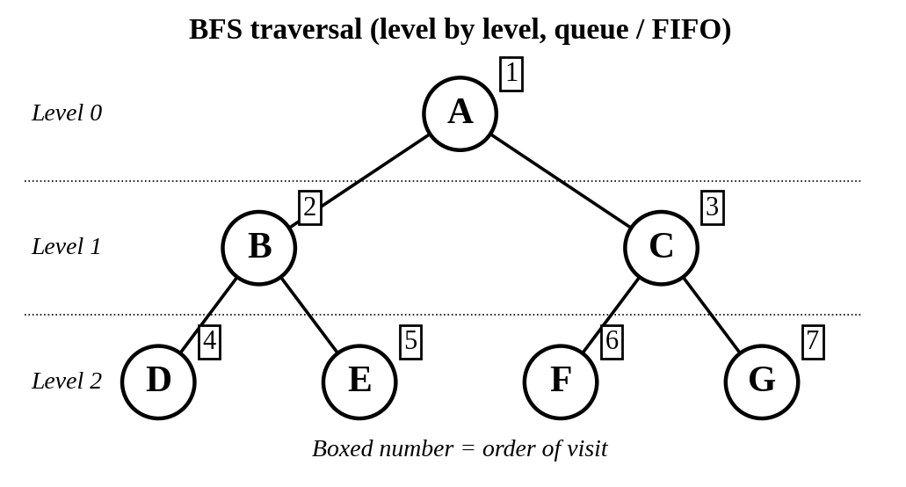
Fig. 1: BFS on the given tree – visited level by level
Dry-run table
Iteration | Queue (before dequeue) | Visited Node | Queue (after adding children)
1 | [A] | A | [B, C]
2 | [B, C] | B | [C, D, E]
3 | [C, D, E] | C | [D, E, F, G]
4 | [D, E, F, G] | D | [E, F, G]
5 | [E, F, G] | E | [F, G]
6 | [F, G] | F | [G]
7 | [G] | G | [ ] (empty)

Answers
- BFS traversal order: A → B → C → D → E → F → G
- Queue after each iteration: [B,C], [C,D,E], [D,E,F,G], [E,F,G], [F,G], [G], [ ] (empty).
- Result: All 7 nodes are visited in 7 iterations; nodes at depth d are always visited before nodes at depth d+1.
Question 2 – Depth-First Search (DFS)
Rule: DFS uses a LIFO stack. Pop the top node, visit it, then push its children so that the left child is on top (push right child first). Go as deep as possible, then backtrack.
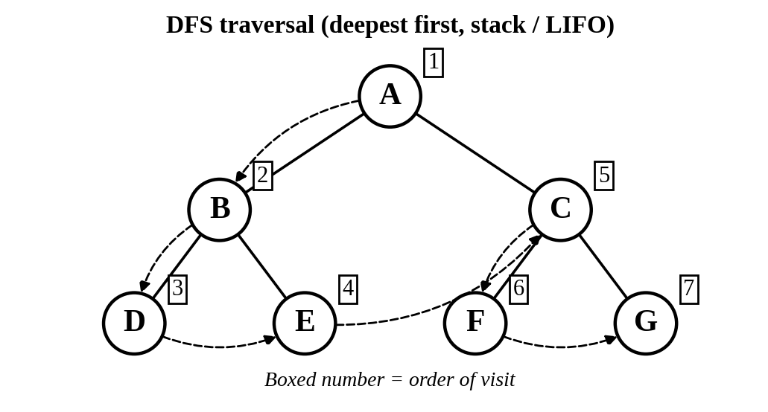
Fig. 2: DFS on the same tree – dashed arrows show the visiting path and backtracking
Dry-run table
Iteration | Stack (top at left, before pop) | Visited Node | Stack (after pushing children)
1 | [A] | A | [B, C]
2 | [B, C] | B | [D, E, C]
3 | [D, E, C] | D | [E, C]
4 | [E, C] | E | [C]
5 | [C] | C | [F, G]
6 | [F, G] | F | [G]
7 | [G] | G | [ ] (empty)

Answers
- DFS traversal order: A → B → D → E → C → F → G
- Backtracking: after the leaf D, DFS returns to B to visit E; after E, it returns to the root and goes down the right branch C → F → G.
- BFS vs DFS: same 7 nodes, different order – BFS uses a queue (level order), DFS uses a stack (depth order).
Question 3 – BFS on the 8-Puzzle
Initial: 136 / 5_2 / 478 Goal: 123 / 456 / 78_ (_ = blank)
Method: FIFO queue; blank moves in the order Up, Down, Left, Right; already-generated states are not added again; the goal test is done when a state is dequeued.
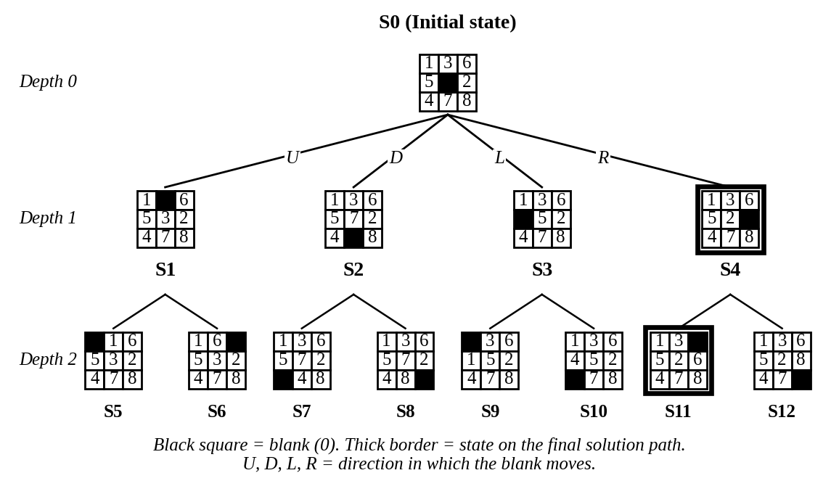
Fig. 3: First two levels of the BFS search tree (S0 to S12)
BFS dry-run table (first 5 iterations)
Iteration | Current State (expanded) | Queue Before Expansion | Queue After Expansion
1 | S0  1 3 6  5 _ 2  4 7 8 | [S0] | [S1, S2, S3, S4]
2 | S1  1 _ 6  5 3 2  4 7 8 | [S1, S2, S3, S4] | [S2, S3, S4, S5, S6]
3 | S2  1 3 6  5 7 2  4 _ 8 | [S2, S3, S4, S5, S6] | [S3, S4, S5, S6, S7, S8]
4 | S3  1 3 6  _ 5 2  4 7 8 | [S3, S4, S5, S6, S7, S8] | [S4, S5, S6, S7, S8, S9, S10]
5 | S4  1 3 6  5 2 _  4 7 8 | [S4, S5, S6, S7, S8, S9, S10] | [S5, S6, S7, S8, S9, S10, S11, S12]
The queue keeps growing level by level; the goal is dequeued at iteration 311 (310 states expanded before it).
State key (S0–S12)
State | Parent | Move (blank) | Board (row by row)
S0 | – | Initial | 1 3 6 | 5 _ 2 | 4 7 8
S1 | S0 | Up | 1 _ 6 | 5 3 2 | 4 7 8
S2 | S0 | Down | 1 3 6 | 5 7 2 | 4 _ 8
S3 | S0 | Left | 1 3 6 | _ 5 2 | 4 7 8
S4 | S0 | Right | 1 3 6 | 5 2 _ | 4 7 8
S5 | S1 | Left | _ 1 6 | 5 3 2 | 4 7 8
S6 | S1 | Right | 1 6 _ | 5 3 2 | 4 7 8
S7 | S2 | Left | 1 3 6 | 5 7 2 | _ 4 8
S8 | S2 | Right | 1 3 6 | 5 7 2 | 4 8 _
S9 | S3 | Up | _ 3 6 | 1 5 2 | 4 7 8
S10 | S3 | Down | 1 3 6 | 4 5 2 | _ 7 8
S11 | S4 | Up | 1 3 _ | 5 2 6 | 4 7 8
S12 | S4 | Down | 1 3 6 | 5 2 8 | 4 7 _

Answers
- Node expanded in each iteration: S0, S1, S2, S3, S4 in iterations 1–5 (FIFO order); then S5 … S12, and so on level by level (all depth-1 nodes, then depth-2 nodes, …) until the goal is dequeued at depth 8.
- Total states generated: 500 (including the initial state), of which 310 were expanded before the goal was reached. The count depends slightly on the move order; here it is Up, Down, Left, Right.
- Solution path (8 moves): Right → Up → Left → Down → Left → Down → Right → Right (moves of the blank).
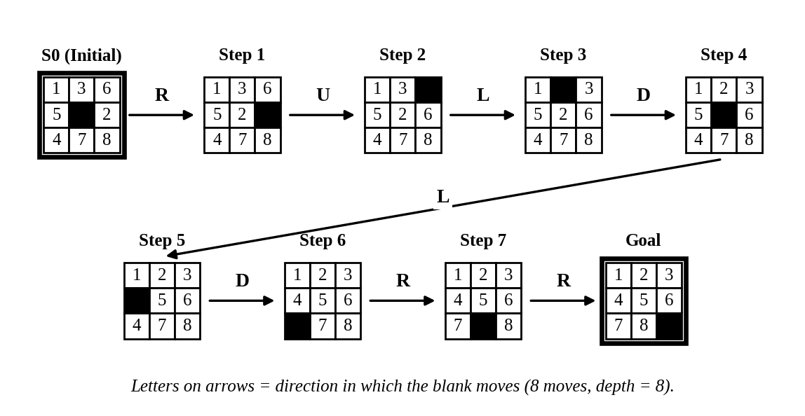
Fig. 4: Complete solution path from the initial state to the goal state
- Why BFS gives the shortest solution: BFS expands all states at depth d before any state at depth d+1. Every move in the 8-puzzle has the same cost (1), so depth equals path cost. The first time the goal appears is therefore at the smallest possible depth (here 8), and no shorter path can exist. BFS is also complete because the branching factor is finite (at most 4).

RUBRICS FOR CALCULATION
Criteria | Weightage (%) | Marks (of 30) | Level 4 – Exemplary (4) | Level 3 – Proficient (3) | Level 2 – Developing (2) | Level 1 – Beginning (1)
Understanding of Search Problem | 20 | 6 | Clearly understands the search problem, initial state, goal state, and search strategy. | Understands the problem with minor misunderstandings. | Demonstrates partial understanding of the search problem. | Shows little or no understanding of the search problem.
State Expansion and Dry Run Execution | 30 | 9 | Correctly traces every iteration, expands nodes accurately, and maintains the Queue/Stack/Priority Queue without errors. | Performs most iterations correctly with minor mistakes in state expansion or data structure updates. | Performs only some iterations correctly; several errors in tracing or node expansion. | Unable to correctly perform the dry run or expand states.
Application of Search Algorithm | 20 | 6 | Applies the selected algorithm (BFS/DFS/UCS) correctly, following all algorithmic rules. | Applies the algorithm correctly with a few procedural errors. | Applies only basic algorithm steps with noticeable mistakes. | Fails to apply the correct search algorithm.
Accuracy of Solution Path | 20 | 6 | Identifies the correct traversal order/solution path and goal state with proper justification. | Solution path is mostly correct with minor errors. | Partially correct solution path; goal may not be reached correctly. | Incorrect or incomplete solution path.
Presentation and Logical Reasoning | 10 | 3 | Queue/Stack/Priority Queue updates, state diagrams, and explanations are neat, organized, and logically presented. | Presentation is clear with minor organizational issues. | Limited explanation and organization; reasoning is partially clear. | Poor presentation with unclear or missing reasoning.
Total | 100 | 30

