AI-Based EV Charging Demand Prediction
Capstone Project Report
Prepared as an educational machine-learning demonstration

1. Abstract
This project demonstrates an AI-based approach for predicting electric-vehicle (EV) charging demand. A simulated dataset is used to build a Random Forest regression model for estimating charging-session counts and a Random Forest classifier for categorizing demand as Low, Medium, or High. The workflow includes data preprocessing, feature engineering, time-ordered model evaluation, and a Streamlit dashboard. Because the dataset is simulated, the results demonstrate the workflow only and should not be interpreted as real-world station forecasts.

2. Problem Statement and Objectives
Charging operators need to understand when demand may be high so that staffing, energy planning, and charger maintenance can be scheduled. The objective is to predict a demand indicator from time and session-related features, compare model performance using suitable metrics, and display trends in an interactive dashboard.

3. Dataset Description
The project uses 3200 simulated records spanning calendar year 2024. Each row represents an observation with a timestamp, hour, day of week, month, weekend flag, charger type, session duration, energy delivered, session count, and demand label. The data is synthetic and was generated to illustrate typical daily and seasonal variation. It is not sourced from a real charging network.
Feature | Description
timestamp | Date and time of the observation
hour, day_of_week, month | Time-based predictors
is_weekend | 1 for Saturday/Sunday, otherwise 0
session_duration_hours | Simulated charging-session duration
energy_delivered_kwh | Simulated energy delivered
charging_sessions | Target for regression
demand_level | Low, Medium, or High target for classification

4. Preprocessing and Feature Engineering
The timestamp was converted into hour, weekday, and month features. A weekend indicator was derived from the weekday. Rows were sorted chronologically, and the first 80% were used for training while the final 20% were held out for testing. This time-ordered split is more appropriate for forecasting than randomly mixing future and past observations.

5. Model Design
Two Random Forest models were trained. The regressor predicts the number of charging sessions. The classifier predicts Low, Medium, or High demand. Random Forests combine multiple decision trees and can model non-linear relationships. The models use hour, day of week, month, weekend status, session duration, and energy delivered as inputs.

6. Evaluation
Example evaluation results from the included simulated dataset:
Task | Metric | Result
Regression | MAE | 2.347
Regression | RMSE | 3.039
Regression | R² | 0.508
Classification | Accuracy | 0.561
Classification | Weighted F1 | 0.539
MAE and RMSE measure prediction error in session-count units; lower values are better. R² describes the proportion of variance explained relative to a mean baseline. Accuracy and weighted F1 summarize classification performance. These values are only illustrative because the dataset is synthetic.

Figure 1. Average simulated charging demand by hour
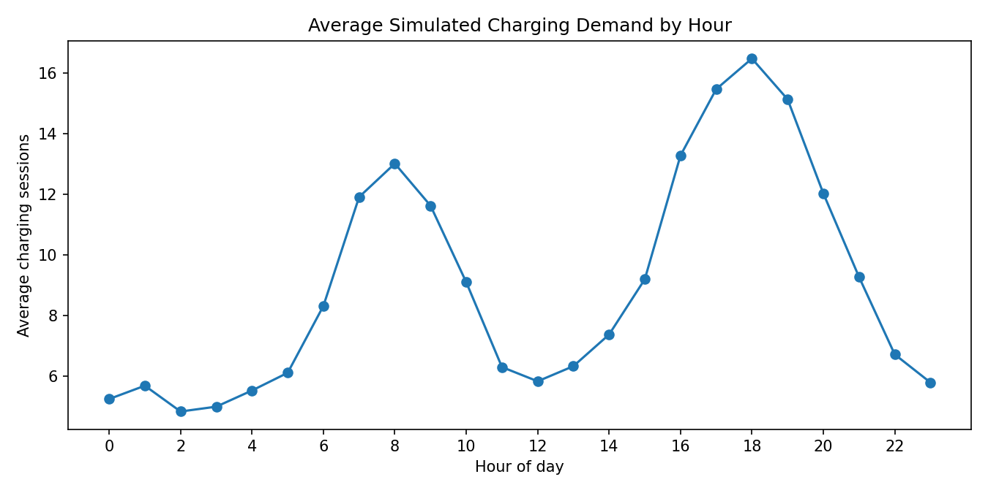

Figure 2. Regression predictions on the held-out set
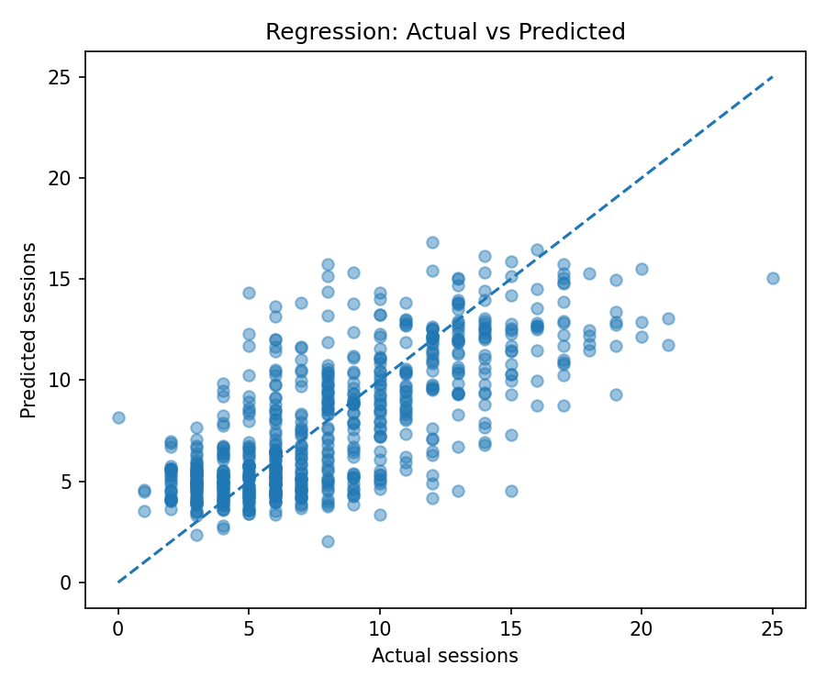

Figure 3. Random Forest feature importance
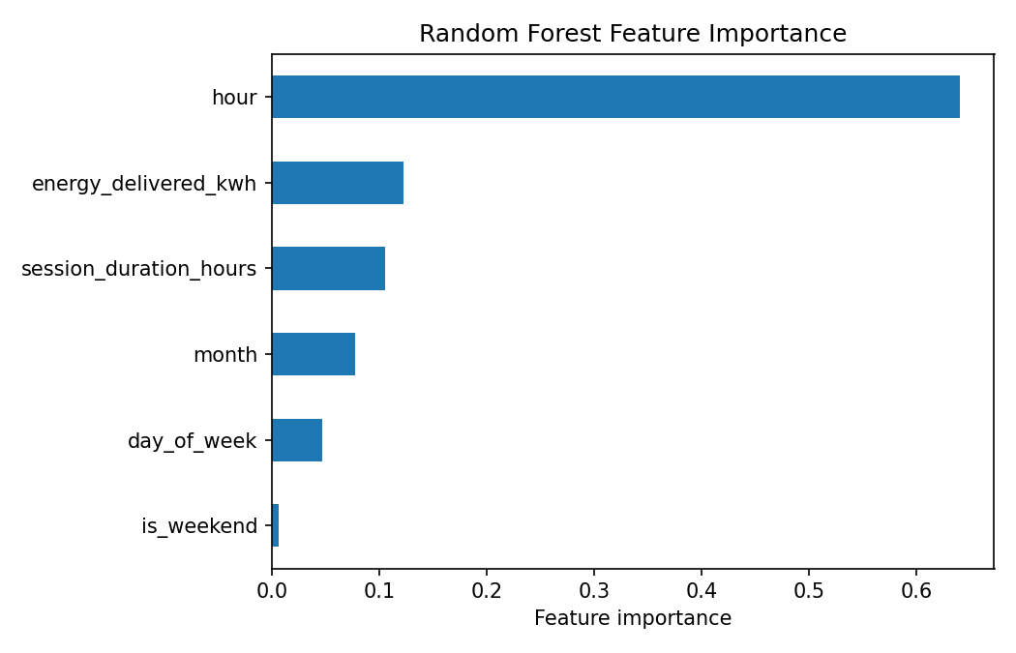

7. Dashboard
The Streamlit dashboard displays dataset summaries, average demand by hour, the distribution of demand labels, and a scenario form. Users can choose a time and session characteristics to see an estimated session count and demand level.

8. Limitations and Ethical Use
- The data is simulated and does not represent a real station or charging network.
- The model does not include location, holidays, weather, price, traffic, charger outages, or grid constraints.
- Session duration and energy may not be known before a future charging period; using them as predictors may limit real forecasting usefulness.
- The dashboard is a demonstration and does not show live station status or guarantee charger availability.
- For deployment, obtain a documented public or operator dataset, check privacy and data quality, and validate on later dates and different stations.

9. Conclusion and Future Work
The project provides an end-to-end example of EV charging demand analysis using Python and machine learning. Future work should replace the synthetic dataset with real historical charging records, add weather and station/location features where appropriate, compare additional algorithms, tune parameters using time-series validation, and monitor model drift.

10. How to Run
Install dependencies with `pip install -r requirements.txt`, train models with `python train_model.py`, and launch the dashboard with `streamlit run app.py`.

