# [[2, Key components of the invention]]

Aspects of the present disclosure include a spectroscopy device that is amenable to miniaturization, incorporating several key components. A light source may be utilized, which can either be broad-spectrum or consist of multiple light sources, each operating at a specific wavelength. Sensors, such as photodiodes, may be employed to measure the intensity of light at designated wavelengths. The device is designed with a small cavity or chamber to hold the substance under test, allowing for the performance of various types of spectroscopy, including absorption and reflectance spectroscopy. The orientation of the light source(s) and sensor(s) may be configured differently based on the desired type of spectroscopy. The output of the device may include an optical spectrum at a discrete set of wavelengths, such as 24 different wavelengths, rather than a full spectrum, which typically necessitates the use of expensive benchtop equipment. This output spectrum may provide aggregate information regarding the different molecules present in the substance under test. Signal processing, machine learning, and other algorithms may be utilized to recover and estimate the composition of the substance based on the measured optical spectrum at the discrete set of wavelengths.

# [[3, Sketches]]

Referring to Figure 3(a) and to Figure 3(b), aspects of the present disclosure include sketches that illustrate the interaction of light within engineered environments for advanced spectroscopic applications. In this aspect, Figure 3(a) depicts a light source interacting with a spherical structure, which is designed to enhance light properties. The sketch features a person operating the device, indicating its practical application. Key components such as the light source, enhancement cavity, and photodiodes are highlighted, showcasing their roles in the overall functionality. Figure 3(b) presents a perspective view of a sample being analyzed, with directional flow indicated towards the sample. The enhancement cavity is shown above the sample, which is crucial for improving sensitivity in detection. The flow of light is depicted moving through a filter and exiting as analyzed data, emphasizing the sequential process involved in spectroscopic analysis. Overall, these sketches provide a visual representation of the advanced photonic technologies employed in the miniaturization of spectroscopy devices, illustrating both their design and operational principles.  
Missed : Explaining the functionality if the sketch

# [[4, Li's Input]]

Aspects of the present disclosure include an on-chip photonic sensing device that is based on enhanced interactions between guided optical modes and chemical analytes within a high-finesse nano cavity formed by photonic crystals. The device may exhibit high sensitivity to low concentrations of analytes despite a strong background noise floor and may provide a high level of identification for distinguishing different chemical species compared to conventional mass spectroscopy methods. Key on-chip components and technologies may include semiconductor light sources with certain tunability, silicon waveguides, and electro-optic modulators (EOMs), particularly when a two-photon Raman scheme is adopted. Additionally, photonic crystals may be configured as either a one-dimensional array or a two-dimensional hexagon pattern, and photodetectors may be utilized across the visible (VIS), near-infrared (NIR), and mid-infrared (MIR) ranges.

# [[5, ]]

Aspects of the present disclosure include the miniaturization of spectroscopy devices, which may address specific challenges encountered in previous attempts. Prior solutions often suffered from low specificity and low spectral signal-to-noise ratio (SNR), primarily due to the requirement for high-quality off-chip optics, complicating the overall design. The integration of broad-spectrum light sources and specialized sensors, such as photodiodes, may enhance the measurement precision. By utilizing high-finesse nano cavities, the interaction of the excitation source with the sample may be significantly increased, resulting in a higher spectral SNR at each wavelength. This configuration allows for the generation of multiple spectral responses within different cavities on a single chip, thereby reinforcing the sensing capabilities and eliminating the necessity for off-chip optics. Consequently, the device may perform various types of spectroscopy, including absorption and reflectance, while maintaining compactness and efficiency, thus setting a new standard for spectroscopic analysis.

# Extracted Images

Image from Slide 3:

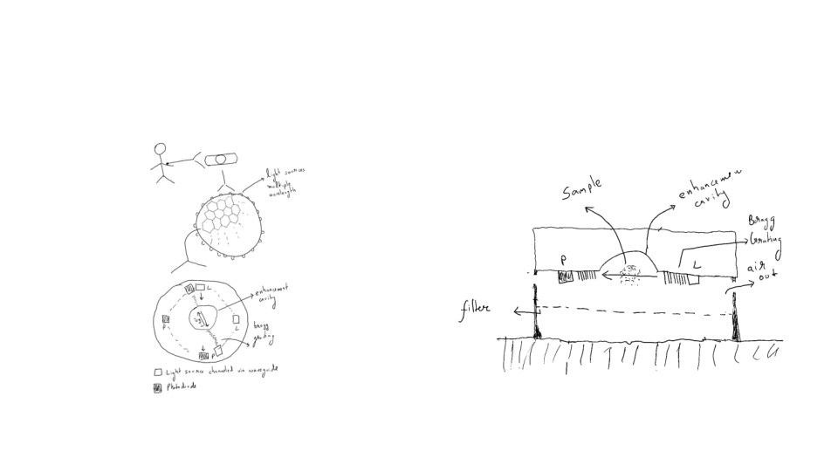

# Overall Theme

**Theme: "Innovative Miniaturization in Spectroscopy: Bridging Precision and Sensitivity through Advanced Photonic Technologies"**  
  
This theme encapsulates the core concepts and advancements presented in the PowerPoint content, highlighting the following key ideas:  
  
1. **Miniaturization of Spectroscopy Devices**: Emphasizing the invention's capability to condense complex spectroscopy functions into a compact device, overcoming previous challenges in size and performance.  
  
2. **Key Components and Technologies**:  
 - **Light Source and Sensors**: The integration of broad-spectrum light sources and specialized sensors (photodiodes) for precise measurement.  
 - **Enhanced Interaction Mechanisms**: Utilizing high-finesse nano cavities and photonic crystals to improve sensitivity and specificity, enabling accurate detection of low-concentration analytes amidst background noise.  
  
3. **Spectroscopy Techniques**: The device's ability to perform various types of spectroscopy (absorption, reflectance) and generate an optical spectrum at discrete wavelengths, providing valuable information about the sample's molecular composition.  
  
4. **Signal Processing and Machine Learning**: Highlighting the role of algorithms in interpreting the optical spectrum, enhancing the device's analytical capabilities.  
  
5. **Visual Representations**: The sketches illustrate the interaction of light within engineered environments, showcasing the innovative designs that facilitate enhanced light behavior and manipulation for sensing applications.  
  
6. **Overcoming Previous Challenges**: Addressing how the miniaturization process has resolved issues related to spectral SNR, off-chip optics, and the need for high-quality components, setting a new standard for compact spectroscopic analysis.  
  
Overall, this theme reflects a cohesive narrative of how advanced photonic technologies are revolutionizing spectroscopy through miniaturization, precision, and enhanced sensitivity, paving the way for future innovations in chemical analysis and detection.