**TASK 03 DOCKER IMAGE DEPLOYMENT USING KUBERNETES AIM:**

The objective is to push a Docker image to Docker Hub and deploy it on Minikube to ensure that the application runs successfully in a Kubernetes environment. This involves:

**Building & Pushing Docker Image:**

Creating a Docker image of the application.

Pushing the image to Docker Hub for accessibility.

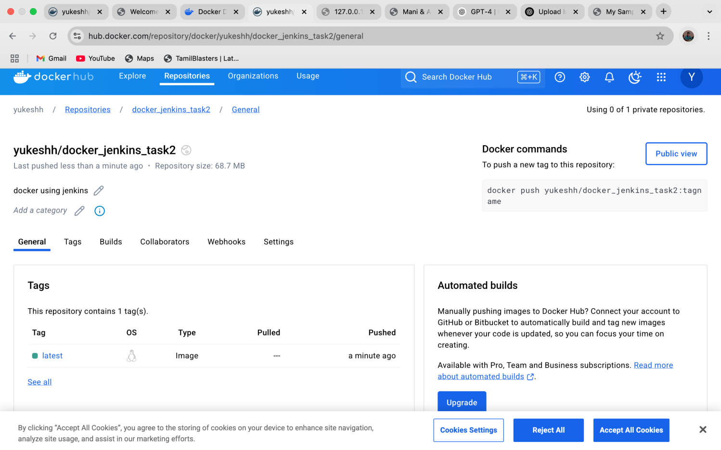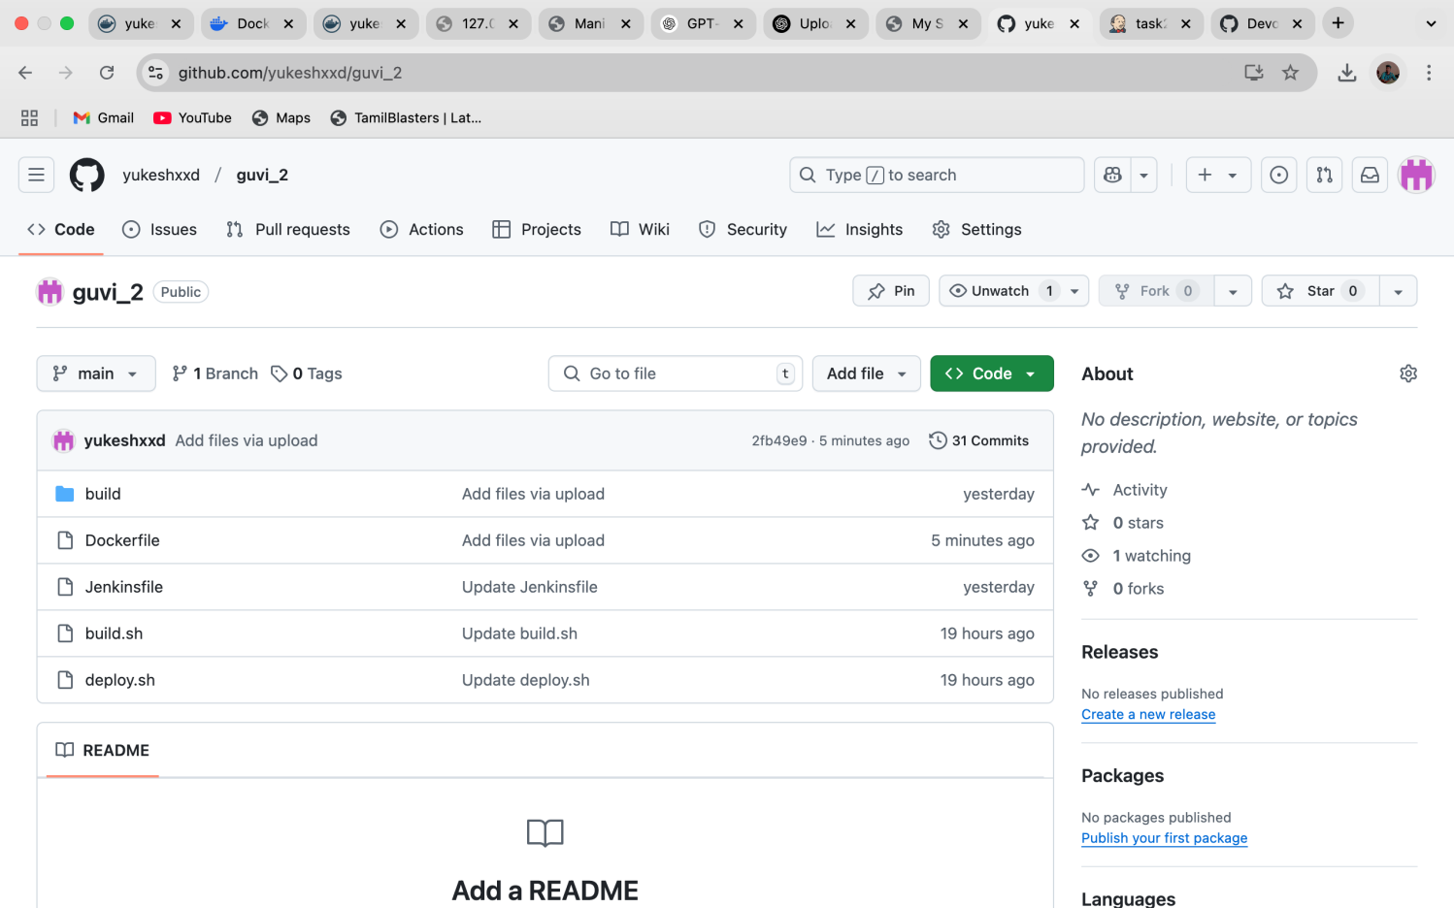

**Setting Up Minikube:**

Starting a Minikube cluster locally.

Configuring Minikube to pull images from Docker Hub.

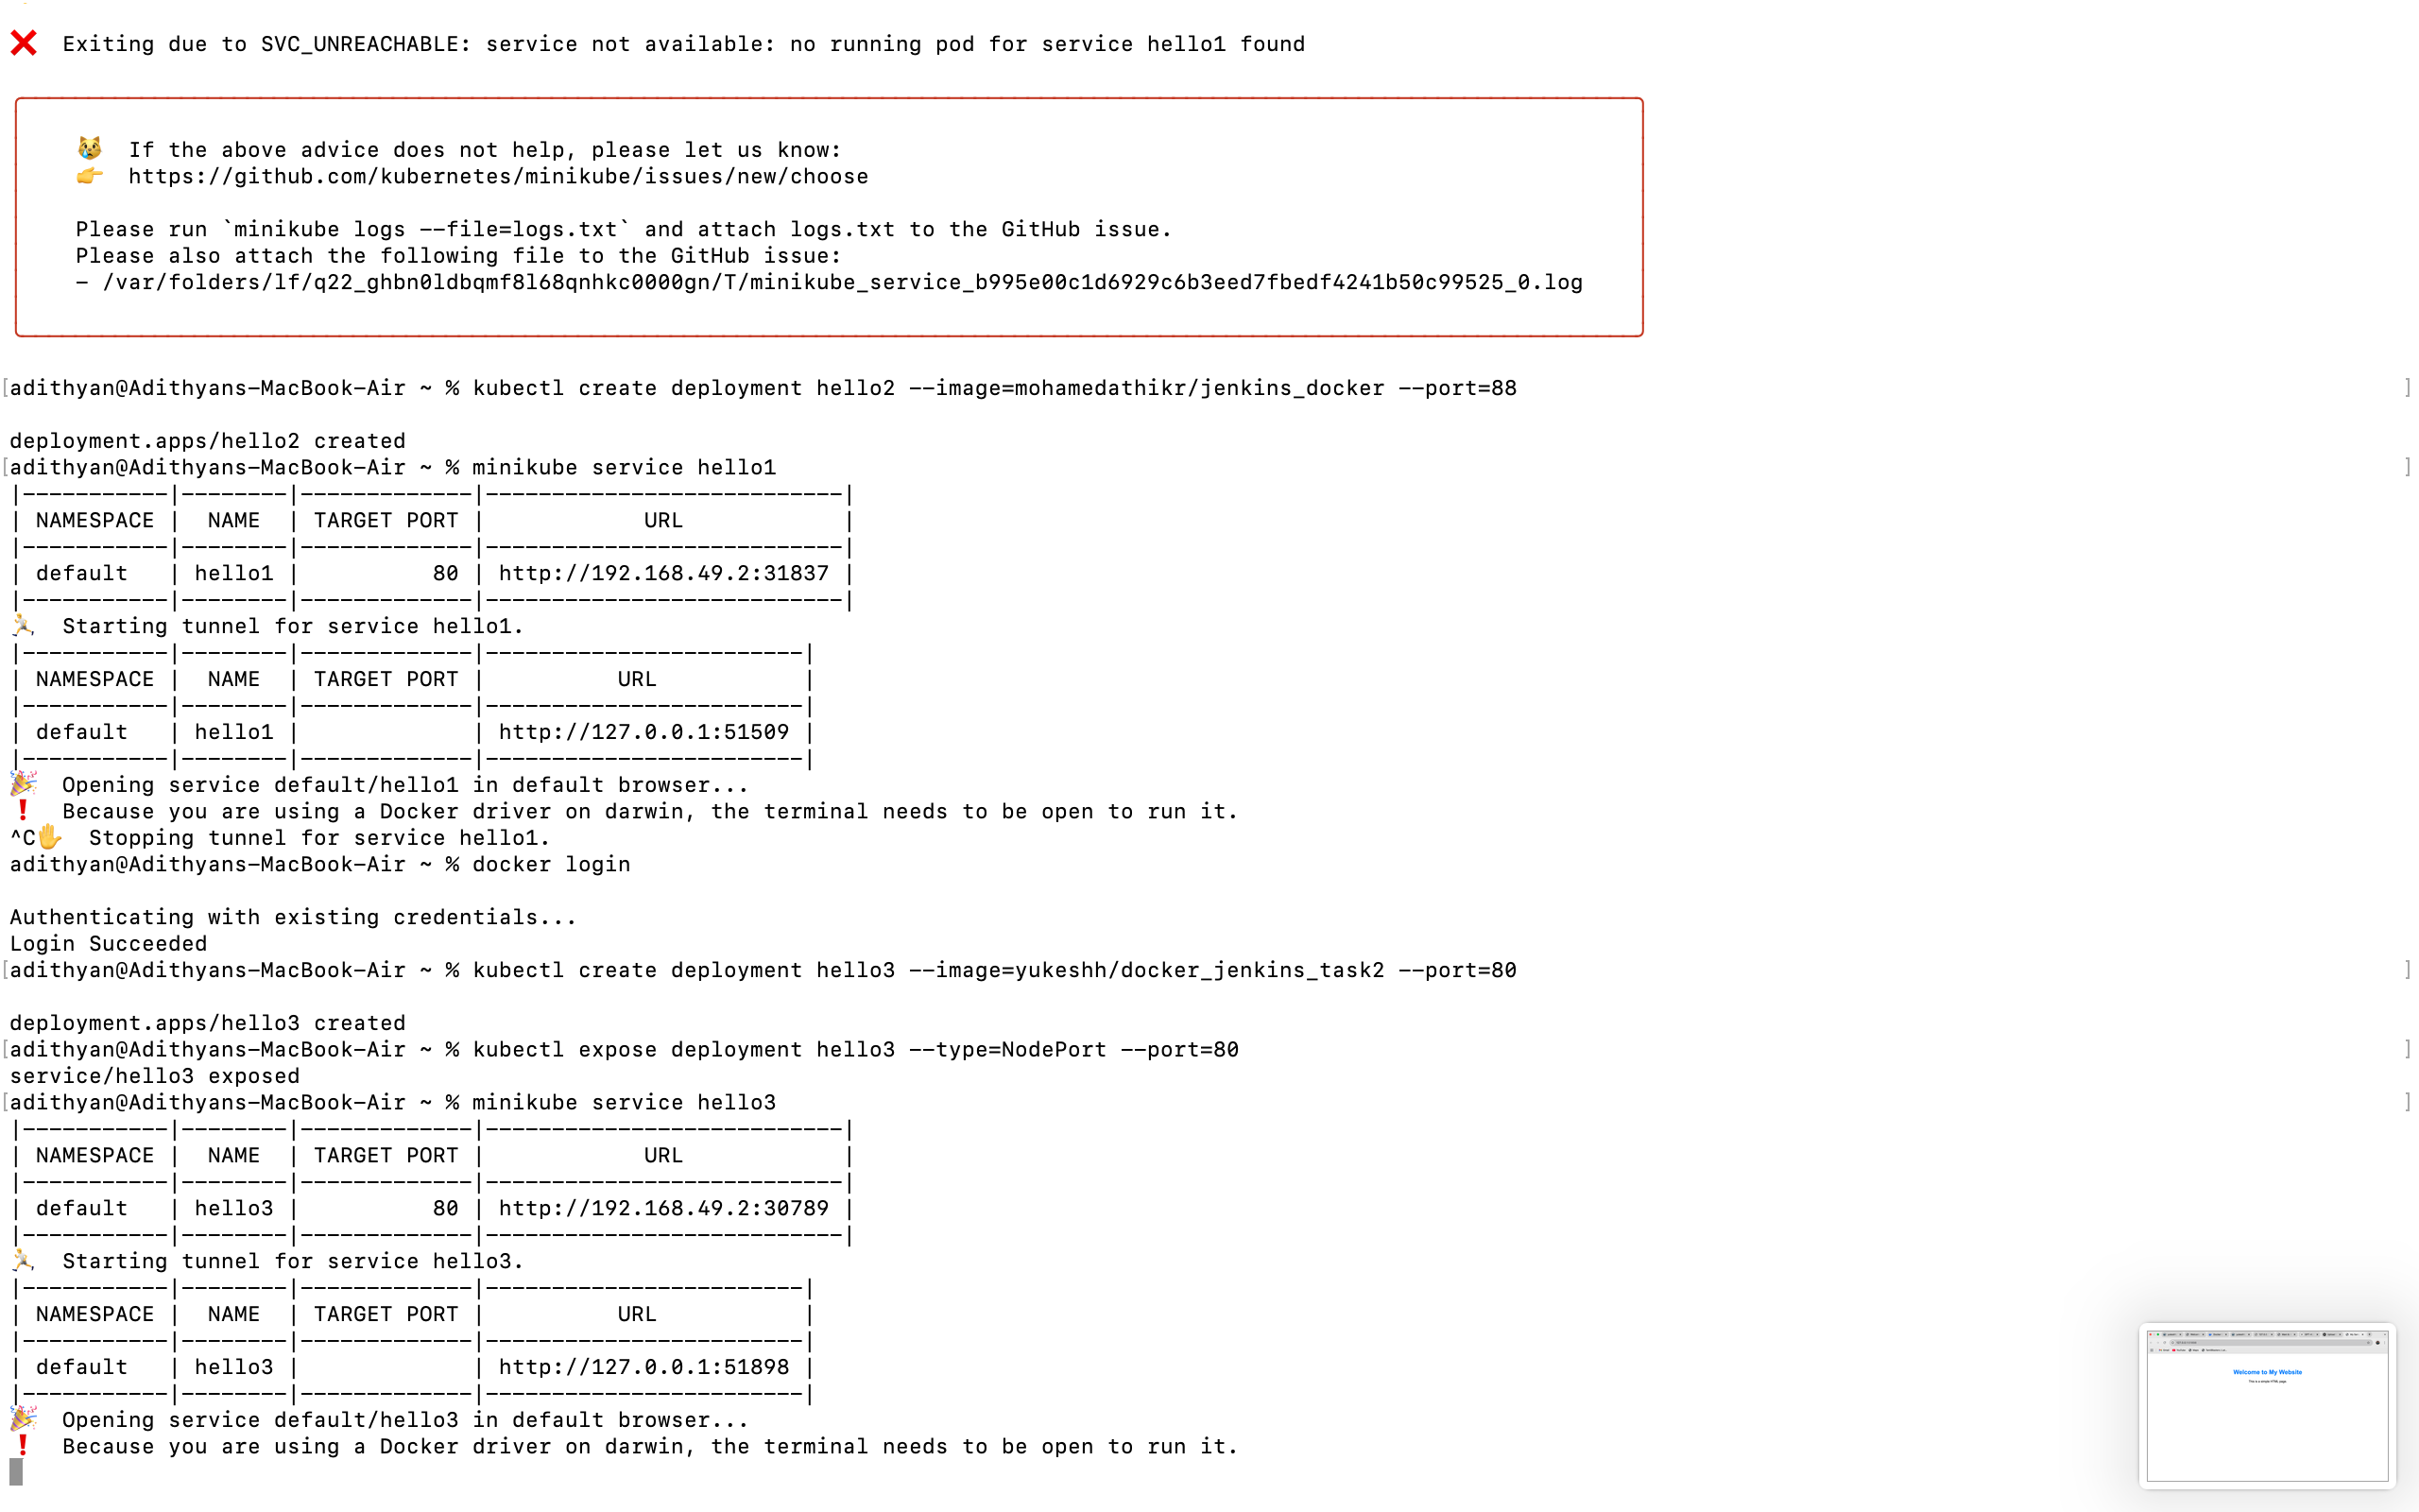

**Verifying Deployment:**

Checking if the pods are running.

Accessing the application through Minikube service.



