**Lab 1-1: Building a Synchronization Task**

**Scenario:**

In this lab, you will create a synchronization task that will load customer data from a CSV file into the Salesforce.com Account object.

**Objective:**

In this lab, you will: Learn how to create a new synchronization task

**Prerequisites:**

1. Save the following lab files to your flat file directory (C:\IICSLabFiles):

Customers.csv

1. Examine the Source File. Open the file, **Customers.csv**.

Note how many records are in the file.

Note one or two account names in the file.

1. Close the source file.



1. **Create a Synchronization Task in IICS:**

a. Log in to the Informatica Intelligent Cloud Services (IICS).

b. Select the **Data Integration** service.

c. The Home page appears.

d. To create a new Asset, in the left navigation pane, click **New**.

e. To create a new synchronization task, click **Synchronization Task** option.

f. Click the **Create** button.

**Note:** A six step Synchronization Task wizard appears, as shown below:

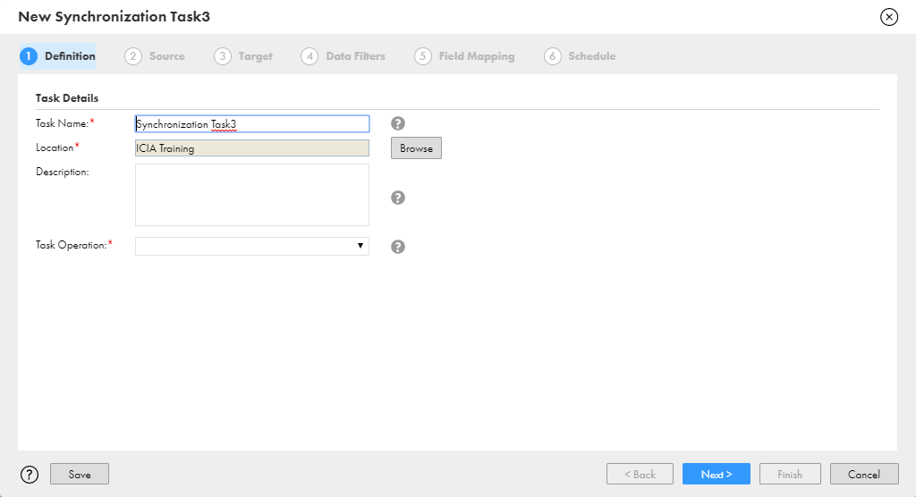

2. **Specify Definition Information:**

a. In the Task Name field, enter **XX_AccountLoad** (where XX is your name or initials).

b. Keep the Location set to Default (Project or Folder).

c. From the Task Operation dropdown, select **Insert**.

d. Click **Next**.

3. **Specify Source Information:**

a. From the Connection dropdown, select **XX_LocalCSVFiles** (where XX is your name or initials).

b. From the Source Object dropdown, select **Customers.csv**.

**Note:** The Data Preview appears.

c. Click **Next**.

4. **Specify Target Information:**

a. From the Connection dropdown, select **XX_SFDCDeveloper**.

b. From the Target Object dropdown, select **Account**. **Note:** A preview of the current data in the Account object is displayed. In this case, there is no data.

c. Click **Next**.

5. **Skip Data Filters Step:**

**Note:**

a. In this lab, you will not define a data filter.

b. Note that the Row Limit setting does not apply to CSV files.

c. You can optionally define a data filter on the source data.

d. Data filters will be discussed later in the course.

e. To skip this step, click **Next**.

6. **Define Field Mappings:**

**Note:**

a. Name field in the Source has automatically been mapped to the Account Name field in the Target.

b. The green checkmark in the Status column indicates that the field has been mapped.

c. Map the fields by dragging them from the source to the target.

|  |  |
| --- | --- |
| **Source Field Name** | **Target Field Name** |
| AreaCode | Account Phone |
| City | Billing City |
| Country | Billing Country |
| Customer_Type | Account Type |
| PhoneNumber | Account Phone |
| Postal Code | Billing Zip/Postal Code |
| State | Billing State/Province |
| Street | Billing Street |

b. To ensure that the mapping has no errors, click **Validate Mapping**.

c. Click **Next**.

7. **Define Schedule and Save the Task:**

**Note:**

i. In this lab, we will not create a schedule.

ii. Schedules will be discussed later in the course.

a. To save the task and continue working, click **Save**.

b. To save and close the synchronization task wizard, click **Finish**

**Note:** The Synchronization Task Asset will now be displayed on the Navigation Pane and the task details will be displayed on the page,

c. To run the Synchronization task, Click **Run**.

8. **Monitor the Synchronization Task:**

a. To monitor the task, in the Navigation Pane, click **My Jobs**.

**Note:** The task status is shown in the Status column on My Jobs page.

**Note:** After the Synchronization task is completed, the status will change to Success. In addition, a notification will appear in the Notifications section.

b. To view the notifications, click the **Notifications** icon.

9. **Verify Results:**

a. Log in to your Salesforce developer Org and search for the accounts you noted in Prerequisites step.

b. Verify that all of the accounts in the source file are now in Salesforce Account object.

**Lab 1-2: Building a Replication Task**

**Scenario:**

In this lab, you will create a replication task that will replicate data from the Account and Opportunities objects in Salesforce to flat files.

**Objective:**

In this lab, you will: Learn how to build and run a replication task.

**Tasks:**

1. **Create One or More Opportunities in Salesforce:**

a. Locate one of the accounts that have been created in your Salesforce org (Tyco, for example).

b. On the Account Details page, scroll-down to the Opportunities section and click the **New Opportunity** button.

**Note:** Complete the required fields and click the Save button.

c. Repeat the steps above to create an opportunity for another account (Honeywell, for example).

2. **Create a Replication Task:**

a. Log in to the Informatica Intelligent Cloud Services (IICS).

b. Select the **Data Integration** service.

c. To create a new Asset, in the left navigation pane, click **New.**

d. To create a new replication task, click **Replication Task** option.

e. Click the **Create** button.

3. **Specify Source Information:**

a. In the Task Name field, enter **XX_OpptyAcct** (where XX is your name or initials).

b. Browse and select the Location as **Default** (Project or Folder).

c. From the Connection dropdown, select **XX_SFDCDeveloper** (where XX is your name or initials).

d. For the Objects to replicate field, select **Include Objects** and then click the **Select** button.

e. Select **Opportunity** and **Account** in the Available Objects list. Click **Select**.

f. Click **Next**.

4. **Specify Target Information:**

a. From the Connection dropdown, select **XX_LocalCSVFiles** (where XX is your name or initials).

b. In the Target Prefix field, enter **XX_** (where XX is your name or initials).

c. Click **Next**.

5. **Skip Field Exclusions and Data Filters Step:**

a. To skip the Field Exclusions step, click **Next**.

b. To skip the Data Filters step, again click **Next**.

6. **Save and Run the Task:**

a. To save and close the replication task wizard, click **Finish**.

b. Run the replication task.

c. Monitor the task.

7. **View the CSV Files:**

a. Locate the files that were created.

**Note:** Go to your local CSV files directory.

b. View the Accounts file – it will be named: **XX_ACCOUNT.csv** (where XX is your name or initials). **Note:** How many records were replicated to the file?

**Note:** A few fields that contain no data and could be excluded from the file.

c. View the Opportunities file.

**Lab 1-3: Setting up External IDs in Salesforce**

**Scenario:**

In order to Upsert the information when you synchronize data from an external system with Salesforce.com, you need to store the record’s identifier (from the external system) in Salesforce. This can be accomplished using an External ID field in Salesforce.

**Objective:**

In this lab, you will: Set up an external ID field on two Salesforce objects: Account and Contact

**Tasks:**

1. **Create External ID Custom Field on your Salesforce Developer Org > Account Object:**

a. Log in to Salesforce.com, using your developer credentials.

b. In the upper right corner of the screen, click **Setup**

c. Under Build, click **Customize** > **Accounts** > **Fields**.

d. Click **New** in the Account Custom Fields & Relationships section (in the bottom part of the page).

2. **Specify the Field Type:**

a. For the field data type, select **Text**.

b. Click **Next** (either of the two available Next buttons).

3. **Specify the Field Details:**

a. In the Field Label field, enter **Account External ID**.

b. In the Length field, enter **50**.

c. Select the **External ID** property checkbox.

d. Click **Next**.

e. Click **Next**. **Note:** For this lab, you don’t need to make any changes in this step.

f. Click **Save**.

4. **Create External ID Custom Field on the Contact Object:**

a. Under Build, click **Customize** > **Contacts** > **Fields**.

b. Click **New** in the Contact Custom Fields & Relationships section (in the bottom part of the page).

c. Repeat steps 2 and 3 (above) to create an External ID field on the Contact object.

d. You should name this field: **Contact External ID**.

**Lab 1-4 Upserting Account Data**

**Scenario:**

You need to insert new records, and update existing records, in Salesforce – using data in a file that you receive each day.

**Objective:**

In this lab, you will: Practice using a flat file connection.

Practice creating a synchronization task and mapping an external ID.

**Tasks:**

1. **Create a Synchronization Task:**

a. Log in to the Informatica Intelligent Cloud Services (IICS).

b. Select the **Data Integration** service.

c. The Home page appears.

d. To create a new Asset, in the left navigation pane, click **New**

e. To create a new synchronization task, click **Synchronization Task** option.

Click the Create button

Note: A six-step Synchronization Task wizard appears

2. **Specify Definition Information:**

a. In the Task Name field, enter **XX_UpsertAccountsByExternal_ID** (where XX is your name or initials).

b. Keep the Location set to Default (Project or Folder).

c. From the Task Operation dropdown, select **Upsert**.

d. Click **Next**.

3. **Specify Source Information:**

a. From the Connection dropdown, select **XX_LocalCSVFiles** (where XX is your name or initials).

b. From the Source Object dropdown, select **Account_Data.csv**.



**Note:** The Data Preview appears.

c. Click **Next**.

**Note:**

i. This file is on your computer where you installed the secure agent.

ii. Click the **Formatting Options** button and make sure that Comma is selected in the Delimiter field.

4. **Specify Target Information:**

a. From the Connection dropdown, select **XX_SFDCDeveloper**.

b. From the Target Object dropdown, select **Account**. **Note:** A preview of the current data in the Accounts object is displayed.

c. Click **Next**.

5. **Skip Data Filters Step:**

a. To skip this step, click **Next**.

6. **Define Field Mappings:**

a. Map the fields by dragging them from the source to the target.

|  |  |
| --- | --- |
| **Source Field Name** | **Target Field Name** |
| ACCOUNT_ID | Account External ID |
| ACCOUNT_NAME | Account Name |
| AREA_CODE | Account Phone |
| BILLINGCITY | Billing City |
| BILLINGCOUNTRY | Billing Country |
| BILLINGPOSTALCODE | Billing Zip/Postal Code |
| BILLINGSTATE | Billing State/Province |
| BILLINGSTREET | Billing Street |
| PHONE_NUMBER | Account Phone |
| TYPE | Account Type |

**Note:** Some of the fields will be mapped automatically.

b. To ensure that the mapping has no errors, click **Validate Mapping**.

c. Click **Next**.

7. **Define Schedule and Save the Task:**

**Note:**

i. In this lab, we will not create a schedule.

ii. Schedules will be discussed later in the course.

b. To save the task and continue working, click **Save**.

c. To save and close the synchronization task wizard, click **Finish**.

d. To run the Synchronization task, Click **Run**.

**Note:** After the Synchronization task gets started, a message ‘Started XX_UpsertAccountByExternal_ID. View in My Jobs’ appears, as shown below:

e. Monitor the task. **Note:** The number of success rows should match the number of rows in the source file.

8. **View Data in Salesforce:**

a. Log in to your Salesforce developer Org.

b. Click on the **Accounts** tab and view new account records that were inserted. **Note:** You can use the New This Week view.

c. Click into an account to view details and note the External ID field.

9. **Edit Source Data and Restart the Task:**

a. Open the source data file, **Account_Data.csv** (found in C:\IICSLabFiles).

b. Edit some data. **Note:** Change an address or phone number for a specific account, for example.

c. To restart the task

i. Go to **My Jobs** page.

ii. Hover over the task **XX_UpsertAccountByExternal_ID.**

10. **Verify Data in Salesforce:**

a. Verify that the record is updated in Salesforce.

**End of Exercise 1**