**University Analytics System**

**Software Requirements Document**

**V 1.0**

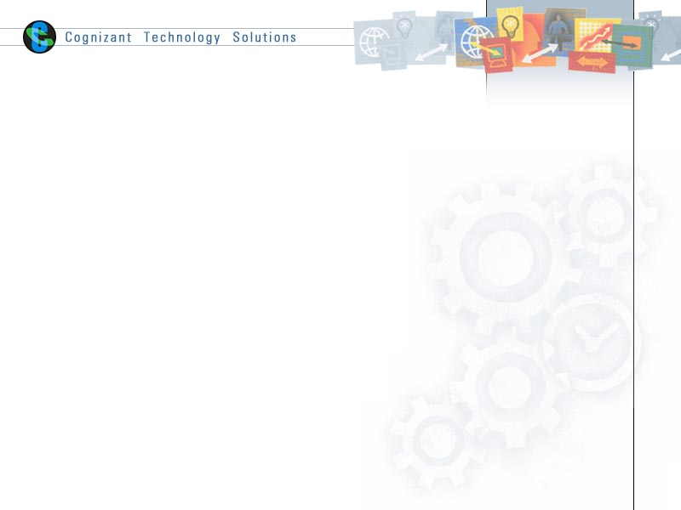

|  |  |  |  |
| --- | --- | --- | --- |
|  | **Prepared By** | **Reviewed by** | **Approved By** |
| **Name** |  |  |  |
| **Role** | Team member | Project Leader/ Team Leader/ Team Member | Project Manager/ Team Leader |
| **Signature** |  |  |  |
| **Date** |  |  |  |

Table of Contents

1 Introduction 3

1.1 About this document 3

1.1.1 Purpose & Scope of the document 3

1.1.2 Intended Audience 3

1.2 About the Software System 3

1.2.1 Scope of the system 3

1.2.2 Exclusions 4

1.2.3 System Perspective 4

1.2.4 System diagram 5

1.2.5 System Environment 5

1.2.6 Architecture diagram 5

1.2.7 User Characteristics 6

1.2.8 Impact of the System 6

1.2.9 Assumptions, Risks / Constraints 6

1.2.10 Design Constraints 6

2 System Requirements 6

2.1 Functional Requirements 6

2.1.1 Student Dimension 6

2.1.2 College Dimension 7

2.1.3 Faculty Dimension 7

2.1.4 Department Dimension 7

2.1.5 Course Dimension 7

2.1.6 Time Dimension 8

2.1.7 Result Staging 8

2.1.8 Result Fact 8

2.1.9 Result Aggregate 9

3 Terms and conditions 9

4 Change Log 9

# Introduction

## About this document

### Purpose & Scope of the document

The purpose of the software requirements document is to systematically capture requirements for the project and the system “University Analytics” to be developed. Both functional and non-functional requirements of this system are captured in this document. It also serves as the input for the project scoping.

The scope of this document is limited to addressing the requirements from the business perspective. It is recommended that design aspects are not added in this document

### Intended Audience

Project Team

## About the Software System

The following section will cover aspects related to University Analytics System (UAS) application. UAS is a system used for the analysis of various department/student/faculty performances.

The following are the modules in this proposed system

1. Student Dimension
2. College Dimension
3. Department Dimension
4. Course Dimension
5. Faculty Dimension
6. Time Dimension
7. Results Staging
8. Results Fact
9. Results Aggregate

### Scope of the system

The scope of the system is explained through its modules as follows

* 1. **Student Dimension** – The Student dimension table ***CDW_UAS_D_STUDENT*** is a Type – II SCD table which contains all students’ information. The source file’s name is ***CDW_UAS_STUDENT.txt***. The source file is a comma (,) delimited file. The source sends the file on a daily basis. History of the students’ needs to be maintained in the table.
* **College Dimension -** The College dimension table ***CDW_UAS_D_COLLEGE***is a Type – I SCD which contains all college details. *Data is added to this table, only when a new college is being opened*. So, the load schedule would be *on demand*. The source file’s name is ***CDW_UAS_COLLEGE.txt*** and it is pipe (|) delimited. The table is updated/ inserted for old/ new branches respectively and no history is maintained
* **Department Dimension -** The Department dimension table ***CDW_UAS_D_DEPARTMENT*** is a Type – I SCD table which contains all the departments’ information. The source file’s name is ***CDW_UAS_DEPARTMENT.txt*** and it is pipe (|) delimited. The table is updated/inserted for old/new suppliers respectively on a daily basis and no history is maintained.
* **Course Dimension -** The course dimension table ***CDW_UAS_D_COURSE*** is a Type – I SCD which contains all course information. The source file’s name is ***CDW_UAS_COURSE.txt*** and it is comma (,) delimited. This table is *dependent on the Department table* for the Department Id. The department table must contain the *respective department information before loading course* table. The table is updated/inserted for old/new products respectively on a daily basis and no history is maintained.
* **Faculty Dimension -** The faculty dimension table ***CDW_UAS_D_FACULTY***is a Type – I SCD which contains all faculty details. The source file’s name is ***CDW_UAS_FACULTY.txt*** and it is comma (,) delimited. The table is updated/ inserted for old/ new branches respectively and no history is maintained
* **Time Dimension** - The Time dimension table ***CDW_UAS_D_TIME*** is a static table which contains the time key and other relevant information. This table is loaded once in a year from the source file ***Src_Calender_file.txt*** which is fixed width file.
* **Results Staging -** The results staging table ***CDW_UAS_STG_RESULTS*** receives the results data from the different evaluation centers (Two delimited & one fixed width) ***CDW_UAS_F_RESULTS_BR_XX.txt*** and the delimiter used is comma. The information from different files is standardized in the staging table. This table is refreshed every day. The data is loaded with all related dimension information from the respective dimension tables in the warehouse. Records containing invalid information will be sent to the ***CDW_UAS_ERR*** error table. The two delimited files are joined before loading in to the staging area.
* **Results Fact -** The results fact table ***CDW_UAS_F_RESULTS*** contains all the transactions loaded from the staging table ***CDW_UAS_STG_RESULTS*.** This table is loaded o*nly after the staging table has been loaded completely from the transaction files arriving from all the different centers.*
* **Results Aggregate -** The Sales Aggregate table ***CDW_UAS_F_AGG_DATA*** pulls data from the Results fact table ***CDW_UAS_F_RESULTS***. The table is aggregated by college_code &course_code for the current month.

### Exclusions

* + - * + N/A -

### System Perspective

* + - * + N/A -

### System diagram

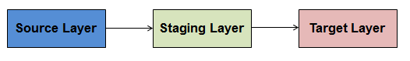

### System Environment

The “**UAS”** application will be extracting data from source files, transforms based on the logic and loads into target.

1. Informatica for application deployment.
2. Oracle database for data storage

### Architecture diagram

#### Logical Architecture:

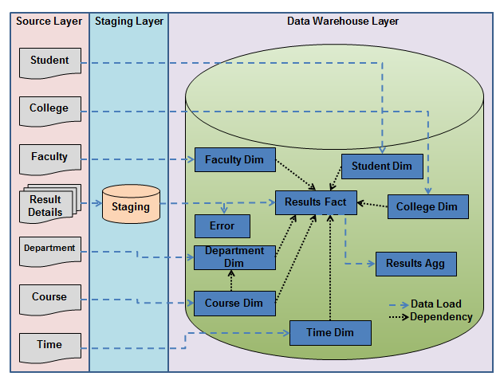

### User Characteristics

* + - * + N/A -

### Impact of the System

* + - * + N/A -

### Assumptions, Risks / Constraints

**Assumptions:**

* Database server is up and running.
* Structure of file sources and targets will be provided*.*
* A valid user id will have provided for development.

**Risks:**

* + - * + NA -

### Design Constraints

* Course table should get loaded only when a valid department exist for the course in department dimension table.
* A student record getting loaded in to the fact table should have corresponding entry in student dimension table.
* Date of result getting loaded in to the fact table should have corresponding entry in Time dimension table.
* The ETL data flow schedule should accommodate the order of dimension table loading before the fact table load.

# System Requirements

## Functional Requirements

### Student Dimension

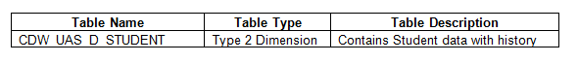

**ETL Logic:**



### College Dimension



**ETL Logic:**



### Faculty Dimension



**ETL Logic:**



### Department Dimension



**ETL Logic:**



### Course Dimension



**ETL Logic:**



### Time Dimension



**ETL Logic:**



### Result Staging

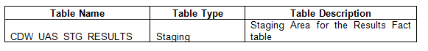

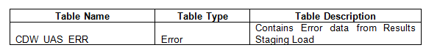

**ETL Logic:**



### Result Fact

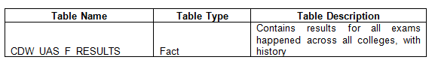

**ETL Logic:**



### Result Aggregate

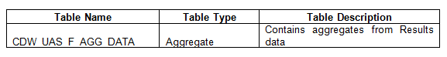

**ETL Logic:**



# Terms and conditions

GenCs shall be solely responsible for all its acts and omissions under this program. GenCs will comply at all times with all applicable laws. GenCs shall not use Cognizant’s name, logo and trademark in any promotional materials or other communications with third parties without the prior written consent of Cognizant. Any materials used by GenCs in relation to program will not infringe the copyrights, trademarks, patents, trade secrets or other intellectual property rights, privacy or similar rights of any person or entity. GenCs agrees not to post, draw, make, display any content that is threatening, libelous, obscene, defamatory, abusive, pornographic, or advocates/encourages any conduct that could constitute a criminal offence or give rise to any civil liability. Cognizant its associates’ personal details including but not limited to name, address, contact number shall not be shared or forwarded to any third party, without prior written consent of Cognizant, its associates. All intellectual property provided by Cognizant as part of program shall be owned exclusively by Cognizant. Intern shall indemnify, defend and indemnify Cognizant its associates, officers, directors from and against any claims, demands, loss, damage, liability, causes of action, judgments, or costs and expenses of every nature (including attorney’s fees and expenses) incurred by Cognizant based on any claim that any breach of terms and conditions of this program.

# Change Log

Please note that this table needs to be maintained even if a Configuration Management tool is used.

|  |  |  |  |  |
| --- | --- | --- | --- | --- |
| Version Number | Changes made | | | |
| V1.0 | First version. | | | |
| V1.1 | *<If the change details are not explicitly documented in the table below, reference should be provided here>* | | | |
| Page no | Changed by | Effective date | Changes effected |
|  |  |  |  |
|  |  |  |  |
|  |  |  |  |
|  |  |  |  |
| V1.2 | *<If the change details are not explicitly documented in the table below, reference should be provided here>* | | | |
| Page no | Changed by | Effective date | Changes effected |
|  |  |  |  |
|  |  |  |  |
|  |  |  |  |