Responses to reviewers

## The introduction lacks clarity and needs to be more concise.

Thank you for pointing out this.

The introduction has been revised more clearly and concisely.

[Original manuscript]

The study aims to explore the various factors influencing the growth of small businesses in urban areas.

It is important to understand these factors to develop effective strategies for supporting small business growth.

[Revised manuscript]p.1 l.5

~~The~~ This study ~~aims to explore~~ explores ~~the various~~ factors influencing ~~the~~ small business growth ~~of small businesses~~ in urban ~~areas.~~ areas, aiming ~~It is important to understand these factors~~ to develop effective support ~~strategies~~ strategies. ~~for supporting small business growth.~~

[Original]  
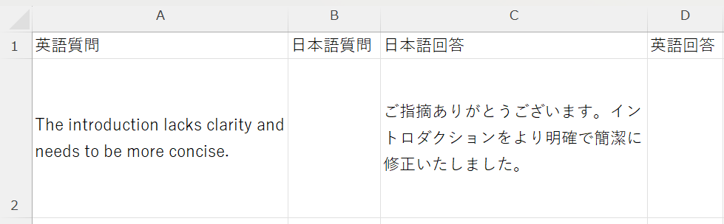

[Revised]  
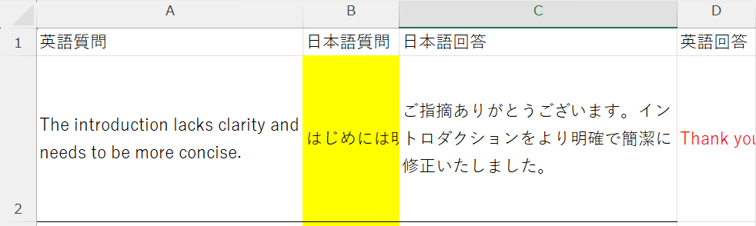

## There are several grammatical errors throughout the manuscript.

We have corrected grammatical errors in the entire manuscript.

[Original manuscript]

The results shows that there is a significant correlation between the marketing strategies and the sales performance.

[Revised manuscript]p.2

The results ~~shows~~ show ~~that there is~~ a significant correlation between ~~the~~ marketing strategies and ~~the~~ sales performance.

## The methodology section is not detailed enough.

The methodology section has been described in more detail.

[Original manuscript]

We conducted surveys and interviews to collect data

[Revised manuscript]pp.2-5

We conducted surveys with 100 participants and in-depth interviews with 20 business owners to collect comprehensive ~~data~~ data.