**UX2 Documentation**

**PART D – Documentation**

1. Screen Shot of Performance tab in DevTools

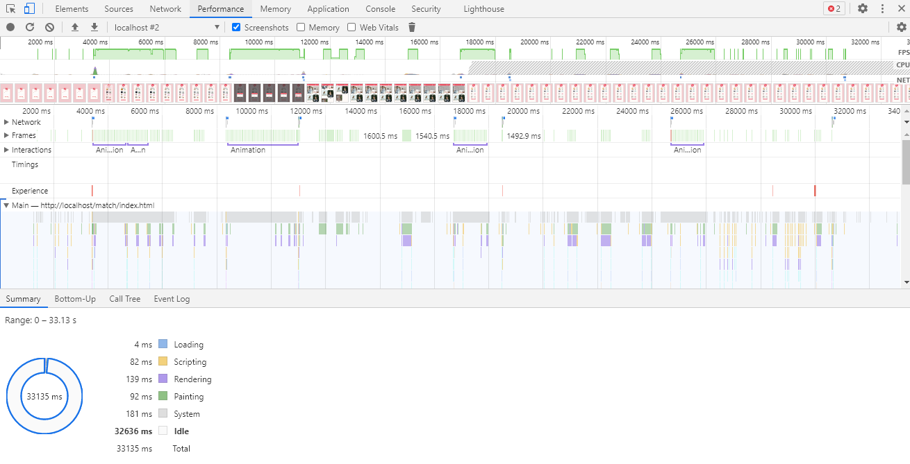

1. Screen shot showing AJAX (network tab)

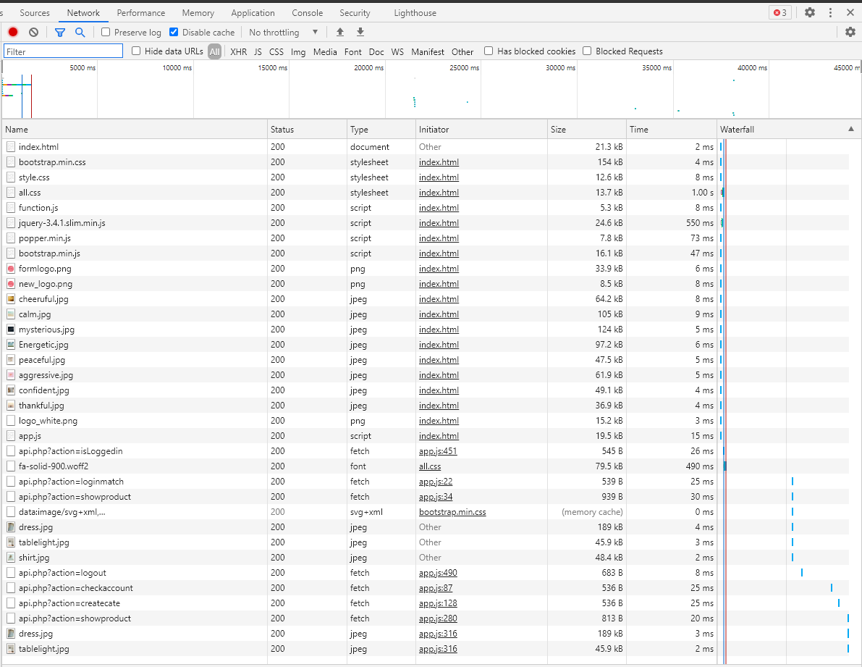

1. localStorage (application tab) inside devtools to prove app works

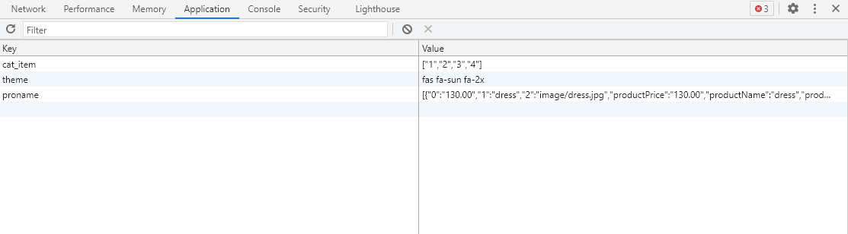

1. PWA audit completed under audits tab

