

UX3 - Continuous Improvement

Mobile shopping application

PART A

1. Associate a README.TXT with the app outlining technical implementation matters

Readme.file is in my repository folder or I also attached it in the submission folder as well.

Please find readme folder that contains readme.file.

Thank you,

Miyuki

1. Write HTML help document and associated? icon covering common user interface elements in the UI

|  |  |
| --- | --- |
| 1. Click help icon | 1. Help document come out |
|  |  |

1. Write a Roadmap going forward of the developments to the interface, include in development repository where code is stored

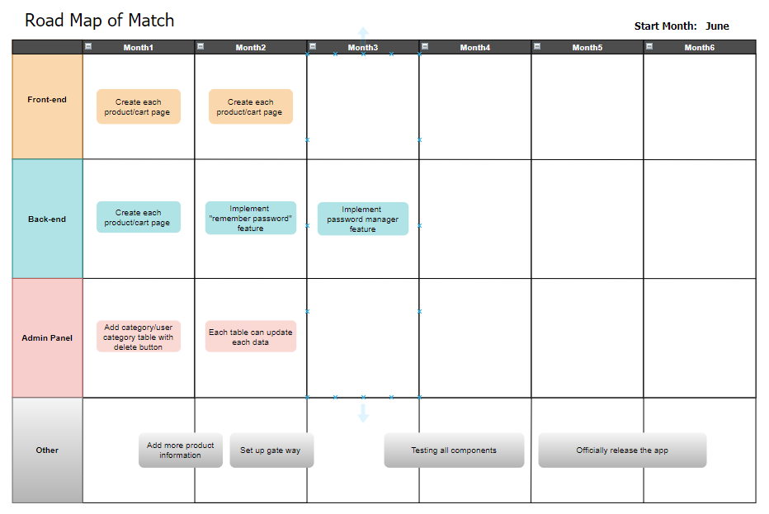

|  |
| --- |
| Expected time to release the app officially 5 - 6 months |

**Repository**

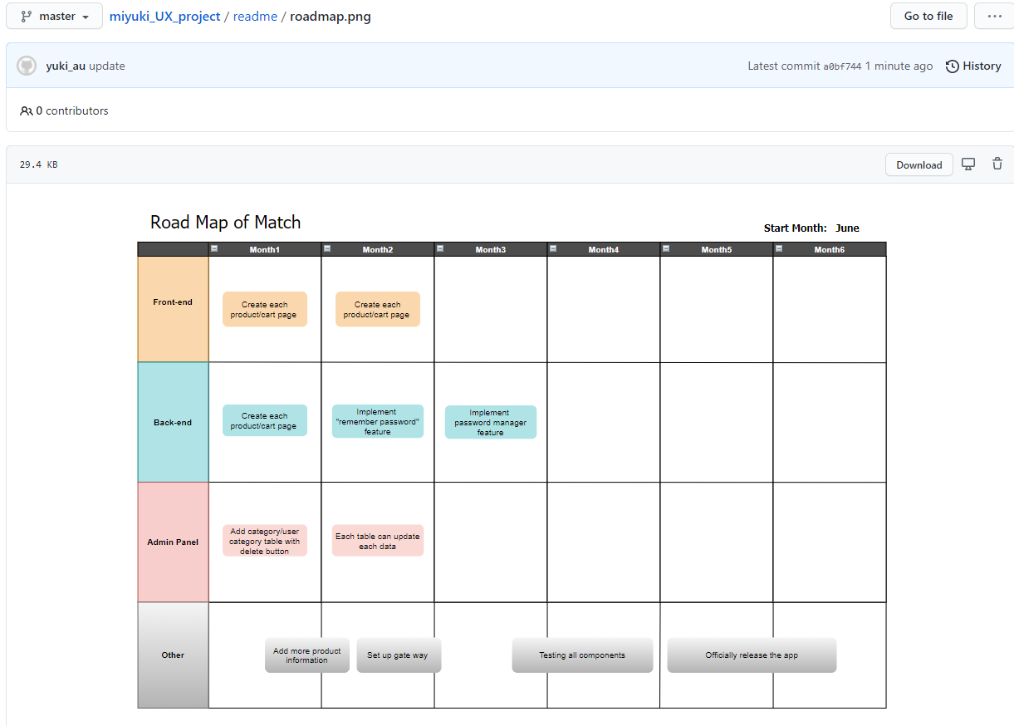

1. Prepare (build) project for production environment

I deployed my application in Heroku.

https://lit-sea-18183.herokuapp.com/

1. Why is it important to implement the above (1-4)

|  |  |
| --- | --- |
| Task1: | Helps gives users a detailed technical information of the project that you have created. |
| Task2: | Helps guide users how to use your app. It would be one of the components to improve user satisfaction. |
| Task3: | Helps organize your mind and plan a rough schedule for the further development of their app towards to the official release. |
| Task4: | Developers must choose the suitable deployment environment for their app and have knowledge of deployment environment. |

1. What other types of documentation may be necessary for this project?

**These following html documentations for users:**

Copyright document

Privacy policy document

Technical support document

PART B

1. What portions of the development went particularly well?

* Creating the code to call category list that includes the checklist you checked before.
* Modals in register and update category
* The consistency of the colors and layout

1. What was the most difficult to implement?

**Create/Update category list feature**

I received many errors due to my wrong identification of the data type of the category list. I read the error messages carefully and put **“print_r(getype (“valuable name”))”** in every single if statement to know exactly where those errors come from.

1. If you had the chance to do this again, what would you do differently

**UI:**

* Friendly to PC view
* Includes more animations
* Organize the indentation and make the code simpler and more readable

**PHP:**

* Organize the indentation and make the code simpler and more readable

**Admin:**

* Improve usability with changing the layout
* Show more information from the app with organized tables
* Enable to manipulate more details of each table such as update and create.

1. What parts of the implementation incomplete at this stage of delivery?

**UI:**

* Cart
* Gateway
* Product detail page

**PHP:**

* Cart part
* Show product detail part
* Password manager feature
* Remember password feature

**Admin:**

* Show category/user category tables
* Allow users to update/delete each table

1. Write and reflect on "Quality Assurance" how are you practicing this?

**Do testing by ensure the quality assurance of my app such as:**

1. Cross-Platform Testing.
2. Functional Testing.
3. User Interface Testing.
4. Accessibility Testing.
5. Performance Testing.
6. Security Testing.

**Do the following methods while the above tests**

1. Test on different devices
2. Document each test case and each result
3. How much of the prototype UX1 remains in the final project?

80% of planning in UX1 has been implemented in final project.

Some of the features such as cart and each product page has not been implemented yet.

However, I am going to implement the rest of the project later as the road map.

1. Where has your project Object Oriented programming implemented

|  |  |
| --- | --- |
| In se.php(api folder) | In api.php(api folder) |
| In db.php(api folder) |  |
|  |  |

|  |  |
| --- | --- |
| In admin-se.php(admin folder) | In admin-api.php(admin folder) |
| In admin-db.php(admin folder) |  |
|  |  |