**Documentation for PROJECT 3**

PART D - Metacognition

1. Comment on each of the 3rd party frameworks used, why was it chosen

**React**

* Change without reloading
* Fast
* Composable
* stateful
* Reusable functions and components
* Reflect

React will simply *react* to the changes such as regenerating the HTML views in the Document Object Model (DOM) in browser

**Material Ui**

* Documented well
* Update regularly
* Compatible with React
* Flexible to create your app unique, stylish and modern-looking

**Formik (Validation)**

* Easy to use
* Simple and less codes
* Documented well

1. What other technologies did you investigate in order to settle on a path

Vue instead of React

I was considering which technology is more useful for what I am looking for in my app and my career.

I was very interested in React because it has been hugely grown, even though it is new technology. And I thought it would possibly be one of the most valuable experience to learn/

1. Describe the rules by which your authentication restricts access. Comment in code.

I used formik to validate the form.

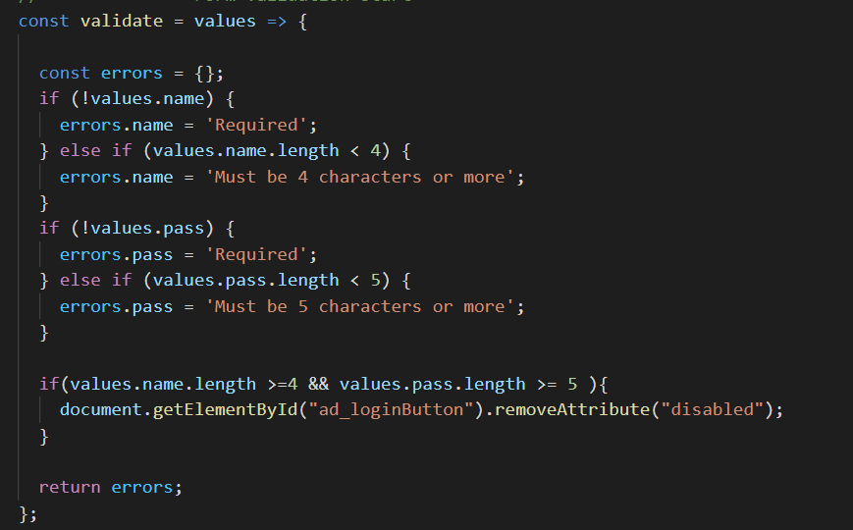

The above code prevents users to send empty values or values less than required the number of digits.

Also, for access limitation,

I created .env file in admin file to declare the origin and api.

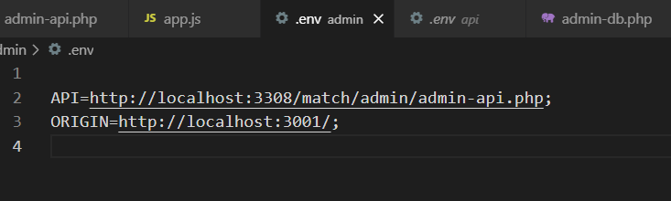

1. Describe why you chose this particular encryption technology

I used “password_hash” to encode the password in php because hash is more secure than encrypting

